Supplementary Information 2

Dentine ⁸⁷Sr/⁸⁶Sr analysis and calculating the ‘local’ range

Strontium isotope ratios in dentine were analysed in 13 randomly selected teeth from Lubná. Results from three of these teeth were excluded when calculating the local range:

- LB1 produced ⁸⁷Sr/⁸⁶Sr readings substantially different to all other teeth (Supplementary Figure 1), and ⁸⁴Sr/⁸⁶Sr ratios well below the expected value of 0.0565 (Supplementary Figure 3).

- LB6 produced the second-lowest ⁸⁴Sr/⁸⁶Sr ratios (after LB1) among the Lubná dentines (Supplementary Figure 3) and additionally had exceptionally high yttrium levels (Supplementary Figure 2) and was therefore excluded.

- In LB19, the measured dentine ⁸⁷Sr/⁸⁶Sr ratios varied systematically over a large range, contrary to what is expected from dentine that has equilibrated with the burial environment (Supplementary Figure 1) and was therefore excluded.

In LB18 ⁸⁷Sr/⁸⁶Sr ratios varied systematically over the length of sampled dentine, but the results overlapped entirely with those measured in the majority of other teeth and the data were therefore retained. LB10 contained very high yttrium, but was also retained for the same reason.

Supplementary Figure 1 – Lubná dentine ⁸⁷Sr/⁸⁶Sr ratios (values represent 10-point mean averages of individual measurements). Black lines indicate the defined ‘local’ range of 0.710255–0.711078 (calculated as a median of 0.710666 ± 1.5* the IQR of 0.000274
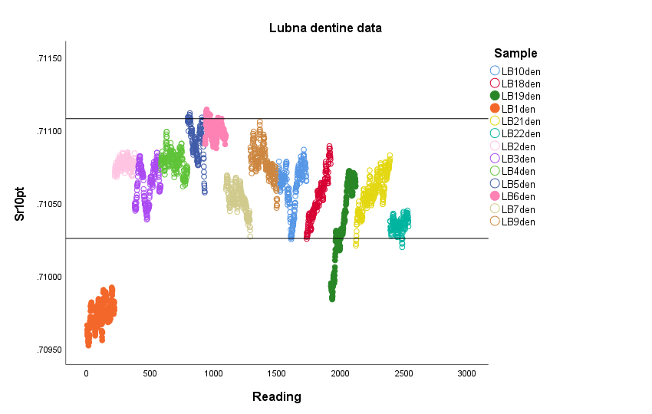

Figure 2 – Lubná dentine 10-point ⁸⁷Sr/⁸⁶Sr ratio data vs ⁸⁹Y (shown in volts). Black lines indicate the defined ‘local’ range of 0.710255–0.711078 (calculated as a median of 0.710666 ± 1.5* the IQR of 0.000274

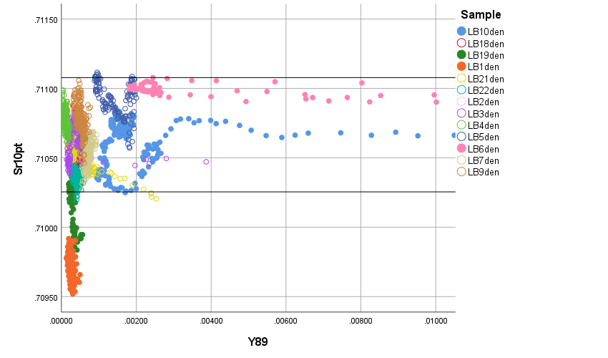

Supplementary Figure 3 – Lubná dentine ⁸⁴Sr/⁸⁶Sr ratios
