Osteological age-at-death estimation in an archaeological sample avoiding age-mimicry.
Archaeological and Anthropological Sciences
Denise U. Navitainuck1, Werner Vach1 2, Kurt W. Alt1 3, Sandra L. Pichler1
1 Integrative Prehistory and Archeological Science (IPAS) Department of Environmental
Sciences, University of Basel, Spalenring 145, CH-4055 Basel, Switzerland
2 Basel Academy for Quality and Research in Medicine, Steinenring 6, CH-4051 Basel,
Switzerland
3 Danube Private University, Center of Natural and Cultural Human History, Krems, Austria
Corresponding author: denise.navitainuck@unibas.ch

Appendix S7: Derivation of descriptions

Fau-L

The descriptions are based on the publication by Hens & Godde (2016). The authors scored the facies auricularis according to the scoring system developed by Lovejoy et al. 1985 in a sample of American males from the Bass Collection. They fit an ordinal probit model (cf. Appendix S3) using the natural log of age as covariate. This resulted in the following table in their publication:

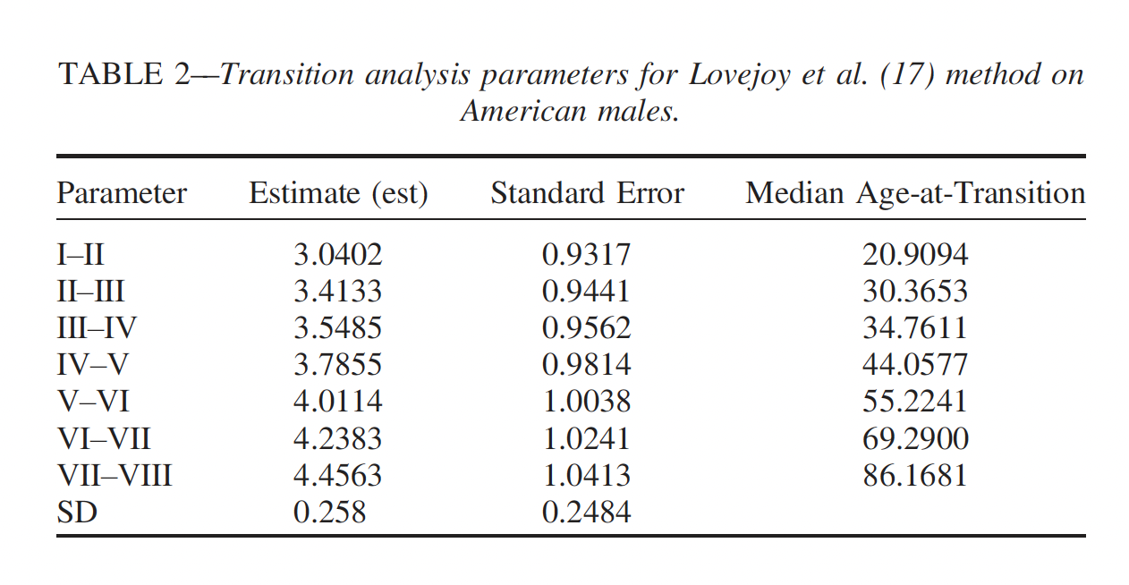
Table 2 reprinted, with permission, from Hens SM, Godde K (2016) Auricular Surface Aging: Comparing Two Methods that Assess Morphological Change in the Ilium with Bayesian Analyses. J Forensic Sci 61:S30–S38, courtesy of John Wiley and Sons Publishers.

The numbers in the column labeled “Estimate” refer to the values of the $κ$ parameters, except of the number in the final line which refers to $σ$. We use these numbers as description.

PS-Todd

The description is based on the publication by Todd (1920).

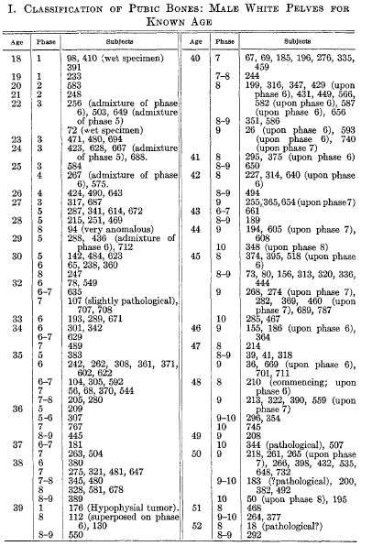
The author presents in the Appendix the raw data, i.e., true age and phase for each individual:

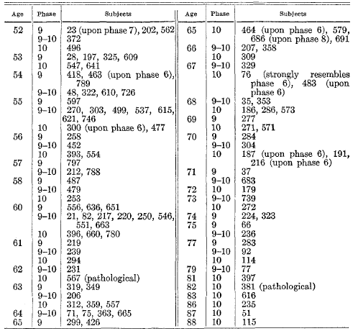
Appendix reprinted, with permission, from Todd TW (1920) Age changes in the pubic bone. I. The male white pubis. Am J Phys Anthropol 3:285–334, courtesy of John Wiley and Sons Publishers.

To this data we fitted ordinal regression models as described in Appendix S3. We tried both a probit and a logit model and models with age or the logarithm of age as covariate. The best fitting model (according to the log-likelihood) was a probit model with the logarithm of age as covariate. The estimated parameter values could be read of the following output:
. oprobit newphase logage

Iteration 0: log likelihood = -560.5582
Iteration 1: log likelihood = -350.83321
Iteration 2: log likelihood = -327.47501
Iteration 3: log likelihood = -326.954
Iteration 4: log likelihood = -326.95279
Iteration 5: log likelihood = -326.95279

Ordered probit regression Number of obs = 305
LR chi2(1) = 467.21
Prob > chi2 = 0.0000
Log likelihood = -326.95279 Pseudo R2 = 0.4167

------------------------------------------------------------------------------
newphase | Coef. Std. Err. z P>|z| [95% Conf. Interval]
-------------+----------------------------------------------------------------
logage | 6.974478 .4137686 16.86 0.000 6.163506 7.785449
-------------+----------------------------------------------------------------
/cut1 | 20.75595 1.349976 18.11005 23.40185
/cut2 | 21.03197 1.348314 18.38932 23.67462
/cut3 | 22.26812 1.380549 19.56229 24.97394
/cut4 | 22.66578 1.400786 19.92029 25.41127
/cut5 | 23.59047 1.450141 20.74824 26.43269
/cut6 | 24.50355 1.490284 21.58265 27.42446
/cut7 | 25.28937 1.521191 22.30789 28.27085
/cut8 | 26.33885 1.568669 23.26431 29.41338
/cut9 | 28.46408 1.672213 25.18661 31.74156
RT-PU

The description is based on the publication by Prince & Ubelaker (2002).

The authors present output from two regression analysis regressing the true age against three tooth translucency measures, one for males and one for females.
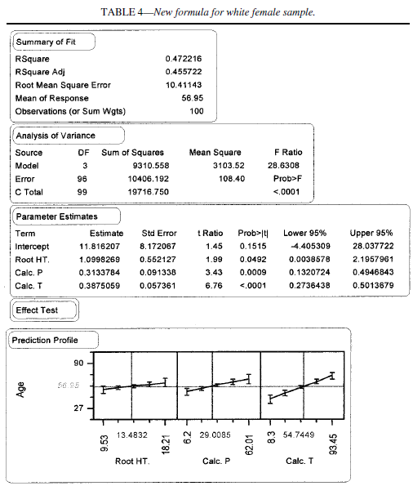

Table 4 reprinted, with permission, from Prince DA, Ubelaker DH (2002) Application of Lamendin’s adult dental aging technique to a diverse skeletal sample. J Forensic Sci 47:107–116, copyright ASTM International, 100 Barr Harbor Drive, West Conshohocken, PA 19428.

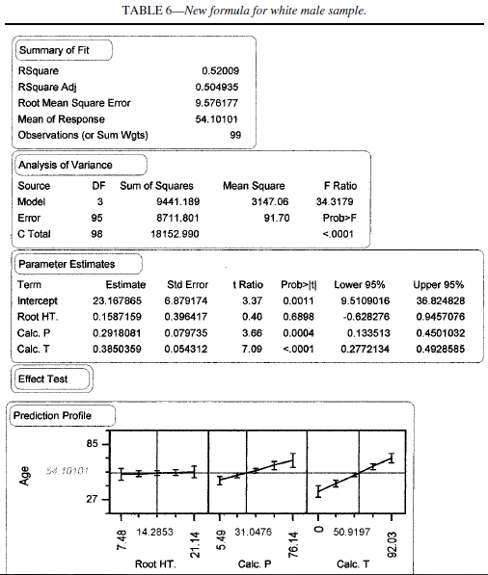

Table 6 reprinted, with permission, from Prince DA, Ubelaker DH (2002) Application of Lamendin’s adult dental aging technique to a diverse skeletal sample. J Forensic Sci 47:107–116, copyright ASTM International, 100 Barr Harbor Drive, West Conshohocken, PA 19428.

These outputs refer to regression models with three covariates. However, if we define a new covariate corresponding to the predictions from these models and fit the model again, we would obtain an intercept of 0, a slope of 1, but the same adjusted $R^{2}$ value. As in the outputs the mean of the response variable age is reported, too, it is possible to reverse the regression equations as outlined in Appendix S3 (D).

This way we obtain the estimates 31.00, 0.456 and 7.028 for intercept, slope and the error standard deviation in females, and 26.78, 0.505 and 6.805 in males. Since these two equations are rather similar, we averaged the parameter values to obtain one equation.

EnSa-ML and EnSv-ML

The description is based on the publication by Meindl & Lovejoy (1985).

The authors present the following two tables, reporting sample sizes and mean values for a coarsened version of the composite score:

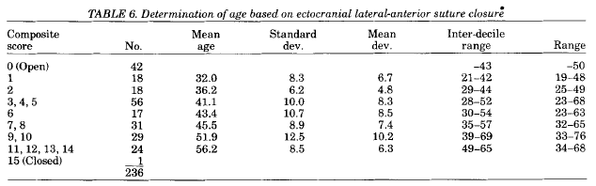
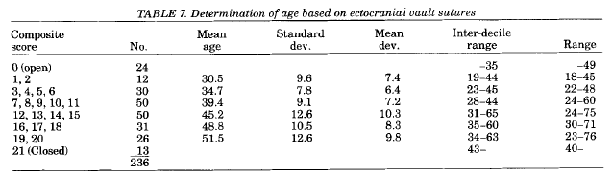
Table 6 and 7 reprinted, with permission, from Meindl RS, Lovejoy CO (1985) Ectocranial Suture Closure: A Revised Method for the Determination of Skeletal Age at Death Based on the Lateral-Anterior Sutures. Am J Phys Anthropol 68:57–66, courtesy of John Wiley and Sons Publishers.

In principle, we can apply the approach outlined in Appendix S3 (C). However, mean age and standard deviations are missing for the extreme categories in the table give above. In the first table we assumed a mean age of 26 and a standard deviation of 8 if the composite score is equal to 0, and a mean age of 64 and a standard deviation of 10 if the composite score was equal to 15. In the second table we assumed a mean age of 26 and a standard deviation of 8 if the composite score is equal to 0, and a mean age of 58 and a standard deviation of 12 if the composite score was equal to 21.

Fau-BC

The description is based on the publication by Buckberry & Chamberlain (2002)

The authors present the raw data in the Appendix. :
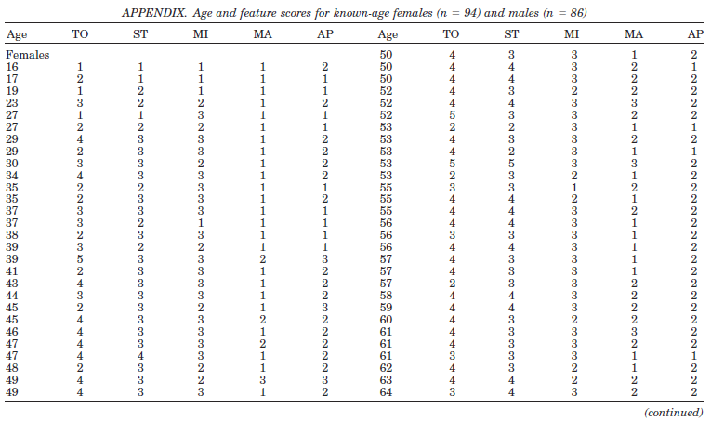
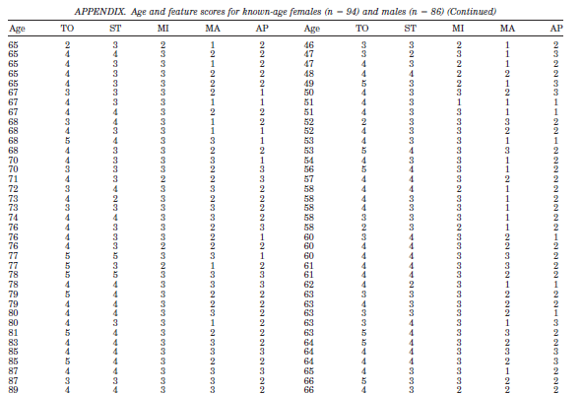
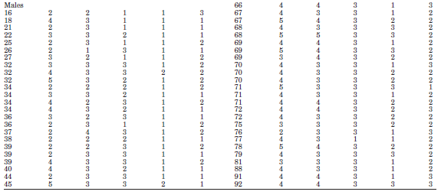
Appendix reprinted, with permission, from Buckberry JL, Chamberlain AT (2002) Age Estimation from the Auricular Surface of the Ilium: A Revised Method. Am J Phys Anthropol 119:231–239, courtesy of John Wiley and Sons Publishers.

To this data we fitted ordinal regression models as described in Appendix S3. Since the maximally observed score value in our study was 16, we collapsed all observations of 16 and above into one category.

We tried both a probit and a logit model and models with age or the logarithm of age as covariate. The best fitting model (according to the log-likelihood) was a probit model with the logarithm of age as covariate. Adding sex as a covariate to this model did not indicate a statistically significant sex effect. (This was already observed by Buckberry & Chamberlain).

The estimated parameter values could be read of the following output:

oprobit score logage

Iteration 0: log likelihood = -385.07015
Iteration 1: log likelihood = -326.29429
Iteration 2: log likelihood = -325.24781
Iteration 3: log likelihood = -325.2435
Iteration 4: log likelihood = -325.2435

Ordered probit regression Number of obs = 180
LR chi2(1) = 119.65
Prob > chi2 = 0.0000
Log likelihood = -325.2435 Pseudo R2 = 0.1554

------------------------------------------------------------------------------
score | Coef. Std. Err. z P>|z| [95% Conf. Interval]
-------------+----------------------------------------------------------------
logage | 2.804022 .2681272 10.46 0.000 2.278502 3.329542
-------------+----------------------------------------------------------------
/cut1 | 7.626443 .9657441 5.733619 9.519266
/cut2 | 7.885827 .9675098 5.989543 9.782111
/cut3 | 8.568066 .9799019 6.647494 10.48864
/cut4 | 9.163754 1.002307 7.199268 11.12824
/cut5 | 9.824351 1.034703 7.79637 11.85233
/cut6 | 10.28492 1.055329 8.216512 12.35333
/cut7 | 10.73228 1.071691 8.631802 12.83275
/cut8 | 11.37204 1.088675 9.238276 13.5058
/cut9 | 11.95003 1.100583 9.792928 14.10713
/cut10 | 12.5057 1.112073 10.32607 14.68532

PS-BS

The description is based on the publication by Konigsberg, Herrmann, Wescott and Kimmerle (2008). The authors fit an ordinal probit model with the logarithm of age as covariate (cf. Appendix S3) to six different skeletal samples and presented the results in the following Table. In all samples the pubic symphysis had been scored according to the system proposed by Brooks & Suchey (1990). However, the scoring was performed by different researchers.

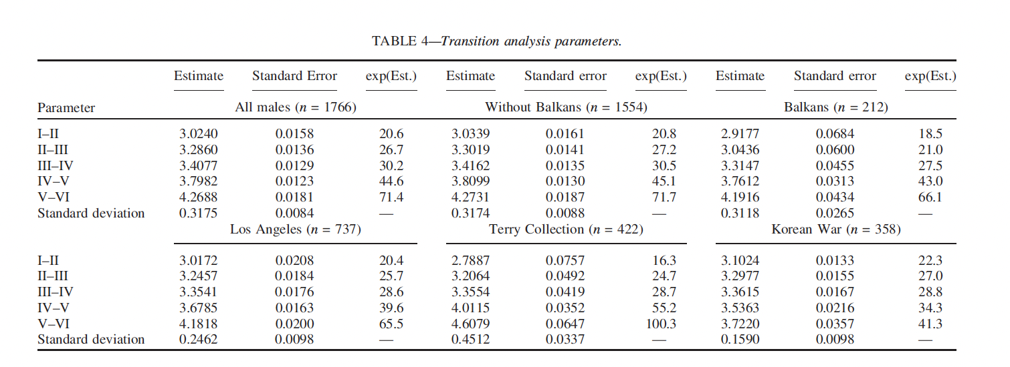
Table 4 reprinted, with permission, from Konigsberg LW, Herrmann NP, Wescott DJ, Kimmerle EH (2008) Estimation and Evidence in Forensic Anthropology: Age-at-Death. J Forensic Sci 541–557, courtesy of John Wiley and Sons Publishers.

We used the results from the Terry Collection as description. The numbers presented in the column labeled “Estimate” were used.

PS-Nem

The description is based on the publication by Nemeskeri et al. (1960). The authors present the following table regarding the pubic symphysis with mean values, standard deviations, and sample sizes for the five stage groups.

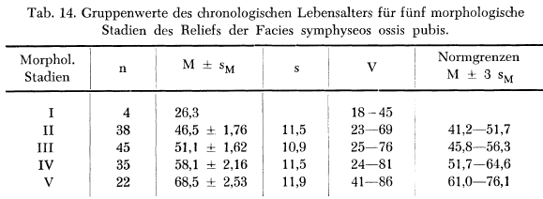
Table 14 reprinted, with permission, from Nemeskéri J, Harsányi L, Acsádi G. 1960. Methoden zur Diagnose des Lebensalters von Skelettfunden. Anthropol Anz 24: 70–95, copyright www.schweizerbart.de/journals/anthranz

Using the information given in the columns n, M and s, the approach described in Appendix S3 (C) could be used. For stage I, we assumed a standard deviation of 11.0.

EnS-Nem

The description is based on the publication by Nemeskeri et al. (1960). The authors present the following table regarding the endocranial suture closure with mean values, standard deviations, and sample sizes for five stage groups.

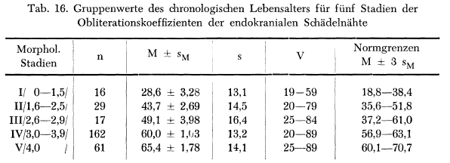
Table 16 reprinted, with permission, from Nemeskéri J, Harsányi L, Acsádi G. 1960. Methoden zur Diagnose des Lebensalters von Skelettfunden. Anthropol Anz 24:70–95, copyright www.schweizerbart.de/journals/anthranz

Using the information given in the columns n, M and s, the approach described in Appendix S3 (C) could be used.

