Osteological age-at-death estimation in an archaeological sample avoiding age-mimicry. Archaeological and Anthropological Sciences
Denise U. Navitainuck¹, Werner Vach¹ ², Kurt W. Alt¹ ³, Sandra L. Pichler¹
¹ Integrative Prehistory and Archeological Science (IPAS) Department of Environmental Sciences, University of Basel, Spalenring 145, CH-4055 Basel, Switzerland
² Basel Academy for Quality and Research in Medicine, Steinenring 6, CH-4051 Basel, Switzerland
³ Danube Private University, Center of Natural and Cultural Human History, Krems, Austria
corresponding author’s e-mail: denise.navitainuck@unibas.ch

Supplementary Figures

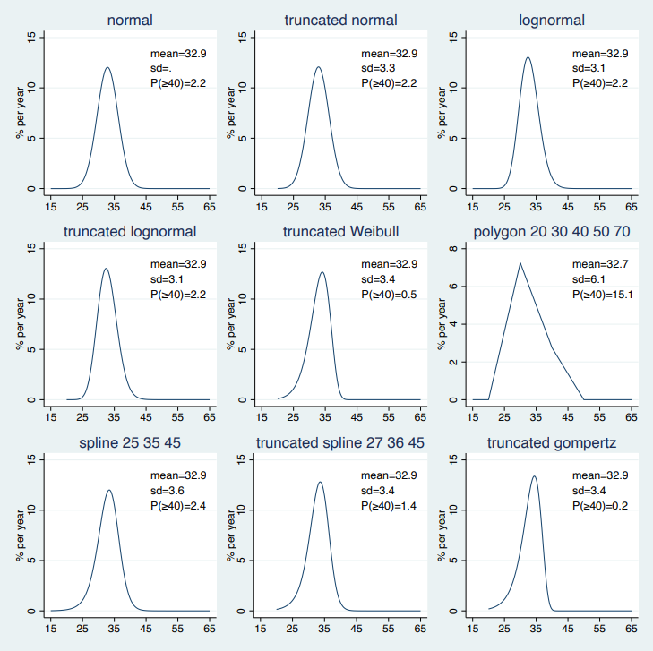

Figure S1: Estimated population age distributions based on the age-estimation-methods PS-BS, Fau-L, EcSv-ML, EnS-Nem and RT-PU and considering nine different distributional assumptions.

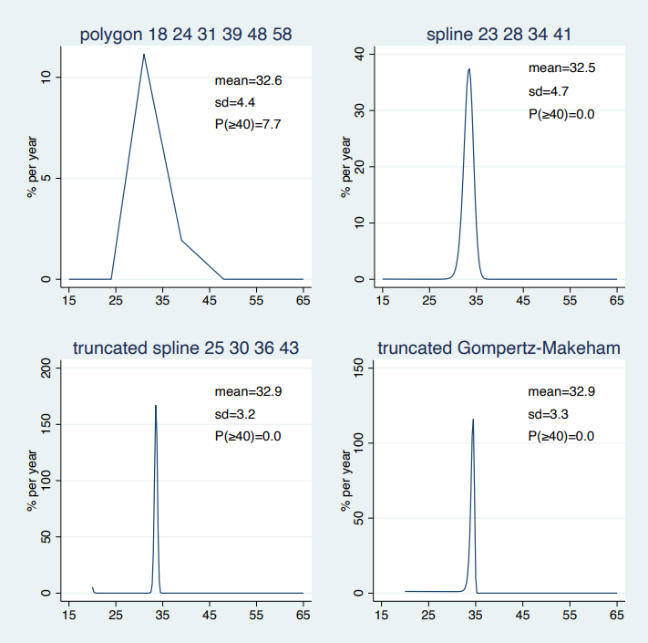

Figure S2: Estimated population age distributions based on the age-estimation-methods PS-BS, Fau-L, EcSv-ML, EnS-Nem and RT-PU and considering four different distributional assumptions.

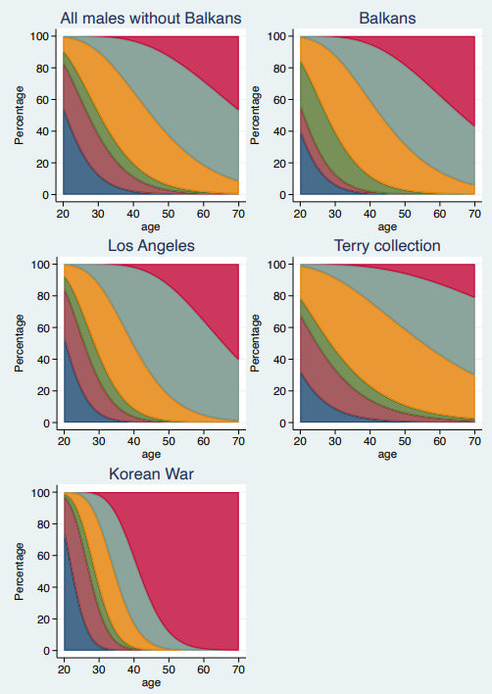

Figure S3: Descriptions of the relation between PS-BS and age in five different samples. Further information on the samples and derivation of the descriptions in Konigsberg et al. (2008).

