Meals for the dead: investigating Romano-British accessory vessels in burials using organic residue analysis
Authors: Julie Dunne¹, Edward Biddulph², Lucy J.E. Cramp³, Caitlin Greenwood³, Enid Allison⁴, Jeremy Evans⁵, Richard Helm⁴, Bekky Hillman⁶, Malcom Lyne⁷, Nigel Page⁶, Caroline Rann⁶ and Richard P. Evershed¹

Supplementary information
Material and methods
Organic residue analysis of pottery assemblages from both the Rhodaus Town, Canterbury and Baginton, the Lunt Fort, Coventry were commissioned as part of the commercial post-excavation analysis programme for both sites.
Lipid analysis and interpretations were performed using established protocols described in detail in earlier publications (Correa-Ascencio and Evershed 2014, Dunne et al. 2019) except that a sampling procedure was adopted to minimise damage to the complete vessels. A total of twenty complete or nearly complete vessels from each site were supplied for analysis. Where vessels were partially broken, they were sampled by removing a piece of sherd from near the break whereas a modified sampling procedure was adopted, where possible, for the complete vessels to minimise possible damage. In that case, part of the internal surface layer of vessel was removed by abrasion, to remove contamination, then the underlying fabric taken as a powder for analysis of absorbed organic residues.
The sherd powder was weighed into a furnaced culture tube (I). An internal standard was added (20 µg n-tetratriacontane; Sigma Aldrich Company Ltd) together with 5 mL of H₂SO₄/MeOH 2 - 4% (δ¹³C value measured) and the culture tubes were placed on a heating block for 1 h at 70°C, mixing every 10 min. Once cooled, the methanolic acid was transferred to test tubes and centrifuged at 2500 rpm for 10 min. The supernatant was then decanted into another furnaced culture tube (II) and 2 mL of DCM extracted double distilled water was added. In order to recover any lipids not fully solubilised by the methanol solution, 2 x 3 mL of n-hexane was added to the extracted potsherds contained in the original culture tubes, mixed well and transferred to culture tube II. The extraction was transferred to a clean, furnaced 3.5 mL vial and blown down to dryness. Following this, 2 x 2 mL n-hexane was added directly to the H₂SO₄/MeOH solution in culture tube II and whirlimixed to extract the remaining residues, then transferred to the 3.5 mL vials and blown down until a full vial of n-hexane remained. Aliquots of the TLE’s were derivatised using 20 µl BSTFA, excess BSTFA was removed under nitrogen and the derivatised TLE was dissolved in n-hexane prior to GC, GC-MS and GC-C-IRMS. Firstly, the samples underwent high-temperature gas chromatography using a gas chromatograph (GC) fitted with a high temperature non-polar column (DB1-HT; 100% dimethylpolysiloxane, 15 m x 0·32 mm i.d., 0.1 μm film thickness). The carrier gas was helium and the temperature programme comprised a 50°C isothermal followed by an increase to 350°C at a rate of 10°C min⁻¹ followed by a 10 min isothermal. A procedural blank (no sample) was prepared and analysed alongside every batch of samples. Further compound identification was accomplished using GC-MS. FAMEs were then introduced by autosampler onto a GC-MS fitted with a non-polar column (100% dimethyl polysiloxane stationary phase; 60 m x 0.25 mm i.d., 0·1 μm film thickness). The instrument was a ThermoFinnigan single quadrupole TraceMS run in EI mode (electron energy 70 eV, scan time of 0.6 s). Samples were run in full scan mode (m/z 50–650) and the temperature programme comprised an isothermal hold at 50°C for 2 min, ramping to 300°C at 10°C min⁻¹, followed by an isothermal hold at 300°C (15 min). The instrument was a ThermoFinnigan single quadrupole TraceMS run in EI mode (electron energy 70 eV, scan time of 0·6 s). Samples were run in full scan mode (m/z 50–650) and the temperature programme comprised an isothermal hold at 50°C for 2 min, ramping to 300°C at 10°C min⁻¹, followed by an isothermal hold at 300°C (15 min). Data acquisition and processing were carried out using the HP Chemstation software (Rev. C.01.07 (27), Agilent Technologies) and Xcalibur software (version 3.0). Peaks were identified on the basis of their mass spectra and GC retention times, by comparison with the NIST mass spectral library (version 2.0).
Carbon isotope analyses by GC-C-IRMS were also carried out using a GC Agilent Technologies 7890A coupled to an Isoprime 100 (EI, 70eV, three Faraday cup collectors m/z 44, 45 and 46) via an IsoprimeGC5 combustion interface with a CuO and silver wool reactor maintained at 850°C. Instrument accuracy was determined using an external FAME standard mixture (C₁₁, C₁₃, C₁₆, C₂₁ and C₂₃) of known isotopic composition. Samples were run in duplicate and an average taken. The δ¹³C values are the ratios ¹³C/¹²C and expressed relative to the Vienna Pee Dee Belemnite, calibrated against a CO₂ reference gas of known isotopic composition. Instrument error was ±0.3‰. Data processing was carried out using Ion Vantage software (version 1.6.1.0, IsoPrime).

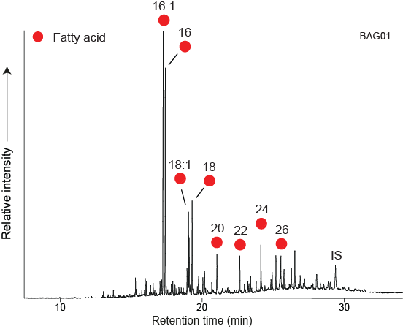
Supplementary Fig. 1 Partial gas chromatogram of the acid-extracted FAMEs from the Baginton (The Lunt Fort) Roman accessory vessel pottery extract BAG01. Circles, n-alkanoic acids (fatty acids, FA); IS, internal standard, C₃₄ n-tetratriacontane. Numbers denote carbon chain length

Supplementary bibliography
Correa-Ascencio, M., and Evershed, R.P. 2014: ‘High throughput screening of organic residues in archaeological potsherds using direct acidified methanol extraction’, Analytical Methods 6, 5, 1330-1340
Dunne, J., Rebay-Salisbury, K., Salisbury, R., Frisch, A., Walton-Doyle, C. and Evershed, R.P. 2019: Milk of ruminants in ceramic baby bottles from prehistoric child graves. Nature, 1-3.

