Minimising Decalcification Time
To optimise the speed of AutoZooMS, an investigation into the minimum required decalcification time was conducted. Bone fragments (n = 24) were place in 5 mL Eppendorf tubes and 4 mL of 0.6 M HCl was added. Then at 2-, 4-, 6- and 24-hour intervals 0.3 mL of acid was removed and frozen. After the final acid had been removed, samples were thawed, and a protein assay was performed using an Invitrogen Qubit Protein Assay Kit and a Qubit 2.0 Fluorometer (Thermofisher Scientific, UK). Protein assay was performed as by product specification. Protein quantification was performed on 24 acid-soluble protein samples. Protein concentration at both 6 and 24 hours was significantly higher than protein concentration at 2 and 4 hours (2 - 6 hours: p < 0.01, 2 - 24: p < 0.0001, 4 - 6: p < 0.01, 4 - 24: p < 0.01). No significant difference in protein concentration was recorded between 2–4 hours, and between 6–24 hours respectively (p > 0.05 for all), indicating that a 6-hour decalcification could be considered adequate.

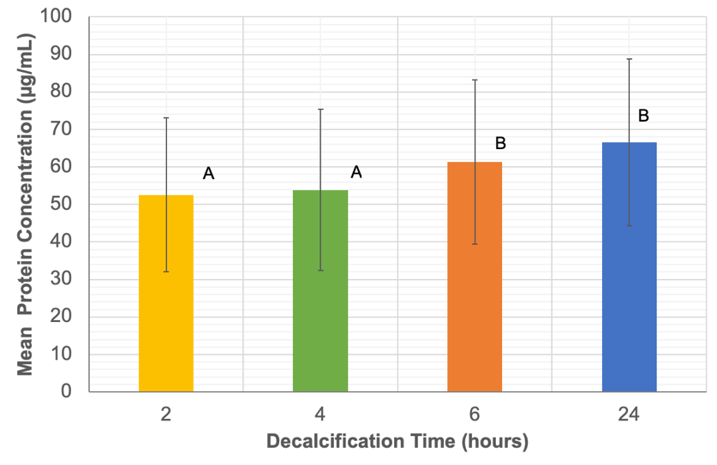
Figure S1: The mean acid-soluble protein concentration of samples after 2-, 4-, 6- and 24-hours decalcification. A and B lettering indicates groups of statistical significance.

Minimising Enzymatic Digestion Time
ZooMS is typically performed with overnight (~ 18–24 hour) digests at 37 ˚C, reducing this time to 2-, 4- and 6-hour intervals was evaluated (Supplementary Figure S2). The success rate of collagen fingerprinting, as determined by species identification success, was identical across 2, 6 and 24-hours, while the success rate at 4 hours was slightly higher; these results indicate that a 2-hour digestion time would be adequate.

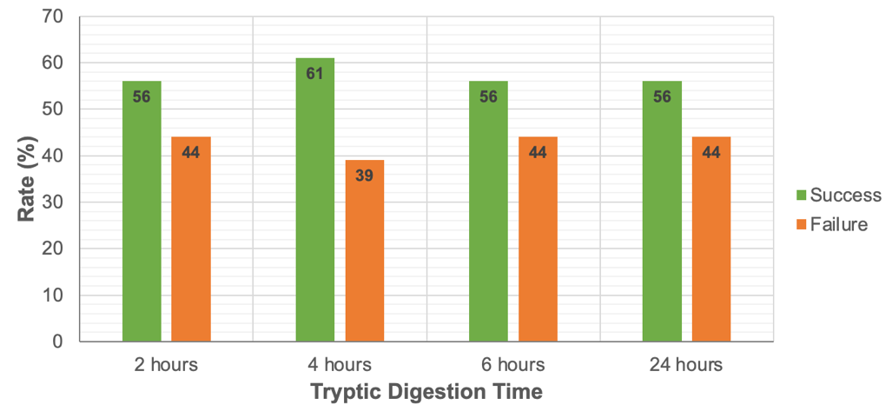
Figure S2: Rate of AutoZooMS success and failure across 2-, 4-, 6- and 24-hour digestion times (n = 24), using 0.04 µg trypsin.
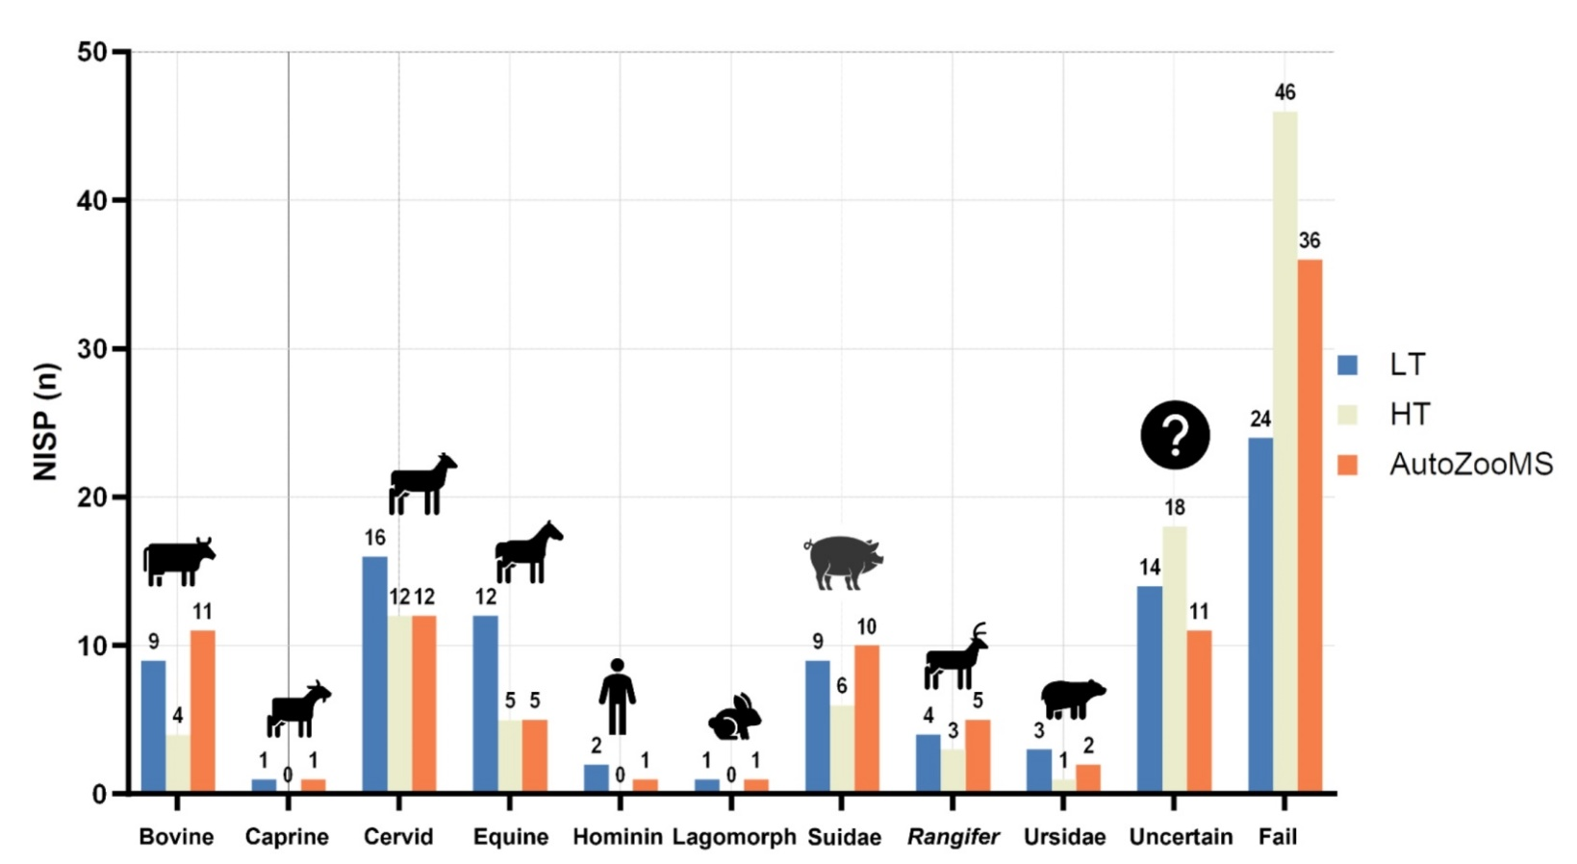
Figure S3: Initial testing via LT, HT, AutoZooMS NISP(n) for each taxa identified, including uncertain and failed samples. The data for 95 samples each analyzed via three methods is presented. In the initial test LT and AutoZooMS exhibited the same species richness (9), with the highest failure rate and thus lowest number of taxonomic identifications (and successful sample size), HT exhibits a lower species richness (6).
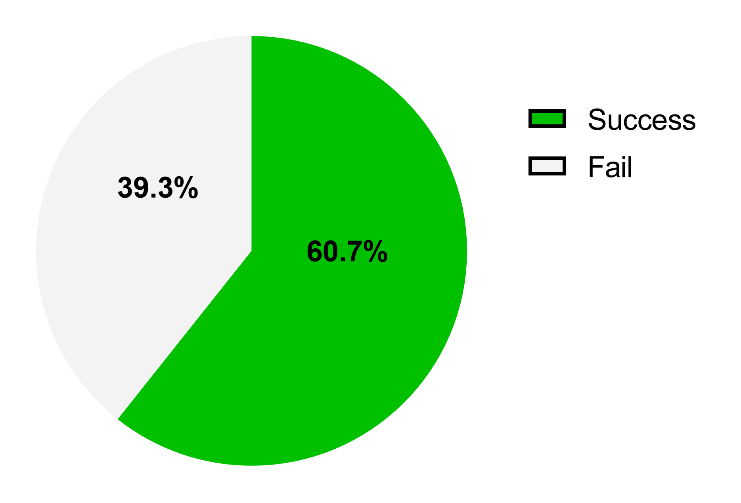
Figure S4: Success rate of final AutoZooMS analysis of B2-ZT Grotte Mandrin (n = 1612)

Table S1: NISP and NISP (%) of ZooMS faunal identifications at B2-ZT Grotte Mandrin. All presented NISP (%) are rounded to two decimal places. Data shown encompasses all samples analyzed (n = 1215), including initial testing and the final AutoZooMS run. The apparent total NISP (n) across all three ZooMS methodologies is 1275, where the additional 60 identifications represent species identification overlaps of the same bone fragment between the methods.

 | NISP (n) |  |  | NISP (%)
Taxonomy | LT | HT | AutoZooMS | LT | HT | AutoZooMS
Bovine | 9 | 27 | 137 | 9.38 | 5.76 | 8.03
Caprine | 1 | 11 | 27 | 1.04 | 2.35 | 1.58
Rangifer tarandus | 4 | 9 | 50 | 4.17 | 1.92 | 2.93
Cervid | 16 | 56 | 368 | 16.67 | 11.94 | 21.56
Equine | 12 | 63 | 195 | 12.50 | 13.43 | 11.42
Hominin | 2 | 3 | 49 | 2.08 | 0.64 | 2.87
Lagomorph | 1 | 9 | 13 | 1.04 | 1.92 | 0.76
Suidae | 10 | 9 | 139 | 10.42 | 1.92 | 8.14
Ursidae | 3 | 3 | 35 | 3.13 | 0.64 | 2.05
Coelodonta | 0 | 1 | 11 | 0 | 0.21 | 0.64
Mammuthus | 0 | 0 | 2 | 0 | 0 | 0.12
Uncertain | 14 | 47 | 11 | 14.58 | 10.02 | 0.64
Fail | 24 | 231 | 670 | 25.00 | 49.25 | 39.25
Total | 96 | 469 | 1707 | 100.00 | 100.00 | 100.00
Total Collagen Yielding | 72 | 238 | 1037 | 75.00 | 50.75 | 60.75
Total Successful Species Identification | 58 | 191 | 1026 | 60.42 | 40.72 | 60.11

Figure S5: Zoom in of five collagen fingerprints acquired in the analysis of B2-ZT Grotte Mandrin to show partially deamidated glutamine at m/z 1105.6.
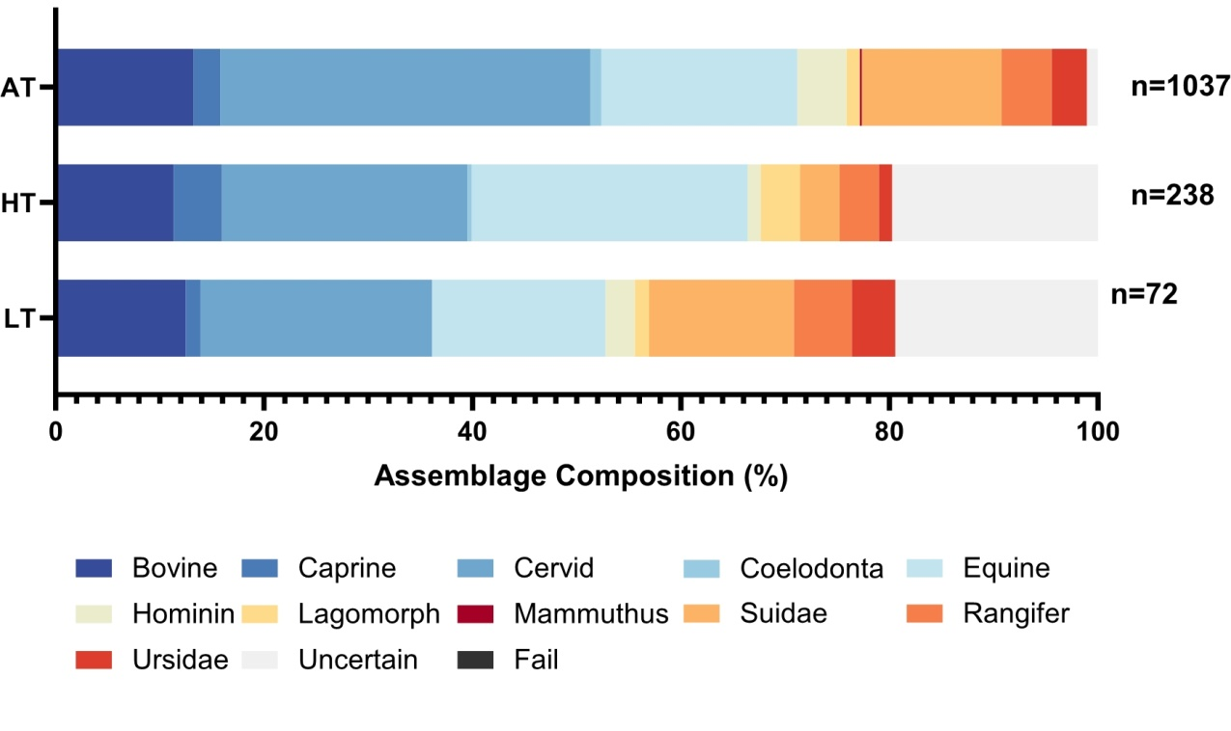
Figure S6: Species abundance of Layer B2-ZT, Grotte Mandrin as measured by LT, HT and AutoZooMS. This plot includes all samples that yielded collagen, including successful species identification and uncertain species identification, but excludes collagen-void (failed) samples.

