Wonderboom, South Africa: An Acheulean workshop with evidence of flake harvesting
Matt G. Lotter^{a, *} (ORCID: 0000-0002-8257-2162)
Marlize Lombardª (ORCID: 0000-0002-0675-0414)
Matthew V. Caruanaª (ORCID: 0000-0002-2095-5360)
ªPalaeo-Research Institute, University of Johannesburg, Auckland Park, 2006, South Africa
*Corresponding author: mmatt@uj.ac.za

Supplementary online material (SOM) 1: additional figures and tables
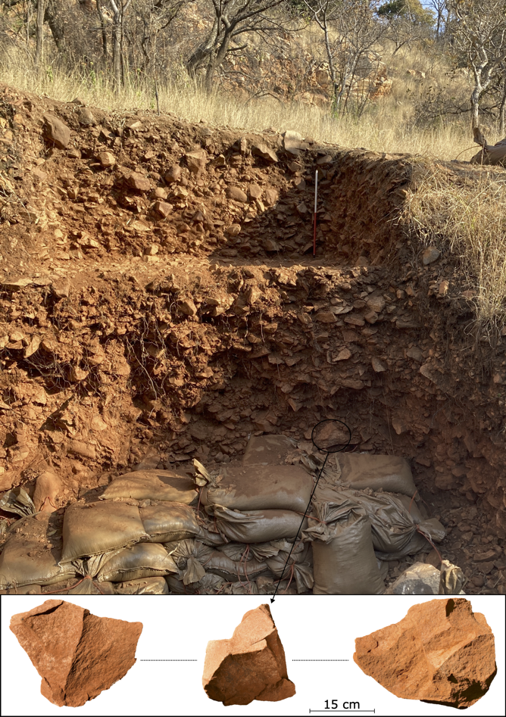
Figure 1. Facing south, the excavation profile at Wonderboom during the 2023 field season (scale is 60 cm). Note proximity of the southern quartzite ridge in the background. The sandbags provide temporary support to the basal units. Note the position of a large boulder core recovered from the base of the profile during the 2024 field season.
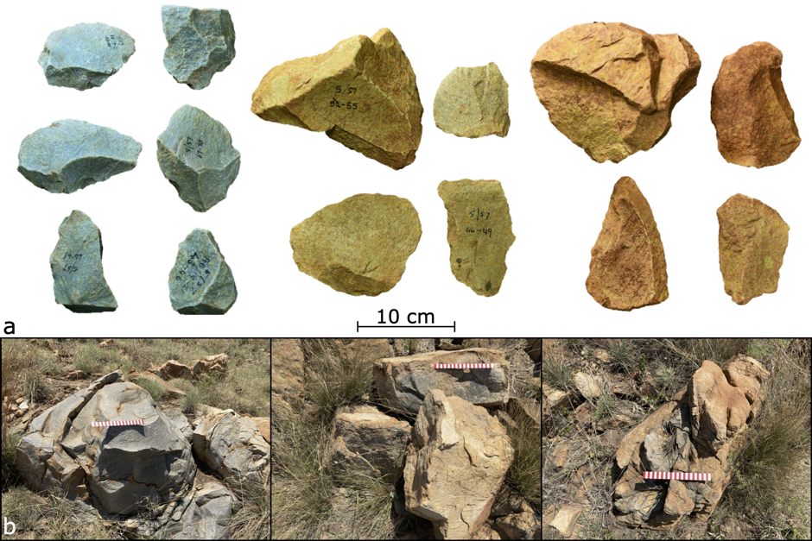
Figure 2. Classification of weathering for flakes and cores from the excavation (a: from variable depths between 0.5 m to 2 m) and the exposed outcrops (b). Fresh, unweathered artefacts with characteristic dark grey quartzite colour (a: left), intermediate condition quartzite showing light staining (a: middle), and heavy weathering with characteristic red rind on outer surfaces (a: right). Fresh, exfoliated quartzite outcrop (b: left), exposed boulders showing variability in condition in the same location with intermediate weathering on the boulder in the foreground and a fresher boulder in the background (b: middle), and heavily weathered bedrock with characteristic weathering rind (b: right).

Table 1. Harvesting site positions, raw material and outcrop traits, and associated artefacts.
Site | Landscape position | Raw material properties | Outcrop type, height and shape | Associated artefacts | Other key features
001 | -North face of southern ridge  -30 m away from ridge crest  -Open, gently sloped area  -Views of valley, neck and northern ridge | -Flake scars have exposed dark, inner rock surface  -Outcrop contains ~3 cm thick weathering rind of lighter colour  -Quartzite is homogenous in texture  -Minimal weathering post flake extraction  -Visible cleavage at base of face one | -Immovable outcropping bedrock  -Large and low  -Elongated and blocky-shaped | -None | -Favourably flat platform for knapping  -Similar outcrops nearby lacking harvesting evidence
002 | -North face of southern ridge  -Basal ridge position  -Near (<50 m) site 001 and excavation  -Secluded, amphitheatre-like area framed by southern ridge, on slightly sloped surface  -Views of neck and northern ridge | -Darker, finer, more homogenous, and less weathered than the surrounding outcrops  -Outcrop contains ~3 cm thick weathering rind of lighter colour  -Visible flaws at base of face one with cleavage surfaces adjacent to flaked platform | -Immovable outcropping bedrock  -Large and high  -Blocky and tabular-shaped | -None | -Abundant exfoliated clasts in the area  -Favourably flat platform for knapping
004 | -North of southern ridge  -Open, flat area  -Most easterly of all harvesting sites  -Closest to spring  -Views south, northern ridge and valley | -Darker, finer, more homogenous, and less weathered than the surrounding outcrops  -Raw material properties visible from some distance  -Flaws not immediately visible | -Immovable outcropping bedrock  -Small and low  -Irregular shape | -None | -Exfoliated clasts sporadic  -Favourably flat platform adjacent to acute edge
006 | -On top of the southern ridge  -Flat area along ridge crest  -Views south, north, and of the valley | -Grey and homogenous  -Less weathered angular flat surfaces  -Outcrop contains ~3 cm thick weathering rind of lighter colour  -Flaws visible within the flaked faces | -Immovable outcropping bedrock  -Two large outcrops occurring next to each other (north and south), variable in height  -Blocky-shaped | -Yes: three refitting flakes | -Abundant exfoliated clasts in the area  -Favourably flat platforms adjacent to acute edges
007 | -On top of the southern ridge  -Flat area adjacent to ridge crest  -Near site 006  -Views south, north, and of the neck and valley | -Darker, finer, more homogenous, and less weathered than the surrounding outcrops  -Raw material properties visible from some distance  -Flaws visible within the flaked faces | -Immovable outcropping bedrock  -Large and high  -Irregular and blocky-shaped | -None | -Sporadic large boulders in the area detached from nearby ridge crest  -Abundant exfoliated clasts in the area
008 | -Near southern ridge crest  -Gently sloped area  -View of southern and northern ridges, and valley | -Naturally detached boulder  -Darker quartzite that is heterogenous in quality with variable grain textures  -Flaws visible across flaked faces and unknapped cortex  -Layering/banding visible  -Boulder contains ~3 cm thick weathering rind of lighter colour | -Movable boulder core  -Large and low  -Blocky and square-like shape  -Likely exceeds 100 kg | -None | -Smaller exfoliated boulders and abundant clasts occur in the area  -Contains multiple large faces conducive to flaking, three of which are flat and adjacent to acute edges
009 | -Within valley at base of southern ridge  -Next to excavation and sites 001 and 002  -Views of valley, northern ridge and neck | -Naturally detached boulder  -Darker, finer, more homogenous, and less weathered than the surrounding outcrops  -Raw material properties visible from some distance  -Flaws not immediately visible | -Movable boulder core  -Large and low  -Irregular and rectangular shape | -Yes: one refitting split flake | -Favourably flat platforms adjacent to acute edges  -Occurs in slumped deposit from eroded excavation profile  -Occurs within artefact-rich hillslope deposit  -Occurs within lithic production area
010 | -Near southern ridge crest  -Open, flat area  -Near site 008  -Views east, west and north | -Naturally detached boulder  -Darker, finer, more homogenous, and less weathered than the surrounding outcrops  -Flaws not immediately visible | -Potentially movable boulder core  -Small and low  -Irregular shape with angular surfaces | -None | -Favourably flat platforms created by natural exfoliations, adjacent to acute edges and decorticated surfaces

Table 2. Consideration of knapper body position and movement adjustments.
Site | Body position during knapping | Movement adjustments | Other key features
001 | -While standing bent over  -Resting foot on the edge of the outcrop and leaning over  -Kneeling next to the outcrop (least likely) | -None | -Two scars preserve clear points of percussion  -Failed percussive attempts occur
002 | -While standing using across-the-body twisting motion | -None | -Multiple scars preserve clear points of percussion  -Failed percussive attempts occur
004 | -Kneeling in front of face one (south of the outcrop) | -None | -Failed percussive attempt occurs associated with step fractures
006 | -Different for each outcrop  -Northern outcrop: while sitting on top of the southern outcrop with feet placed either side, or while standing  -Southern outcrop: while standing bent over, or while resting one foot on the lower northern outcrop (for support/stability) | -Yes: evident for the southern outcrop where the knapper moved around the outcrop to detach two flakes from opposing directions | -Failed percussive attempt occurs on northern outcrop
007 | -While standing bent over  -Resting a foot on parts of the outcrop (for support/stability) | -Yes: the knapper moved around the outcrop to detach single flakes from each of the two platforms | -Failed percussive attempts occur associated with flaws
008 | -While standing bent over  -Resting foot on part of the boulder (for support/stability)  -Kneeling also possible in some instances | -Yes: multiple adjustments to target the different platforms  -Rolling of boulder evident based on access to platforms and flake scar chronologies | -High reduction likely linked to rarity of large boulders on the landscape
009 | -While standing bent over  -Resting foot on part of the boulder (for support/stability) | -Yes: multiple adjustments to target the different platforms  -Rolling of boulder not needed given access to all platforms in its current orientation | -Small percussive attempts occur with the failed flaking series
010 | -While kneeling | -Yes: given different flaking directions along a single edge  -Rolling unlikely given access to platforms in its current orientation | -Flaking exposed natural flaws in material, and failed flaking attempts to circumvent the flaws are evident

Table 3. Morphological scar and refit data, by site (TL=technological length, TW, technological width, ML=maximum length, MW=maximum width, PW=platform width, PA=platform angle, IPA=interior platform angle; grey cells indicate that values should be treated as minimums).
Site | Measurements | SD | Mean | CV | Median | Min | Max | Range
001 | TL (mm) | 37.6 | 196.0 | 19.2 | 193.0 | 160.0 | 235.0 | 75.0
 | TW (mm) | 25.7 | 178.3 | 14.4 | 185.0 | 150.0 | 200.0 | 50.0
 | ML (mm) | 44.6 | 227.3 | 19.6 | 210.0 | 194.0 | 278.0 | 84.0
 | MW (mm) | 49.3 | 193.3 | 25.5 | 170.0 | 160.0 | 250.0 | 90.0
 | PW (mm) | 63.6 | 180.0 | 35.4 | 180.0 | 135.0 | 225.0 | 90.0
 | PA (°) | 16.5 | 96.0 | 17.2 | 104.0 | 77.0 | 107.0 | 30.0
 | IPA (°) | 16.5 | 84.0 | 19.7 | 76.0 | 73.0 | 103.0 | 30.0
002 | TL (mm) | 49.8 | 107.8 | 46.3 | 90.0 | 40.0 | 175.0 | 135.0
 | TW (mm) | 74.4 | 115.9 | 64.2 | 77.5 | 40.0 | 245.0 | 205.0
 | ML (mm) | 84.0 | 194.3 | 43.3 | 171.0 | 90.0 | 306.0 | 216.0
 | MW (mm) | 51.0 | 100.1 | 51.0 | 87.0 | 45.0 | 180.0 | 135.0
 | PW (mm) | 14.6 | 86.8 | 16.8 | 83.5 | 75.0 | 105.0 | 30.0
 | PA (°) | 5.5 | 76.5 | 7.2 | 77.0 | 70.0 | 82.0 | 12.0
 | IPA (°) | 5.5 | 103.5 | 5.3 | 103.0 | 98.0 | 110.0 | 12.0
004 | TL (mm) | - | 62.0 | - | - | - | - | -
 | TW (mm) | - | 138.0 | - | - | - | - | -
 | ML (mm) | - | 208.0 | - | - | - | - | -
 | MW (mm) | - | 138.0 | - | - | - | - | -
 | PW (mm) | - | 105.0 | - | - | - | - | -
 | PA (°) | - | 70.0 | - | - | - | - | -
 | IPA (°) | - | 110.0 | - | - | - | - | -
006 | TL (mm) | 17.0 | 178.0 | 9.5 | 178.0 | 166.0 | 190.0 | 24.0
 | TW (mm) | 29.7 | 211.0 | 14.1 | 211.0 | 190.0 | 232.0 | 42.0
 | ML (mm) | 71.2 | 222.0 | 32.1 | 258.0 | 140.0 | 268.0 | 128.0
 | MW (mm) | 56.8 | 152.3 | 37.3 | 180.0 | 87.0 | 190.0 | 103.0
 | PW (mm) | 66.6 | 156.7 | 42.5 | 140.0 | 100.0 | 230.0 | 130.0
 | PA (°) | 16.3 | 97.7 | 16.6 | 101.0 | 80.0 | 112.0 | 32.0
 | IPA (°) | 16.3 | 82.3 | 19.7 | 79.0 | 68.0 | 100.0 | 32.0
007 | TL (mm) | 37.5 | 151.5 | 24.7 | 151.5 | 125.0 | 178.0 | 53.0
 | TW (mm) | 77.8 | 225.0 | 34.6 | 225.0 | 170.0 | 280.0 | 110.0
 | ML (mm) | 95.5 | 277.5 | 34.4 | 277.5 | 210.0 | 345.0 | 135.0
 | MW (mm) | 106.1 | 245.0 | 43.3 | 245.0 | 170.0 | 320.0 | 150.0
 | PW (mm) | 35.4 | 245.0 | 14.4 | 245.0 | 220.0 | 270.0 | 50.0
 | PA (°) | 8.5 | 81.0 | 10.5 | 81.0 | 75.0 | 87.0 | 12.0
 | IPA (°) | 8.5 | 99.0 | 8.6 | 99.0 | 93.0 | 105.0 | 12.0
008 | TL (mm) | 87.2 | 150.8 | 57.8 | 166.0 | 25.0 | 260.0 | 235.0
 | TW (mm) | 91.6 | 160.6 | 57.1 | 156.5 | 35.0 | 385.0 | 350.0
 | ML (mm) | 112.8 | 237.1 | 47.6 | 236.5 | 50.0 | 465.0 | 415.0
 | MW (mm) | 81.0 | 163.3 | 49.6 | 167.5 | 30.0 | 298.0 | 268.0
 | PW (mm) | 89.7 | 157.0 | 57.1 | 135.0 | 45.0 | 377.0 | 332.0
 | PA (°) | 21.6 | 96.4 | 22.4 | 93.5 | 67.0 | 133.0 | 66.0
 | IPA (°) | 21.6 | 83.6 | 25.8 | 86.5 | 47.0 | 113.0 | 66.0
009 | TL (mm) | 80.6 | 110.6 | 72.9 | 115.0 | 14.0 | 240.0 | 226.0
 | TW (mm) | 72.1 | 93.9 | 76.9 | 80.0 | 23.0 | 225.0 | 202.0
 | ML (mm) | 118.2 | 150.4 | 78.5 | 160.0 | 30.0 | 380.0 | 350.0
 | MW (mm) | 99.7 | 115.3 | 86.5 | 90.0 | 12.0 | 302.0 | 290.0
 | PW (mm) | 107.7 | 116.4 | 92.5 | 81.0 | 43.0 | 306.0 | 263.0
 | PA (°) | 10.4 | 91.3 | 11.4 | 90.0 | 75.0 | 105.0 | 30.0
 | IPA (°) | 10.4 | 88.7 | 11.7 | 90.0 | 75.0 | 105.0 | 30.0
010 | TL (mm) | 58.4 | 158.7 | 36.8 | 136.0 | 115.0 | 225.0 | 110.0
 | TW (mm) | 52.0 | 150.0 | 34.6 | 180.0 | 90.0 | 180.0 | 90.0
 | ML (mm) | 15.0 | 230.0 | 6.5 | 230.0 | 215.0 | 245.0 | 30.0
 | MW (mm) | 10.4 | 128.3 | 8.1 | 125.0 | 120.0 | 140.0 | 20.0
 | PW (mm) | 53.3 | 160.7 | 33.1 | 145.0 | 117.0 | 220.0 | 103.0
 | PA (°) | 1.7 | 107.0 | 1.6 | 108.0 | 105.0 | 108.0 | 3.0
 | IPA (°) | 1.7 | 73.0 | 2.4 | 72.0 | 72.0 | 75.0 | 3.0
Refits | TL (mm) | 43.5 | 163.8 | 26.5 | 167.5 | 110.0 | 210.0 | 100.0
 | TW (mm) | 35.7 | 226.8 | 15.7 | 230.5 | 180.0 | 266.0 | 86.0
 | TT (mm) | 16.8 | 54.3 | 31.0 | 52.5 | 37.0 | 75.0 | 38.0
 | ML (mm) | 32.9 | 253.5 | 13.0 | 259.0 | 210.0 | 286.0 | 76.0
 | MW (mm) | 30.2 | 189.0 | 16.0 | 200.0 | 146.0 | 210.0 | 64.0
 | MT (mm) | 19.9 | 62.8 | 31.7 | 57.5 | 46.0 | 90.0 | 44.0
 | PW (mm) | 33.2 | 188.5 | 17.6 | 188.5 | 165.0 | 212.0 | 47.0
 | IPA (°) | 9.2 | 91.5 | 10.0 | 91.5 | 85.0 | 98.0 | 13.0

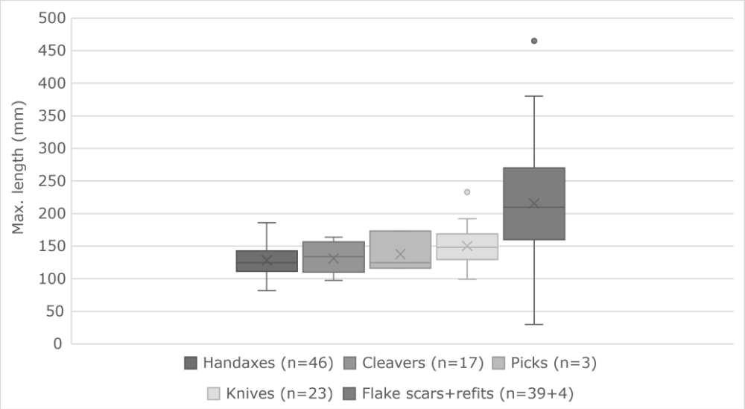
Figure 3. Maximum length of all blanks (clasts and flakes).

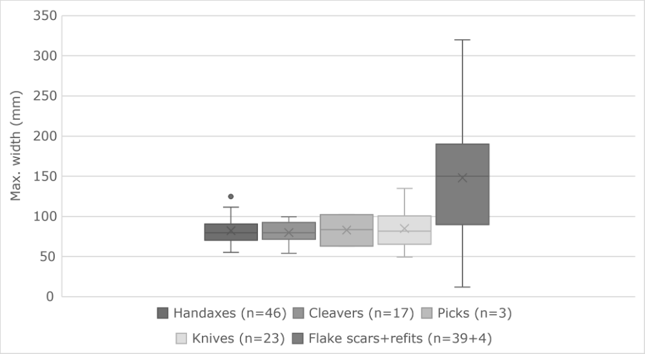
Figure 4. Maximum width of all blanks (clasts and flakes).

