Supplementary Information 5; Fig. S5

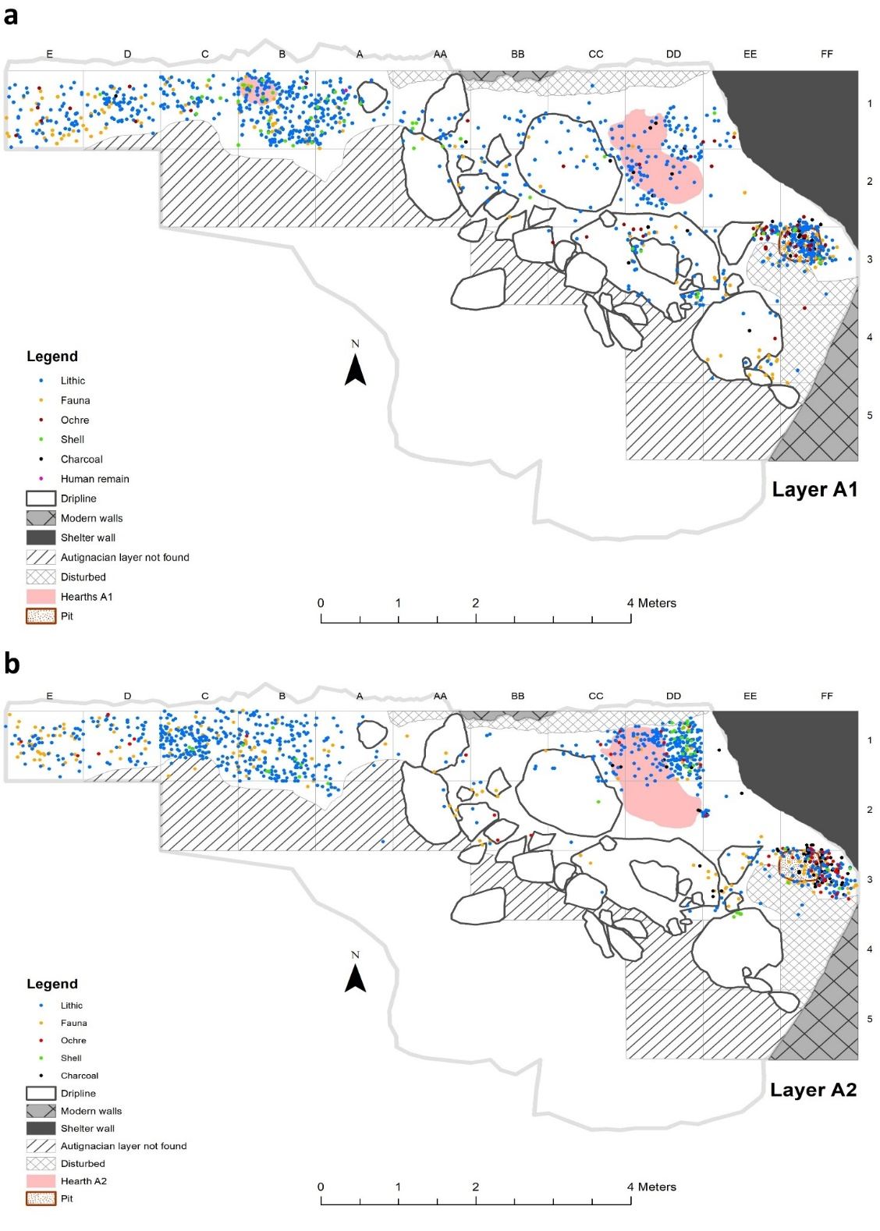
Fig. S5 Distribution map of level A1 (A) and A2 (B) showing different categories of plotted finds. Hearths identified in the two levels are highlighted in red

