Supplementary Information 8; Fig. S8

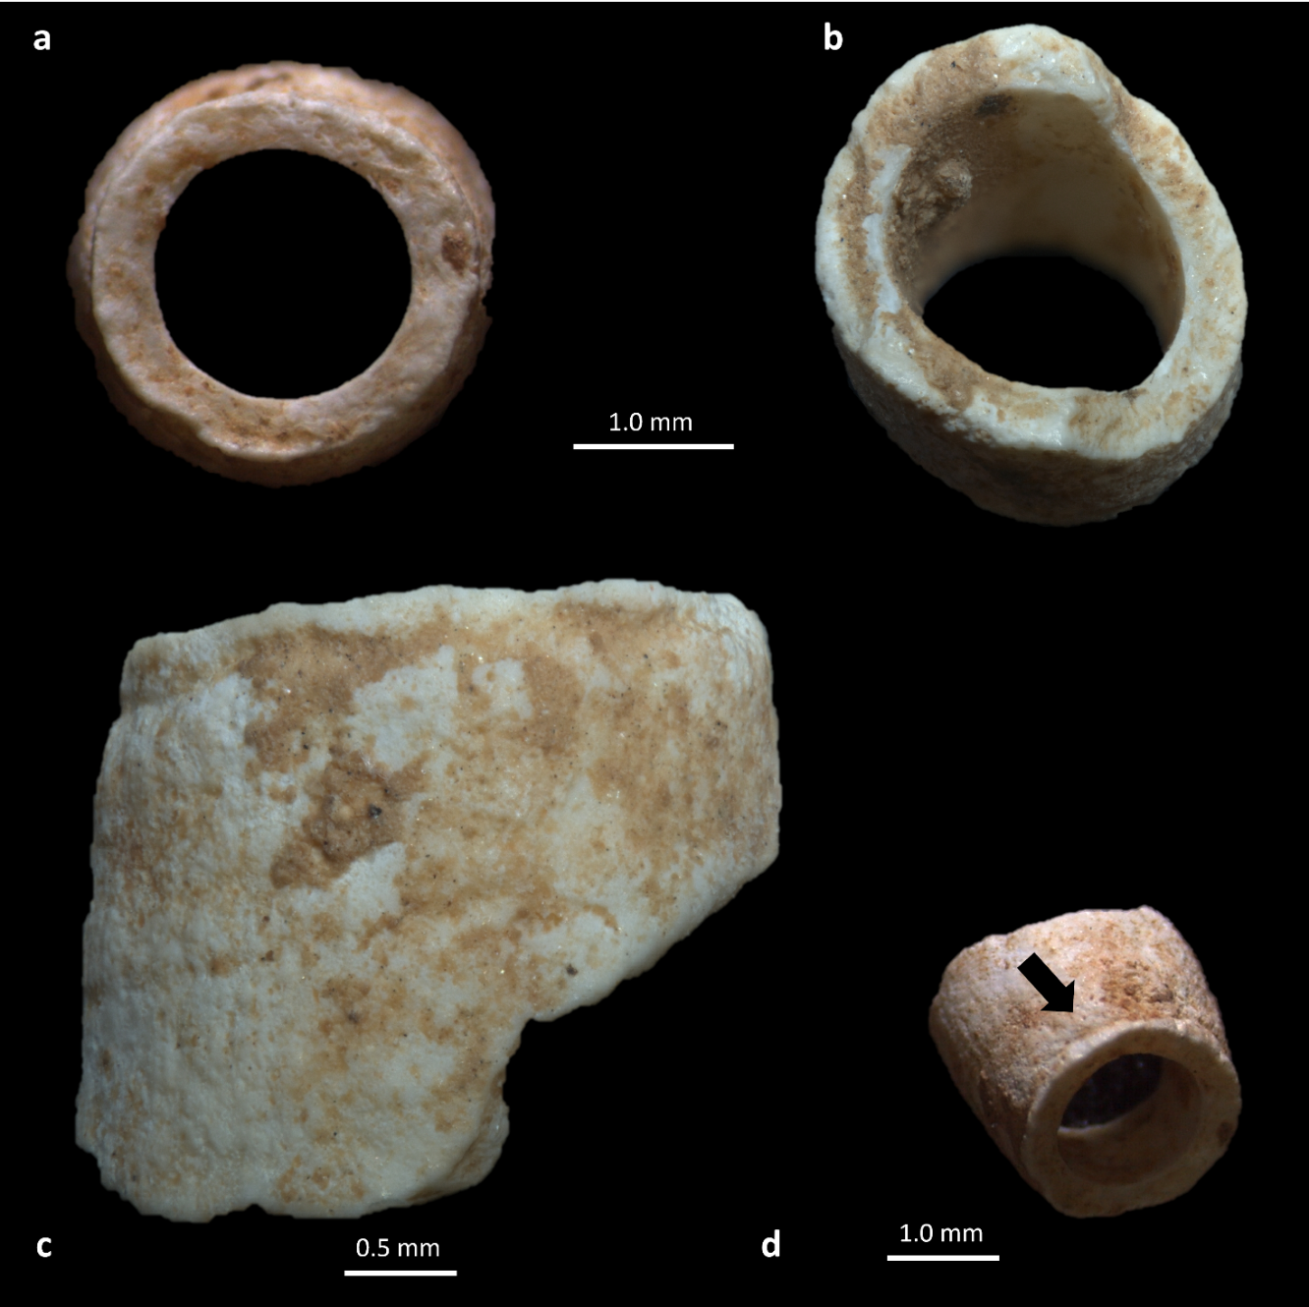
Fig. S8 Tusk shell (Antalis sp.) from level A3. A) rectilinear fracture on the apical (or distal) portion; B) flute-mouth fracture in the basal (or proximal) portion; C) front view; D) angled perspective, the black arrow indicates a cut-mark on the shell's surface, near the rectilinear fracture

