Appendix 1: Optical analysis on colour and sherds cross section coarseness of Shushan site samples. Sample colour numbers refer to (based on the Munsell colour chart): 1. red (10R 4/6;10 R:5/6-5/8;2.5YR:5/6-5/8;2.5YR:4/6-4/8); 2. reddish-brown (2.5 YR 4/3.4/4.5/3,5/4; 5YR 5/3,5/4,4/3,4/4); 3. pale brown (7.5YR 7/1; 10YR 7/1, 7/2; 2.5Y 7/1,7/2; 5Y 7/1, 7/2); 4. dark reddish-brown (5YR 3/2,3/3,3/4; 2.5/2; 2.5 YR 3/3,3/4,2.5/4,2.5/4); 5. dark grey (5Y 4/1; 2.5Y 4/1; 10YR 4/1; 7.5YR 4/1; 5YR 4/1); 6. reddish grey (5YR 5/2,4/2). Sample cross-section coarseness numbers (based on Percentage Diagrams for Estimating Composition by Volume) (Compton and Compton 1985, p. 336) refer to: 1. fine clay (1%-5%); 2. fine to medium (5-15%); 3. Medium (15-25%); 4. medium to coarse (25-35%); 5. Coarse (Over 35%). The periods listed are: Late Ming (1522–1644 CE); Early Qing (1644–1735 CE); Mid Qing (1735–1840 CE); Late Qing-Republic (1840–1945 CE)
Sample No. | Excavation  number | Sample colour (Optical identification) | Sample coarseness (Optical identification) | Period
1 | 05BG1(4)_7 | 1 | 5 | Late Ming
2 | 05BG1(4)_80 | 5 | 3 | Late Ming
3 | 05BG1(4)_18 | 4 | 3 | Late Ming
4 | 05BG1(4)_86 | 4 | 5 | Late Ming
5 | 05BG1(4)_84 | 1 | 5 | Late Ming
6 | 05BG1(4)_48 | 1 | 4 | Late Ming
7 | 05BG1(4)_102 | 5 | 2 | Late Ming
8 | 05BG1(4)_8 | 1 | 1 | Late Ming
9 | 06BG1K1(4)_293 | 4 | 2 | Late Ming
10 | 06BG1K1(5)_5 | 5 | 1 | Late Ming
11 | 06BG1K1(5)_10 | 1 | 1 | Late Ming
12 | 06BG1K1(5)_135 | 4 | 1 | Late Ming
13 | 06BG1K1(5)_125 | 1 | 5 | Late Ming
14 | 06BG1K1(5)_29 | 2 | 3 | Late Ming
15 | 06BG1K1(5)_40 | 1 | 1 | Late Ming
16 | 06BG1K1(5)_76 | 4 | 1 | Late Ming
17 | 06BG1K1(5)_130 | 1 | 2 | Late Ming
18 | 05ET1K(25)_5 | 1 | 3 | Early Qing
19 | 05ET1K(18)_30 | 5 | 2 | Early Qing
20 | 05ET1K(18)_22 | 1 | 1 | Early Qing
21 | 05ET1K(17)_11 | 5 | 1 | Early Qing
22 | 05ET1K(26)_15 | 5 | 2 | Early Qing
23 | 05ET1K(25)_7 | 3 | 1 | Early Qing
24 | 05ET1K(23)_7 | 1 | 2 | Early Qing
25 | 05ET1K1(27)_(?) | 1 | 2 | Early Qing
26 | 05ET1K(26)_45 | 3 | 1 | Early Qing
27 | 06ET1K2(12)_23 | 1 | 1 | Early Qing
28 | 06ET1K2(14)_141 | 1 | 2 | Early Qing
29 | 06ET1K2(14)_24 | 5 | 1 | Early Qing
30 | 06ET1K2(14)_114 | 1 | 2 | Early Qing
31 | 06ET1K2(13)_36 | 2 | 2 | Early Qing
32 | 06ET1K(17)_55 | 4 | 3 | Early Qing
33 | 06ET1K2(17)_99 | 1 | 1 | Early Qing
34 | 06ET1K2(17)_30 | 1 | 2 | Early Qing
35 | 06ET1YI(1)_19 | 1 | 3 | Early Qing
36 | 06ET1K2(17)_14 | 2 | 1 | Early Qing
37 | 06ET1K2(13)_10 | 3 | 1 | Early Qing
38 | 06ET1K(17)_41 | 1 | 1 | Early Qing
39 | 06ET1K2(17)_31 | 5 | 2 | Early Qing
40 | 06ET1K2(13)_46 | 2 | 1 | Early Qing
41 | 06ET1K2(12)_33 | 1 | 1 | Early Qing
42 | 06ET1K(12)_18 | 2 | 3 | Early Qing
43 | 06ET1Y1_5 | 4 | 3 | Early Qing
44 | 06ET1K2(6)_312 | 2 | 4 | Early Qing
45 | 06ET1Y1(1)_1 | 1 | 5 | Early Qing
46 | 06ETK(17)_55 | 4 | 3 | Early Qing
47 | 05BG1(3)_134 | 3 | 2 | Mid-Qing
48 | 05BG1(3)_8 | 1 | 1 | Mid-Qing
49 | 05BG1(3)_85 | 1 | 1 | Mid-Qing
50 | 05BG1(3)_30 | 1 | 1 | Mid-Qing
51 | 05BG1(3)_62 | 5 | 2 | Mid-Qing
52 | 05BG1(3)_133 | 1 | 3 | Mid-Qing
53 | 05BG1(3)_98 | 6 | 1 | Mid-Qing
54 | 05BG1(3)_140 | 1 | 1 | Mid-Qing
55 | 05BG1(3)_29 | 4 | 1 | Mid-Qing
56 | 05BG1(3)_105 | 4 | 2 | Mid-Qing
57 | 05BG1(3)_86 | 5 | 1 | Mid-Qing
58 | 05ET1(14)_39 | 4 | 2 | Mid-Qing
59 | 05ET1K(9)_10 | 4 | 1 | Mid-Qing
60 | 05ET1K(7)_59 | 1 | 3 | Mid-Qing
61 | 05ET1K(10)_18 | 2 | 3 | Mid-Qing
62 | 05ET1K(15)_15 | 2 | 2 | Mid-Qing
63 | 05ET1K(12)_9 | 2 | 1 | Mid-Qing
64 | 05ET1K(12)_26 | 1 | 1 | Mid-Qing
65 | 05ET1K(7)_27 | 1 | 1 | Mid-Qing
66 | 05ET1K(7)_47 | 1 | 1 | Mid-Qing
67 | 05ET1K(15)_8 | 2 | 2 | Mid-Qing
68 | 05ET1K(15)_26 | 1 | 1 | Mid-Qing
69 | 05ET1K(12)_15 | 2 | 1 | Mid-Qing
70 | 05ET1K(14)_13 | 2 | 2 | Mid-Qing
71 | 05ET1K(14)_37 | 2 | 2 | Mid-Qing
72 | 05ET1K(14)_8 | 2 | 2 | Mid-Qing
73 | 05ET1K(9)_16 | 1 | 1 | Mid-Qing
74 | 05ET1K(9)_14 | 5 | 1 | Mid-Qing
75 | 05ET1K(12)_23 | 5 | 2 | Mid-Qing
76 | 05ET1K(7)_30 | 5 | 2 | Mid-Qing
77 | 05ET1K(7)_46 | 1 | 1 | Mid-Qing
78 | 05ET1K(7)_50 | 1 | 1 | Mid-Qing
79 | 05ET1K(7)_47 | 2 | 2 | Mid-Qing
80 | 05ET1K(13)_87 | 1 | 1 | Mid-Qing
81 | 05ET1K(13)_71 | 1 | 4 | Mid-Qing
82 | 06BG1K1(3)_138 | 4 | 2 | Mid-Qing
83 | 06BG1K1(4)_89 | 5 | 1 | Mid-Qing
84 | 06BG1K1(3)_678 | 1 | 1 | Mid-Qing
85 | 06BG1K1(3)_185 | 1 | 2 | Mid-Qing
86 | 06BG1K1(3)_768 | 1 | 1 | Mid-Qing
87 | 06BG1K1(3) | 2 | 1 | Mid-Qing
88 | 06BG1K1(3)_196 | 1 | 1 | Mid-Qing
89 | 06BG1K1(3) | 1 | 3 | Mid-Qing
90 | 06BG1K1(3)_679 | 1 | 1 | Mid-Qing
91 | 06BG1K1(3)_223 | 2 | 1 | Mid-Qing
92 | 06BG1K1(4)_66 | 1 | 1 | Mid-Qing
93 | 06BG1K1(3)_304 | 2 | 1 | Mid-Qing
94 | 06BG1K1(3)_774 | 5 | 2 | Mid-Qing
95 | 06BG1K1(3)_315 | 1 | 2 | Mid-Qing
96 | 06BG1K1(3)_824 | 3 | 1 | Mid-Qing
97 | 06BG1K1(3)_1518 | 2 | 2 | Mid-Qing
98 | 06BG1K1(3)_220 | 2 | 2 | Mid-Qing
99 | 06BG1K1(3)_312 | 2 | 1 | Mid-Qing
100 | 06BG1K1(3)_802 | 2 | 2 | Mid-Qing
101 | 06BG1K1(3)_269 | 4 | 1 | Mid-Qing
102 | 06BG1K1(4)_57 | 1 | 1 | Mid-Qing
103 | 06BG1K1(3)_558 | 1 | 2 | Mid-Qing
104 | 06BG1K2(3)_830 | 3 | 1 | Mid-Qing
105 | 06ET1K2(5)_77 | 1 | 1 | Mid-Qing
106 | 06ET1K2(5)_70 | 1 | 1 | Mid-Qing
107 | 06ET1K2(9)_4 | 5 | 2 | Mid-Qing
108 | 06ET1K2(3) | 5 | 1 | Mid-Qing
109 | 06ET1K2(4)_12 | 2 | 3 | Mid-Qing
110 | 06ET1K2(3)_401 | 1 | 2 | Mid-Qing
111 | 06ET1K2(6)_312 | 3 | 3 | Mid-Qing
112 | 06ET1K2(10)_35 | 5 | 2 | Mid-Qing
113 | 06ET1K2(9)_61 | 2 | 2 | Mid-Qing
114 | 06ET1K2(5)_122 | 5 | 2 | Mid-Qing
115 | 06ET1K2(5)_116 | 1 | 2 | Mid-Qing
116 | 06ET1K2(12)_15 | 5 | 2 | Mid-Qing
117 | 05AG2(9)_24 | 1 | 2 | Mid-Qing
118 | 05AG2(9)_46 | 1 | 2 | Mid-Qing
119 | 05AG2(9)_44 | 1 | 3 | Mid-Qing
120 | 05AG2(9)_129 | 2 | 1 | Mid-Qing
121 | 05AG2(9)_53 | 2 | 2 | Mid-Qing
122 | 05AG2(10)_49 | 2 | 2 | Mid-Qing
123 | 05AG1Y3_1 | 1 | 3 | Mid-Qing
124 | 05AG1Y3_24 | 1 | 1 | Mid-Qing
125 | 05AG2(9)_166 | 2 | 2 | Mid-Qing
126 | 05AG2(9)_85 | 1 | 3 | Mid-Qing
127 | 05AG2(9)_56 | 5 | 3 | Mid-Qing
128 | 05CT2(2)_2 | 4 | 1 | Late Qing - Republican
129 | 05CT2(2)_40 | 4 | 2 | Late Qing - Republican
130 | 05CT1(2)_64 | 1 | 2 | Late Qing - Republican
131 | 05CT1(1)_48 | 1 | 1 | Late Qing - Republican
132 | 05CT2(2)_13 | 1 | 2 | Late Qing - Republican
133 | 05ET1(2)_151 | 3 | 2 | Late Qing - Republican
134 | 05ET1(3)_226 | 2 | 2 | Late Qing - Republican
135 | 05ET1K(3)_154 | 2 | 2 | Late Qing - Republican
136 | 05ET1K(5)_3 | 2 | 3 | Late Qing - Republican
137 | 05ET1K(5)_40 | 4 | 1 | Late Qing - Republican
138 | 05ET1K(5)_7 | 1 | 4 | Late Qing - Republican
139 | 05FT1(1)_7 | 2 | 1 | Late Qing - Republican
140 | 05FT1(1)_12 | 1 | 1 | Late Qing - Republican
141 | 05FT1(1)_4 | 2 | 1 | Late Qing - Republican
142 | 06BG1K1(2)_306 | 4 | 2 | Late Qing - Republican
143 | 06BG1K1(2)_5 | 2 | 1 | Late Qing - Republican
144 | 05AG1(1)_44 | 1 | 2 | Late Qing - Republican
145 | 05AG1(2)_34 | 1 | 2 | Late Qing - Republican
146 | 05AG1(1)_54 | 1 | 3 | Late Qing - Republican
147 | 05AG1Y2_6 | 2 | 2 | Late Qing - Republican
148 | 05AG2(3)_24 | 1 | 1 | Late Qing - Republican
149 | 05AG1Y2_8 | 1 | 1 | Late Qing - Republican
150 | 05AG1Y2_10 | 2 | 3 | Late Qing - Republican
151 | 05AG1Y2_15 | 1 | 2 | Late Qing - Republican
152 | 05AG1(3)_23 | 5 | 2 | Late Qing - Republican
153 | 05AG2(1)_8 | 2 | 1 | Late Qing - Republican
154 | 05AG1(3)_41 | 1 | 3 | Late Qing - Republican
155 | 05AG1(3)_30 | 1 | 3 | Late Qing - Republican
156 | 05AG2(4)_105 | 1 | 1 | Late Qing - Republican
157 | 05AG1(3)_42 | 6 | 1 | Late Qing - Republican
158 | 05AG2(2)_8 | 6 | 1 | Late Qing - Republican
159 | 05AG2(2)_26 | 2 | 3 | Late Qing - Republican
160 | 05AG1(3)_12 | 5 | 2 | Late Qing - Republican
161 | 05AG1(1)_33 | 2 | 3 | Late Qing - Republican
162 | 05AG1(1)_65 | 5 | 2 | Late Qing - Republican
163 | 05AG1(1)_55 | 5 | 2 | Late Qing - Republican
164 | 05AG1(1)_5 | 5 | 3 | Late Qing - Republican
165 | 05AG1(1)_41 | 6 | 2 | Late Qing - Republican
166 | 05AG2(6)_13 | 2 | 2 | Late Qing - Republican
167 | 05AG2(2)_130 | 5 | 1 | Late Qing - Republican
168 | 05AG2(6)_66 | 4 | 1 | Late Qing - Republican
169 | 05AG2(2)_39 | 4 | 2 | Late Qing - Republican
170 | 05AG2(6)_38 | 4 | 1 | Late Qing - Republican
171 | 05AG2(2)_37 | 2 | 3 | Late Qing - Republican
172 | 05AG2(2)_123 | 3 | 2 | Late Qing - Republican
173 | 05AG2(2)_17 | 2 | 2 | Late Qing - Republican
174 | 05AG1(4)_28 | 2 | 2 | Late Qing - Republican
175 | 05AG1(4)_12 | 1 | 1 | Late Qing - Republican
176 | 05AG2(3)_27 | 4 | 3 | Late Qing - Republican
177 | 05AG2(3)_28 | 5 | 2 | Late Qing - Republican
178 | 05AG2(3)_2 | 4 | 3 | Late Qing - Republican
179 | 05AG2(2)_44 | 5 | 3 | Late Qing - Republican
180 | 05AG2(2)_137 | 5 | 2 | Late Qing - Republican
181 | 05AG2(2)_91 | 1 | 2 | Late Qing - Republican
182 | 05AG2(2)_22 | 6 | 1 | Late Qing - Republican
183 | 05AG2(2)_100 | 6 | 1 | Late Qing - Republican
184 | 05AG2(2)_199 | 5 | 2 | Late Qing - Republican
185 | 05AG2(4)_49 | 1 | 1 | Late Qing - Republican
186 | 05AG2(4)_43 | 5 | 2 | Late Qing - Republican
187 | 05AG1(1)_62 | 5 | 1 | Late Qing - Republican

Appendix 2: SEM EDS chemical composition of Shushan samples. SEM analysis was conducted at the University of Oxford Research Laboratory for Archaeology and History of Art (RLAHA), with JEOL JSM-5910 SEM. The measurement error can expect around ±2% to ±5% relative for major components. Mn and Cr are not detected in lab work; therefore, we put n.d. The detection limits can expect around 0.08-0.1%.
Time period | Sample number | Average chemical composition of three SEM-EDS detected areas on Shushan samples in percentage |  |  |  |  |  |  |  |  |  |  | Color number
Time period | Sample number | Na₂O | MgO | Al₂O₃ | SiO₂ | K₂O | CaO | TiO₂ | Cr₂O₃ | MnO | Fe₂O₃ * | Total | Color number
Ming | 05BG1(4)_63 | 0.07 | 0.44 | 19.07 | 70.93 | 2.09 | 0.24 | 0.98 | n.d. | n.d. | 6.16 | 99.98 | 2
Ming | 06BG1K1(5)_130 | 0.00 | 0.45 | 16.89 | 74.12 | 2.06 | 0.38 | 1.07 | n.d. | n.d. | 5.03 | 100.00 | 1
Ming | 05BG1(4)_18 | 0.11 | 0.42 | 20.23 | 69.75 | 2.26 | 0.21 | 1.10 | n.d. | n.d. | 5.92 | 100.00 | 4
Ming | 05BG1K1(5)_5 | 0.24 | 0.63 | 17.77 | 70.90 | 2.13 | 0.28 | 1.19 | n.d. | n.d. | 6.87 | 100.01 | 5
Early Qing | 06ET1Y1(1)_19 | 0.29 | 0.43 | 15.18 | 75.67 | 1.52 | 0.40 | 0.91 | n.d. | n.d. | 5.60 | 100.00 | 2
Early Qing | 06ET1K2(6)_312 | 0.35 | 0.81 | 20.18 | 68.85 | 2.21 | 0.47 | 0.93 | n.d. | n.d. | 6.20 | 100.00 | 3
Early Qing | 06ET1Y1(1)_1 | 0.07 | 0.51 | 23.18 | 67.14 | 1.87 | 0.46 | 0.93 | n.d. | n.d. | 5.83 | 99.99 | 1
Early Qing | 06ET1K(17)_55 | 0.31 | 0.52 | 16.21 | 74.04 | 1.87 | 0.34 | 1.05 | n.d. | n.d. | 5.68 | 100.02 | 4
Early Qing | 06ET1K2(14)_24 | 0.18 | 0.79 | 21.93 | 65.66 | 2.75 | 0.38 | 0.97 | n.d. | n.d. | 7.33 | 99.99 | 5
Mid-Qing | 05BG1(3)_134 | 0.24 | 0.71 | 24.96 | 64.56 | 5.45 | 0.26 | 1.12 | n.d. | n.d. | 2.69 | 99.99 | 3
Mid-Qing | 06BG1K1(3)_223 | 0.55 | 0.77 | 16.08 | 73.19 | 1.79 | 0.56 | 0.89 | n.d. | n.d. | 6.17 | 100.00 | 1
Mid-Qing | 06BG1K2(3)_269 | 0.00 | 0.45 | 23.68 | 64.11 | 2.45 | 0.28 | 1.18 | n.d. | n.d. | 7.85 | 100.00 | 4
Mid-Qing | 05BG1(3)_98 | 0.45 | 0.73 | 16.57 | 73.66 | 2.17 | 0.49 | 0.89 | n.d. | n.d. | 5.04 | 100.00 | 6
Mid-Qing | 05ET1K(10)_18 | 0.18 | 0.48 | 15.79 | 73.80 | 1.57 | 0.31 | 1.01 | n.d. | n.d. | 6.87 | 100.01 | 2
Mid-Qing | 05AG2(9)_56 | 0.14 | 0.52 | 18.11 | 72.19 | 1.95 | 0.36 | 0.91 | n.d. | n.d. | 5.82 | 100.00 | 5
Late Qing–Republican period | 05AG2(2)_17 | 0.00 | 0.52 | 25.00 | 63.27 | 2.29 | 0.26 | 1.07 | n.d. | n.d. | 7.59 | 100.00 | 2
Late Qing–Republican period | 05AG1(1)_55 | 0.00 | 0.44 | 19.22 | 70.43 | 2.10 | 0.19 | 0.99 | n.d. | n.d. | 6.65 | 100.02 | 5
Late Qing–Republican period | 05AG1(3)_42 | 0.82 | 0.77 | 17.17 | 70.69 | 2.16 | 0.81 | 0.87 | n.d. | n.d. | 6.72 | 100.01 | 6
Late Qing–Republican period | 05ET1(1)_12 | 0.00 | 0.39 | 16.99 | 74.02 | 1.67 | 0.21 | 0.91 | n.d. | n.d. | 5.81 | 100.00 | 1
Late Qing–Republican period | 05AG2(2)_39 | 0.04 | 0.40 | 19.54 | 69.71 | 1.91 | 0.18 | 1.09 | n.d. | n.d. | 7.13 | 100.00 | 4
Late Qing–Republican period | 05AG2(2)_123 | 0.17 | 0.44 | 22.46 | 70.36 | 3.23 | 0.19 | 1.06 | n.d. | n.d. | 2.10 | 100.01 | 3

Appendix 3: Microscopic photos for five representative coarseness groups of Shushan site zisha samples
Sample No. | Excavation No. | Coarseness group  in optical analysis and in SEM and ImageJ analysis | Microscopic image of representative sample
1 | 06ET1K2(17)_99 | Optical analysis: Fine clay group  SEM and ImageJ analysis: Fine clay group | 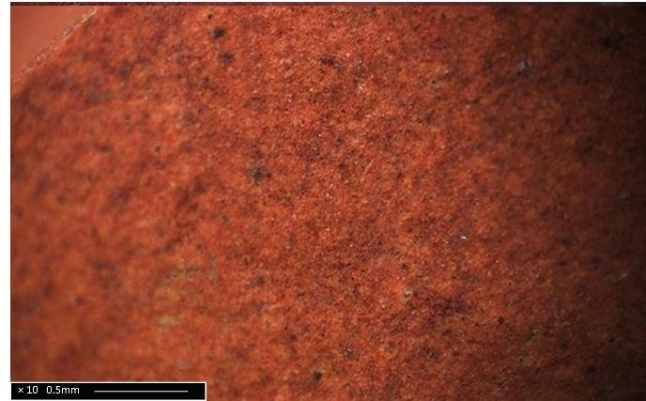
2 | 05BG1(3)_133 | Optical analysis: Fine to medium clay group  SEM and ImageJ analysis: Fine clay group | 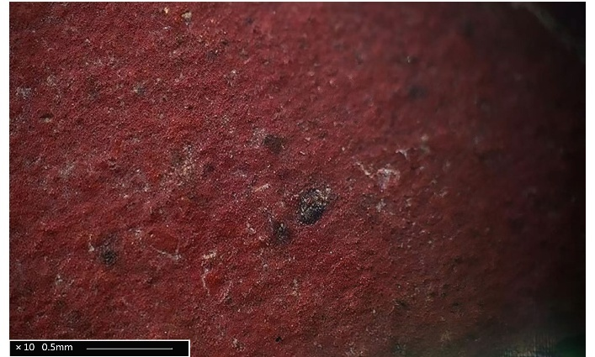
3 | 05AG1(1)_54 | Optical analysis: Medium clay group  SEM and ImageJ analysis: Medium clay group | 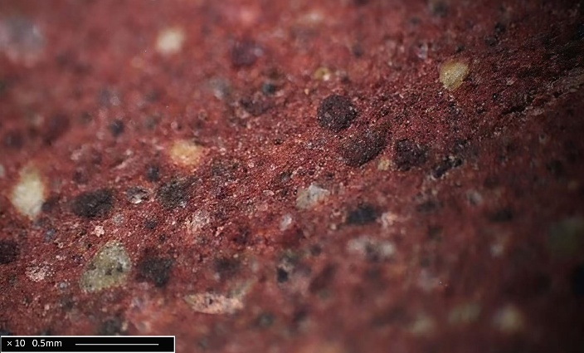
4 | 05BG1(4)_48 | Optical analysis: Medium to coarse clay group  SEM and ImageJ analysis: Medium clay group | 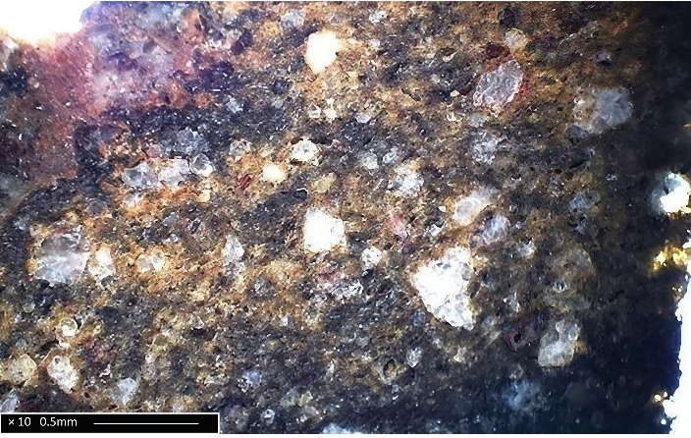
5 | 05BG1(4)_84 | Optical analysis: Coarse clay group  SEM and ImageJ analysis: Coarse clay group | 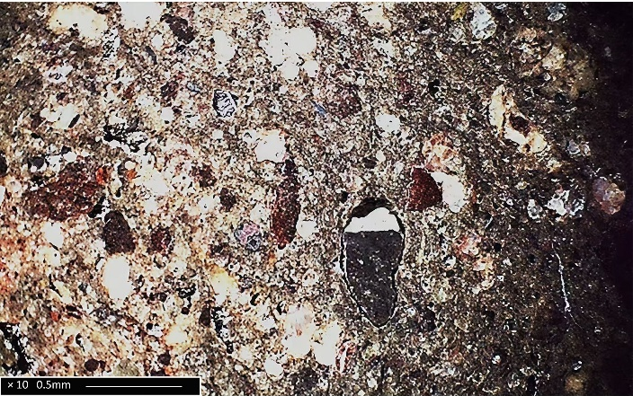

Appendix 4: Zisha clay quartz particle area calculated using SEM EDS and ImageJ on Shushan samples. The SEM-EDS silicon distribution map was generated by HITACHI TM 4000 Plus in the Oxford Research Laboratory for Archaeology and the History of Art (RLAHA) using 20kV vacuum mode 3. The input count was 16000-25000 cps. The particle area was calculated using the following method: 1. sum up all particle areas of each mapping image (each piece has three silicon distribution SEM mapping areas); 2. calculate average number of sum up particle areas of three mapping areas.
Dated period | Sample No. | Excavation No. | Total particle area | Coarse clay group
Ming | 1 | 05BG1(4)_102 | 50537.25433 | Fine clay group
Ming | 2 | 06BG1K1(5)_40 | 60273.31633 | Fine clay group
Ming | 3 | 05BG1(4)_18 | 53507.54367 | Medium clay group
Ming | 4 | 05BG1(4)_48 | 80911.45267 | Medium clay group
Ming | 5 | 05BG1(4)_7 | 55303.90033 | Coarse clay group
Ming | 6 | 05BG1(4)_84 | 63548.62067 | Coarse clay group
Early Qing | 7 | 06ET1K2(12)_23 | 51587.597 | Fine clay group
Early Qing | 8 | 06ET1K2(14)_141 | 50029.12433 | Fine clay group
Early Qing | 9 | 06ETK(17)_55 | 49056.241 | Medium clay group
Early Qing | 10 | 06ET1Y1(1)_1 | 47896.08 | Medium clay group
Mid-Qing | 11 | 06BG1K1(3)_196 | 35922.31767 | Fine clay group
Mid-Qing | 12 | 06BG1K1(3)_223 | 33353.094 | Fine clay group
Mid-Qing | 13 | 05AG2(9)_56 | 41925.207 | Medium clay group
Mid-Qing | 14 | 05AG2(9)_85 | 39679.58867 | Medium clay group
Late Qing | 15 | 05AG1(3)_42 | 33292.50733 | Fine clay group
Late Qing | 16 | 05AG2(2)_17 | 33844.011 | Fine clay group
Late Qing | 17 | 05AG1(3)_30 | 26311.913 | Medium clay group
Late Qing | 18 | 05ET1K(5)_7 | 34275.02667 | Medium clay group

Appendix 5: Area of individual quartz inclusions on Shushan zisha samples calculated using SEM EDS and ImageJ. This SEM-EDS silicon distribution map was generated by HITACHI TM 4000 Plus at the Oxford Research Laboratory for Archaeology and the History of Art (RLAHA) using 20kV vacuum mode 3. The input count was 16000-25000 cps. The average particle size was calculated: 1. calculate average particle size of each mapping area (each piece has three silicon distribution SEM mapping areas); 2. average calculation of three mapping area average particle size.
Dated period | Sample No. | Excavation No. | Average particle size | Coarse clay group
Ming | 1 | 05BG1(4)_102 | 110.64 | Fine clay group
Ming | 2 | 06BG1K1(5)_40 | 129.85 | Fine clay group
Ming | 3 | 05BG1(4)_18 | 287.95 | Medium clay group
Ming | 4 | 05BG1(4)_48 | 296.63 | Medium clay group
Ming | 5 | 05BG1(4)_7 | 157.24 | Coarse clay group
Ming | 6 | 05BG1(4)_84 | 183.46 | Coarse clay group
Early Qing | 7 | 06ET1K2(12)_23 | 200.15 | Fine clay group
Early Qing | 8 | 06ET1K2(14)_141 | 298.44 | Fine clay group
Early Qing | 9 | 06ETK(17)_55 | 210.43 | Medium clay group
Early Qing | 10 | 06ET1Y1(1)_1 | 222.29 | Medium clay group
Mid-Qing | 11 | 06BG1K1(3)_196 | 82.73 | Fine clay group
Mid-Qing | 12 | 06BG1K1(3)_223 | 72.71 | Fine clay group
Mid-Qing | 13 | 05AG2(9)_56 | 120.66 | Medium clay group
Mid-Qing | 14 | 05AG2(9)_85 | 124.79 | Medium clay group
Late Qing | 15 | 05AG1(3)_42 | 69.64 | Fine clay group
Late Qing | 16 | 05AG2(2)_17 | 115.71 | Fine clay group
Late Qing | 17 | 05AG1(3)_30 | 103.38 | Medium clay group
Late Qing | 18 | 05ET1K(5)_7 | 88.58 | Medium clay group

Appendix 6: Zisha clay quartz particle size deviation of Shushan samples calculated by SEM EDS and ImageJ. This SEM-EDS silicon distribution map was generated by HITACHI TM 4000 Plus at the Oxford Research Laboratory for Archaeology and the History of Art (RLAHA) using 20kV vacuum mode 3; the input count is 16000-25000 cps. The average particle size deviation was calculated: 1. Calculate particle size standard deviation of each mapping area (each piece has three silicon distribution SEM mapping areas); 2. average calculation of three mapping area standard deviation.
Dated period | Sample No. | Excavation  No. | Average particle size standard deviation | Coarseness group in SEM analysis
Ming | 1 | 05BG1(4)_102 | 630.22 | Fine clay group
Ming | 2 | 06BG1K1(5)_40 | 354.87 | Fine clay group
Ming | 3 | 05BG1(4)_18 | 1665.07 | Medium clay group
Ming | 4 | 05BG1(4)_48 | 1918.68 | Medium clay group
Ming | 5 | 05BG1(4)_7 | 691.25 | Coarse clay group
Ming | 6 | 05BG1(4)_84 | 866.61 | Coarse clay group
Early Qing | 7 | 06ET1K2(12)_23 | 489.39 | Fine clay group
Early Qing | 8 | 06ET1K2(14)_141 | 711.43 | Fine clay group
Early Qing | 9 | 06ETK(17)_55 | 1025.49 | Medium clay group
Early Qing | 10 | 06ET1Y1(1)_1 | 579.62 | Medium clay group
Mid-Qing | 11 | 06BG1K1(3)_196 | 164.19 | Fine clay group
Mid-Qing | 12 | 06BG1K1(3)_223 | 412.54 | Fine clay group
Mid-Qing | 13 | 05AG2(9)_56 | 398.45 | Medium clay group
Mid-Qing | 14 | 05AG2(9)_85 | 195.35 | Medium clay group
Late Qing | 15 | 05AG1(3)_42 | 109.2 | Fine clay group
Late Qing | 16 | 05AG2(2)_17 | 342.47 | Fine clay group
Late Qing | 17 | 05AG1(3)_30 | 607.75 | Medium clay group
Late Qing | 18 | 05ET1K(5)_7 | 415.35 | Medium clay group

Goldstein JI, Newbury DE, Michael JR, Ritchie NW, Scott JHJ, and Joy DC. (2017) Scanning Electron Microscopy and X-ray Microanalysis. Springer, New York: 295; JEOL (2020) Can I Trust My Quantitative EDS Data? JEOL Electron Optical Documents, https://www.jeolusa.com/RESOURCES/Electron-Optics/Documents-Downloads/can-i-trust-my-quantitative-eds-data#. Accessed 17 September 2025.
Reed, S. J. B. (1993) Electron Microprobe Analysis. Cambridge University Press, Cambridge: 183; JEOL (2020) Can I Trust My Quantitative EDS Data? JEOL Electron Optical Documents, https://www.jeolusa.com/RESOURCES/Electron-Optics/Documents-Downloads/can-i-trust-my-quantitative-eds-data#. Accessed 17 September 2025.
Iron oxides are by default calculated as Fe₂O₃ in SEM-EDS software.

