Supplementary Materials
EDS major element composition of mineral phases of the investigated pozzolana samples (CL, LP, SAV).
Alkali feldspars (Fig.1a) are sanidine with the following compositions: CL (An₂Ab₁₈Or₈₀), LP (An₀₋₂Ab₁₇₋₁₈Or₈₀₋₈₂), SAV (An₃₋₇Ab₁₄₋₂₇Or₆₈₋₈₄). Plagioclases (Fig.1a) are observed only in LP and CL samples and identified as bytownite and labradorite: CL (An₈₃Ab₁₄Or₂), LP (An₅₆₋₇₅Ab₃₈₋₂₁Or₄₋₆).
The pyroxenes (Fig.1b) (Fe calculated following Papike et al. 2005) are diopside (Wo₄₉En₄₄Fs₇ for CL sample, Wo₄₉En₃₈Fs₁₃ for the LP sample and Wo₄₆₋₄₇En₃₆₋₄₈Fs₁₆ for SAV sample).
The identified mineral phases are consistent with those from Phlegraean Fields products (Morra et al. 2010 and references therein).
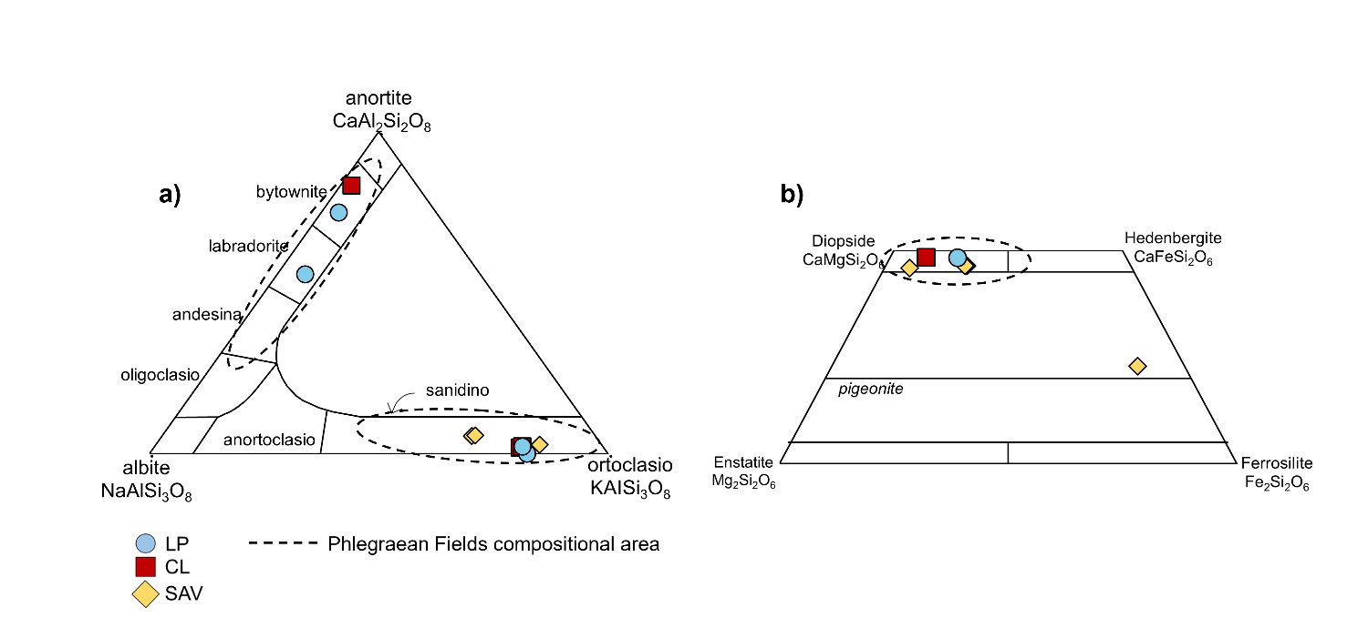
Fig.1 (a) Composition of the analyzed feldspar and plagioclase; (b) composition of the analyzed pyroxenes. Compositional areas of Phlegraean Fields feldspar, plagioclase and pyroxenes are from Morra et al. 2010 and references therein

Major elements EDS data of alkali feldspars (wt.%).
Sample | CL | CL | CL | SAV | SAV | SAV | LP | LP
SiO₂ | 64.71 | 64.06 | 62.04 | 62.77 | 63.31 | 62.20 | 65.39 | 63.22
Al₂O₃ | 19.01 | 19.17 | 18.44 | 19.86 | 19.17 | 19.52 | 19.23 | 19.51
FeO | 0.32 | 0.14 | 0.28 | 0.50 | 0.15 | 0.37 | 0.34 | 0.40
CaO | 0.42 | 0.46 | 0.47 | 1.13 | 0.59 | 1.16 | - | 0.44
Na₂O | 2.20 | 2.07 | 2.02 | 3.10 | 1.61 | 2.95 | 2.04 | 1.93
K₂O | 13.03 | 12.91 | 12.51 | 10.54 | 13.53 | 10.48 | 12.94 | 11.97
BaO | 0.15 | 0.38 | 0.24 | 0.49 | 0.44 | 0.19 | 0.24 | 0.72
SrO | - | - | - | 0.86 | 0.40 | 0.70 | - | 1.23
Total | 99.84 | 99.19 | 96.00 | 99.25 | 99.20 | 97.57 | 100.18 | 99.42
 | cation based on 32 oxygens
Si | 11.63 | 11.61 | 11.61 | 11.40 | 11.51 | 11.47 | 11.74 | 11.56
Al | 4.07 | 4.14 | 4.11 | 4.30 | 4.16 | 4.29 | 4.12 | 4.25
Fe | 0.05 | 0.02 | 0.04 | 0.08 | 0.02 | 0.06 | 0.05 | 0.06
Ca | 0.08 | 0.09 | 0.10 | 0.22 | 0.12 | 0.23 | - | 0.09
Na | 0.78 | 0.74 | 0.74 | 1.10 | 0.57 | 1.07 | 0.72 | 0.69
K | 3.38 | 3.38 | 3.38 | 2.76 | 3.55 | 2.79 | 3.36 | 3.16
Ba | 0.01 | 0.03 | 0.02 | 0.04 | 0.03 | 0.01 | 0.02 | 0.05
Sr | - | - | - | 0.09 | 0.04 | 0.08 | - | 0.13
Total | 20.00 | 20.00 | 20.00 | 20.00 | 20.00 | 20.00 | 20.00 | 20.00
An% | 1.93 | 2.15 | 2.26 | 5.44 | 2.74 | 5.67 | - | 2.21
Ab% | 18.30 | 17.50 | 17.58 | 27.00 | 13.53 | 26.09 | 17.64 | 17.57
Or% | 79.77 | 80.35 | 80.16 | 67.57 | 83.72 | 68.24 | 82.36 | 80.22
An%: anorthite mol%; Ab%= albite mol%; Or%= orthoclase mol%

Major elements EDS data of plagioclase (wt.%)
Sample | CL | LP | LP
SiO₂ | 46.41 | 53.69 | 48.47
Al₂O₃ | 32.91 | 29.16 | 31.67
FeO | 0.82 | 1.18 | 0.88
CaO | 16.70 | 11.30 | 14.65
Na₂O | 1.58 | 4.27 | 2.30
K₂O | 0.36 | 0.93 | 0.56
BaO | 0.64 | 0.41 | 0.35
SrO | - | - | 0.07
Total | 99.42 | 100.94 | 98.95
 | cation based on 32 oxygens
Si | 8.57 | 9.62 | 8.95
Al | 7.25 | 6.23 | 6.97
Fe | 0.13 | 0.18 | 0.14
Ca | 3.34 | 2.20 | 2.93
Na | 0.57 | 1.50 | 0.83
K | 0.10 | 0.24 | 0.15
Ba | 0.05 | 0.03 | 0.03
Sr | - | - | 0.01
Total | 20.00 | 20.00 | 20.00
An% | 83.34 | 55.76 | 74.91
Ab% | 14.27 | 38.13 | 21.28
Or% | 2.39 | 6.11 | 3.81
An%: anorthite mol%; Ab%= albite mol%; Or%= orthoclase mol%
Major elements EDS data of pyroxenes (wt.%)
Sample | CL | SAV | SAV | SAV | SAV | LP
SiO₂ | 54.18 | 52.89 | 48.88 | 53.84 | 49.83 | 50.09
TiO₂ | 0.45 | 0.30 | 0.74 | 0.86 | 0.54 | 0.59
Al₂O₃ | 2.44 | 2.22 | 2.90 | 15.15 | 2.55 | 3.33
Fe₂O₃ | 4.97 | 3.28 | 10.3 | 7.82 | 10.01 | 8.87
MnO | 0.16 | 0.28 | 0.35 | 0.29 | 0.52 | 0.25
MgO | 15.99 | 17.3 | 11.97 | 0.69 | 12.19 | 12.68
CaO | 24.6 | 22.69 | 21.55 | 2.15 | 21.75 | 23.06
Na₂O | 0.28 | 0.25 | 0.51 | 6.30 | 0.47 | 0.44
K₂O | 0.06 | 0.05 | 0.16 | 4.90 | 0.17 | 0.07
Total | 103.13 | 99.26 | 97.36 | 92.00 | 98.03 | 99.38
 | cation based on 6 oxygens
Si | 1.96 | 1.97 | 1.94 | 2.38 | 1.95 | 1.93
Ti | 0.01 | 0.01 | 0.02 | 0.03 | 0.02 | 0.02
^{IV}Al | 0.04 | 0.03 | 0.06 | - | 0.05 | 0.07
^{VI}Al | 0.01 | 0.02 | - | 0.78 | 0.01 | 0.01
Fe³⁺ | 0.01 | 0.01 | 0.04 | - | 0.02 | 0.04
Fe²⁺ | 0.14 | 0.09 | 0.31 | 1.24 | 0.31 | 0.25
Mn | - | 0.01 | 0.01 | 0.01 | 0.01 | 0.01
Mg | 0.86 | 0.96 | 0.71 | 0.05 | 0.71 | 0.73
Ca | 0.95 | 0.90 | 0.91 | 0.10 | 0.91 | 0.95
Na | 0.01 | 0.01 | 0.02 | 0.27 | 0.02 | 0.02
Total | 4.01 | 4.00 | 4.02 | 3.52 | 4.01 | 4.02
Wo% | 48.69 | 46.08 | 47.23 | 7.30 | 46.97 | 49.23
En% | 44.02 | 48.86 | 36.49 | 3.26 | 36.61 | 37.65
Fs% | 7.29 | 5.06 | 16.29 | 89.43 | 16.42 | 13.11
Wo%: wollastonite mol%; En%= enstatite mol%; Fs%= ferrosilite mol%; ^{IV}Al calculated by difference with Si; Fe³⁺ and Fe²⁺ were calculated following Papike et al. (2005)

