Supplementary Information [S1] - Polarized Optical Microscopy (POM)
Microphotographs of investigated pozzolana samples. CL, LP, SAV samples are shown at plane polarized light (PPL).
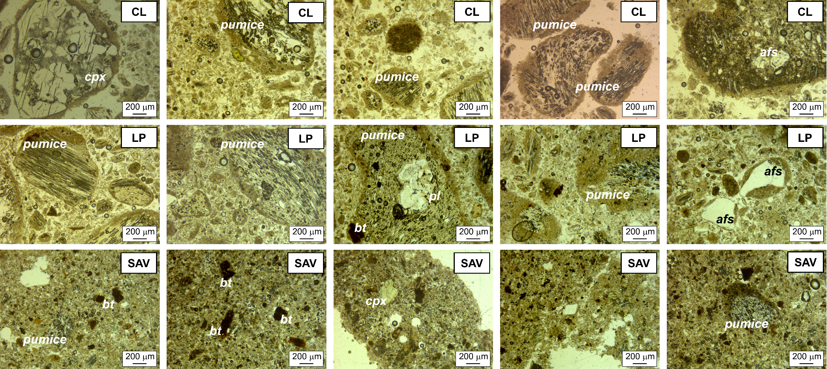
Abbreviations: cpx=clinopyroxene; pl=plagioclase; afs=alkali feldspar; bt=biotite.

