Appendix A. Creation of macroexpressions and Microexpressions


Figure A.1. Microexpression of happiness created with GANimation using the same image as both a source and a target. On the very left is the image that is to be animated and on the very right is an image with a target expression. The blended animation frames of increasing strength of the emotion are shown in between. Picture of the digital human retrieved from partner company (name anonymized for review).



Figure A.2. Upper row show GANimation creating a macroexpression of sadness, the lower row shows disgust. Neither of the resulting animations seem to capture the emotion of the source image, e.g., the rightmost created images appears closer to anger than to sadness and disgust. The image of sadness retrieved from Imgflip (2015). The image of disgust downloaded from Independent (2018).

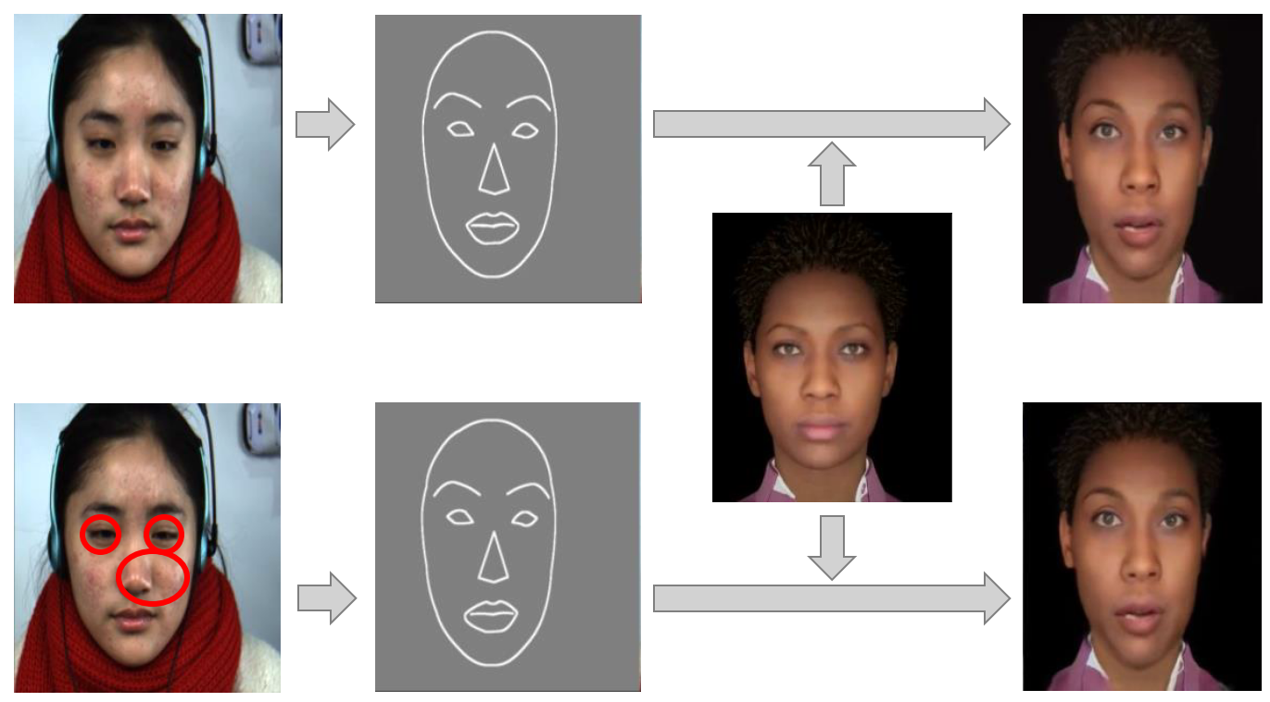

Figure A.3. Using fs-vid2vid to synthesize microexpressions. On the left: source frames with a microexpression, the upper left image shows the neutral baseline, and the lower left image shows the apex frame of disgust (the muscle near the nose is contracted and the eyes narrowed – as highlighted by the circles). Then, the generated facial landmarks (segmentation masks) are shown. Next, the image of the target digital human is displayed. Finally, the results are displayed on the very right. For digital humans (right images) differences are hardly noticeable for different microexpressions, indicating that fs-vid2vid is not suitable. Sources: CASME-II for the microexpression (Yan et al., 2014), UE (Epic Games, 2021) for the virtual human.

Appendix B. Our Experiment Platform: Experiment 1
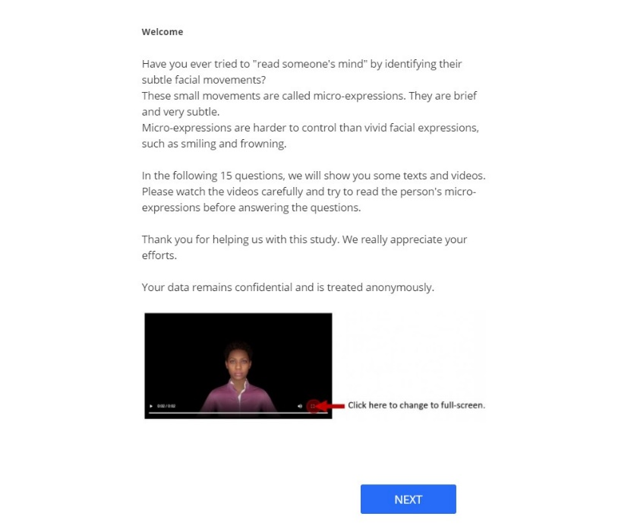
Figure B.1. Welcome screen

Figure B.2. Customer Service Representative scenario, pure text. Questions related to perceived affect and emotion recognition (control). The text is the first stimulus of the first experiment.

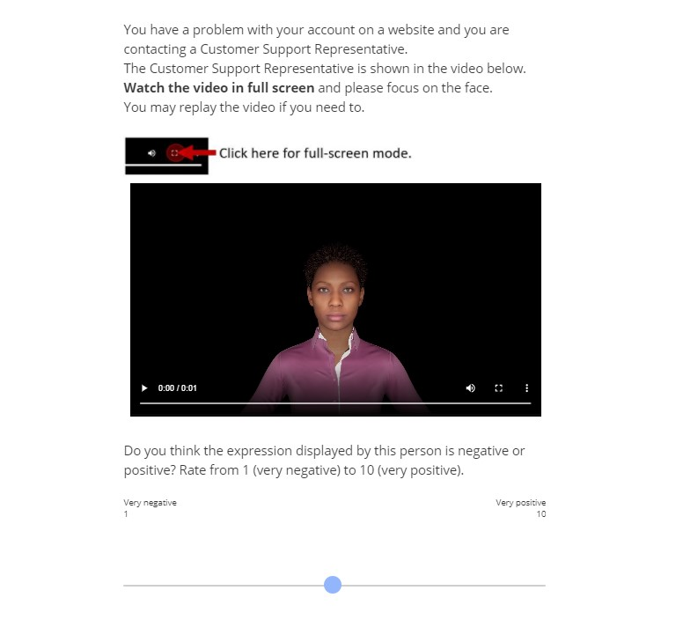
Figure B.3. Customer Service Representative scenario, video only with a microexpression, which is the second stimulus; Question for perceived affect.

Figure B.4. Customer Service Representative scenario. Questions for emotion recognition (for control) and perceived trustworthiness related to the second stimulus.
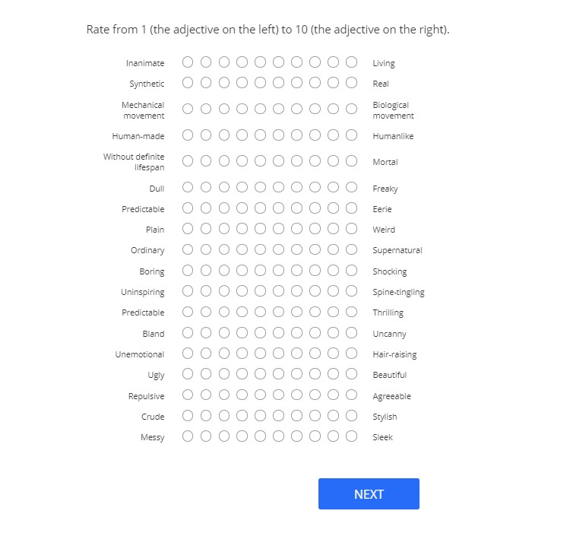
Figure B.5. 2 Customer Service Representative scenario. Overall perception questions related to the second stimulus.
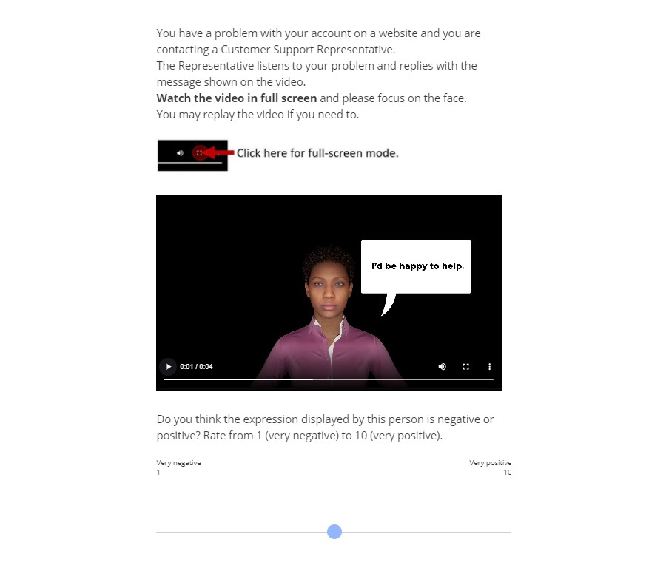
Figure B.6. Customer Service Representative scenario, video with a microexpression and a bubble text, the third stimulus.
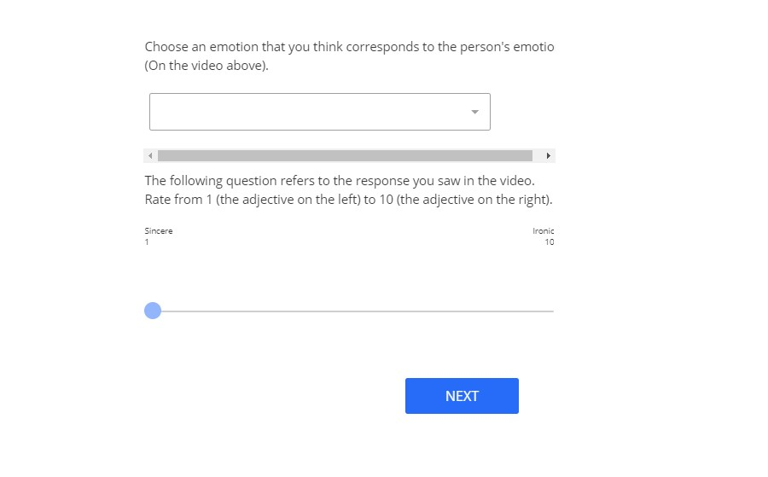
Figure B.7. Customer Service Representative scenario, video with a microexpression and a bubble text: emotion recognition and perceived sincerity question related to the third stimulus.

Appendix C. Our Experiment Platform: Experiment 2

Figure C.1. Recruitment scenario introduction
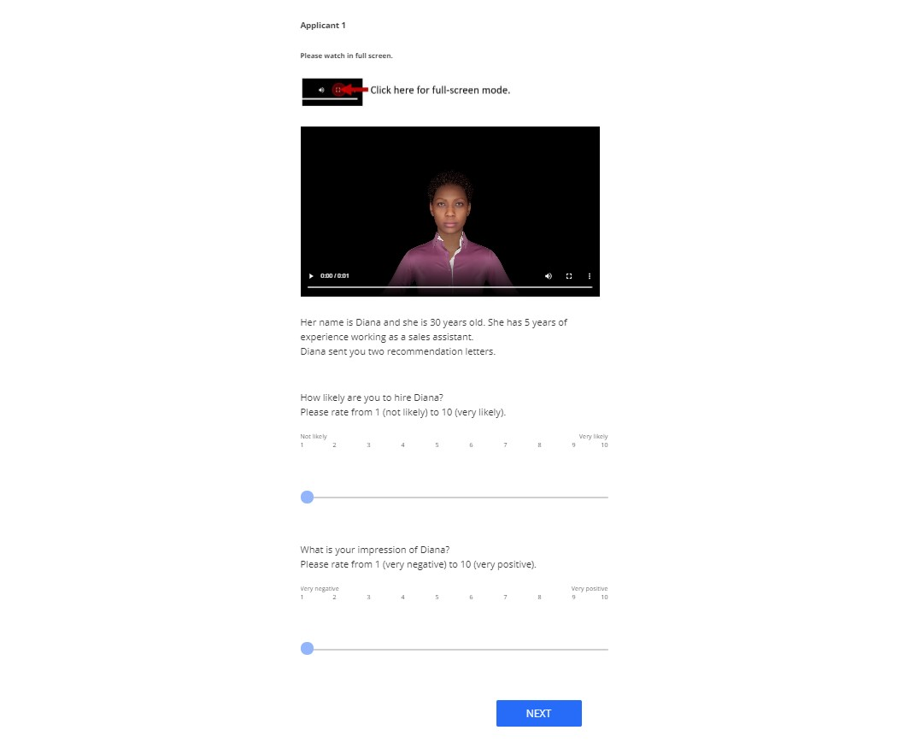
Figure C.2. Recruitment scenario: the first applicant introduction, general evaluation, and intention to hire questions
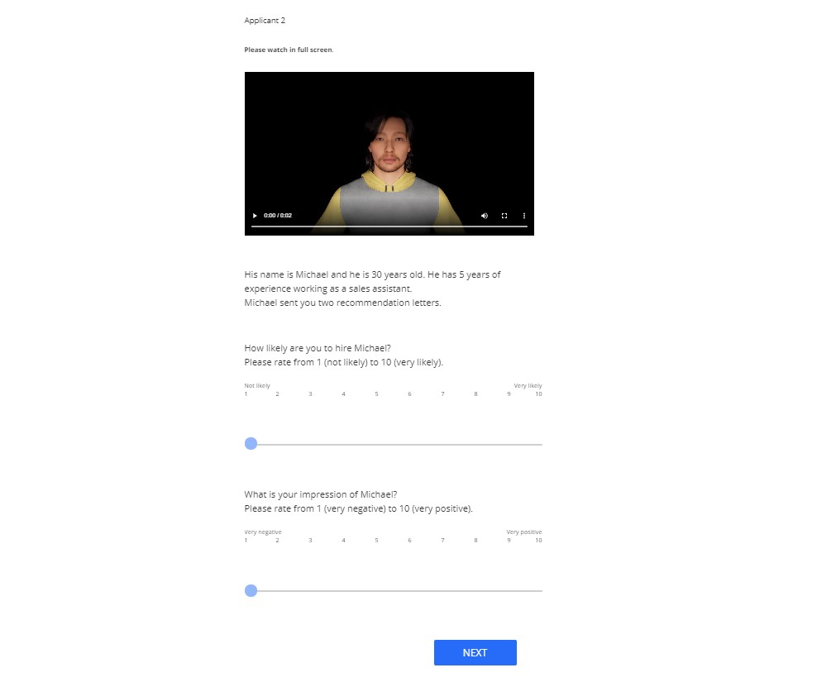
Figure C.3. Recruitment scenario: the second applicant introduction, general evaluation, and intention to hire questions
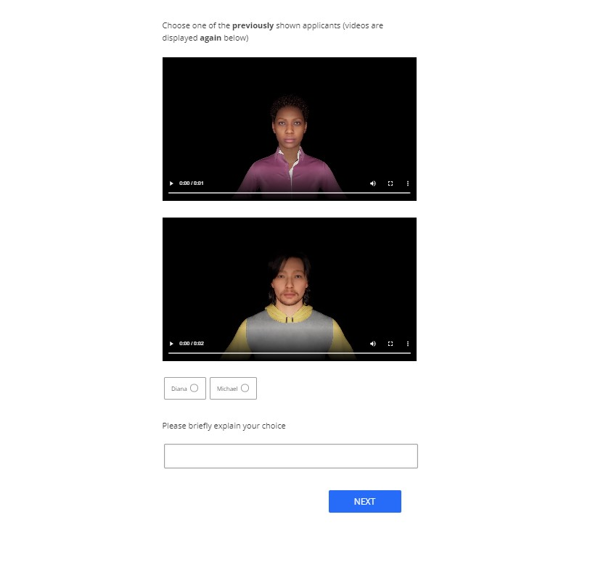
Figure C.4. Recruitment scenario, choice between the applicants
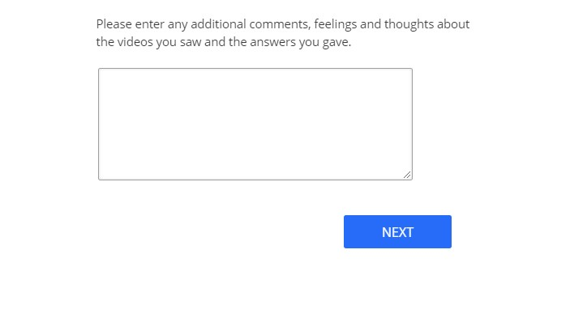
Figure C.5. Additional comments

Appendix D. Full ANOVA Tables
DV |  | Effects | SS | F | p
Perceived affect |  | Emotion | 106.66 | 21.127 | 0.000
 |  | Intensity | 0.17 | 0.033 | 0.856
 |  | Verbal | 28.18 | 5.583 | 0.018
 |  | Emotion × Intensity | 15.03 | 2.977 | 0.085
 |  | Emotion × Verbal | 8.09 | 1.602 | 0.206
 |  | Intensity × Verbal | 3.43 | 0.680 | 0.410
 |  | Emotion × Intensity × Verbal | 0.20 | 0.039 | 0.843
Perceived sincerity |  | Emotion | 0.14 | 0.024 | 0.878
 |  | Intensity | 24.98 | 4.263 | 0.040
 |  | Emotion × Intensity | 7.64 | 1.303 | 0.255
Perceived trustworthiness |  | Emotion | 59.18 | 10.484 | 0.001
 |  | Intensity | 0.83 | 0.147 | 0.701
 |  | Emotion × Intensity | 14.30 | 2.532 | 0.112
Overall perception | Humanness | Emotion | 0.076 | 0.012 | 0.914
Overall perception | Humanness | Intensity | 9.313 | 1.436 | 0.232
Overall perception | Humanness | Emotion × Intensity | 0.469 | 0.072 | 0.788
Overall perception | Eeriness | Emotion | 16.99 | 4.791 | 0.029
Overall perception | Eeriness | Intensity | 13.75 | 3.876 | 0.050
Overall perception | Eeriness | Emotion × Intensity | 0.83 | 0.235 | 0.628
Overall perception | Spine-tingling | Emotion | 6.90 | 1.865 | 0.173
Overall perception | Spine-tingling | Intensity | 16.13 | 4.360 | 0.038
Overall perception | Spine-tingling | Emotion × Intensity | 0.12 | 0.031 | 0.860
Overall perception | Attractiveness | Emotion | 0.54 | 0.183 | 0.669
Overall perception | Attractiveness | Intensity | 0.54 | 0.183 | 0.669
Overall perception | Attractiveness | Emotion × Intensity | 0.70 | 0.237 | 0.627
Table 12: ANOVA Results of Experiment 1

DV | Effects | SS | F | p
Intention to hire | Emotion | 21.37 | 4.964 | 0.026
Intention to hire | Intensity | 17.23 | 4.002 | 0.046
Intention to hire | Applicant | 1.30 | 0.302 | 0.583
Intention to hire | Emotion × Intensity | 0.35 | 0.081 | 0.776
Intention to hire | Emotion × Applicant | 0.02 | 0.005 | 0.944
Intention to hire | Intensity × Applicant | 2.34 | 0.545 | 0.461
Intention to hire | Emotion × Intensity × Applicant | 0.36 | 0.084 | 0.772
General evaluation | Emotion | 19.28 | 4.604 | 0.032
General evaluation | Intensity | 21.53 | 5.142 | 0.024
General evaluation | Applicant | 2.92 | 0.697 | 0.404
General evaluation | Emotion × Intensity | 0.28 | 0.066 | 0.797
General evaluation | Emotion × Applicant | 0.95 | 0.227 | 0.634
General evaluation | Intensity × Applicant | 4.40 | 1.050 | 0.306
General evaluation | Emotion × Intensity × Applicant | 0.05 | 0.013 | 0.909
Table 13: ANOVA results of Experiment 2

