Appendix 1
Category | Question
Getting started | 1 | How many variables are in the dataset?
Getting started | 2 | What can you use the variable PassengerID for?
Cleanup | 3 | Perform a data cleaning. Which observations would you mark as conspicuous?
Analysis | 4 | Calculate how much a ticket typically cost for Titanic passengers. *
Analysis | 5 | Which figure did you calculate to get the typical ticket price? *
Analysis | 6 | What influence would you expect the variable Gender to have on the variable passenger class? **
Knowledge Questions | 7 | What is a binary variable?
Knowledge Questions | 8 | What does the variance measure?
Knowledge Questions | 9 | What type of variable is the passenger class?
Knowledge Questions | 10 | You want to plot the variable age. What plot type do you chose?
Knowledge Questions | 11 | What should you look out for when interpreting plots?
Knowledge Questions | 12 | What method could you chose to statistically test whether the variable age (predictor) has an effect on the probability of survival?
Note: All tasks have been free text questions, except for * and ** which have been selections or offered an optional cross table respectively.
Table A1: Experiment tasks

Construct | Item
Data Analysis Knowledge | I have knowledge in the field of data analysis.
Software Skills | I’m experienced in working with a spreadsheet software (e.g. Excel)
Science Motivation questionnaire adapted from Glynn et al. (2011) | Learning Science is interesting.
 | I’m curious about discoveries in science.
 | I’m sure I can understand science.
 | My career will involve science.
 | Learning science will make my life more meaningful.
 | Knowing science will give me a career advantage.
 | Learning science will benefit my career.
Citizen Science concept | I have heard about Citizen Science before. *
Dataset experience | I have worked with datasets before. *
Note: All items have been measured on 7-point Likert Scales, except for *, which were binary variables
Table A2: Prequestionnaire

Construct | Item
Open Questions | How did you go about processing the tasks in today’s data analysis? What support did you use? *
Open Questions | Where would you have liked more support in the data analysis process? How could a support have looked like? *
Open Questions | Where could you imagine the usage of DataBot? For whom could it be interesting? *
Perceived Learning adapted from Alavi et al. (2002) | I became more interested in exploring scientific data.
Perceived Learning adapted from Alavi et al. (2002) | I gained a good understanding of how to familiarize myself with scientific data.
Perceived Learning adapted from Alavi et al. (2002) | I learned to identify central ideas in data analysis.
Perceived Learning adapted from Alavi et al. (2002) | I found today’s analysis activity to be a good learning experience.
Perceived Learning adapted from Alavi et al. (2002) | Given a choice I would take part in a data exploration activity similar to today’s session.
Motivation adapted from Center for Self-Determination Theory (2022) | I thought today’s analysis activity was a boring activity.
 | Working on the data exploration tasks did not hold my attention at all.
 | I would describe today’s analysis activity as very interesting.
 | I enjoyed working on the data exploration tasks very much.
Empowerment adapted from Kim and Gupta (2014) | I have mastered the skills necessary for exploring scientific data.
Empowerment adapted from Kim and Gupta (2014) | I am confident about my ability to familiarize myself with scientific data.
Empowerment adapted from Kim and Gupta (2014) | I am self-assured about my capabilities to gain insights from scientific data.
Empowerment adapted from Kim and Gupta (2014) | Based on my data analysis activity, my impact on what happens in a Citizen Science project is large.
Empowerment adapted from Kim and Gupta (2014) | Based on my data analysis activities, I have significant influence over what happens in a Citizen Science project.
Empowerment adapted from Kim and Gupta (2014) | Based on the chatbot usage, I have a great deal of control over what happens in a Citizen Science project.
Empowerment adapted from Kim and Gupta (2014) | Being able to gain insights from scientific data is very important to me.
Empowerment adapted from Kim and Gupta (2014) | My ability to explore scientific data is personally meaningful to me.
Empowerment adapted from Kim and Gupta (2014) | Being able to familiarize myself with scientific data is meaningful to me.
Empowerment adapted from Kim and Gupta (2014) | I have significant autonomy in determining how I gain insights from scientific data.
Empowerment adapted from Kim and Gupta (2014) | I can decide on my own how to go about exploring scientific data.
Empowerment adapted from Kim and Gupta (2014) | I have considerable opportunity for independence and freedom in familiarizing myself with scientific data.
UEQ adapted from Schrepp et al. (2017) | To me the bot was …
UEQ adapted from Schrepp et al. (2017) | ...obstructive/...supporting
UEQ adapted from Schrepp et al. (2017) | ...complicated/...simple
UEQ adapted from Schrepp et al. (2017) | ...confusing/...clear
UEQ adapted from Schrepp et al. (2017) | ...inefficient/...efficient
UEQ adapted from Schrepp et al. (2017) | ...boring/...exciting
UEQ adapted from Schrepp et al. (2017) | ...uninteresting/...interesting
UEQ adapted from Schrepp et al. (2017) | ...conventional/...innovative
UEQ adapted from Schrepp et al. (2017) | ...traditional/...novel
Note: All items have been measured on 7-point Likert Scales, except for *, which were free text answers. The CA has been introduced as “DataBot” to the participants.
Table A3: Main questionnaire
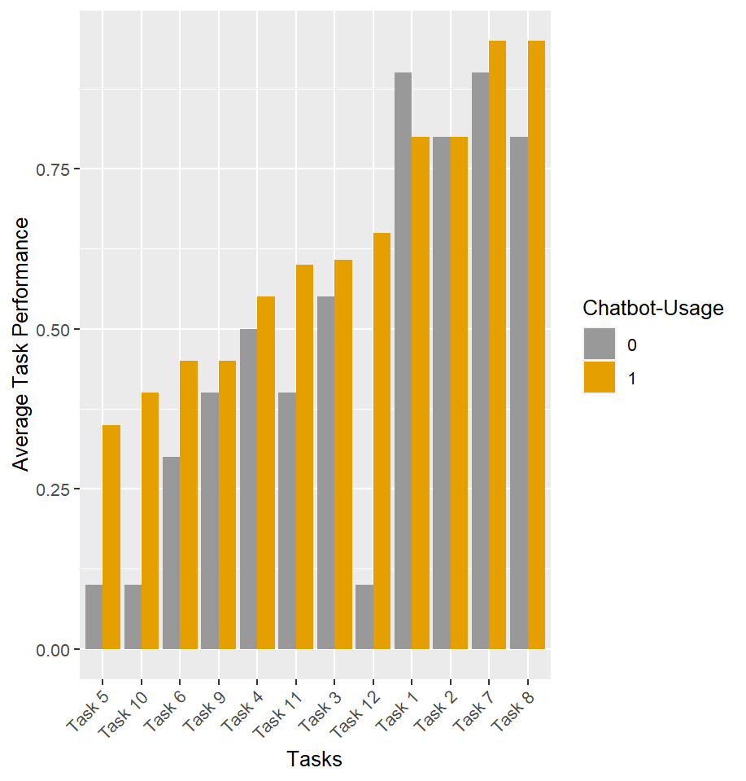
Figure A1: Average task performance per treatment and task
References

Alavi, M., Marakas, G. M., Yoo, Y. (2002). A comparative study of distributed learning environments on l earning outcomes. Information Systems Research, 13 (4), 404–415.
Center for Self-Determination Theory. (2022). Intrinsic Motivation Inventory (IMI). https://selfdeterminationtheory.org/intrinsic-motivation-inventory/
Glynn, S. M., Brickman, P., Armstrong, N., Taasoobshirazi, G. (2011). Science motivation questionnaire II: Validation with science majors and nonscience majors. Journal of Research in Science Teaching, 48 (10), 1159-1176
Kim, H.-W., Gupta, S. (2014). A user empowerment approach to information systems infusion. IEEE Transactions on Engineering Management, 61 (4), 656–668.
Schrepp, M., Hinderks, A., Thomaschewski, J. (2017). Design and evaluation of ashort version of the user experience questionnaire (UEQ-S). International Journal of Interactive Multimedia and Artificial Intelligence, 4 (6), 103-108.

