Appendix
Comprehension Check | Levels
What payment intervals does “SupportMe” offer? | “One time payment”; “Weekly payment”; “Monthly payment”
What type of platform is “SupportMe”? | “A platform for buying groceries locally”; “A video subscription platform”; “A subscription-based crowdfunding platform”
Does "SupportMe" offer a reward system? | “Yes”; “No”
Table 8: Overview of Comprehension Checks

Construct | Item | Count | % of N
Gender | Female | 183 | 62.24%
Gender | Male | 108 | 36.73%
Gender | Other | 2 | 0.68%
Gender | I prefer not to answer | 1 | 0.34%
Age $\left(\overline{x}=36.13, σ=12.67\right)$ | 18-20 | 21 | 7.14%
Age $\left(\overline{x}=36.13, σ=12.67\right)$ | 21-29 | 87 | 29.59%
Age $\left(\overline{x}=36.13, σ=12.67\right)$ | 30-39 | 76 | 25.85%
Age $\left(\overline{x}=36.13, σ=12.67\right)$ | 40-49 | 61 | 20.75%
Age $\left(\overline{x}=36.13, σ=12.67\right)$ | 50-59 | 33 | 11.22%
Age $\left(\overline{x}=36.13, σ=12.67\right)$ | ≥ 60 | 16 | 5.44%
Marital status | Single (never married) | 160 | 54.42%
Marital status | Married | 117 | 39.80%
Marital status | Separated | 3 | 1.02%
Marital status | Widowed | 1 | 0.34%
Marital status | Divorced | 8 | 2.72%
Marital status | I prefer not to answer | 5 | 1.70%
Highest degree of school | Less than high school | 2 | 0.68%
Highest degree of school | High school graduate | 102 | 34.69%
Highest degree of school | Associate degree | 21 | 7.14%
Highest degree of school | Bachelor’s degree | 117 | 39.80%
Highest degree of school | Master’s degree | 43 | 14.63%
Highest degree of school | Doctorate degree | 6 | 2.04%
Highest degree of school | I prefer not to answer | 3 | 1.02%
Household income | less than US$20,000 | 55 | 18.71%
Household income | between US$20,000 and US$29,999 | 30 | 10.20%
Household income | between US$30,000 and US$39,999 | 38 | 12.93%
Household income | between US$40,000 and US$49,999 | 32 | 10.88%
Household income | between US$50,000 and US$59,999 | 30 | 10.20%
Household income | between US$60,000 and US$69,999 | 20 | 6.80%
Household income | between US$70,000 and US$79,999 | 14 | 4.76%
Household income | between US$80,000 and US$89,999 | 9 | 3.06%
Household income | between US$90,000 and US$99,999 | 11 | 3.74%
Household income | above US$100,000 | 17 | 5.78%
Household income | I prefer not to answer | 38 | 12.93%
Familiarity with subscription-based crowdfunding platforms | 1 strongly disagree | 41 | 13.95%
Familiarity with subscription-based crowdfunding platforms | 2 | 38 | 12.93%
Familiarity with subscription-based crowdfunding platforms | 3 | 31 | 10.54%
Familiarity with subscription-based crowdfunding platforms | 4 | 32 | 10.88%
Familiarity with subscription-based crowdfunding platforms | 5 | 65 | 22.11%
Familiarity with subscription-based crowdfunding platforms | 6 | 43 | 14.63%
Familiarity with subscription-based crowdfunding platforms | 7 strongly agree | 44 | 14.97%
Experience with subscription-based crowdfunding (SBCF) platforms | I have never used SBCF platforms | 209 | 71.09%
 | less than 6 months | 33 | 11.22%
 | 6 to less than 12 months | 14 | 4.76%
 | 1 to 3 years | 31 | 10.54%
 | 4 to 6 years | 6 | 2.04%
 | 7 years or more | 1 | 0.34%
Table 9: Discrete Choice Experiment Demographics (N=294)

Figure 3: Descriptive Mock-Up of SupportMe Campaign
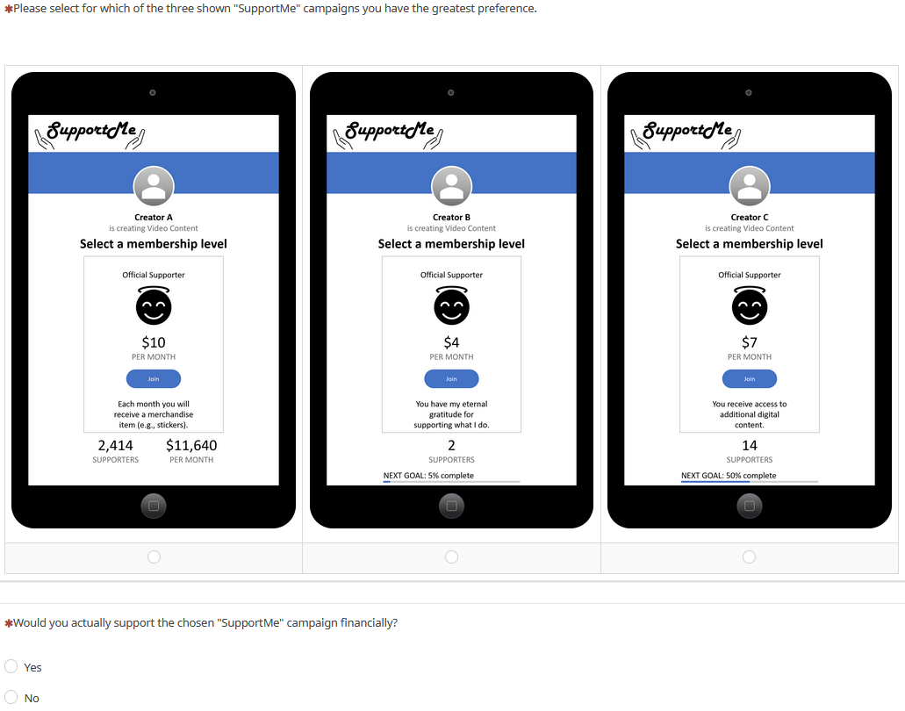
Figure 4: Example Choice Set with Dual Response No-Choice Option

Figure 5: Visualization of the U-Shaped Effect of Goal Proximity Parameters

