Appendix A
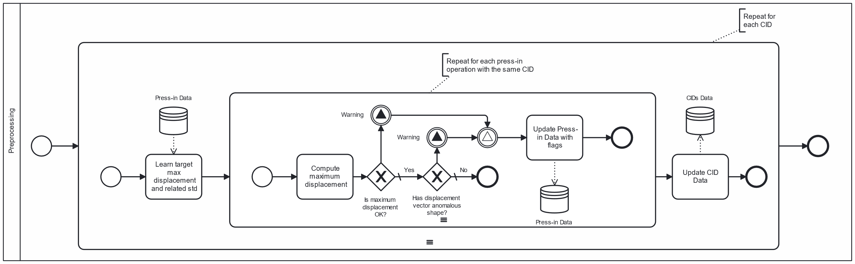 | 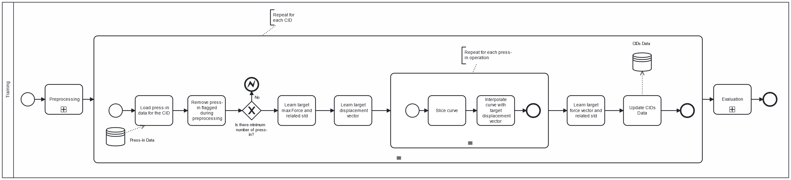 | 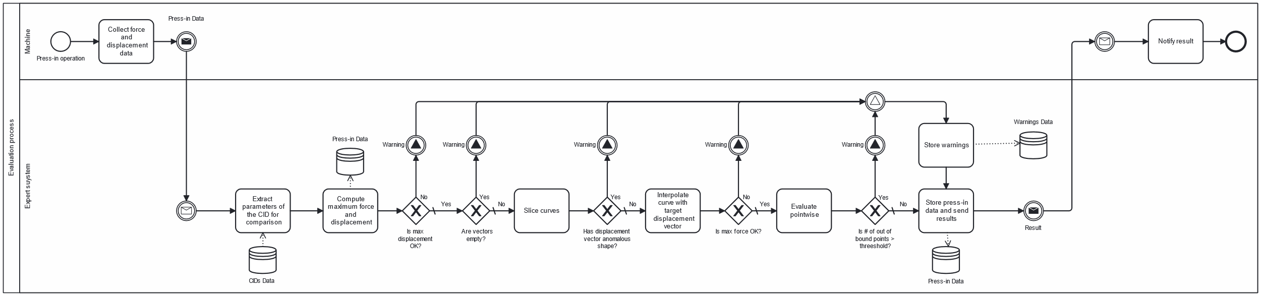

Appendix B
As indicated in Table 4, the most prevalent flag pertains to the vertical component of the block window. This observation is logical, given that this evaluation assesses the maximum force exerted by the press. When joining partners are not correctly aligned, increased force might be needed to rectify their position, potentially causing component deformations.
In contrast, the check on the horizontal component of the block window registers a lower count of flags. This discrepancy may stem from dataset processing that excluded press-in operations not reaching a predetermined displacement target, established in collaboration with the company.
Conversely, the envelope technique identifies curves flagged by other checks, as it engages in a point-wise evaluation. As anticipated, the combination of all three checks yields the most favorable outcomes.
Horizontal block window | Vertical block window | Envelope | Percentage of flagged press-in operations
 |  |  | 14.91%
- |  |  | 14.69%
 |  | - | 12.98%
- |  | - | 12.98%
 | - |  | 4.79%
- | - |  | 4.55%
 | - | - | 2.16%
Table 4 - Results of the ablation study with different combinations of parameters. Curves are flagged based on three different checks: on the horizontal component of the block window, on the vertical component of the block window and on the envelope

