Appendix

Appendix 1. Data Collection and Cleaning Process for Face-to-Face Surveys

The survey operator implemented continuous technical and procedural quality control during fieldwork. Interview data were transmitted in real time to a secure cloud‑based data management server, allowing immediate technical validation. Daily interviewer debriefings addressed questions and emerging issues, while supervisors monitored performance to ensure correct routing, timing, and recording.

After each upload, automated and manual checks validated case completeness, coded responses, and adherence to predefined value ranges. Metadata such as interview start and end times and total duration were reviewed to detect anomalies. Contact protocols collected by interviewers documented refusals and helped verify overall data coverage and field compliance. Patterns in response distributions were compared across interviewers to detect potential interviewer effects or deviations from the survey plan.

Final cleaning followed a stepwise procedure combining completeness checks, plausibility tests, and adherence to sampling and fieldwork rules. Based on this verification, which utilized 6 exclusion criteria, 26 of 5,583 interviews (0.47%) were excluded from the dataset, resulting in a final usable sample of 5,557.
Detailed Explanation of Exclusion Criteria:
1. Test Interview/Unusual Duration (n=12): Interviews that were either conducted as test runs during training or exhibited interview durations that were statistically anomalous (either extremely short <4 minutes or extremely long >16 minutes without plausible explanation in interviewer notes).
2. Incorrect Filter Routing (n=6): Cases where the survey software's automatic filtering logic was not properly followed, leading to respondents being asked questions that should not have applied to them based on previous answers.
3. Under 14 Years Old (n=2): Respondents who did not meet the minimum age eligibility criterion of 14 years for participation in the study.
4. Outside Survey Times (n=2): Interviews conducted outside the predefined fieldwork schedule specified in the deployment plan.
5. Wrong Survey/Accommodation Location (n=2): Cases where the recorded survey location or accommodation location did not correspond to the interviewer's assigned deployment location.
6. Deviation from Deployment Plan (n=2): Interviews that violated other aspects of the deployment plan beyond timing or location specifications.
A detailed distribution by location is shown in Table A1.
Survey Location | Test interview/Unusual duration | Incorrect filter routing | Under 14 years old | Outside survey times | Wrong survey/accommodation location | Deviation from deployment plan
Füssen | 2 | 0 | 0 | 1 | 1 | 1
Allgäu Rural Area | 3 | 0 | 0 | 0 | 0 | 0
Sauerland | 5 | 0 | 1 | 0 | 1 | 0
Ruhr Valley Cycle Path | 1 | 6 | 0 | 0 | 0 | 0
North Sea coast | 0 | 0 | 0 | 0 | 0 | 1
Baltic Sea coast | 1 | 0 | 1 | 1 | 0 | 0
Total | 12 | 6 | 2 | 2 | 2 | 2
Table A1: Excluded Interviews by Location and Exclusion Criteria

Appendix 2. Statistical Testing and Probability Predictions
Model | Model Deviance | Null Deviance | Difference (Null - Model) | Nagelkerke $R^{2}$ | AIC
Full Model | 22299.89 | 22704.61 | 404.72 | 0.072 | 22385.89
Model Urban | 4768.41 | 4781.65 | 13.24 | 0.012 | 4798.41
Model Natural | 17697.15 | 17731.98 | 34.38 | 0.008 | 17727.15
Table A2.1: Model Fit Statistics – Comparison of Model and Null Deviance, Nagelkerke $R^{2}$ and AIC for all three Models
Predictor | X2 | df | probability
Omnibus | 447.88 | 272 | 9.47E-11
First_Time_Visitor1 | 13.27 | 8 | 0.10
volatilitylow | 19.01 | 8 | 0.01
volatilitymoderate | 19.55 | 8 | 0.01
constraintsopen | 11.25 | 8 | 0.19
constraintsrestricted | 11.56 | 8 | 0.17
Web_Based_Inforamtion_Sources1 | 20.46 | 8 | 0.01
Printed_Information_Sources1 | 5.97 | 8 | 0.65
Personal_Contacts_Information_Sources1 | 6.53 | 8 | 0.59
Informed_Multiple_Days1 | 14.19 | 8 | 0.08
Informed_During_Trip1 | 4.10 | 8 | 0.85
First_Time_Visitor1:volatilitylow | 7.37 | 8 | 0.50
First_Time_Visitor1:volatilitymoderate | 8.70 | 8 | 0.37
First_Time_Visitor1:constraintsopen | 11.10 | 8 | 0.20
First_Time_Visitor1:constraintsrestricted | 24.32 | 8 | 0.00
volatilitylow:Web_Based_Inforamtion_Sources1 | 11.89 | 8 | 0.16
volatilitymoderate:Web_Based_Inforamtion_Sources1 | 24.14 | 8 | 0.00
constraintsopen:Web_Based_Inforamtion_Sources1 | 8.95 | 8 | 0.35
constraintsrestricted:Web_Based_Inforamtion_Sources1 | 3.63 | 8 | 0.89
volatilitylow:Printed_Information_Sources1 | 9.44 | 8 | 0.31
volatilitymoderate:Printed_Information_Sources1 | 10.49 | 8 | 0.23
constraintsopen:Printed_Information_Sources1 | 4.86 | 8 | 0.77
constraintsrestricted:Printed_Information_Sources1 | 5.23 | 8 | 0.73
volatilitylow:Personal_Contacts_Information_Sources1 | 8.82 | 8 | 0.36
volatilitymoderate:Personal_Contacts_Information_Sources1 | 8.08 | 8 | 0.43
constraintsopen:Personal_Contacts_Information_Sources1 | 5.05 | 8 | 0.75
constraintsrestricted:Personal_Contacts_Information_Sources1 | 6.46 | 8 | 0.60
volatilitylow:Informed_Multiple_Days1 | 13.50 | 8 | 0.10
volatilitymoderate:Informed_Multiple_Days1 | 10.57 | 8 | 0.23
constraintsopen:Informed_Multiple_Days1 | 15.13 | 8 | 0.06
constraintsrestricted:Informed_Multiple_Days1 | 12.74 | 8 | 0.12
volatilitylow:Informed_During_Trip1 | 2.02 | 8 | 0.98
volatilitymoderate:Informed_During_Trip1 | -20.04 | 8 | 1.00
constraintsopen:Informed_During_Trip1 | 46.53 | 8 | 1.88E-07
constraintsrestricted:Informed_During_Trip1 | 0.00 | 8 | 1
Table A2.2: Results of Brant Test for Pooled Model

Predictor | X2 | df | probability
Omnibus | 447.88 | 272 | 9.5E-11
First_Time_Visitor1 | 13.27 | 8 | 0.10
volatilitylow | 19.01 | 8 | 0.01
volatilitymoderate | 19.55 | 8 | 0.01
constraintsopen | 11.25 | 8 | 0.19
constraintsrestricted | 11.56 | 8 | 0.17
Web_Based_Inforamtion_Sources1 | 20.46 | 8 | 0.01
Printed_Information_Sources1 | 5.97 | 8 | 0.65
Personal_Contacts_Information_Sources1 | 6.53 | 8 | 0.59
Informed_Multiple_Days1 | 14.19 | 8 | 0.08
Informed_During_Trip1 | 4.10 | 8 | 0.85
First_Time_Visitor1:volatilitylow | 7.37 | 8 | 0.50
First_Time_Visitor1:volatilitymoderate | 8.70 | 8 | 0.37
First_Time_Visitor1:constraintsopen | 11.10 | 8 | 0.20
First_Time_Visitor1:constraintsrestricted | 24.32 | 8 | 0.00
volatilitylow:Web_Based_Inforamtion_Sources1 | 11.89 | 8 | 0.16
volatilitymoderate:Web_Based_Inforamtion_Sources1 | 24.14 | 8 | 0.00
constraintsopen:Web_Based_Inforamtion_Sources1 | 8.95 | 8 | 0.35
constraintsrestricted:Web_Based_Inforamtion_Sources1 | 3.63 | 8 | 0.89
volatilitylow:Printed_Information_Sources1 | 9.44 | 8 | 0.31
volatilitymoderate:Printed_Information_Sources1 | 10.49 | 8 | 0.23
constraintsopen:Printed_Information_Sources1 | 4.86 | 8 | 0.77
constraintsrestricted:Printed_Information_Sources1 | 5.23 | 8 | 0.73
volatilitylow:Personal_Contacts_Information_Sources1 | 8.82 | 8 | 0.36
volatilitymoderate:Personal_Contacts_Information_Sources1 | 8.08 | 8 | 0.43
constraintsopen:Personal_Contacts_Information_Sources1 | 5.05 | 8 | 0.75
constraintsrestricted:Personal_Contacts_Information_Sources1 | 6.46 | 8 | 0.60
volatilitylow:Informed_Multiple_Days1 | 13.50 | 8 | 0.10
volatilitymoderate:Informed_Multiple_Days1 | 10.57 | 8 | 0.23
constraintsopen:Informed_Multiple_Days1 | 15.13 | 8 | 0.06
constraintsrestricted:Informed_Multiple_Days1 | 12.74 | 8 | 0.12
volatilitylow:Informed_During_Trip1 | 2.02 | 8 | 0.98
volatilitymoderate:Informed_During_Trip1 | -20.04 | 8 | 1
constraintsopen:Informed_During_Trip1 | 46.53 | 8 | 1.9E-07
constraintsrestricted:Informed_During_Trip1 | 0.00 | 8 | 1
Table A2.3: Results of Brant Test for Split Model (Urban)

Predictor | X2 | df | probability
Omnibus | 447.88 | 272 | 9.5E-11
First_Time_Visitor1 | 13.27 | 8 | 0.10
volatilitylow | 19.01 | 8 | 0.01
volatilitymoderate | 19.55 | 8 | 0.01
constraintsopen | 11.25 | 8 | 0.19
constraintsrestricted | 11.56 | 8 | 0.17
Web_Based_Inforamtion_Sources1 | 20.46 | 8 | 0.01
Printed_Information_Sources1 | 5.97 | 8 | 0.65
Personal_Contacts_Information_Sources1 | 6.53 | 8 | 0.59
Informed_Multiple_Days1 | 14.19 | 8 | 0.08
Informed_During_Trip1 | 4.10 | 8 | 0.85
First_Time_Visitor1:volatilitylow | 7.37 | 8 | 0.50
First_Time_Visitor1:volatilitymoderate | 8.70 | 8 | 0.37
First_Time_Visitor1:constraintsopen | 11.10 | 8 | 0.20
First_Time_Visitor1:constraintsrestricted | 24.32 | 8 | 0.00
volatilitylow:Web_Based_Inforamtion_Sources1 | 11.89 | 8 | 0.16
volatilitymoderate:Web_Based_Inforamtion_Sources1 | 24.14 | 8 | 0.00
constraintsopen:Web_Based_Inforamtion_Sources1 | 8.95 | 8 | 0.35
constraintsrestricted:Web_Based_Inforamtion_Sources1 | 3.63 | 8 | 0.89
volatilitylow:Printed_Information_Sources1 | 9.44 | 8 | 0.31
volatilitymoderate:Printed_Information_Sources1 | 10.49 | 8 | 0.23
constraintsopen:Printed_Information_Sources1 | 4.86 | 8 | 0.77
constraintsrestricted:Printed_Information_Sources1 | 5.23 | 8 | 0.73
volatilitylow:Personal_Contacts_Information_Sources1 | 8.82 | 8 | 0.36
volatilitymoderate:Personal_Contacts_Information_Sources1 | 8.08 | 8 | 0.43
constraintsopen:Personal_Contacts_Information_Sources1 | 5.05 | 8 | 0.75
constraintsrestricted:Personal_Contacts_Information_Sources1 | 6.46 | 8 | 0.60
volatilitylow:Informed_Multiple_Days1 | 13.50 | 8 | 0.10
volatilitymoderate:Informed_Multiple_Days1 | 10.57 | 8 | 0.23
constraintsopen:Informed_Multiple_Days1 | 15.13 | 8 | 0.06
constraintsrestricted:Informed_Multiple_Days1 | 12.74 | 8 | 0.12
volatilitylow:Informed_During_Trip1 | 2.02 | 8 | 0.98
volatilitymoderate:Informed_During_Trip1 | -20.04 | 8 | 1
constraintsopen:Informed_During_Trip1 | 46.53 | 8 | 1.9E-07
constraintsrestricted:Informed_During_Trip1 | 0.00 | 8 | 1
Table A2.4: Results of Brant Test for Split Model (Natural)

The tables A2.5-A2.10 and figures A2.1-A2.6 report average predicted probabilities of high perceived crowding (Y ≥ 7) by information source and timing across moderator levels (spatial constraints, environmental volatility, regional typology), based on the pooled ordered-logit model in the Methods. Probabilities are averaged over the empirical covariate distribution (marginal standardization). 95% bootstrap CIs use 500 resamples stratified by site. Tables A2.5–A2.10 provide the numerical values. Figures A2.1–A2.6 visualize the same contrasts.
Moderator | Group | N | Mean (p) | 95% CI
mixed | Formal (web/print) | 1088 | 0.193 | [0.192, 0.194]
mixed | Informal (contacts) | 265 | 0.19 | [0.187, 0.194]
open | Formal (web/print) | 2891 | 0.119 | [0.117, 0.121]
open | Informal (contacts) | 1011 | 0.112 | [0.109, 0.115]
restricted | Formal (web/print) | 622 | 0.102 | [0.099, 0.105]
restricted | Informal (contacts) | 249 | 0.058 | [0.056, 0.060]
Table A2.5. Average predicted probability P(Y≥7) by information source (Formal vs. Informal) across spatial constraints (mixed / open / restricted). 95% bootstrap CIs (B = 500)
Moderator | Group | N | Mean (p) | 95% CI
mixed | Not real-time | 1067 | 0.19 | [0.189, 0.191]
mixed | Real-time | 74 | 0.19 | [0.185, 0.194]
open | Not real-time | 3532 | 0.117 | [0.115, 0.118]
open | Real-time | 31 | 0.156 | [0.114, 0.194]
restricted | Not real-time | 826 | 0.118 | [0.115, 0.121]
restricted | Real-time | 6 | 0 | [0.000, 0.000]
Table A2.6. Average predicted probability P(Y≥7) by information timing (Real-time vs. Not real-time) across spatial constraints. 95% bootstrap CIs (B = 500)
Moderator | Group | N | Mean (p) | 95% CI
high | Formal (web/print) | 1533 | 0.113 | [0.111, 0.114]
high | Informal (contacts) | 556 | 0.104 | [0.102, 0.106]
low | Formal (web/print) | 1354 | 0.085 | [0.084, 0.087]
low | Informal (contacts) | 490 | 0.067 | [0.066, 0.069]
moderate | Formal (web/print) | 1714 | 0.191 | [0.190, 0.193]
moderate | Informal (contacts) | 479 | 0.182 | [0.179, 0.185]
Table A2.7. Average predicted probability P(Y≥7) by information source (Formal vs. Informal) across environmental volatility (low / moderate / high). 95% bootstrap CIs (B = 500)
Moderator | Group | N | Mean (p) | 95% CI
high | Not real-time | 1892 | 0.109 | [0.108, 0.110]
high | Real-time | 15 | 0.255 | [0.226, 0.285]
low | Not real-time | 1673 | 0.095 | [0.093, 0.097]
low | Real-time | 17 | 0.024 | [0.015, 0.033]
moderate | Not real-time | 1860 | 0.187 | [0.185, 0.188]
moderate | Real-time | 79 | 0.185 | [0.180, 0.191]
Table A2.8. Average predicted probability P(Y≥7) by information timing (Real-time vs. Not real-time) across environmental volatility. 95% bootstrap CIs (B = 500)
Moderator | Group | N | Mean (p) | 95% CI
Natural regions | Formal (web/print) | 3513 | 0.116 | [0.114, 0.117]
Natural regions | Informal (contacts) | 1260 | 0.101 | [0.099, 0.103]
Urban site | Formal (web/print) | 1088 | 0.193 | [0.192, 0.194]
Urban site | Informal (contacts) | 265 | 0.19 | [0.187, 0.194]
Table A2.9. Average predicted probability P(Y≥7) by information source (Formal vs. Informal) across regional typology (urban / natural). 95% bootstrap CIs (B = 500)
Moderator | Group | N | Mean (p) | 95% CI
Natural regions | Not real-time | 4358 | 0.117 | [0.116, 0.118]
Natural regions | Real-time | 37 | 0.131 | [0.096, 0.170]
Urban site | Not real-time | 1067 | 0.19 | [0.189, 0.191]
Urban site | Real-time | 74 | 0.19 | [0.185, 0.194]
Table A2.10. Average predicted probability P(Y≥7) by information timing (Real-time vs. Not real-time) across regional typology. 95% bootstrap CIs (B = 500)
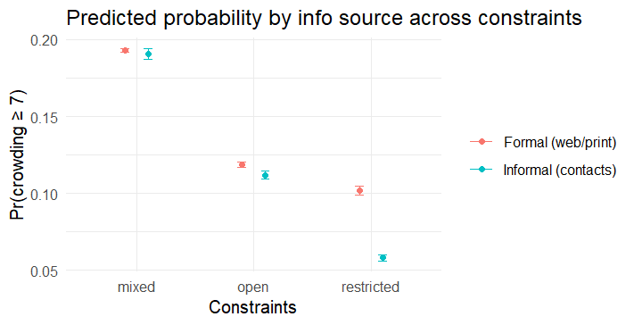
Figure A2.1. Predicted probability (Y ≥ 7) by information source across spatial constraints
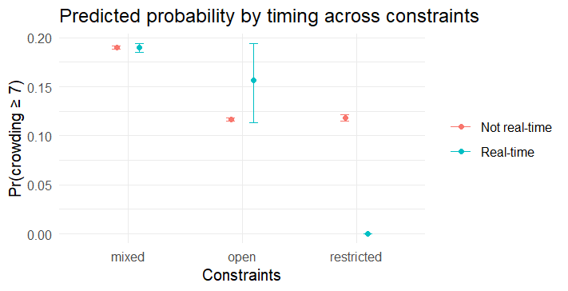
Figure A2.2. Predicted probability (Y ≥ 7) by information timing across spatial constraints
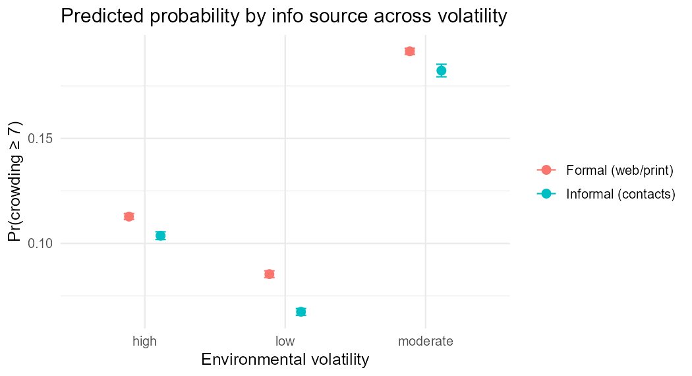
Figure A2.3. Predicted probability (Y ≥ 7) by information source across environmental volatility
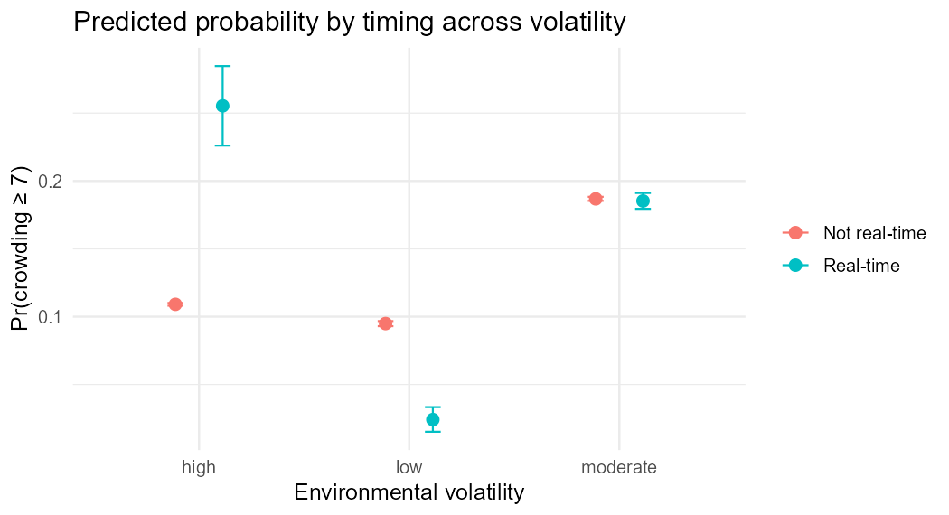
Figure A2.4. Predicted probability (Y ≥ 7) by information timing across environmental volatility
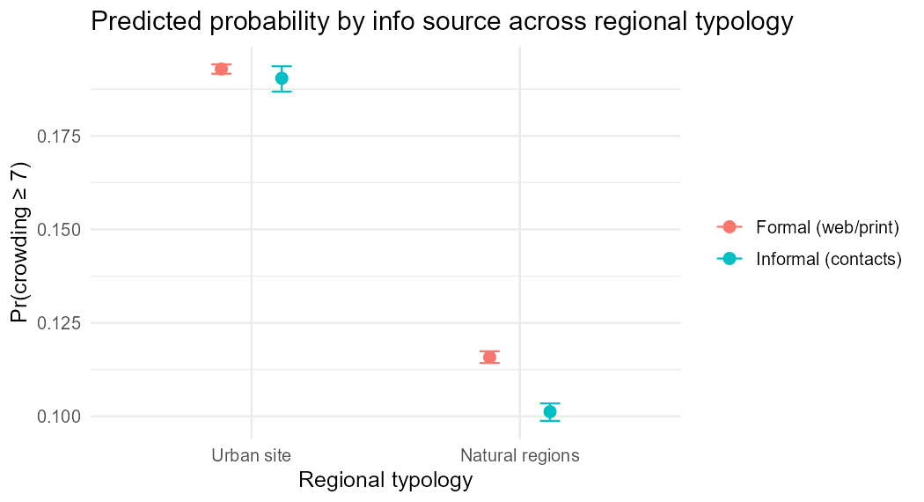
Figure A2.5. Predicted probability (Y ≥ 7) by information source across regional typology

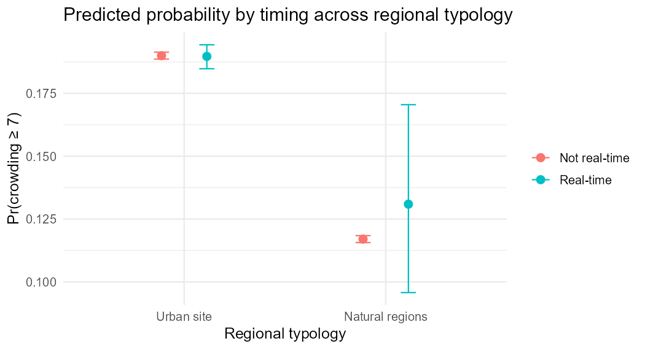
Figure A2.6. Predicted probability (Y ≥ 7) by information timing across regional typology

