Appendix A: Operationalization of Product Features
The List of Key Features in Our Sample
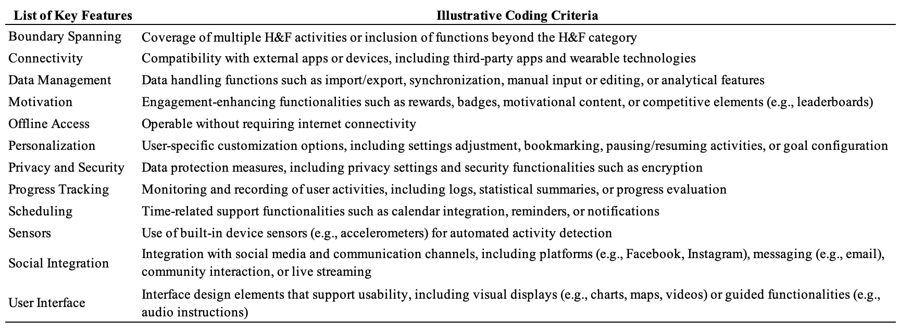

Borderline Cases and Coding Decisions
This section provides representative examples illustrating how the feature-coding criteria described in the main text were applied in borderline cases when identifying product features from application descriptions. The examples below illustrate how descriptions were evaluated to determine whether they met the criteria for inclusion as one of the functional features listed above.
Vague or ambiguous descriptions: Descriptions that referenced functionality only in vague terms, without specifying an identifiable functional capability, were not coded as features. For example, abstract descriptions such as “comprehensive fitness tracking” were excluded because they did not specify the detailed tracking mechanism or metrics involved. In contrast, descriptions such as “GPS tracking of outdoor runs” or “track weight, body fat, and body measurements” were coded as features because they clearly identified specific functional capabilities. Similarly, “smart workout recommendations” was excluded when no adaptation mechanism was described, whereas “algorithmically tailored workouts based on user performance and goals” was coded as a feature. Generic claims such as “join our community” or “stay motivated” were also excluded unless accompanied by concrete functionality (e.g., “connect with friends via Facebook” or “earn achievement badges”).
Non-user-facing information: Statements referring to developer credentials, backend technologies, or general marketing claims that did not describe user-accessible functionality were excluded. For example, “developed by a certified personal trainer” was not coded as a feature because it reflects a developer credential rather than a functional capability available to users. In contrast, descriptions specifying user-accessible functionality—such as “audio coaching guidance during workouts”—were coded as a feature.
Repeated references to the same functionality: When the same functional capability was mentioned multiple times within an application’s description, it was coded only once. For example, references to “GPS tracking of outdoor runs” and later “such accurate GPS-based route tracking” within the same description were treated as a single GPS tracking feature.

Appendix B: Experimental Materials (Visual Manipulation and Measures)
Visual Manipulation
Condition 1: “Only a few features”
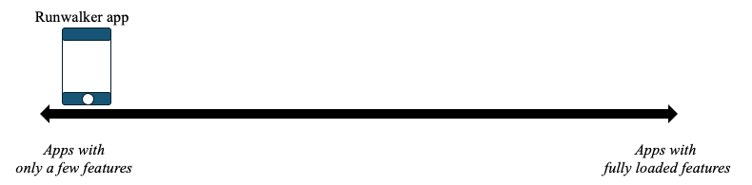
Condition 2: “A market-averaged number of features”
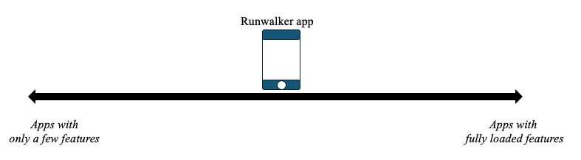
Condition 3: “Fully loaded with features”
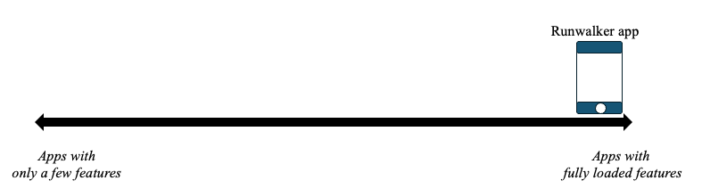

Experimental Measures
Construct | Item wording | Scale
Perceived product complexity (manipulation check) | “I think RunWalker is very complex.” | 1 = Strongly disagree; 7 = Strongly agree
Anticipated maintenance frequency | “I would update RunWalker very frequently (e.g., bug fixes, feature enhancements, interoperability adjustments).” | 1 = Strongly disagree; 7 = Strongly agree
Expected adaptability to platform-wide changes | “I would quickly adapt RunWalker to new operating system releases (e.g., new versions of iOS).” | 1 = Strongly disagree; 7 = Strongly agree

In addition to the focal experimental measures reported above, participants completed standard demographic items (e.g., age, gender, education, employment status, ethnicity) and background questions related to mobile application usage and experience (e.g., prior use of running or walking applications, activity level, and experience working at a mobile application company). These items followed conventional survey formats and are available from the authors upon request.

