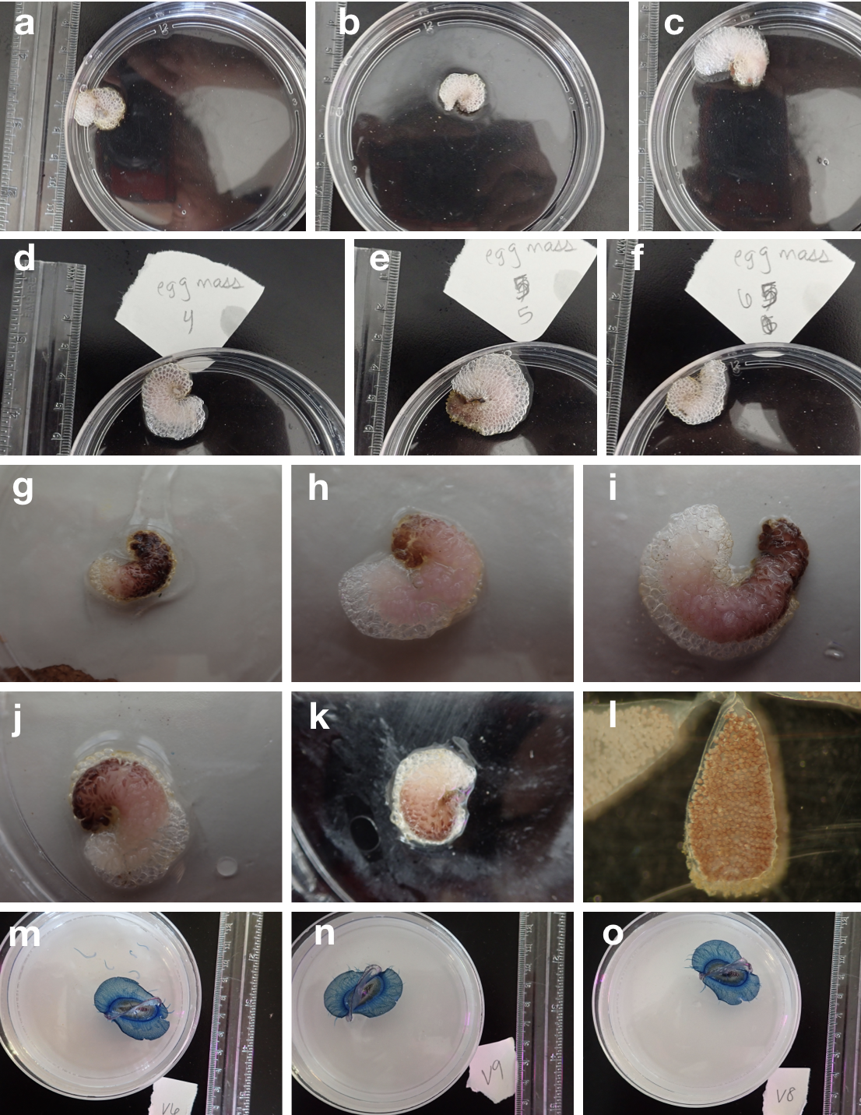
Supplemental Figure 1. Raw images used in this study. a-f Janthina pallida bubble rafts viewed from above, g-k J. pallida bubble rafts with eggs cases visible, l. J. paillida egg case with embryos visible, m-o Velella sp. size references.

