Benthic megafaunal biodiversity of the Charlie-Gibbs Fracture Zone: spatial variation, potential drivers, and conservation status.
Poppy Keogh^{1,2}, Rylan J. Command², Evan Edinger¹, Aggeliki Georgiopoulou³, Katleen Robert².
¹Geography Department, Memorial University of Newfoundland and Labrador.
²Fisheries and Marine Institute, Memorial University of Newfoundland and Labrador.
³School of Environment and Technology, University of Brighton.
Corresponding author: Poppy Keogh; pkeogh@mun.ca

Supplementary material

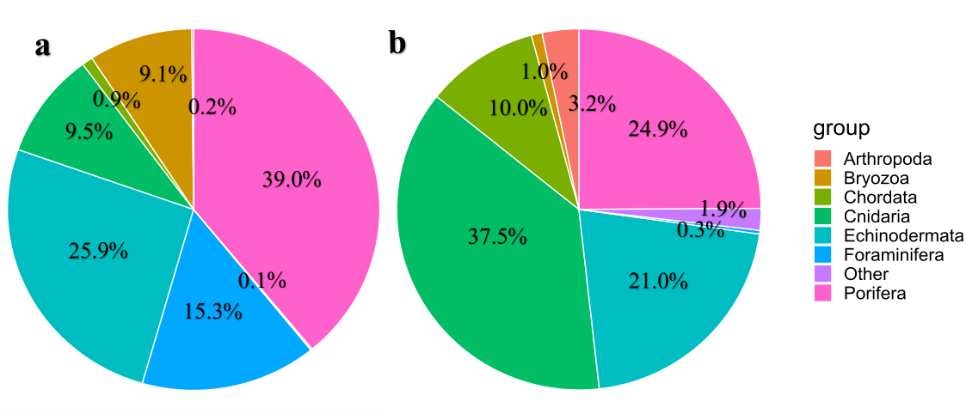
Figure 1. Pie charts showing (a) the proportions of individual organisms observed per Phylum and (b) the number of morphospecies per Phylum present in all ROV dives from the TOSCA survey. “Foraminifera” includes one morphospecies of Xenophyophore. “Other” includes Mollusca (Decapodiformes and Bivalvia) and Annelida (Bonellia sp., Sabellidae). Total number of individuals observed (n=154,509) and total number of morphospecies recorded (z=309).

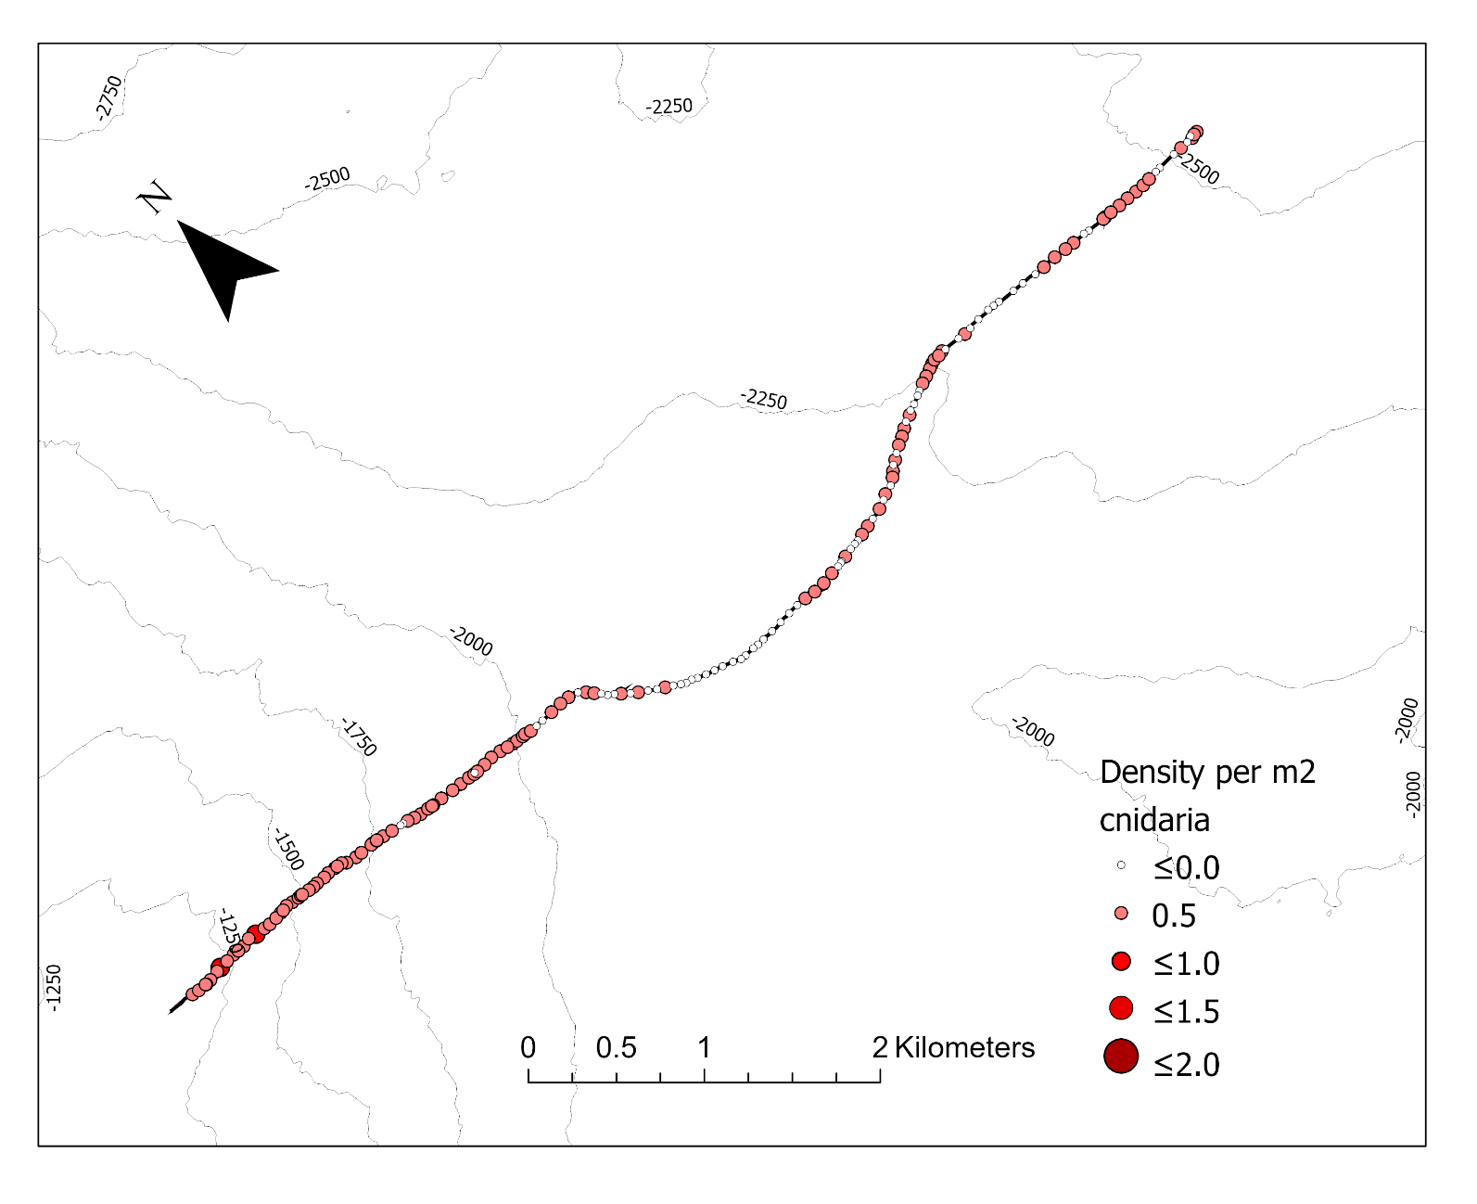
Figure 2. Bubble transect plot showing coral densities on Dive 5. Each circle represents coral observations for a 50 m section of the transect. White circles represent a 50 m section with no observations. No circles present represent the sections of the transect where visibility was too poor to annotate. These sections were removed from the analysis. Density values refer to number of corals per m2. Same details apply for all transect plots.
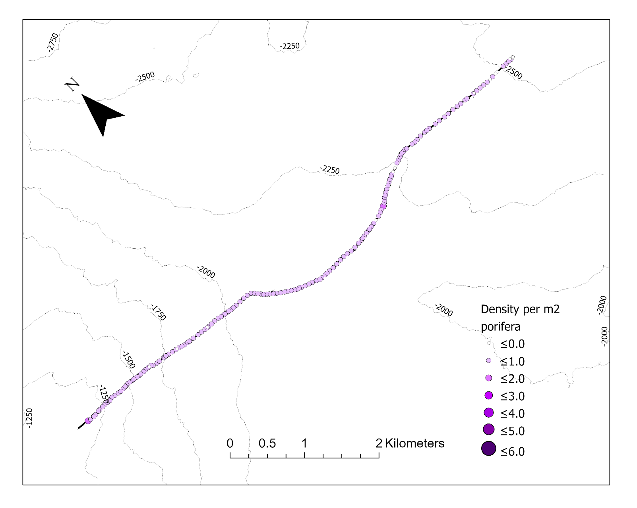
Figure 3. Dive 5 Porifera density.
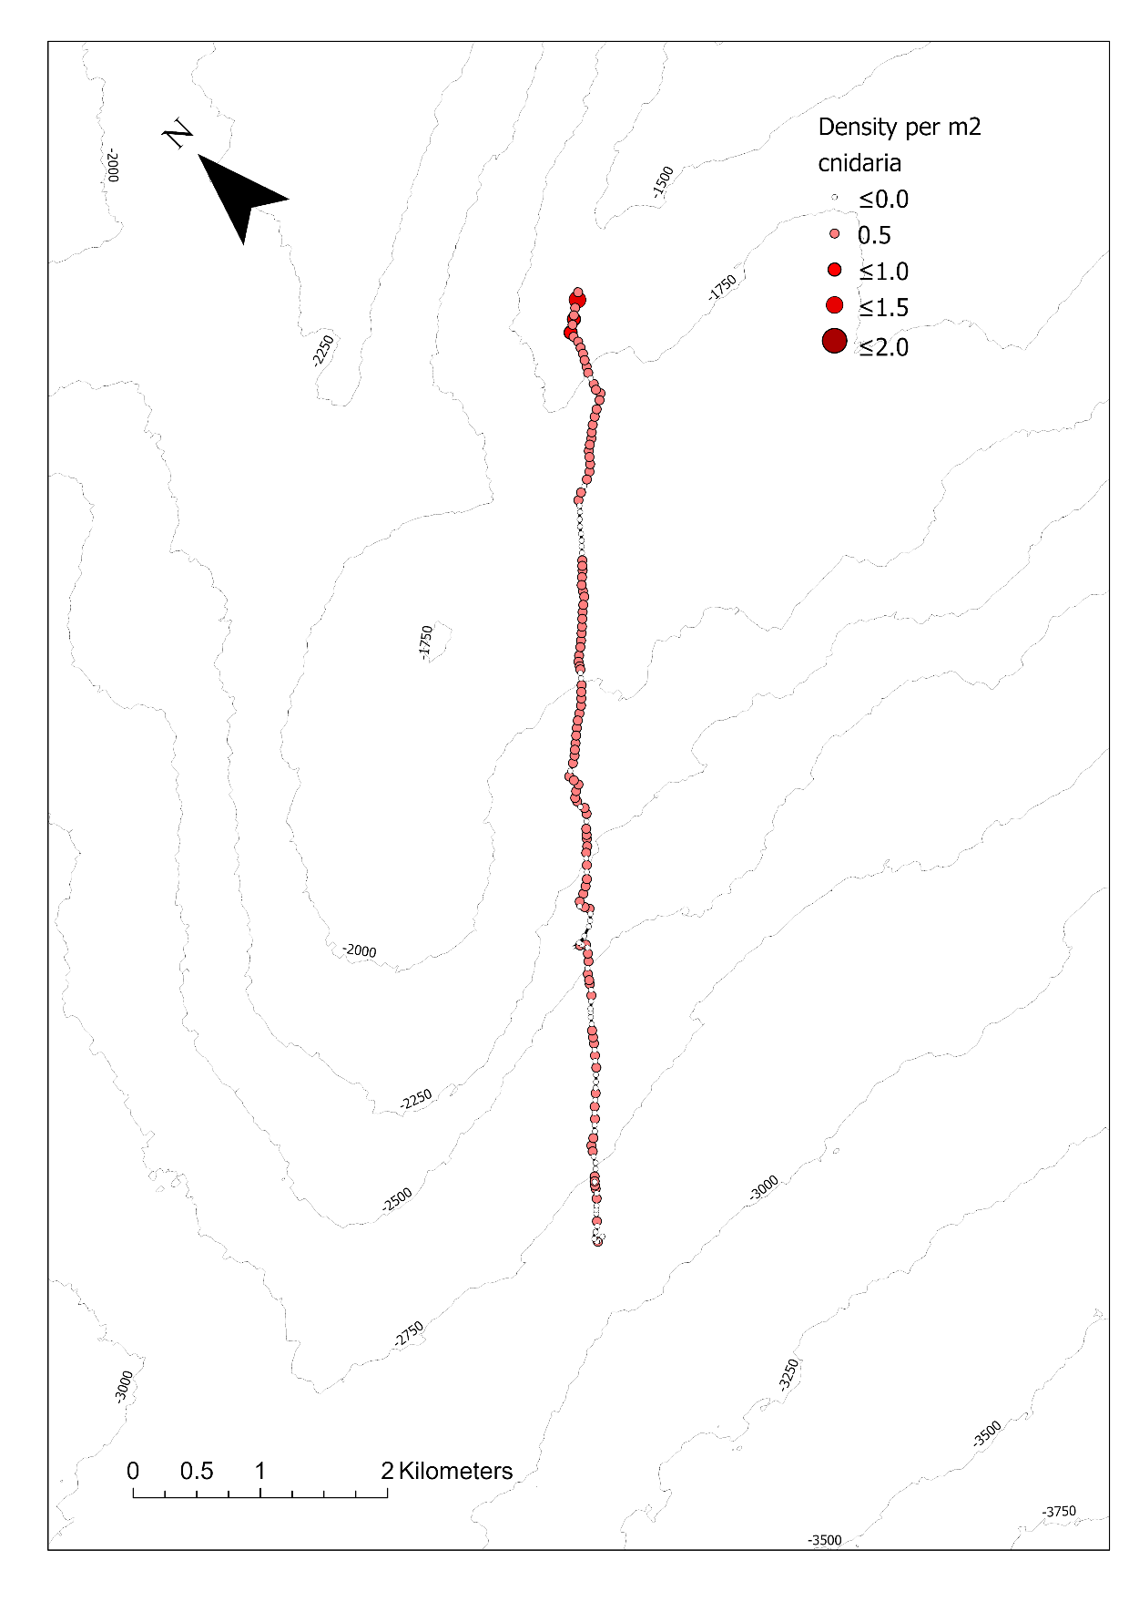
Figure 4. Dive 6 Cnidaria density.

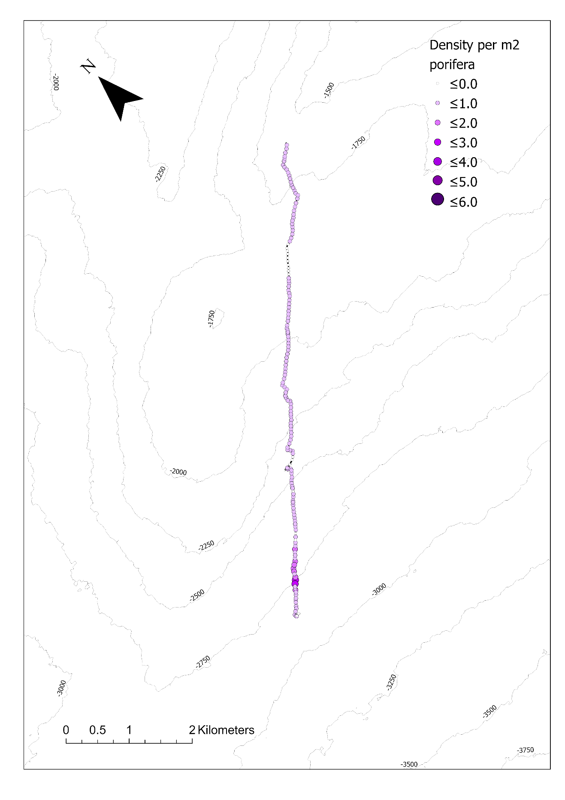
Figure 5. Dive 6 Porifera density.
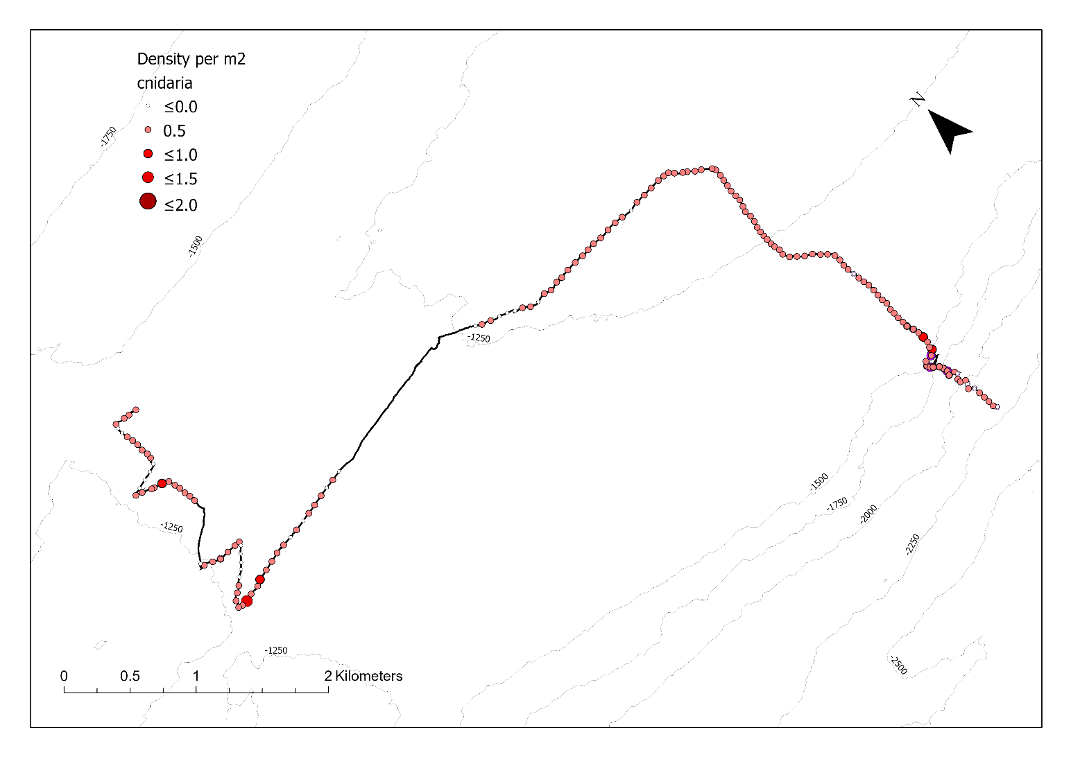
Figure 6. Dive 7 Cnidaria density.
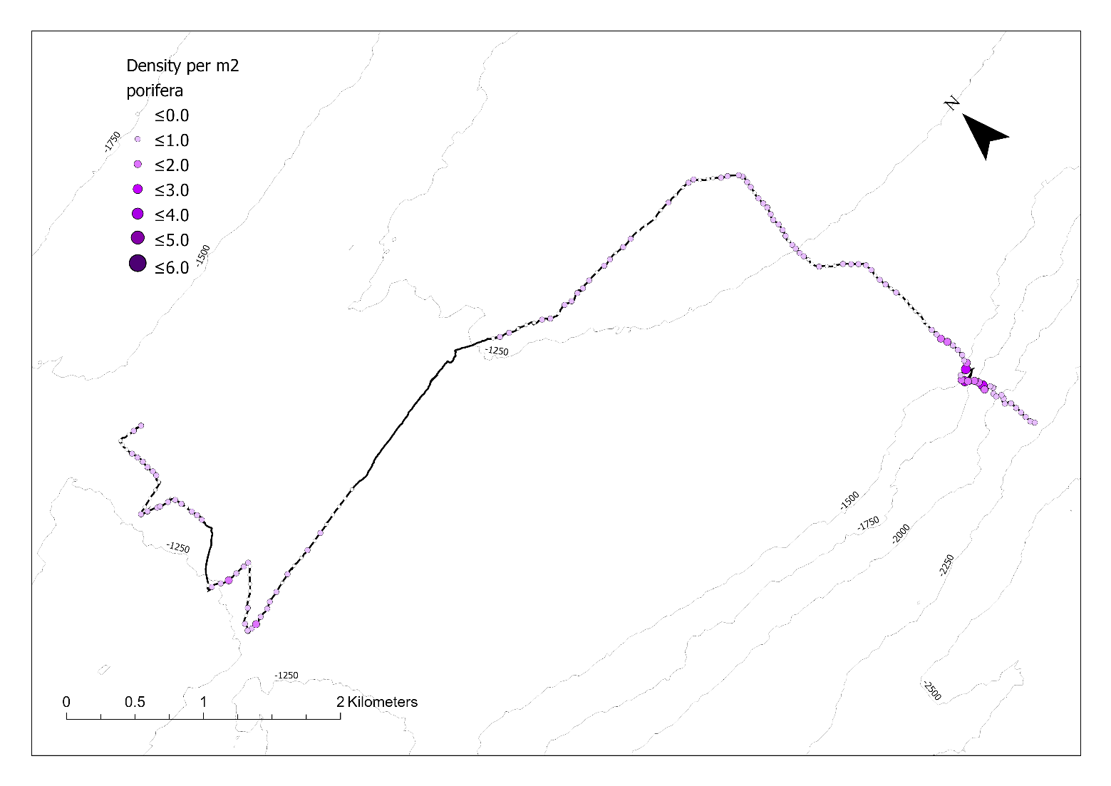
Figure 7. Dive 7 Porifera density.
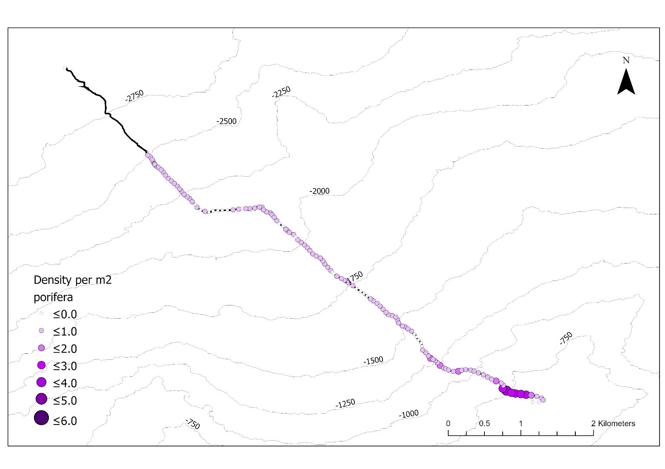
Figure 8. Dive 8 Porifera density.
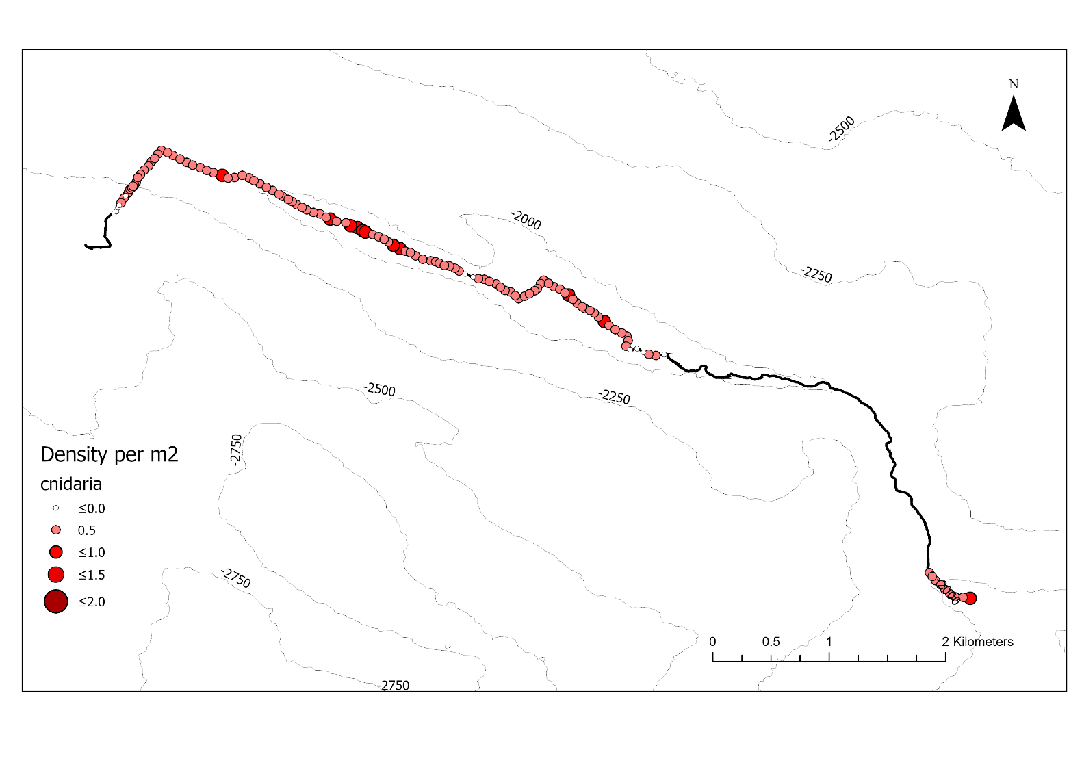
Figure 9. Dive 9 Cnidaria density.

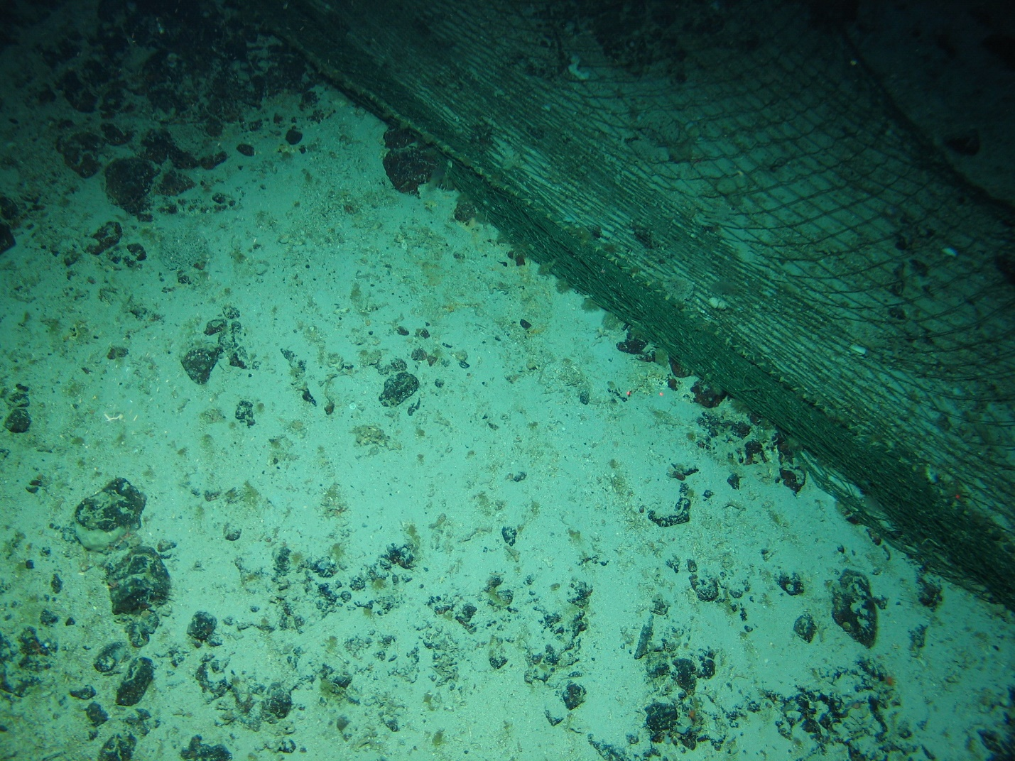
Figure 10. Trawl net on Hecate seamount (Dive 8).
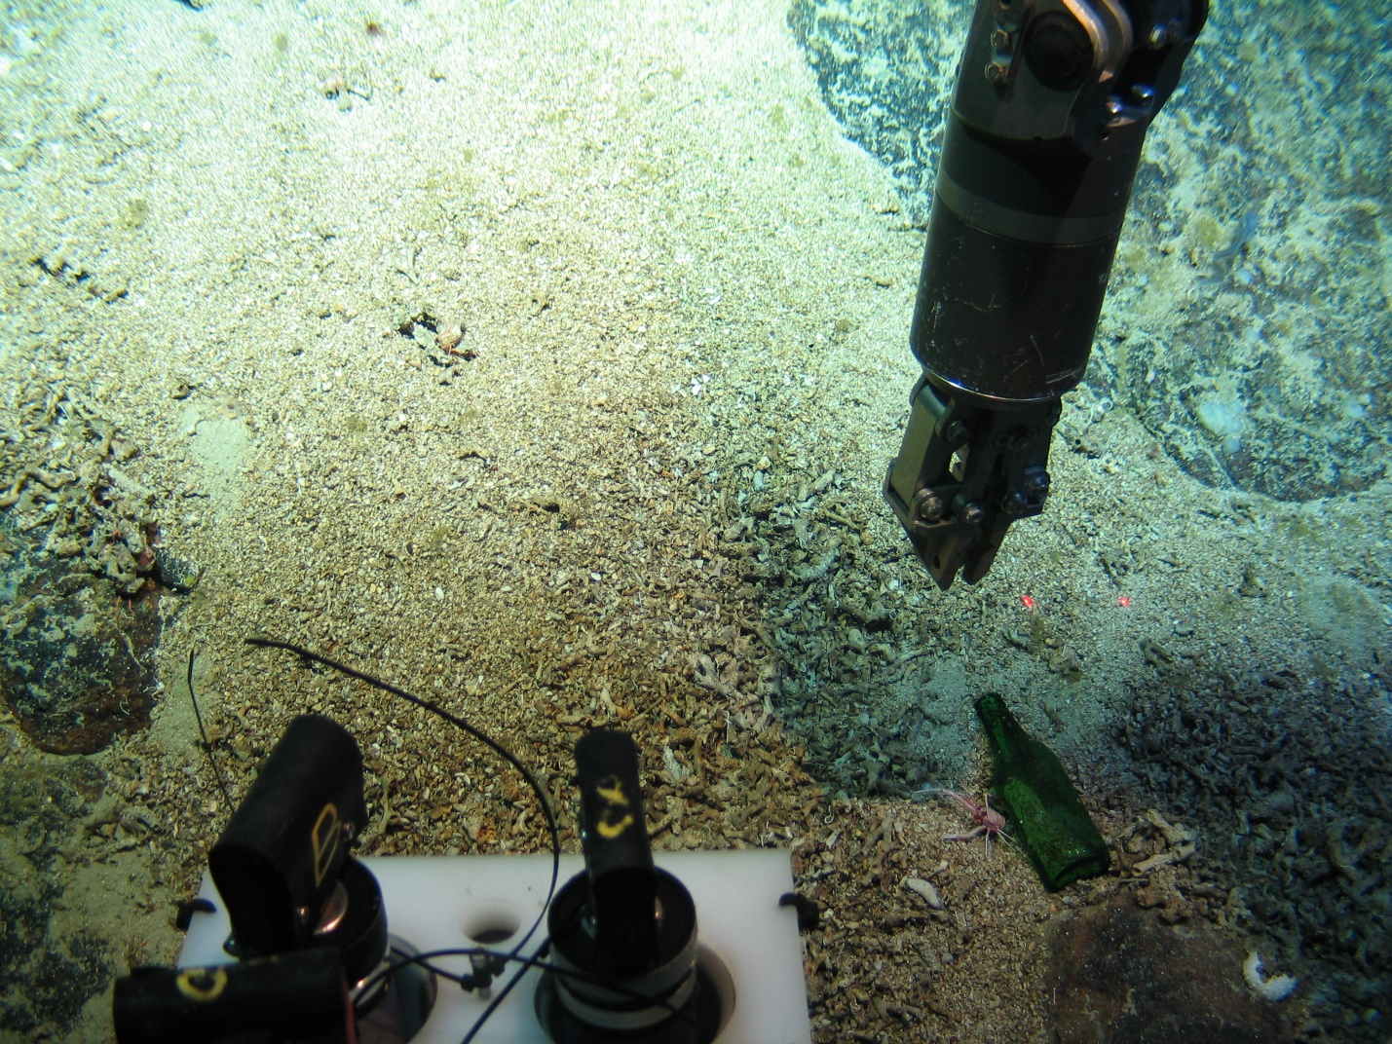
Figure 11. Bottle found on Hecate seamount (Dive 8)

Species Catalogue – Charlie-Gibbs Fracture Zone

In this catalogue, all observed morphospecies from the TOSCA (Tectonic Ocean Spreading at the Charlie-Gibbs Fracture Zone) survey are compiled as a reference guide. Information on the taxonomic status are given as well as the species names when applicable. Names of the taxonomic experts identifying the species are given for each species. All morphospecies were observed by the ROV Holland I video camera along five ROV transects (indicated by dive number in the catalogue), with a high-definition oblique-facing camera. No physical samples that were collected on the TOSCA survey were documented here, only morphospecies observed from the video.

TAXONOMY | NAME | HABITAT | NOTES | IMAGE
Phylum:  Porifera  Class:  Demospongiae  Order:  Family: | Morphospecies code: SPONGE2 | Gear:  ROV  Photo by:  Holland I 2018  Identified by:  J. Xavier  Dive: 8 |  | 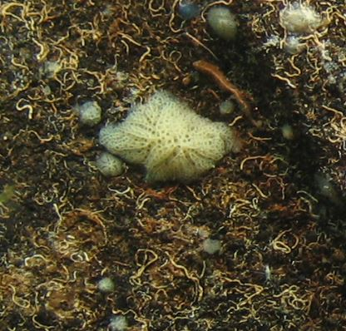
Phylum:  Porifera  Class:  Order:  Family: | Morphospecies code: SPONGE5 | Gear:  ROV  Photo by:  Holland I 2018  Identified by:  J. Xavier  Dive: 5 |  | 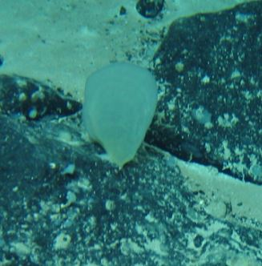
Phylum:  Porifera  Class:  Demospongiae  Order:  Family: | Morphospecies code: SPONGE6 | Gear:  ROV  Photo by:  Holland I 2018  Identified by:  J. Xavier  Dive: 5 |  | 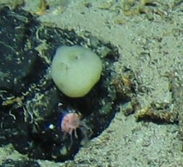
Phylum:  Porifera  Class:  Demospongiae  Order:  Family: | Morphospecies code: SPONGE11 | Gear:  ROV  Photo by:  Holland I 2018  Identified by:  J. Xavier  Dive: 7 | Possibly Cladorhizidae (J. Xavier) | 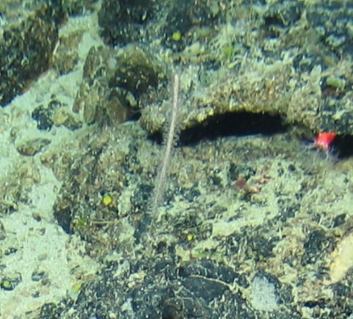
Phylum:  Porifera  Class:  Demospongiae  Order:  Family: | Morphospecies code: SPONGE12 | Gear:  ROV  Photo by:  Holland I 2018  Identified by:  J. Xavier  Dive: 5 |  | 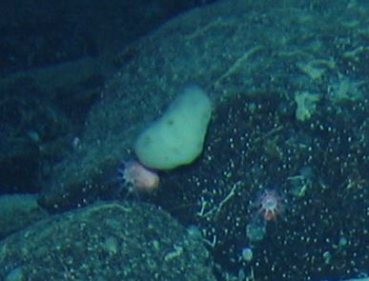
TAXONOMY | NAME | HABITAT | NOTES | IMAGE
Phylum:  Porifera  Class:  Demospongiae  Order:  Family: | Morphospecies code: SPONGE13 | Gear:  ROV  Photo by:  Holland I 2018  Identified by:  J. Xavier  Dive: 5 |  | 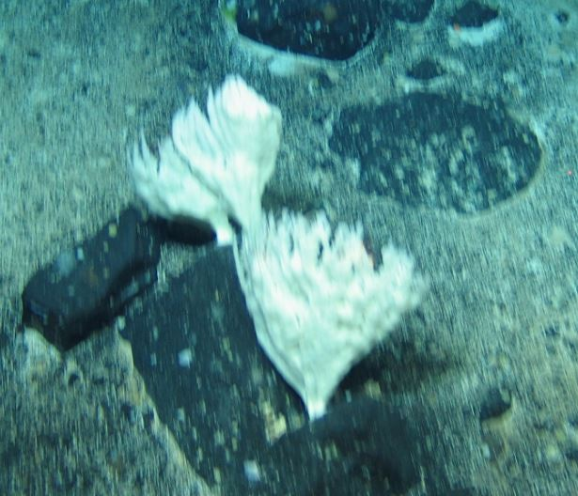
Phylum:  Porifera  Class:  Demospongiae  Order:  Family: | Morphospecies code: SPONGE14 | Gear:  ROV  Photo by:  Holland I 2018  Identified by:  J. Xavier  Dive: 7 |  | 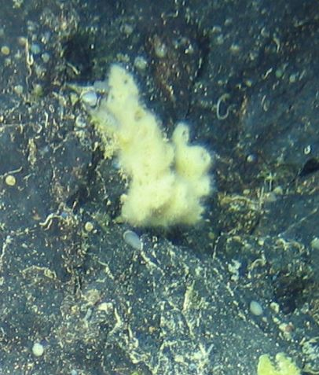
Phylum:  Porifera  Class:  Demospongiae  Order:  Family: | Morphospecies code: SPONGE17 | Gear:  ROV  Photo by:  Holland I 2018  Identified by:  J. Xavier  Dive: 5 |  | 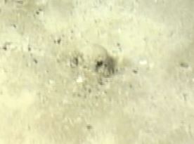
Phylum:  Porifera  Class:  Order:  Family: | Morphospecies code: SPONGE18 | Gear:  ROV  Photo by:  Holland I 2018  Identified by:  Dive: 8 |  | 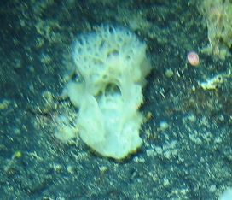
Phylum:  Porifera  Class:  Order:  Family: | Morphospecies code: SPONGE20 | Gear:  ROV  Photo by:  Holland I 2018  Identified by:  Dive: 6 |  | 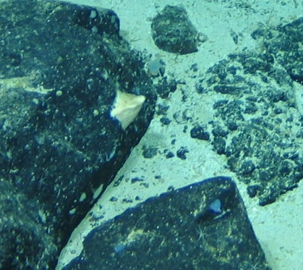
TAXONOMY | NAME | HABITAT | NOTES | IMAGE
Phylum:  Porifera  Class:  Order:  Family: | Morphospecies code: SPONGE21 | Gear:  ROV  Photo by:  Holland I 2018  Identified by:  Dive: 8 |  | 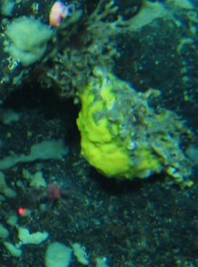
Phylum:  Porifera  Class:  Order:  Family: | Morphospecies code: SPONGE22 | Gear:  ROV  Photo by:  Holland I 2018  Identified by:  Dive: 9 |  | 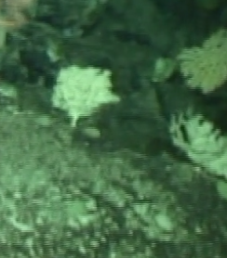
Phylum:  Porifera  Class:  Order:  Family: | Morphospecies code: SPONGE23 | Gear:  ROV  Photo by:  Holland I 2018  Identified by:  Dive: 6 |  | 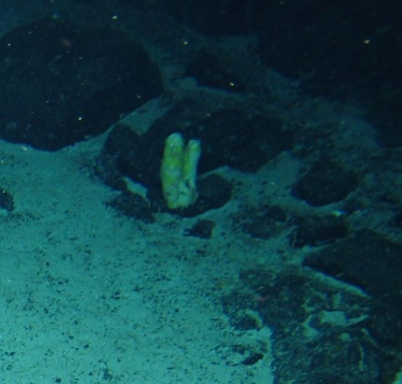
Phylum:  Porifera  Class:  Demospongiae  Order:  Family: | Morphospecies code: ENCR1 | Gear:  ROV  Photo by:  Holland I 2018  Identified by:  J. Xavier  Dive: 5 |  | 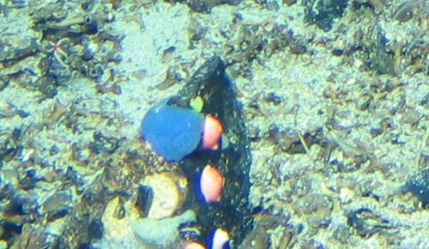
Phylum:  Porifera  Class:  Demospongiae  Order:  Family: | Morphospecies code: ENCR3 | Gear:  ROV  Photo by:  Holland I 2018  Identified by:  J. Xavier  Dive: 7 |  | 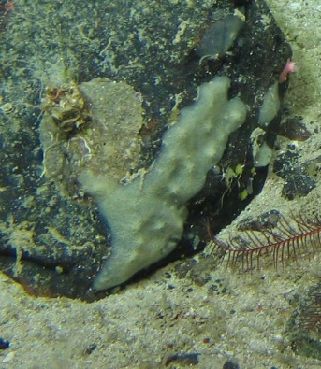
TAXONOMY | NAME | HABITAT | NOTES | IMAGE
Phylum:  Porifera  Class:  Demospongiae  Order:  Family: | Morphospecies code: ENCR4 | Gear:  ROV  Photo by:  Holland I 2018  Identified by:  J. Xavier  Dive: 7 |  | 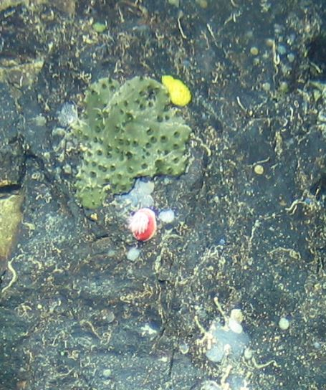
Phylum:  Porifera  Class:  Demospongiae  Order:  Family: | Morphospecies code: ENCR5 | Gear:  ROV  Photo by:  Holland I 2018  Identified by:  J. Xavier  Dive: 7 |  | 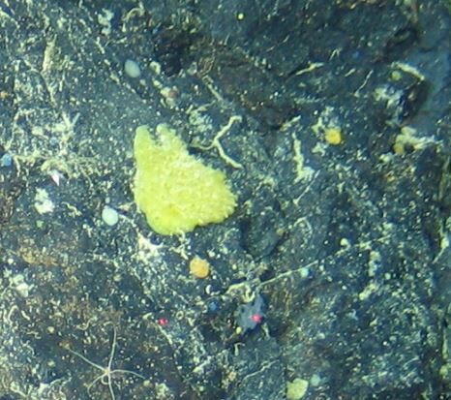
Phylum:  Porifera  Class:  Demospongiae  Order:  Family: | Morphospecies code: ENCR6 | Gear:  ROV  Photo by:  Holland I 2018  Identified by:  J. Xavier  Dive: 6 |  | 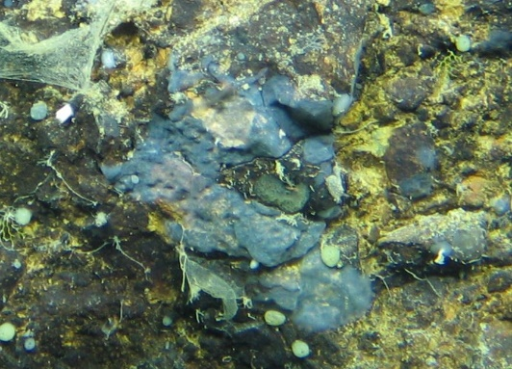
Phylum:  Porifera  Class:  Demospongiae  Order:  Family: | Morphospecies code: ENCR8 | Gear:  ROV  Photo by:  Holland I 2018  Identified by:  J. Xavier  Dive: 5 |  | 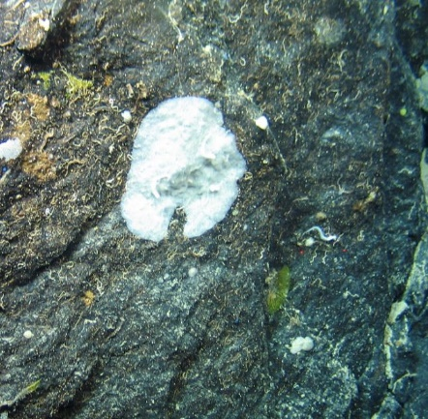
Phylum:  Porifera  Class:  Demospongiae  Order:  Family: | Morphospecies code: ENCR9 | Gear:  ROV  Photo by:  Holland I 2018  Identified by:  J. Xavier  Dive: 5 |  | 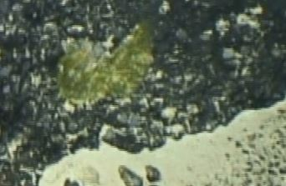
TAXONOMY | NAME | HABITAT | NOTES | IMAGE
Phylum:  Porifera  Class:  Demospongiae  Order:  Family: | Morphospecies code: ENCR10 | Gear:  ROV  Photo by:  Holland I 2018  Identified by:  J. Xavier  Dive: 8 |  | 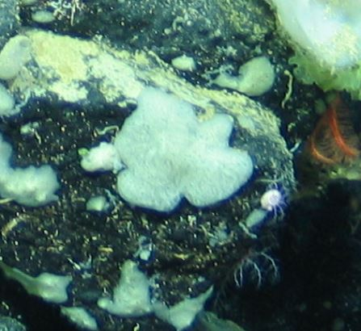
Phylum:  Porifera  Class:  Order:  Family: | Morphospecies code: ENCR12 | Gear:  ROV  Photo by:  Holland I 2018  Identified by:  Poppy Keogh  Dive: 5 |  | 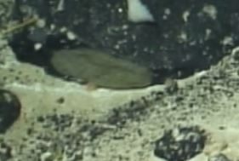
Phylum:  Porifera  Class:  Demospongiae  Order:  Family: | Morphospecies code: DEMOS3 | Gear:  ROV  Photo by:  Holland I 2018  Identified by:  J. Xavier  Dive: 6 | Could be a Tetractinellida but difficult to say (J. Xavier) | 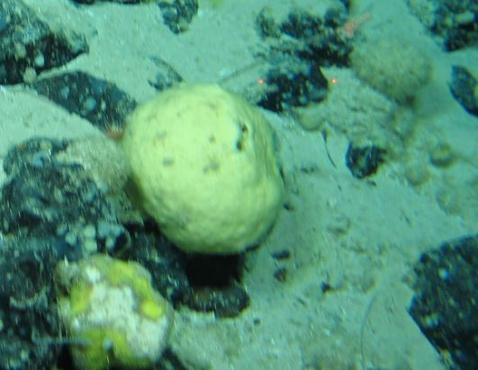
Phylum:  Porifera  Class:  Demospongiae  Order:  Family:  Genus: | Morphospecies code: DEMOS5 | Gear:  ROV  Photo by:  Holland I 2018  Identified by:  J. Xavier  Dive: 5 | Stelletta or Geodia sp. | 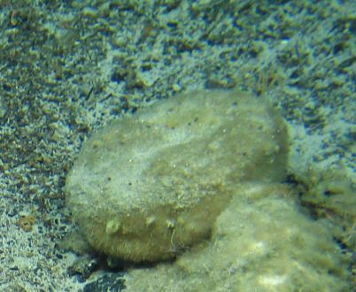
Phylum:  Porifera  Class:  Demospongiae  Order:  Family:  Genus: | Morphospecies code: DEMOS6 | Gear:  ROV  Photo by:  Holland I 2018  Identified by:  J. Xavier  Dive: 6 | Stelletta or Geodia sp. | 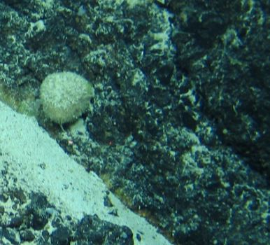
TAXONOMY | NAME | HABITAT | NOTES | IMAGE
Phylum:  Porifera  Class:  Demospongiae  Order: Tetractinellida  Family: Geodiidae  Genus: Geodia  Species: G. phlegraei | Morphospecies code: DEMOS7  Geodia phlegraei | Gear:  ROV  Photo by:  Holland I 2018  Identified by:  J. Xavier  Dive: 6 | (Sollas, 1880) | 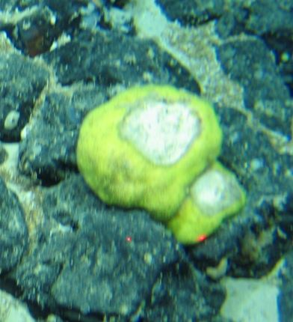
Phylum:  Porifera  Class:  Demospongiae  Order: Tetractinellida  Family: Geodiidae  Genus: Geodia  Species: | Morphospecies code: DEMOS8  Geodia sp. | Gear:  ROV  Photo by:  Holland I 2018  Identified by:  J. Xavier  Dive: 7 |  | 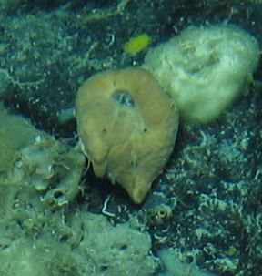
Phylum:  Porifera  Class:  Demospongiae  Order:  Family:  Genus:  Species: | Morphospecies code: DEMOS9 | Gear:  ROV  Photo by:  Holland I 2018  Identified by:  J. Xavier  Dive: 5 |  | 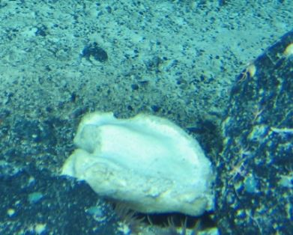
Phylum:  Porifera  Class:  Demospongiae  Order:  Family:  Genus:  Species: | Morphospecies code: DEMOS10 | Gear:  ROV  Photo by:  Holland I 2018  Identified by:  J. Xavier  Dive: 7 |  | 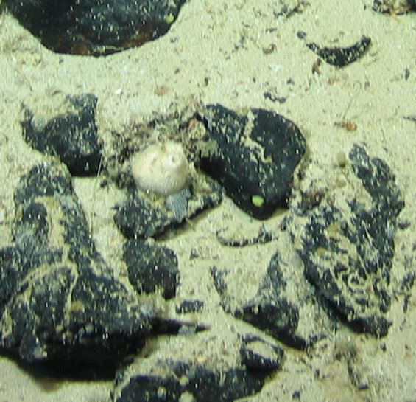
Phylum:  Porifera  Class:  Demospongiae  Order:  Family:  Genus:  Species: | Morphospecies code: DEMOS11 | Gear:  ROV  Photo by:  Holland I 2018  Identified by:  J. Xavier  Dive: 5 |  | 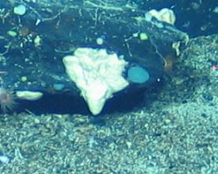

TAXONOMY | NAME | HABITAT | NOTES | IMAGE
Phylum:  Porifera  Class:  Demospongiae  Order: Haplosclerida  Family: Chalinidae  Genus: Haliclona  Species: H. magna | Morphospecies code: DEMOS12  cf. Haliclona (Halichoclona) magna | Gear:  ROV  Photo by:  Holland I 2018  Identified by:  J. Xavier  Dive: 5 | (Vacelet, 1969) | 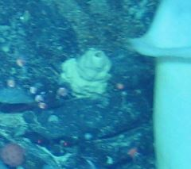
Phylum:  Porifera  Class:  Demospongiae  Order: Tetractinellida  Family: Geodiidae  Genus: Geodia  Species: G. macandrewii | Morphospecies code: DEMOS13  cf. Geodia macandrewii | Gear:  ROV  Photo by:  Holland I 2018  Identified by:  J. Xavier  Dive: 5 | (Bowebank, 1858) | 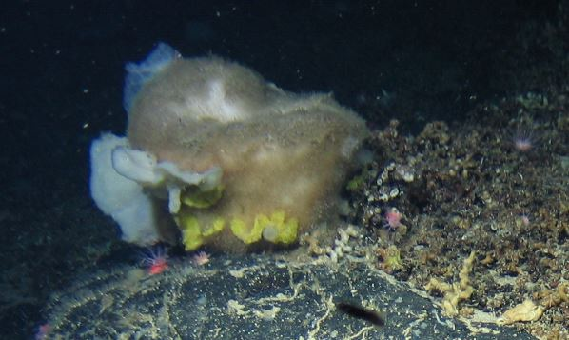
Phylum:  Porifera  Class:  Demospongiae  Order:  Family:  Genus:  Species: | Morphospecies code: DEMOS15 | Gear:  ROV  Photo by:  Holland I 2018  Identified by:  J. Xavier  Dive: 6 | Possibly within family Axinellidae but too difficult to say for sure | 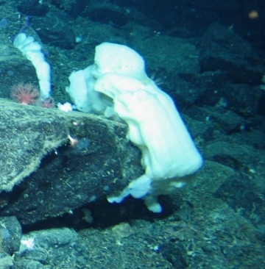
Phylum:  Porifera  Class:  Demospongiae  Order:  Family:  Genus:  Species: | Morphospecies code: DEMOS17 | Gear:  ROV  Photo by:  Holland I 2018  Identified by:  Dive: 5 |  | 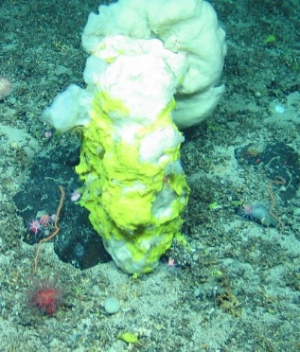
Phylum:  Porifera  Class:  Demospongiae  Order:  Family:  Genus:  Species: | Morphospecies code: DEMOS18 | Gear:  ROV  Photo by:  Holland I 2018  Identified by:  Dive: 5 |  | 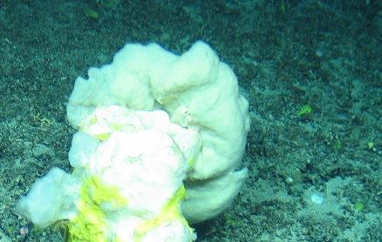

TAXONOMY | NAME | HABITAT | NOTES | IMAGE
Phylum:  Porifera  Class:  Demospongiae  Order:  Family:  Genus: Geodia  Species: G. megastrella | Morphospecies code: GEODIA1  Geodia megastrella | Gear:  ROV  Photo by:  Holland I 2018  Identified by:  J. Xavier  Dive: 7 | (Carter, 1876) | 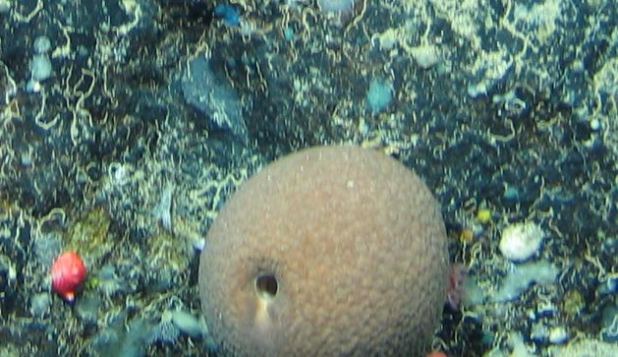
Phylum:  Porifera  Class:  Demospongiae  Order:  Family:  Genus: Geodia  Species: G. megastrella | Morphospecies code: GEODIA2  Geodia megastrella | Gear:  ROV  Photo by:  Holland I 2018  Identified by:  J. Xavier  Dive: 5 | (Carter, 1876) | 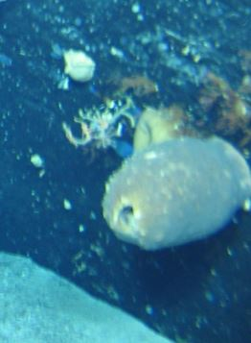
Phylum:  Porifera  Class:  Demospongiae  Order:  Family:  Genus: Geodia  Species: | Morphospecies code: GEODIA3  Geodia sp. | Gear:  ROV  Photo by:  Holland I 2018  Identified by:  J. Xavier  Dive: 5 |  | 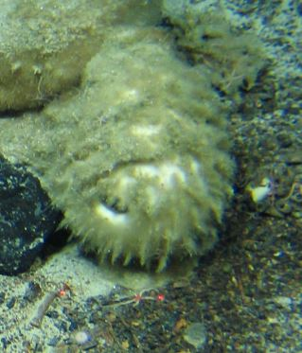
Phylum:  Porifera  Class:  Demospongiae  Order:  Family:  Genus: Geodia  Species: G. hentscheli | Morphospecies code: GEODIA4  cf. Geodia hentscheli | Gear:  ROV  Photo by:  Holland I 2018  Identified by:  J. Xavier  Dive: 6 | (Cárdenas, Rapp, Schander & Tendal, 2010) | 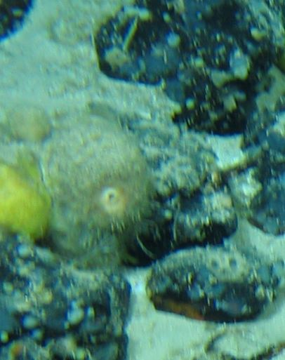
Phylum:  Porifera  Class:  Demospongiae  Order:  Family:  Genus: Polymastia  Species: P. corticata | Morphospecies code: POLYM1  cf. Polymastia corticata | Gear:  ROV  Photo by:  Holland I 2018  Identified by:  J. Xavier  Dive: 5 | (Ridley & Dendy, 1886) | 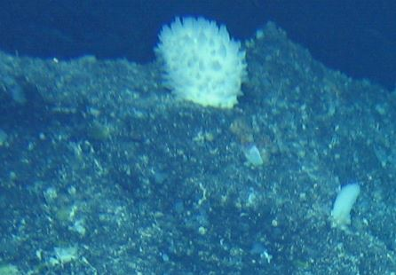
TAXONOMY | NAME | HABITAT | NOTES | IMAGE
Phylum:  Porifera  Class: Hexactinellida  Order:  Family:  Genus:  Species: | Morphospecies code: HEXACT1 | Gear:  ROV  Photo by:  Holland I 2018  Identified by:  J. Xavier  Dive: 6 |  | 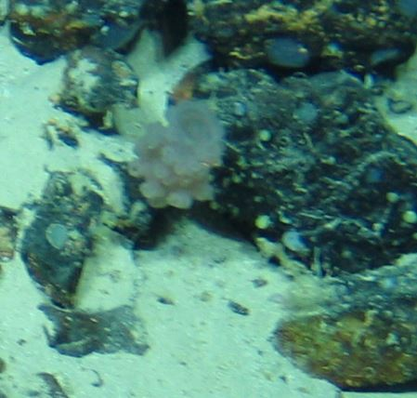
Phylum:  Porifera  Class: Hexactinellida  Order:  Family:  Genus:  Species: | Morphospecies code: HEXACT2 | Gear:  ROV  Photo by:  Holland I 2018  Identified by:  J. Xavier  Dive: 5 |  | 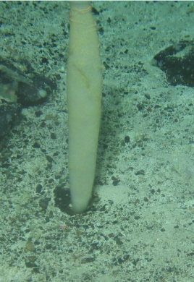
Phylum:  Porifera  Class: Hexactinellida  Order:  Family:  Genus: Hertwigia  Species: H. falcifera | Morphospecies code: HEXACT3  Hertwigia falcifera | Gear:  ROV  Photo by:  Holland I 2018  Identified by:  J. Xavier  Dive: 5 | yellow color morph (more common) (J. Xavier)  (Schmidt, 1880) | 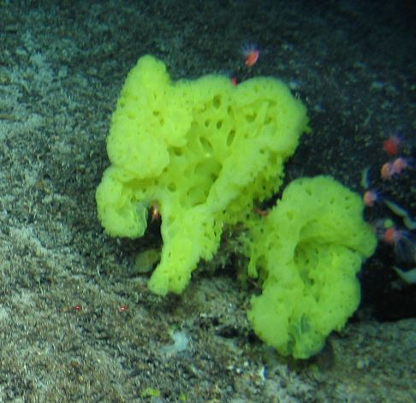
Phylum:  Porifera  Class: Hexactinellida  Order:  Family:  Genus: Hertwigia  Species: H. falcifera | Morphospecies code: HEXACT4  cf. Hertwigia falcifera | Gear:  ROV  Photo by:  Holland I 2018  Identified by:  J. Xavier  Dive: 8 | Probably the same as HEXACT3, just different growth form  (J. Xavier) | 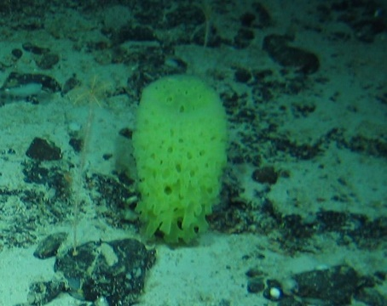
Phylum:  Porifera  Class: Hexactinellida  Order:  Family:  Genus:  Species: | Morphospecies code: HEXACT5 | Gear:  ROV  Photo by:  Holland I 2018  Identified by:  J. Xavier  Dive: 6 |  | 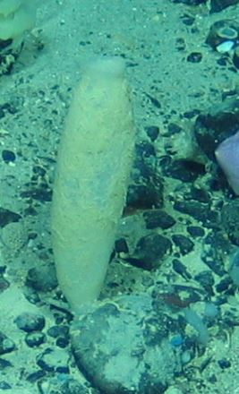
TAXONOMY | NAME | HABITAT | NOTES | IMAGE
Phylum:  Porifera  Class: Hexactinellida  Order:  Family:  Genus: Amphidiscella  Species: | Morphospecies code: HEXACT6  Amphidiscella sp. | Gear:  ROV  Photo by:  Holland I 2018  Identified by:  J. Xavier  Dive: 6 |  | 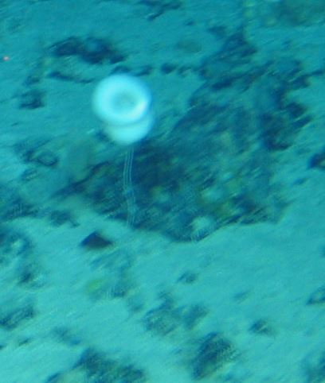
Phylum:  Porifera  Class: Hexactinellida  Order:  Family:  Genus: Asconema  Species: | Morphospecies code: HEXACT7  Asconema sp. | Gear:  ROV  Photo by:  Holland I 2018  Identified by:  J. Xavier  Dive: 7 |  | 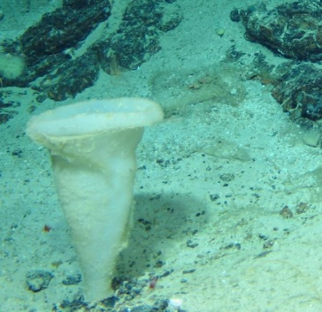
Phylum:  Porifera  Class: Hexactinellida  Order:  Family:  Genus:  Species: | Morphospecies code: HEXACT8 | Gear:  ROV  Photo by:  Holland I 2018  Identified by:  J. Xavier  Dive: 6 |  | 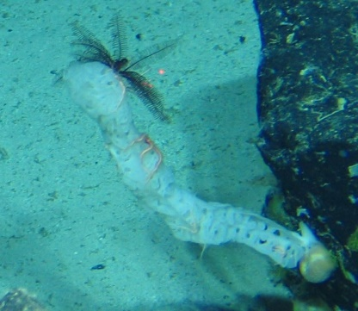
Phylum:  Porifera  Class: Hexactinellida  Order:  Family:  Genus: Hertwigia  Species: H. falcifera | Morphospecies code: HEXACT9  Hertwigia falcifera | Gear:  ROV  Photo by:  Holland I 2018  Identified by:  J. Xavier  Dive: 5 | (Schmidt, 1880)  white color morph | 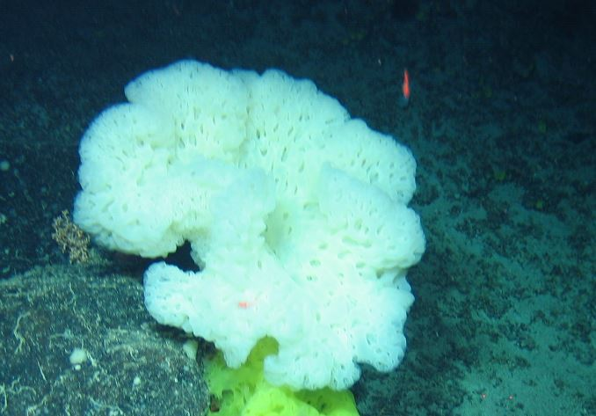
Phylum:  Porifera  Class: Hexactinellida  Order:  Family:  Genus:  Species: | Morphospecies code: HEXACT10 | Gear:  ROV  Photo by:  Holland I 2018  Identified by:  J. Xavier  Dive: 7 |  | 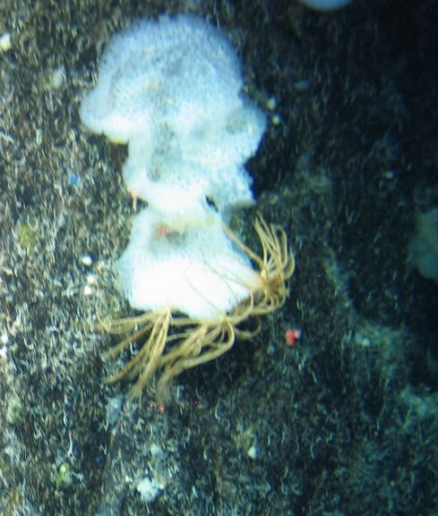
TAXONOMY | NAME | HABITAT | NOTES | IMAGE
Phylum:  Porifera  Class: Hexactinellida  Order:  Family:  Genus:  Species: | Morphospecies code: HEXACT11 | Gear:  ROV  Photo by:  Holland I 2018  Identified by:  J. Xavier  Dive: 6 |  | 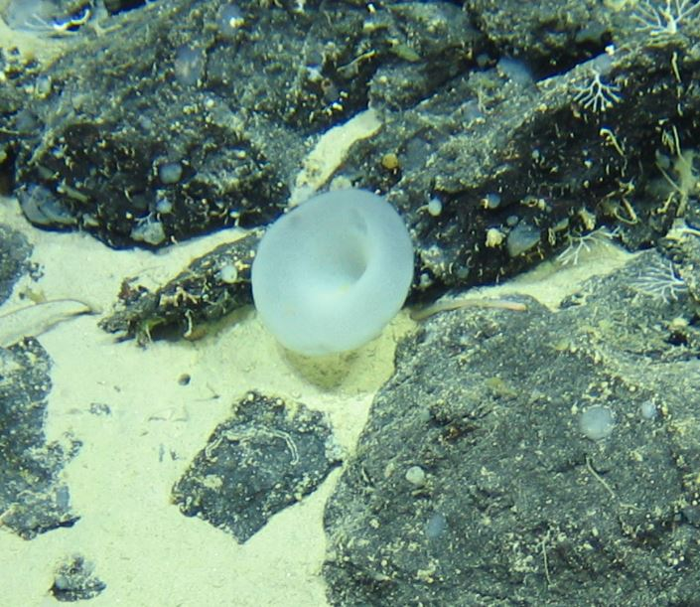
Phylum:  Porifera  Class: Hexactinellida  Order:  Family:  Genus:  Species: | Morphospecies code: HEXACT13 | Gear:  ROV  Photo by:  Holland I 2018  Identified by:  Dive: 5 |  | 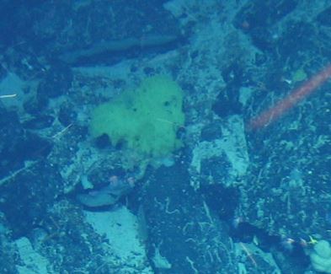
Phylum:  Porifera  Class: Hexactinellida  Order:  Family:  Genus:  Species: | Morphospecies code: HEXACT14 | Gear:  ROV  Photo by:  Holland I 2018  Identified by:  Dive: 5 | Not certain it is a Hexactinellida (J. Xavier) | 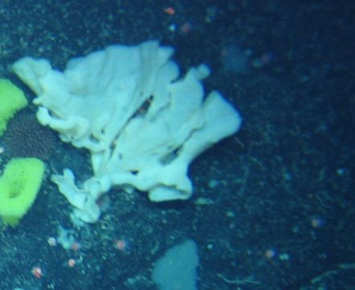
Phylum:  Porifera  Class: Hexactinellida  Order:  Family:  Genus:  Species: | Morphospecies code: HEXACT15 | Gear:  ROV  Photo by:  Holland I 2018  Identified by:  Dive: 5 | Not certain it is a Hexactinellida or Demospongiae  (J. Xavier) | 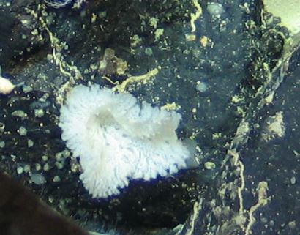
Phylum:  Porifera  Class: Hexactinellida  Order:  Family:  Genus: Farrea  Species: | Morphospecies code: HEXACT16  Farrea sp. | Gear:  ROV  Photo by:  Holland I 2018  Identified by:  Dive: 6 |  | 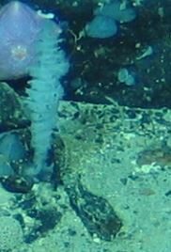
TAXONOMY | NAME | HABITAT | NOTES | IMAGE
Phylum:  Porifera  Class: Hexactinellida  Order:  Family:  Genus:  Species: | Morphospecies code: HEXACT17 | Gear:  ROV  Photo by:  Holland I 2018  Identified by:  J. Xavier  Dive: 7 | Possibly Sympagella or Amphidiscella (J. Xavier) | 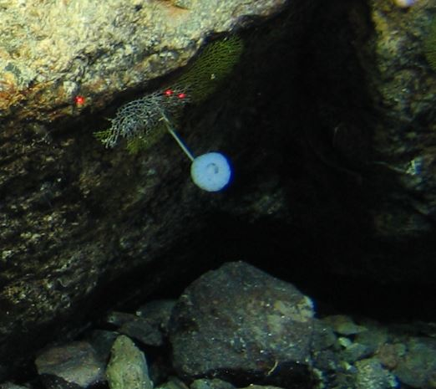
Phylum:  Porifera  Class: Hexactinellida  Order:  Family:  Genus:  Species: | Morphospecies code: HEXACT18 | Gear:  ROV  Photo by:  Holland I 2018  Identified by:  J. Xavier  Dive: 8 | Possibly Hertwigia sp. (J. Xavier) | 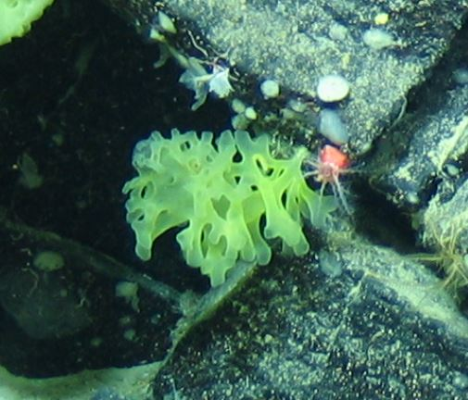
Phylum:  Porifera  Class: Hexactinellida  Order:  Family:  Genus:  Species: | Morphospecies code: HEXACT20 | Gear:  ROV  Photo by:  Holland I 2018  Identified by:  Dive: 5 |  | 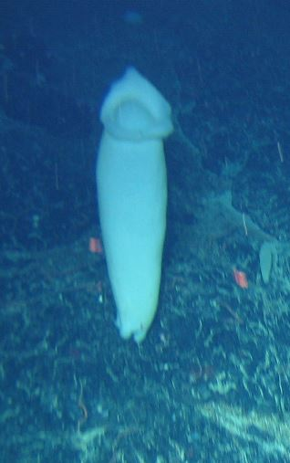
Phylum:  Porifera  Class: Hexactinellida  Order:  Family:  Genus:  Species: | Morphospecies code: HEXACT21 | Gear:  ROV  Photo by:  Holland I 2018  Identified by:  Dive: 7 |  | 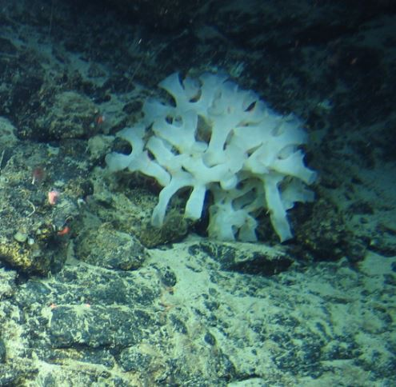
Phylum:  Porifera  Class: Hexactinellida  Order:  Family:  Genus:  Species: | Morphospecies code: HEXACT22 | Gear:  ROV  Photo by:  Holland I 2018  Identified by:  Dive: 8 |  | 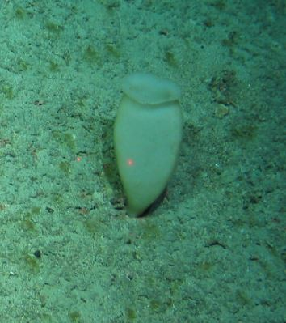
TAXONOMY | NAME | HABITAT | NOTES | IMAGE
Phylum:  Porifera  Class: Hexactinellida  Order:  Family:  Genus:  Species: | Morphospecies code: HEXACT24 | Gear:  ROV  Photo by:  Holland I 2018  Identified by:  Dive: 8 |  | 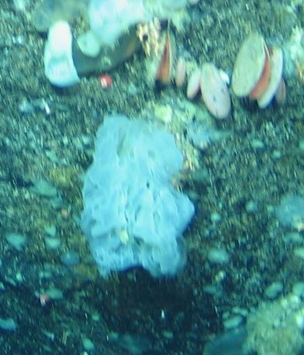
Phylum:  Porifera  Class: Hexactinellida  Order:  Family:  Genus:  Species: | Morphospecies code: HEXACT25 | Gear:  ROV  Photo by:  Holland I 2018  Identified by:  Dive: 7 |  | 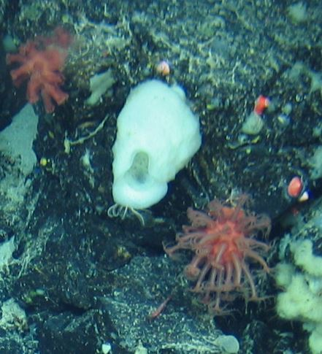
Phylum:  Porifera  Class: Hexactinellida  Order:  Family:  Genus:  Species: | Morphospecies code: HEXACT26 | Gear:  ROV  Photo by:  Holland I 2018  Identified by:  Dive: 9 |  | 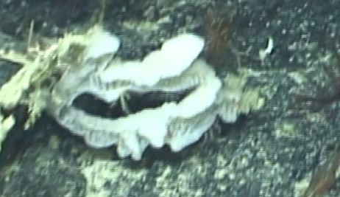
Phylum:  Porifera  Class: Hexactinellida  Order:  Family:  Genus:  Species: | Morphospecies code: HEXACT27 | Gear:  ROV  Photo by:  Holland I 2018  Identified by:  Dive: 6 |  | 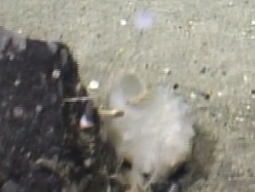
Phylum:  Porifera  Class: Hexactinellida  Order: Lyssacinosida  Family: Euplectellida  Genus:  Species: | Morphospecies code: EUPL1 | Gear:  ROV  Photo by:  Holland I 2018  Identified by:  Dive: 5 | This could be Euplectella, Dictyaulus, Regadrella  (J. Xavier) | 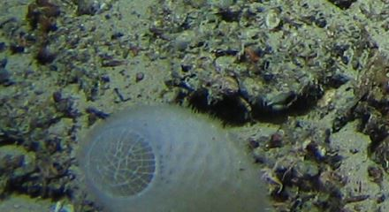
TAXONOMY | NAME | HABITAT | NOTES | IMAGE
Phylum: Bryozoa  Class:  Order:  Family:  Genus:  Species: | Morphospecies code: BRYOZ1 | Gear:  ROV  Photo by:  Holland I 2018  Identified by:  Dive: 6 |  | 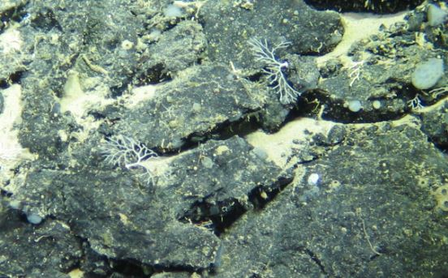
Phylum: Bryozoa  Class:  Order:  Family:  Genus:  Species: | Morphospecies code: BRYOZ2 | Gear:  ROV  Photo by:  Holland I 2018  Identified by: Poppy Keogh  Dive: 6 |  | 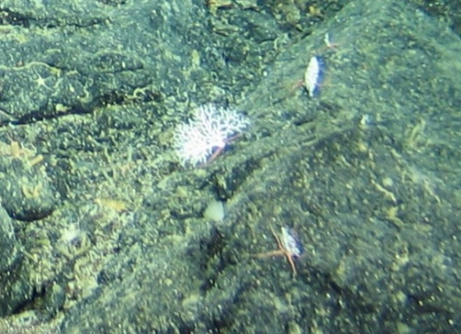
Phylum: Bryozoa  Class: Gymnolaemata  Order:  Family:  Genus: Canda  Species: | Morphospecies code: CANDA  Canda sp. | Gear:  ROV  Photo by:  Holland I 2018  Identified by: Megan McCuller  Dive: 6 |  | 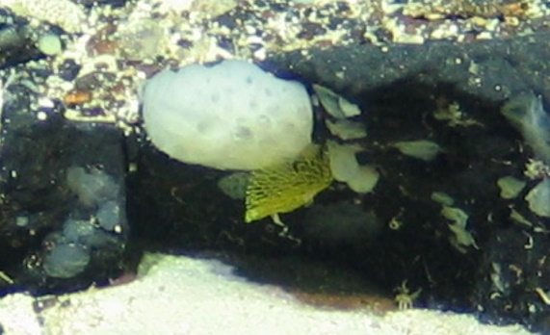
Phylum: Cnidaria  Class: Anthozoa  Subclass:  Hexacorillia  Order: Antipatharia  Family:  Genus:  Species: | Morphospecies code: ANTIPATHARIA1 | Gear:  ROV  Photo by:  Holland I 2018  Identified by: Poppy Keogh  Dive: 6 |  | 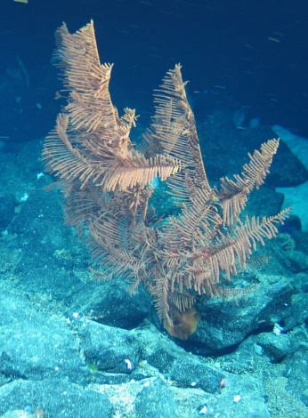
Phylum: Cnidaria  Class: Anthozoa  Subclass:  Hexacorillia  Order: Antipatharia  Family:  Genus:  Species: | Morphospecies code: ANTIPATHARIA2 | Gear:  ROV  Photo by:  Holland I 2018  Identified by: Poppy Keogh  Dive: 9 |  | 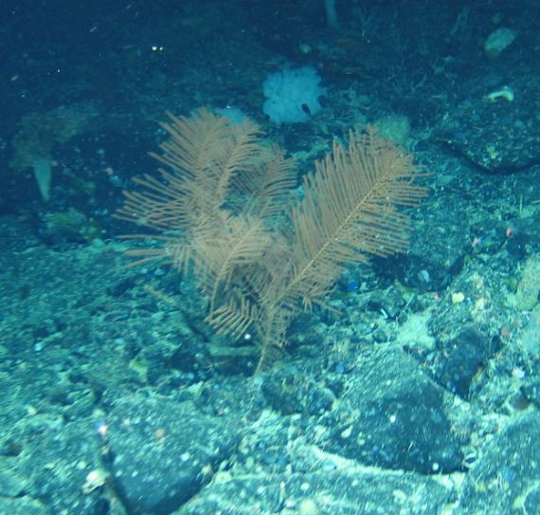

TAXONOMY | NAME | HABITAT | NOTES | IMAGE
Phylum: Cnidaria  Class: Anthozoa  Subclass:  Hexacorillia  Order: Antipatharia  Family:  Genus:  Species: | Morphospecies code: ANTIPATHARIA3 | Gear:  ROV  Photo by:  Holland I 2018  Identified by: Poppy Keogh  Dive: 6 |  | 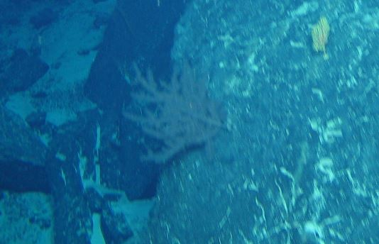
Phylum: Cnidaria  Class: Anthozoa  Subclass:  Hexacorillia  Order: Antipatharia  Family:  Genus: Stauropathes  Species: S. arctica | Morphospecies code: ANTIPATHARIA4  cf. Stauropathes arctica | Gear:  ROV  Photo by:  Holland I 2018  Identified by: Tina Molodtsova  Dive: 5 |  | 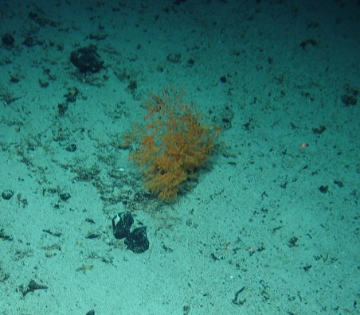
Phylum: Cnidaria  Class: Anthozoa  Subclass:  Hexacorillia  Order: Antipatharia  Family:  Genus:  Species: | Morphospecies code: ANTIPATHARIA6 | Gear:  ROV  Photo by:  Holland I 2018  Identified by: Poppy Keogh  Dive: 9 |  | 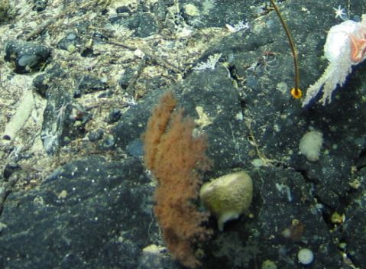
Phylum: Cnidaria  Class: Anthozoa  Subclass:  Hexacorillia  Order: Antipatharia  Family:  Genus: Stauropathes  Species: S. arctica | Morphospecies code: ANTIPATHARIA7  cf. Stauropathes arctica | Gear:  ROV  Photo by:  Holland I 2018  Identified by: Tina Molodtsova  Dive: 6 |  | 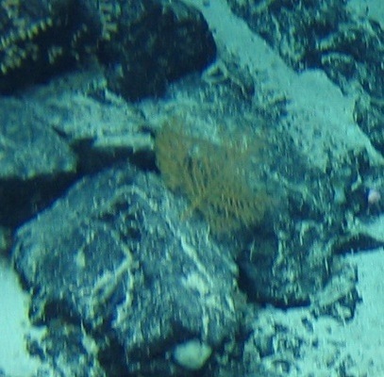
TAXONOMY | NAME | HABITAT | NOTES | IMAGE
Phylum: Cnidaria  Class: Anthozoa  Subclass:  Hexacorillia  Order: Antipatharia  Family: Schizopathidae  Genus: Parantipathes  Species: | Morphospecies code: ANTIPATHARIA8  Parantipathes sp. | Gear:  ROV  Photo by:  Holland I 2018  Identified by: Tina Molodtsova  Dive: 7 |  | 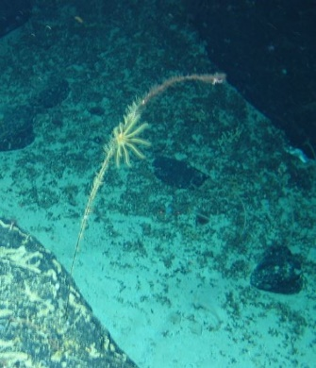
Phylum: Cnidaria  Class: Anthozoa  Subclass:  Hexacorillia  Order: Antipatharia  Family:  Genus:  Species: | Morphospecies code: ANTIPATHARIA9 | Gear:  ROV  Photo by:  Holland I 2018  Identified by: Poppy Keogh  Dive: 9 |  | 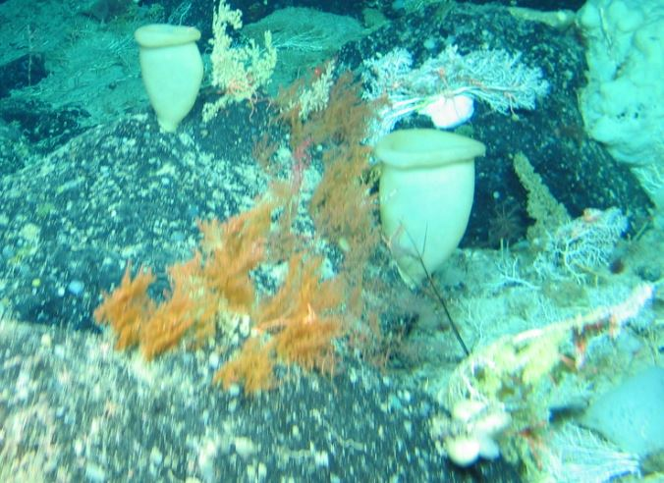
Phylum: Cnidaria  Class: Anthozoa  Subclass:  Hexacorillia  Order: Antipatharia  Family:  Genus:  Species: | Morphospecies code: ANTIPATHARIA10 | Gear:  ROV  Photo by:  Holland I 2018  Identified by: Poppy Keogh  Dive: 9 |  | 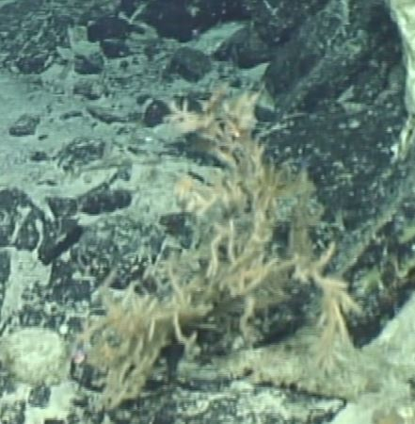
Phylum: Cnidaria  Class: Anthozoa  Subclass:  Hexacorillia  Order: Antipatharia  Family:  Genus:  Species: | Morphospecies code: ANTIPATHARIA11 | Gear:  ROV  Photo by:  Holland I 2018  Identified by: Poppy Keogh  Dive: 9 |  | 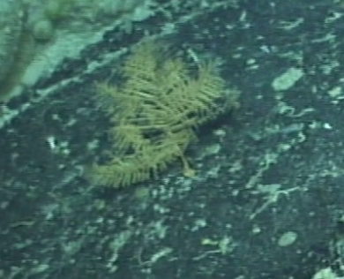
TAXONOMY | NAME | HABITAT | NOTES | IMAGE
Phylum: Cnidaria  Class: Anthozoa  Subclass:  Hexacorillia  Order: Antipatharia  Family:  Genus:  Species: | Morphospecies code: ANTIPATHARIA12 | Gear:  ROV  Photo by:  Holland I 2018  Identified by: Poppy Keogh  Dive: 6 |  | 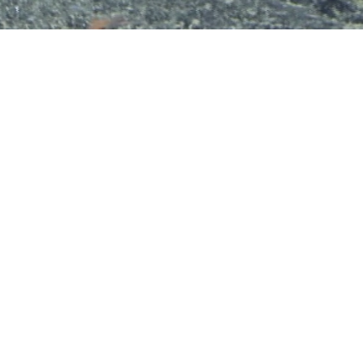
Phylum: Cnidaria  Class: Anthozoa  Subclass:  Hexacorillia  Order: Antipatharia  Family:  Genus:  Species: | Morphospecies code: ANTIPATHARIA13 | Gear:  ROV  Photo by:  Holland I 2018  Identified by: Poppy Keogh  Dive: 6 |  | 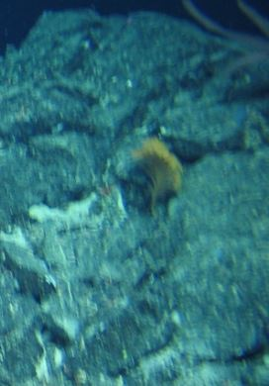
Phylum: Cnidaria  Class: Anthozoa  Subclass:  Hexacorillia  Order: Antipatharia  Family: Schizopathidae  Genus: Bathypathes  Species: | Morphospecies code: BATHY1  Bathypathes n.sp. | Gear:  ROV  Photo by:  Holland I 2018  Identified by: Tina Molodtsova  Dive: 9 | Bathypathes n.sp. under description (T. Molodtsova) | 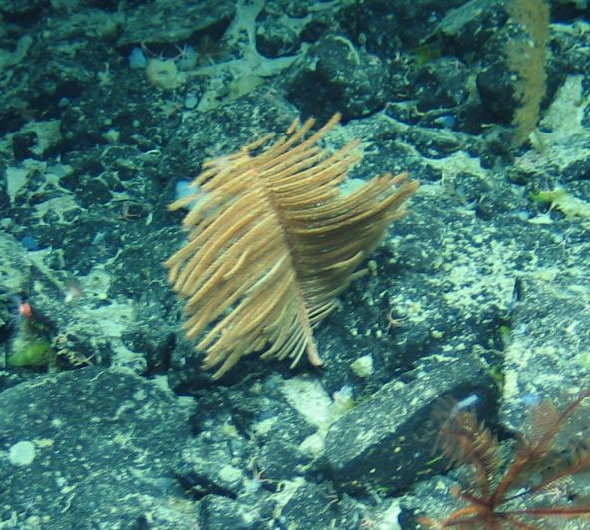
Phylum: Cnidaria  Class: Anthozoa  Subclass:  Hexacorillia  Order: Antipatharia  Family: Schizopathidae  Genus: Bathypathes  Species: | Morphospecies code: BATHY2  Bathypathes sp. | Gear:  ROV  Photo by:  Holland I 2018  Identified by: Poppy Keogh  Dive: 7 |  | 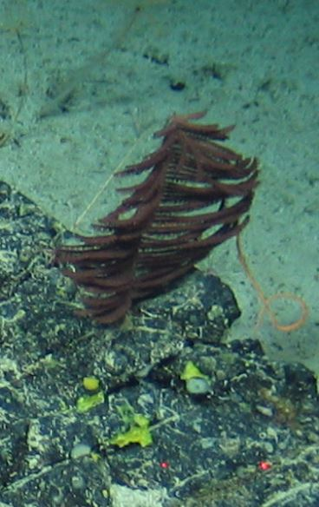
TAXONOMY | NAME | HABITAT | NOTES | IMAGE
Phylum: Cnidaria  Class: Anthozoa  Subclass:  Hexacorillia  Order: Antipatharia  Family: Schizopathidae  Genus: Bathypathes  Species: | Morphospecies code: BATHY3  Bathypathes sp. | Gear:  ROV  Photo by:  Holland I 2018  Identified by: Poppy Keogh  Dive: 8 |  | 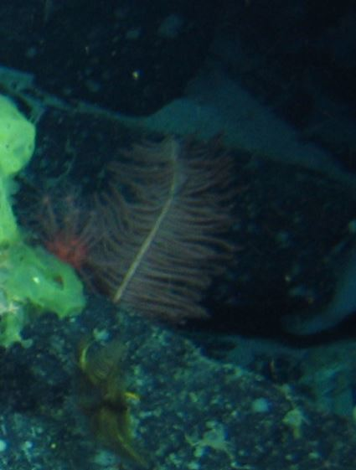
Phylum: Cnidaria  Class: Anthozoa  Subclass:  Hexacorillia  Order: Antipatharia  Family: Schizopathidae  Genus: Bathypathes  Species: | Morphospecies code: BATHY4  Bathypathes sp. | Gear:  ROV  Photo by:  Holland I 2018  Identified by: Poppy Keogh  Dive: 6 |  | 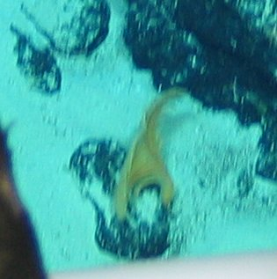
Phylum: Cnidaria  Class: Anthozoa  Subclass:  Hexacorillia  Order: Antipatharia  Family: Schizopathidae  Genus: Bathypathes  Species: | Morphospecies code: BATHY5  Bathypathes sp. | Gear:  ROV  Photo by:  Holland I 2018  Identified by: Poppy Keogh  Dive: 5 |  | 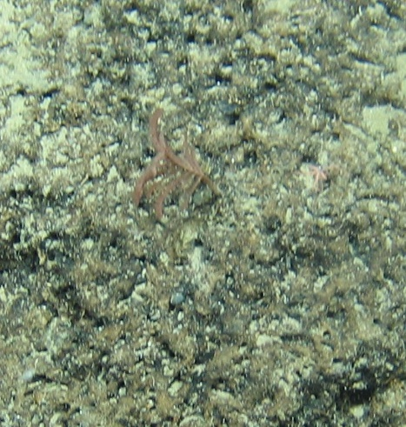
Phylum: Cnidaria  Class: Anthozoa  Subclass:  Hexacorillia  Order: Antipatharia  Family: Schizopathidae  Genus: Bathypathes  Species: | Morphospecies code: BATHY6  Bathypathes sp. | Gear:  ROV  Photo by:  Holland I 2018  Identified by: Poppy Keogh  Dive: 9 |  | 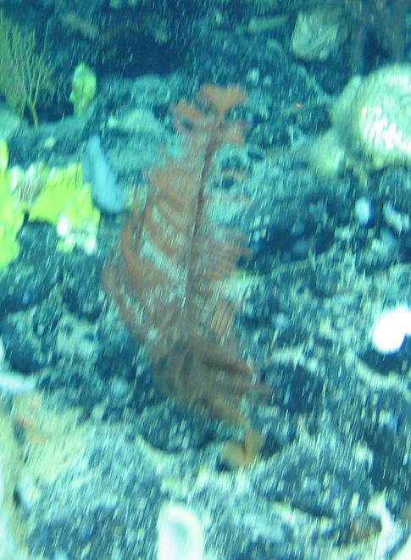
TAXONOMY | NAME | HABITAT | NOTES | IMAGE
Phylum: Cnidaria  Class: Anthozoa  Subclass:  Hexacorillia  Order: Antipatharia  Family: Leiopathidae  Genus: Leiopathes  Species: | Morphospecies code: LEIOPAT  Leiopathes sp. | Gear:  ROV  Photo by:  Holland I 2018  Identified by: Tina Molodtsova  Dive: 5 |  | 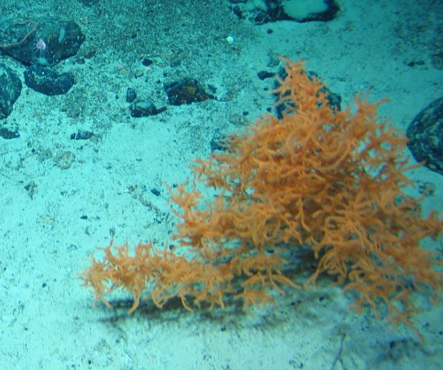
Phylum: Cnidaria  Class: Anthozoa  Subclass:  Hexacorillia  Order: Antipatharia  Family: Schizopathidae  Genus: Parantipathes  Species: | Morphospecies code: PARAN1  Parantipathes sp. | Gear:  ROV  Photo by:  Holland I 2018  Identified by: Poppy Keogh  Dive: 6 |  | 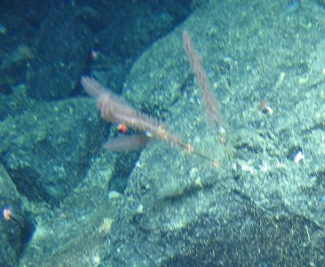
Phylum: Cnidaria  Class: Anthozoa  Subclass:  Hexacorillia  Order: Antipatharia  Family: Schizopathidae  Genus: Parantipathes  Species: | Morphospecies code: PARAN2  Parantipathes sp. | Gear:  ROV  Photo by:  Holland I 2018  Identified by: Poppy Keogh  Dive: 5 |  | 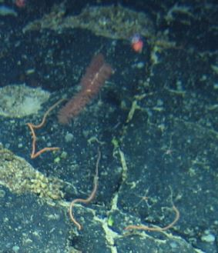
Phylum: Cnidaria  Class: Anthozoa  Subclass:  Hexacorillia  Order: Antipatharia  Family: Schizopathidae  Genus: Parantipathes  Species: P. hirondelle | Morphospecies code: PARAN3  cf. Parantipathes hirondelle | Gear:  ROV  Photo by:  Holland I 2018  Identified by: Tina Molodtsova  Dive: 8 |  | 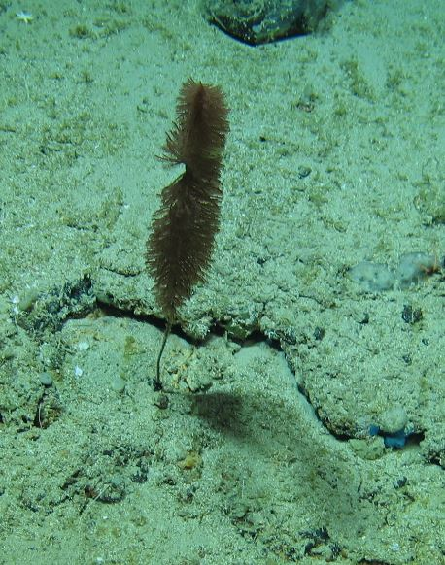
TAXONOMY | NAME | HABITAT | NOTES | IMAGE
Phylum: Cnidaria  Class: Anthozoa  Subclass:  Hexacorillia  Order: Antipatharia  Family: Schizopathidae  Genus: Parantipathes  Species: | Morphospecies code: PARAN4  Parantipathes sp. | Gear:  ROV  Photo by:  Holland I 2018  Identified by: Poppy Keogh  Dive: 7 |  | 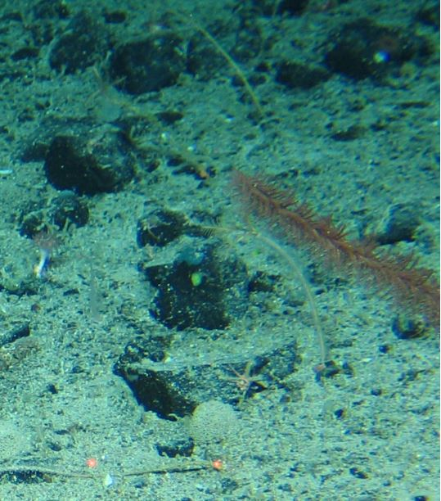
Phylum: Cnidaria  Class: Anthozoa  Subclass:  Hexacorillia  Order: Antipatharia  Family: Schizopathidae  Genus: Stauropathes  Species: | Morphospecies code: STAURO  Stauropathes sp. | Gear:  ROV  Photo by:  Holland I 2018  Identified by: Poppy Keogh  Dive: 8 |  | 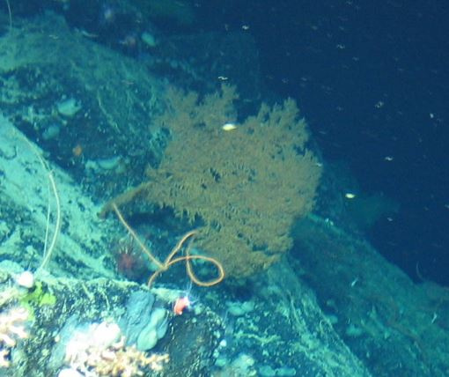
Phylum: Cnidaria  Class: Anthozoa  Subclass:  Hexacorillia  Order: Antipatharia  Family: Antipathidae  Genus: Stichopathes  Species: | Morphospecies code: STICHO1  Stichopathes sp. | Gear:  ROV  Photo by:  Holland I 2018  Identified by: Poppy Keogh  Dive: 6 |  | 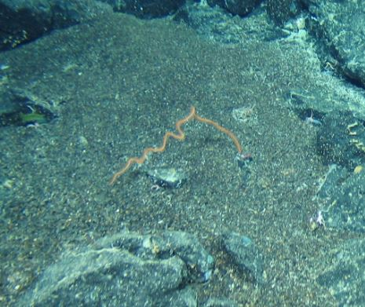
Phylum: Cnidaria  Class: Anthozoa  Subclass:  Hexacorillia  Order: Antipatharia  Family: Schizopathidae  Genus: Parantipathes  Species: | Morphospecies code: TRISSO1  Parantipathes sp. | Gear:  ROV  Photo by:  Holland I 2018  Identified by: Tina Molodtsova  Dive: 9 | Misidentified as a member of Trissopathes genus | 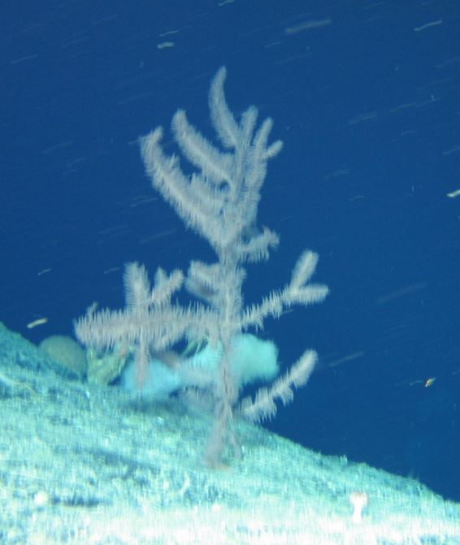
TAXONOMY | NAME | HABITAT | NOTES | IMAGE
Phylum: Cnidaria  Class: Anthozoa  Subclass: Hexacorillia  Order: Actiniaria  Family:  Genus:  Species: | Morphospecies code: ANEMONE1 | Gear:  ROV  Photo by:  Holland I 2018  Identified by: Poppy Keogh  Dive: 5 |  | 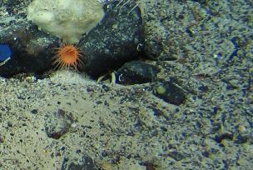
Phylum: Cnidaria  Class: Anthozoa  Subclass: Hexacorillia  Order: Actiniaria  Family: Actinernidae  Genus: Actinernus  Species: | Morphospecies code: ANEMONE2  Actinernus sp. | Gear:  ROV  Photo by:  Holland I 2018  Identified by: Tina Molodtsova  Dive: 5 |  | 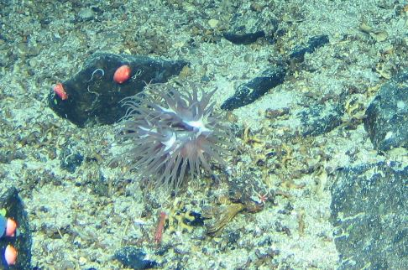
Phylum: Cnidaria  Class: Anthozoa  Subclass: Hexacorillia  Order: Actiniaria  Family: Liponematidae  Genus: Liponema  Species: | Morphospecies code: ANEMONE3  cf Liponema | Gear:  ROV  Photo by:  Holland I 2018  Identified by: Tina Molodtsova  Dive: 5 |  | 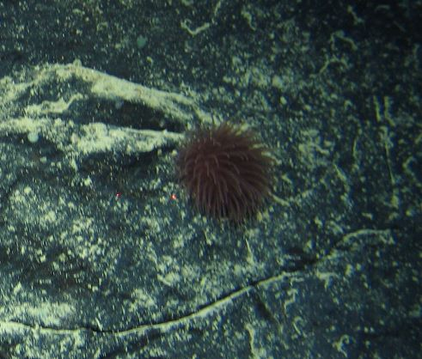
Phylum: Cnidaria  Class: Anthozoa  Subclass: Hexacorillia  Order: Actiniaria  Family:  Genus:  Species: | Morphospecies code: ANEMONE4 | Gear:  ROV  Photo by:  Holland I 2018  Identified by: Poppy Keogh  Dive: 7 |  | 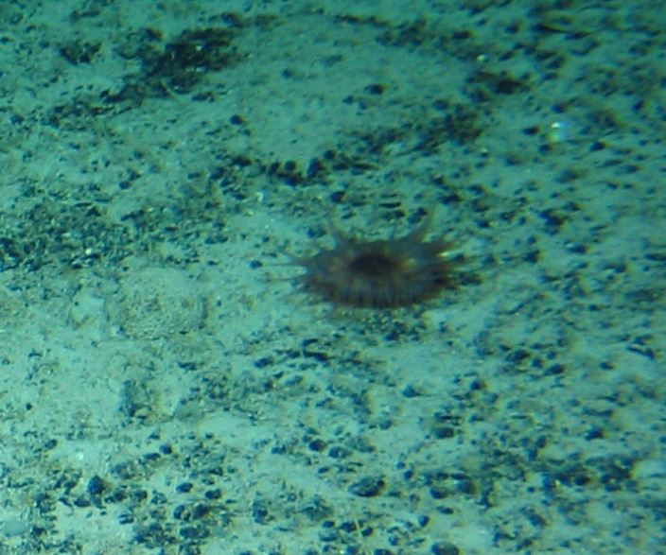
TAXONOMY | NAME | HABITAT | NOTES | IMAGE
Phylum: Cnidaria  Class: Anthozoa  Subclass: Hexacorillia  Order: Actiniaria  Family:  Genus:  Species: | Morphospecies code: ANEMONE5 | Gear:  ROV  Photo by:  Holland I 2018  Identified by: Poppy Keogh  Dive: 8 | Possibly Actinoscyphia sp. (P. Keogh) | 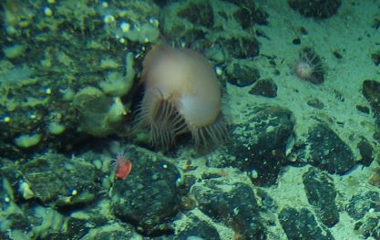
Phylum: Cnidaria  Class: Anthozoa  Subclass: Hexacorillia  Order: Actiniaria  Family:  Genus:  Species: | Morphospecies code: ANEMONE6 | Gear:  ROV  Photo by:  Holland I 2018  Identified by: Poppy Keogh  Dive: 7 | Actinostolidae sp.? (P Keogh) | 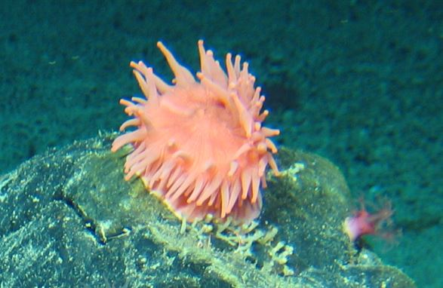
Phylum: Cnidaria  Class: Anthozoa  Subclass: Hexacorillia  Order: Actiniaria  Family:  Genus:  Species: | Morphospecies code: ANEMONE7 | Gear:  ROV  Photo by:  Holland I 2018  Identified by: Poppy Keogh  Dive: 8 |  | 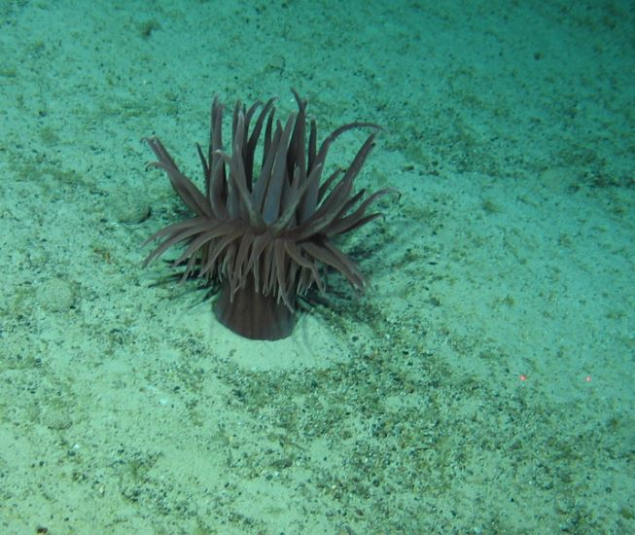
Phylum: Cnidaria  Class: Anthozoa  Subclass: Hexacorillia  Order: Actiniaria  Family:  Genus:  Species: | Morphospecies code: ANEMONE8 | Gear:  ROV  Photo by:  Holland I 2018  Identified by: Poppy Keogh  Dive: 8 | Possibly Bolocera tuediae (P. Keogh) | 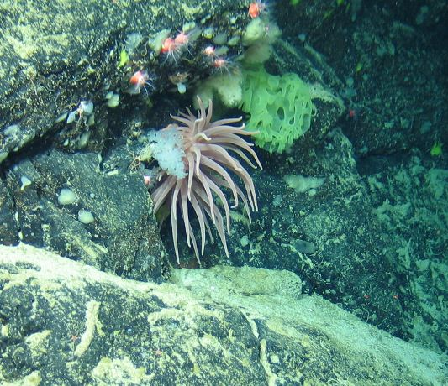
TAXONOMY | NAME | HABITAT | NOTES | IMAGE
Phylum: Cnidaria  Class: Anthozoa  Subclass: Hexacorillia  Order: Corallimorpharia  Family: Corallimorphidae  Genus: Corallimorphus  Species: | Morphospecies code: ANEMONE9  Corallimorphus sp. | Gear:  ROV  Photo by:  Holland I 2018  Identified by: Tina Molodtsova  Dive: 7 |  | 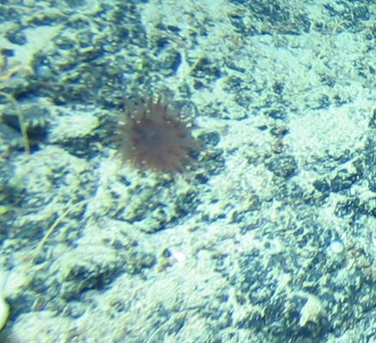
Phylum: Cnidaria  Class: Anthozoa  Subclass: Hexacorillia  Order: Actiniaria  Family:  Genus:  Species: | Morphospecies code: ANEMONE10 | Gear:  ROV  Photo by:  Holland I 2018  Identified by: Poppy Keogh  Dive: 5 |  | 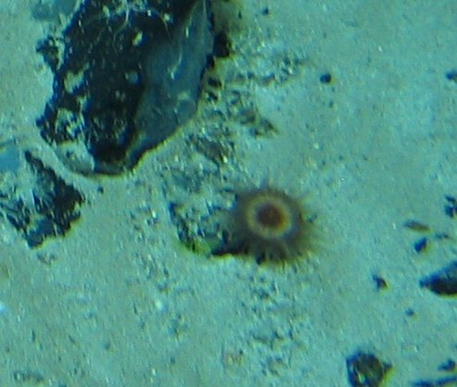
Phylum: Cnidaria  Class: Anthozoa  Subclass: Hexacorillia  Order: Actiniaria  Family:  Genus:  Species: | Morphospecies code: ANEMONE12 | Gear:  ROV  Photo by:  Holland I 2018  Identified by: Poppy Keogh  Dive: 8 |  | 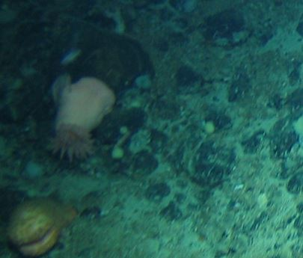
Phylum: Cnidaria  Class: Anthozoa  Subclass: Hexacorillia  Order: Actiniaria  Family:  Genus:  Species: | Morphospecies code: ANEMONE13 | Gear:  ROV  Photo by:  Holland I 2018  Identified by: Poppy Keogh  Dive: 6 | Possibly Phelliactis hertwigii (P. Keogh) | 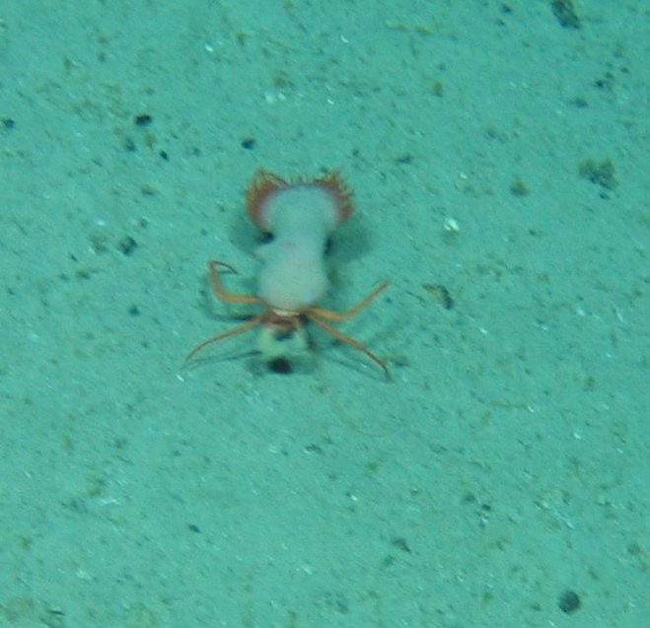
TAXONOMY | NAME | HABITAT | NOTES | IMAGE
Phylum: Cnidaria  Class: Anthozoa  Subclass: Ceriantharia  Order:  Family:  Genus:  Species: | Morphospecies code: ANEMONE14  ? Ceriantharia? | Gear:  ROV  Photo by:  Holland I 2018  Identified by: Tina Molodtsova  Dive: 7 |  | 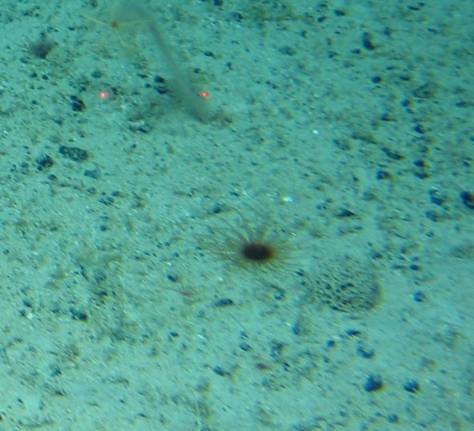
Phylum: Cnidaria  Class: Anthozoa  Subclass: Ceriantharia  Order:  Family:  Genus:  Species: | Morphospecies code: ANEMONE15  ? Ceriantharia? | Gear:  ROV  Photo by:  Holland I 2018  Identified by: Tina Molodtsova  Dive: 9 |  | 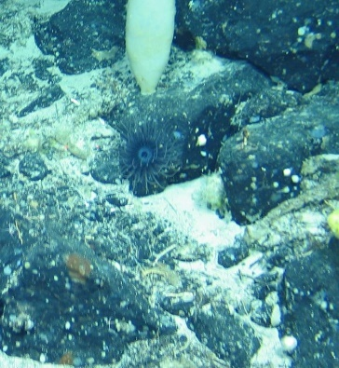
Phylum: Cnidaria  Class: Anthozoa  Subclass: Hexacorillia  Order: Actiniaria  Family:  Genus:  Species: | Morphospecies code: ANEMONE18 | Gear:  ROV  Photo by:  Holland I 2018  Identified by: Poppy Keogh  Dive: 5 |  | 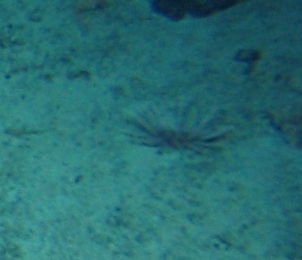
Phylum: Cnidaria  Class: Anthozoa  Subclass: Hexacorillia  Order: Scleractinia  Family:  Genus:  Species: | Morphospecies code: ANEMONE19  ?Scleractinia | Gear:  ROV  Photo by:  Holland I 2018  Identified by: Tina Molodtsova  Dive: 8 | Probably Flabellum sp. (T. Molodtsova) | 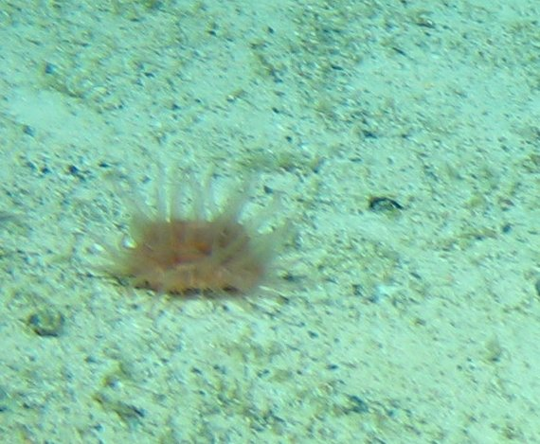
Phylum: Cnidaria  Class: Anthozoa  Subclass: Hexacorillia  Order: Actiniaria  Family:  Genus:  Species: | Morphospecies code: ANEMONE20 | Gear:  ROV  Photo by:  Holland I 2018  Identified by: Poppy Keogh  Dive: 6 |  | 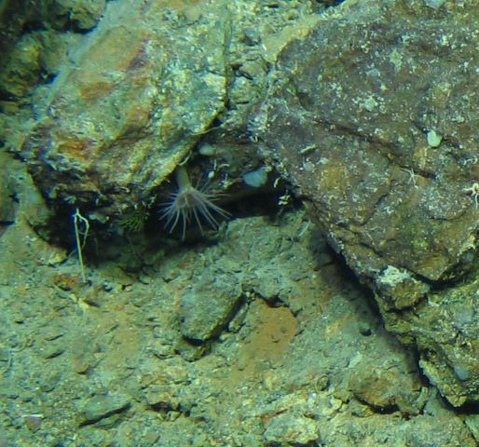
TAXONOMY | NAME | HABITAT | NOTES | IMAGE
Phylum: Cnidaria  Class: Anthozoa  Subclass: Hexacorillia  Order: Scleractinia  Family:  Genus:  Species: | Morphospecies code: ANEMONE21  ? Scleractinia? | Gear:  ROV  Photo by:  Holland I 2018  Identified by: Tina Molodtsova  Dive: 5 | looks like something flat, as Fungiocysthus (T. Molodtsova) | 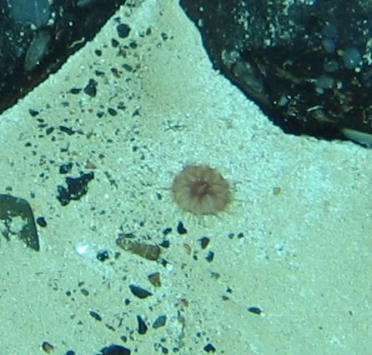
Phylum: Cnidaria  Class: Anthozoa  Subclass: Hexacorillia  Order: Actiniaria  Family: Hormathiidae  Genus:  Species: | Morphospecies code: ANEMONE22  Hormathiidae | Gear:  ROV  Photo by:  Holland I 2018  Identified by: Tina Molodtsova  Dive: 8 |  | 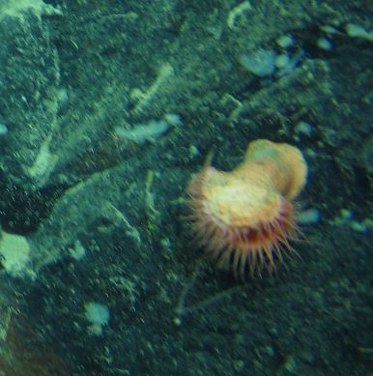
Phylum: Cnidaria  Class: Anthozoa  Subclass: Hexacorillia  Order: Actiniaria  Family:  Genus:  Species: | Morphospecies code: ANEMONE23 | Gear:  ROV  Photo by:  Holland I 2018  Identified by: Poppy Keogh  Dive: 6 |  | 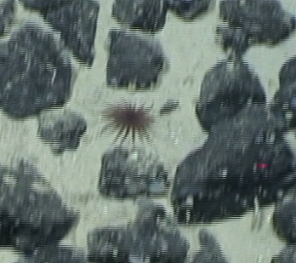
Phylum: Cnidaria  Class: Anthozoa  Subclass: Hexacorillia  Order: Actiniaria  Family:  Genus:  Species: | Morphospecies code: ANEMONE24 | Gear:  ROV  Photo by:  Holland I 2018  Identified by: Poppy Keogh  Dive: 6 |  | 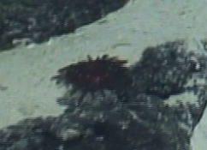
TAXONOMY | NAME | HABITAT | NOTES | IMAGE
Phylum: Cnidaria  Class: Anthozoa  Subclass: Ceriantharia  Order:  Family:  Genus:  Species: | Morphospecies code: CERANTID | Gear:  ROV  Photo by:  Holland I 2018  Identified by: Tina Molodtsova  Dive: 8 |  | 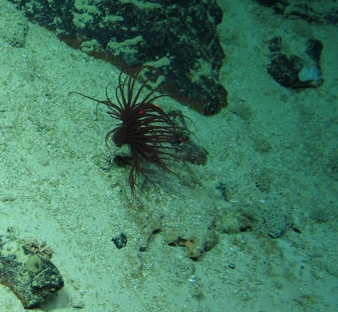
Phylum: Cnidaria  Class: Anthozoa  Subclass:  Hexacorillia  Order: Scleractinia  Family:  Genus:  Species: | Morphospecies code: CUP1 | Gear:  ROV  Photo by:  Holland I 2018  Identified by: Poppy Keogh  Dive: 5 |  | 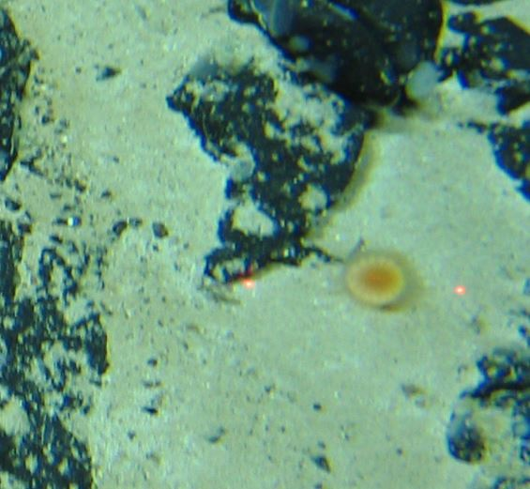
Phylum: Cnidaria  Class: Anthozoa  Subclass:  Hexacorillia  Order: Scleractinia  Family:  Genus:  Species: | Morphospecies code: CUP2 | Gear:  ROV  Photo by:  Holland I 2018  Identified by: Poppy Keogh  Dive: 7 |  | 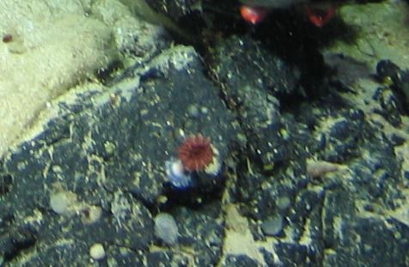
Phylum: Cnidaria  Class: Anthozoa  Subclass:  Hexacorillia  Order: Scleractinia  Family:  Genus:  Species: | Morphospecies code: CUP3 | Gear:  ROV  Photo by:  Holland I 2018  Identified by: Poppy Keogh  Dive: 8 |  | 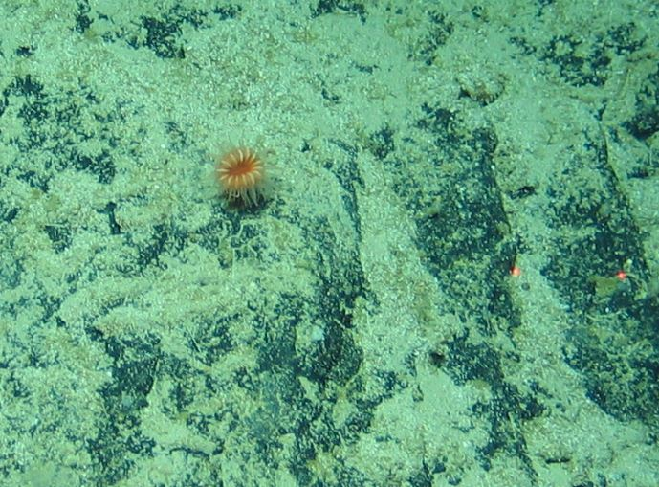
Phylum: Cnidaria  Class: Anthozoa  Subclass:  Hexacorillia  Order: Scleractinia  Family:  Genus:  Species: | Morphospecies code: CUP4 | Gear:  ROV  Photo by:  Holland I 2018  Identified by: Poppy Keogh  Dive: 7 |  | 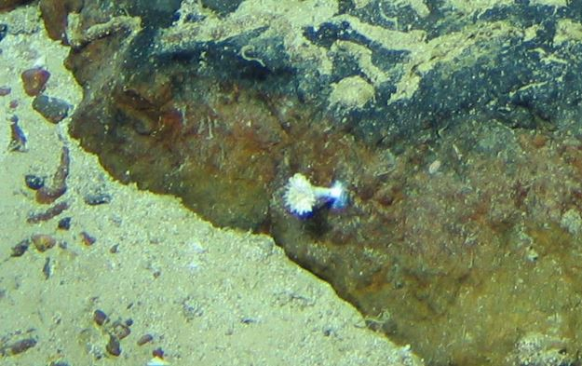
TAXONOMY | NAME | HABITAT | NOTES | IMAGE
Phylum: Cnidaria  Class: Anthozoa  Subclass:  Hexacorillia  Order: Scleractinia  Family:  Genus:  Species: | Morphospecies code: CUP5 | Gear:  ROV  Photo by:  Holland I 2018  Identified by: Poppy Keogh  Dive: 9 |  | 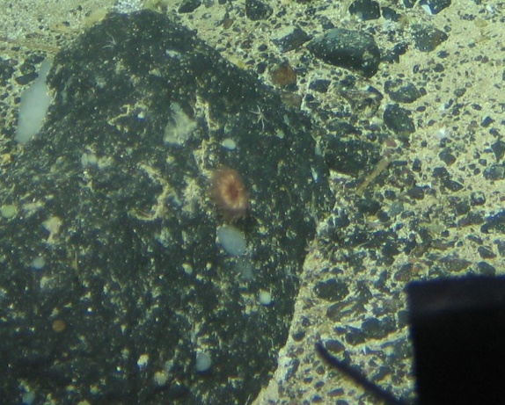
Phylum: Cnidaria  Class: Anthozoa  Subclass:  Hexacorillia  Order: Scleractinia  Family:  Genus:  Species: | Morphospecies code: CUP6 | Gear:  ROV  Photo by:  Holland I 2018  Identified by: Poppy Keogh  Dive: 8 |  | 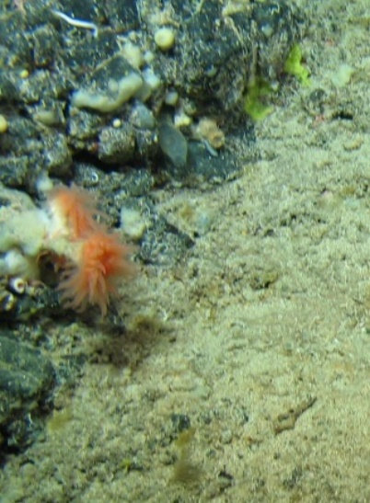
Phylum: Cnidaria  Class: Anthozoa  Subclass:  Hexacorillia  Order: Scleractinia  Family:  Genus:  Species: | Morphospecies code: CUP7 | Gear:  ROV  Photo by:  Holland I 2018  Identified by: Poppy Keogh  Dive: 6 |  | 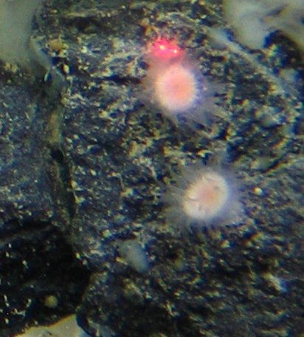
Phylum: Cnidaria  Class: Anthozoa  Subclass:  Hexacorillia  Order: Scleractinia  Family: Flabellidae  Genus: Flabellum  Species: | Morphospecies code: CUP8  Flabellum sp. | Gear:  ROV  Photo by:  Holland I 2018  Identified by: Tina Molodtsova  Dive: 8 |  | 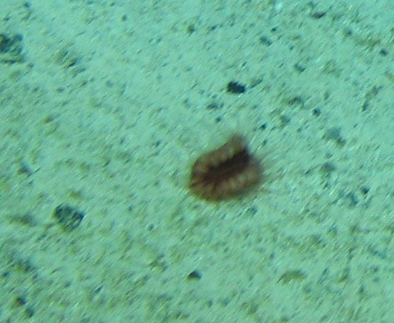
TAXONOMY | NAME | HABITAT | NOTES | IMAGE
Phylum: Cnidaria  Class: Anthozoa  Subclass:  Hexacorillia  Order: Scleractinia  Family: Caryophylliidae  Genus: Solenosmilia  Species: | Morphospecies code: SCLERA1  Solenosmilia sp. | Gear:  ROV  Photo by:  Holland I 2018  Identified by: Rebecca Ross  Dive: 8 |  | 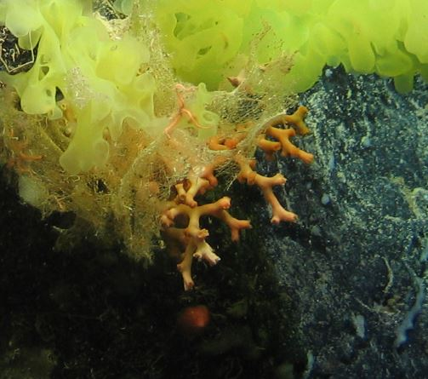
Phylum: Cnidaria  Class: Anthozoa  Subclass: Octocorallia  Order: Alcyonacea  Family: Coralliidae  Genus: Corallium  Species: | Morphospecies code: CORALI  Corallium sp. | Gear:  ROV  Photo by:  Holland I 2018  Identified by:  Renata Arantes  Dive: 6 |  | 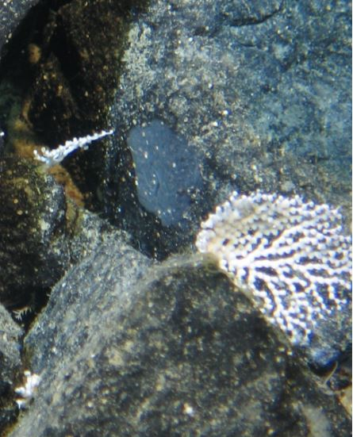
Phylum: Cnidaria  Class: Anthozoa  Subclass: Octocorallia  Order:  Family:  Genus:  Species: | Morphospecies code: OCTOCORAL1 | Gear:  ROV  Photo by:  Holland I 2018  Identified by: Poppy Keogh  Dive: 8 |  | 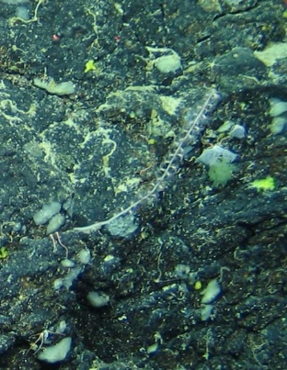
Phylum: Cnidaria  Class: Anthozoa  Subclass: Octocorallia  Order:  Family:  Genus:  Species: | Morphospecies code: OCTOCORAL2 | Gear:  ROV  Photo by:  Holland I 2018  Identified by:  Poppy Keogh  Dive: 9 |  | 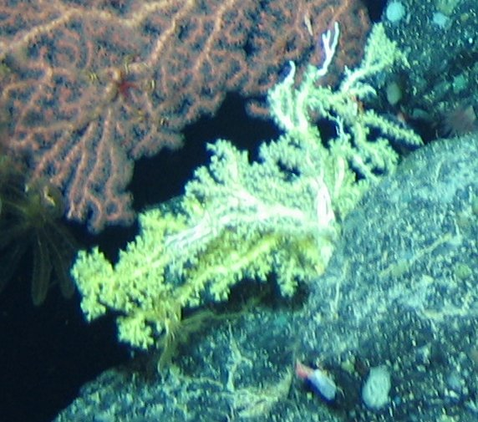
TAXONOMY | NAME | HABITAT | NOTES | IMAGE
Phylum: Cnidaria  Class: Anthozoa  Subclass: Octocorallia  Order: Alcyonacea  Family: Acanthogorgiidae  Genus: Acanthogorgia  Species: | Morphospecies code: ACANT1  Acanthogorgia sp. | Gear:  ROV  Photo by:  Holland I 2018  Identified by:  Renata Arantes  Dive: 7 |  | 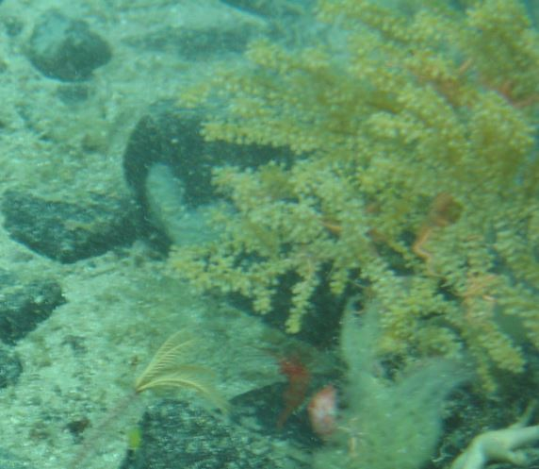
Phylum: Cnidaria  Class: Anthozoa  Subclass: Octocorallia  Order: Alcyonacea  Family:  Genus:  Species: | Morphospecies code: ALCYONACEA1 | Gear:  ROV  Photo by:  Holland I 2018  Identified by:  Poppy Keogh  Dive: 8 |  | 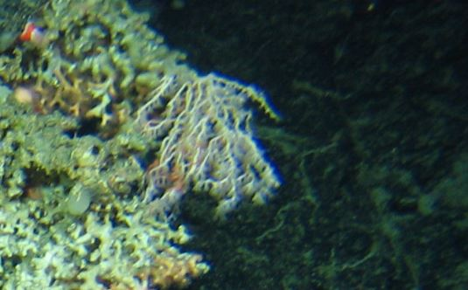
Phylum: Cnidaria  Class: Anthozoa  Subclass: Octocorallia  Order: Alcyonacea  Family:  Genus:  Species: | Morphospecies code: ALCYONACEA2 | Gear:  ROV  Photo by:  Holland I 2018  Identified by:  Poppy Keogh  Dive: 9 |  | 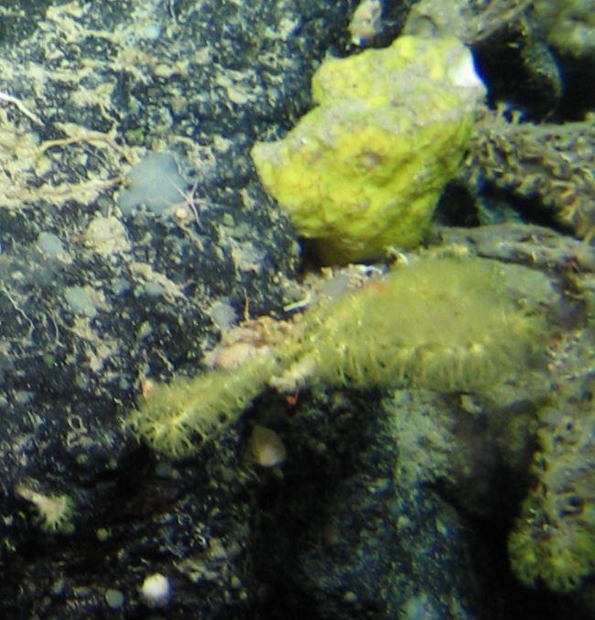
Phylum: Cnidaria  Class: Anthozoa  Subclass: Octocorallia  Order: Alcyonacea  Family:  Genus:  Species: | Morphospecies code: ALCYONACEA3 | Gear:  ROV  Photo by:  Holland I 2018  Identified by:  Poppy Keogh  Dive: 6 |  | 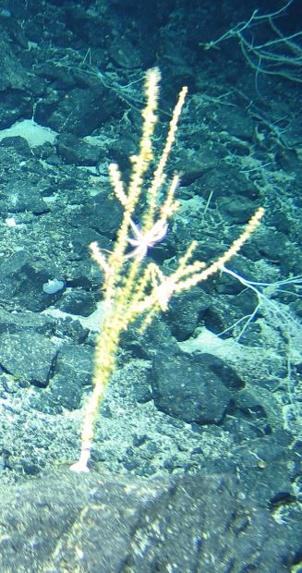
TAXONOMY | NAME | HABITAT | NOTES | IMAGE
Phylum: Cnidaria  Class: Anthozoa  Subclass: Octocorallia  Order: Alcyonacea  Family: Alcyoniidae  Genus: Anthomastus  Species: | Morphospecies code: ANTHO1  Anthomastus sp. | Gear:  ROV  Photo by:  Holland I 2018  Identified by:  Poppy Keogh  Dive: 7 |  | 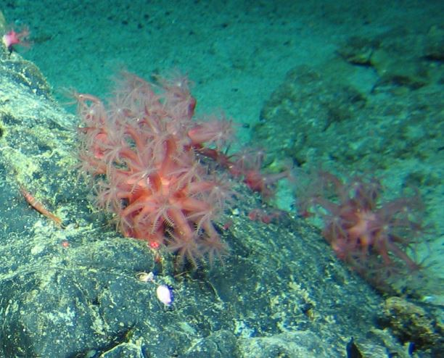
Phylum: Cnidaria  Class: Anthozoa  Subclass: Octocorallia  Order: Alcyonacea  Family: Alcyoniidae  Genus: Anthomastus  Species: | Morphospecies code: ANTHO2  Anthomastus sp. | Gear:  ROV  Photo by:  Holland I 2018  Identified by:  Poppy Keogh  Dive: 7 |  | 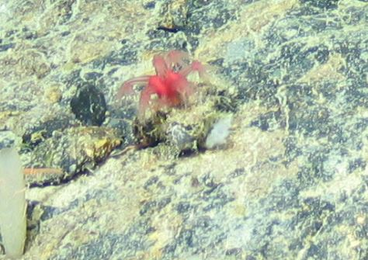
Phylum: Cnidaria  Class: Anthozoa  Subclass: Octocorallia  Order: Alcyonacea  Family: Alcyoniidae  Genus: Anthomastus  Species: | Morphospecies code: ANTHO3  Anthomastus sp. | Gear:  ROV  Photo by:  Holland I 2018  Identified by:  Poppy Keogh  Dive: 7 |  | 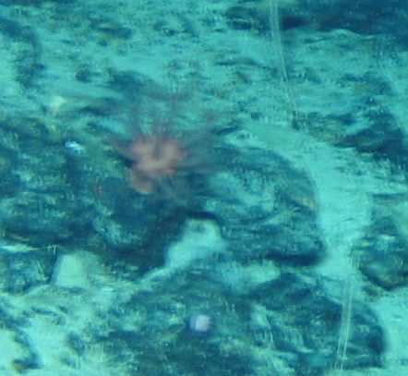
Phylum: Cnidaria  Class: Anthozoa  Subclass: Octocorallia  Order: Alcyonacea  Family: Chrysogorgiidae  Genus: Chrysogorgia  Species: | Morphospecies code: CRYSOG1  Chrysogorgia sp | Gear:  ROV  Photo by:  Holland I 2018  Identified by:  Renata Arantes  Dive: 9 |  | 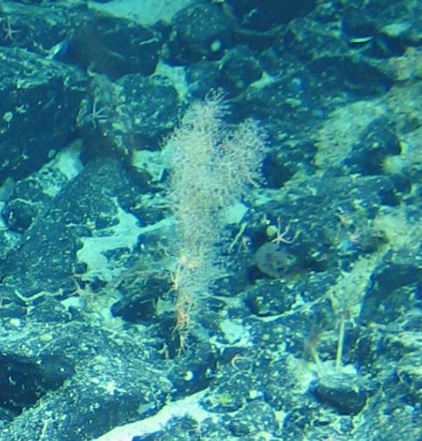
TAXONOMY | NAME | HABITAT | NOTES | IMAGE
Phylum: Cnidaria  Class: Anthozoa  Subclass: Octocorallia  Order: Alcyonacea  Family: Chrysogorgiidae  Genus: Chrysogorgia  Species: | Morphospecies code: CRYSOG2  Chrysogorgia sp | Gear:  ROV  Photo by:  Holland I 2018  Identified by:  Renata Arantes  Dive: 9 |  | 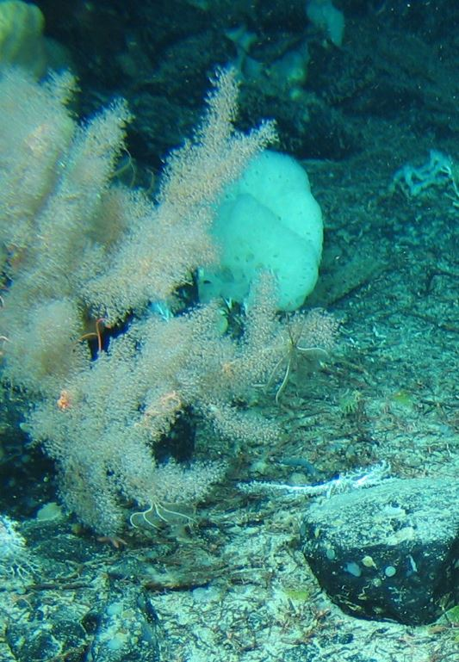
Phylum: Cnidaria  Class: Anthozoa  Subclass: Octocorallia  Order: Alcyonacea  Family: Chrysogorgiidae  Genus: Chrysogorgia  Species: | Morphospecies code: CRYSOG3  Chrysogorgia sp | Gear:  ROV  Photo by:  Holland I 2018  Identified by:  Renata Arantes  Dive: 8 |  | 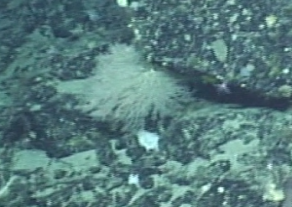
Phylum: Cnidaria  Class: Anthozoa  Subclass: Octocorallia  Order: Alcyonacea  Family: Chrysogorgiidae  Genus: Iridogorgia  Species: | Morphospecies code: IRIDOG1  Iridogorgia sp | Gear:  ROV  Photo by:  Holland I 2018  Identified by:  Renata Arantes  Dive: 9 |  | 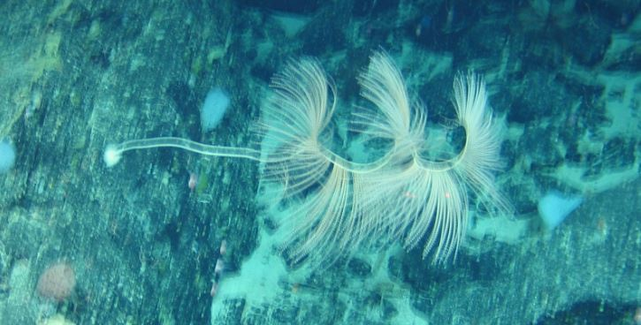
Phylum: Cnidaria  Class: Anthozoa  Subclass: Octocorallia  Order: Alcyonacea  Family: Clavulariidae  Genus: Clavularia  Species: | Morphospecies code: CLAVU1  Clavularia sp. | Gear:  ROV  Photo by:  Holland I 2018  Identified by:  Renata Arantes  Dive: 6 |  | 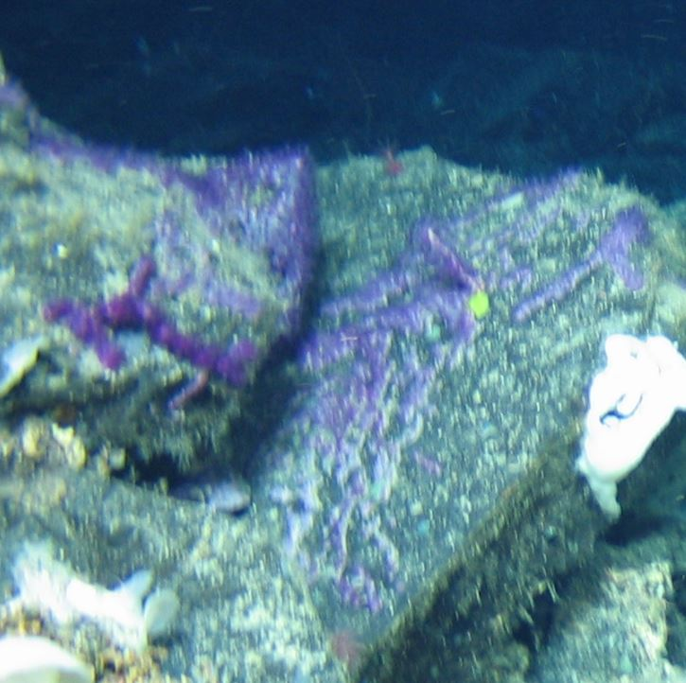
TAXONOMY | NAME | HABITAT | NOTES | IMAGE
Phylum: Cnidaria  Class: Anthozoa  Subclass: Octocorallia  Order: Alcyonacea  Family: Isididae  Genus: Acanella  Species: | Morphospecies code: ACANEL1  Acanella sp. | Gear:  ROV  Photo by:  Holland I 2018  Identified by:  Renata Arantes  Dive: 7 |  | 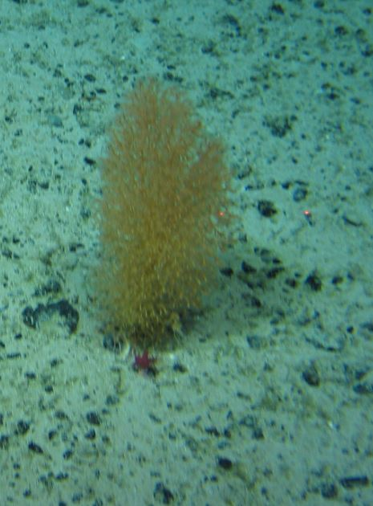
Phylum: Cnidaria  Class: Anthozoa  Subclass: Octocorallia  Order: Alcyonacea  Family: Isididae  Genus:  Species: | Morphospecies code: ISIDIDAE1 | Gear:  ROV  Photo by:  Holland I 2018  Identified by:  Poppy Keogh  Dive: 6 |  | 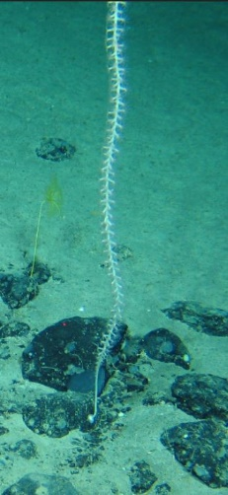
Phylum: Cnidaria  Class: Anthozoa  Subclass: Octocorallia  Order: Alcyonacea  Family: Isididae  Genus:  Species: | Morphospecies code: ISIDIDAE2 | Gear:  ROV  Photo by:  Holland I 2018  Identified by:  Poppy Keogh  Dive: 6 |  | 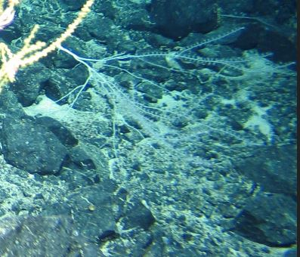
Phylum: Cnidaria  Class: Anthozoa  Subclass: Octocorallia  Order: Alcyonacea  Family: Isididae  Genus:  Species: | Morphospecies code: ISIDIDAE3 | Gear:  ROV  Photo by:  Holland I 2018  Identified by:  Poppy Keogh  Dive: 6 |  | 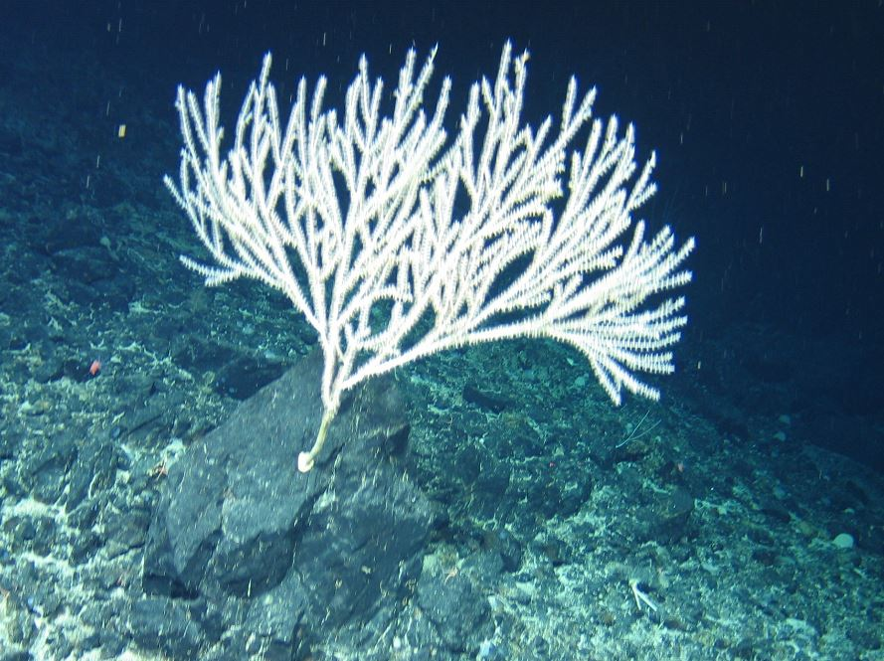
TAXONOMY | NAME | HABITAT | NOTES | IMAGE
Phylum: Cnidaria  Class: Anthozoa  Subclass: Octocorallia  Order: Alcyonacea  Family: Isididae  Genus:  Species: | Morphospecies code: ISIDIDAE4 | Gear:  ROV  Photo by:  Holland I 2018  Identified by:  Poppy Keogh  Dive: 5 |  | 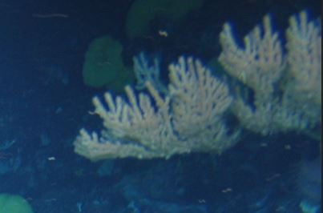
Phylum: Cnidaria  Class: Anthozoa  Subclass: Octocorallia  Order: Alcyonacea  Family: Isididae  Genus:  Species: | Morphospecies code: ISIDIDAE5 | Gear:  ROV  Photo by:  Holland I 2018  Identified by:  Poppy Keogh  Dive: 6 |  | 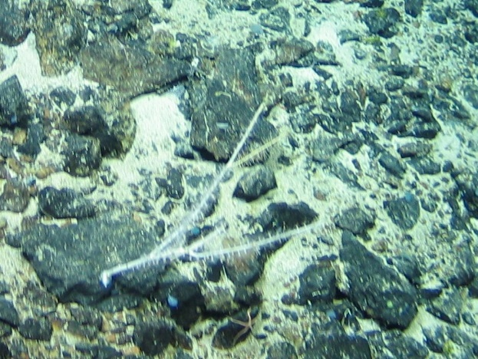
Phylum: Cnidaria  Class: Anthozoa  Subclass: Octocorallia  Order: Alcyonacea  Family: Isididae  Genus:  Species: | Morphospecies code: ISIDIDAE7 | Gear:  ROV  Photo by:  Holland I 2018  Identified by:  Poppy Keogh  Dive: 7 |  | 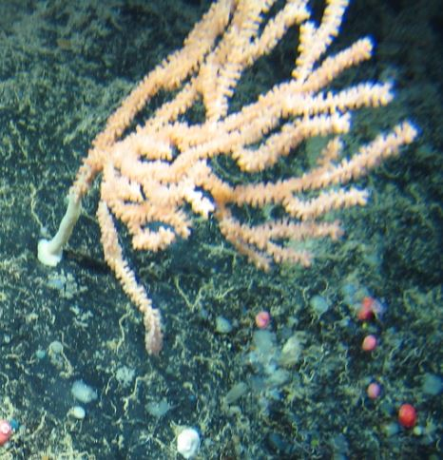
Phylum: Cnidaria  Class: Anthozoa  Subclass: Octocorallia  Order: Alcyonacea  Family: Isididae  Genus:  Species: | Morphospecies code: ISIDIDAE9 | Gear:  ROV  Photo by:  Holland I 2018  Identified by:  Poppy Keogh  Dive: 6 | Probably the same as ISIDIDAE5 (Poppy Keogh) | 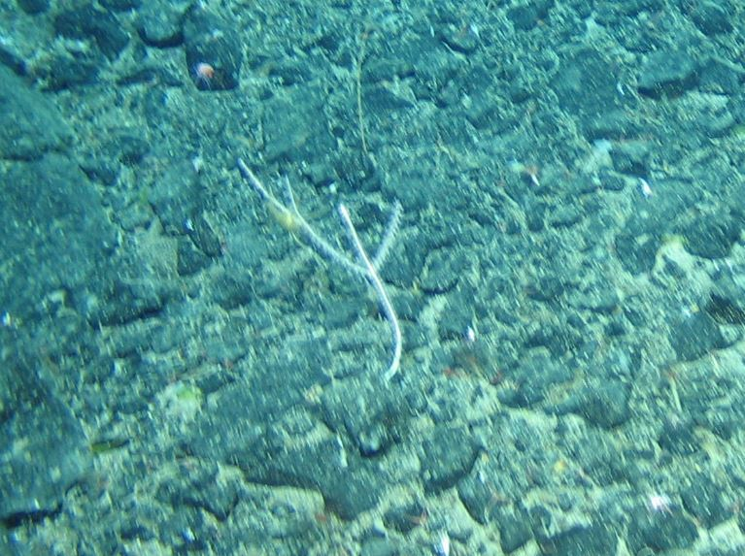
TAXONOMY | NAME | HABITAT | NOTES | IMAGE
Phylum: Cnidaria  Class: Anthozoa  Subclass: Octocorallia  Order: Alcyonacea  Family: Isididae  Genus:  Species: | Morphospecies code: ISIDIDAE10 | Gear:  ROV  Photo by:  Holland I 2018  Identified by:  Poppy Keogh  Dive: 5 | Probably the same as ISIDIDAE4 (Poppy Keogh) | 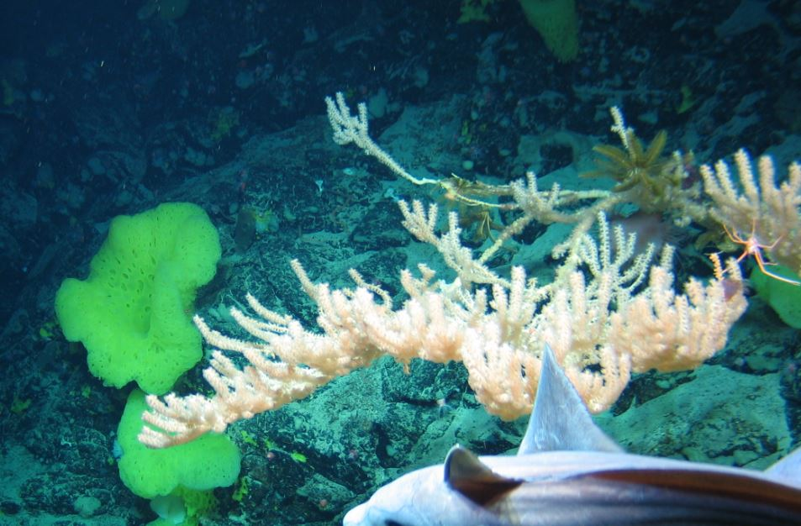
Phylum: Cnidaria  Class: Anthozoa  Subclass: Octocorallia  Order: Alcyonacea  Family: Isididae  Genus:  Species: | Morphospecies code: ISIDIDAE11 | Gear:  ROV  Photo by:  Holland I 2018  Identified by:  Poppy Keogh  Dive: 7 |  | 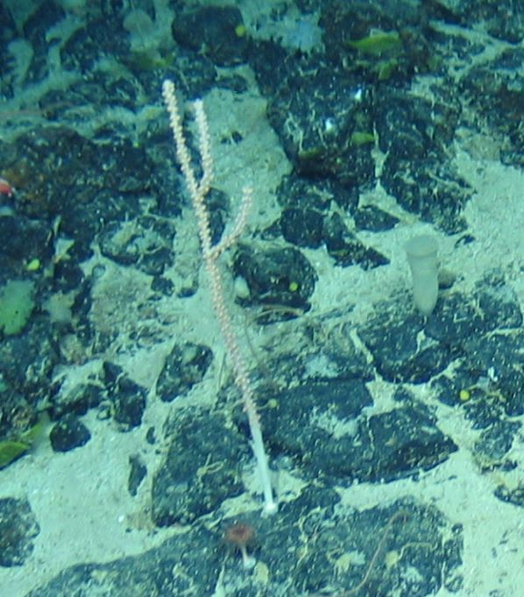
Phylum: Cnidaria  Class: Anthozoa  Subclass: Octocorallia  Order: Alcyonacea  Family: Paragorgiidae  Genus:  Species: | Morphospecies code: PARAGO1 | Gear:  ROV  Photo by:  Holland I 2018  Identified by:  Poppy Keogh  Dive: 9 |  | 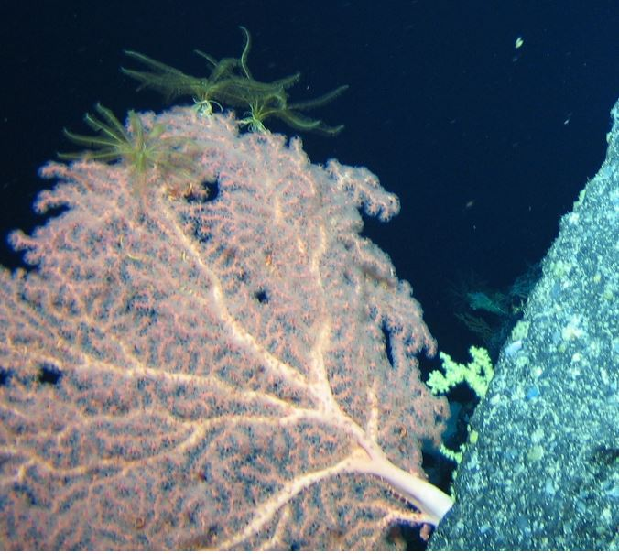
Phylum: Cnidaria  Class: Anthozoa  Subclass: Octocorallia  Order: Alcyonacea  Family: Paragorgiidae  Genus:  Species: | Morphospecies code: PARAGO5 | Gear:  ROV  Photo by:  Holland I 2018  Identified by:  Poppy Keogh  Dive: 6 |  | 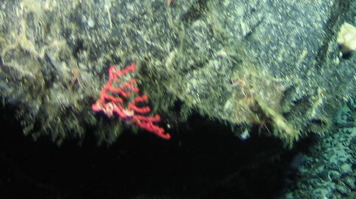
TAXONOMY | NAME | HABITAT | NOTES | IMAGE
Phylum: Cnidaria  Class: Anthozoa  Subclass: Octocorallia  Order: Alcyonacea  Family: Paragorgiidae  Genus:  Species: | Morphospecies code: PARAGO6 | Gear:  ROV  Photo by:  Holland I 2018  Identified by:  Poppy Keogh  Dive: 7 |  | 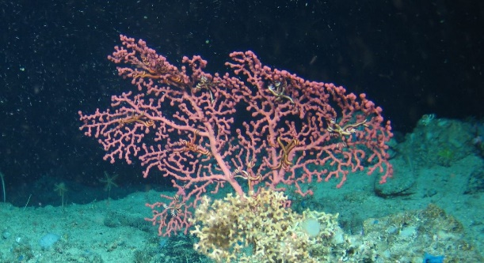
Phylum: Cnidaria  Class: Anthozoa  Subclass: Octocorallia  Order: Alcyonacea  Family: Paragorgiidae  Genus:  Species: | Morphospecies code: PARAGO7 | Gear:  ROV  Photo by:  Holland I 2018  Identified by:  Poppy Keogh  Dive: 9 |  | 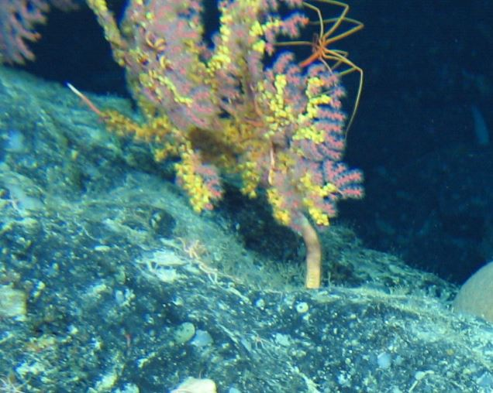
Phylum: Cnidaria  Class: Anthozoa  Subclass: Octocorallia  Order: Alcyonacea  Family: Paragorgiidae  Genus:  Species: | Morphospecies code: PARAGO8 | Gear:  ROV  Photo by:  Holland I 2018  Identified by:  Poppy Keogh  Dive: 8 |  | 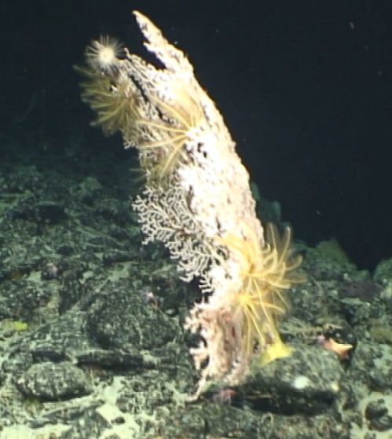
Phylum: Cnidaria  Class: Anthozoa  Subclass: Octocorallia  Order: Alcyonacea  Family: Plexauridae  Genus:  Species: | Morphospecies code: PLEXAURIDAE1 | Gear:  ROV  Photo by:  Holland I 2018  Identified by:  Poppy Keogh  Dive: 6 |  | 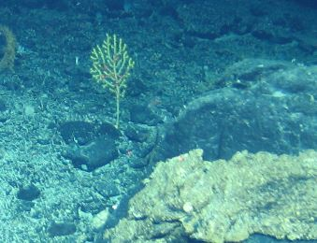
TAXONOMY | NAME | HABITAT | NOTES | IMAGE
Phylum: Cnidaria  Class: Anthozoa  Subclass: Octocorallia  Order: Alcyonacea  Family: Plexauridae  Genus:  Species: | Morphospecies code: PLEXAURIDAE2 | Gear:  ROV  Photo by:  Holland I 2018  Identified by:  Renata Arantes  Dive: 9 |  | 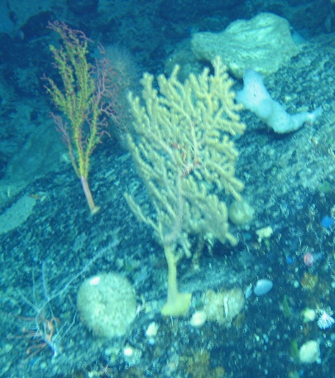
Phylum: Cnidaria  Class: Anthozoa  Subclass: Octocorallia  Order: Alcyonacea  Family: Primnoidae  Genus: Calyptrophora  Species: | Morphospecies code: CALYPT1  Calyptrophora sp. | Gear:  ROV  Photo by:  Holland I 2018  Identified by:  Renata Arantes  Dive: 9 |  | 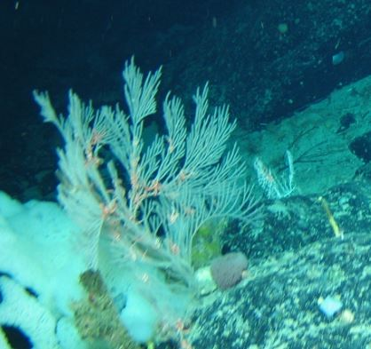
Phylum: Cnidaria  Class: Anthozoa  Subclass: Octocorallia  Order: Alcyonacea  Family: Primnoidae  Genus:  Species: | Morphospecies code: PRIMNO1 | Gear:  ROV  Photo by:  Holland I 2018  Identified by:  Renata Arantes  Dive: 9 |  | 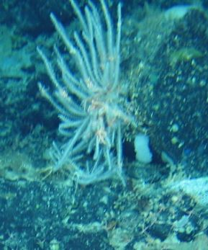
Phylum: Cnidaria  Class: Anthozoa  Subclass: Octocorallia  Order: Pennatulacea  Family:  Genus:  Species: | Morphospecies code: PENNATULA1 | Gear:  ROV  Photo by:  Holland I 2018  Identified by:  Poppy Keogh  Dive: 5 |  | 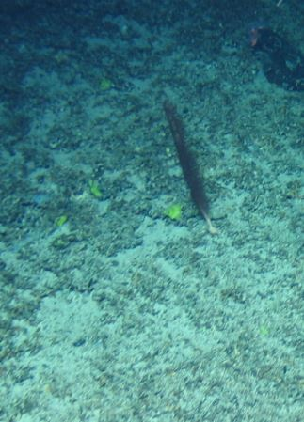
TAXONOMY | NAME | HABITAT | NOTES | IMAGE
Phylum: Cnidaria  Class: Anthozoa  Subclass: Octocorallia  Order: Pennatulacea  Family: Anthoptilidae  Genus: Anthoptilum  Species: A. grandiflorum | Morphospecies code: PENNATULA2  Anthoptilum cf. grandiflorum | Gear:  ROV  Photo by:  Holland I 2018  Identified by:  Raissa Hogan  Dive: 7 |  | 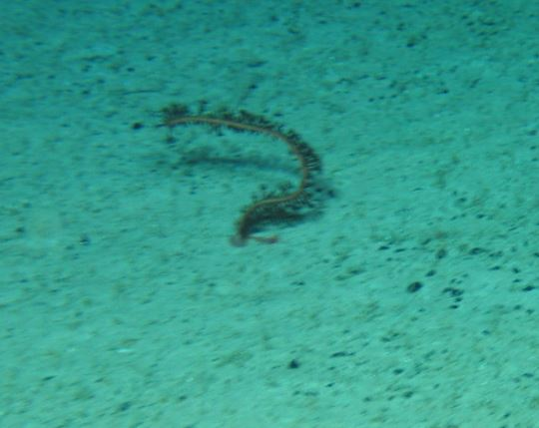
Phylum: Cnidaria  Class: Anthozoa  Subclass: Octocorallia  Order: Pennatulacea  Family: Anthoptilidae  Genus: Anthoptilum  Species: | Morphospecies code: PENNATULA3  Anthoptilum sp. | Gear:  ROV  Photo by:  Holland I 2018  Identified by:  Raissa Hogan  Dive: 8 |  | 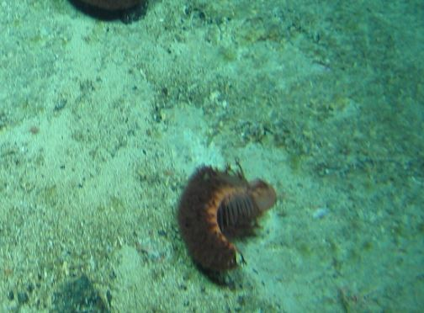
Phylum: Cnidaria  Class: Anthozoa  Subclass: Octocorallia  Order: Pennatulacea  Family:  Genus:  Species: | Morphospecies code: PENNATULA4 | Gear:  ROV  Photo by:  Holland I 2018  Identified by:  Poppy Keogh  Dive: 7 |  | 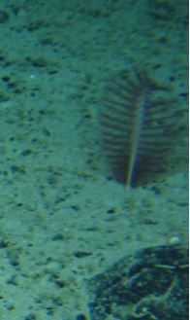
Phylum: Cnidaria  Class: Anthozoa  Subclass: Octocorallia  Order: Pennatulacea  Family:  Genus:  Species: | Morphospecies code: PENNATULA6 | Gear:  ROV  Photo by:  Holland I 2018  Identified by:  Poppy Keogh  Dive: 7 |  | 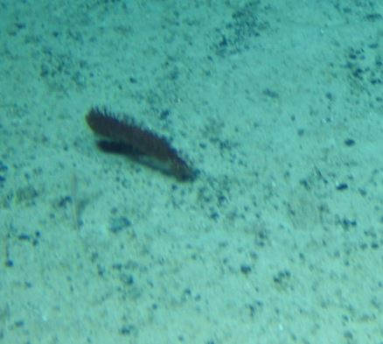
TAXONOMY | NAME | HABITAT | NOTES | IMAGE
Phylum: Cnidaria  Class: Anthozoa  Subclass: Octocorallia  Order: Pennatulacea  Family: Anthoptilidae  Genus: Anthoptilum  Species: | Morphospecies code: PENNATULA8  Anthoptilum sp. | Gear:  ROV  Photo by:  Holland I 2018  Identified by:  Raissa Hogan  Dive: 7 |  | 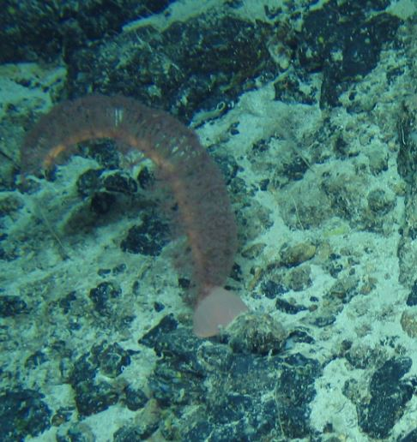
Phylum: Cnidaria  Class: Anthozoa  Subclass: Octocorallia  Order: Pennatulacea  Family: Halipteridae  Genus: Halipteris  Species: H. finmarchica | Morphospecies code: PENNATULA9  Halipteris cf. finmarchica | Gear:  ROV  Photo by:  Holland I 2018  Identified by:  Raissa Hogan  Dive: 7 |  | 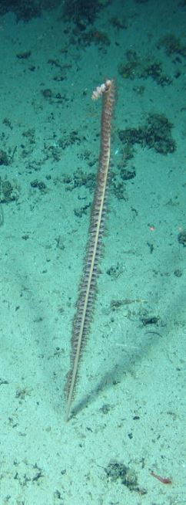
Phylum: Cnidaria  Class: Anthozoa  Subclass: Octocorallia  Order: Pennatulacea  Family:  Genus:  Species: | Morphospecies code: PENNATULA10  Pennatula sp. or Ptilella | Gear:  ROV  Photo by:  Holland I 2018  Identified by:  Raissa Hogan  Dive: 5 |  | 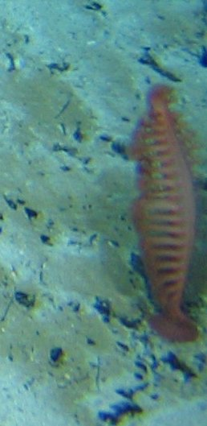
Phylum: Cnidaria  Class: Anthozoa  Subclass: Octocorallia  Order: Pennatulacea  Family:  Genus:  Species: | Morphospecies code: PENNATULA11 | Gear:  ROV  Photo by:  Holland I 2018  Identified by:  Poppy Keogh  Dive: 7 |  | 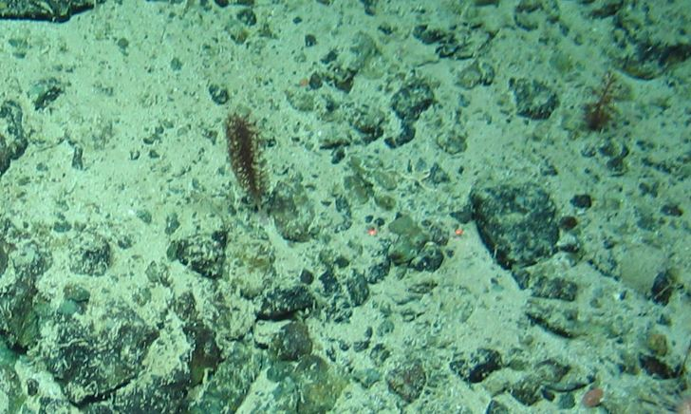
TAXONOMY | NAME | HABITAT | NOTES | IMAGE
Phylum: Cnidaria  Class: Anthozoa  Subclass: Octocorallia  Order: Pennatulacea  Family:  Genus:  Species: | Morphospecies code: PENNATULA12 | Gear:  ROV  Photo by:  Holland I 2018  Identified by:  Poppy Keogh  Dive: 7 |  | 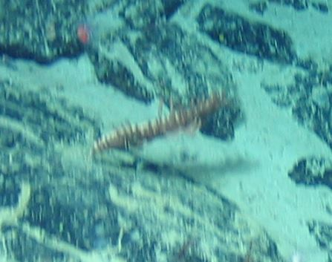
Phylum: Cnidaria  Class: Anthozoa  Subclass: Octocorallia  Order: Pennatulacea  Family:  Genus:  Species: | Morphospecies code: PENNATULA16 | Gear:  ROV  Photo by:  Holland I 2018  Identified by:  Poppy Keogh  Dive: 7 |  | 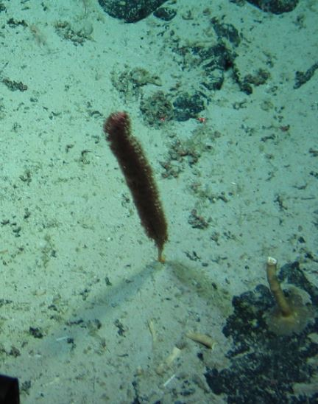
Phylum: Cnidaria  Class: Anthozoa  Subclass: Octocorallia  Order: Pennatulacea  Family: Halipteridae  Genus: Halipteris  Species: finmarchica | Morphospecies code: PENNATULA17  Halipteris cf. finmarchica | Gear:  ROV  Photo by:  Holland I 2018  Identified by:  Raissa Hogan  Dive: 7 | Probably the same as PENNATULA9 (P Keogh) | 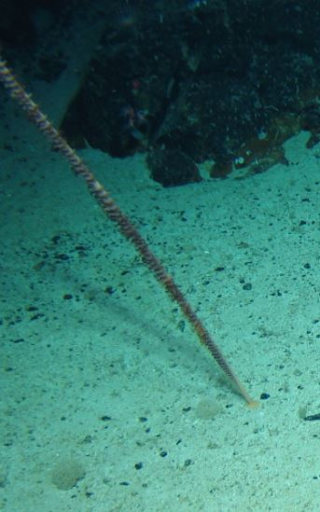
Phylum: Cnidaria  Class: Anthozoa  Subclass: Octocorallia  Order: Pennatulacea  Family: Halipteridae  Genus: Halipteris  Species: | Morphospecies code: PENNATULA18  Halipteris sp. | Gear:  ROV  Photo by:  Holland I 2018  Identified by:  Raissa Hogan  Dive: 7 | Probably the same as PENNATULA9 (P Keogh) | 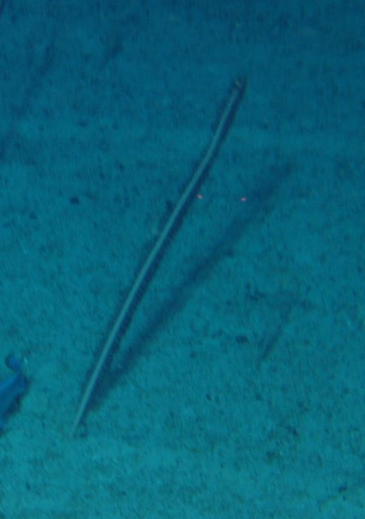
TAXONOMY | NAME | HABITAT | NOTES | IMAGE
Phylum: Cnidaria  Class: Anthozoa  Subclass: Octocorallia  Order: Pennatulacea  Family:  Genus:  Species: | Morphospecies code: PENNATULA19 | Gear:  ROV  Photo by:  Holland I 2018  Identified by:  Poppy Keogh  Dive: 9 |  | 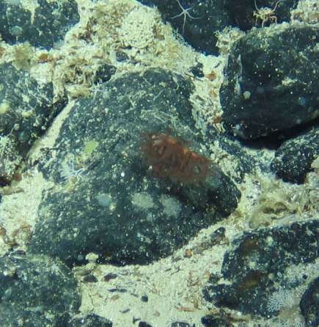
Phylum: Cnidaria  Class: Anthozoa  Subclass: Octocorallia  Order: Pennatulacea  Family: Umbellulidae  Genus: Umbellula  Species: | Morphospecies code: UMBELLULA1  Umbellula sp. | Gear:  ROV  Photo by:  Holland I 2018  Identified by:  Raissa Hogan  Dive: 6 |  | 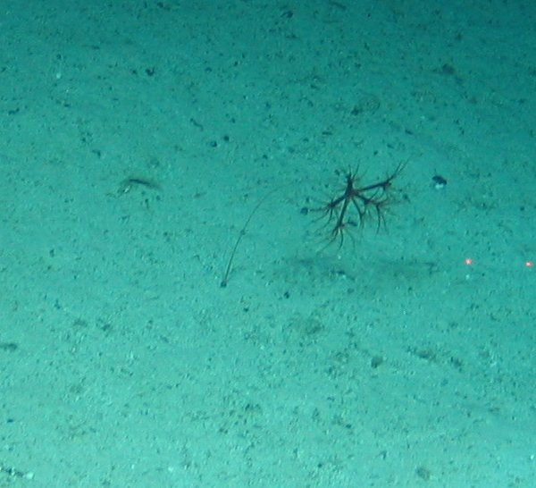
Phylum: Cnidaria  Class:  Subclass:  Order:  Family:  Genus:  Species: | Morphospecies code: CNID1 | Gear:  ROV  Photo by:  Holland I 2018  Identified by:  Poppy Keogh  Dive: 5 |  | 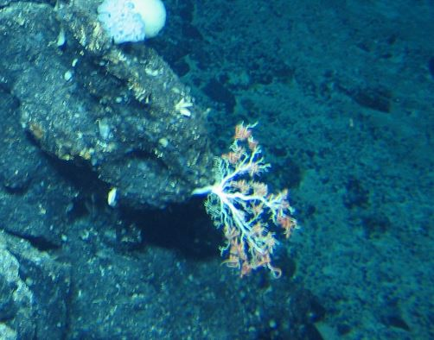
Phylum: Cnidaria  Class:  Subclass:  Order:  Family:  Genus:  Species: | Morphospecies code: CNID3 | Gear:  ROV  Photo by:  Holland I 2018  Identified by:  Poppy Keogh  Dive: 9 |  | 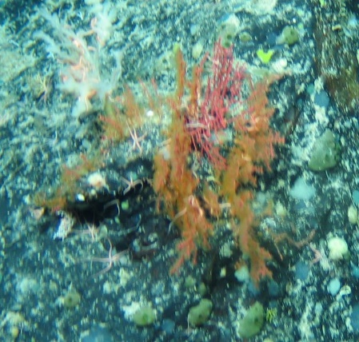
Phylum: Cnidaria  Class:  Subclass:  Order:  Family:  Genus:  Species: | Morphospecies code: CNID7 | Gear:  ROV  Photo by:  Holland I 2018  Identified by:  Poppy Keogh  Dive: 5 |  | 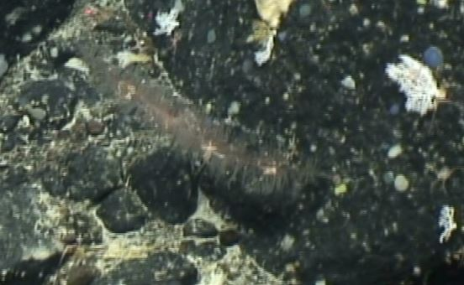
TAXONOMY | NAME | HABITAT | NOTES | IMAGE
Phylum: Cnidaria  Class:  Subclass:  Order:  Family:  Genus:  Species: | Morphospecies code: CNID8 | Gear:  ROV  Photo by:  Holland I 2018  Identified by:  Poppy Keogh  Dive: 5 |  | 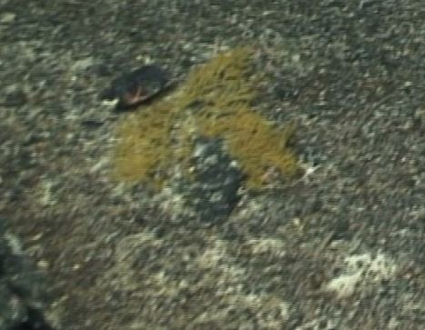
Phylum: Cnidaria  Class:  Subclass:  Order:  Family:  Genus:  Species: | Morphospecies code: CNID9 | Gear:  ROV  Photo by:  Holland I 2018  Identified by:  Poppy Keogh  Dive: 9 |  | 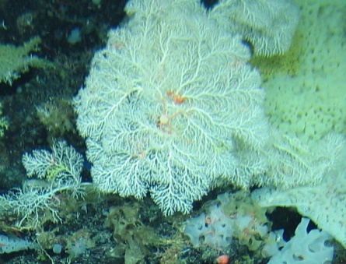
Phylum: Cnidaria  Class:  Subclass:  Order:  Family:  Genus:  Species: | Morphospecies code: CNID10 | Gear:  ROV  Photo by:  Holland I 2018  Identified by:  Poppy Keogh  Dive: 9 |  | 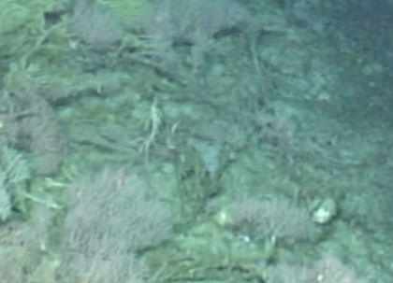
Phylum: Cnidaria  Class:  Subclass:  Order:  Family:  Genus:  Species: | Morphospecies code: CNID11 | Gear:  ROV  Photo by:  Holland I 2018  Identified by:  Poppy Keogh  Dive: 9 |  | 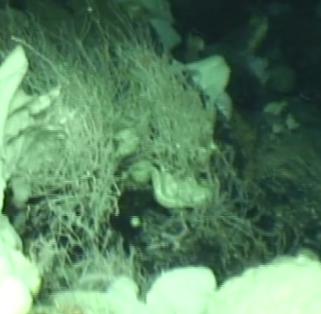
Phylum: Cnidaria  Class: Hydrozoa  Subclass:  Order:  Family:  Genus:  Species: | Morphospecies code: HYDRO1 | Gear:  ROV  Photo by:  Holland I 2018  Identified by:  Poppy Keogh  Dive: 9 |  | 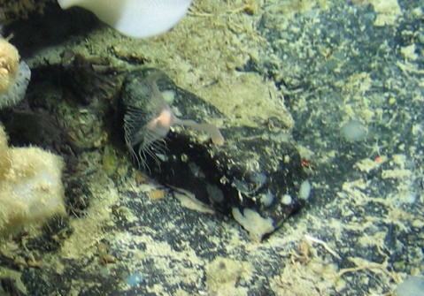
Phylum: Cnidaria  Class: Hydrozoa  Subclass:  Order:  Family:  Genus:  Species: | Morphospecies code: HYDRO2 | Gear:  ROV  Photo by:  Holland I 2018  Identified by:  Poppy Keogh  Dive: 8 | Probably the same as HYDRO1 | 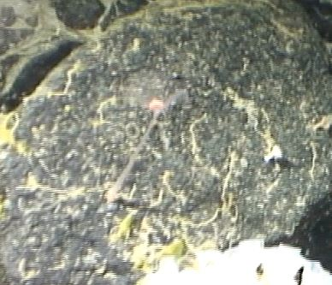
TAXONOMY | NAME | HABITAT | NOTES | IMAGE
Phylum: Echinodermata  Class: Asteroidea  Subclass:  Order:  Family:  Genus:  Species: | Morphospecies code: ASTERO1 | Gear:  ROV  Photo by:  Holland I 2018  Identified by:  Poppy Keogh  Dive: 5 | Possibly a Brisingidae (H. coronate / B. endecacnemos) (P. Keogh) | 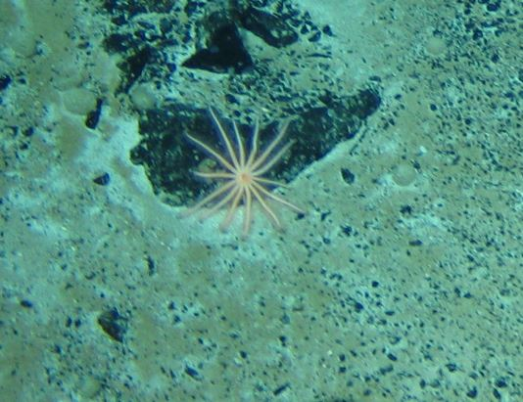
Phylum: Echinodermata  Class: Asteroidea  Subclass:  Order:  Family:  Genus:  Species: | Morphospecies code: ASTERO2 | Gear:  ROV  Photo by:  Holland I 2018  Identified by:  Poppy Keogh  Dive: 5 | Possibly Henricia sanguinolenta (P. Keogh) | 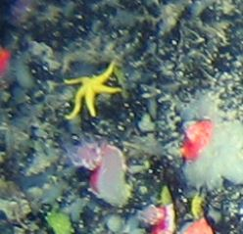
Phylum: Echinodermata  Class: Asteroidea  Subclass:  Order:  Family:  Genus:  Species: | Morphospecies code: ASTERO3 | Gear:  ROV  Photo by:  Holland I 2018  Identified by:  Poppy Keogh  Dive: 5 |  | 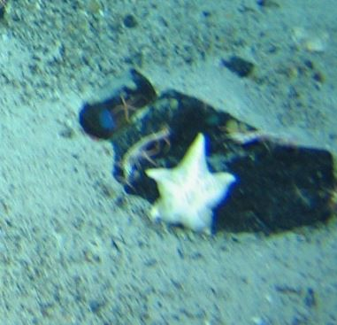
Phylum: Echinodermata  Class: Asteroidea  Subclass:  Order:  Family:  Genus:  Species: | Morphospecies code: ASTERO4 | Gear:  ROV  Photo by:  Holland I 2018  Identified by:  Poppy Keogh  Dive: 5 | Possibly Porania pulvillis (P. Keogh) | 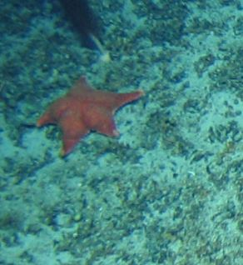
Phylum: Echinodermata  Class: Asteroidea  Subclass:  Order:  Family:  Genus:  Species: | Morphospecies code: ASTERO6 | Gear:  ROV  Photo by:  Holland I 2018  Identified by:  Poppy Keogh  Dive: 6 | Possibly Porania pulvillis (P. Keogh) | 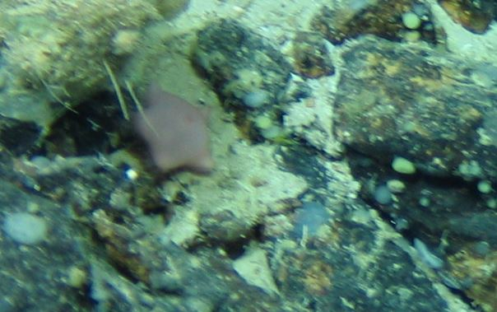
TAXONOMY | NAME | HABITAT | NOTES | IMAGE
Phylum: Echinodermata  Class: Asteroidea  Subclass:  Order:  Family:  Genus:  Species: | Morphospecies code: ASTERO7 | Gear:  ROV  Photo by:  Holland I 2018  Identified by:  Poppy Keogh  Dive: 7 |  | 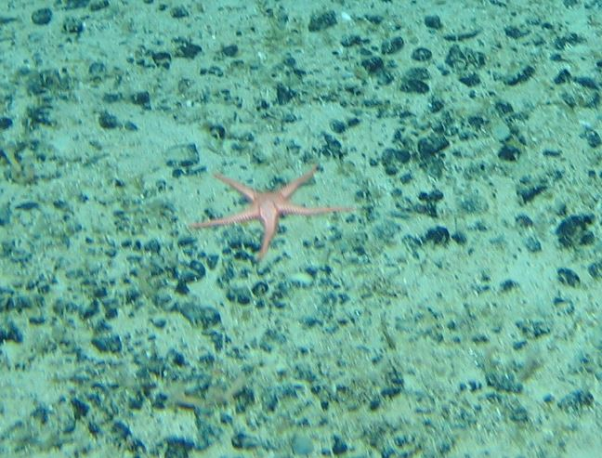
Phylum: Echinodermata  Class: Asteroidea  Subclass:  Order:  Family:  Genus:  Species: | Morphospecies code: ASTERO9 | Gear:  ROV  Photo by:  Holland I 2018  Identified by:  Poppy Keogh  Dive: 6 | Possibly Hymenaster sp. (P. Keogh) | 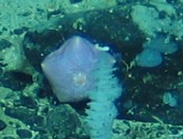
Phylum: Echinodermata  Class: Asteroidea  Subclass:  Order:  Family:  Genus:  Species: | Morphospecies code: ASTERO10 | Gear:  ROV  Photo by:  Holland I 2018  Identified by:  Poppy Keogh  Dive: 7 |  | 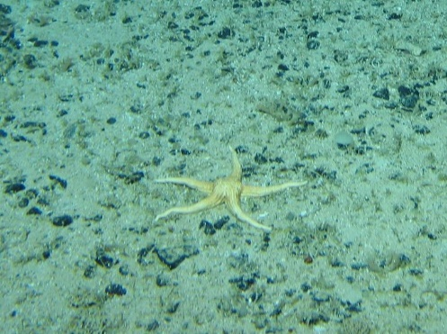
Phylum: Echinodermata  Class: Asteroidea  Subclass:  Order:  Family:  Genus:  Species: | Morphospecies code: ASTERO11 | Gear:  ROV  Photo by:  Holland I 2018  Identified by:  Poppy Keogh  Dive: 6 |  | 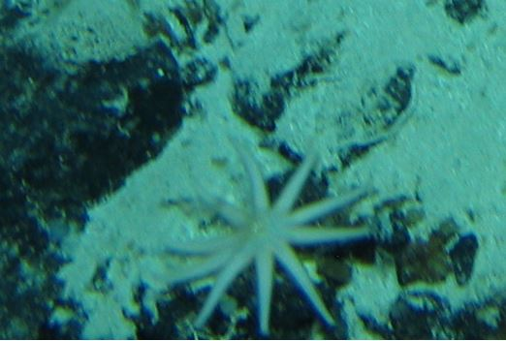
Phylum: Echinodermata  Class: Asteroidea  Subclass:  Order:  Family:  Genus:  Species: | Morphospecies code: ASTERO12 | Gear:  ROV  Photo by:  Holland I 2018  Identified by:  Poppy Keogh  Dive: 6 |  | 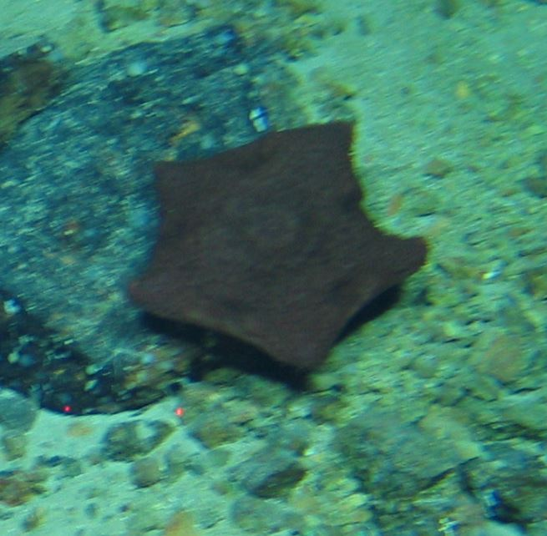
TAXONOMY | NAME | HABITAT | NOTES | IMAGE
Phylum: Echinodermata  Class: Asteroidea  Subclass:  Order:  Family:  Genus:  Species: | Morphospecies code: ASTERO13 | Gear:  ROV  Photo by:  Holland I 2018  Identified by:  Poppy Keogh  Dive: 6 |  | 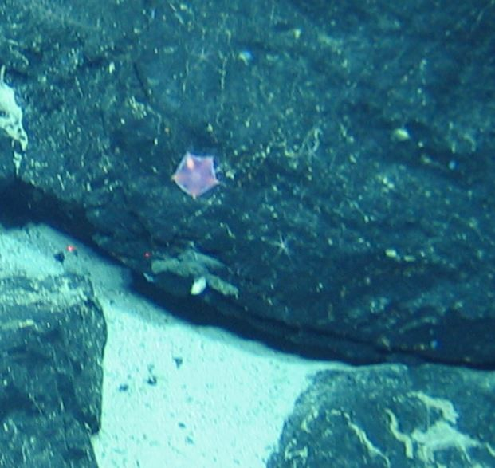
Phylum: Echinodermata  Class: Asteroidea  Subclass:  Order:  Family:  Genus:  Species: | Morphospecies code: ASTERO14 | Gear:  ROV  Photo by:  Holland I 2018  Identified by:  Poppy Keogh  Dive: 7 |  | 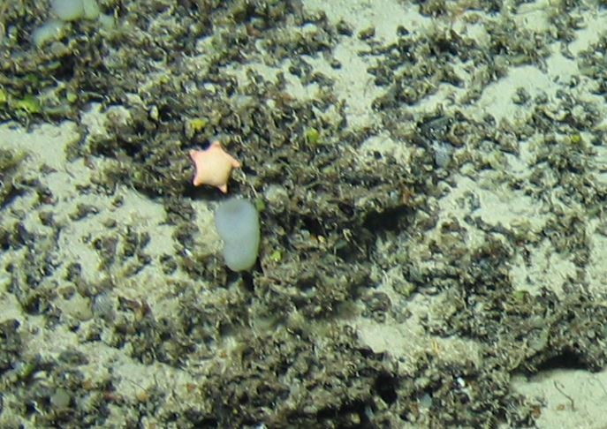
Phylum: Echinodermata  Class: Asteroidea  Subclass:  Order:  Family:  Genus:  Species: | Morphospecies code: ASTERO18 | Gear:  ROV  Photo by:  Holland I 2018  Identified by:  Poppy Keogh  Dive: 5 |  | 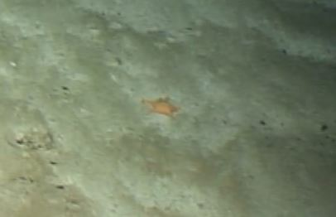
Phylum: Echinodermata  Class: Asteroidea  Subclass:  Order:  Family:  Genus:  Species: | Morphospecies code: ASTERO19 | Gear:  ROV  Photo by:  Holland I 2018  Identified by:  Poppy Keogh  Dive: 8 |  | 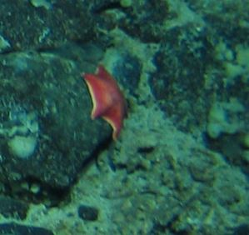
Phylum: Echinodermata  Class: Asteroidea  Subclass:  Order:  Family:  Genus:  Species: | Morphospecies code: ASTERO20 | Gear:  ROV  Photo by:  Holland I 2018  Identified by:  Poppy Keogh  Dive: 8 |  | 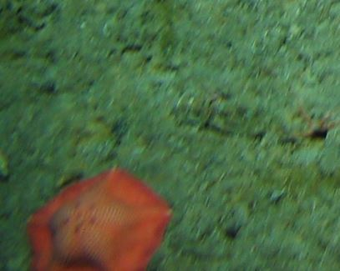
TAXONOMY | NAME | HABITAT | NOTES | IMAGE
Phylum: Echinodermata  Class: Asteroidea  Subclass:  Order:  Family:  Genus:  Species: | Morphospecies code: ASTERO21 | Gear:  ROV  Photo by:  Holland I 2018  Identified by:  Poppy Keogh  Dive: 8 |  | 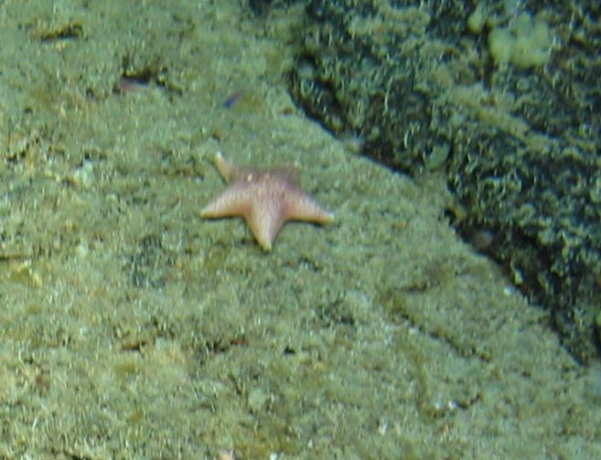
Phylum: Echinodermata  Class: Asteroidea  Subclass:  Order:  Family:  Genus:  Species: | Morphospecies code: ASTERO22 | Gear:  ROV  Photo by:  Holland I 2018  Identified by:  Poppy Keogh  Dive: 8 |  | 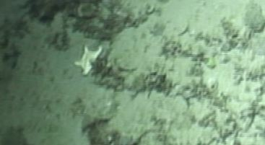
Phylum: Echinodermata  Class: Asteroidea  Subclass:  Order:  Family:  Genus:  Species: | Morphospecies code: ASTERO23 | Gear:  ROV  Photo by:  Holland I 2018  Identified by:  Poppy Keogh  Dive: 9 |  | 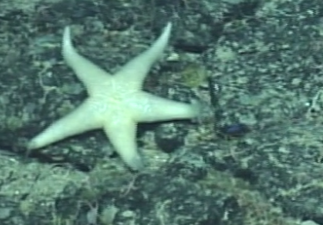
Phylum: Echinodermata  Class: Asteroidea  Subclass:  Order:  Family:  Genus:  Species: | Morphospecies code: ASTERO24 | Gear:  ROV  Photo by:  Holland I 2018  Identified by:  Poppy Keogh  Dive: 7 |  | 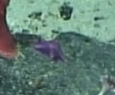
Phylum: Echinodermata  Class: Asteroidea  Subclass:  Order:  Family:  Genus:  Species: | Morphospecies code: ASTERO25 | Gear:  ROV  Photo by:  Holland I 2018  Identified by:  Poppy Keogh  Dive: |  | 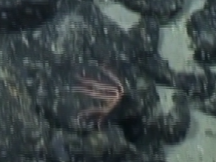
TAXONOMY | NAME | HABITAT | NOTES | IMAGE
Phylum: Echinodermata  Class: Asteroidea  Subclass:  Order: Brisingida  Family: Brisingidae  Genus:  Species: | Morphospecies code: BRISIN1 | Gear:  ROV  Photo by:  Holland I 2018  Identified by:  Poppy Keogh  Dive: 8 | Possibly Novodinia sp. (P. Keogh) | 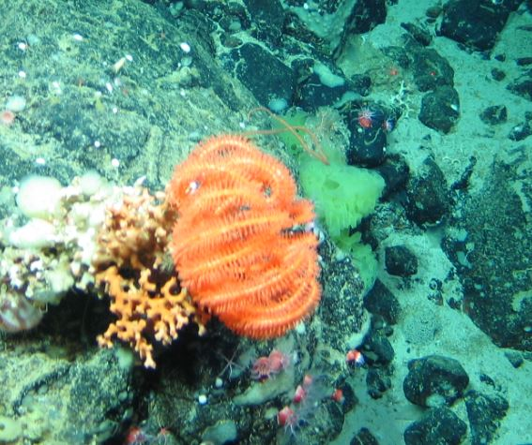
Phylum: Echinodermata  Class: Crinoidea  Subclass:  Order: Hyocrinida  Family: Hyocrinidae  Genus: Anachalypsicrinus  Species: A. nefertiti | Morphospecies code: ANACH  Anachalypsicrinus nefertiti | Gear:  ROV  Photo by:  Holland I 2018  Identified by:  Poppy Keogh  Dive: 6 |  | 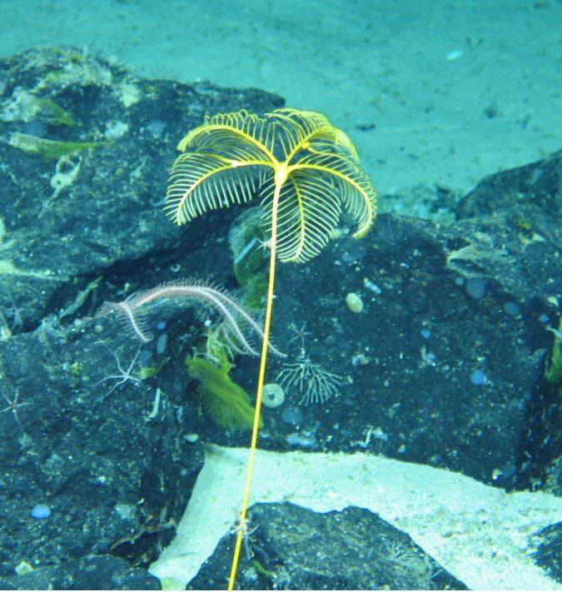
Phylum: Echinodermata  Class: Crinoidea  Subclass:  Order:  Family:  Genus:  Species: | Morphospecies code: CRINO3 | Gear:  ROV  Photo by:  Holland I 2018  Identified by:  Poppy Keogh  Dive: 5 |  | 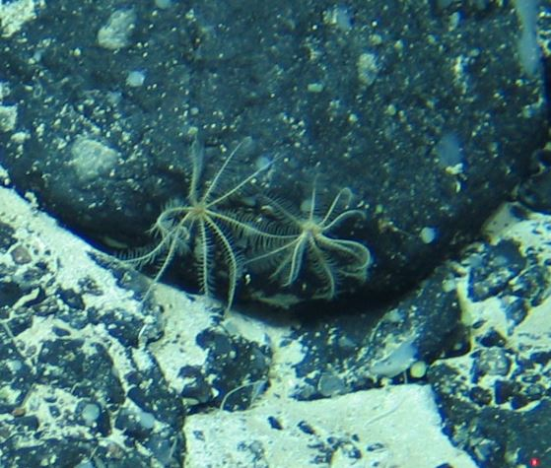
Phylum: Echinodermata  Class: Crinoidea  Subclass:  Order:  Family:  Genus:  Species: | Morphospecies code: CRINO4 | Gear:  ROV  Photo by:  Holland I 2018  Identified by:  Poppy Keogh  Dive: 5 |  | 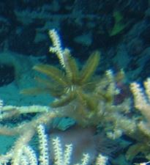
TAXONOMY | NAME | HABITAT | NOTES | IMAGE
Phylum: Echinodermata  Class: Crinoidea  Subclass:  Order: Comatulida  Family: Bathycrinidae  Genus: Bathycrinidae  Species: | Morphospecies code: CRINO6  Bathycrinidae sp. | Gear:  ROV  Photo by:  Holland I 2018  Identified by:  Poppy Keogh  Dive: 7 |  | 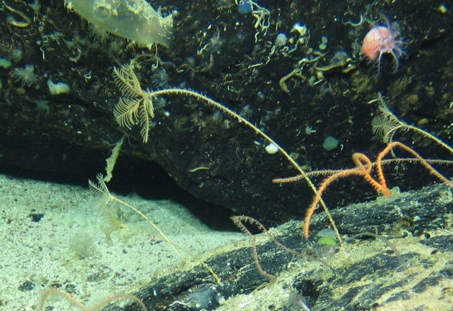
Phylum: Echinodermata  Class: Crinoidea  Subclass:  Order:  Family:  Genus:  Species: | Morphospecies code: CRINO9 | Gear:  ROV  Photo by:  Holland I 2018  Identified by:  Poppy Keogh  Dive: 6 |  | 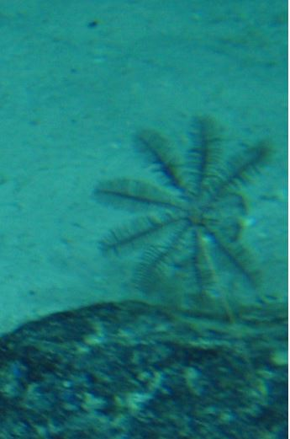
Phylum: Echinodermata  Class: Crinoidea  Subclass:  Order:  Family:  Genus:  Species: | Morphospecies code: CRINO10 | Gear:  ROV  Photo by:  Holland I 2018  Identified by:  Poppy Keogh  Dive: 6 |  | 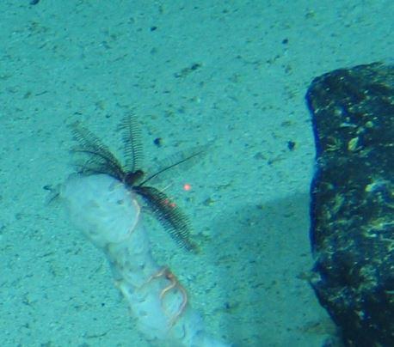
Phylum: Echinodermata  Class: Crinoidea  Subclass:  Order:  Family:  Genus:  Species: | Morphospecies code: CRINO11 | Gear:  ROV  Photo by:  Holland I 2018  Identified by:  Poppy Keogh  Dive: 6 |  | 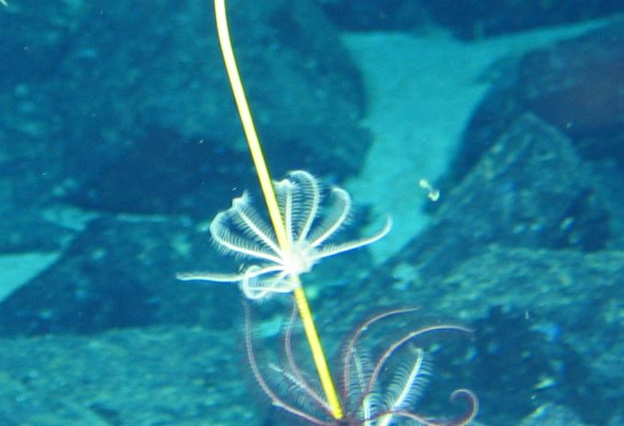
Phylum: Echinodermata  Class: Crinoidea  Subclass:  Order:  Family:  Genus:  Species: | Morphospecies code: CRINO12 | Gear:  ROV  Photo by:  Holland I 2018  Identified by:  Poppy Keogh  Dive: 6 |  | 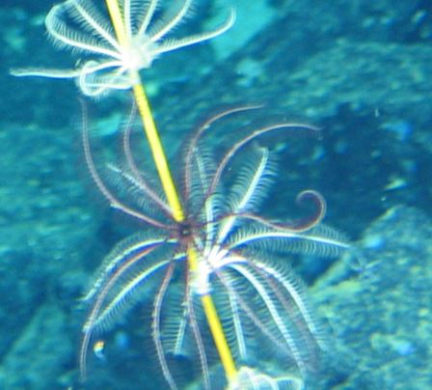
TAXONOMY | NAME | HABITAT | NOTES | IMAGE
Phylum: Echinodermata  Class: Crinoidea  Subclass:  Order:  Family:  Genus:  Species: | Morphospecies code: CRINO13 | Gear:  ROV  Photo by:  Holland I 2018  Identified by:  Poppy Keogh  Dive: 6 |  | 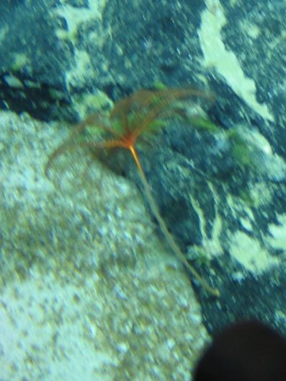
Phylum: Echinodermata  Class: Crinoidea  Subclass:  Order:  Family:  Genus:  Species: | Morphospecies code: CRINO14 | Gear:  ROV  Photo by:  Holland I 2018  Identified by:  Poppy Keogh  Dive: 6 |  | 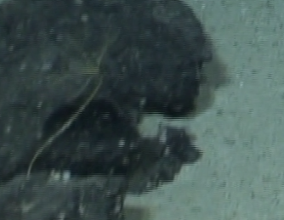
Phylum: Echinodermata  Class: Crinoidea  Subclass:  Order:  Family:  Genus:  Species: | Morphospecies code: CRINO15 | Gear:  ROV  Photo by:  Holland I 2018  Identified by:  Poppy Keogh  Dive: 6 |  | 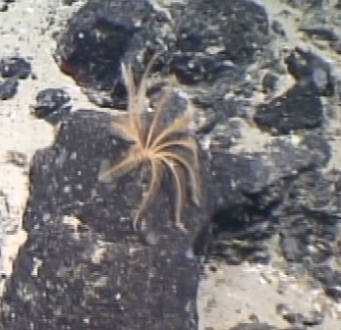
Phylum: Echinodermata  Class: Crinoidea  Subclass:  Order: Comatulida  Family: Pentametrocrinidae  Genus: Pentametrocrinus  Species: P. atlanticus | Morphospecies code: PENTA  Pentametrocrinus atlanticus | Gear:  ROV  Photo by:  Holland I 2018  Identified by:  Poppy Keogh  Dive: 5 |  | 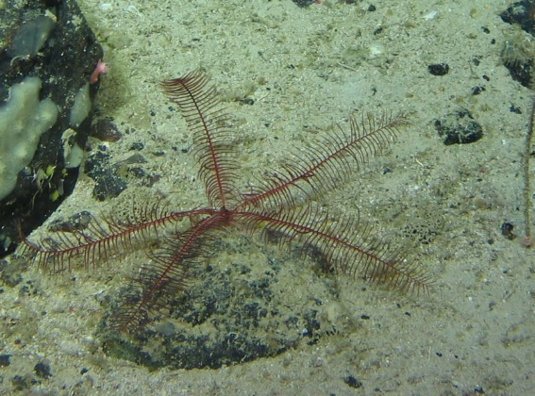
TAXONOMY | NAME | HABITAT | NOTES | IMAGE
Phylum: Echinodermata  Class: Crinoidea  Subclass:  Order: Comatulida  Family: Septocrinidae  Genus: Zeuctocrinus  Species: Z. gisleni | Morphospecies code: ZEUCT  Zeuctocrinus gisleni | Gear:  ROV  Photo by:  Holland I 2018  Identified by:  Poppy Keogh  Dive: 5 |  | 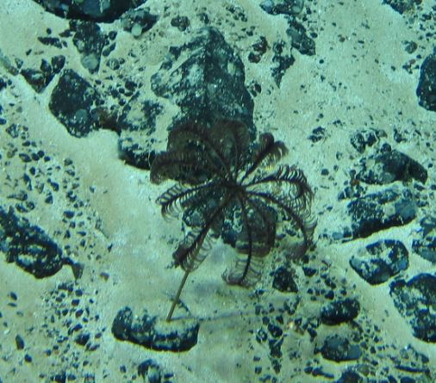
Phylum: Echinodermata  Class: Echinoidea  Subclass:  Order:  Family:  Genus:  Species: | Morphospecies code: ECHINO1 | Gear:  ROV  Photo by:  Holland I 2018  Identified by:  Poppy Keogh  Dive: 6 | Possibly Echinothuroidea sp. | 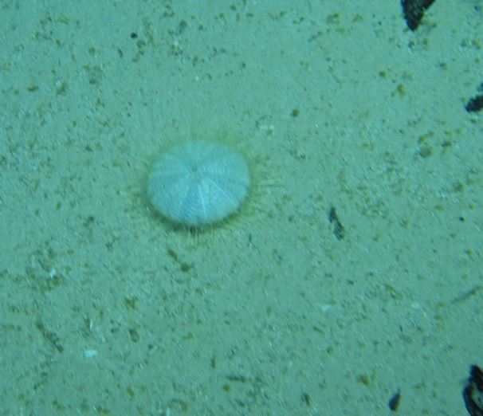
Phylum: Echinodermata  Class: Echinoidea  Subclass:  Order:  Family:  Genus:  Species: | Morphospecies code: ECHINO2 | Gear:  ROV  Photo by:  Holland I 2018  Identified by:  Poppy Keogh  Dive: 6 |  | 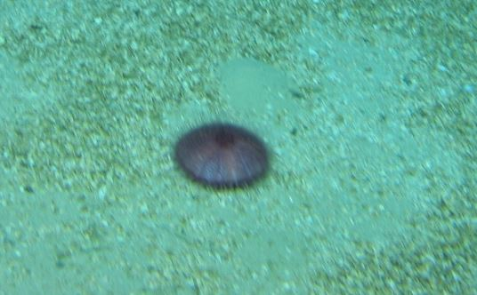
Phylum: Echinodermata  Class: Echinoidea  Subclass:  Order:  Family:  Genus:  Species: | Morphospecies code: ECHINO3 | Gear:  ROV  Photo by:  Holland I 2018  Identified by:  Poppy Keogh  Dive: 7 |  | 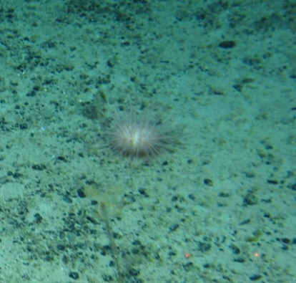
Phylum: Echinodermata  Class: Echinoidea  Subclass:  Order:  Family:  Genus: Echinus  Species: | Morphospecies code: ECHINO4  cf. Echinus dp. | Gear:  ROV  Photo by:  Holland I 2018  Identified by:  Poppy Keogh  Dive: 5 |  | 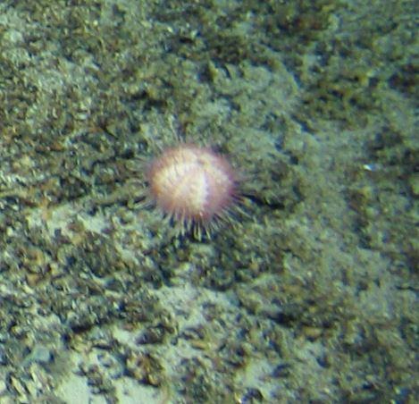
TAXONOMY | NAME | HABITAT | NOTES | IMAGE
Phylum: Echinodermata  Class: Echinoidea  Subclass:  Order:  Family:  Genus:  Species: | Morphospecies code: ECHINO5 | Gear:  ROV  Photo by:  Holland I 2018  Identified by:  Poppy Keogh  Dive: 7 |  | 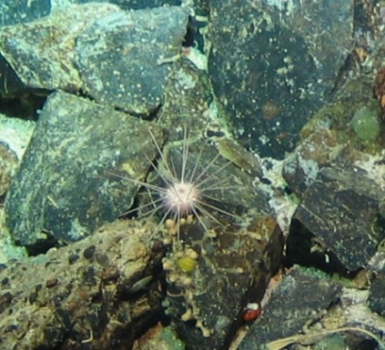
Phylum: Echinodermata  Class: Echinoidea  Subclass:  Order:  Family:  Genus:  Species: | Morphospecies code: ECHINO6 | Gear:  ROV  Photo by:  Holland I 2018  Identified by:  Poppy Keogh  Dive: 8 |  | 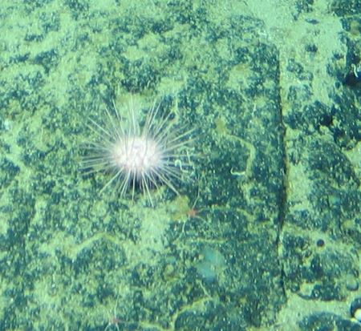
Phylum: Echinodermata  Class: Holothuroidea  Subclass: Actinopoda  Order: Synallactida  Family: Synallactidae  Genus: Synallactes  Species: | Morphospecies code: HOLO1  cf. Synallactes sp. | Gear:  ROV  Photo by:  Holland I 2018  Identified by:  Poppy Keogh  Dive: 5 |  | 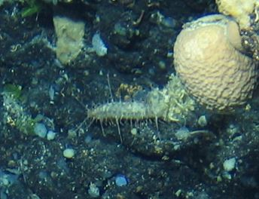
Phylum: Echinodermata  Class: Holothuroidea  Subclass:  Order:  Family:  Genus: Psolus  Species: | Morphospecies code: HOLO2  Psolus sp. | Gear:  ROV  Photo by:  Holland I 2018  Identified by:  Poppy Keogh  Dive: 8 |  | 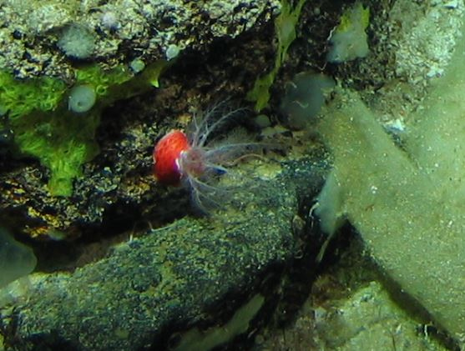
Phylum: Echinodermata  Class: Holothuroidea  Subclass:  Order:  Family:  Genus:  Species: | Morphospecies code: HOLO4 | Gear:  ROV  Photo by:  Holland I 2018  Identified by:  Poppy Keogh  Dive: 6 |  | 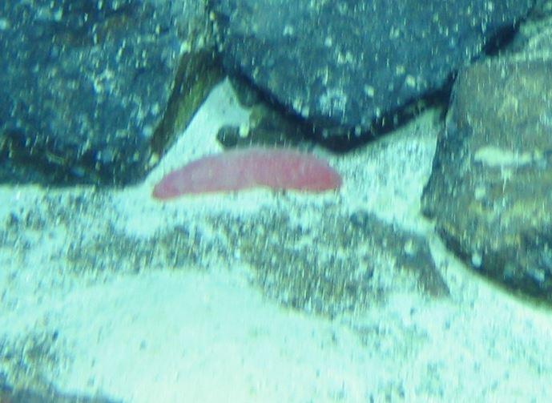
TAXONOMY | NAME | HABITAT | NOTES | IMAGE
Phylum: Echinodermata  Class: Holothuroidea  Subclass: Actinopoda  Order: Elasipodida  Family: Laetmogonidae  Genus: Benthogone  Species: | Morphospecies code: HOLO5  cf. Benthogone sp. | Gear:  ROV  Photo by:  Holland I 2018  Identified by:  Poppy Keogh  Dive: 7 |  | 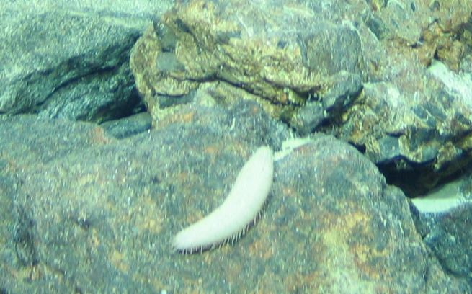
Phylum: Echinodermata  Class: Holothuroidea  Subclass: Actinopoda  Order: Elasipodida  Family: Elpidiidae  Genus: Amperima  Species: | Morphospecies code: HOLO6  cf. Amperima sp. | Gear:  ROV  Photo by:  Holland I 2018  Identified by:  Poppy Keogh  Dive: 7 |  | 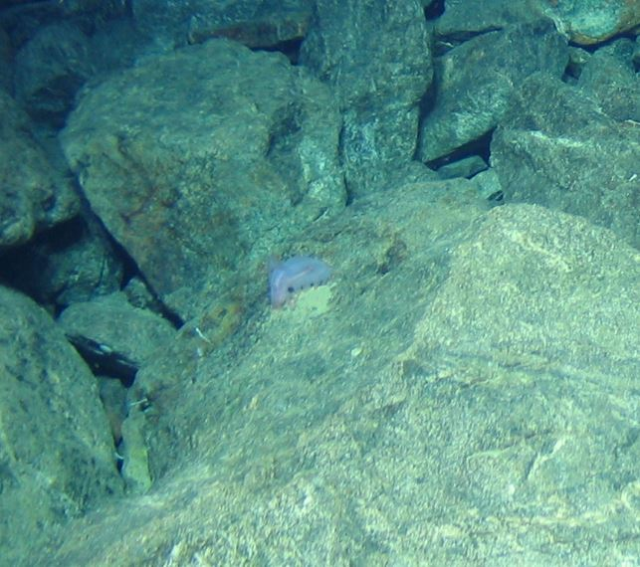
Phylum: Echinodermata  Class: Holothuroidea  Subclass:  Order:  Family:  Genus:  Species: | Morphospecies code: HOLO7 | Gear:  ROV  Photo by:  Holland I 2018  Identified by:  Poppy Keogh  Dive: 6 |  | 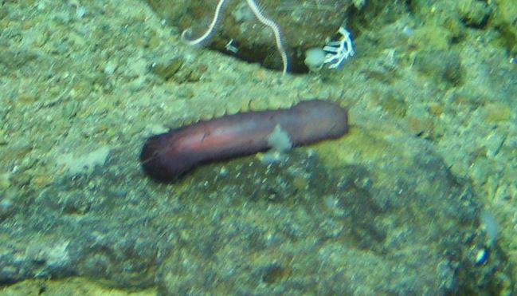
Phylum: Echinodermata  Class: Holothuroidea  Subclass:  Order:  Family:  Genus:  Species: | Morphospecies code: HOLO8 | Gear:  ROV  Photo by:  Holland I 2018  Identified by:  Poppy Keogh  Dive: 6 |  | 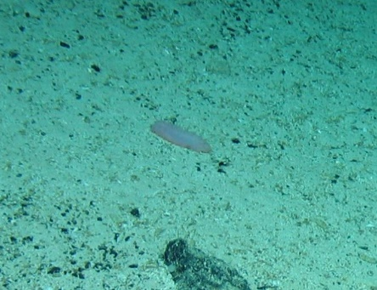
Phylum: Echinodermata  Class: Holothuroidea  Subclass:  Order:  Family:  Genus:  Species: | Morphospecies code: HOLO10 | Gear:  ROV  Photo by:  Holland I 2018  Identified by:  Poppy Keogh  Dive: 6 |  | 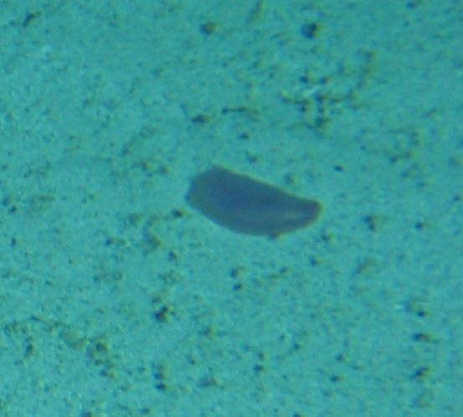
TAXONOMY | NAME | HABITAT | NOTES | IMAGE
Phylum: Echinodermata  Class: Holothuroidea  Subclass:  Order:  Family:  Genus:  Species: | Morphospecies code: HOLO11 | Gear:  ROV  Photo by:  Holland I 2018  Identified by:  Poppy Keogh  Dive: 8 |  | 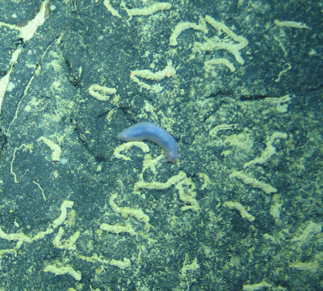
Phylum: Echinodermata  Class: Holothuroidea  Subclass:  Order:  Family:  Genus:  Species: | Morphospecies code: HOLO12 | Gear:  ROV  Photo by:  Holland I 2018  Identified by:  Poppy Keogh  Dive: 8 |  | 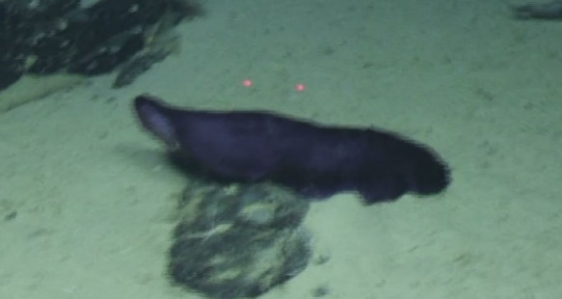
Phylum: Echinodermata  Class: Holothuroidea  Subclass: Actinopoda  Order: Holothuriida  Family: Mesothuriidae  Genus: Mesothuria  Species: M. intestinalis | Morphospecies code: HOLO13  cf. Mesothuria intestinalis | Gear:  ROV  Photo by:  Holland I 2018  Identified by:  Poppy Keogh  Dive: 8 |  | 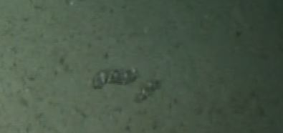
Phylum: Echinodermata  Class: Ophiuroidea  Subclass:  Order:  Family:  Genus:  Species: | Morphospecies code: OPHIURO1 | Gear:  ROV  Photo by:  Holland I 2018  Identified by:  Poppy Keogh  Dive: 5 |  | 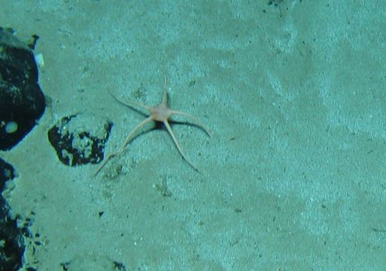
Phylum: Echinodermata  Class: Ophiuroidea  Subclass:  Order:  Family:  Genus:  Species: | Morphospecies code: OPHIURO2 | Gear:  ROV  Photo by:  Holland I 2018  Identified by:  Poppy Keogh  Dive: 5 |  | 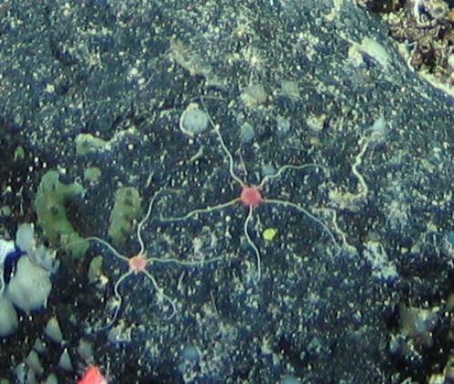
TAXONOMY | NAME | HABITAT | NOTES | IMAGE
Phylum: Echinodermata  Class: Ophiuroidea  Subclass:  Order:  Family:  Genus:  Species: | Morphospecies code: OPHIURO3 | Gear:  ROV  Photo by:  Holland I 2018  Identified by:  Poppy Keogh  Dive: 6 |  | 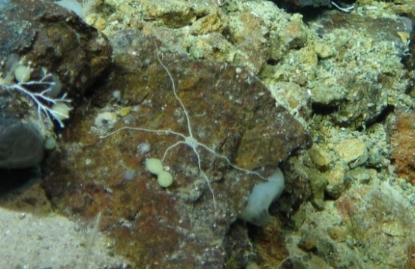
Phylum: Echinodermata  Class: Ophiuroidea  Subclass:  Order:  Family:  Genus:  Species: | Morphospecies code: OPHIURO4 | Gear:  ROV  Photo by:  Holland I 2018  Identified by:  Poppy Keogh  Dive: 6 |  | 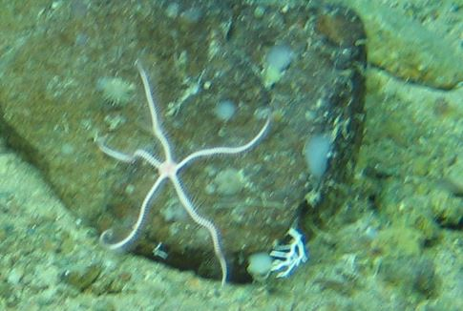
Phylum: Echinodermata  Class: Ophiuroidea  Subclass:  Order:  Family:  Genus:  Species: | Morphospecies code: OPHIURO5 | Gear:  ROV  Photo by:  Holland I 2018  Identified by:  Poppy Keogh  Dive: 6 |  | 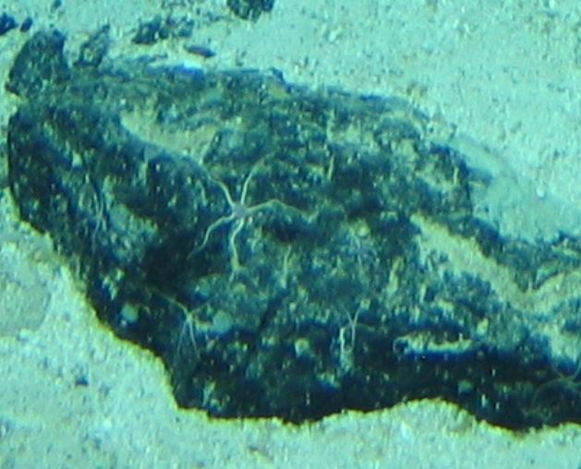
Phylum: Echinodermata  Class: Ophiuroidea  Subclass:  Order:  Family:  Genus:  Species: | Morphospecies code: OPHIURO7 | Gear:  ROV  Photo by:  Holland I 2018  Identified by:  Poppy Keogh  Dive: 6 |  | 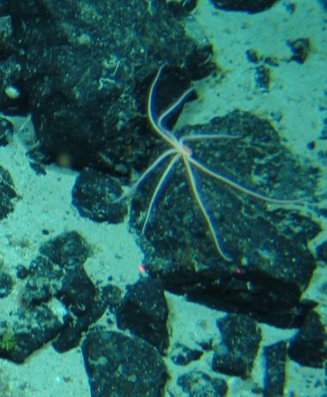
Phylum: Echinodermata  Class: Ophiuroidea  Subclass:  Order:  Family:  Genus:  Species: | Morphospecies code: OPHIURO8 | Gear:  ROV  Photo by:  Holland I 2018  Identified by:  Poppy Keogh  Dive: 9 |  | 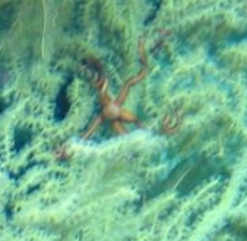
TAXONOMY | NAME | HABITAT | NOTES | IMAGE
Phylum: Chordata  Class: Ascidiacea  Order:  Family:  Genus:  Species: | Morphospecies code: ASCID  Ascidiacea spp. | Gear:  ROV  Photo by:  Holland I 2018  Identified by: Poppy Keogh  Dive: 6 |  | 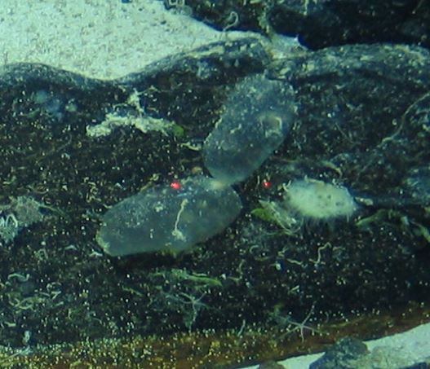
Phylum: Chordata  Class: Actinopterygii  Order:  Family:  Genus:  Species: | Morphospecies code: ACTP1 | Gear:  ROV  Photo by:  Holland I 2018  Identified by: Poppy Keogh  Dive: 7 | Blue Hake (P. Keogh) | 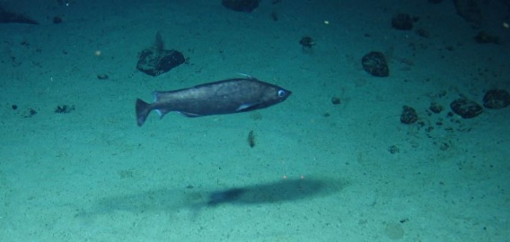
Phylum: Chordata  Class: Actinopterygii  Order:  Family:  Genus:  Species: | Morphospecies code: ACTP2 | Gear:  ROV  Photo by:  Holland I 2018  Identified by: Poppy Keogh  Dive: 7 |  | 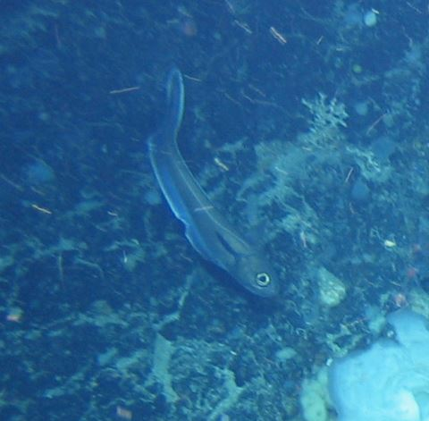
Phylum: Chordata  Class: Actinopterygii  Order:  Family:  Genus:  Species: | Morphospecies code: ACTP3 | Gear:  ROV  Photo by:  Holland I 2018  Identified by: Poppy Keogh  Dive: 6 |  | 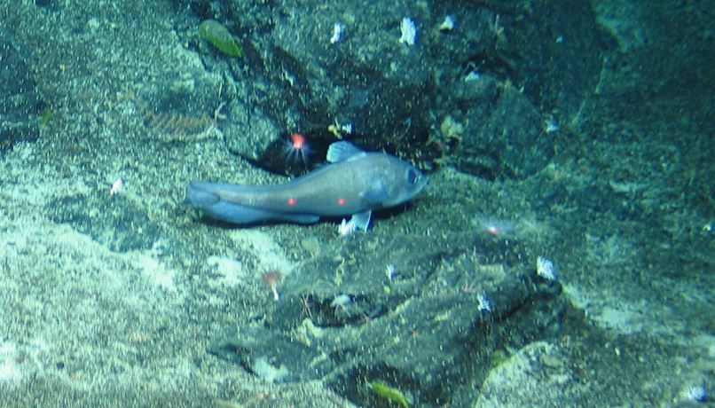
Phylum: Chordata  Class: Actinopterygii  Order:  Family:  Genus:  Species: | Morphospecies code: ACTP4 | Gear:  ROV  Photo by:  Holland I 2018  Identified by: Poppy Keogh  Dive: 6 |  | 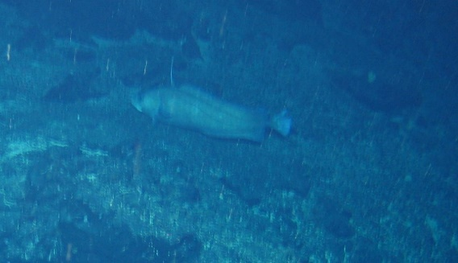
TAXONOMY | NAME | HABITAT | NOTES | IMAGE
Phylum: Chordata  Class: Actinopterygii  Order:  Family:  Genus:  Species: | Morphospecies code: ACTP5 | Gear:  ROV  Photo by:  Holland I 2018  Identified by: Poppy Keogh  Dive: 5 |  | 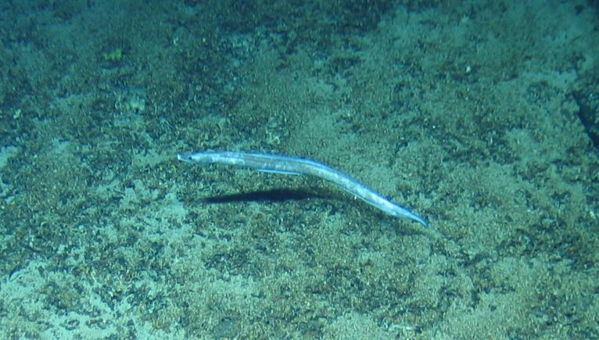
Phylum: Chordata  Class: Actinopterygii  Order:  Family:  Genus:  Species: | Morphospecies code: ACTP6 | Gear:  ROV  Photo by:  Holland I 2018  Identified by: Poppy Keogh  Dive: 5 |  | 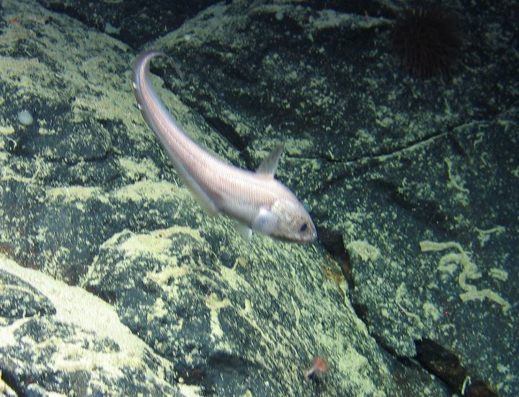
Phylum: Chordata  Class: Actinopterygii  Order:  Family:  Genus:  Species: | Morphospecies code: ACTP7 | Gear:  ROV  Photo by:  Holland I 2018  Identified by: Poppy Keogh  Dive: 6 |  | 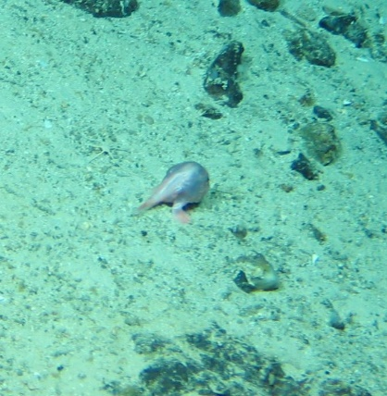
Phylum: Chordata  Class: Actinopterygii  Order:  Family:  Genus:  Species: | Morphospecies code: ACTP8 | Gear:  ROV  Photo by:  Holland I 2018  Identified by: Poppy Keogh  Dive: 7 |  | 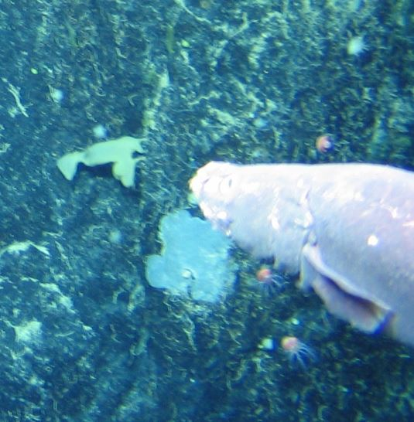
Phylum: Chordata  Class: Actinopterygii  Order:  Family:  Genus:  Species: | Morphospecies code: ACTP9 | Gear:  ROV  Photo by:  Holland I 2018  Identified by: Poppy Keogh  Dive: 6 |  | 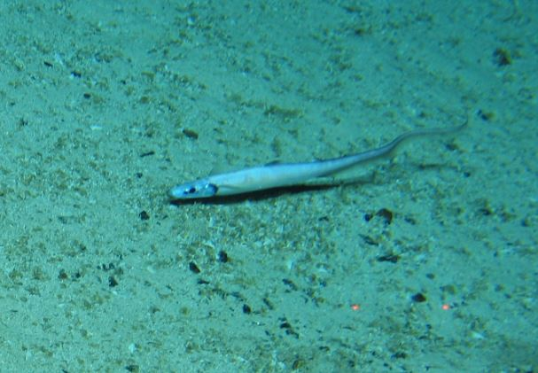
TAXONOMY | NAME | HABITAT | NOTES | IMAGE
Phylum: Chordata  Class: Actinopterygii  Order:  Family:  Genus:  Species: | Morphospecies code: ACTP10 | Gear:  ROV  Photo by:  Holland I 2018  Identified by: Poppy Keogh  Dive: 7 |  | 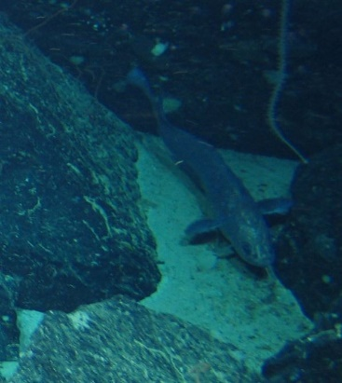
Phylum: Chordata  Class: Actinopterygii  Order:  Family:  Genus:  Species: | Morphospecies code: ACTP11 | Gear:  ROV  Photo by:  Holland I 2018  Identified by: Poppy Keogh  Dive: 7 |  | 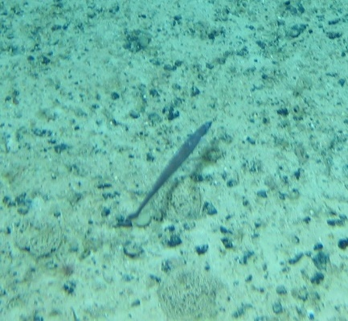
Phylum: Chordata  Class: Actinopterygii  Order:  Family:  Genus:  Species: | Morphospecies code: ACTP14 | Gear:  ROV  Photo by:  Holland I 2018  Identified by: Poppy Keogh  Dive: 8 | Possibly Sebastes mentella (P. Keogh) | 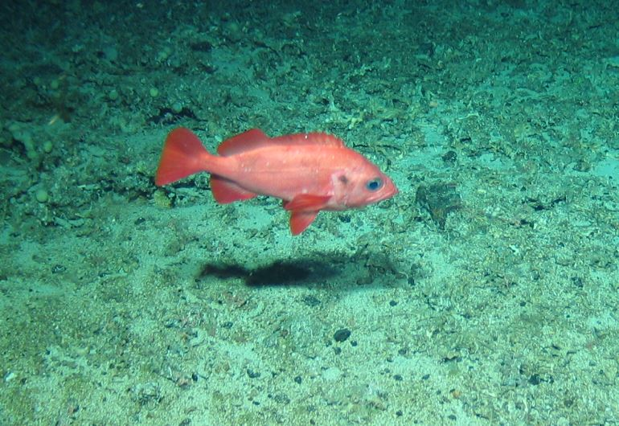
Phylum: Chordata  Class: Actinopterygii  Order:  Family:  Genus:  Species: | Morphospecies code: ACTP15 | Gear:  ROV  Photo by:  Holland I 2018  Identified by: Poppy Keogh  Dive: 7 |  | 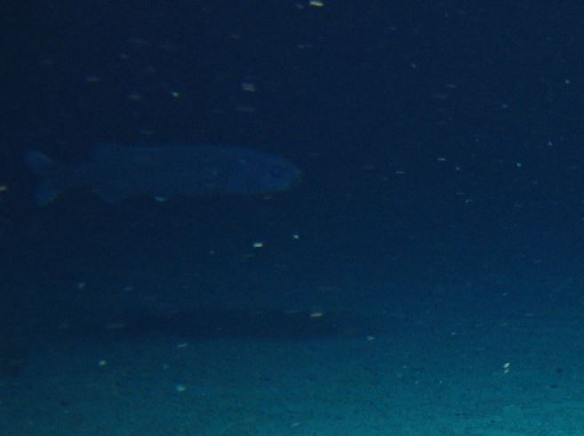
Phylum: Chordata  Class: Actinopterygii  Order:  Family:  Genus:  Species: | Morphospecies code: ACTP16 | Gear:  ROV  Photo by:  Holland I 2018  Identified by: Poppy Keogh  Dive: 8 |  | 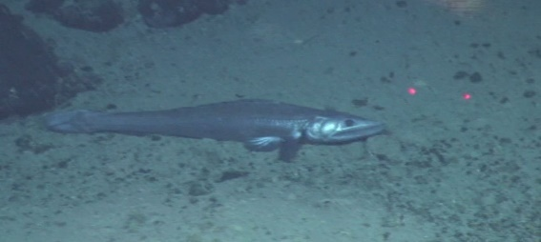
TAXONOMY | NAME | HABITAT | NOTES | IMAGE
Phylum: Chordata  Class: Actinopterygii  Order:  Family:  Genus:  Species: | Morphospecies code: ACTP17 | Gear:  ROV  Photo by:  Holland I 2018  Identified by: Poppy Keogh  Dive: 5 |  | 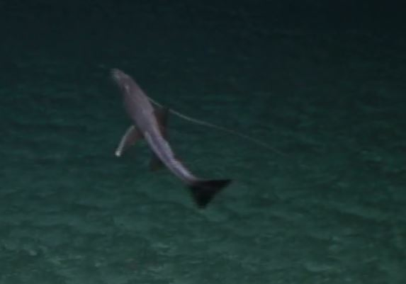
Phylum: Chordata  Class: Actinopterygii  Order:  Family:  Genus:  Species: | Morphospecies code: ACTP18 | Gear:  ROV  Photo by:  Holland I 2018  Identified by: Poppy Keogh  Dive: 8 |  | 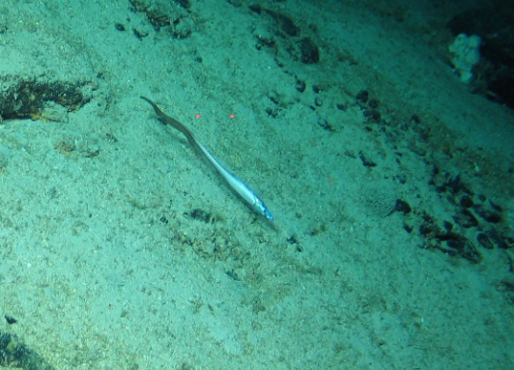
Phylum: Chordata  Class: Actinopterygii  Order:  Family:  Genus:  Species: | Morphospecies code: ACTP19 | Gear:  ROV  Photo by:  Holland I 2018  Identified by: Poppy Keogh  Dive: 8 |  | 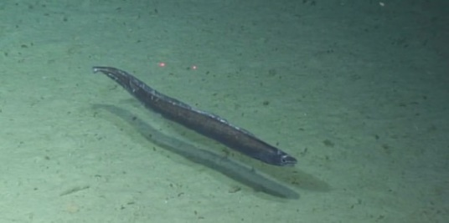
Phylum: Chordata  Class: Actinopterygii  Order:  Family:  Genus:  Species: | Morphospecies code: ACTP20 | Gear:  ROV  Photo by:  Holland I 2018  Identified by: Poppy Keogh  Dive: 8 |  | 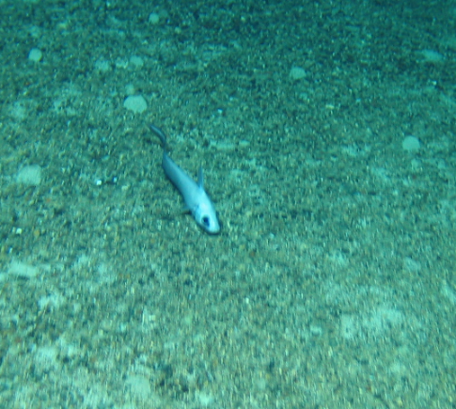
Phylum: Chordata  Class: Actinopterygii  Order: Trachichthyiformes  Family: Trachichthyidae  Genus: Hoplostethus  Species: H. atlanticus | Morphospecies code: ACTP21  cf. Hoplostethus atlanticus | Gear:  ROV  Photo by:  Holland I 2018  Identified by: Poppy Keogh  Dive: 8 | Orange Roughy (P. Keogh) | 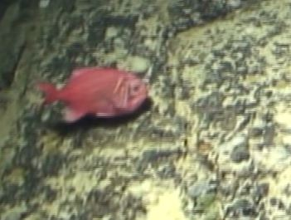
TAXONOMY | NAME | HABITAT | NOTES | IMAGE
Phylum: Chordata  Class: Actinopterygii  Order:  Family:  Genus:  Species: | Morphospecies code: ACTP22 | Gear:  ROV  Photo by:  Holland I 2018  Identified by: Poppy Keogh  Dive: 8 | Possibly the same as ACTP21, Orange Roughy (P. Keogh) | 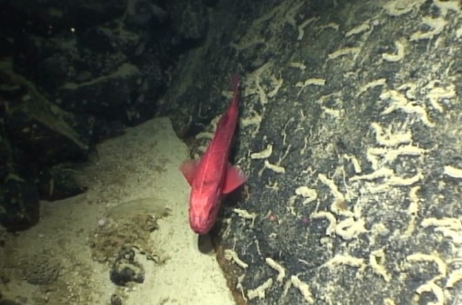
Phylum: Chordata  Class: Actinopterygii  Order:  Family:  Genus:  Species: | Morphospecies code: ACTP23 | Gear:  ROV  Photo by:  Holland I 2018  Identified by: Poppy Keogh  Dive: 9 |  | 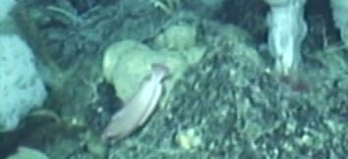
Phylum: Chordata  Class: Actinopterygii  Order:  Family:  Genus:  Species: | Morphospecis code: ACTP24 | Gear:  ROV  Photo by:  Holland I 2018  Identified by: Poppy Keogh  Dive: 9 |  | 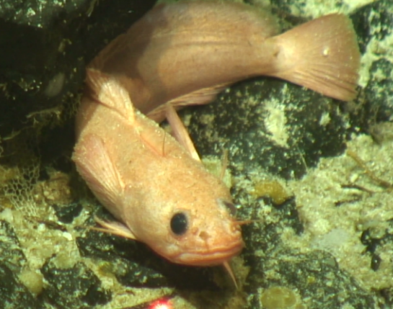
Phylum: Chordata  Class: Actinopterygii  Order: Gadiformes  Family: Macrouridae  Genus:  Species: | Morphospecies code: GRENADIER | Gear:  ROV  Photo by:  Holland I 2018  Identified by: Poppy Keogh  Dive: 7 |  | 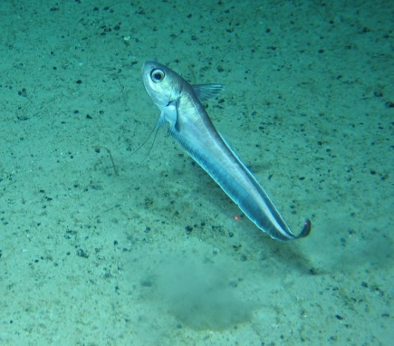
Phylum: Chordata  Class: Actinopterygii  Order: Notacanthiformes  Family: Halosauridae  Genus:  Species: | Morphospecies code: HALOSAURIDAE  Halosauridae sp. | Gear:  ROV  Photo by:  Holland I 2018  Identified by: Poppy Keogh  Dive: 5 |  | 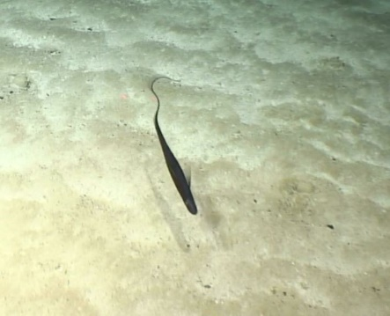
TAXONOMY | NAME | HABITAT | NOTES | IMAGE
Phylum: Chordata  Class: Actinopterygii  Order: Gadiformes  Family: Moridae  Genus: Lepidion  Species: | Morphospecies code: LEPIDION  Lepidion sp. | Gear:  ROV  Photo by:  Holland I 2018  Identified by: Poppy Keogh  Dive: 7 |  | 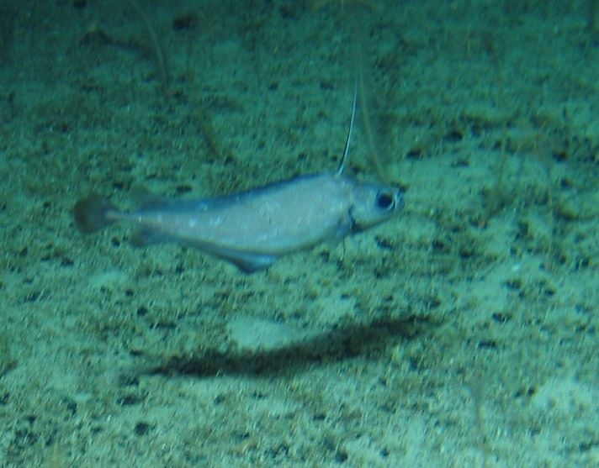
Phylum: Chordata  Class: Actinopterygii  Order: Zeiformes  Family: Oreosomatidae  Genus: Neocyttus  Species: N. helgae | Morphospecies code: OREO  Neocyttus helgae | Gear:  ROV  Photo by:  Holland I 2018  Identified by: Poppy Keogh  Dive: 7 | Common name is Oreo (P. Keogh) | 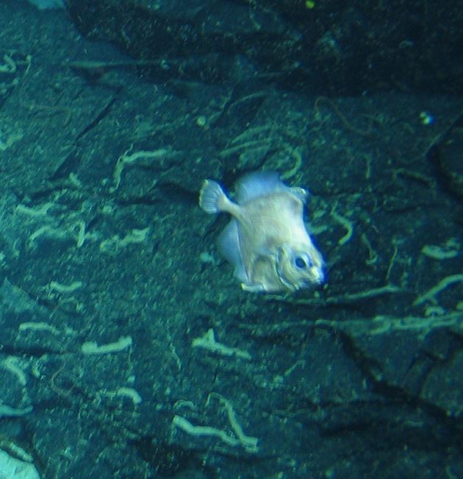
Phylum: Foraminifera  Class: Xenophyophorea  Order:  Family:  Genus:  Species: | Morphospecies code: FORAM | Gear:  ROV  Photo by:  Holland I 2018  Identified by: Poppy Keogh  Dive: 8 |  | 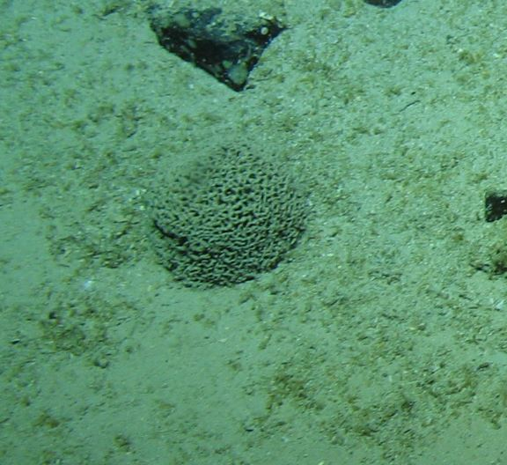
Phylum: Annelida  Class: Polychaeta  Order: Sabellida  Family: Sabellidae  Genus:  Species: | Morphospecies code: SABELLI | Gear:  ROV  Photo by:  Holland I 2018  Identified by: Poppy Keogh  Dive: 6 |  | 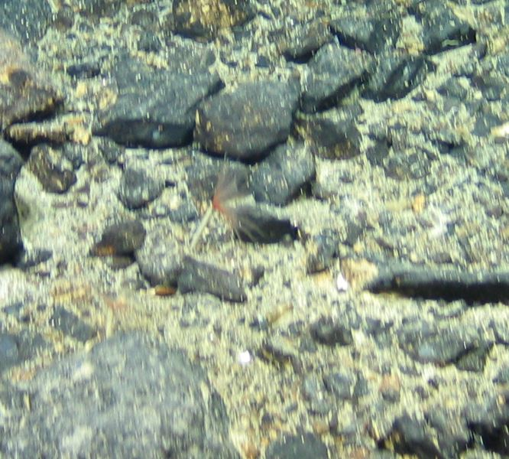
TAXONOMY | NAME | HABITAT | NOTES | IMAGE
Phylum: Arthropoda  Class: Pycnogonida  Order: Pantopoda  Family: Colossendeidae  Genus: Colossendeis  Species: | Morphospecies code: COLOS  Colossendeis sp. | Gear:  ROV  Photo by:  Holland I 2018  Identified by: Jamie Maxwell  Dive: 6 |  | 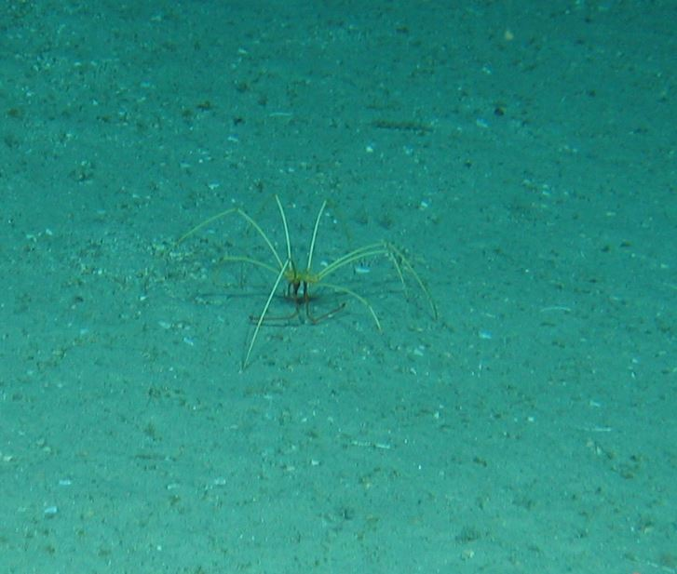
Phylum: Arthropoda  Class: Malacostraca  Order: Decapoda  Family: Chirostylidae  Genus: Chirostylidae  Species: | Morphospecies code: CRAB1  Chirostylidae sp. | Gear:  ROV  Photo by:  Holland I 2018  Identified by: Poppy Keogh  Dive: 5 |  | 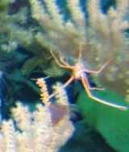
Phylum: Arthropoda  Class: Malacostraca  Order: Decapoda  Family: Munidopsidae  Genus: Munidopsis  Species: | Morphospecies code: CRAB2  Munidopsis sp. | Gear:  ROV  Photo by:  Holland I 2018  Identified by: Poppy Keogh  Dive: 5 |  | 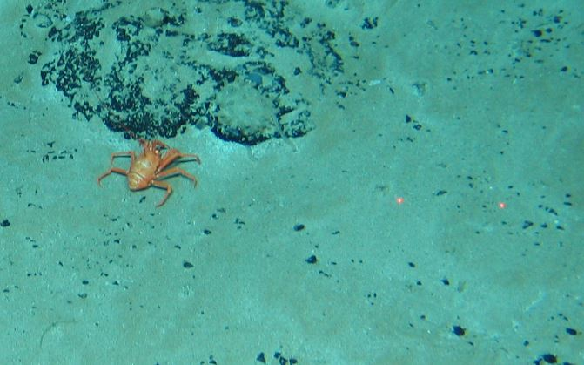
Phylum: Arthropoda  Class: Malacostraca  Order: Decapoda  Family:  Genus:  Species: | Morphospecies code: CRAB3 | Gear:  ROV  Photo by:  Holland I 2018  Identified by: Poppy Keogh  Dive: 5 |  | 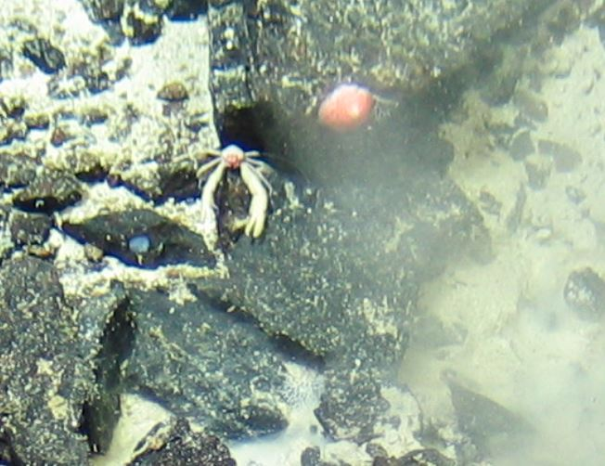
Phylum: Arthropoda  Class: Malacostraca  Order: Decapoda  Family: Paguridae  Genus:  Species: | Morphospecies code: CRAB4 | Gear:  ROV  Photo by:  Holland I 2018  Identified by: Poppy Keogh  Dive: 6 |  | 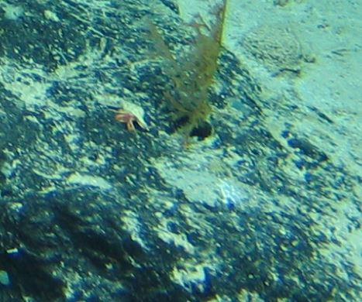
TAXONOMY | NAME | HABITAT | NOTES | IMAGE
Phylum: Arthropoda  Class: Malacostraca  Order: Decapoda  Family: Munididae  Genus: Munida  Species: | Morphospecies code: CRAB5  Munida sp | Gear:  ROV  Photo by:  Holland I 2018  Identified by: Poppy Keogh  Dive: 8 |  | 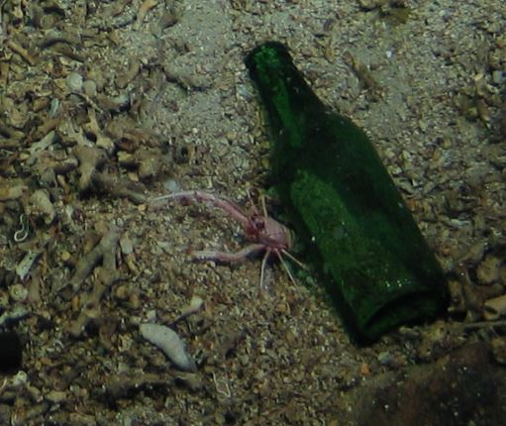
Phylum: Arthropoda  Class: Malacostraca  Order: Decapoda  Family:  Genus:  Species: | Morphospecies code: CRAB6 | Gear:  ROV  Photo by:  Holland I 2018  Identified by: Poppy Keogh  Dive: 9 |  | 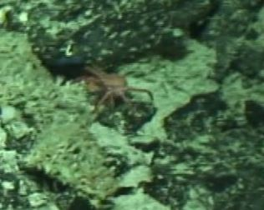
Phylum: Arthropoda  Class: Malacostraca  Order: Isopoda  Family:  Genus:  Species: | Morphospecies code: ISOPOD1 | Gear:  ROV  Photo by:  Holland I 2018  Identified by: Poppy Keogh  Dive: 6 |  | 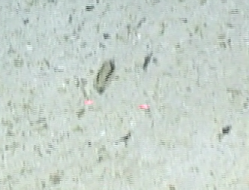
Phylum: Arthropoda  Class: Malacostraca  Order: Decapoda  Family: Lithodidae  Genus: Neolithodes  Species: | Morphospecies code: NEOLI  Neolithodes sp. | Gear:  ROV  Photo by:  Holland I 2018  Identified by: Poppy Keogh  Dive: 5 |  | 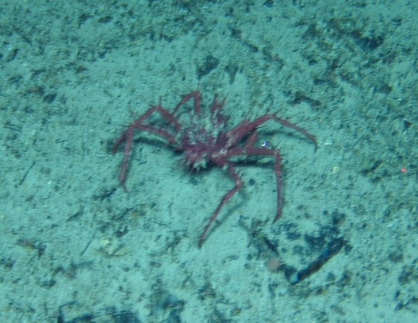
Phylum: Arthropoda  Class: Malacostraca  Order: Decapoda  Family:  Genus:  Species: | Morphospecies code: SHRIMP1 | Gear:  ROV  Photo by:  Holland I 2018  Identified by: Poppy Keogh  Dive: 6 |  | 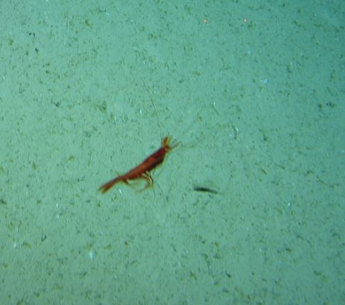
TAXONOMY | NAME | HABITAT | NOTES | IMAGE
Phylum: Arthropoda  Class: Malacostraca  Order: Decapoda  Family:  Genus:  Species: | Morphospecies code: SHRIMP2 | Gear:  ROV  Photo by:  Holland I 2018  Identified by: Poppy Keogh  Dive: 7 |  | 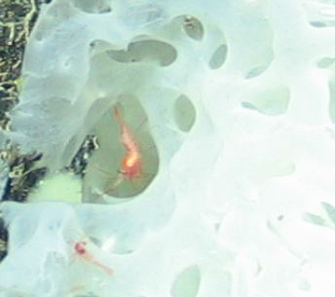
Phylum: Mollusca  Class: Bivalvia  Order:  Family:  Genus:  Species: | Morphospecies code: BIVALV1 | Gear:  ROV  Photo by:  Holland I 2018  Identified by: Poppy Keogh  Dive: 8 |  | 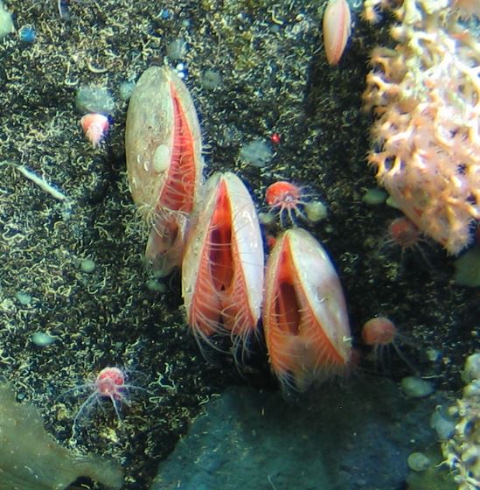
Phylum: Mollusca  Class: Cephalopoda  Order: Octopoda  Family: Stauroteuthidae  Genus: Stauroteuthis  Species: | Morphospecies code: OCTO1  Stauroteuthis sp. | Gear:  ROV  Photo by:  Holland I 2018  Identified by: Poppy Keogh  Dive: 5 |  | 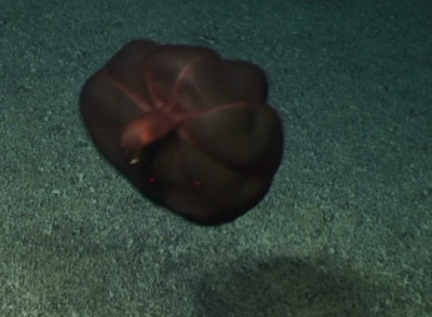
Phylum: Mollusca  Class: Cephalopoda  Order: Octopoda  Family:  Genus:  Species: | Morphospecies code: OCTO2 | Gear:  ROV  Photo by:  Holland I 2018  Identified by: Poppy Keogh  Dive: 8 |  | 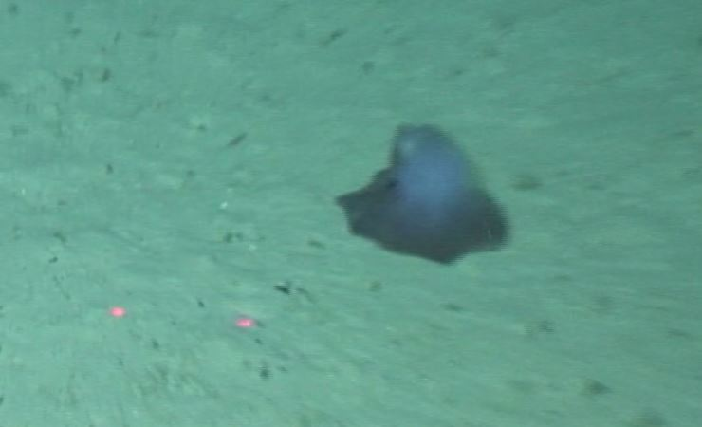
Phylum: Mollusca  Class: Cephalopoda  Order: Octopoda  Family:  Genus:  Species: | Morphospecies code: OCTO3 | Gear:  ROV  Photo by:  Holland I 2018  Identified by: Poppy Keogh  Dive: 8 |  | 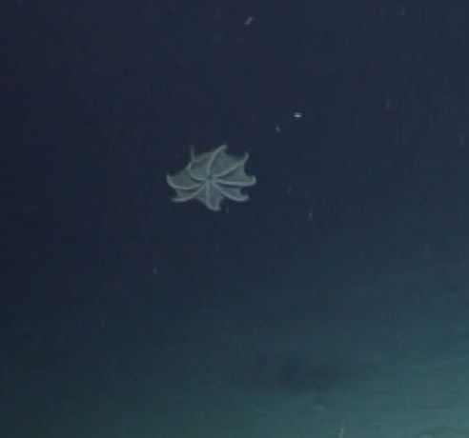
TAXONOMY | NAME | HABITAT | NOTES | IMAGE
Phylum: Mollusca  Class: Cephalopoda  Order:  Family:  Genus:  Species: | Morphospecies code: SQUID1 | Gear:  ROV  Photo by:  Holland I 2018  Identified by: Poppy Keogh  Dive: 8 |  | 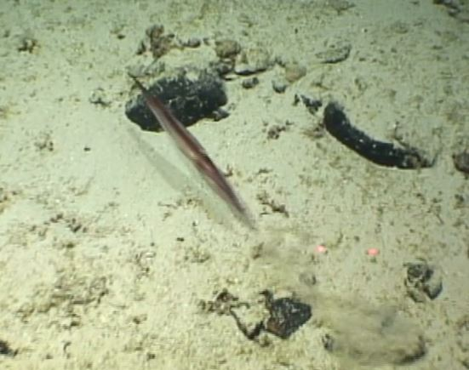
Phylum: Mollusca  Class: Cephalopoda  Order:  Family:  Genus:  Species: | Morphospecies code: SQUID2 | Gear:  ROV  Photo by:  Holland I 2018  Identified by: Poppy Keogh  Dive: 7 | Not a squid, probably and Octopod (P. Keogh) | 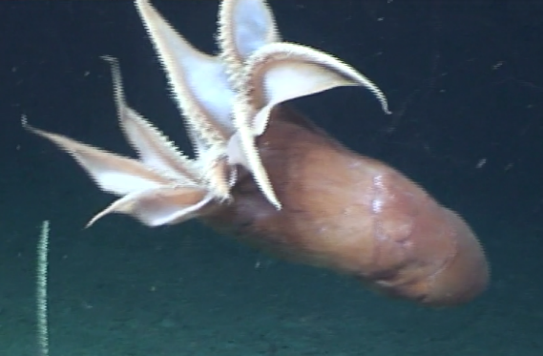
Phylum: Hemichordata  Class: Enteropneusta  Order: Enteropneusta (temporary name)  Family: Torquaratoridae  Genus: Yoda  Species: Y. purpurata | Morphospecies code: YODA  Yoda purpurata | Gear:  ROV  Photo by:  Holland I 2018  Identified by: Poppy Keogh  Dive: 8 |  | 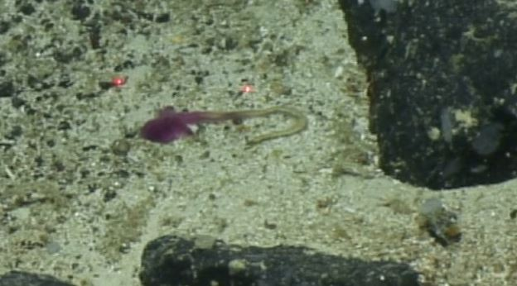
Phylum:  Class:  Order:  Family:  Genus:  Species: | Morphospecies code: ANIMAL1 | Gear:  ROV  Photo by:  Holland I 2018  Identified by: Poppy Keogh  Dive: 6 |  | 