New observations of the dendrophylliid coral species Heteropsammia cochlea (Spengler, 1781) from the Halimeda bioherms on the Northern Great Barrier Reef
Stefano Borghi¹, Matthew Clements², Monique Webb², Helen Bostock³, Jody M. Webster⁴, Mardi McNeil⁵, Luke Nothdurft⁶, Maria Byrne²

¹ARC Centre of Excellence for Coral Reef Studies, James Cook University, Townsville QLD, Australia
² School of Life and Environmental Sciences, The University of Sydney, New South Wales 2006, Australia.
³ School of Earth and Environmental Sciences, University of Queensland, Australia.
⁴ Geocoastal Research Group, School of Geosciences, The University of Sydney, NSW, 2006, Australia.
⁵ Geoscience Australia, Canberra, ACT 2601, Australia.
⁶ School of Earth and Atmospheric Sciences, Queensland University of Technology, Brisbane, QLD 4001, Australia.

Stefano.borghi@my.jcu.edu.au

Figure S1
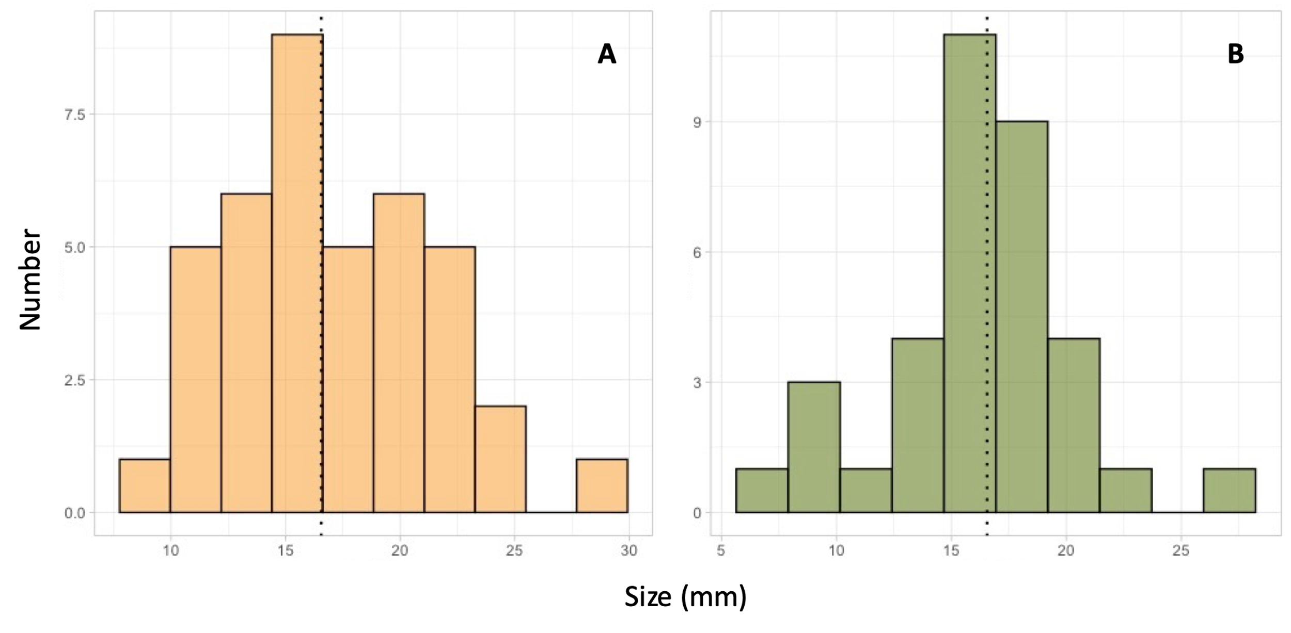
Figure S1. Size frequency distribution analysis on Heteropsammia cochlea corals from (A) open sand (n = 40) and (B) Halimeda (n = 35). The mean size is shown as black dashed line.

Table S1
Table S1. Number of H.cochlea photographed and counted within the four sites along the Lizard Island transect where the species occurred. Two 1x1m quadrats were obtained from each photo for replicates.
Replicate | Habitat type | Count
S1 | Sand | 133
S2 | Sand | 195
S3 | Sand | 12
S4 | Sand | 16
H1 | Halimeda | 37
H2 | Halimeda | 72
H3 | Halimeda | 6
H4 | Halimeda | 2

Table S2
Table S2. GPS coordinates of the sites along the Lizard Island transect where H. cochlea corals were observed and collected.
Site number | Latitude | Longitude | Depth (m)
20 | 145.535844 | -14.657471 | 32.46
21 | 145.540566 | -14.654535 | 30.96
22 | 145.544974 | -14.652809 | 34.40
24 | 145.553793 | -14.648124 | 28.52

Table S3
Table S3. Distribution of H. cochlea and the literature that was used to confirm the presence of the corals. Observations that did not result in the collection of specimens and which credibility could not be further verified were not included.
Location | Literature
Amami Island | Igawa and Kato 2017
Okinawa Island | Gill and Coates 1977
Kochi Prefecture | Gill and Coates 1977
Koh Tao | Gill and Coates 1977; Hoeksema and Matthews 2015
Changuu Island | Gill and Coates 1977; Herrán et al. 2022
Bawe Island | Gill and Coates 1977; Herrán et al. 2022
Lizard Island | Fisk 1983
Komodo Island | Hoeksema and Best 1991
Irian Jaya | Hoeksema and Best 1991
Timor Leste | Hoeksema and Best 1991
Kei Island | Hoeksema and Best 1991
Banda | Hoeksema and Best 1991
Ambon | Hoeksema and Best 1991
Sumbawa | Hoeksema and Best 1991
Taka Bonerate | Hoeksema and Best 1991
Buton | Hoeksema and Best 1991
Southwestern Sulawesi | Hoeksema and Best 1991
Northern Sulawesi | Hoeksema and Best 1991
Paternoster Island | Hoeksema and Best 1991
Eastern Kalimantan | Hoeksema and Best 1991
Lombok | Hoeksema and Best 1991
Eastern Java | Hoeksema and Best 1991
Western Java | Hoeksema and Best 1991
Southern Sumatra | Hoeksema and Best 1991
Whampoa Island | Hoeksema and Best 1991
Tranquebar | Hoeksema and Best 1991
Pandanon Island | Hoeksema and Best 1991
Agusan | Hoeksema and Best 1991
Ganjam Coast | Hoeksema and Best 1991
Shogunyama | Hoeksema and Best 1991
Kikai Island | Hoeksema and Best 1991
Byoritsu Beds | Gill and Coates 1977
Ikomo Bay | Gill and Coates 1977
Wistari Reef | Fine et al 2013
New Caledonia | Arrigoni et al. 2014

