Going deep into Parazoanthus axinellae (Anthozoa: Zoantharia) complex. The description of two species in the Alboran Sea based on an integrative method.
Marine Biodiversity.
*Alfredo Rosales Ruiz^{1,2}, Oscar Ocaña², ^Roberto de la Herrán¹, Rafael Navajas-Pérez¹, Carmelo Ruiz Rejón¹, Ander Congil Ross² & Francisca Robles¹. 2024
¹Department of Genetics, University of Granada, Granada, Spain
²Fundacion Museo del Mar de Ceuta, Ceuta, Spain
*alfredrosales@correo.ugr.es, ^rherran@ugr.es
Supplementary Material. Figures

Supplementary Figures
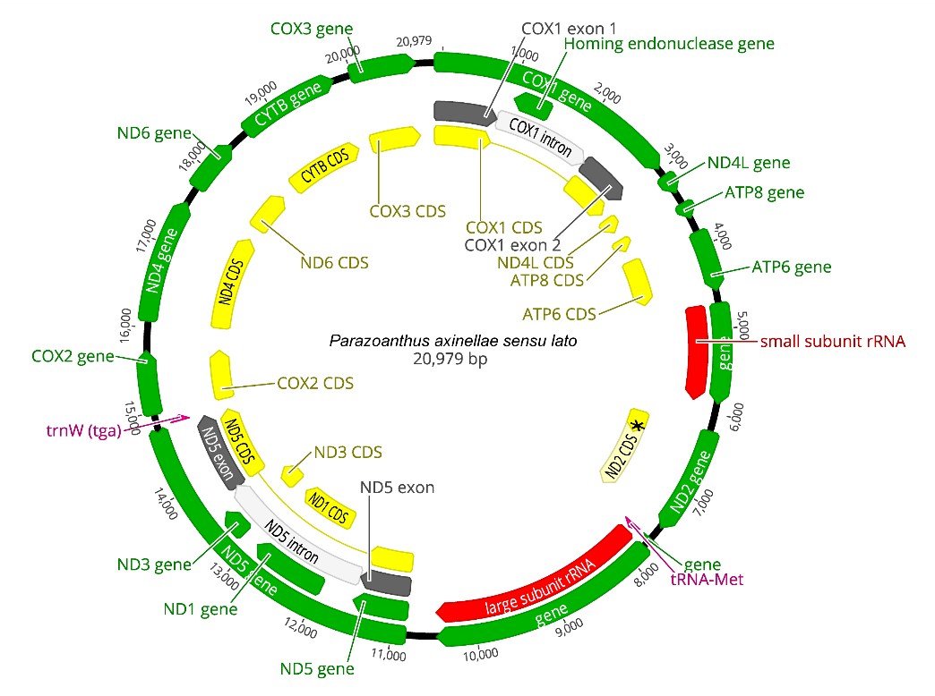
Supplementary Figure 1. Mitochondrial genome of Parazoanthus axinellae sensu lato collected in Calahonda-Castell de Ferro SAC, Granada, Spain, encrusting over a bare rocky wall at 15 meters deep. Genes have been annotated using Parazoanthus brevitentacularis stat. nov. as a model.

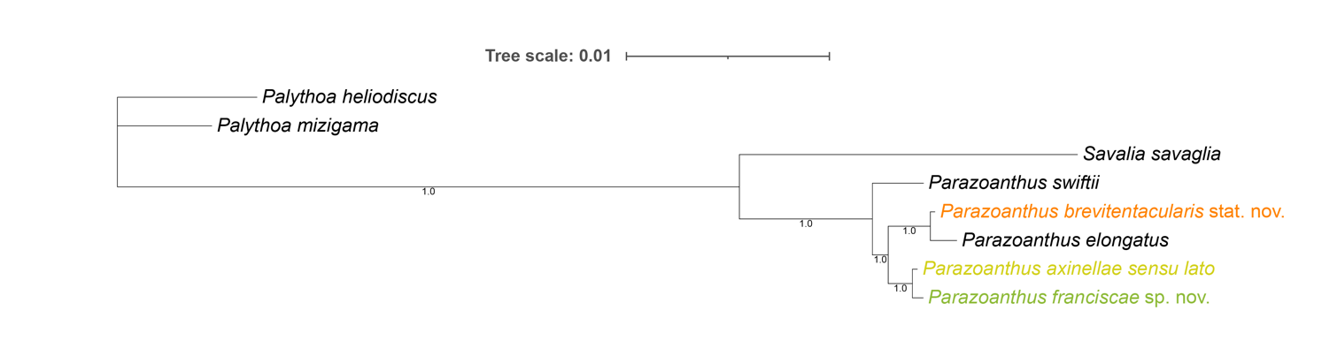
Supplementary Figure 2. Bayesian phylogenetic tree of staggered gene coding regions. TVM+I+G was identified on JModelTest2 ratio test as the best fitting nucleotide substitution model for the aligns, being GTR+I+G the best fitting model available in Genious Prime for Bayesian and Maximum likelihood analyses. Tree edited on iTOL (Letunic, I., & Bork, P. (2021). Interactive Tree Of Life (iTOL) v5: an online tool for phylogenetic tree display and annotation. Nucleic acids research, 49(W1), W293-W296.) and Adobe Illustrator 25.4.1.

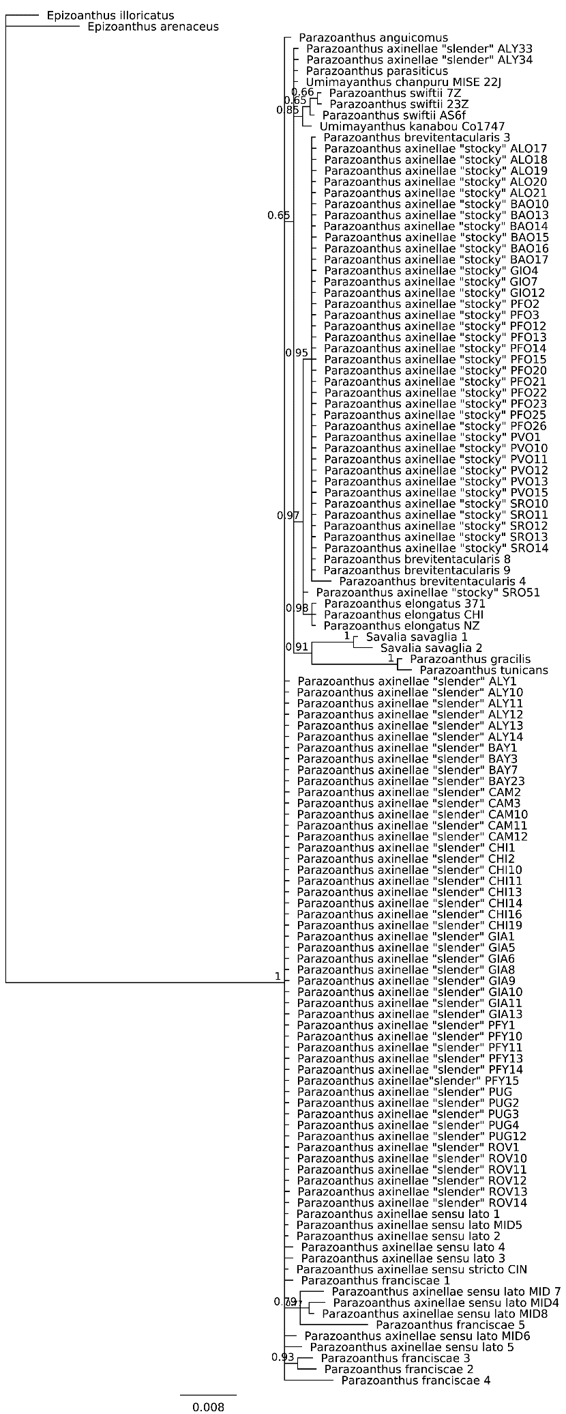
Supplementary Figure 3. COI phylogeny of Parazoanthus and Umimayanthus genus using Bayesian method and GTR+G as nucleotide evolution model. Numbers indicate posterior probability of the branches.
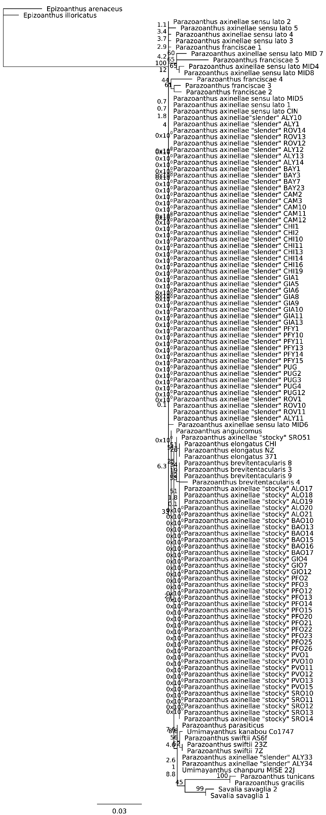
Supplementary Figure 4. COI Phylogeny of Parazoanthus and Umimayanthus genus using Maximum Likelihood method and GTR+G as nucleotide evolution model. Numbers indicate bootstrap proportions.

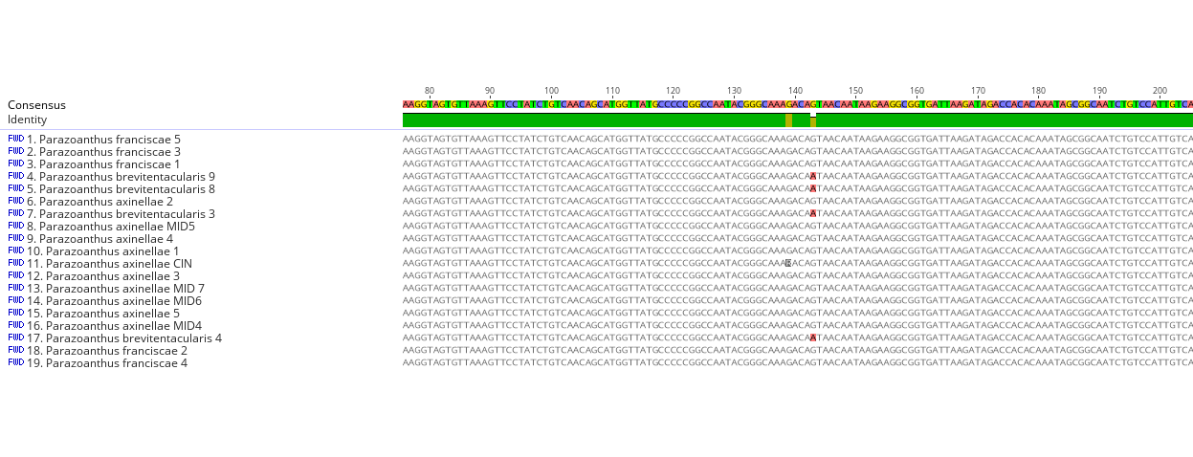
Supplementary Figure 5. COI sequences alignment using MAFFT to search for molecular signatures for specie diagnosis. Position 143 of P. brevitentacularis is an adenine, while in the others is a guanine
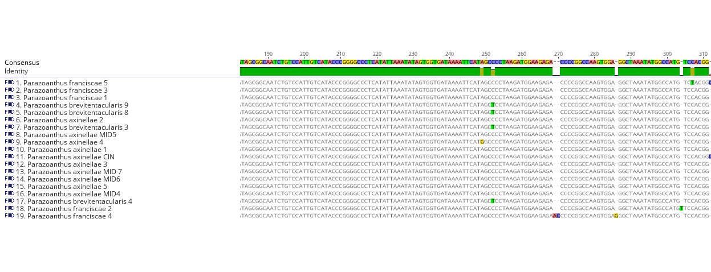
Supplementary Figure 6. COI sequences alignment using MAFFT to search for molecular signatures for specie diagnosis. Position 252 in P. brevitentacularis is a thymine, while cytosines in the others.
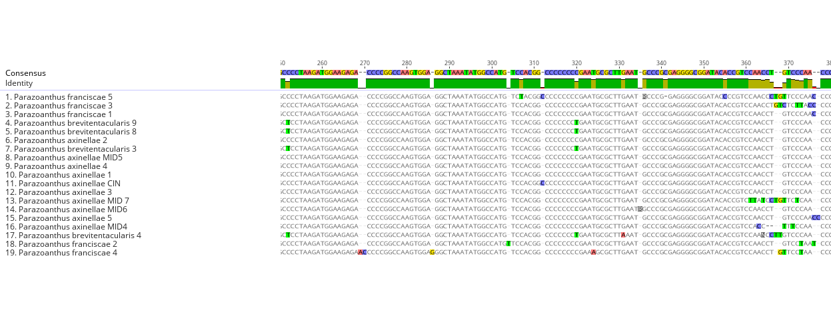
Supplementary Figure 7. COI sequences alignment using MAFFT to search for molecular signatures for specie diagnosis. Position 320 in P. brevitentacularis is a thymine, while cytosines in the others. A high intraspecific variation can be seen in some positions.
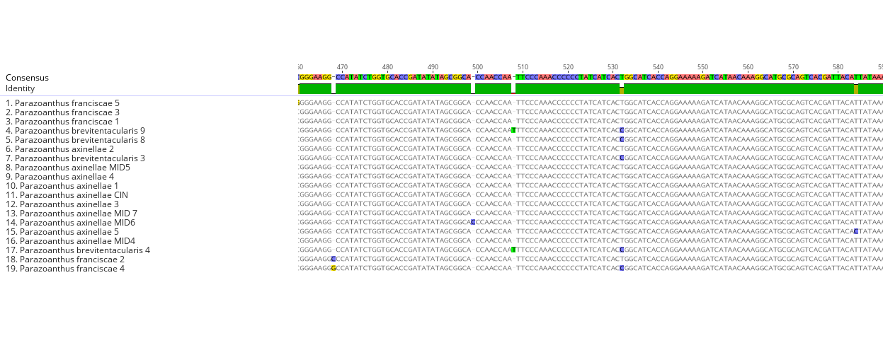
Supplementary Figure 8. COI sequences alignment using MAFFT to search for molecular signatures for specie diagnosis. Position 532 seems to be different in P. brevitentacularis, with a cytosine when compared to P. axinellae sequences, with a thymine. Nevertheless, on the sequences of P. franciscae 4 (OQ456489), this position is also a cytosine, while in the other sequences of the specie is a thymine. Some intraspecific variations can be also seen.
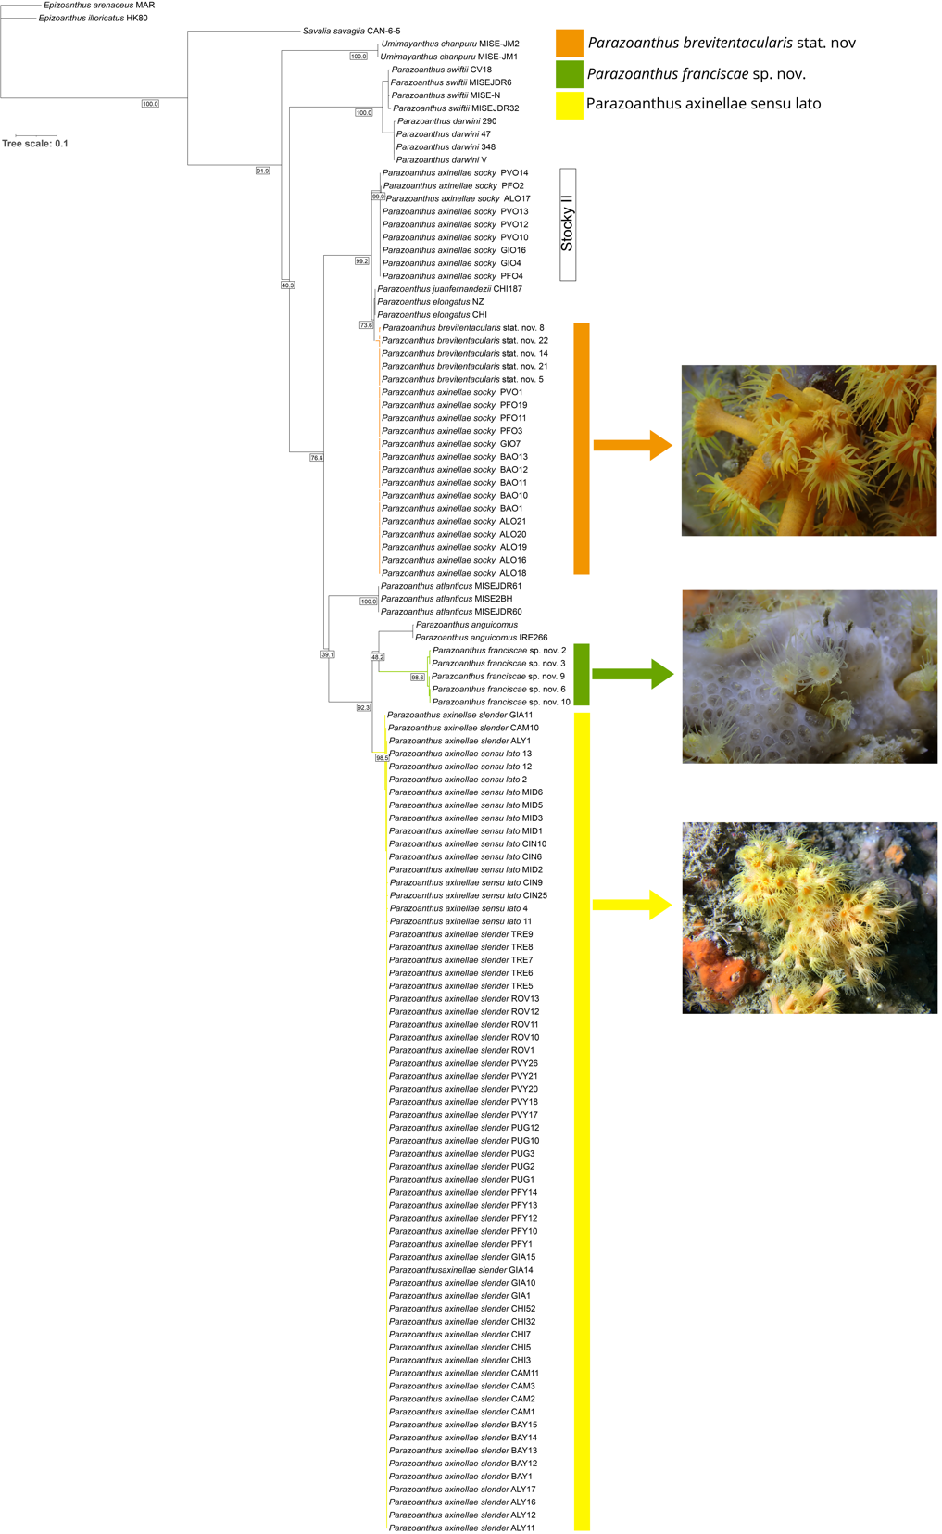
Supplementary Figure 9. ITS Phylogeny of Parazoanthus and Umimayanthus genus using Maximum Likelihood method and HKY+G as nucleotide evolution model. Numbers indicate bootstrap proportions. Epizoanthus sequences were used as outgroups.

