Going deep into Parazoanthus axinellae (Anthozoa: Zoantharia) complex. The description of two species in the Alboran Sea based on an integrative method.
Marine Biodiversity.
*Alfredo Rosales Ruiz^{1,2}, Oscar Ocaña², ^Roberto de la Herrán¹, Rafael Navajas-Pérez¹, Carmelo Ruiz Rejón¹, Ander Congil Ross² & Francisca Robles¹. 2024
¹Department of Genetics, University of Granada, Granada, Spain
²Fundacion Museo del Mar de Ceuta, Ceuta, Spain
*alfredrosales@correo.ugr.es, ^rherran@ugr.es
Supplementary Material. Tables
Sample collected | Location | Coordinates (ETRS 89) | Analysis performed
5 colonies of Parazoanthus axinellae sensu lato | Calahonda-Castell de Ferro Special Area of Conservation (SAC) | 36.701154, -3.409326 | Ecology and in situ morphology observations, morphological analyses, whole mitochondrial genome analyses and COI and rDNA analyses.
6 colonies of Parazoanthus brevitentacularis stat. nov. |  | 36.701154, -3.409326
3 colonies of Parazoanthus franciscae sp. nov. |  | 36.701154, -3.409326
1 colony of Parazoanthus axinellae sensu lato | Punta de la Mona SAC, Granada, Spain | 36.716967, -3.731701 | Ecology and in situ morphology observations and COI and rDNA analyses.
1 colony of Parazoanthus brevitentacularis stat. nov. | Punta de la Mona SAC, Granada, Spain | 36.716967, -3.731701 | Ecology and in situ morphology observations and COI and rDNA analyses.
1 colony of Parazoanthus franciscae sp. nov. | Punta de la Mona SAC, Granada, Spain | 36.716967, -3.731701 | Ecology and in situ morphology observations.
1 colony of Parazoanthus axinellae sensu lato | Maro-Cerro Gordo Reserve, Granada, Spain | 36.727397, -3.775932 | Ecology and in situ morphology observations and COI and rDNA analyses.
5 colonies of Parazoanthus franciscae sp. nov. | Maro-Cerro Gordo Reserve, Granada, Spain | 36.727397, -3.775932 | Ecology and in situ morphology observations, morphological analyses and COI and rDNA analyses.
1 colony of Parazoanthus franciscae sp. nov. | Chafarinas Islands SAC | 35.185292, -2.431905 | Ecology and in situ morphology observations.
5 colonies of Parazoanthus axinellae sensu lato | Monte Hacho Site of Community Importance (SCI), Ceuta, Spain | 35.903960, -5.301489 | Ecology and in situ morphology observations and COI and rDNA analyses.
1 colony of P. brevitentacularis stat. nov. | Monte Hacho Site of Community Importance (SCI), Ceuta, Spain | 35.903960, -5.301489 | Ecology and in situ morphology observations.
Supplementary Table 1. List of species with associated GenBank accession number for COI used in the phylogenetic analyses. Bold accession numbers mark the sequences obtained in this work.

Accession number | Specie | Morphotype | Samplig location | Code used in this work | References
EF672672 | Epizoanthus arenaceus |  | NW Mediterranean Sea |  | Sinniger et al. (2008)
EU591614 | Epizoanthus illoricatus |  | New Caledonia, France |  | Sinniger & Häussermann (2009)
EF672660 | Parazoanthus anguicomus |  | NE Atlantic |  | Sinniger et al. (2008)
MT769344, MT769345, MT769346, MT769347, MT769348, MT769349, MT769330 & MT769331 | Parazoanthus axinellae | Slender | East Ligurian Sea, Alassio, Italy | ALY1, ALY10, ALY11, ALY12, ALY13, ALY14, ALY33 & ALY34 | Villamor et al. (2020)
MT769406, MT769408, MT769409 & MT769407 | Parazoanthus axinellae | Slender | Gulf of Lions, Banyuls-sur-Mer, France | BAY1, BAY3, BAY7 & BAY23 | Villamor et al. (2020)
MT769413, MT769414, MT769410, MT769411 & MT769412 | Parazoanthus axinellae | Slender | East Tyrrhenian Sea, Campania, Italy | CAM2, CAM3, CAM10, CAM11 & CAM12 | Villamor et al. (2020)
MT769421, MT769428, MT769422, MT769423, MT769424, MT769425, MT769426 & MT769427 | Parazoanthus axinellae | Slender | North East Adriatic Sea, Chioggia, Italy | CHI1, CHI2, CHI10, CHI11, CHI13, CHI14, CHI16 & CHI19 | Villamor et al. (2020)
MT769442, MT769459, MT769460, MT769462, MT769463, MT769443, MT769444 & MT769446 | Parazoanthus axinellae | Slender | North Tyrrhenian Sea, Giannutri, Italy | GIA1, GIA5, GIA6, GIA8, GIA9, GIA10, GIA11 & GIA13 | Villamor et al. (2020)
MT769479, MT769480, MT769481, MT769482, MT769483 & MT769484 | Parazoanthus axinellae | Slender | Central Ligurian Sea, Portofino, Italy | PFY1, PFY10, PFY11, PFY13, PFY14 & PFY15 | Villamor et al. (2020)
MT769524, MT769526, MT769527, MT769528 & MT769525 | Parazoanthus axinellae | Slender | Ionian Sea, Gallipoli, Tukey | PUG11, PUG2, PUG3, PUG4 & PUG12 | Villamor et al. (2020)
MT769554, MT769555, MT769556, MT769557, MT769558 & MT769559 | Parazoanthus axinellae | Slender | North West Adriatic Sea, Rovigno, Italy | ROV1, ROV10, ROV11, ROV12, ROV13 & ROV14 | Villamor et al. (2020)
OQ456505 | Parazoanthus axinellae | Sensu lato (slender) | (36.719127, -3.728451) 40m over Axinella damicornis. Punta de la Mona, Granada, Spain | CIN | This work
OQ456486, OQ456487, OQ456488, OQ456489 & OQ456490 | Parazoanthus axinellae | Sensu lato (slender) | (36.719127, -3.728451) 12-20m. Punta de Cerro Gordo, Castell de Ferro, Granada, Spain. | 1, 2, 3, 4 & 5 | This work
OQ456500, OQ456501, OQ456503, OQ456504 & OQ456502 | Parazoanthus axinellae | Sensu lato (slender) | (35.907639,-5.297733) 35m. Ciclón de Fuera, Ceuta, Spain. | MID4, MID5, MID6, MID8 & MID7 | This work
MT769332, MT769333, MT769334, MT769335 & MT769336 | Parazoanthus axinellae | Stocky | East Ligurian Sea, Alassio, Italy | ALO17, ALO18, ALO19, ALO20, ALO21 | Villamor et al. (2020)
MT769388, MT769389, MT769390, MT769391, MT769392 & MT769393 | Parazoanthus axinellae | Stocky | Gulf of Lions, Banyuls-sur-Mer, France | BAO10, BAO13, BAO15, BAO16 & BAO17 | Villamor et al. (2020)
MT769458, MT769458, | Parazoanthus axinellae | Stocky | North Tyrrhenian Sea, Giannutri, Italy | GIO4, GIO7 & GIO12 | Villamor et al. (2020)
MT769471, MT769472, MT769467, MT769468, MT769469, MT769470, MT769513, MT769514, MT769516, MT769515, MT769517 & MT769518 | Parazoanthus axinellae | Stocky | Central Ligurian Sea, Portofino, Italy | PFO2, PFO3, PFO12, PFO13, PFO14, PFO15, PFO20, PFO21, PFO22, PFO23, PFO25 & PFO26 | Villamor et al. (2020)
MT769534, MT769535, MT769536, MT769537, MT769538 & MT769539 | Parazoanthus axinellae | Stocky | South Ligurian Sea, Porto Venere, Italy | PVO1, PVO10, PVO12, PVO13 & PVO15 | Villamor et al. (2020)
MT769581, MT769582, MT769583, MT769584, MT769585 & MT769580 | Parazoanthus axinellae | Stocky | South Ligurian Sea, Porto Venere, Italy | SRO10, SRO11, SRO12, SRO13, SRO14 & SRO51 | Villamor et al. (2020)
OQ456491, OQ456492, OQ456493 & OQ456494 | Parazoanthus brevitentacularis stat. nov. |  | (36.719127, -3.728451) 12-20m. Punta de Cerro Gordo, Castell de Ferro, Granada, Spain. | 5, 8, 14, 21 & 22 | This work
EU591622 | Parazoanthus elongatus |  | Chile | 371 | Sinniger & Häussermann (2009)
EF672661 | Parazoanthus elongatus |  | Chile | CHI | Sinniger & Häussermann (2009)
EF672662 | Parazoanthus elongatus |  | New Zealand | NZ | Sinniger & Häussermann (2009)
OQ456495, OQ456497, OQ456496 & OQ456499 | Parazoanthus franciscae sp. nov. |  | (36.701622, -3.410316) Punta de Cerro Gordo, Castell de Ferro, Granada, Spain | 9, 6 & 10 | This work
OQ456498 | Parazoanthus franciscae sp. nov. |  | (36,738078, -3,778437) Cueva de Cantariján, Almuñecar, Granada, Spain | 2 & 3 | This work
EF672668 | Parazoanthus gracilis |  | Igai-jima, Kamogawa, Chiba, Japan |  | Sinniger et al. (2008)
EF672663 | Parazoanthus parasiticus |  | Bookends, Trinidad & Tobago |  | Sinniger et al. (2008)
KT454363 | Parazoanthus swiftii |  | Rio de Janeiro, Brasil | 7Z | Vaga et al. (2020)
KT454364 | Parazoanthus swiftii |  | São Paulo, Brasil | 23Z | Vaga et al. (2020)
KJ794180 | Parazoanthus swiftii |  | São Paulo, Brasil | AS6f | Vaga et al. (2020)
EF672667 | Parazoanthus tunicans |  | Little Tobago, Trinidad & Tobago |  | Sinniger et al. (2008)
HQ110947 | Savalia savaglia |  | Ria de Arousa, Galicia, Spain | 1 | Altuna et al. (2010)
AB247356 | Savalia savaglia |  | Marseille, France | 2 | Reimer et al. (2007)
KR092631 | Umimayanthus chanpuru |  | Kita-Nakase, Okinawa, Japan | MISE 22J | Montenegro et al. (2015)
MZ298132 | Umimayanthus kanabou |  | Ryukyu Islands, Japan | Co1747 | Fujii et al. (2021)
Supplementary Table 2. List of species with associated GenBank accession number for COI used in the phylogenetic analyses. Bold accession numbers mark the sequences obtained in this work.
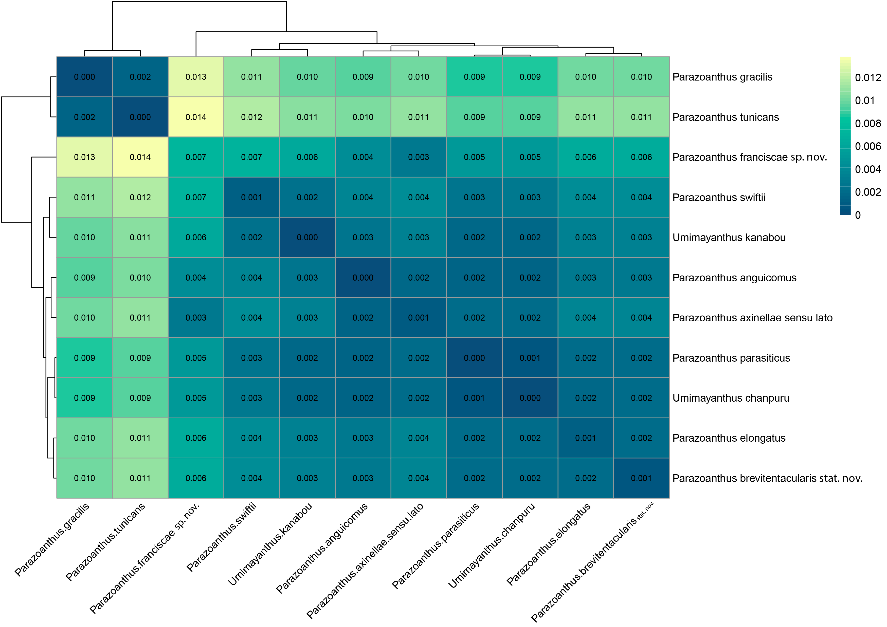
Supplementary Table 3. Heatmap illustrating COI Bayesian patristic mean genetic distances matrix between species generated using Pheatmap function (Kolde & Kolde, 2018) on RStudio. Outgroups used in phylogenetics analyses have been removed to enhance definition. The colors yellow to blue indicate high to low divergences.
Accession number | Specie | Morphotype | Samplig location | Code used in this work | References
EU591538 | Epizoanthus arenaceus |  | Marseille, France | MAR | Sinniger & Häussermann (2009)
KU175768 | Epizoanthus illoricatus |  | Okinawa, Japan | HK80 | Kise & Reimer (2016)
EU591574 | Parazoanthus anguicomus |  | NE Atlantic |  | Sinniger & Häussermann (2009)
GQ464880 | Parazoanthus anguicomus |  | Ruecallan, Rathin Island, Northern Ireland, United Kingdom | IRE266 | Swain (2010)
MT103525 | Parazoanthus atlanticus |  | Blue Wall, Curaçao | MISE2BH | Montenegro et al. (2020)
MT103528 | Parazoanthus atlanticus |  | Caracas Bay, Tugboat, Curaçao | MISEJDR 60 | Montenegro et al. (2020)
MT103539 | Parazoanthus atlanticus |  | Caracas Bay, Tugboat, Curaçao | MISEJDR 61 | Montenegro et al. (2020)
MT771071, MT771072, MT771073, MT771074 & MT771075 | Parazoanthus axinellae | Slender | East Ligurian Sea, Alassio, Italy | ALY1, ALY11, ALY12, ALY16 & ALY17 | Villamor et al. (2020)
MT771111, MT771112, MT771113, MT771114 & MT771115 | Parazoanthus axinellae | Slender | Gulf of Lions, Banyuls-sur-Mer, France | BAY1, BAY12, BAY13, BAY14 & BAY15 | Villamor et al. (2020)
MT771126, MT771129, MT771130, MT771127 & MT771128 | Parazoanthus axinellae | Slender | East Tyrrhenian Sea, Campania, Italy | CAM1, CAM2, CAM3, CAM10 & CAM11 | Villamor et al. (2020)
MT771135, MT771137, MT771139, MT771136 & MT771138 | Parazoanthus axinellae | Slender | North East Adriatic Sea, Chioggia, Italy | CHI3, CHI5, CHI7, CHI32 & CHI52 | Villamor et al. (2020)
MT771143, MT771144, MT771145, MT771146 & MT771147 | Parazoanthus axinellae | Slender | North Tyrrhenian Sea, Giannutri, Italy | GIA1, GIA10, GIA11, GIA14 & GIA15 | Villamor et al. (2020)
MT771165, MT771166, MT771167, MT771168 & MT771169 | Parazoanthus axinellae | Slender | Central Ligurian Sea, Portofino, Italy | PFY1, PFY10, PFY12, PFY13 & PFY14 | Villamor et al. (2020)
MT771185, MT771188, MT771189, MT771186 & MT771187 | Parazoanthus axinellae | Slender | Ionian Sea, Gallipoli, Tukey | PUG1, PUG2, PUG3, PUG10 & PUG12 | Villamor et al. (2020)
MT771217, MT771218, MT771219, MT771220 & MT771221 | Parazoanthus axinellae | Slender | South Ligurian Sea, Porto Venere, Italy | PVY17, PVY18, PVY20, PVY21 & PVY26 | Villamor et al. (2020)
MT771222, MT771223, MT771224, MT771225 & MT771226 | Parazoanthus axinellae | Slender | North West Adriatic Sea, Rovigno, Italy | ROV1, ROV10, ROV11, ROV12 & ROV13 | Villamor et al. (2020)
MT771283, MT771284, MT771285, MT771286 & MT771287 | Parazoanthus axinellae | Slender | South Adriatic Sea, Tremiti, Italy | TRE5, TRE6, TRE7, TRE8 & TRE9 | Villamor et al. (2020)
OP724387, OP724388, OP724389 & OP724395 | Parazoanthus axinellae | Sensu lato (slender) | (36.719127, -3.728451) 40m over Axinella damicornis. Punta de la Mona, Granada, Spain | CIN6, CIN9, CIN10 & CIN25 | This work
OP724390, OP724391, OP724392, OP724393 & OP724394 | Parazoanthus axinellae | Sensu lato (slender) | (36.719127, -3.728451) 12-20m. Punta de Cerro Gordo, Castell de Ferro, Granada, Spain. | 2, 4, 11, 12 & 13 | This work
OP724396, OP724397, OP724398, OP724399 & OP724400 | Parazoanthus axinellae | Sensu lato (slender) | (35.907639, -5.297733) 35m. Ciclón de Fuera, Ceuta, Spain. | MID1, MID2, MID3, MID5 & MID6 | This work
MT771056, MT771057, MT771058, MT771059, MT771060 & MT771061 | Parazoanthus axinellae | Stocky | East Ligurian Sea, Alassio, Italy | ALO16, ALO17, ALO18, ALO19, ALO20 & ALO21 | Villamor et al. (2020)
MT771087, MT771088, MT771089, MT771090 & MT771091 | Parazoanthus axinellae | Stocky | Gulf of Lions, Banyuls-sur-Mer, France | BAO1, BAO10, BAO11, BAO12 & BAO13 | Villamor et al. (2020)
MT771156, MT771157 & MT771155 | Parazoanthus axinellae | Stocky | North Tyrrhenian Sea, Giannutri, Italy | GIO4, GIO7 & GIO16 | Villamor et al. (2020)
MT771160, MT771161, MT771162, MT771158 & MT771159 | Parazoanthus axinellae | Stocky | Central Ligurian Sea, Portofino, Italy | PFO2, PFO3, PFO4, PFO11 & PFO19 | Villamor et al. (2020)
MT771196, MT771197, MT771198, MT771199 & MT771200 | Parazoanthus axinellae | Stocky | South Ligurian Sea, Porto Venere, Italy | PVO1, PVO10, PVO12, PVO13 & PVO14 | Villamor et al. (2020)
OP724401, OP724402, OP724403, OP724404 & OP724405 | Parazoanthus brevitentacularis stat. nov. | Stocky | (36.719127, -3.728451) 12-20m. Punta de Cerro Gordo, Castell de Ferro, Granada, Spain. | 5, 8, 14, 21 & 22 | This work
EU333801 | Parazoanthus darwini |  | Punta Vicente, Isabella Island, Galápagos, Ecuador | 47 | Reimer et al. (2007)
EU333801 | Parazoanthus darwini |  | Punta Vicente, Isabella Island, Galápagos, Ecuador | 290 | Reimer et al. (2007)
EU333801 | Parazoanthus darwini |  | Punta Vicente, Isabella Island, Galápagos, Ecuador | 348 | Reimer et al. (2007)
MH029324 | Parazoanthus darwini |  | Pared, El Pelado Islet, Santa Elena, Ecuador | V | Reimer et al. (2007)
EU591565 | Parazoanthus elongatus |  | Chile | CHI | Sinniger & Häussermann (2009)
EU591564 | Parazoanthus elongatus |  | New Zealand | NZ | Sinniger & Häussermann (2009)
OP724408, OP724409 & OP724410 | Parazoanthus franciscae sp. nov. |  | (36.701622, -3.410316) Punta de Cerro Gordo, Castell de Ferro, Granada, Spain | 9, 6 & 10 | This work
OP724406 & OP724407 | Parazoanthus franciscae sp. nov. |  | (36,738078, -3,778437) Cueva de Cantariján, Almuñecar, Granada, Spain | 2 & 3 | This work
GQ464879 | Parazoanthus juanfernandezii |  | Renihué Fjord, Chile | CHI187 | Swain (2010)
MN545904 | Parazoanthus swiftii |  | Mataçoes, Alcatrazes Archipelago, Brasil | CV18 | Vaga et al. (2020)
MT103530 | Parazoanthus swiftii |  | Santa Marta, Water Factory, Curaçao | MISEJDR 6 | Montenegro et al. (2020)
MT103531 | Parazoanthus swiftii |  | Saint Michiel’s Bay, Curaçao | MISEJDR 32 | Montenegro et al. (2020)
KR092641 | Parazoanthus swiftii |  | Gulf of Mexico, Florida | MISE N | Montenegro et al. (2015)
OP848231 | Savalia savaglia |  | (29.295315, -13.541665) La Graciosa, Canary Islands, Spain | CAN-6-5 | This work
KR092682 | Umimayanthus chanpuru |  | Okinawa, Japan | MISE-JM-1 | Montenegro et al. (2015)
KR092669 | Umimayanthus chanpuru |  | Okinawa, Japan | MISE-JM-2 | Montenegro et al. (2015)
Supplementary Table 4. List of species with associated GenBank accession number for ITS used in the phylogenetic analyses. Bold accession numbers mark the sequences obtained in this work.

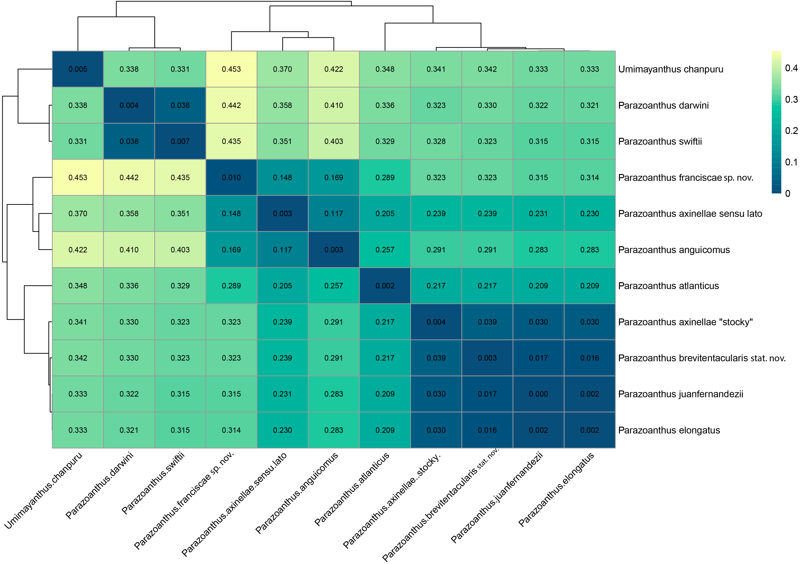
Supplementary Table 5. Heatmap illustrating ITS Bayesian patristic mean genetic distances matrix between species generated using Pheatmap function (Kolde & Kolde, 2018) on RStudio. Outgroups used in phylogenetics analyses have been removed to enhance definition. The colors yellow to blue indicate high to low divergences.
Accession number | Specie | Morphotype | Samplig location | References
MN873588 | Epizoanthus illoricatus |  | Okinawa, Japan | Poliseno et al. (2020)
MN873593 | Palythoa heliodiscus |  | Dongsha, Taiwan | Poliseno et al. (2020)
MN873594 | Palythoa mizigama |  | Okinawa, Japan | Poliseno et al. (2020)
OQ469830 | Parazoanthus axinellae | Sensu lato | (36.719127, -3.728451) 12-20m. Punta de Cerro Gordo, Castell de Ferro, Granada, Spain. | This work
OQ469832 | Parazoanthus brevitentacularis stat. nov. |  | (36.719127, -3.728451) 12-20m. Punta de Cerro Gordo, Castell de Ferro, Granada, Spain. | This work
OQ469831 | Parazoanthus franciscae sp. nov. |  | (36.701622, -3.410316) Punta de Cerro Gordo, Castell de Ferro, Granada, Spain | This work
MN873596 | Parazoanthus elongatus |  | Chile | Poliseno et al. (2020)
MN873597 | Parazoantus swiftii |  | St Eustatius, The Netherlands | Poliseno et al. (2020)
DQ825686 | Savalia savaglia |  | Embiez Islands, France | Sinniger et al. (2007)
Supplementary Table 6. List of species with associated GenBank accession number for mitogenomes used in the phylogenetic analyses. Bold accession numbers mark the sequences obtained in this work.

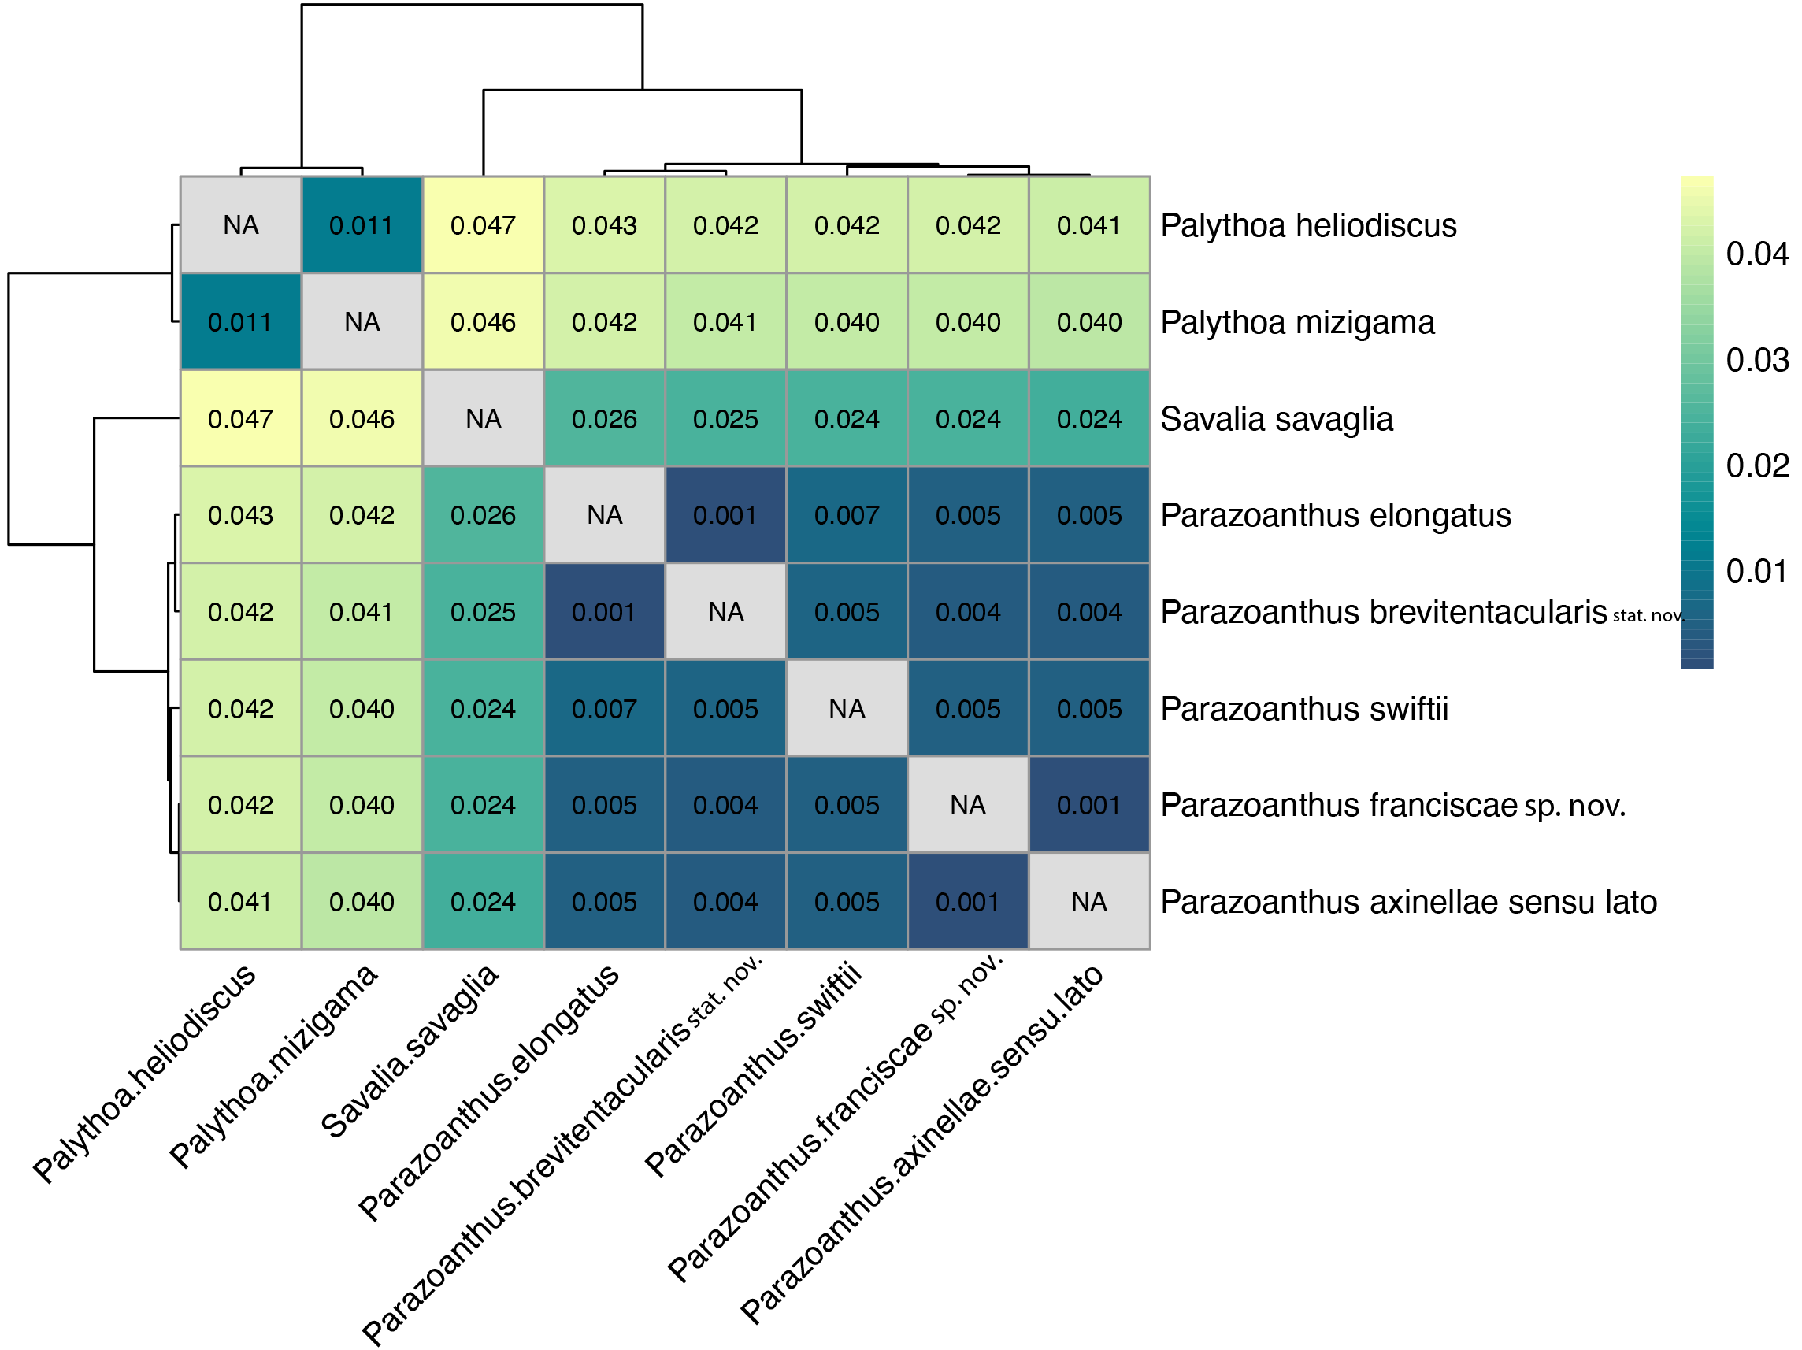
Supplementary Table 7. Heatmap illustrating concatenated gene coding mitochondrial regions Bayesian patristic mean distances matrix between species generated using Pheatmap function (Kolde & Kolde, 2018) on RStudio. The colors yellow to blue indicate high to low divergences.
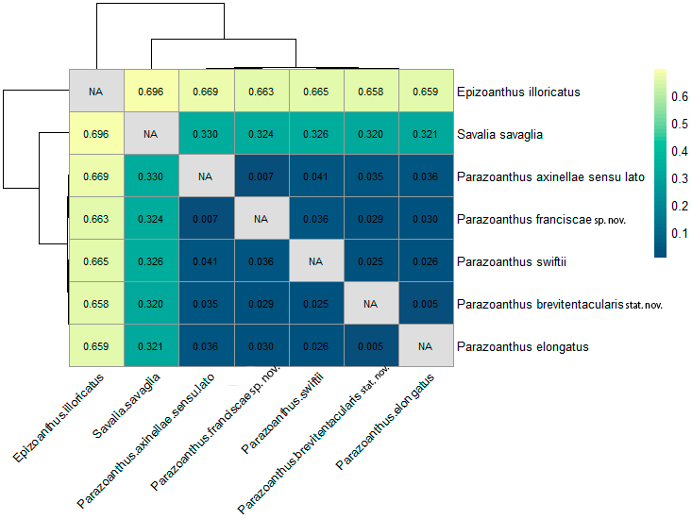
Supplementary Table 8. Heatmap illustrating concatenated intergenic mitochondrial regions Bayesian patristic mean distances matrix between species generated using Pheatmap function (Kolde & Kolde, 2018) on RStudio. The colors yellow to blue indicate high to low divergences.

