Supplementary materials

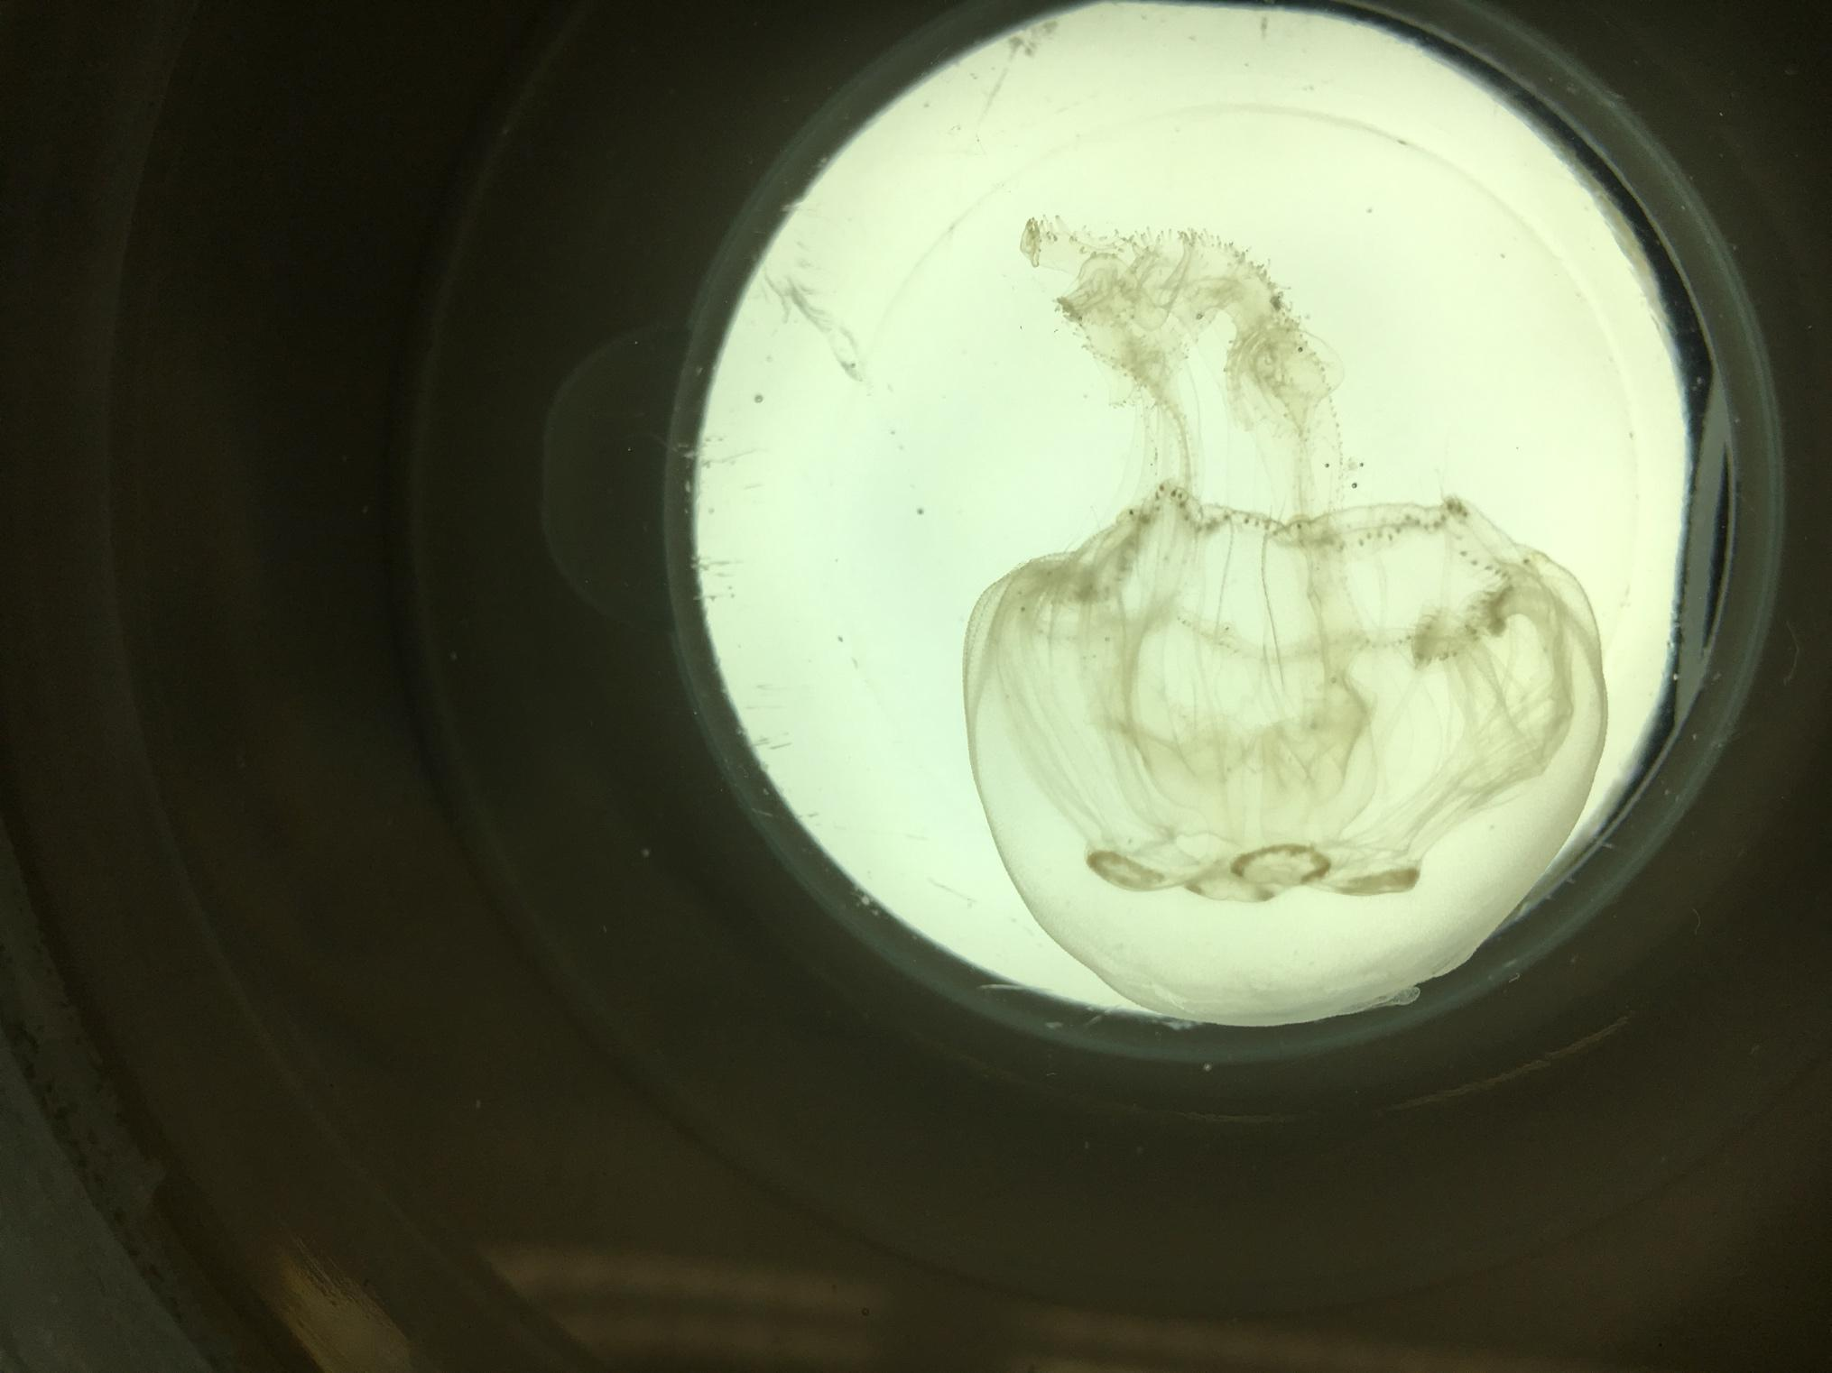 | 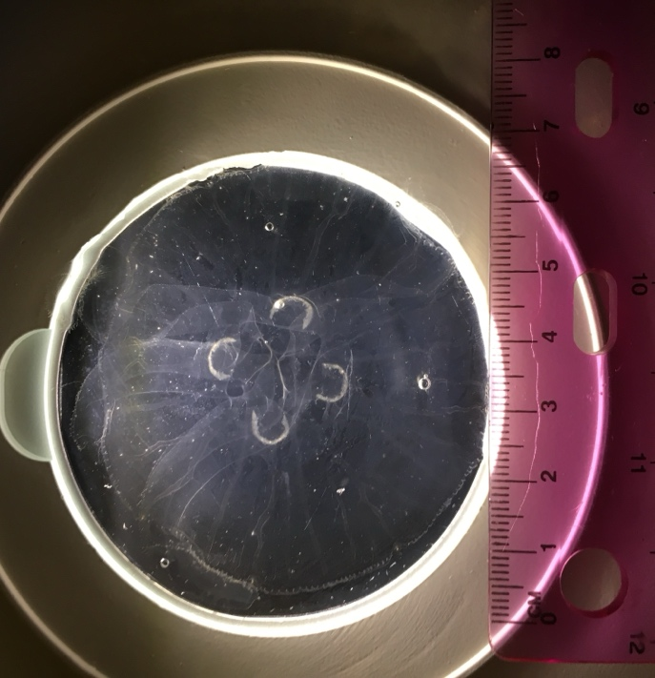
Figure S1. Juvenile medusa Aurelia profunda sp. nov. medusa

Figure S2. Pictures of Aurelia profunda sp. nov. polyps. A,B,C oral view D,E budding polyp F strobilating polyp

Table S1. Results of SIMPER analysis showing the contribution of each morphometric character to the dissimilarity among Aurelia profunda polyps (Group 3) and the polyps of Aurelia marginalis (Group 9) and Aurelia coerulea (Group 1).

Group 1
Average squared distance = 3.80
Species Av.Value Av.sq.Dist sq. Dist/SD Contrib% Cum.%
TBL -0.869 0.0829 0.46 2.18 2.18
HL_std 0.641 0.786 0.47 20.67 22.85
MDD_std 1.31 1.3 0.57 34.16 57.01
StL_std -0.121 1.63 0.55 42.99 100.00

Group 3
Average squared distance = 3.52
Species Av.Value Av.Sq.Dist Sq.Dist/SD contrib% Cum.%
MDD_std -0.385 0.406 0.48 11.53 11.53
TBL 0.768 0.817 0.44 23.21 34.74
StL_std -0.0157 1.02 0.56 28.84 63.58
HL_std -0.288 1.28 0.47 36.42 100.00

Group 9
Average squared distance = 1.34
Species Av.value Av.Sq.Dist sq.Dist/SD contrib% Cum %
TBL -0.604 0.0832 0.55 6.20 6.20
MDD_std -0.374 0.138 0.57 10.26 16.47
HL_std -0.0189 0.402 0.54 29.97 46.44
StL_std 0.12 0.718 0.52 53.56 100.00

Groups 1 & 3
Average squared distance = 12.95
Group 1 Group 3
variable Av.Value Av.Value Av.Sq.Dist sq. Dist/SD Contrib% Cum.%
MDD_std 1.31 -0.385 4.35 0.92 33.60 33.60
TBL -0.869 0.768 3.51 0.91 27.10 60.70
HL_std 0.641 -0.288 2.73 1.07 21.09 81.79

Groups 1 & 9
Average squared distance = 7.84
Group 1 Group 9
Variable Av.Value Av.Value Av.Sq.Dist sq.Dist/SD Contrib% Cum %
MDD_std 1.31 -0.374 4.06 0.96 51.78 51.78
StL_std -0.121 0.12 2.1 0.75 26.77 78.55

Groups 3 & 9
Average squared distance = 6.45
Group 3 Group 9
Variable Av.Value Av.Value Av.Sq.Dist Sq.Dist/SD Contrib% Cum.%
TBL 0.768 -0.604 2.72 0.81 42.13 42.13
HL_std -0.288 -0.0189 1.63 0.86 25.22 67.35
stL_std -0.0157 0.12 1.6 0.88 24.88 92.22

