Supplementary Material for
Towards a broader perspective on marine biodiversity change
Hillebrand et al.
Details of the Systematic Literature Review
A systematic literature search was performed in the ISI Web of Science (WoS) on 17th April 2023 using a search string aimed to detect all published scientific studies of the past 5 years (2019-2023) monitoring or assessing biodiversity in the European marine environment (topic = biodivers* AND (monitor* OR assess*) and (coast* or marin*)). The term “European” was not included in the search string due to the various ways of phrasing it (e.g., countries, regions), but it was considered an inclusion criterion. The search retrieved 3799 studies, which were screened based on their title and abstract (Figure S1). This first screening phase excluded non-European, non-marine, or not observational studies. The full text was accessed and manually screened for the remaining 562 studies. In the full-text screening phase, studies were excluded if they did not present any biodiversity metric, the assessed time period was less than 12 months, the study focused on paleo-data, was a data paper or if it was not accessible. The biodiversity studies analysed in this review focus on community and species diversity, thus neglecting habitat diversity. The remaining 162 studies were considered for this literature map, and information on the location, temporal and spatial extent of used data, assessed organism groups, used biodiversity indicators, and referenced biodiversity frameworks and tools was extracted. Further details on the methodology can be found in the supplementary material (Figure S1, Table S1).
Subsequently, the used biodiversity indicators were grouped into 11 indicator categories and analysed in terms of the relative frequency of use in scientific studies separated by ecosystem component. A map showing the number of studies per regional was created using the R packages “sf” (Pebesma and Bivand, 2023) and “rnaturalearth” (Masicotte and South, 2023). Moreover, the number of indicators used per study and the average length of the used times series were calculated.
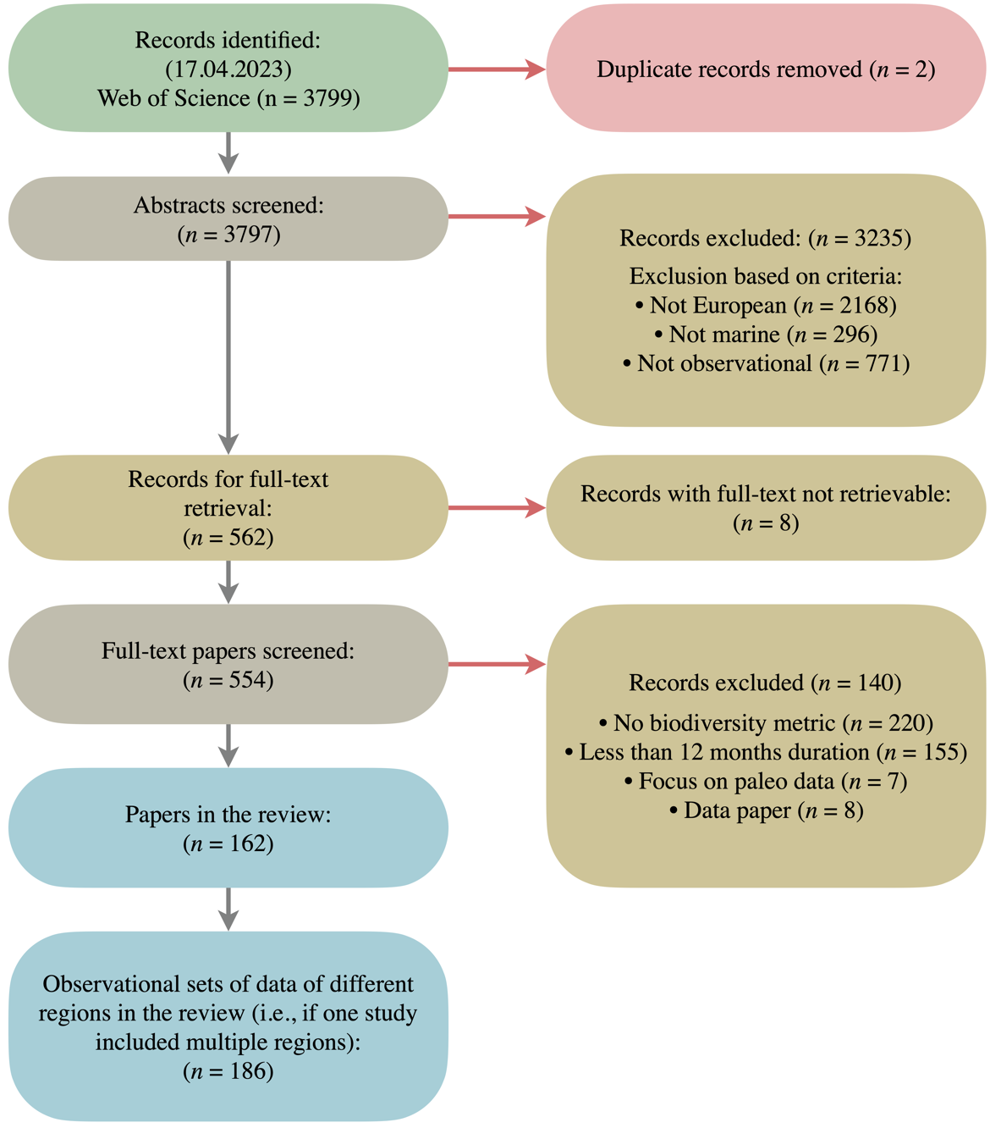
Figure S1: PRISMA-style flowchart of the study selection process conducted for the systematic literature review. The colors of the boxes indicate the step within the selection process i.e., green shows the step of study identification, red indicates the step of removing duplicates, grey is the screening step, yellow marks the excluded papers and blue the included papers. n stands for the number of studies or papers. This flowchart is adapted from Fig. 3 in O’Dea et al. 2021.
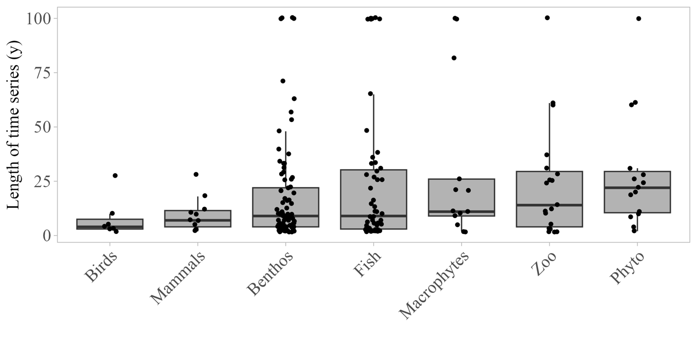
Figure S2: Length of time series used in scientific studies to assess biodiversity change separated by organism group. Abbreviations are in place for zooplankton (Zoo) and phytoplankton (Phyto).
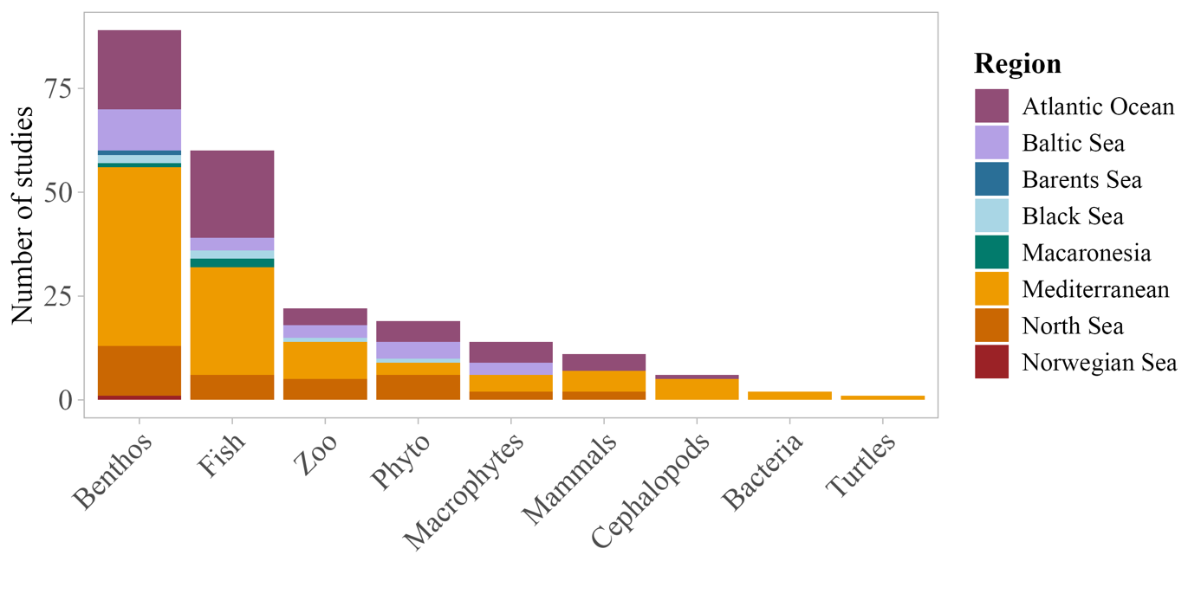Figure S3: Number of scientific studies per organism group colored by the region in which the study was conducted. The overall number of studies is higher than the actual number due to studies assessing multiple organism groups and thus, appearing multiple times. Abbreviations are in place for zooplankton (Zoo) and phytoplankton (Phyto).
Table S1: Details on the inclusion and exclusion criteria in the abstract screening phase and full-text screening phase of the systematic literature map.

Abstract Screening Phase
European? | Include all Mediterranean islands, Azores, Canary Islands, Réunion, Guadeloupe, Martinique, Guayana. Also, specifically include Israel, Bulgaria, and Turkey. If it is a global study, write „Global“. Insert the name of the country if it is on the mainland or the name of the island if it is an island in the column next to it.
Marine? | Insert TRUE if it is marine. We include everything that is fully marine, bays, fjords and lagoons. We do not include estuaries, freshwaters (e.g., rivers, lakes), wetlands or terrestrial studies.
Observational? | Include if the study includes observational data (e.g., samples taken in the field, long-term monitoring data). If the study uses data from data bases, it is no reason for exclusion (but it should be mentioned in the comments). Insert FALSE if it is e.g., a review, a modelling study, a presentation of a new method, an opinion paper, an experimental study (e.g., laboratory, mesocosm), an expert survey, a questionnaire, or a meta-analysis.
Full-text Screening Phase
Biodiversity? | Do they look at biodiversity or do they only mention that based on their study someone should look at biodiversity or that it highlights the importance of biodiversity?
More than 12 months? | We want to look at studies that monitor biodiversity. In this definition, we want to look at studies that are longer than one year (minimum is two data points in two different years).
Not paleo? | We do not include studies that are based on sediment cores (paleo-studies) which date back to 1800s, we want to look at recent studies and how they monitor and assess data in the present and young past.
Not a data paper | FALSE if publication is a data paper (only describing their data).

Studies included in the literature review
Adao, A. C., N. E. Bosch, L. Bentes, R. Coelho, P. G. Lino, P. Monteiro, J. M. S. Gonçalves, and K. Erzini. 2022. Complementary Sampling Methods to Improve the Monitoring of Coastal Lagoons. Diversity-Basel 14.
Almeida, R., C. S. Mateus, M. J. Alves, J. P. Marques, J. Pereira, N. Prista, H. Cabral, P. R. Almeida, and B. R. Quintella. 2022. Evidence of Genetic Segregation among Meagre (Argyrosomus regius) Atlantic Spawning Areas. Journal of Marine Science and Engineering 10.
Alve, E., S. Hess, V. M. P. Bouchet, J. K. Dolven, and B. Rygg. 2019. Intercalibration of benthic foraminiferal and macrofaunal biotic indices: An example from the Norwegian Skagerrak coast (NE North Sea). Ecological Indicators 96:107-115.
Andrés, C., L. Cardona, and J. Gonzalvo. 2021. Common bottlenose dolphin (Tursiops truncatus) interaction with fish farms in the Gulf of Ambracia, western Greece. Aquatic Conservation-Marine and Freshwater Ecosystems 31:2229-2240.
Appolloni, L., F. Ferrigno, G. F. Russo, and R. Sandulli. 2020. β-Diversity of morphological groups as indicator of coralligenous community quality status. Ecological Indicators 109.
Arroyo, E., E. Moya-Urbano, C. García-Ruíz, A. Esteban, and A. A. Ramos-Esplá. 2021. Ascidians (Chordata: Tunicata) from circalittoral and upper-bathyal soft bottoms sampled by experimental trawling in the Iberian Mediterranean Sea. Regional Studies in Marine Science 43.
Aubry, F. B., F. Acri, S. Finotto, and A. Pugnetti. 2021. Phytoplankton Dynamics and Water Quality in the Venice Lagoon. Water 13.
Azzola, A., G. Bavestrello, M. Bertolino, C. N. Bianchi, M. Bo, F. Enrichetti, C. Morri, A. Oprandi, M. Toma, and M. Montefalcone. 2021. You cannot conserve a species that has not been found: The case of the marine sponge Axinella polypoides in Liguria, Italy. Aquatic Conservation-Marine and Freshwater Ecosystems 31:737-747.
Azzola, A., G. Furfaro, E. Trainito, M. Doneddu, and M. Montefalcone. 2022. Seawater warming favours the northward range expansion of Lessepsian species in the Mediterranean Sea: the cephalaspidean. Journal of the Marine Biological Association of the United Kingdom 102:167-173.
Azzurro, E., L. Bolognini, B. Dragicevic, D. Drakulovic, J. Dulcic, E. Fanelli, F. Grati, J. Kolitari, L. Lipej, E. Magaletti, O. Markovic, S. Matic-Skoko, B. Mavric, N. Milone, A. Joksimovic, J. Tomanic, A. Scarpato, P. Tutman, D. Vrdoljak, and F. Zappacosta. 2019. Detecting the occurrence of indigenous and non-indigenous megafauna through fishermen knowledge: A complementary tool to coastal and port surveys. Marine Pollution Bulletin 147:229-236.
Bacouillard, L., N. Baux, J. C. Dauvin, N. Desroy, K. J. Geiger, F. Gentil, and É. Thiébaut. 2020. Long-term spatio-temporal changes of the muddy fine sand benthic community of the Bay of Seine (eastern English Channel). Marine Environmental Research 161.
Banchi, E., V. Manna, V. Fonti, C. Fabbro, and M. Celussi. 2022. Improving environmental monitoring of Vibrionaceae in coastal ecosystems through 16S rRNA gene amplicon sequencing. Environmental Science and Pollution Research 29:67466-67482.
Bancila, R. I., M. Skolka, P. Ivanova, V. Surugiu, K. Stefanova, V. Todorova, and A. Zenetos. 2022. Alien species of the Romanian and Bulgarian Black Sea coast: state of knowledge, uncertainties, and needs for future research. Aquatic Invasions 17:353-373.
Bedford, J., C. Ostle, D. G. Johns, A. Budria, and A. McQuatters-Gollop. 2020. The influence of temporal scale selection on pelagic habitat biodiversity indicators. Ecological Indicators 114.
Begun, T., A. Teaca, M. Muresan, P. A. Quijón, S. Menabit, and V. Surugiu. 2022. Habitat and Macrozoobenthic Diversity in Marine Protected Areas of the Southern Romanian Black Sea Coast. Frontiers in Marine Science 9.
Bevilacqua, S., S. Katsanevakis, F. Micheli, E. Sala, G. Rilov, G. Sarà, D. A. Malak, A. Abdulla, V. Gerovasileiou, E. Gissi, A. D. Mazaris, C. Pipitone, M. Sini, V. Stelzenmüller, A. Terlizzi, V. Todorova, and S. Fraschetti. 2020. The Status of Coastal Benthic Ecosystems in the Mediterranean Sea: Evidence From Ecological Indicators. Frontiers in Marine Science 7.
Bevilacqua, S., V. Vellani, P. Fabbrizio, A. Falace, S. Ciriaco, M. Segarich, and M. Spoto. 2022. Multidecadal monitoring highlighted long-term stability of protected assemblages within a Mediterranean marine reserve. Estuarine Coastal and Shelf Science 274.
Bianchi, C. N., A. Azzola, V. Parravicini, A. Peirano, C. Morri, and M. Montefalcone. 2019. Abrupt Change in a Subtidal Rocky Reef Community Coincided with a Rapid Acceleration of Sea Water Warming. Diversity-Basel 11.
Bicknell, A. W. J., E. Sheehan, B. J. Godley, P. D. Doherty, and M. J. Witt. 2019. Assessing the impact of introduced infrastructure at sea with cameras: A case study for spatial scale, time and statistical power. Marine Environmental Research 147:126-137.
Blampied, S. R., S. E. Rees, M. J. Attrill, F. C. T. Binney, and E. Sheehan. 2022. Removal of bottom-towed fishing from whole-site Marine Protected Areas promotes mobile species biodiversity. Estuarine Coastal and Shelf Science 276.
Bluemel, J. K., S. H. Fischer, D. W. Kulka, C. P. Lynam, and J. R. Ellis. 2022. Decline in Atlantic wolffish Anarhichas lupus in the North Sea: Impacts of fishing pressure and climate change. Journal of Fish Biology 100:253-267.
Boavida, J., R. Becheler, M. Choquet, N. Frank, M. Taviani, J. F. Bourillet, A. L. Meistertzheim, A. Grehan, A. Savini, and S. Arnaud-Haond. 2019. Out of the Mediterranean? Post-glacial colonization pathways varied among cold-water coral species. Journal of Biogeography 46:915-931.
Bolam, S. G., J. Eggleton, and J. Barry. 2020. Spatial variability of macrofaunal traits across the Greater North Sea. Journal of Sea Research 163.
Borja, A., I. Menchaca, J. M. Garmendia, J. Franco, J. Larreta, Y. Sagarminaga, Y. Schembri, R. Gonzalez, R. Antón, T. Micallef, S. Camilleri, O. Solaun, A. Uriarte, and M. C. Uyarra. 2021. Big Insights From a Small Country: The Added Value of Integrated Assessment in the Marine Environmental Status Evaluation of Malta. Frontiers in Marine Science 8.
Borja, A., S. Pouso, I. Galparsoro, E. Manca, M. Vasquez, W. H. Lu, L. Yang, and A. Uriarte. 2022. Applying the China's marine resource-environment carrying capacity and spatial development suitability approach to the Bay of Biscay (North-East Atlantic). Frontiers in Marine Science 9.
Boscari, E., M. Abbiati, F. Badalamenti, G. Bavestrello, L. Benedetti-Cecchi, R. Cannas, A. Cau, C. Cerrano, G. Chimienti, F. Costantini, S. Fraschetti, G. Ingrosso, I. A. M. Marino, F. Mastrototaro, C. Papetti, M. Paterno, M. Ponti, L. Zane, and L. Congiu. 2019. A population genomics insight by 2b-RAD reveals populations' uniqueness along the Italian coastline in (Scleractinia, Dendrophylliidae). Diversity and Distributions 25:1101-1117.
Boyé, A., É. Thiébaut, J. Grall, P. Legendre, C. Broudin, C. Houbin, V. Le Garrec, M. Maguer, G. Droual, and O. Gauthier. 2019. Trait-based approach to monitoring marine benthic data along 500 km of coastline. Diversity and Distributions 25:1879-1896.
Breton, E., E. Goberville, B. Sautour, A. Ouadi, D. I. Skouroliakou, L. Seuront, G. Beaugrand, L. Kléparski, M. Crouvoisier, D. Pecqueur, C. Salmeron, A. Cauvin, A. Poquet, N. Garcia, F. Gohin, and U. Christaki. 2022. Multiple phytoplankton community responses to environmental change in a temperate coastal system: A trait-based approach. Frontiers in Marine Science 9.
Cabezas, M. P., J. M. Guerra-Garcia, and A. M. Santos. 2022. Disentangling the Taxonomic Status of (Amphipoda: Caprellidae) Using an Integrative Approach. Life-Basel 12.
Campana, I., D. Angeletti, G. Giovani, M. Paraboschi, and A. Arcangeli. 2022. Cetacean sensitivity and threats analysis to assess effectiveness of protection measures: an example of integrated approach for cetacean conservation in the Bonifacio Bouches. Biodiversity and Conservation 31:517-541.
Caputi, L., F. Toscano, M. Arienzo, L. Ferrara, G. Procaccini, and P. Sordino. 2019. Temporal correlation of population composition and environmental variables in the marine invader. Marine Ecology-an Evolutionary Perspective 40.
Carmezim, J., M. G. Pennino, J. Martínez-Minaya, D. Conesa, and M. Coll. 2022. A mesoscale analysis of relations between fish species richness and environmental and anthropogenic pressures in the Mediterranean Sea. Marine Environmental Research 180.
Carriço, R., M. A. Silva, G. M. Menezes, M. Vieira, M. Bolgan, P. J. Fonseca, and M. C. P. Amorim. 2020. Temporal dynamics in diversity patterns of fish sound production in the Condor seamount (Azores, NE Atlantic). Deep-Sea Research Part I-Oceanographic Research Papers 164.
Cau, A., A. Bellodi, R. Cannas, M. Fois, P. Guidetti, D. Moccia, C. Porcu, A. Pusceddu, and M. C. Follesa. 2019. European spiny lobster recovery from overfishing enhanced through active restocking in Fully Protected Areas. Scientific Reports 9.
Chaikin, S., S. Dubiner, and J. Belmaker. 2022. Cold-water species deepen to escape warm water temperatures. Global Ecology and Biogeography 31:75-88.
Clausen, K. T., J. Teilmann, D. M. Wisniewska, J. D. Balle, M. Delefosse, and F. M. van Beest. 2021. Echolocation activity of harbour porpoises, Phocoena phocoena, shows seasonal artificial reef attraction despite elevated noise levels close to oil and gas platforms. Ecological Solutions and Evidence 2.
Clavel-Henry, M., C. Piroddi, F. Quattrocchi, D. Macias, and V. Christensen. 2020. Spatial Distribution and Abundance of Mesopelagic Fish Biomass in the Mediterranean Sea. Frontiers in Marine Science 7.
Consoli, P., C. Altobelli, P. Perzia, M. Bo, A. Rosso, G. Alongi, D. Serio, S. Canese, T. Romeo, and F. Andaloro. 2021. Species and habitats of conservation interest in the Ecologically and Biologically Significant Area of the Strait of Sicily: a contribution towards the creation of a Specially Protected Area of Mediterranean Importance. Mediterranean Marine Science 22:297-316.
Coolen, J. W. P., J. Vanaverbeke, J. Dannheim, C. Garcia, S. N. R. Birchenough, R. Krone, and J. Beermann. 2022. Generalized changes of benthic communities after construction of wind farms in the southern North Sea. Journal of Environmental Management 315.
Coppa, S., A. Pronti, G. Massaro, R. Brundu, A. Camedda, L. Palazzo, G. Nobile, E. Pagliarino, and G. A. de Lucia. 2021. Fishery management in a marine protected area with compliance gaps: Socio-economic and biological insights as a first step on the path of sustainability. Journal of Environmental Management 280.
Crosti, R., A. Arcangeli, S. Campagnuolo, L. Castriota, M. Falautano, T. Maggio, and F. Andaloro. 2020. Assessing worth of marine protected areas for the protection of threatened biodiversity using IUCN Red List and Red List Index. A pilot study in six mediterranean areas. Ecological Indicators 119.
Culhane, F. E., R. A. Briers, P. Tett, and T. F. Fernandes. 2019. Response of a marine benthic invertebrate community and biotic indices to organic enrichment from sewage disposal. Journal of the Marine Biological Association of the United Kingdom 99:1721-1734.
Daban, I. B., K. Cabbar, and C. Ç. Yigin. 2022. Feeding Ecology of Thornback Ray, Raja clavata (Linnaeus 1758) in Gokceada Island, Northern Aegean Sea, Turkey. Thalassas 38:197-211.
Damalas, D., C. Stamouli, N. Fotiadis, M. Kikeri, V. Kousteni, and D. Mantopoulou-Palouka. 2022. The Gyaros island marine reserve: A biodiversity hotspot in the eastern Mediterranean Sea. PLoS One 17.
Davies, B. F. R., L. Holmes, A. Bicknell, M. J. Attrill, and E. Sheehan. 2022. A decade implementing ecosystem approach to fisheries management improves diversity of taxa and traits within a marine protected area in the UK. Diversity and Distributions 28:173-188.
Davies, B. F. R., L. Holmes, A. Rees, M. J. Attrill, A. Y. Cartwright, and E. V. Sheehan. 2021. Ecosystem Approach to Fisheries Management works-How switching from mobile to static fishing gear improves populations of fished and non-fished species inside a marine-protected area. Journal of Applied Ecology 58:2463-2478.
de la Torriente, A., R. Aguilar, J. M. González-Irusta, M. Blanco, and A. Serrano. 2020. Habitat forming species explain taxonomic and functional diversities in a Mediterranean seamount. Ecological Indicators 118.
Di Capua, I., R. D'Angiolo, R. Piredda, C. Minucci, F. Boero, M. Uttieri, and Y. Carotenuto. 2022. From Phenotypes to Genotypes and Back: Toward an Integrated Evaluation of Biodiversity in Calanoid Copepods. Frontiers in Marine Science 9.
Di Capua, I., R. Piredda, M. G. Mazzocchi, and A. Zingone. 2021. Metazoan diversity and seasonality through eDNA metabarcoding at a Mediterranean long-term ecological research site. ICES Journal of Marine Science 78:3303-3316.
Di Martino, E., and A. Rosso. 2021. Seek and ye shall find: new species and new records of Microporella (Bryozoa, Cheilostomatida) in the Mediterranean. Zookeys:1-42.
Diez, A. D., J. M. González-Irusta, A. Serrano, R. Aguilar, F. Sánchez, M. Blanco, and A. Punzón. 2022. Spatial assessment of benthic habitats vulnerability to bottom fishing in a Mediterranean seamount. Marine Policy 135.
Djeghri, N., A. Boyé, C. Ostle, and P. Hélaouët. 2023. Reinterpreting two regime shifts in North Sea plankton communities through the lens of functional traits. Global Ecology and Biogeography 32:962-975.
Duhamet, A., C. Albouy, V. Marques, S. Manel, and D. Mouillot. 2023. The global depth range of marine fishes and their genetic coverage for environmental DNA metabarcoding. Ecol Evol 13:e9672.
Dupaix, A., L. Mérillet, D. Kopp, M. Mouchet, and M. Robert. 2021. Using biological traits to get insights into the bentho-demersal community sensitivity to trawling in the Celtic Sea. ICES Journal of Marine Science 78:1063-1073.
Dzido, J., L. Rolbiecki, J. N. Izdebska, J. Rokicki, T. Kuczkowski, and I. Pawliczka. 2021. A global checklist of the parasites of the harbor porpoise Phocoena phocoena, a critically-endangered species, including new findings from the Baltic Sea. International Journal for Parasitology-Parasites and Wildlife 15:290-302.
Eme, D., M. M. Rufino, V. M. Trenkel, Y. Vermard, P. Laffargue, P. Petitgas, L. Pellissier, and C. Albouy. 2022. Contrasted spatio-temporal changes in the demersal fish assemblages and the dominance of the environment vs fishing pressure, in the Bay of Biscay and Celtic Sea. Progress in Oceanography 204.
Enrichetti, F., S. Bava, G. Bavestrello, F. Betti, L. Lanteri, and M. Bo. 2019. Artisanal fishing impact on deep coralligenous animal forests: A Mediterranean case study of marine vulnerability. Ocean & Coastal Management 177:112-126.
Evseeva, O. Y., and A. G. Dvoretsky. 2023. Shallow-Water Bryozoan Communities in a Glacier Fjord of West Svalbard, Norway: Species Composition and Effects of Environmental Factors. Biology (Basel) 12.
Farinas-Franco, J. M., R. L. Cook, F. R. Gell, D. B. Harries, N. Hirst, F. Kent, R. MacPherson, C. Moore, J. M. Mair, J. S. Porter, and W. G. Sanderson. 2023. Are we there yet? Management baselines and biodiversity indicators for the protection and restoration of subtidal bivalve shellfish habitats. Sci Total Environ 863:161001.
Farinós-Celdrán, P., F. Robledano-Aymerich, and J. A. Palazón-Ferrando. 2019. Stable isotope analysis reveals the feeding distribution of wintering Great cormorant Phalacrocorax carbo sinensis along a marine-continental Mediterranean gradient. Estuarine Coastal and Shelf Science 216:157-164.
Fernandez-Arcaya, U., I. Bitetto, A. Esteban, M. T. Farriols, C. García-Ruiz, L. G. de Sola, B. Guijarro, A. Jadaud, S. Kavadas, G. Lembo, G. Milisenda, I. Maina, S. Petovic, L. Sion, S. Vaz, and E. Massutí. 2019. Large-scale distribution of a deep-sea megafauna community along Mediterranean trawlable grounds. Scientia Marina 83:175-187.
Fiori, E., M. Benzi, C. R. Ferrari, and C. Mazziotti. 2019. Zooplankton community structure before and after Mnemiopsis leidyi arrival. Journal of Plankton Research 41:803-820.
Fraschetti, S., E. Fabbrizzi, L. Tamburello, M. C. Uyarra, F. Micheli, E. Sala, C. Pipitone, F. Badalamenti, S. Bevilacqua, J. Boada, E. Cebrian, G. Ceccherelli, M. Chiantore, G. D'Anna, A. Di Franco, S. Farina, S. Giakoumi, E. Gissi, I. Guala, P. Guidetti, S. Katsanevakis, E. Manea, M. Montefalcone, M. Sini, V. Asnaghi, A. Calò, M. Di Lorenzo, J. Garrabou, L. Musco, A. Oprandi, G. Rilov, and A. Borja. 2022. An integrated assessment of the Good Environmental Status of Mediterranean Marine Protected Areas. Journal of Environmental Management 305.
Frid, O., M. Lazarus, S. Malamud, J. Belmaker, and R. Yahel. 2022. Effects of marine protected areas on fish communities in a hotspot of climate change and invasion. Mediterranean Marine Science 23:157-190.
Frid, O., S. Malamud, A. Di Franco, P. Guidetti, E. Azzurro, J. Claudet, F. Micheli, R. Yahel, E. Sala, and J. Belmaker. 2023. Marine protected areas' positive effect on fish biomass persists across the steep climatic gradient of the Mediterranean Sea. Journal of Applied Ecology 60:638-649.
Galanidi, M., and A. Zenetos. 2022. Data-Driven Recommendations for Establishing Threshold Values for the NIS Trend Indicator in the Mediterranean Sea. Diversity-Basel 14.
García-Gómez, J. C., A. R. González, M. J. Maestre, and F. Espinosa. 2020. Detect coastal disturbances and climate change effects in coralligenous community through sentinel stations. PLoS One 15.
Garrison, J. A., M. C. Nordström, J. Albertsson, and F. J. A. Nascimento. 2022. Temporal and spatial changes in benthic invertebrate trophic networks along a taxonomic richness gradient. Ecology and Evolution 12.
Giovos, I., V. O. Stoilas, S. A. A. Al-Mabruk, N. Doumpas, P. Marakis, M. Maximiadi, D. Moutopoulos, P. Kleitou, I. Keramidas, F. Tiralongo, and A. de Maddalena. 2019. Integrating local ecological knowledge, citizen science and long-term historical data for endangered species conservation: Additional records of angel sharks (Chondrichthyes: Squatinidae) in the Mediterranean Sea. Aquatic Conservation-Marine and Freshwater Ecosystems 29:881-890.
Girard, F., A. Girard, J. Monsinjon, A. Arcangeli, E. Belda, L. Cardona, P. Casale, S. Catteau, L. David, F. Dell'Amico, D. Gambaiani, M. Girondot, I. Jribi, G. Lauriano, P. Luschi, D. March, A. D. Mazaris, C. Miaud, A. Palialexis, J. Sacchi, R. Sagarminaga, P. Tepsich, J. Tomas, F. Vandeperre, and F. Claro. 2022. Toward a common approach for assessing the conservation status of marine turtle species within the european marine strategy framework directive. Frontiers in Marine Science 9.
Gogina, M., M. L. Zettler, J. Vanaverbeke, J. Dannheim, G. Van Hoey, N. Desroy, A. Wrede, H. Reiss, S. Degraer, V. Van Lancker, A. Foveau, U. Braeckman, D. Fiorentino, J. Holstein, and S. N. R. Birchenough. 2020. Interregional comparison of benthic ecosystem functioning: Community bioturbation potential in four regions along the NE Atlantic shelf. Ecological Indicators 110.
Gotelli, N. J., F. Moyes, L. H. Antao, S. A. Blowes, M. Dornelas, B. J. McGill, A. Penny, A. M. Schipper, H. Shimadzu, S. R. Supp, C. A. Waldock, and A. E. Magurran. 2022. Long-term changes in temperate marine fish assemblages are driven by a small subset of species. Global Change Biology 28:46-53.
Gregorietti, M., F. Atzori, L. Carosso, F. Frau, G. Pellegrino, G. Sarà, and A. Arcangeli. 2021. Cetacean presence and distribution in the central Mediterranean Sea and potential risks deriving from plastic pollution. Marine Pollution Bulletin 173.
Guamieri, G., S. Bevilacqua, N. Figueras, L. Tambureilo, and S. Fraschetti. 2020. Large-Scale Sea Urchin Culling Drives the Reduction of Subtidal Barren Grounds in the Mediterranean Sea. Frontiers in Marine Science 7.
Gusmao, J. B., D. W. Thieltges, R. Dekker, L. L. Govers, K. J. Meijer, and B. K. Eriksson. 2022. Comparing taxonomic and functional trait diversity in marine macrozoobenthos along sediment texture gradients. Ecological Indicators 145.
Guy-Haim, T., X. Velasquez, T. Terbiyik-Kurt, I. Di Capua, M. G. Mazzocchi, and A. R. Morov. 2022. A new record of the rapidly spreading calanoid copepod Pseudodiaptomus marinus (Sato, 1913) in the Levantine Sea using multi-marker metabarcoding. Bioinvasions Records 11:964-976.
Hentati-Sundberg, J., A. B. Olin, S. Reddy, P. A. Berglund, E. Svensson, M. Reddy, S. Kasarareni, A. A. Carlsen, M. Hanes, S. Kad, and O. Olsson. 2023. Seabird surveillance: combining CCTV and artificial intelligence for monitoring and research. Remote Sensing in Ecology and Conservation.
Iborra, L., M. Leduc, L. Fullgrabe, P. Cuny, and S. Gobert. 2022. Temporal trends of two iconic Mediterranean gorgonians (Paramuricea clavata and Eunicella cavolini) in the climate change context. Journal of Sea Research 186.
Jackson-Bué, M., D. A. Smale, N. G. King, A. G. Rushton, and P. J. Moore. 2023. Spatial variability in the structure of fish assemblages associated with Laminaria hyperborea forests in the NE Atlantic. Journal of Experimental Marine Biology and Ecology 564.
Kallianiotis, A. A., N. Kamidis, A. Tselepides, and I. E. Batjakas. 2022. Spatiotemporal and Environmental Dynamics of Abundances and Diversity of Larval Fish in Artificial Reef Edge Habitats of Kitros, Pieria (Northern Aegean Sea, Eastern Mediterranean). Journal of Marine Science and Engineering 11.
Kaminas, A., M. Shokouros-Oskarsson, V. Minasidis, J. Langeneck, P. Kleitou, F. Tiralongo, and F. Crocetta. 2022. Filling gaps via citizen science: Phyllorhiza punctata von Lendenfeld, 1884 (Cnidaria: Scyphozoa: Mastigiidae) in Cyprus (eastern Mediterranean Sea). Bioinvasions Records 11:667-675.
Karasiewicz, S., and A. Lefebvre. 2022. Environmental Impact on Harmful Species Pseudo-nitzschia spp. and Phaeocystis globosa Phenology and Niche. Journal of Marine Science and Engineering 10.
Kazanidis, G., L. A. Henry, J. Vad, C. Johnson, L. H. De Clippele, and J. M. Roberts. 2021. Sensitivity of a cold-water coral reef to interannual variability in regional oceanography. Diversity and Distributions 27:1719-1731.
Knutsen, J. A., A. R. Kleiven, E. M. Olsen, H. Knutsen, S. H. Espeland, T. K. Sordalen, S. H. Thorbjornsen, J. A. Hutchings, A. Fernández-Chacón, M. Huserbråten, D. Villegas-Ríos, K. T. Halvorsen, P. J. N. Kleiven, T. K. Langeland, and E. Moland. 2022. Lobster reserves as a management tool in coastal waters: Two decades of experience in Norway. Marine Policy 136.
Kousteni, V., K. Tsiamis, E. Gervasini, A. Zenetos, P. K. Karachle, and A. C. Cardoso. 2022. Citizen scientists contributing to alien species detection: the case of fishes and mollusks in European marine waters. Ecosphere 13.
Labuce, A., I. Dimante-Deimantovica, J. Tunens, and S. Strake. 2020. Zooplankton indicator-based assessment in relation to site location and abiotic factors: a case study from the Gulf of Riga (vol 192, pg 147, 2020). Environmental Monitoring and Assessment 192.
Lalzar, M., T. Zvi-Kedem, Y. Kroin, S. Martinez, D. Tchernov, and D. Meron. 2023. Sediment Microbiota as a Proxy of Environmental Health: Discovering Inter- and Intrakingdom Dynamics along the Eastern Mediterranean Continental Shelf. Microbiol Spectr 11:e0224222.
Langeneck, J., V. Minasidis, N. Doumpas, I. Giovos, A. Kaminas, P. Kleitou, F. Tiralongo, and F. Crocetta. 2022. Citizen Science Helps in Tracking the Range Expansions of Non-Indigenous and Neo-Native Species in Greece and Cyprus (Eastern Mediterranean Sea). Journal of Marine Science and Engineering 10.
Langlois, J., F. Guilhaumon, T. Bockel, P. Boissery, C. D. Braga, J. Deter, F. Holon, G. Marre, A. S. Tribot, and N. Mouquet. 2021. An integrated approach to estimate aesthetic and ecological values of coralligenous reefs. Ecological Indicators 129.
Lauret, V., H. Labach, D. Turek, S. Laran, and O. Gimenez. 2022. Integrated spatial models foster complementarity between monitoring programmes in producing large‐scale bottlenose dolphin indicators. Animal Conservation 26:228-238.
Lazzari, N., B. Martín-López, J. A. Sanabria-Fernandez, and M. A. Becerro. 2020. Alpha and beta diversity across coastal marine social-ecological systems: Implications for conservation. Ecological Indicators 109.
Lehtiniemi, M., O. Outinen, and R. Puntila-Dodd. 2020. Citizen science provides added value in the monitoring for coastal non-indigenous species. Journal of Environmental Management 267.
Leonetti, F. L., E. Sperone, A. Travaglini, A. R. Mojetta, M. Signore, P. N. Psomadakis, T. M. Dinkel, and M. Bottaro. 2020. Filling the Gap and Improving Conservation: How IUCN Red Lists and Historical Scientific Data Can Shed More Light on Threatened Sharks in the Italian Seas. Diversity-Basel 12.
Lewandowska, A. M., L. Jonkers, H. Auel, J. A. Freund, W. Hagen, M. Kucera, and H. Hillebrand. 2020. Scale dependence of temporal biodiversity change in modern and fossil marine plankton. Global Ecology and Biogeography 29:1008-1019.
Liconti, A., S. J. Pittman, S. E. Rees, and N. Mieszkowska. 2022. Identifying conservation priorities for gorgonian forests in Italian coastal waters with multiple methods including citizen science and social media content analysis. Diversity and Distributions 28:1430-1444.
Lo Brutto, S., E. Schimmenti, D. Iaciofano, H. Lubinevsky, M. Cesari, and R. Guidetti. 2022. The morphological diversity within a species can obscure the correct identification. Zoologischer Anzeiger 299:106-114.
Longo, C., G. Corriero, F. Cardone, M. Mercurio, C. Pierri, and C. N. Marzano. 2020. Sponges from rhodolith beds surrounding Ustica Island marine protected area (southern Tyrrhenian Sea), with a comprehensive inventory of the island sponge fauna. Scientia Marina 84:297-308.
López, M. E., M. B. Nord, O. Kaljuste, L. Wennerström, Z. Hekim, J. Tiainen, and A. Vasemägi. 2022. Lack of panmixia of Bothnian Bay vendace-Implications for fisheries management. Frontiers in Marine Science 9.
Louzao, M., J. Ruiz, I. Oyarzabal, M. Basterretxea, A. Pedrajas, A. Mugerza, I. Krug, U. Cotano, E. Mugerza, L. Zarauz, and M. Santurtún. 2020. Including ecosystem descriptors in current fishery data collection programmes to advance towards a holistic monitoring: Seabird abundance attending demersal trawlers. Marine Environmental Research 160.
Lucia, P., D. Grech, and M. C. Buia. 2020. Long-term changes (1800-2019) in marine vegetational habitats: Insights from a historic industrialised coastal area. Marine Environmental Research 161.
Machado, I., T. Moura, I. Figueiredo, C. Chaves, J. L. Costa, and H. N. Cabral. 2020. Effects of scale on the assessment of fish biodiversity in the marine strategy framework directive context. Ecological Indicators 117.
Macic, V., N. Dordevic, M. Durovic, S. Petovic, and T. Russo. 2022. Improving knowledge of Funiculina quadrangularis and vulnerable marine ecosystems in the south Adriatic. Mediterranean Marine Science 23:805-816.
Manconi, R., A. Padiglia, T. Cubeddu, and R. Pronzato. 2019. Long-term sponge stranding along the shores of Sardinia Island (Western Mediterranean Sea). Marine Ecology-an Evolutionary Perspective 40.
Marchessaux, G., D. Thibault, and C. Claeys. 2023. An interdisciplinary assessment of the impact of invasive gelatinous zooplankton in a French Mediterranean lagoon. Biological Invasions 25:499-518.
Marengo, M., L. Iborra, M. Leduc, P. Lejeune, P. Boissery, and S. Gobert. 2021. Assessing Spatial and Temporal Trends in a Mediterranean Fish Assemblage Structure. Diversity-Basel 13.
Masse, C., F. Viard, S. Humbert, E. Antajan, I. Auby, G. Bachelet, G. Bernard, V. M. P. Bouchet, T. Burel, J. C. Dauvin, A. Delegrange, S. Derrien-Courtel, G. Droual, B. Gouillieux, P. Goulletquer, L. Guerin, A. L. Janson, J. Jourde, C. Labrune, N. Lavesque, J. C. Leclerc, M. Le Duff, V. Le Garrec, P. Noel, A. Nowaczyk, C. Pergent-Martini, J. P. Pezy, A. Raoux, V. Raybaud, S. Ruitton, P. G. Sauriau, N. Spilmont, D. Thibault, D. Vincent, and A. Curd. 2023. An Overview of Marine Non-Indigenous Species Found in Three Contrasting Biogeographic Metropolitan French Regions: Insights on Distribution, Origins and Pathways of Introduction. Diversity-Basel 15.
Matear, L., J. R. Robbins, M. Hale, and J. Potts. 2019. Cetacean biodiversity in the Bay of Biscay: Suggestions for environmental protection derived from citizen science data. Marine Policy 109.
McLaverty, C., O. R. Eigaard, J. Olsen, M. E. Brooks, J. K. Petersen, A. C. Erichsen, K. van der Reijden, and G. E. Dinesen. 2023. European coastal monitoring programmes may fail to identify impacts on benthic macrofauna caused by bottom trawling. J Environ Manage 334:117510.
McQuatters-Gollop, A., A. Atkinson, A. Aubert, J. Bedford, M. Best, E. Bresnan, K. Cook, M. Devlin, R. Gowen, D. G. Johns, M. Machairopoulou, A. McKinney, A. Mellor, C. Ostle, C. Scherer, and P. Tett. 2019. Plankton lifeforms as a biodiversity indicator for regional-scale assessment of pelagic habitats for policy. Ecological Indicators 101:913-925.
McQuatters-Gollop, A., L. Guérin, N. L. Arroyo, A. Aubert, L. F. Artigas, J. Bedford, E. Corcoran, Dierschke, S. A. M. Elliott, S. C. Geelhoed, A. Gilles, J. M. González-Irusta, J. Haelters, M. Johansen, F. Le Loc'h, C. P. Lynam, N. Niquil, B. Meakins, Mitchell, B. Padegimas, R. Pesch, Preciado, Rombouts, G. Safi, P. Schmitt, U. Schückel, A. Serrano, P. Stebbing, A. De la Torriente, and C. Vina-Herbon. 2022. Assessing the state of marine biodiversity in the Northeast Atlantic. Ecological Indicators 141.
Menchaca, I., A. Borja, I. Galparsoro, J. Franco, M. C. Uyarra, A. Uriarte, G. Chust, L. Ibaibarriaga, and J. Bald. 2022. Multi-source and multi-scale data integration for the assessment of the marine environmental status of the Basque Coast (SE Bay of Biscay). Estuarine Coastal and Shelf Science 277.
Micaroni, V., R. McAllen, J. Turner, F. Strano, C. Morrow, B. Picton, L. Harman, and J. J. Bell. 2021. Vulnerability of Temperate Mesophotic Ecosystems (TMEs) to environmental impacts: Rapid ecosystem changes at Lough Hyne Marine Nature Reserve, Ireland. Science of the Total Environment 789.
Monteiro, C., J. Pereira, R. Seabra, and F. P. Lima. 2022. Fine-scale survey of intertidal macroalgae reveals recent changes in a cold-water biogeographic stronghold. Frontiers in Marine Science 9.
Moura, T., C. Chaves, I. Figueiredo, H. Mendes, A. Moreno, C. Silva, R. P. Vasconcelos, and M. Azevedo. 2020. Assessing spatio-temporal changes in marine communities along the Portuguese continental shelf and upper slope based on 25 years of bottom trawl surveys. Marine Environmental Research 160.
Moyes, F., I. Trindade-Santos, and A. E. Magurran. 2023. Temporal change in functional rarity in marine fish assemblages. Proc Biol Sci 290:20222273.
Mulas, A., A. Bellodi, P. Carbonara, A. Cau, M. F. Marongiu, P. Pesci, C. Porcu, and M. C. Follesa. 2021. Bio-Ecological Features Update on Eleven Rare Cartilaginous Fish in the Central-Western Mediterranean Sea as a Contribution for Their Conservation. Life-Basel 11.
Nachtsheim, D. A., S. Viquerat, N. C. Ramírez-Martínez, B. Unger, U. Siebert, and A. Gilles. 2021. Small Cetacean in a Human High-Use Area: Trends in Harbor Porpoise Abundance in the North Sea Over Two Decades. Frontiers in Marine Science 7.
Neumann, H., T. Knebelsberger, A. Barco, and H. Haslob. 2022. First record and spread of the long-wristed hermit crab Pagurus longicarpus Say, 1817 in the North Frisian Wadden Sea (Germany). Bioinvasions Records 11:482-494.
Oliveira, N., A. Almeida, H. Alonso, E. Constantino, A. Ferreira, I. Gutiérrez, A. Santos, E. Silva, and J. Andrade. 2021. A contribution to reducing bycatch in a high priority area for seabird conservation in Portugal. Bird Conservation International 31:553-572.
Olofsson, M., J. G. Hagan, B. Karlson, and L. Gamfeldt. 2020. Large seasonal and spatial variation in nano- and microphytoplankton diversity along a Baltic Sea-North Sea salinity gradient. Scientific Reports 10.
Özalp, H. B., V. Demir, A. Evcen, S. Önen-Tarantini, F. Montesanto, S. Erdogan, M. Çulha, and F. Koçak. 2022. Pre-assessment of zoobenthos diversity from the only hard coral Marine Reserve in the Turkish Seas (Canakkale Strait, Turkey). Regional Studies in Marine Science 55.
Padilla, A., L. Recasens, M. Balcells, U. F. de Arcaya, and P. Abelló. 2021. Effects on faunistic composition and population characteristics of decapod crustaceans after the implementation of a fisheries no-take area in the NW Mediterranean. Scientia Marina 86.
Pagès-Escolà, M., B. Hereu, G. Rovira, A. Medrano, E. Aspillaga, P. Capdevila, and C. Linares. 2020. Unravelling the population dynamics of the Mediterranean bryozoan Pentapora fascialis to assess its role as an indicator of recreational diving for adaptive management of marine protected areas. Ecological Indicators 109.
Parretti, P., J. G. Monteiro, F. Gizzi, R. Martínez-Escauriaza, F. Alves, S. Chebaane, S. Almeida, M. P. Pais, F. Almada, M. Fernandez, N. Nogueira, C. Andrade, and J. Canning-Clode. 2023. Citizen Science and Expert Judgement: A Cost-Efficient Combination to Monitor and Assess the Invasiveness of Non-Indigenous Fish Escapees. Journal of Marine Science and Engineering 11.
Pecuchet, L., M. Lindegren, S. Kortsch, J. Calkiewicz, I. Jurgensone, P. Margonski, S. A. Otto, I. Putnis, S. Strake, and M. C. Nordström. 2020. Spatio-temporal dynamics of multi-trophic communities reveal ecosystem-wide functional reorganization. Ecography 43:197-208.
Petrocelli, A., G. Alabiso, E. Cecere, P. Ricci, and R. Carlucci. 2020. Invasive or not? The case of Grateloupia turuturu (Rhodophyta, Halymeniales) in the Northern Ionian Sea (Mediterranean Sea). Marine Pollution Bulletin 161.
Piazzi, L., F. Atzori, N. Cadoni, M. F. Cinti, F. Frau, A. Pansini, F. Pinna, P. Stipcich, and G. Ceccherelli. 2021. Animal Forest Mortality: Following the Consequences of a Gorgonian Coral Loss on a Mediterranean Coralligenous Assemblage. Diversity-Basel 13.
Pierri, C., F. Cardone, G. Corriero, T. Lazic, F. Quattrocchi, G. Alabiso, and M. Gristina. 2021. Density Decline in a Mediterranean Seahorse Population: Natural Fluctuations or New Emerging Threats? Frontiers in Marine Science 8.
Ramalhosa, P., I. Gestoso, R. M. Rocha, G. Lambert, and J. Canning-Clode. 2021. Ascidian biodiversity in the shallow waters of the Madeira Archipelago: Fouling studies on artificial substrates and new records. Regional Studies in Marine Science 43.
Richirt, J., E. Goberville, V. Ruiz-Gonzalez, and B. Sautour. 2019. Local changes in copepod composition and diversity in two coastal systems of Western Europe. Estuarine Coastal and Shelf Science 227.
Righi, S., D. Prevedelli, and R. Simonini. 2020. Ecology, distribution and expansion of a Mediterranean native invader, the fireworm Hermodice carunculata (Annelida). Mediterranean Marine Science 21:558-574.
Rilov, G., O. Peleg, T. Guy-Haim, and E. Yeruham. 2020. Community dynamics and ecological shifts on Mediterranean vermetid reefs. Marine Environmental Research 160.
Rishworth, G. M., J. B. Adams, M. S. Bird, N. K. Carrasco, A. Danhardt, J. Dannheim, D. A. Lemley, P. A. Pistorius, G. Scheiffarth, and H. Hillebrand. 2020. Cross-continental analysis of coastal biodiversity change. Philos Trans R Soc Lond B Biol Sci 375:20190452.
Rodil, I. F., K. M. Attard, J. Norkko, R. N. Glud, and A. Norkko. 2020. Estimating Respiration Rates and Secondary Production of Macrobenthic Communities Across Coastal Habitats with Contrasting Structural Biodiversity. Ecosystems 23:630-647.
Ross, R. E., G. Gonzalez-Mirelis, G. Bakke, M. F. J. Dolan, and P. Buhl-Mortensen. 2023. A data-driven method for identifying conservation-relevant benthic habitats. Ecological Indicators 147.
Sahla, M., H. Tolvanen, A. Ruuskanen, and L. Kurvinen. 2020. Assessing long term change of Fucus spp. communities in the northern Baltic Sea using monitoring data and spatial modeling. Estuarine Coastal and Shelf Science 245.
Salonen, I. S., P. M. Chronopoulou, E. Leskinen, and K. A. Koho. 2019. Metabarcoding successfully tracks temporal changes in eukaryotic communities in coastal sediments. Fems Microbiology Ecology 95.
Schoenrock, K. M., R. O'Callaghan, T. O'Callaghan, A. O'Connor, and D. B. Stengel. 2021. An ecological baseline for Laminaria hyperborea forests in western Ireland. Limnology and Oceanography 66:3439-3454.
Scridel, D., P. Utmar, C. Franzosini, M. Segarich, S. Menon, M. Burca, P. Diviacco, S. Ciriaco, P. del Negro, and M. Spoto. 2020. Sink or swim? Modernization of mussel farming methods may negatively impact established seabird communities. Biological Conservation 243.
Semmouri, I., K. A. C. De Schamphelaere, S. Willemse, M. B. Vandegehuchte, C. R. Janssen, and J. Asselman. 2021. Metabarcoding reveals hidden species and improves identification of marine zooplankton communities in the North Sea. ICES Journal of Marine Science 78:3411-3427.
Serena, F., A. J. Abella, F. Bargnesi, M. Barone, F. Colloca, F. Ferretti, F. Fiorentino, J. Jenrette, and S. Moro. 2020. Species diversity, taxonomy and distribution of Chondrichthyes in the Mediterranean and Black Sea. European Zoological Journal 87:497-536.
Sheehan, E. V., A. Y. Cartwright, M. J. Witt, M. J. Attrill, M. Vural, and L. A. Holmes. 2020. Development of epibenthic assemblages on artificial habitat associated with marine renewable infrastructure. ICES Journal of Marine Science 77:1178-1189.
Shojaei, M. G., L. Gutow, J. Dannheim, A. Schröder, and T. Brey. 2021. Long-term changes in ecological functioning of temperate shelf sea benthic communities. Estuarine Coastal and Shelf Science 249.
Smale, D. A., G. Epstein, M. Parry, and M. J. Attrill. 2019. Spatiotemporal variability in the structure of seagrass meadows and associated macrofaunal assemblages in southwest England (UK): Using citizen science to benchmark ecological pattern. Ecology and Evolution 9:3958-3972.
Staehr, P. A., H. H. Jakobsen, J. L. S. Hansen, P. Andersen, J. Christensen, C. Göke, M. S. Thomsen, and P. D. Stebbing. 2020. Trends in records and contribution of non-indigenous and cryptogenic species to marine communities in Danish waters: potential indicators for assessing impact. Aquatic Invasions 15:217-244.
Sturbois, A., G. Cormy, A. Le Moal, G. Schaal, C. Broudin, E. Thiébaut, A. Ponsero, P. Le Mao, A. Jones, P. Riera, O. Gauthier, and N. Desroy. 2021. Using ecological trajectories to track long-term taxonomic and functional changes in benthic shallow soft-bottom communities (Bay of Saint-Brieuc, English Channel). Aquatic Conservation-Marine and Freshwater Ecosystems 31:3013-3033.
Teschke, K., R. Karez, P. R. Schubert, and J. Beermann. 2020. Colonisation success of introduced oysters is driven by wave-related exposure. Biological Invasions 22:2121-2127.
Theodorou, I., S. Zervoudaki, I. Varkitzi, G. Tsirtsis, and X. Irigoien. 2023. Assessing good environmental status through mesozooplankton biodiversity: a step forward. Journal of Plankton Research 45:52-64.
Thompson, M. S. A., E. Couce, T. J. Webb, M. Grace, K. M. Cooper, and M. Schratzberger. 2021. What's hot and what's not: Making sense of biodiversity 'hotspots'. Global Change Biology 27:521-535.
Thompson, M. S. A., H. Pontalier, M. A. Spence, J. K. Pinnegar, S. P. R. Greenstreet, M. Moriarty, P. Hélaouët, and C. P. Lynam. 2020. A feeding guild indicator to assess environmental change impacts on marine ecosystem structure and functioning. Journal of Applied Ecology 57:1769-1781.
Tiralongo, F., F. Crocetta, E. Riginella, A. O. Lillo, E. Tondo, A. Macali, E. Mancini, F. Russo, S. Coco, G. Paolillo, and E. Azzurro. 2020. Snapshot of rare, exotic and overlooked fish species in the Italian seas: A citizen science survey. Journal of Sea Research 164.
Tomanic, J., A. Pesic, A. Joksimovic, Z. Ikica, P. Simonovic, and I. Cetkovic. 2022. New species of fish and crustaceans in Montenegrin waters (South Adriatic Sea). Acta Adriatica 63:109-122.
Törnroos, A., L. Pecuchet, J. Olsson, A. Gårdmark, M. Blomqvist, M. Lindegren, and E. Bonsdorff. 2019. Four decades of functional community change reveals gradual trends and low interlinkage across trophic groups in a large marine ecosystem. Global Change Biology 25:1235-1246.
Turkozan, O., V. Almpanidou, C. Yilmaz, and A. D. Mazaris. 2021. Extreme thermal conditions in sea turtle nests jeopardize reproductive output. Climatic Change 167.
Tzanatos, E., C. Moukas, and M. Koutsidi. 2020. Mediterranean nekton traits: distribution, relationships and significance for marine ecology monitoring and management. PeerJ 8.
Urra, J., D. Palomino, P. Lozano, E. González-García, C. Farias, A. Mateo-Ramírez, L. M. Fernández-Salas, N. López-González, Y. Vila, C. Orejas, P. Puerta, J. Rivera, L. A. Henry, and J. L. Rueda. 2021. Deep-sea habitat characterization using acoustic data and underwater imagery in Gazul mud volcano (Gulf of Cadiz, NE Atlantic). Deep-Sea Research Part I-Oceanographic Research Papers 169.
Veloy, C., M. Hidalgo, M. G. Pennino, E. Garcia, A. Esteban, C. García-Ruiz, G. Certain, S. Vaz, A. Jadaud, and M. Coll. 2022. Spatial-temporal variation of the Western Mediterranean Sea biodiversity along a latitudinal gradient. Ecological Indicators 136.
Vidal, A., L. Cardador, S. Garcia-Barcelona, D. Macias, J. N. Druon, M. Coll, and J. Navarro. 2023. The relative importance of biological and environmental factors on the trophodynamics of a pelagic marine predator, the blue shark (Prionace glauca). Marine Environmental Research 183.
Vidjak, O., N. Bojanic, A. de Olazabal, M. Benzi, I. Brautovic, E. Camatti, M. Hure, L. Lipej, D. Lucic, M. Pansera, M. Pecarevic, B. Pestoric, S. Pigozzi, and V. Tirelli. 2019. Zooplankton in Adriatic port environments: Indigenous communities and non-indigenous species. Marine Pollution Bulletin 147:133-149.
Wernberg, T., D. A. Smale, and T. M. S. 2012. A decade of climate change experiments on marine organisms: procedures, patterns and problems. Glob. Change Biol. 18:1491-1498.
Witalis, B., A. Iglikowska, M. Ronowicz, and P. Kuklinski. 2021. Biodiversity of epifauna in the ports of Southern Baltic Sea revealed by study of recruitment and succession on artificial panels. Estuarine Coastal and Shelf Science 249.
Zenetos, A., K. Tsiamis, M. Galanidi, N. Carvalho, C. Bartilotti, J. Canning-Clode, L. Castriota, P. Chainho, R. Comas-González, A. C. Costa, B. Dragicevic, J. Dulcic, M. Faasse, A. B. Florin, A. Gittenberger, H. Jakobsen, A. Jelmert, F. Kerckhof, M. Lehtiniemi, S. Livi, K. Lundgreen, V. Macic, C. Massé, B. Mavric, R. Naddafi, M. Orlando-Bonaca, S. Petovic, L. Png-Gonzalez, A. C. Quetglas, R. S. Ribeiro, T. Cidade, S. Smolders, P. A. U. Stæhr, F. Viard, and O. Outinen. 2022. Status and Trends in the Rate of Introduction of Marine Non-Indigenous Species in European Seas. Diversity-Basel 14.

