Supplementary Information for:
Mitochondrial DNA markers reveal panmixia and new sister lineage in the eastern Red Sea mesopelagic fish
Supplementary Table
Table S1. Metadata for mesopelagic fish specimens used in this study. The first tab contains primary data from specimens collected and analyzed in the current stduy, including species identity, morphometrics, genetic barcodes (12S, 16S, COI), environmental data, and sampling information. The second tab contains secondary data mined from public databases, used for supplmentary haplotype network and phylogenetic analyses. Full dataset is available at https://github.com/limkahkheng/mesopelagic-fish-popgen.git.

Table S2. Comparison of counts and measurements of Benthosema pterotum and Benthosema cf. pterotum collected in the Red Sea. Scale bar = 10 mm.
Species | Benthosema cf. pterotum  Benthosema pterotum
Number of specimens | 2 | 4
Standard length (SL, mm) | 36.94–52.83 | 34.36–40.50
Counts
Dorsal fin rays | 14 | 13–14
Anal fin rays | 19–20 | 18–21
Pectoral fin rays | 14 | 14
Pelvin fin rays | 11? | 12
Measurements (in % of SL)
Head length | 30.24–30.48 | 30.05–33.02
Head depth | 21.54–23.12 | 24.16–24.97
Eye diameter | 9.22–10.10 | 9.86–11.95
Snout length | 3.63–4.28 | 4.53–5.30
Postorbital length | 17.54–18.97 | 17.27–18.95
Interorbit width | 5.77–7.33 | 5.43–6.20
Upper jaw length | 20.03–21.30 | 18.42–22.07
Greatest body depth | 21.92–23.83 | 23.17–25.85
Pre-dorsal fin length | 42.08–46.13 | 44.96–49.06
Dorsal fin base length | 20.33 | 15.57–21.98
Caudal peduncle length | 13.36–15.38 | 12.69–14.62
Caudal peduncle depth | 7.93–8.93 | 9.54–10.42

Supplementary Figures
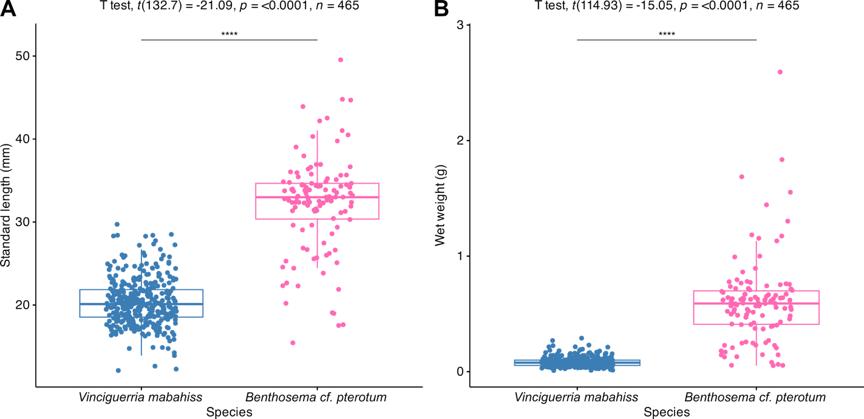
Figure S1. Comparison of (A) standard length and (B) wet weight between Vinciguerria mabahiss (blue) and Benthosema cf. pterotum (pink) in the eastern Red Sea. Asterisks (*) indicate statistically significant differences in size (p < 0.01) between fish species based on Welch's t-test.

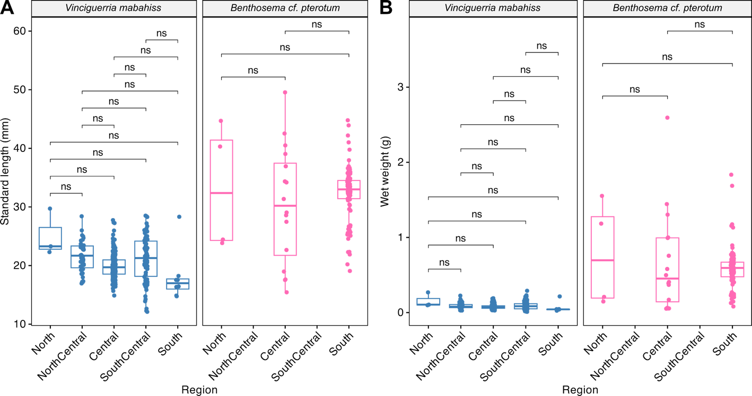
Figure S2. Comparison of (A) standard length and (B) wet weight between Vinciguerria mabahiss (blue) and Benthosema cf. pterotum (pink) across different provinces in the eastern Red Sea. “NS” denotes no statistically significant difference in size (p > 0.05) between fish species based on ANOVA followed by Bonferroni-corrected Tukey post-hoc tests.
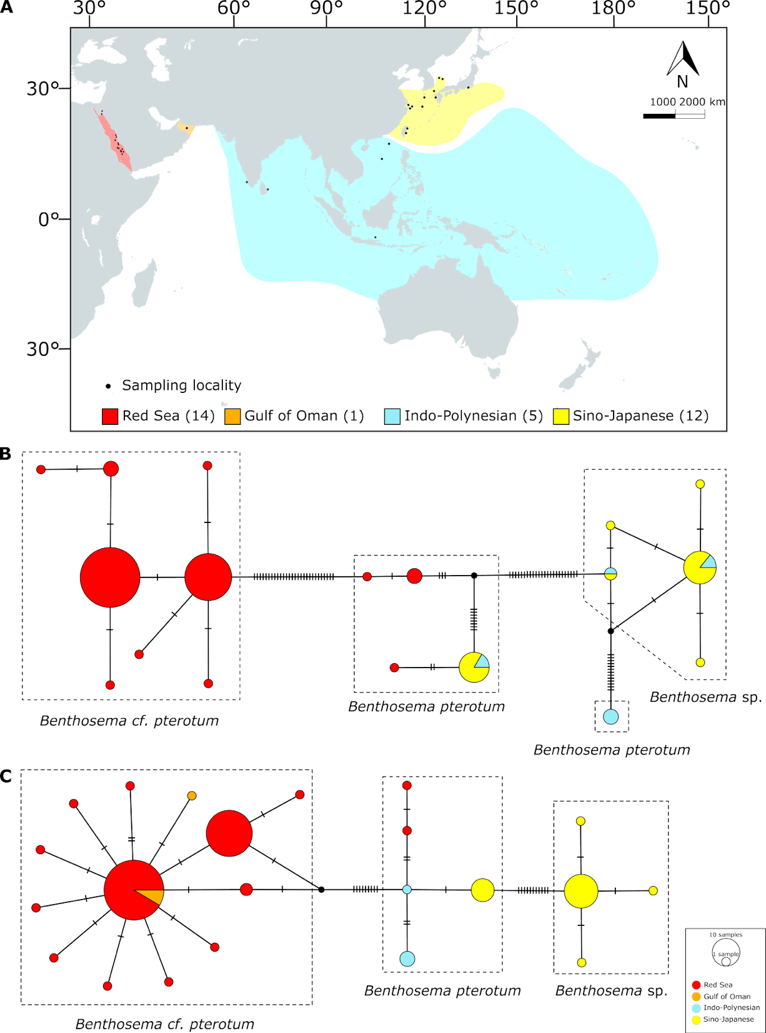
Figure S3. (A) Biogeographic provinces of the Indo-Pacific, defined by >10% endemism (sensu Bowen et al. 2016), are shown in color. The number of Benthosema pterotum species complex occurrences at each biogeographic province is indicated in parentheses (N = 36 total localities). TCS haplotype networks based on (B) 123 mtDNA COI sequences and (C) 118 mtDNA 16S sequences of the B. pterotum species complex from the Red Sea and Indo-Pacific localities.
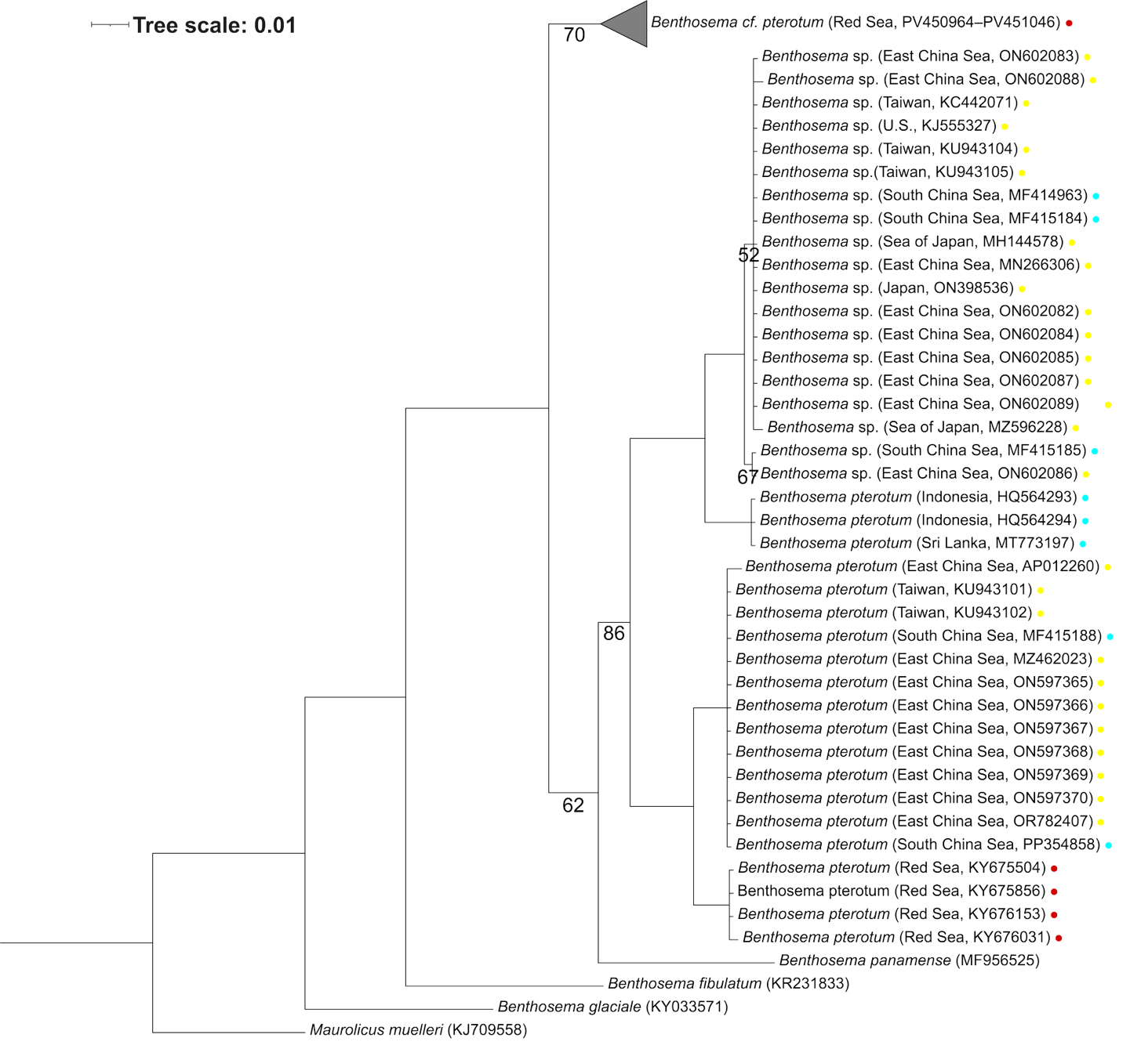
Figure S4. Bayesian tree showing the phylogenetic relationship of Benthosema spp. from the Indo-Pacific based on mtDNA cytochromes oxidase subunit I (COI), with Maurolicus muelleri used as the outgroup. The numbers below each branch represent posterior probabilities (PP). Scale bar indicates genetic distance. Colored dots correspond to the biogeographic provinces as defined in Bowen et al. (2016).
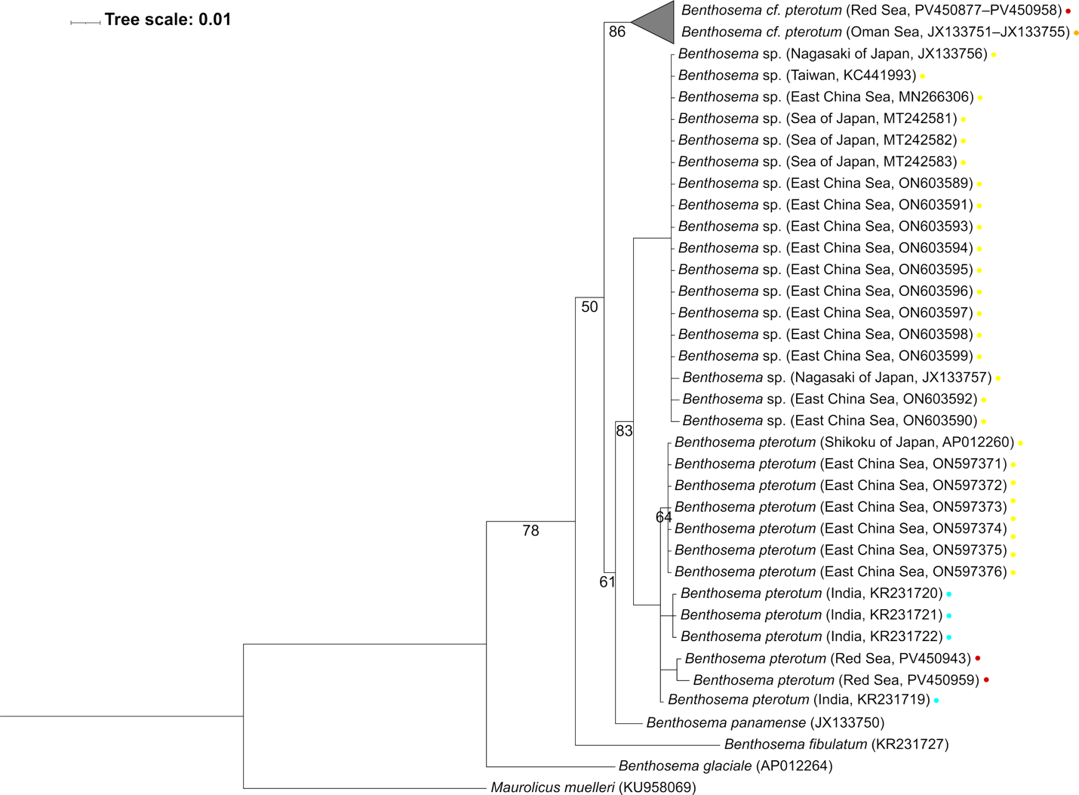
Figure S5. Bayesian tree showing the phylogenetic relationship of Benthosema spp. from the Indo-Pacific based on mtDNA 16S ribosomal RNA genes (16S), with Maurolicus muelleri used as the outgroup. The numbers below each branch represent posterior probabilities (PP). Scale bar indicates genetic distance. Colored dots correspond to the biogeographic provinces as defined in Bowen et al. (2016).

