Electronic Supplementary Material 3: Additional results
Next to key study variables (intention, self-efficacy, and self-monitoring), further motivational and volitional HAPA variables were assessed. Using a scale from 1 to 6, positive outcome expectancies were assessed with the item “If I wash my hands regularly, then I would take care of my health”, negative outcome expectancies with the item “If I wash my hands regularly, then it would take too much of my time”, risk perception with the item “What is your risk of coronavirus SARS-CoV-2 infection, if you wash your hands regularly?”, and planning with the item “In the past 7 days, I have made a concrete plan regarding when and where to wash my hands for at least 20 seconds with soap and water”.
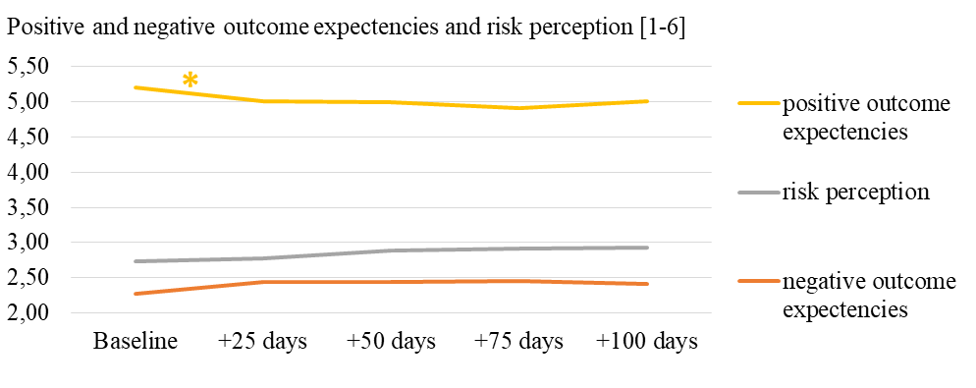
Figure A. Means of positive and negative outcome experiences and risk perception over time
Note. 68 ≤ n ≤ 89 participants due to missing values. * p < .05. Significant between-assessment differences: positive outcome expectancies between D0 and D25 (decrease).

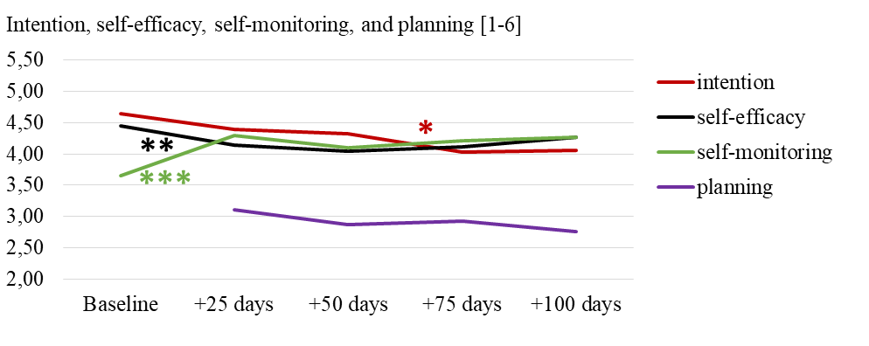
Figure B. Means of intention, self-efficacy, self-monitoring, and planning over time
Note. 67 ≤ n ≤ 89 participants due to missing values. * p < .05; **p < .01; ***p < .001. Significant between-assessment differences: intention between D50 and D75 (decrease); self-efficacy between D0 and D25 (decrease); self-monitoring between D0 and D25 (increase). Note that planning was not assessed at baseline due to technical issues.

Table A. Fixed Effects Estimates for Two-level Models Predicting Hand Washing, With Participant-selected Hand Washing Situations as Additional Covariates
Outcome: Next-week hand washing
Fixed effects
Outcome: Next-week hand washing  Fixed effects | B (SE) | p | 95% CI
Intercept (at study start, D0) | 5.02 (0.58) | <.001 | 3.87; 6.17
Time (assessment following D0) | 0.45 (0.11) | <.001 | 0.22; 0.67
Within- person intention | -0.09 (0.10) | .408 | -0.29; 0.12
Between-person intention | 0.42 (0.40) | .299 | -0.38; 1.21
Within-person self-efficacy | 0.21 (0.13) | .108 | -0.05; 0.47
Between-person self-efficacy | -0.06 (0.43) | .890 | -0.80; 0.92
Within-person self-monitoring | 0.16 (0.09) | .097 | -0.03; 0.34
Between-person self-monitoring | 1.10 (0.41) | .009 | 0.28; 1.91
Age | 0.11 (0.06) | .057 | -0.01; 0.22
Sex (0 = female; 1 = male) | -0.69 (0.82) | .399 | -2.32; 0.94
Flu-like symptoms | -1.58 (1.25) | .210 | -4.06; 0.91
Number of persons in household | -0.16 (0.23) | .494 | -0.62; 0.30
Working in home office | 0.21 (0.68) | .756 | -1.15; 1.58
Negative outcome expectancies at D0 | 0.15 (0.38) | .682 | -0.59; 0.90
Within-level risk perception | -0.20 (0.21) | .348 | -0.61; 0.22
Between-level risk perception | 0.42 (0.61) | .497 | -0.80; 1.64
Situations as selected in the intervention (0 = not selected; 1 = selected)
After coming home | -1.31 (0.77) | .094 | -2.86; 0.23
After (longer) smartphone use | 1.70 (0.79) | .035 | 0.12; 3.28
Before (preparing) a meal | 0.15 (0.86) | .866 | -1.56; 1.85
Before snacking | 1.46 (0.99) | .145 | -0.51; 3.43
Random effect | Variance (SE) | p
Intercept (at study start, D0) | 0.22 (10.80) | .984
Note. Analyses refer to n = 88 participants with 310 observations. SE = standard error. Significant predictions in bold. Regarding random effects, only a random intercept could be modelled. The inclusion of more random effects resulted in model non-convergence.

