Online supplemental
Table 1. Total number of participants providing data per calendar week.
Week commencing | Week | Frequency
21/03/20 | 1 | 28,930
28/03/20 | 2 | 27,873
04/04/20 | 3 | 38,169
11/04/20 | 4 | 38,458
18/04/20 | 5 | 38,500
25/04/20 | 6 | 36,516
02/05/20 | 7 | 36,685
09/05/20 | 8 | 37,595

Table 2. Comparison of items in the original and revised Perceived Social Support Questionnaire (F-SozU K-6).
Original | Adapted for COVID-19  In the past week, I feel…
I experience a lot of understanding and security from others | I have experienced a lot of understanding and support from others
I know a very close person whose help I can always count on | I have a very close person whose help I can always count on
If necessary, I can easily borrow something I might need from neighbours or friends | If necessary, I can easily borrow something I need from neighbours or friends
I know several people with whom I like to do things | I have people with whom I can spend time and do things together
When I am sick, I can without hesitation ask friends and family to take care of  important matters for me | If I get sick, I have friends and family who will take care of me
If I am down, I know to whom I can go without hesitation | If I am feeling down, I have people I can talk to without hesitation

Figure 1. Model of relationship between social support, loneliness, social isolation and physical activity.
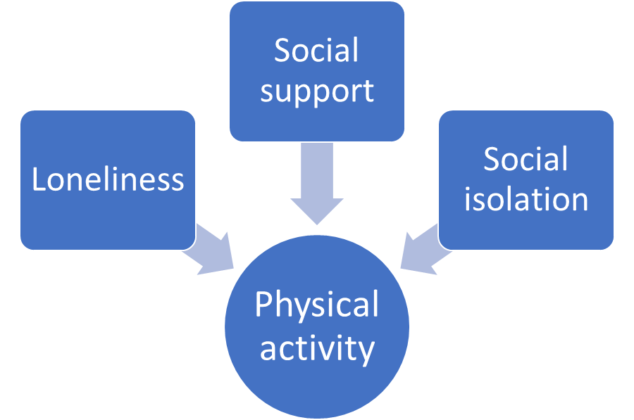

Online supplemental – Full case analysis
Table 3. Number of active weeks and Physical Activity Index (n=6906)
Number of active weeks | Number of participants | Total group % | Within category %
Inactive N=3043 (44%)
0 | 3043 | 44.1% | 100%
Intermittently active N=2748 (40%)
1 | 964 | 14% | 36%
2 | 629 | 9.1% | 23%
3 | 398 | 5.8% | 14%
4 | 436 | 6.3% | 15%
5 | 321 | 4.6% | 12%
Consistently active N=1115 (16%)
6 | 348 | 5% | 31%
7 | 375 | 5.4% | 34%
8 | 392 | 5.7% | 35%
Total | 6906 | 100

Table 4. Ordered logistic regression model of physical activity category (inactive, intermittently, active) with social support, loneliness and social isolation (n=6906)
Physical Activity Category

Variable | Odds ratio (95% CI)
Model 1 – sex, age
Social support  medium  high | 1.42 (1.25 – 1.62)***  1.95 (1.70 – 2.25)***
Loneliness  Yes | 1.03 (0.93 – 1.15)
Social isolation  Yes | 0.79 (0.66 – 0.94)**
Model 2 – sex, age, ethnicity, employment status, income and education
Social support  medium  high | 1.34 (1.17 – 1.54)***  1.81 (1.56 – 2.10)***
Loneliness  Yes | 1.04 (0.92 – 1.16)
Social isolation  Yes | 0.88 (0.73 – 1.06)
Model 3 - sex, age, ethnicity, employment status, income, education, chronic physical and mental health conditions
Social support  medium  high | 1.29 (1.13 – 1.49)***  1.74 (1.49 – 2.02)***
Loneliness  Yes | 1.12 (1.00 – 1.26)
Social isolation  Yes | 1.00 (0.83 – 1.22)
*P<0.05; **P<0.01; ***P<0.001

