Supplementary File

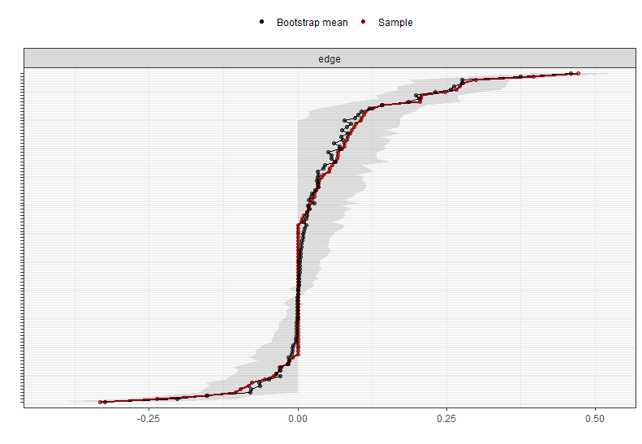

Supplementary Figure 1. The accuracy of the edge weight estimates (red line) and the 95% bootstrapped confidence intervals (grey area; bootstraps number = 2500) for the vaccinated participants. The names of the edges have been removed for clarity reasons.

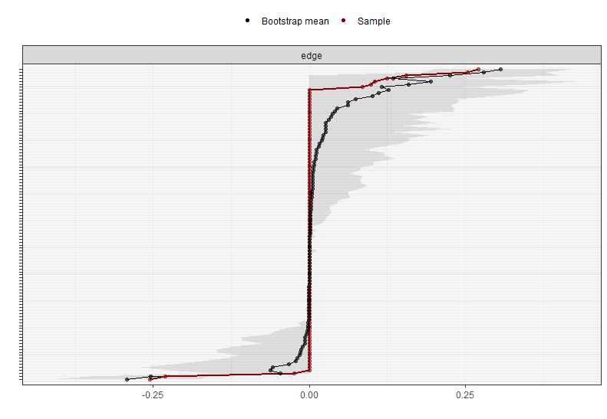

Supplementary Figure 2. The accuracy of the edge weight estimates (red line) and the 95% bootstrapped confidence intervals (grey area; bootstraps number = 2500) for the participants hesitating to be vaccinated. The names of the edges have been removed for clarity reasons.

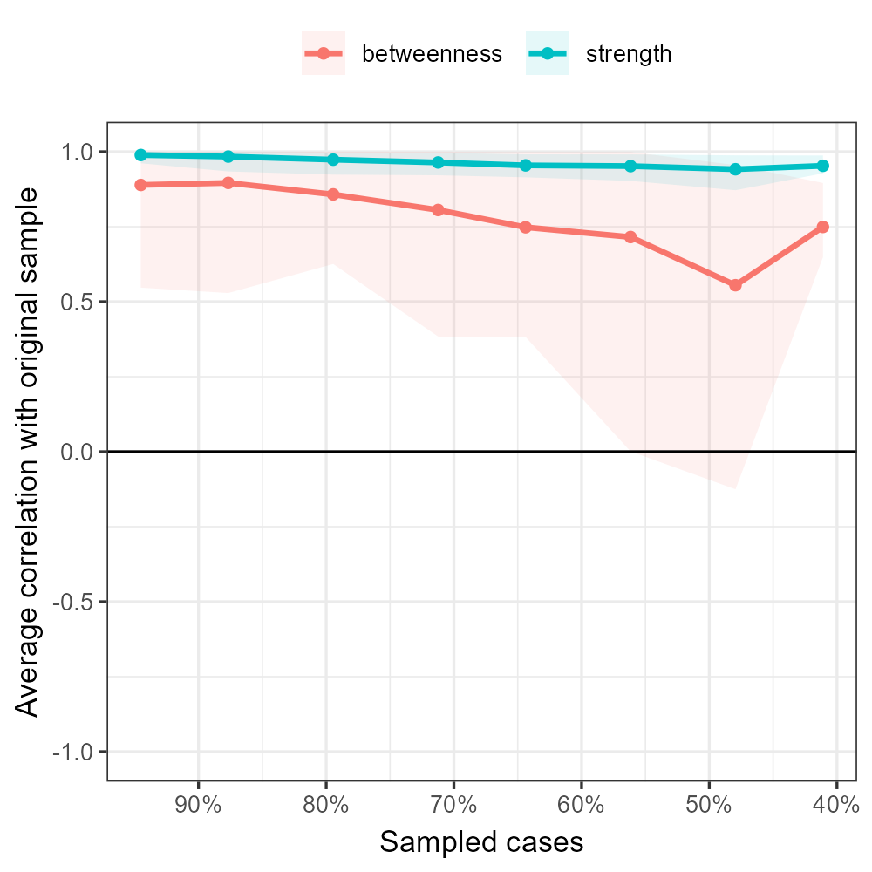 | 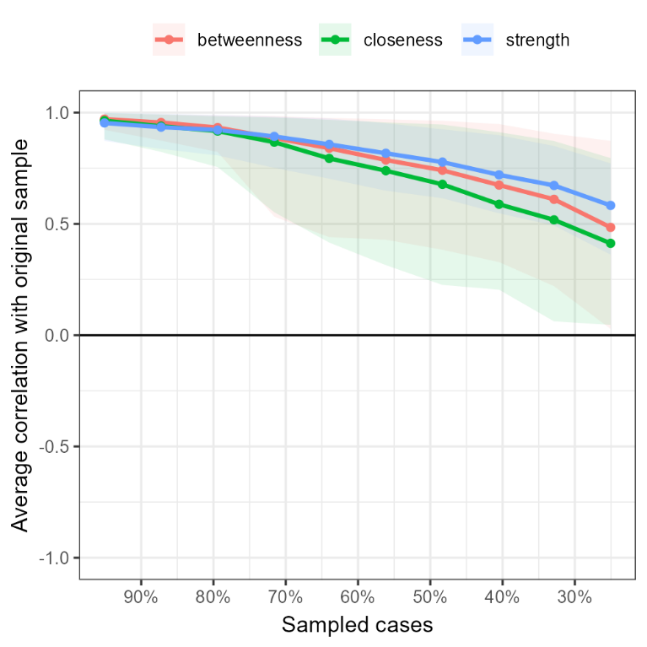

Supplementary Figure 3. The stability of centrality indices (bootstraps number = 2500) for the participants hesitating to be vaccinated (left panel) and those vaccinated (right panel).

