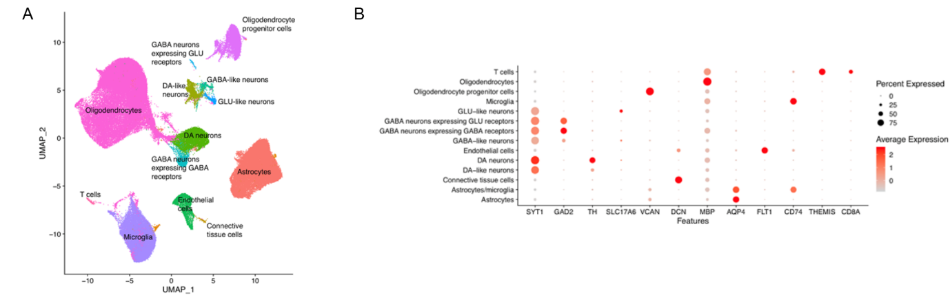

Supplementary Figure S1. The discovery substantia nigra pars compacta single-nucleus RNA-sequencing dataset. (A) UMAP projection of cells annotated per cell type for the discovery dataset. (B) Average expression of key cell type markers across the cell types in the discovery dataset.

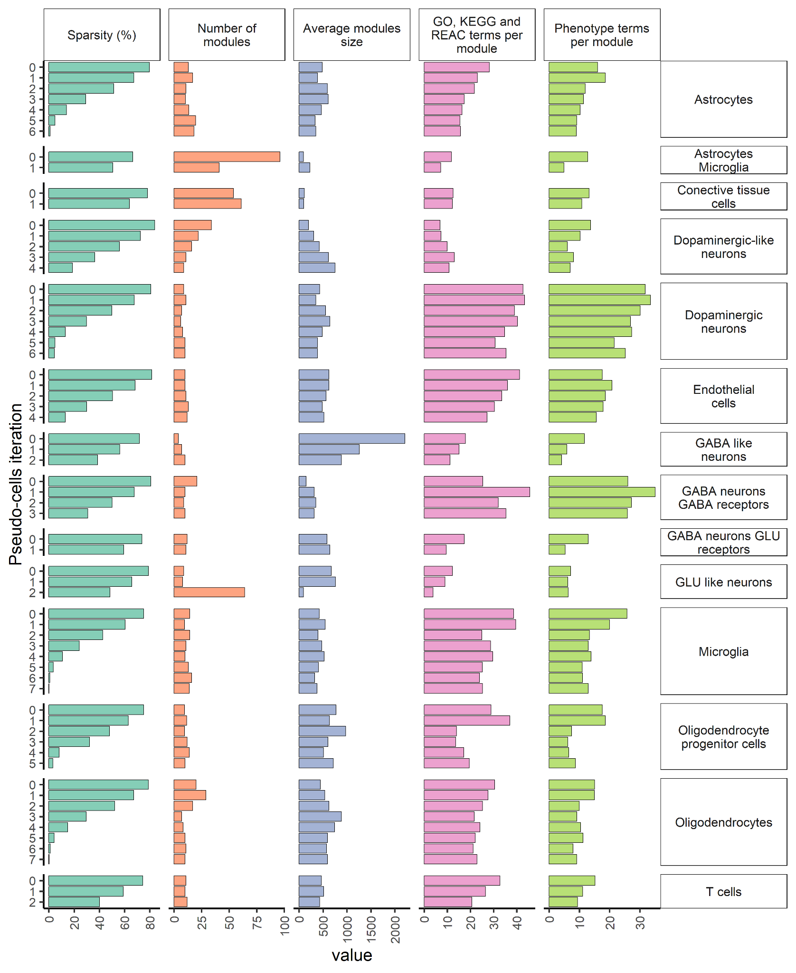
Supplementary Figure S2. GCNs statistics per cell type from the discovery dataset. Cell types are represented within each plot row. Y-axis of each plot refers to the iteration within which the GCN was created from T₀ to T_{n}, where the maximum number of iterations is seven. Plots at columns correspond to the features observed from networks including sparsity (%), number of modules, average module size, mean number of GO, KEGG and REAC terms per module and mean number of phenotype-related terms per module.

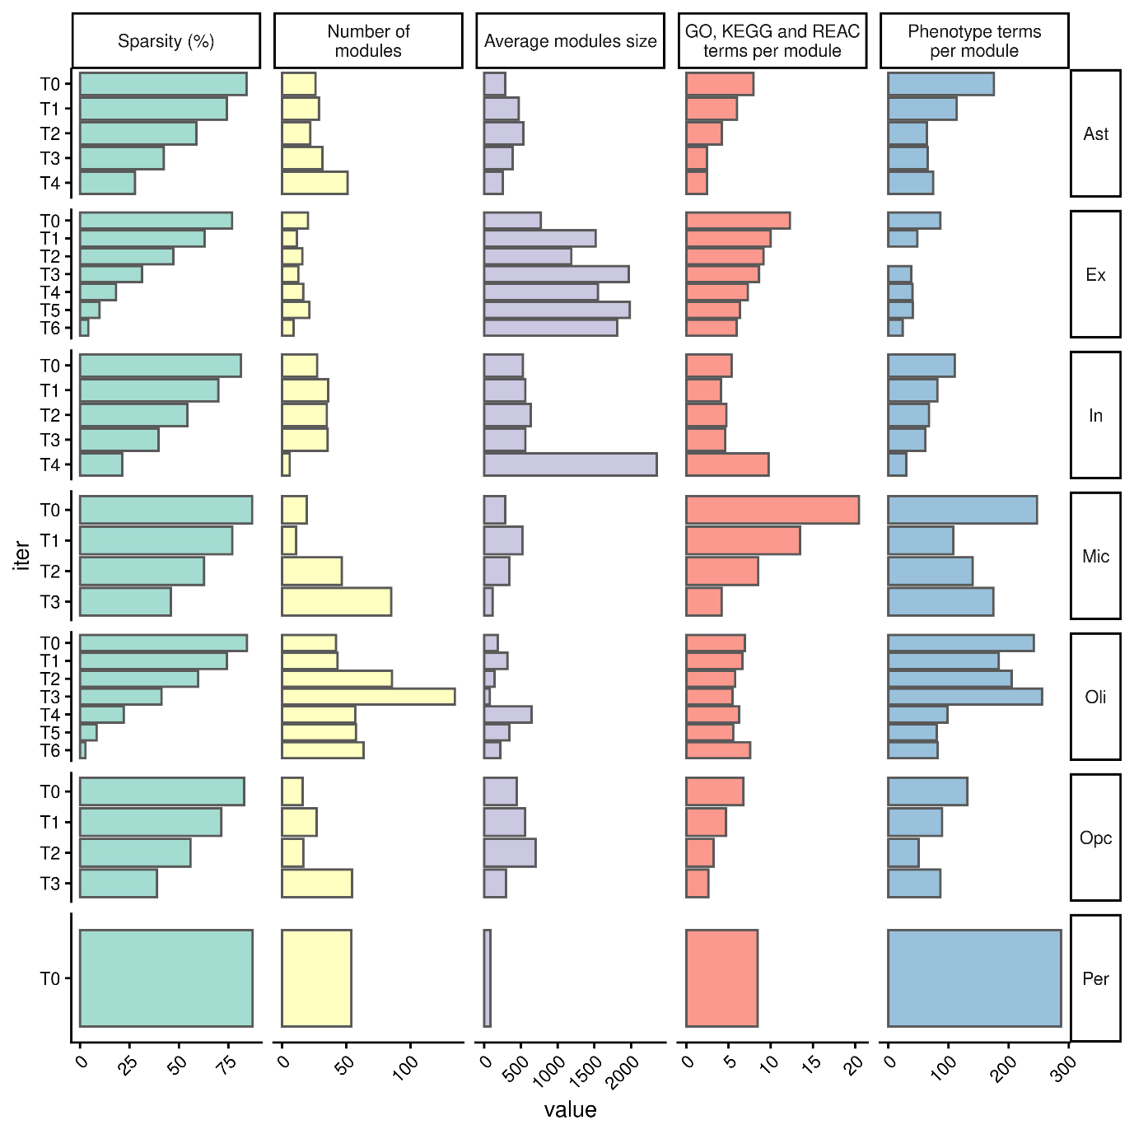

Supplementary Figure S3. GCNs statistics per cell type of the snRNA-seq dataset from Mathys et al. Cell types are represented within each plot row. Y-axis of each plot refers to the iteration within which the GCN was created from T₀ to T_{n}, where the maximum number of iterations is seven. Plots at columns correspond to the features observed from networks including sparsity (%), number of modules, average module size, mean number of GO, KEGG and REAC terms per module and mean number of phenotype-related terms per module.

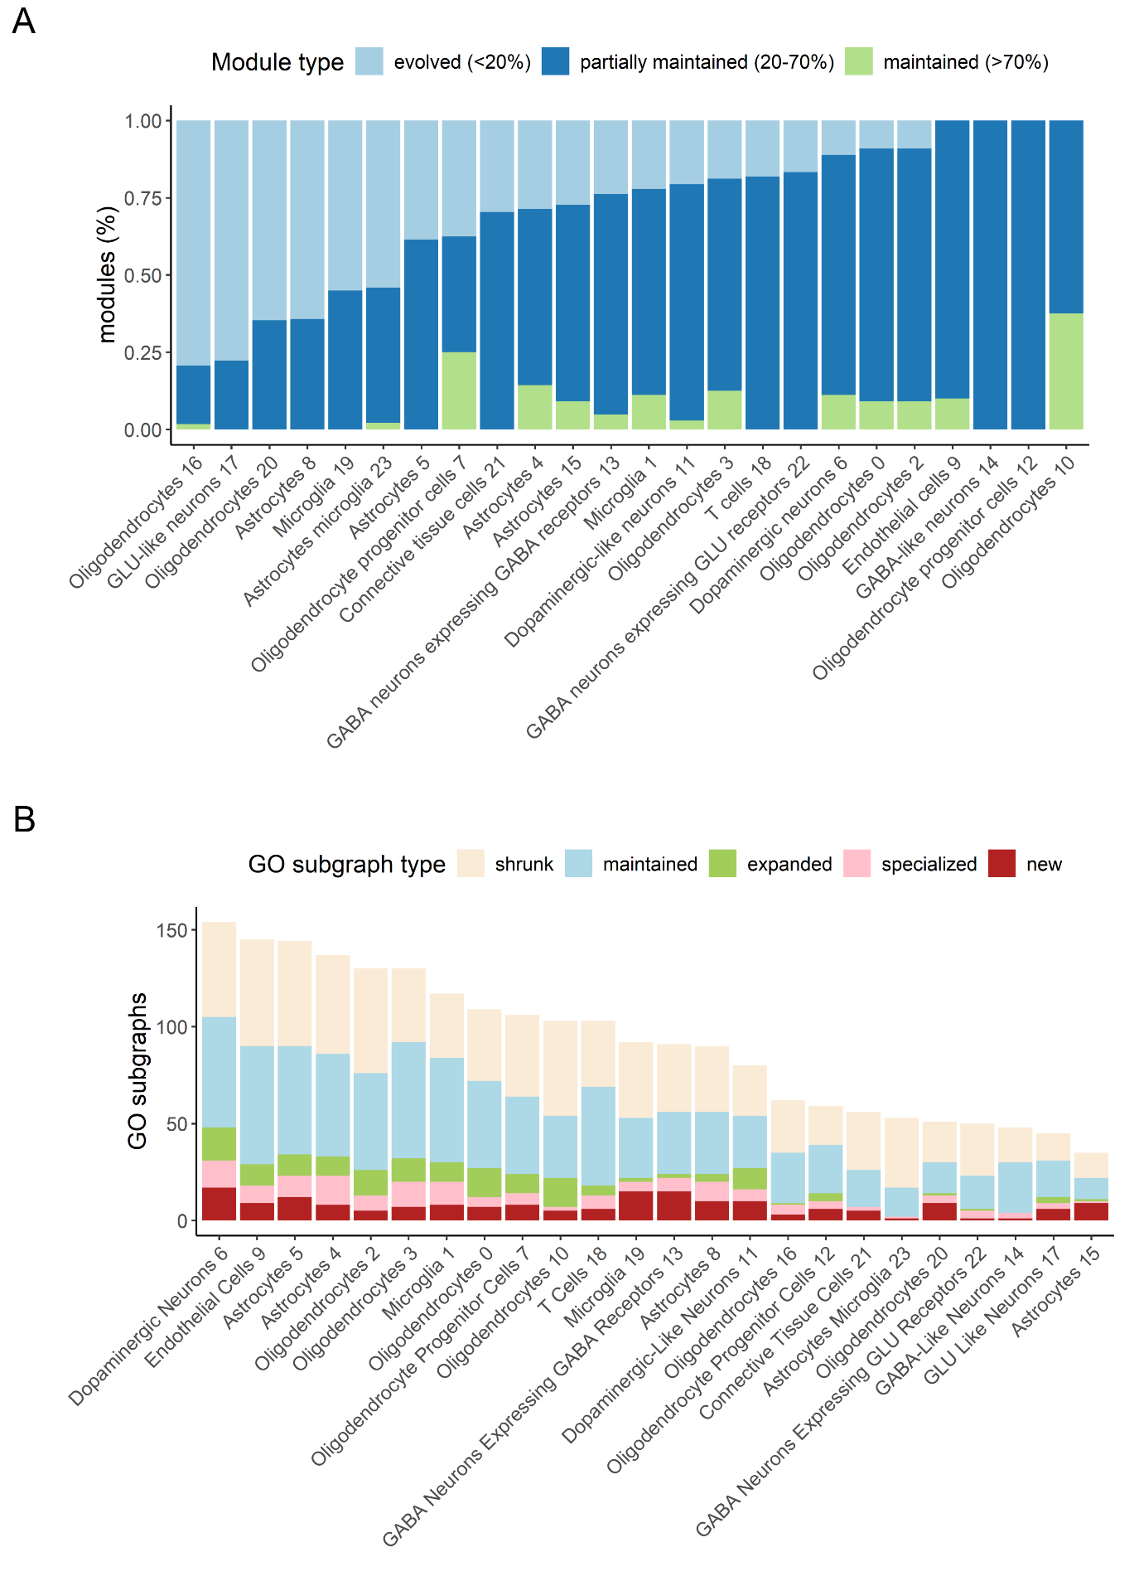
Supplementary Figure S4. scCoExpNets creates multiple GCNs for each cell type to extend the biological insights that can be extracted from scRNA-seq data. (A) Proportion of modules’ types per cell type cluster. The X axis represents the cell type clusters detected in the discovery dataset (the number after the name indicates the cluster where each belongs since the same cell type can have different clusters assigned). The Y axis shows the proportion of T₀ modules maintained, partially maintained and evolved through pseudo-cell iterations for each cell type cluster. Although it may appear that the proportions of modules are different between cell types, a common pattern is observed: most of the modules have significantly changed their transcript composition through pseudo-cell iterations, either partially or completely. That is, there is a low proportion of modules that are robust to sparsity and have maintained their transcript composition throughout the iterations. (B) Number of GO subgraphs detected per cell type cluster. The X axis represents the cell type clusters detected in the discovery dataset. The Y axis shows the number of: (1) T₀ GO subgraphs maintained or shrunk at T_{i} but not in previous iterations; (2) T₀ GO subgraphs expanded or specialized in T_{i} but not in previous iterations; (3) T_{i} GO subgraphs that are completely new and did not appear in previous iterations. Thanks to the creation of multiple GCNs, scCoExpNets is able to detect T_{i} GO subgraphs that provide new knowledge not detected in previous iterations. Dopaminergic neurons stands out as the cell type with the highest number of GO subgraphs that provides new insights.

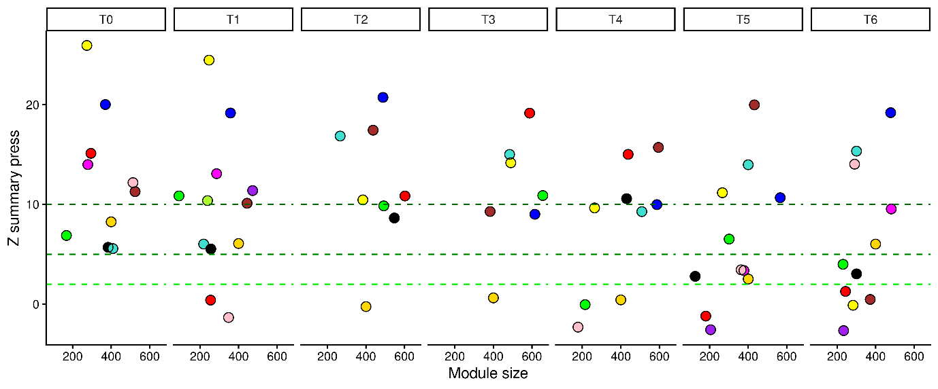

Supplementary Figure S5. Preservation of dopaminergic neurons co-expression modules in the snRNA-seq dataset from Wang et al. The modules created in each pseudo-cell iteration is represented in different columns (from T₀ to T₆). In each iteration, modules of the corresponding iteration are represented as circles. The height of the circle represents the Z summary press. Under the null hypothesis of no module preservation, Z summary press<2 while a Z summary press >5 (or 10) indicates moderate (strong) module preservation (see dashed lines). The X-axis represents the size of the module. All iterations contain a gold module, which is a random module used as a reference of totally random module values. As observed, an average of 85.26% of the dopaminergic neurons modules are preserved in the Wang Qian et al. dataset in each pseudo-cell iteration.

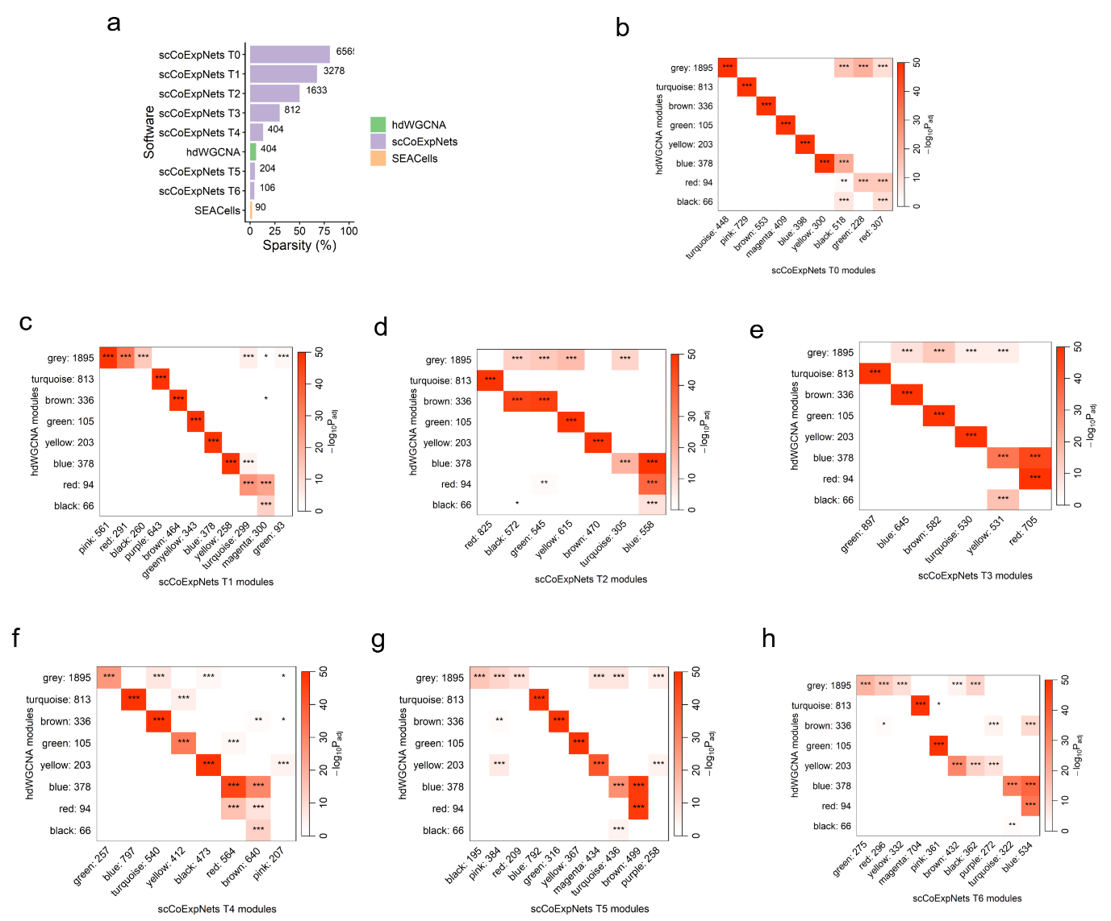

Supplementary Figure S6. Comparison of scCoExpNets with alternative pseudo-cell approaches using dopaminergic neurons expression data from the discovery dataset. (A) Sparsity of the DN expression matrix after applying SEACells, hdWGCNA and scCoExpNets (the last one was applied while the number of pseudo-cell was above m). The height of the bar represents sparsity and over the bars is represented the number of pseudo-cell created. The three methods get reasonably similar ratios. (B-H) Pairwise comparisons between the gene modules detected with scCoExpNets and hdWGCNA approaches using Fisher’s exact test to test module overlaps. Only significant overlaps after p-value adjustment by FDR are colored. We observed that all modules within all GCNs created by scCoExpNets overlaps, at least partially, with one hdWGCNA gene module after p-value adjustment. * : P<0.01, **: P<0.05, ***: P<0.001

Supplementary Table S1. Discovery cohort donors’ features. Neuritic plaque abundance was scored using the CERAD score (0-3). Neurofibrillary tangles were scored using the Braak staging measure. CERAD: Consortium to Establish a Registry for Alzheimer's Disease; HC: healthy controls; PD: Parkinson’s disease; PMI: post-mortem interval; RIN: RNA integrity number.

Donor ID | Clinical diagnosis | Age of death | Sex | RIN | PMI (h) | Neuritic plaque abundance (CERAD score) | Neurofibrillary tangles abundance (Braak stage) | Lewy body presence in midbrain (1=YES) | Lewy body presence in limbic (1=YES) | Lewy body presence in neocortical (1=YES)
s.0096 | PD | 90 | female | 7.8 | 3.00 | 1 | 4 | 1 | 1 | 1
s.0098 | PD | 99 | male | 7.0 | 3.00 | 1 | 4 | 1 | 1 | 1
s.0102 | PD | 57 | female | 6.5 | 3.00 | 0 | 1 | 1 | 1 | 1
s.0103 | PD | 68 | male | 6.4 | 61.00 | 1 | 4 | 1 | 1 | 1
s.0104 | PD | 81 | male | 6.9 | 48.00 | 1 | 4 | 1 | 1 | 1
s.0105 | PD | 78 | male | 6.5 | 12.00 | 0 | 1 | 1 | 1 | 0
s.0107 | PD | 82 | male | 7.1 | 24.00 | 0 | 2 | 1 | 1 | 1
s.0109 | PD | 98 | male | 7.0 | 20.50 | 0 | 3 | 1 | 1 | 1
s.0110 | PD | 82 | male | 7.3 | 4.00 | 0 | 3 | 1 | 1 | 1
s.0111 | PD | 80 | male | 7.5 | 46.00 | 1 | 2 | 1 | 1 | 1
s.0116 | PD | 77 | male | 6.3 | 24.00 | 0 | 1 | 1 | 1 | 0
s.0118 | PD | 85 | female | 7.7 | 40.00 | 1 | 4 | 1 | 1 | 1
s.0119 | PD | 84 | male | 6.4 | 21.00 | 2 | 4 | 1 | 1 | 1
s.0120 | PD | 85 | female | 7.5 | 24.00 | 0 | 3 | 1 | 1 | 1
s.0128 | HC | 81 | female | 6.9 | 24.00 | - | - | - | - | -
s.0129 | HC | 86 | male | 6.7 | 13.00 | - | - | - | - | -
s.0130 | HC | 61 | male | 7.6 | 22.00 | - | - | - | - | -
s.0131 | HC | 65 | male | 7.0 | 22.00 | - | - | - | - | -
s.0142 | HC | 62 | male | 7.6 | 52.00 | - | - | - | - | -
s.0147 | HC | 30 | female | 8.0 | 12.00 | - | - | - | - | -
s.0151 | HC | 77 | female | 6.7 | 11.00 | - | - | - | - | -
s.0152 | HC | 93 | female | 7.7 | 8.00 | - | - | - | - | -
s.0154 | HC | 93 | male | 7.1 | 7.00 | - | - | - | - | -
s.0158 | HC | 89 | male | 7.7 | 18.75 | - | - | - | - | -
s.0159 | HC | 73 | female | 7.7 | 21.00 | - | - | - | - | -
s.0165 | HC | 91 | male | 7.2 | 17.75 | - | - | - | - | -

Supplementary Table S2. Curated list of SNpc DN markers obtained from scRNA-seq studies.
DEGs: differentially expressed genes; GWAS: genome wide association studies; iDN: induced dopaminergic neurons; MB: midbrain; NS: not specified; SNpc: substantia nigra pars compacta; VTA: ventral tegmental area; WT: wild-type.

Reference | Specie | Brain region | Description | DEG | Genes
Grimm et al. (2004) | Mouse | SNpc | DN SNpc vs VTA | UP | 10
 |  |  |  | DOWN | 54
Greene et al. (2005) | Mouse | SNpc | DN SNpc vs VTA | UP | 67
 |  |  |  | DOWN | 57
Chung et al. (2005) | Mouse | SNpc | DN SNpc vs VTA | UP | 57
 |  |  |  | DOWN | 68
Poulin et al. (2014) | Mouse | SNpc | DN SNpc vs VTA | UP | 19
Bifsha et al. (2014) | Mouse | SNpc | DN SNpc vs VTA | UP | 20
 |  |  |  | DOWN | 207
Xia et al. (2016) | iPsc | - | DN PD vs control | DOWN | 13
 |  |  |  | UP | 6
LaManno et al. (2016) | Mouse | SNpc | DN SNpc vs VTA | UP | 17
 |  |  |  | DOWN | 26
Nichterwitz et al. (2016) | Human | SNpc | DN SNpc vs VTA | UP | 32
 |  |  |  | DOWN | 60
Hook  et al. (2018) | Mouse | SNpc | DN markers | DEG | 110
Hook  et al. (2018) | ns | SNpc | DN literature | - | 49
Skene et al. (2018) | Mouse | ns | DN markers | DEG | 33
Skene et al. (2018) | Mouse | SNpc | DN markers | DEG | 25
Kramer et al. (2018) | Mouse | SNpc | DN1 vs all cell types | UP | 27
Kramer et al. (2018) | Mouse | SNpc | DN4 vs all cell types | UP | 25
Agarwal et al. (2020) | Human | SNpc | DN vs all cell types | UP | 129
Agarwal et al. (2020) | Human | SNpc | DN vs neurons | UP | 77
Fernandes et al. (2020) | iPsc | - | DN1 markers | UP | 172
Fernandes et al. (2020) | iPsc | - | DN1 markers | DOWN | 126
Fernandes et al. (2020) | iPsc | - | DN2 markers | UP | 163
Fernandes et al. (2020) | iPsc | - | DN2 markers | DOWN | 152
Fernandes et al. (2020) | iPsc | - | DN3 markers | UP | 174
Fernandes et al. (2020) | iPsc | - | DN3 markers | DOWN | 116
Bryois et al. (2020) | Human | - | PD genetic mutations | - | 66
Bryois et al. (2020) | Human | SNpc | GTEx markers | DEG | 11
Bryois et al. (2020) | Mouse | ns | Cholinergic markers | DEG | 42
Zhong et al. (2021) | Mouse | MB | DN markers | UP | 32
Zhong et al. (2021) | Mouse | MB | DN A53T vs WT | UP | 27
Zhong et al. (2021) | Mouse | MB | DN A53T vs WT | DOWN | 30
Aguila et al. (2021) | Human | SNpc | DN SNpc vs VTA | UP | 23
Aguila et al. (2021) | Human | SNpc | DN SNpc vs VTA | DOWN | 51
Aguila et al. (2021) | Human | SNpc | DN markers | DEG | 167

Supplementary Table S3. Sepulveda cohort donors’ features. PD: Parkinson’s disease; HC: healthy controls; RIN: RNA integrity number; PMI: post-mortem interval.

Donor ID | Clinical diagnosis | Age of death | Sex | RIN | PMI (h)
s.0169 | PD | 71 | male | 7.2 | 21.5
s.0170 | PD | 61 | male | 7.4 | 6.3
s.0171 | HC | 70 | male | 7.8 | 11.8
s.0172 | HC | 84 | male | 7.6 | 11.8
s.0173 | HC | 88 | male | 8.5 | 9.3
s.0176 | PD | 74 | male | 7.7 | 11.4
s.0177 | PD | 79 | male | 7.9 | 12.3

Supplementary Table S4. Cell types identified in the Oregon snRNA-seq dataset.
GABA: Gamma-aminobutyric acid; GLU: glutamate.

Cell type | Genes detected  (CI 95%) | Sparsity (%) | Number of cells | Cell proportion (%)
Astrocytes | 1972 (1960-1984) | 79.76 | 23466 | 22.49
Astrocytes/microglia | 2640 (2531-2748) | 66.63 | 256 | 0.25
Connective tissue cells | 1909 (1804-2014) | 78.25 | 302 | 0.29
Dopaminergic neurons | 1329 (1316-1343) | 80.79 | 6565 | 6.29
Dopaminergic-like neurons | 1306 (1282-1330) | 84.08 | 2103 | 2.02
Endothelial cells | 1773 (1741-1806) | 81.74 | 3080 | 2.95
GABA neurons expressing GABA receptors | 1277 (1248-1306) | 80.95 | 1230 | 1.18
GABA neurons expressing GLU receptors | 1562 (1482-1643) | 73.91 | 291 | 0.28
GABA like neurons | 1623 (1573-1674) | 71.76 | 768 | 0.74
GLU like neurons | 1571 (1526-1615) | 79.16 | 758 | 0.73
Microglia | 1765 (1752-1778) | 75.26 | 15143 | 14.51
Oligodendrocyte progenitor cells | 2063 (2041-2084) | 75.19 | 7029 | 6.74
Oligodendrocytes | 1833 (1825-1841) | 78.94 | 42802 | 41.02
T cells | 1701 (1649-1754) | 74.59 | 545 | 0.52

Supplementary Table S5. Cell types identified in the Sepulveda snRNA-seq dataset.
GABA: Gamma-aminobutyric acid.

Cell type | Genes detected  (CI 95%) | Sparsity (%) | Number of cells | Cell proportion (%)
Astrocytes | 2543 (2520-2566) | 73.44 | 4582 | 16.62
Astrocytes/Oligodendrocytes | 1520 (1483-1558) | 85.25 | 741 | 2.69
Connective tissue cells | 2052 (1925-2179) | 77.61 | 130 | 0.47
Dopaminergic neurons | 1633 (1610-1655) | 80.12 | 567 | 2.06
Dopaminergic-like neurons | 1689 (1619-1759) | 84.04 | 317 | 1.15
Endothelial cells | 2341 (2240-2442) | 77.04 | 317 | 1.15
GABA neurons | 2425 (2293-2558) | 64.58 | 68 | 0.25
GABA-like neurons | 2196 (2103-2288) | 77.21 | 267 | 0.97
Microglia | 2384 (2362-2406) | 71.52 | 3798 | 13.78
Mural cells | 1729 (1659-1799) | 83.51 | 303 | 1.10
Oligodendrocyte progenitor cells | 2799 (2762-2835) | 66.75 | 1674 | 6.07
Oligodendrocytes | 2430 (2419-2441) | 69.42 | 14617 | 53.02
T cells | 1882 (1819-1945) | 74.05 | 187 | 0.68

Supplementary Table S6. T₀ GO subgraphs maintained through all pseudo-cell iterations per cell type cluster. See excel file.

Supplementary Table S7. T₁ new GO subgraphs not detected at T₀ per cell type cluster. See excel file.

Supplementary Table S8. T₁ GO subgraphs that expand or specialize T₀ GO subgraphs per cell type cluster. See excel file.

Supplementary Table S9. Preservation of the M₁ module from the DN GCN at T₀ through pseudo-cell iterations in the Sepulveda dataset. Under the null hypothesis of no module preservation, Z-summary score is below 2 while a Z-summary score greater than 5 (or 10) indicates moderate (strong) module preservation.

Pseudo-cell iteration | Module name | Module size | Z summary pres
0 | pink (M₁) | 309 | 3.39
1 | purple | 316 | 1.57
2 | red | 380 | 2.64
3 | green | 417 | 2.07
4 | blue | 363 | 2.66
5 | blue | 364 | 2.85
6 | magenta | 305 | 2.29

Supplementary Table S10. Functional enrichment of the M₁ module from the DN GCN at T₀. See excel file.

Supplementary Table S11. Fisher’s test results for the pairwise comparison of DN modules created with hdWGCNA and scCoExpNets methods. See excel file.

Supplementary Table S12. hdWGCNA GO subgraphs and its comparison with scCoExpNets GO subgraphs. See excel file.

