Supplementary material
Effects of Sc additions on annealing behavior of heavily cold-rolled Al-Cu-Mn alloys
Xiaoyu Huang ª, Tianlin Huang ^{a,b,*}, Yueyue Zhu ª, Guilin Wu ª , Yongzhong Zhang^{c}, Xiaoxu Huang ^{a,b}, Oleg V. Mishin ^{d,*}
ª International Joint Laboratory for Light Alloys (MOE), College of Materials Science and Engineering, Chongqing University, Chongqing 400044, China
^{b} Electron Microscopy Center of Chongqing University, Chongqing University, Chongqing 400044, China
^{c} National Engineering & Technology Research Center for Non-Ferrous Metals Composites, GRINM Group Co., Ltd., Beijing 101407, China
^{d} Department of Civil and Mechanical Engineering, Technical University of Denmark, 2800 Kgs. Lyngby, Denmark
*corresponding authors: Tianlin Huang (E-mail: huangtl@cqu.edu.cn); Oleg V. Mishin (E-mail: olmi@dtu.dk)
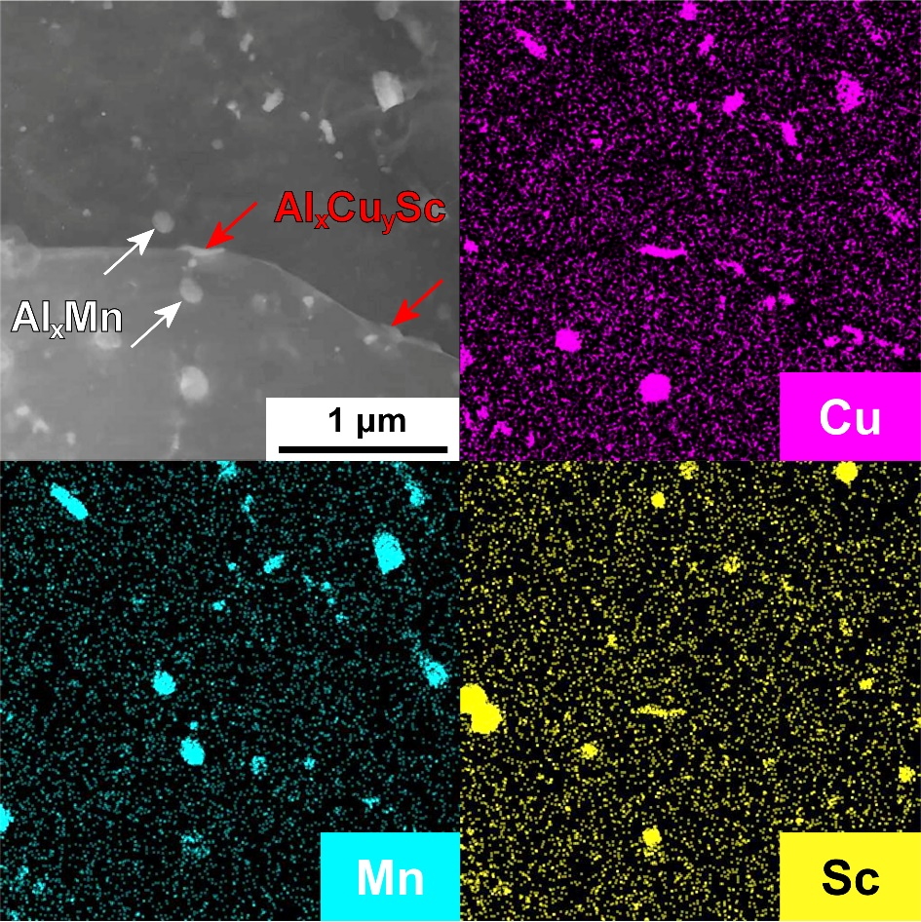
Fig. S1: STEM image showing particles and the corresponding distributions of Cu, Mn and Sc in the Al-Cu-Mn-0.2Sc sample annealed at 300 °C for 100 h. The arrows in the STEM image show some examples of Al_{x}Cu_{y}Sc and Al_{x}Mn particles (the latter are most likely Al₁₂Mn particles). Note that the marked Al_{x}Cu_{y}Sc particles precipitated along a boundary between two recrystallized grains.

