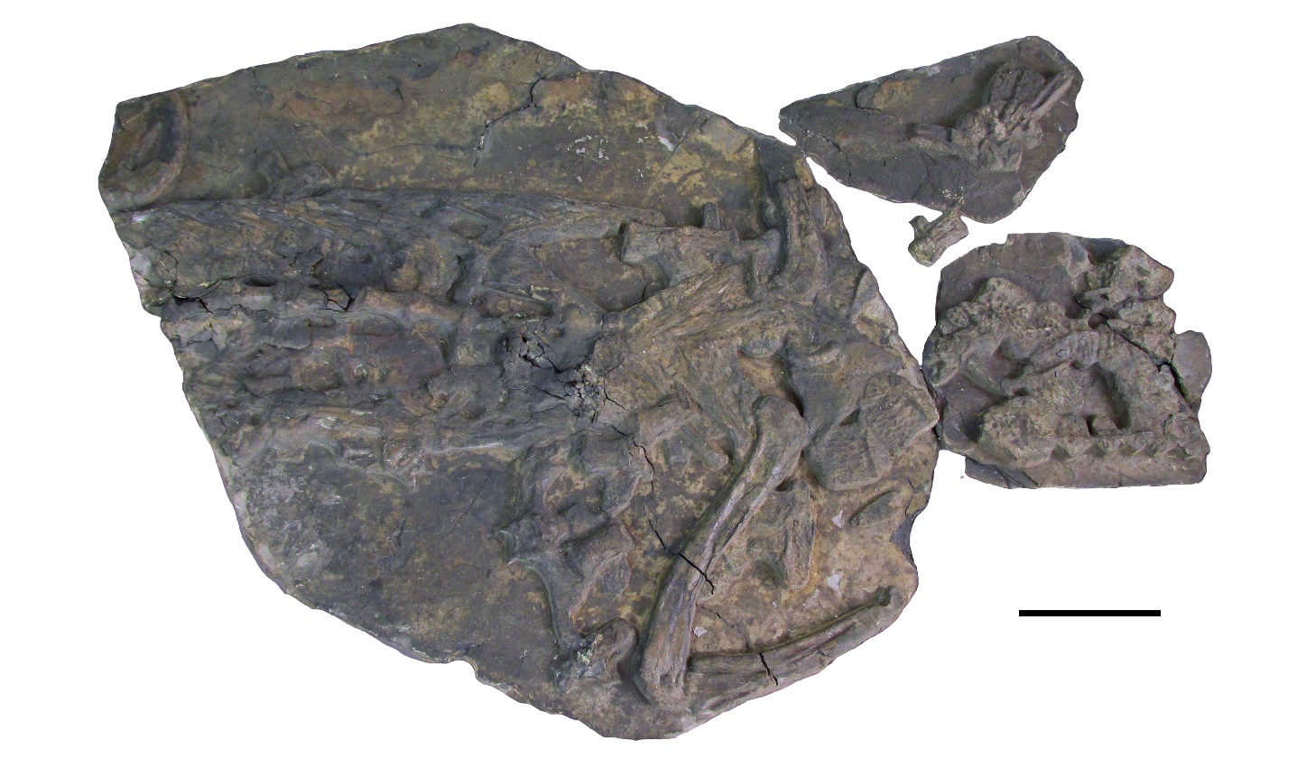
Supplementary Fig. 1. Macrospondylus bollensis (Jaeger 1828), MMG BwJ 595, holotype. Specimen in dorsal view. Scale bar: 10 cm.

