Differentials, barriers and enablers of death registration in Nepal: evidence from the Civil Registration and Vital Statistics (CRVS) survey
Supplementary information
Provinces, ecological belts and ethnic groups of Nepal
Nepal is comprised of seven provinces, which were created in 2015 as per the provision of Schedule 4 of the Constitution of Nepal, 2015.(Nepal Law Commission (NLC), 2015)
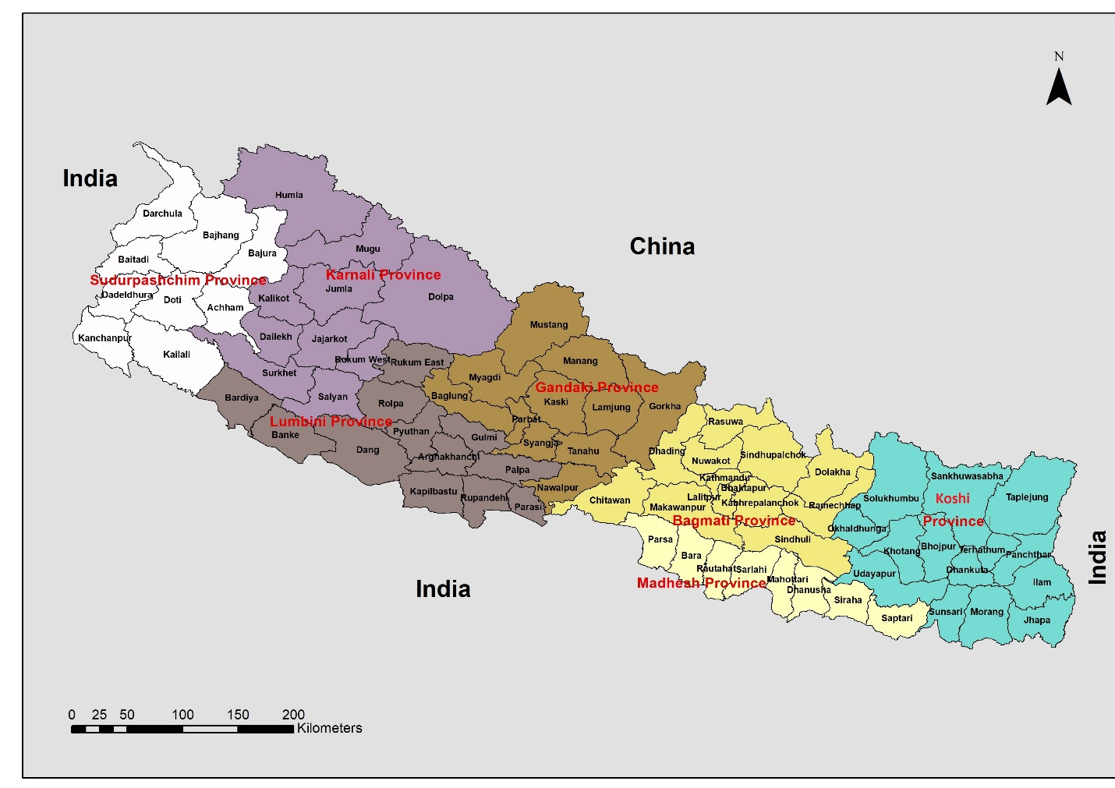

Supplementary Figure 1: Political map of Nepal by provinces and districts

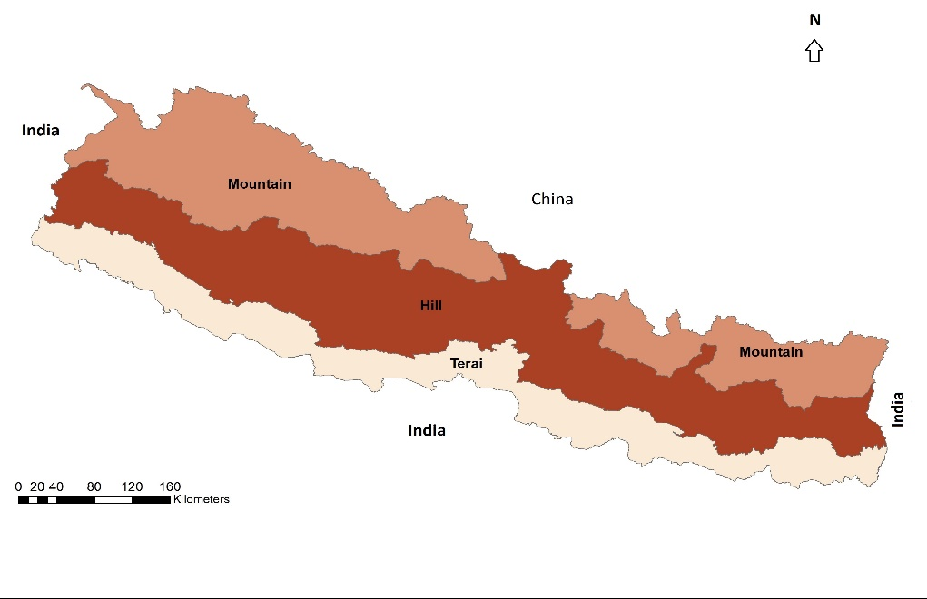
Nepal is divided into three ecological belts: Mountain, Hill and Terai. Mountain is the northern region ranging between from 4877 metres to 8848 metres above sea level and comprises 7% of the total population. Hill is the middle region ranging between altitude of 610 metres to 4876 metres. It covers 43% of the population and includes the major densely populated cities including capital city Kathmandu. Terai is the southern lowland region that borders India and has an altitude ranging between 70 metres to 609 metres. It comprises more than 50% of the total population of Nepal. (Central Bureau of Statistics, 2019, 2022)
Supplementary Figure 2: Ecological belts of Nepal

Nepal is a country of great ethnic diversity. According to the 2011 Census, there were 125 ethnic groups in Nepal, with more than 123 languages spoken as a mother tongue. (Central Bureau of Statistics, 2019, 2021) The number of ethnic groups has increased from 90 in the 1990 Census because of the increasing self-identification with smaller ethnic groups that have sought justful inclusion in different organs of state. (Pradhan & Shrestha, 2005) It is necessary in this study to use a broad categorisation of ethnic groups, hence we adopted a classification used by other studies that combines ethnic groups based on some common characteristics, including geography, to form five broad ethnic groups (Caste Origin: Hill Groups, Hill Adibasi/ Janjati, Newar, Madeshi (Terai Caste) and Other). (Dahal, 2003; Pradhan & Shrestha, 2005).

These ethnic groups have some distinct cultural, socio-economic and geographic characteristics. The Caste Origin: Hill Groups mostly reside or originate in Hill ecological belt and have a relatively high Human Development Index (HDI – a composite index of life expectancy, education, and per capita income).(National Planning Commission & United Nations Development Programme, 2014) Similarly, Hill Adibashi/ Janjati is an ethnic group with their own mother tongue who predominantly resides in the Mountain and Hill ecological belts and have among the lowest poverty and highest HDI among all ethnic groups (Dahal, 2014;Centeral Bureau of Statistics, 2011;Dulal, 2021;National Planning Commission, 2014) . Newar are the historical inhabitants of Kathmandu Valley and surrounding areas and have relatively low poverty. The Terai/Madhesh group are comprised of different inhabitants of the southern Terai region, including Madhesh Province, and have lower HDI compared to other ethnic groups, as reflected by Madhesh Province having the second lowest HDI after Karnali. (Dhungel, 2018; National Planning Commission & United Nations Development Programme, 2014; Pradhan et al., 2007).

Further detail of CRVS Survey
The CRVS Survey was nationally-representative, and a household list obtained from the 2011 Population Census was used as the sample frame. In the first stage, 1,600 (673 urban, 927 rural) Enumeration Areas (EAs) were selected using probability proportional to size (PPS) from 16 analytical domains comprising existing 15 eco-development regions (a cross-section of the contemporaneous five development regions and three ecological belts) and with a separate domain comprising three districts of Kathmandu valley. In the second stage, 50 households were selected systematically from each selected EA, resulting in a total of 80,000 households. In the third stage, only households where at least one personal event occurred of the six possible personal events (birth, death, marriage, divorce, adoption, migration) within the three-year reference period were enumerated in detail, resulting in a total of 24,602 households.

For the service provider questionnaire, 3-4 service providers were selected by each enumerator within their allocated EAs. This selection was based on the availability of respondents and proximity of the local registration office from their assigned EA, so was not a random selection. In Nepal, ward secretaries bear the responsibility of local registrars under the dedicated authority from the Registrar of Nepal. Hence, they were the primary respondents for the service provider questionnaire. In the case of their absence, other local registration office staff or the ward chairs were considered as the alternative respondents. A total of 400 service providers were selected purposively out of 1,600 EAs. The original plan was to administer at least one service provider questionnaire within four allocated EAs. However, the service provide questionnaire was not possible to administer in the first round (16 districts), so only 337 service provider questionnaires were completed at the end of the survey. Only Hill and Terai ecological belts were included in the service provider questionnaire.

The political boundary of Nepal was reshaped after 2015 in the form of a federal state with seven provinces and 753 local levels comprised of the municipalities and rural municipalities. Due to this change, six of the existing analytical domains (eco-development regions) out 16 are not completely located within the new province boundaries. In other words, for these six domains area is now distributed between two provinces. Hence, we converted the CRVS Survey data into provinces using correspondence tables produced by the Central Bureau of Statistics.

The first round of the survey was conducted in Nepalese fiscal years (FY) 2072/73 (falling between 15 July 2015 – 14 July 2016 of the Gregorian Calendar) and the second round was conducted in the following FY 2073/74 (falling between 15 July 2016 – 14 July 2017). However, the 3-year reference period was based on the Nepalese or Bikram Sambat calendar (not FY) which normally starts from April 14. Since field enumerations for both rounds were initiated after 14 April 2016, the three year period between 2070-2072 of the Nepalese calendar (between April 14, 2013- April 13, 2016) was considered as the common reference period for both survey rounds. Accordingly, the CRVS Survey data were published according to the Nepali calendar. To enable comparison of reported registration completeness with estimates of offline registration completeness in a previous study, we converted data to the Gregorian calendar year for all our analyses with deaths allocated according to the proportion of days in the Nepali Calendar in each Gregorian calendar year.(Pandey & Adair, 2022) This did exclude the latest mortality data according to the Nepal calendar, but this process was the most prudent to ensure consistency of periods with other estimates of mortality.

The urban and rural categorisation of place of residence was based on the address reported by respondents, whether it was Village Development Community (VDC) or the Municipality. The VDCs were considered as rural areas and the municipalities were considered as urban areas.

A survey steering committee was established under the chair of the secretary of the existing Ministry of Federal Affairs and Local Development (MOFALD), with representation from major stakeholders. There was also a technical committee, comprising expert officials from both departments, DOCR and CBS.

Different sources of completeness used in this study
There are different sources of completeness used in this manuscript. These are:
- CRVS Survey 2015-16: this household survey asked respondents to a) report all deaths that had occurred in their household in the previous three years, and b) of these reported deaths, report which of these were registered. This results in the following levels of completeness:
  - CRVS Survey reported death completeness: This is reported household deaths as a percentage of estimated total deaths. They are estimated to be 75% complete in 2015 and 54% complete in 2014. These were calculated in using the empirical completeness method (Adair & Lopez, 2018; Pandey & Adair, 2022).
  - CRVS Survey reported death registration completeness: This is deaths reported to be registered as a percentage of reported household deaths (i.e. the denominator is deaths reported in the CRVS Survey (2013/14-2015/16). This is estimated to be 70% (Pandey & Adair, 2022).
- Offline death registration system: Offline death registration completeness is deaths registered through the traditional paper-based death registration system as a percentage of estimated total deaths. This was 69% complete in 2017, as calculated using the empirical completeness method. (Pandey & Adair, 2022)
- Online death registration system: Online death registration completeness is deaths registered in the newer online death registration system as a percentage of estimated total deaths. This was 32% complete in 2019. (Pandey & Adair, 2022)

References
Adair, T., & Lopez, A. D. (2018). Estimating the completeness of death registration: An empirical method. PLOS ONE, 13(5), e0197047. https://doi.org/10.1371/journal.pone.0197047
Central Bureau of Statistics. (2019). Nepal Statistical Year Book of Nepal 2019 (Statistical Year Book, Issue. C. B. o. Statistics. www.cbs.gov.np
Central Bureau of Statistics. (2021). Nepal in Figures. In Central Bureau of Statistics (Ed.), (pp. 7). Kathmandu, Nepal: Central Bureau of Statistics,.
Central Bureau of Statistics. (2022). National Population Census 2021, Perlimilary Results (Ltest News, Issue. https://censusnepal.cbs.gov.np/Home/Details?tpid=1&dcid=0f011f13-7ef6-42dd-9f03-c7d309d4fca3
Dahal, D. R. (2003). Social Composition of the Population: Caste Ethnicity and Religion in Nepal. In Population Monograph of Nepal (Vol. 1). Central Bureau of Statistics.
Dhungel, S. (2018). Provincial comparison of development status in Nepal: an analysis of human development trend for 1996 to 2026. Journal of Management and Development Studies, 28, 53-68.
National Planning Commission, & United Nations Development Programme. (2014). Nepal Human Development Report (Beyond Geography Unlocking Human Potential, Issue. http://hdr.undp.org/sites/default/files/nepal_nhdr_2014-final.pdf
Nepal Law Commission (NLC). (2015). The Constitution of Nepal 2015. Kathmandu: Nepal Law Commission Retrieved from www.lawcommission.gov.np
Pandey, S. P., & Adair, T. (2022). Assessment of the national and subnational completeness of death registration in Nepal. BMC Public Health, 22(1), 429. https://doi.org/10.1186/s12889-022-12767-z
Pradhan, E. K., West Jr, K. P., Katz, J., LeClerq, S. C., Khatry, S. K., & Shrestha, S. R. J. D. (2007). Risk of flood‐related mortality in Nepal. 31(1), 57-70.
Pradhan, R., & Shrestha, A. (2005). Ethnic and caste diversity: Implications for development.

Supplementary Table 1: Brief overview of death registration procedures in Nepal
National Identity Card and Registration Act 2020  National Identity Card and Registration Regulations 2021 | National ID and Registration Act 2020 and National ID and Registration Regulations 2021 promulgated in Nepal after replacing four-decade old Birth, Death and Other Event Registration Act 1976 and Birth, Death and Other Event Registration Regulations 1977.
National CRVS Strategy 2019 | National CRVS Strategy 2019 was the Roadmap for achieving CRVS development goals in Nepal, as guided by the Economic and Social Commission for Asia and the Pacific (ESCAP) “CRVS Regional Action Framework 2014” endorsed by the Ministerial Conference on Civil Registration and Vital Statistics in Asia and Pacific.
Time requirement for death registration | 35 days (deaths registered after 35 days of occurrence are considered as delayed registration)
Late registration fee | Less than $2 USD in Nepal and $25 USD at Nepalese diplomatic missions abroad.
Responsibility to report event for registration (official notifier) | Parents, wife, husband, son, daughter and in their absence any adult member of family (more than 18 years).
Information required for death registration | Name, sex, date of birth, date of death, place of death, cause of death (if certified by physician), education attainment, marital status, occupation, ethnicity, religion, passport number (if deceased is foreign citizen), relation of notifier with deceased, notifier citizenship number, notifier contact number.

Supplementary Table 2: Variables used from CRVS Survey household questionnaire and service provider questionnaire.
Variables from household questionnaire | Variables from service provider questionnaire
Household information | Service provider (local registrar) information
Ecological Belts | Age, sex, education attainment, designation, experience in CRVS sector (years), CRVS related training, computer knowledge level
Provinces | Civil registration related details
Urban Rural (VDC/ Municipality) | What percentage of personal incidents registered last year were registered on time (within 35 days)?
House construction | What could be the reasons for non-registration of personal events? (1. No need to register, 2. lack of information, 3 cumbersome registration process 4. remoteness location of registration office 5. event can be registered at any time 6. difficult to amend certificate 7. Provision of late registration fee, 8. Other)
Access to the communication facilities (media) ( 1. radio, 2. television, 3. computer, 4. interned, 5. telephone, 6. mobile phone, 7. none of above) | Appropriate media for public awareness campaign (1. Radio 2. Television 3. Magazines 4. Poster pamphlet 5. Door to door program 6. Education in school 7. Civic Awareness Center / Community Development Organization / Ward Citizens Forum / Mothers Group)
Household head's Information | What would be appropriate to make the existing law effective to register personal incidents? (1. Make more strict 2. Existing laws are effective 3. Make more flexible 4. Don't know)
Age, sex, ethnicity, education attainment, occupation | In order to make the registration of personal event effective, in which sector do you think, it should make compulsory? (1. School admission 2. To make citizenship / passport 3. To get other government service facilities 4. To do banking business 5. Get health care 6. Others)
What could be done to make registration convenient? ( 1. Promote Online registration 2. Mobile registration camps 3. Register from the place of occurrence 4. Deploying dedicated local registrar other than VDC secretary 5. Other | What are the main features of the details to make personal event registration effective? (1. Registering from the place of occurrence 2. Making mobile registration teams 3. Promoting online registration system 4. By providing some concessions to the service providers or service recipients from the government for timely registration 5. Others)
Individual’s (Deceased's) Information | What should be done to manage the registration of personal events in the office of the local registrar? ( 1. Keep records digitized 2. Adopting online registration 3. Appoint dedicated local registrar 4. Conduct regular trainings 4. Improve record keeping system)
Sex of deceased, age at death, marital status, death year, cause of death, place of occurrence, death registration status, duration of registration after occurrence. | What are the major office related problems faced by the local registrar? (1. High workload 2. Lack of resources 3. Lack of acts, rules, guidelines 4. lack of CRVS training 5. Vague legislations 6. Other)
Respondent responses regarding death registration
Relation of notifier with deceased (1. Spouse 2. Son/daughter 3. Parents 4. Grand Parents 5. Brother/ Sister 6. Grandchildren 7. Uncle/ Aunty 8. Person authorized by law 9. Other)
Main reason for registration (1. Required for transferring property entitlement 2. For getting access to social security 3. For other legal purposes 4. Because registering within 35 days is free 5. Easy registration process 6. Proximity to registration office 7. Influenced via media campaign 8. Local registrar advised 9. Neighbor advised 10. Other)
Main reason for not registration (1. Due to cumbersome process 2. Not required 3. Need to pay more money 4. Lack of required documents 5. Remoteness of Local Registrar’s Office 6. Absence of Local Registrar ( when I visited) 7. Lack of knowledge about registration 8. No information about death could also even be registered after 35 days 9. Since the registration could be done any time 10. Other)
Thinking of registering (1. Yes 2. No)
Registration period after death occurrence (1. Within 35 days 2. …. Months)

Further results
Nationally, completeness of CRVS survey reported registered deaths in 2014 for males was 68% and 48% for females, while in 2015 it dropped slightly for males (64%) and increased for females (50%). In 2014, estimated CRVS survey reported subnational death registration completeness varied for males between 53% (Madhesh) and 87% (Bagmati) and for females between 36% (Sudurpashchim) and 70% (Bagmati) (Figure 1). Similarly, in 2015 completeness varied for males between 45% (Madhesh) and 84% (Gandaki) and for females between 30% (Karnali) and 62% (Gandaki).

Overall, there was a strong positive correlation at the province level between CRVS survey reported and offline (i.e. estimated from actual CRVS system data) death registration completeness. Specifically, for both years and each sex, death registration completeness from both sources in Madhesh, Karnali and, for females only, Sudurpashchim was below the national level and in Koshi, Gandaki (except for males in 2014) and Lumbini (except for females in 2015) was higher than the national level. Bagmati had high completeness according to the survey but in the offline registration data it was estimated to be close to the national level.

For ecological belts, the highest survey reported death registration completeness was found in Hill for males (75%) and in Mountain for females (58%) and the lowest completeness was in Terai for each sex (male 63%, female 44%). In contrast, estimated offline death registration completeness for females in Mountain was lowest.

We excluded Bagmati Province, Mountain and Hill in our analysis for 2015 to minimise the impact of a high number of deaths due to devastating earthquake that occurred in those areas in that year. We did so because actual death registration completeness was estimated using the empirical completeness method, and results are biased if the population was affected with a mortality shock like a natural disaster (Adair & Lopez, 2018).

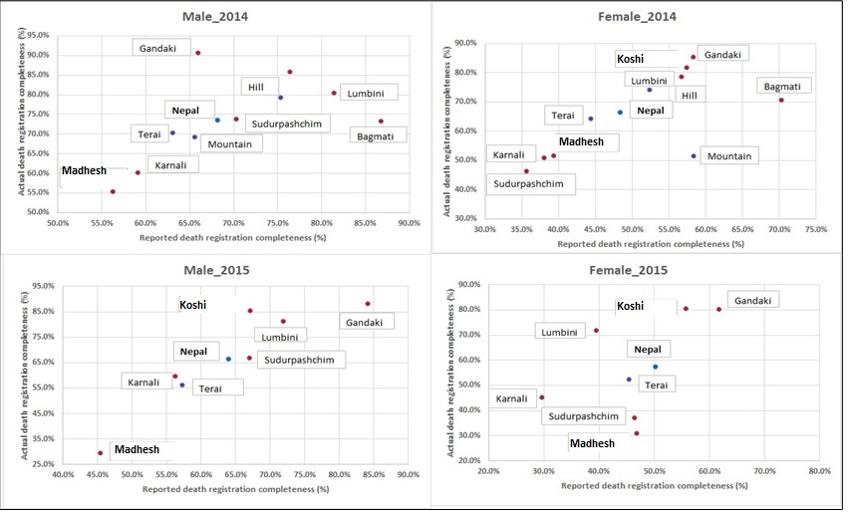
Note: Bagmati province, Mountain and Hill excluded from the analysis for 2015, due to large number earthquakes caused deaths in this province.
Supplementary Figure 3: Reported death registration completeness (CRVS Survey) versus estimated offline death registration completeness (CRVS system) (%) by ecological belt, province and sex, Nepal, 2014 and 2015

Area | CRVS Survey reported death registration completeness (%) |  |  |  |  |  | Estimated offline death registration completeness (%) |  |  |  |  |  | CRVS Survey estimated reported death completeness (%)ª
Area | 2014 |  |  | 2015 |  |  | 2014 |  |  | 2015 |  |  | 2014 |  |  | 2015
Area | Both sexes | Male | Female | Both sexes | Male | Female | Both sexes | Male | Female | Both sexes | Male | Female | Both Sexes | Male | Female | Both Sexes | Male | Female
Nepal | 59.8 | 68.1 | 48.3 | 57.8 | 63.9 | 50.1 | 70.7 | 73.7 | 66.7 | 62.0 | 66.6 | 57.5 | 54.4 | 57.2 | 52.9 | 74.9 | 74.0 | 75.9
Ecological Belts
Mountain | 62.7 | 65.6 | 58.2 | 59.0 | 59.0 | 58.9 | 61.8 | 69.4 | 51.6 | - | - | - | 45.5 | 50.3 | 41.4 | - | - | -
Hill | 65.9 | 75.3 | 52.3 | 66.4 | 76.8 | 53.1 | 77.3 | 79.4 | 74.2 | - | - | - | 57.6 | 63.1 | 52.6 | - | - | -
Terai | 54.9 | 63.0 | 44.3 | 51.6 | 56.3 | 45.3 | 67.6 | 70.5 | 64.4 | 55.6 | 59.7 | 52.4 | 55.5 | 54.9 | 57.9 | 68.9 | 67.7 | 71.0
Provinces
Koshi | 69.3 | 76.4 | 57.3 | 62.3 | 67.1 | 55.7 | 84.4 | 85.9 | 81.8 | 83.4 | 85.3 | 80.6 | 60.1 | 62.6 | 59.4 | 76.6 | 73.6 | 80.4
Madhesh | 48.6 | 56.2 | 39.3 | 46.0 | 45.4 | 46.8 | 52.8 | 55.4 | 51.7 | 28.4 | 29.4 | 30.8 | 67.3 | 63.1 | 72.8 | 72.0 | 66.8 | 78.1
Bagmati | 78.0 | 86.8 | 70.2 | 78.6 | 83.6 | 72.8 | 72.3 | 73.2 | 70.8 | - | - | - | 50.8 | 53.6 | 49.0 | - | - | -
Gandaki | 62.0 | 66.0 | 58.3 | 72.6 | 84.1 | 61.7 | 88.8 | 90.6 | 85.3 | 85.1 | 88.2 | 80.3 | 59.8 | 65.1 | 55.9 | 80.7 | 83.1 | 78.2
Lumbini | 71.1 | 81.4 | 56.7 | 57.4 | 71.9 | 39.5 | 79.8 | 80.4 | 78.6 | 77.3 | 81.2 | 71.9 | 50.8 | 56.0 | 47.2 | 70.1 | 72.7 | 67.6
Karnali | 51.4 | 59.1 | 38.0 | 45.0 | 57.2 | 29.6 | 55.1 | 60.2 | 50.9 | 50.0 | 56.3 | 45.1 | 67.3 | 75.4 | 56.1 | 80.3 | 82.5 | 76.6
Sudurpashchim | 58.5 | 70.3 | 35.6 | 58.7 | 67.0 | 46.4 | 61.6 | 73.8 | 46.4 | 52.7 | 67.0 | 37.1 | 45.6 | 49.1 | 44.2 | 61.0 | 63.2 | 59.9
Supplementary Table 3: Reported death registration completeness (CRVS Survey), estimated offline death registration completeness (CRVS system) and CRVS Survey estimated reported death completeness (%) by sex, ecological belt, and province, Nepal 2014 and 2015
ª Figures obtained from (Pandey & Adair, 2022). Estimated completeness not made for Mountain and Hill ecological belts and Bagmati province in 2015 because of earthquake (see Appendix 1).

Supplementary Table 4: Logistic regression analysis of reported death registration, demographic and geographic variables, CRVS Survey, Nepal, 2013/14-2015/16
Categories / Variables | Odds ratio | 95% CI
Sex of deceased
Male (Ref.) | 1
Female | 0.373** | 0.323, 0.429
Deceased’s age group
0-14 years (Ref.) | 1
15-44 years | 5.918** | 4.324, 8.099
45-64 years | 10.178** | 7.512, 13.789
65-74 years | 11.102** | 8.107, 15.204
75+ years | 10.594** | 7.758, 14.466
Province
Koshi (Ref.) | 1
Madhesh | 0.404** | 0.318,0.512
Bagmati | 1.848** | 1.395,2.449
Gandaki | 1.375* | 1.007,1.879
Lumbini | 0.863 | 0.668,1.114
Karnali | 0.549** | 0.409,0.736
Sudurpashchim | 0.599** | 0.455,0.788
Urban / rural
Urban (Ref.) | 1
Rural | 0.904 | 0.775,1.054
Constant | 0.603** | 0.427,0.850
Statistical significance (p-value) * less than 0.05, ** less than 0.01.
N=4,532 (4,320 household clusters). Ref.: Reference category. CI: Confidence interval.
If the p-value is less than 0.05, result is considered statistically significant

Supplementary Table 5: Logistic regression results of reported death registration status, demographic/geographical and characteristics of death variables, Nepal, CRVS Survey, 2013/14-2015/16
Categories / Variables | Odds ratio | 95% CI | Categories / Variables | Odds ratio | 95% CI
Sex of deceased |  |  | Cause of death
Male (Ref.) | 1 |  | Disease (Ref.) | 1
Female | 0.374** | 0.324, 0.432 | Pregnancy /childbirth / unable to give birth | 0.234** | 0.092, 0.594
Deceased’s age group |  |  | Malnutrition | 0.875 | 0.425, 1.805
0-14 year (Ref.) | 1 |  | Accidents | 2.037** | 1.344, 3.087
15-44 year | 5.916** | 4.270, 8.197 | Suicide | 1.779* | 1.073, 2.950
45-64 year | 11.195** | 8.177, 15.328 | Natural disaster | 2.547** | 1.773,3.658
65-74 year | 12.473** | 9.024, 17.241 | Unknown | 0.865 | 0.672, 1.113
75+ year | 11.944** | 8.676, 16.444 | Other | 1.27 | 0.950, 1.697
Provinces |  |  | Place of death
Koshi (Ref.) | 1 |  | House (Ref.) | 1
Madhesh | 0.382** | 0.298, 0.489 | Health facility | 1.172 | 0.980, 1.401
Bagmati | 1.564** | 1.182, 2.069 | Abroad | 0.898 | 0.520, 1.550
Gandaki | 1.359 | 0.990, 1.865 | Other | 0.931 | 0.603,1.435
Lumbini | 0.837 | 0.645, 1.085 | Constant | 0.514** | 0.357, 0.740
Karnali | 0.542** | 0.402,0.730 | Statistical significance (p-value): * less than 0.05, ** less than 0.01  If the p-value is less than 0.05, result is considered statistically significant.  n = 4,532 (4,320 household clusters)  Ref.: Reference category  CI: Confidence Interval
Sudurpashchim | 0.586** | 0.444,0.774
Urban / rural
Urban (Ref.) | 1
Rural | 0.889 | 0.759, 1.040

Supplementary Table 6: Logistic regression results of reported death registration status, all variables, age of deceased less than 65 years, Nepal, CRVS Survey, 2013/14-2015/16
Categories / Variables | Odds Ratio | 95% CI | Categories / Variables | Odds Ratio | 95% CI
Sex of deceased |  |  | Household head's age
Male (Ref.) | 1 |  | 0-18 year (Ref.) | 1
Female | 0.324** | 0.255, 0.411 | 19-34 year | 3.556* | 1.202,10.517
Deceased’s age group |  |  | 35-44 year | 4.039* | 1.358,12.013
0-14 year (Ref.) | 1 |  | 45-54 year | 3.503* | 1.169, 10.496
15-44 year | 7.151** | 4.895, 10.446 | 55-64 year | 4.409** | 1.463, 13.285
45-64 year | 13.732** | 9.475, 19.901 | 65+ year | 5.050** | 1.635, 15.603
Province |  |  | Household head's sex
Koshi (Ref.) | 1 |  | Male (Ref.) | 1
Madhesh | 0.467** | 0.311,0.702 | Female | 1.874** | 1.413, 2.485
Bagmati | 1.508 | 0.974, 2.336 | Household head's occupation
Gandaki | 1.168 | 0.697, 1.957 | Skilled workers in agriculture, forestry, and fishing (Ref.) | 1
Lumbini | 0.621* | 0.416,0.926 | Armed force, admin and technical works | 1.235 | 0.655, 2.328
Karnali | 0.477** | 0.304,0.751 | Business, service and factory workers | 0.820 | 0.616,1.091
Sudurpashchim | 0.449** | 0.288, 0.701 | Household work | 0.843 | 0.632, 1.125
Urban/ Rural |  |  | Student and have no work | 0.497** | 0.303, 0.816
Urban (Ref.) | 1 |  | Household head's ethnicity
Rural | 0.957 | 0.754, 1.215 | Caste Origin: Hill Groups (Khas_Aryan) (Ref.) | 1
Cause of death |  |  | Hill Adibasi/Janajati groups | 0.796 | 0.596, 1.063
Disease (Ref.) | 1 |  | Newars | 0.929 | 0.586, 1.474
Pregnancy / childbirth / unable to give birth | 0.319* | 0.124, 0.821 | Madeshi ( Terai Caste) | 0.670 | 0.466, 0.965
Malnutrition | 0.774 | 0.260, 2.309 | Other | 1.795 | 0.306, 10.527
Accidents | 2.168** | 1.329, 3.536 | House Construction
Suicide | 1.852* | 1.092, 3.139 | Mud House (soil / bamboo / tile / slate/ jhingati) (Ref.) | 1
Natural disaster | 4.666** | 2.654, 8.204 | Cement bonded bricks house (brick / stone / zinc / tin) | 1.036 | 0.801, 1.340
Unknown | 0.839 | 0.585, 1.203 | Cement / Concrete | 0.993 | 0.707, 1.395
Other | 1.586 | 0.959, 2.623 | Mixed ( Cement / Mud/ Concrete) | 1.227 | 0.476, 3.160
Place of death |  |  | Total communication facilities in household | 1.107 | 0.982, 1.249
House (Ref.) | 1 |  | Constant | 0.095** | 0.027, 0.333
Health facility | 1.009 | 0.781, 1.302
Abroad | 0.811 | 0.441, 1.495 | Statistical significance (p-value): * less than 0.05, ** less than 0.01  If the p-value is less than 0.05, result is considered statistically significant  n = 2,223 (2,118 household clusters).  Ref.: Reference category  CI: Confidence Interval
Other | 0.658 | 0.386, 1.121
Household head's education attainment
Illiterate (Ref.) | 1
Primary | 1.033 | 0.733, 1.454
Secondary | 1.541** | 1.108, 2.142
Higher education | 2.152* | 1.023, 4.526
Other academic degree and literate ( including informal education) | 0.897 | 0.648, 1.243

Supplementary Table 7: Logistic regression results of reported death registration status, all variables, age of deceased 65 years and above, Nepal, CRVS Survey, 2013/14-2015/16
Categories / Variables | Odds Ratio | 95% CI | Categories / Variables | Odds Ratio | 95% CI
Sex of deceased |  |  | Household head's age group
Male | 1 |  | 10-18 year (Ref.) | 1
Female | 0.426** | 0.347, 0.524 | 19-34 year | 1.207 | 0.173, 8.419
Deceased’s age group |  |  | 35-44 year | 1.235 | 0.178, 8.558
65-74 year (Ref.) |  |  | 45-54 year | 1.264 | 0.182, 8.786
75+ year | 0.918 | 0.739, 1.140 | 55-64 year | 1.367 | 0.196, 9.535
 |  |  | 65+ year | 1.937 | 0.275, 13.640
Province |  |  | Household head's sex
Koshi (Ref.) | 1 |  | Male (Ref.) | 1
Madhesh | 0.764 | 0.512, 1.140 | Female | 1.151 | 0.873, 1.518
Bagmati | 1.389 | 0.932, 2.072 | Household head's occupation
Gandaki | 1.217 | 0.796, 1.859 | Skilled workers in agriculture, forestry, and fishing (Ref.) | 1
Lumbini | 1.080 | 0.741, 1.576 | Armed force, admin and technical works | 1.963* | 1.162, 3.316
Karnali | 0.535* | 0.331, 0.867 | Business, service and factory workers | 1.042 | 0.798, 1.361
Sudurpashchim | 0.671 | 0.444, 1.016 | Household work | 1.148 | 0.846, 1.559
Settlement (Urban/ Rural) |  |  | Student and have no work | 0.873 | 0.542, 1.406
Urban (Ref.) | 1
Rural | 0.996 | 0.788, 1.259 | Household head's ethnicity
Cause of death |  |  | Caste Origin: Hill Groups (Khas_Aryan) (Ref.) | 1
Disease (Ref.) | 1 |  | Hill Adibasi/Janajati groups | 0.784 | 0.597, 1.029
Malnutrition | 1.732 | 0.482, 6.233 | Newars | 0.801 | 0.546, 1.175
Accidents | 1.877 | 0.510, 6.909 | Madeshi (Terai Caste) | 0.511** | 0.355,0.738
Suicide | - |  | Other | 0.228* | 0.053,0.975
Natural disaster | 1.241 | 0.792, 1.943 | House Construction
Unknown | 0.864 | 0.596, 1.253 | Mud House (soil / bamboo / tile / slate/ jhingati) (Ref.) | 1
Other | 1.081 | 0.745, 1.570 | Cement bonded bricks house (brick / stone / zinc / tin) | 1.102 | 0.849,1.430
Place of death |  |  | Cement / Concrete | 1.082 | 0.785,1.491
House (Ref.) | 1 |  | Mixed (Cement / Mud/ Concrete) | 1.397 | 0.621,3.144
Health facility | 1.271 | 0.935, 1.727 | Total communication facilities in household | 1.089 | 0.975, 1.217
Abroad | 0.341 | 0.082, 1.422 | Constant | 2.753 | 0.368,20.576
Other | 6.044 | 0.782, 46.731 | Statistical significance (p-value): * less than 0.05, ** less than 0.01  If the p-value is less than 0.05, result is considered statistically significant.  n = 2,302 (2,253 household clusters).  Ref.: Reference category  CI: Confidence Interval
Household head's education attainment
Illiterate (Ref.) | 1
Primary | 0.908 | 0.632, 1.305
Secondary | 1.526* | 1.091, 2.134
Higher education | 1.778 | 0.915, 3.455
Other academic degree and literate (including informal education) | 0.991 | 0.706, 1.392

Supplementary Table 8: Main reasons for death registration (% of deaths reported as registered) by various characteristics, Nepal, CRVS Survey, 2013/14-2015/16
 | Death registration reasons
Variables/ Categories | To transfer home / land / property ownership | For social security allowance and access public service | For other legal processes | Knowing timely (within 35 days) registration is free | Due to convenient registration process | Due to the proximity of the place of registration | As it has been informed in the media that registration should be done | VDC secretary / local registrar advised | Advised by the neighbor | Other
Nepal | 29.0 | 24.9 | 30.7 | 9.1 | 1.8 | 0.8 | 0.4 | 0.4 | 1.1 | 1.9
Ecological Belts
Mountain | 16.1 | 30.6 | 38.7 | 8.1 | 2.3 | 0.9 | 0.6 | 1.3 | 0.0 | 1.5
Hill | 29.0 | 25.1 | 29.8 | 9.5 | 2.7 | 1.2 | 0.5 | 0.4 | 0.7 | 1.1
Terai | 32.0 | 23.3 | 29.9 | 8.8 | 0.6 | 0.3 | 0.2 | 0.2 | 1.9 | 2.8
Provinces
Koshi | 18.4 | 28.8 | 34.8 | 12.2 | 2.4 | 0.4 | 0.7 | 1.1 | 0.2 | 1.1
Madhesh | 48.3 | 19.6 | 23.4 | 5.2 | 0.2 | 0.4 | 0.0 | 0.4 | 1.9 | 0.4
Bagmati | 23.2 | 22.2 | 37.7 | 7.7 | 4.1 | 1.6 | 0.0 | 0.3 | 0.5 | 2.2
Gandaki | 29.8 | 24.0 | 25.5 | 12.9 | 0.0 | 0.9 | 0.6 | 0.6 | 0.9 | 4.9
Lumbini | 37.5 | 19.2 | 26.9 | 10.4 | 0.4 | 0.4 | 0.0 | 0.2 | 2.9 | 2.2
Karnali | 23.4 | 34.5 | 27.6 | 8.9 | 1.4 | 1.5 | 0.0 | 0.0 | 0.5 | 1.9
Sudurpashchim | 20.5 | 38.1 | 31.3 | 6.4 | 2.0 | 0.3 | 0.4 | 0.0 | 0.7 | 0.4
Sex
Male | 28.2 | 34.4 | 24.3 | 7.9 | 1.4 | 0.6 | 0.3 | 0.4 | 1.0 | 1.6
Female | 30.4 | 8.9 | 41.4 | 11.1 | 2.5 | 1.0 | 0.6 | 0.5 | 1.4 | 2.2
Age group
0-14 years | 4.7 | 37.2 | 36.0 | 5.4 | 5.6 | 1.1 | 1.1 | 1.1 | 1.1 | 6.7
15-44 years | 12.1 | 35.9 | 37.9 | 8.1 | 1.2 | 0.5 | 0.2 | 0.2 | 2.4 | 1.5
45-64 years | 26.6 | 30.7 | 28.8 | 8.2 | 1.9 | 0.9 | 0.3 | 0.1 | 1.0 | 1.3
65-74 years | 36.2 | 21.1 | 26.7 | 9.7 | 1.8 | 0.6 | 0.2 | 0.9 | 1.1 | 1.7
75+ years | 34.8 | 16.6 | 32.2 | 10.1 | 1.5 | 1.0 | 0.5 | 0.3 | 0.7 | 2.2
Cause of death
Disease | 31.6 | 24.5 | 28.9 | 8.9 | 2.3 | 0.9 | 0.4 | 0.4 | 1.0 | 1.2
Pregnancy / childbirth / unable to give birth | 0.0 | 0.0 | 80.3 | 0.0 | 19.7 | 0.0 | 0.0 | 0.0 | 0.0 | 0.0
Malnutrition | 34.8 | 26.3 | 38.8 | 0.0 | 0.0 | 0.0 | 0.0 | 0.0 | 0.0 | 0.0
Accidents | 18.3 | 29.3 | 36.5 | 9.2 | 0.6 | 1.2 | 1.2 | 0.0 | 1.2 | 2.3
Suicide | 11.6 | 28.4 | 42.1 | 6.4 | 4.9 | 0.0 | 0.0 |  | 4.9 | 1.7
Natural disaster | 16.0 | 30.5 | 42.5 | 6.6 | 0.4 | 0.8 | 0.0 | 1.2 | 0.8 | 1.1
Unknown | 30.9 | 22.6 | 29.9 | 11.0 | 0.0 | 0.3 | 0.4 | 0.5 | 0.9 | 3.5
Other | 30.2 | 21.0 | 26.8 | 12.5 | 0.4 | 0.4 | 0.4 |  | 2.0 | 6.4
Place of death
House | 29.4 | 24.9 | 29.5 | 10.1 | 1.5 | 0.8 | 0.4 | 0.4 | 1.1 | 1.9
Health facility | 31.6 | 21.6 | 33.7 | 6.0 | 3.1 | 0.8 | 0.1 | 0.6 | 0.8 | 1.7
Abroad | 5.7 | 49.2 | 35.4 | 5.8 | 0.0 | 1.9 | 0.0 | 0.0 | 1.9 | 0.0
Other | 16.9 | 34.6 | 31.7 | 10.0 | 0.0 | 0.8 | 0.8 | 0.0 | 2.3 | 3.0
Household head educational attainment
Primary | 24.1 | 28.8 | 32.2 | 9.5 | 0.6 | 0.9 | 0.0 | 0.2 | 1.6 | 2.0
Secondary | 32.9 | 17.5 | 33.0 | 10.0 | 2.2 | 1.2 | 0.3 | 0.6 | 0.9 | 1.4
Higher education | 30.6 | 13.2 | 37.4 | 9.4 | 2.5 | 0.0 | 2.3 | 0.0 | 0.0 | 4.4
Other academic degree and literate (including informal education) | 26.5 | 29.5 | 28.7 | 8.0 | 1.9 | 0.7 | 0.5 | 0.7 | 1.2 | 2.4
Illiterate | 26.9 | 34.5 | 25.7 | 7.9 | 1.6 | 0.3 | 0.1 | 0.2 | 1.5 | 1.4
Number of communication facilities in household
0 | 22.5 | 40.8 | 26.2 | 4.6 | 1.4 | 0.0 | 0.5 | 0.4 | 3.2 | 0.5
1-2 facilities | 29.7 | 26.4 | 29.2 | 9.1 | 1.2 | 0.5 | 0.3 | 0.5 | 1.3 | 1.8
3+ facilities | 29.0 | 18.2 | 34.7 | 10.0 | 3.0 | 1.7 | 0.6 | 0.3 | 0.3 | 2.2

Supplementary Table 9: Main reasons for death not being registered (% of deaths reported as not registered) by various characteristics, Nepal, CRVS Survey, 2013/14-2015/16
 | Reasons for death not registered
Variables/ Categories | Because it is a cumbersome process | Because there is no need | Because you have to pay more | Due to lack of required documents (citizenship, recommendation etc.) | The office of the local registrar is far away | As the local registrar could not be found | No information to register | There is no information that registration can be done even after 35 days | Since the registration could be done any time | Other
Nepal | 5.2 | 71.9 | 0.3 | 4.1 | 2.6 | 1.1 | 4.6 | 0.6 | 6.0 | 3.5
Ecological Belts
Mountain | 3.3 | 62.7 | 0.0 | 3.4 | 5.3 | 1.7 | 11.9 | 1.7 | 5.2 | 4.8
Hill | 3.4 | 68.9 | 0.0 | 4.5 | 4.7 | 1.1 | 5.8 | 0.6 | 7.7 | 3.4
Terai | 6.7 | 75.6 | 0.5 | 3.9 | 0.8 | 1.1 | 2.4 | 0.4 | 5.0 | 3.4
Provinces
Koshi | 3.0 | 70.6 | 0.0 | 8.0 | 2.4 | 1.0 | 6.0 | 0.5 | 3.3 | 5.1
Madhesh | 9.7 | 79.7 | 0.7 | 1.0 | 0.0 | 1.2 | 2.2 | 0.0 | 4.5 | 1.0
Bagmati | 2.9 | 59.5 | 0.0 | 5.8 | 4.7 | 1.2 | 7.4 | 0.0 | 12.2 | 6.5
Gandaki | 3.7 | 49.4 | 0.0 | 12.3 | 4.9 | 2.5 | 3.8 | 1.2 | 16.1 | 6.1
Lumbini | 2.0 | 84.6 | 0.0 | 2.0 | 1.0 | 0.0 | 2.5 | 1.0 | 4.0 | 3.0
Karnali | 1.4 | 66.2 | 0.0 | 1.9 | 9.2 | 1.2 | 8.3 | 1.2 | 4.9 | 5.6
Sudurpashchim | 7.1 | 67.7 | 0.6 | 5.8 | 2.4 | 1.8 | 5.5 | 1.8 | 4.7 | 2.6
Sex
Male | 4.4 | 70.9 | 0.4 | 4.4 | 2.3 | 1.0 | 5.1 | 0.2 | 6.1 | 5.2
Female | 5.8 | 72.7 | 0.3 | 3.8 | 2.8 | 1.2 | 4.2 | 0.9 | 5.9 | 2.3
Age group
0-14 years | 3.2 | 78.5 |  | 0.8 | 0.8 | 0.3 | 5.5 | 0.8 | 1.5 | 8.8
15-44 years | 4.2 | 73.7 | 0.4 | 4.8 | 1.9 | 0.4 | 4.1 | 0.7 | 6.8 | 3.0
45-64 years | 6.3 | 71.4 | 0.6 | 4.9 | 2.2 | 1.6 | 3.2 |  | 8.3 | 1.5
65-74 years | 7.2 | 69.6 | 0.4 | 4.6 | 3.2 | 0.8 | 4.4 | 0.7 | 6.2 | 3.0
75+ years | 4.8 | 67.3 |  | 5.0 | 4.8 | 2.4 | 6.0 | 1.1 | 6.4 | 2.1
Cause of death
Disease | 5.8 | 70.1 | 0.3 | 4.4 | 2.8 | 1.0 | 5.4 | 0.7 | 6.5 | 2.9
Pregnancy / childbirth / unable to give birth | 2.7 | 79.1 | 0.0 | 2.7 | 0.0 | 0.0 | 2.4 | 0.0 | 5.4 | 7.8
Malnutrition | 0.0 | 89.7 | 0.0 | 0.0 | 3.8 | 2.8 | 0.0 | 0.0 | 0.0 | 3.7
Accidents | 4.1 | 64.8 | 0.0 | 3.7 | 0.0 | 0.0 | 4.2 | 0.0 | 12.7 | 10.5
Suicide | 0.0 | 82.3 | 0.0 | 4.3 | 0.0 | 0.0 | 4.5 | 0.0 | 9.0 | 0.0
Natural disaster | 11.4 | 69.9 | 0.0 | 5.0 | 1.3 | 3.7 | 5.0 | 1.2 | 2.6 | 0.0
Unknown | 3.0 | 77.8 | 0.6 | 3.0 | 2.3 | 1.2 | 3.0 | 0.0 | 4.8 | 4.2
Other | 2.4 | 73.7 | 0.0 | 3.4 | 5.9 | 1.1 | 1.2 | 1.1 | 3.7 | 7.3
Place of death
House | 5.8 | 72.5 | 0.4 | 4.0 | 2.7 | 1.6 | 4.2 | 0.6 | 4.8 | 3.5
Health facility | 4.3 | 70.5 | 0.0 | 3.6 | 2.5 | 0.0 | 4.8 | 1.0 | 9.4 | 3.9
Abroad | 0.0 | 65.1 | 0.0 | 7.0 | 4.7 | 0.0 | 9.3 | 0.0 | 4.7 | 9.3
Other | 2.3 | 73.3 | 0.0 | 6.6 | 0.0 | 0.0 | 8.8 | 0.0 | 9.0 | 0.0
Household head educational attainment
Primary | 3.8 | 70.5 | 0.0 | 6.2 | 2.5 | 1.7 | 7.7 | 1.1 | 2.5 | 3.8
Secondary | 4.0 | 70.4 | 0.7 | 3.7 | 4.7 | 1.8 | 2.5 | 1.1 | 6.4 | 4.7
Higher education |  | 77.1 |  | 3.4 | 3.4 |  | 3.4 |  | 9.4 | 3.4
Other academic degree and literate (including informal education) | 6.1 | 71.9 | 0.0 | 5.3 | 0.7 | 0.0 | 3.7 | 0.0 | 6.9 | 5.3
Illiterate | 7.1 | 74.1 | 0.3 | 2.4 | 1.7 | 0.9 | 5.5 | 0.2 | 6.7 | 1.0
Number of communication facilities in household
0 | 12.5 | 66.2 | 1.5 | 0.7 | 3.2 | 0.5 | 8.4 | 0.5 | 3.6 | 2.8
1-2 facilities | 4.7 | 73.6 | 0.2 | 4.1 | 2.3 | 1.3 | 3.8 | 0.7 | 6.1 | 3.2
3+ facilities | 3.2 | 68.6 | 0.0 | 5.9 | 3.5 | 0.8 | 5.5 | 0.4 | 7.0 | 5.2

