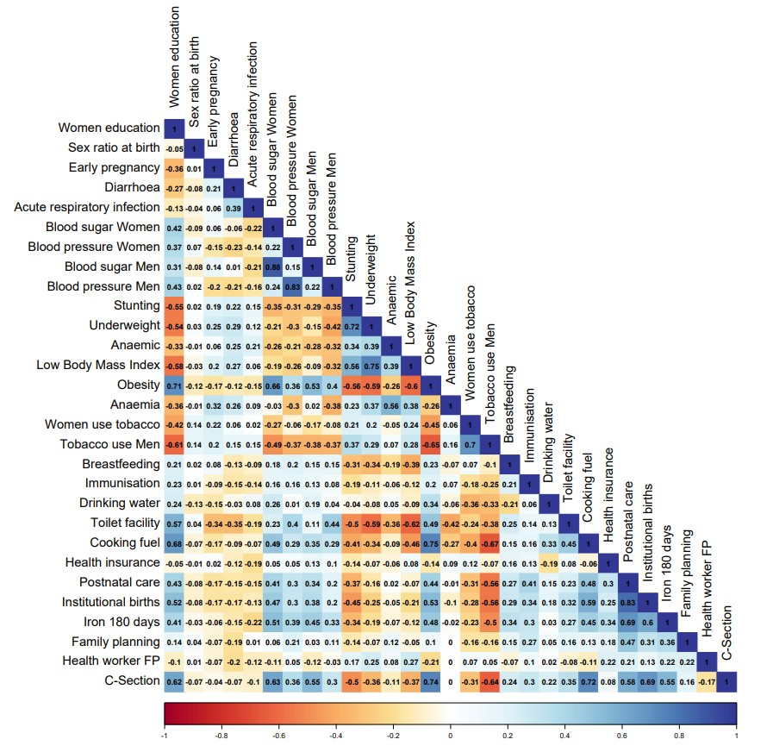
Supplementary Fig 1 Pearson correlation coefficients between the indicators in the India Health Index

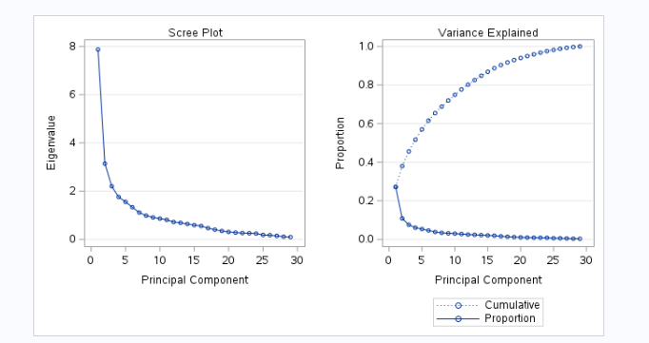
Supplementary Fig. 2 Scree plot of eigenvalues plotted against factors for the initial 29 variables used for principal component analysis.
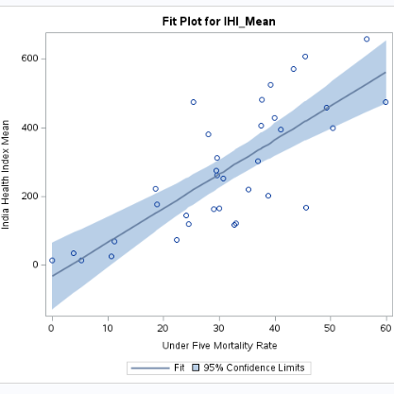
Supplementary Fig. 3 Plot of mean India Health Index (IHI) and Under Five Mortality Rate for states/ UTs

