Supplementary Figures for:

Late Pliocene to early Pleistocene climate dynamics in western North America based on a new pollen record from paleo-Lake Idaho – Palaeobiodiversity and Palaeoenvironments

Frederik J. Allstädt^{1*}, Andreas Koutsodendris¹, Erwin Appel², Wolfgang Rösler², Tammo Reichgelt³, Stefanie Kaboth-Bahr^{1,4}, Alexander A. Prokopenko⁵, Jörg Pross¹

¹Institute of Earth Sciences, Heidelberg University, Im Neuenheimer Feld 234–236, 69120 Heidelberg, Germany
²Department of Geosciences, University of Tübingen, Hölderlinstraße 12, 72074 Tübingen, Germany
³ Department of Geosciences, University of Connecticut, 354 Mansfield Road, Storrs, CT 06269, United States of America
⁴Institute of Geosciences, University of Potsdam, Karl-Liebknecht-Straße 24-26, 14467 Potsdam-Golm, Germany
⁵Institute of Geology and Mineralogy, University of Cologne, Zülpicherstr. 49a, 50674 Cologne, Germany

*Corresponding author: Frederik J. Allstädt (phone: +49 (0)6221 544830, fax: +49 (0)6221 545503, e-mail: frederik.allstaedt@geow.uni-heidelberg.de)

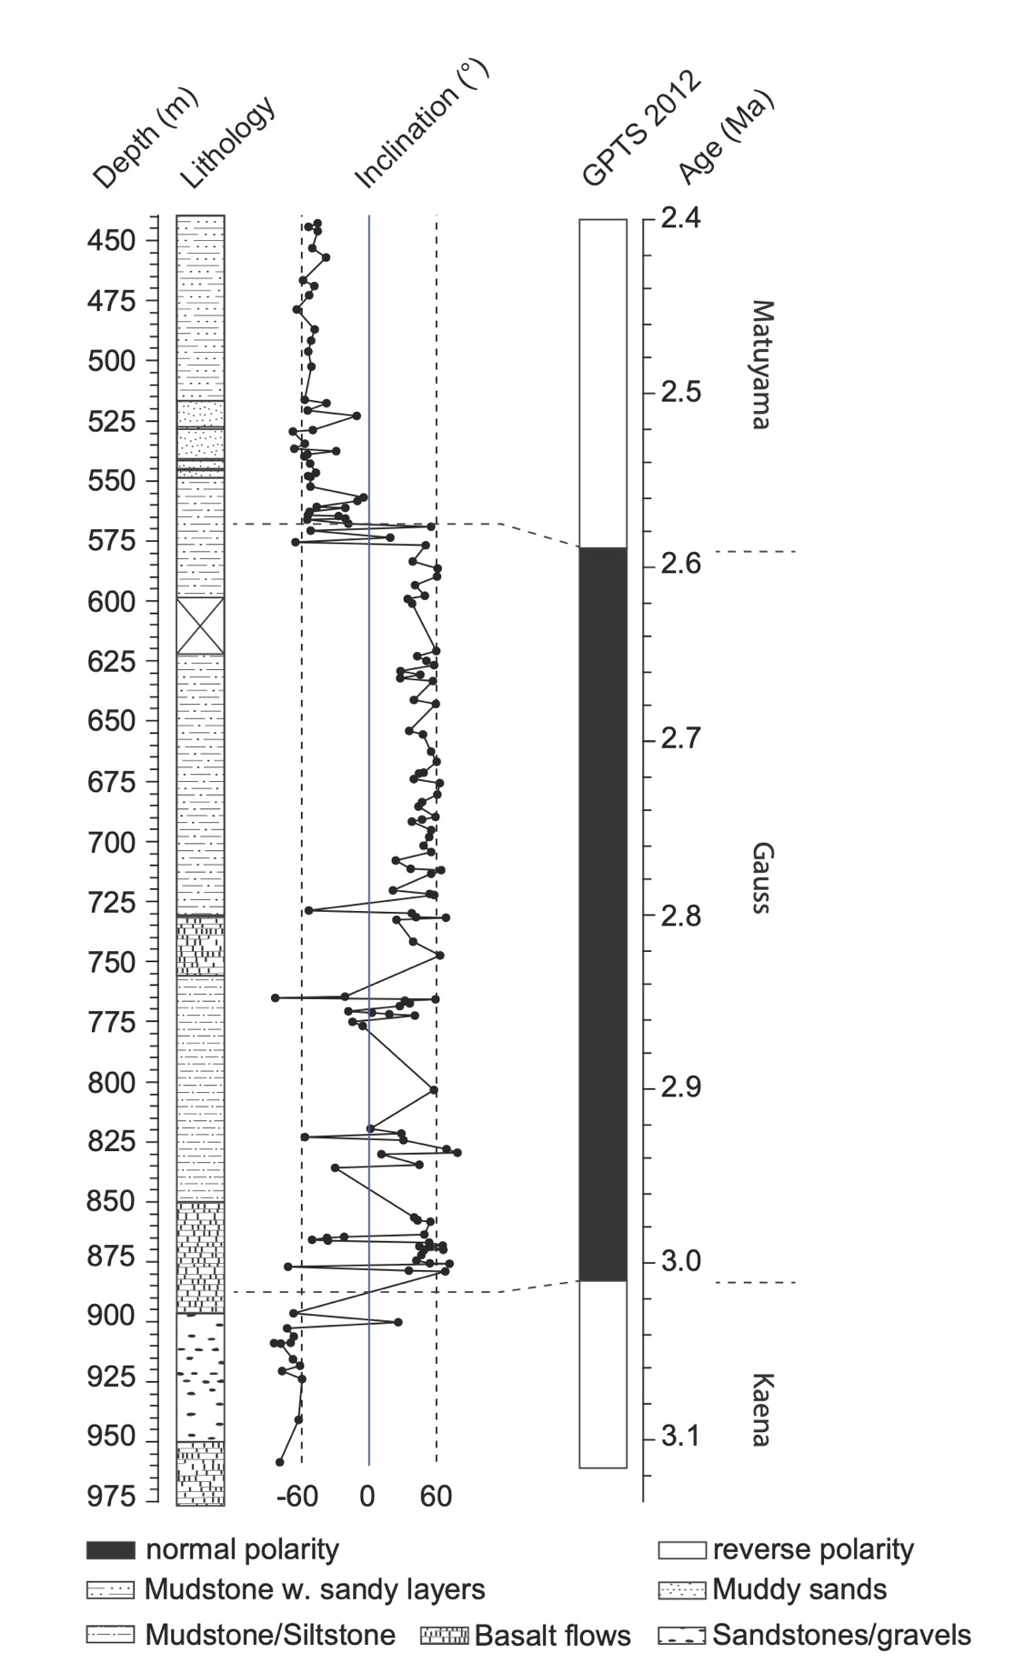
Supplementary Fig. 1 Lithology of core MHAFB11 and inclination pattern of all paleomagnetic samples treated with ThD ﻿(vertical dashed lines at 62° mark the expected geomagnetic dipole field inclination at 2.5 Ma for the drill site; after Torsvik et al. 2012). Ages in right-hand column after Ogg (2012)

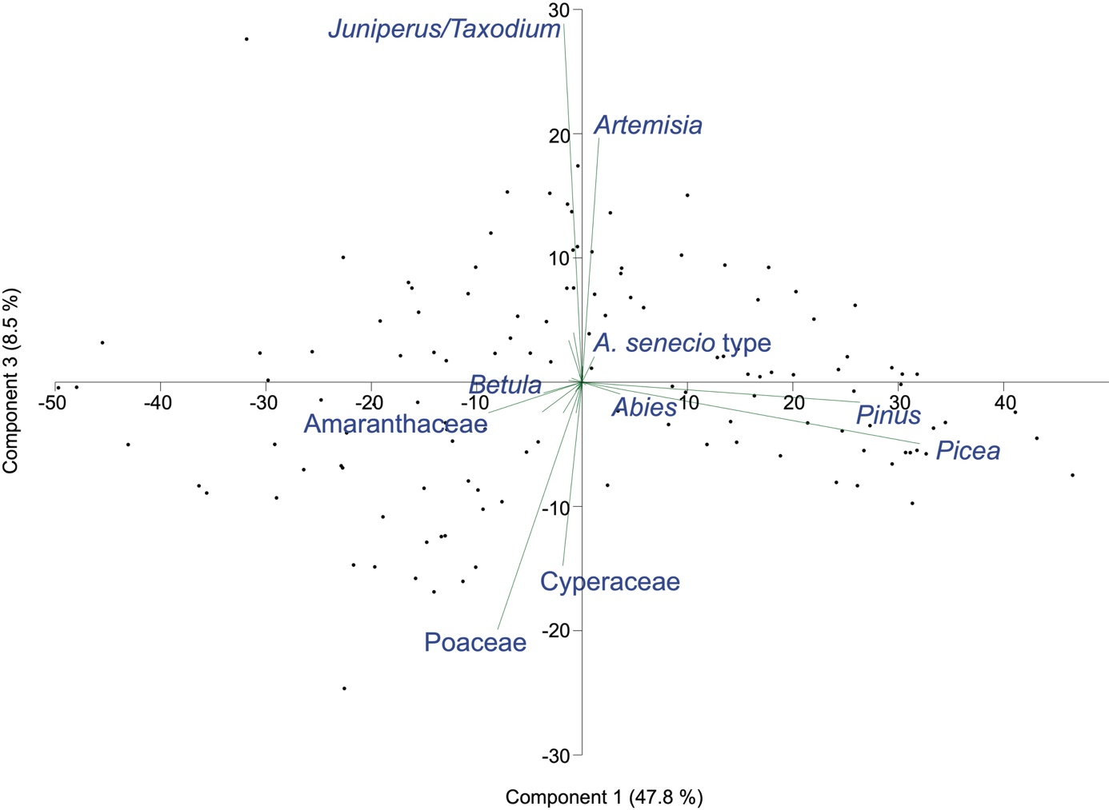

Supplementary Fig. 2 Principal component analysis of the palynological dataset from the MHAFB11 core. The first and the third principal components explain 56.3 % of the total variance. Only pollen taxa with high loadings (>0.1) in the first three components are labeled

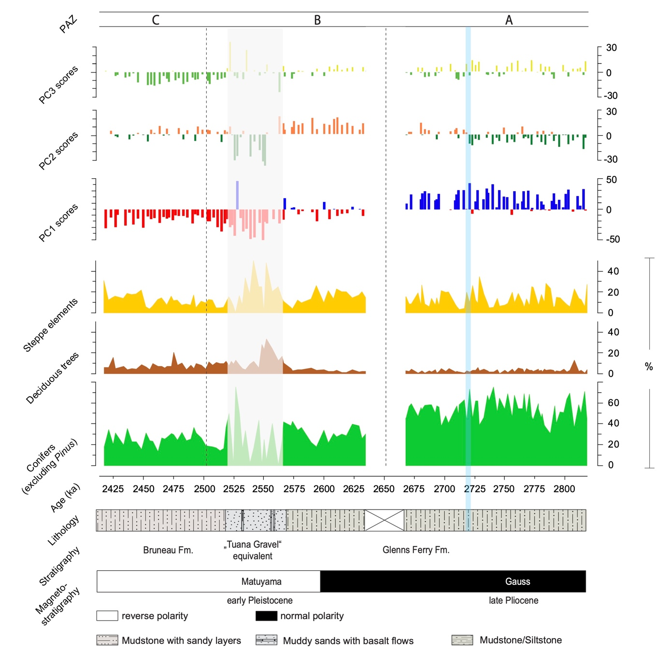

Supplementary Fig. 3 Selected pollen groups and PC scores of the paleo-Lake Idaho record from core MHAFB11 for ~2.8 to ~2.4 Ma. Blue bar marks stratigraphic position of lake-level decline at c. 2.7 Ma as indicated by PC2 and PC3 scores

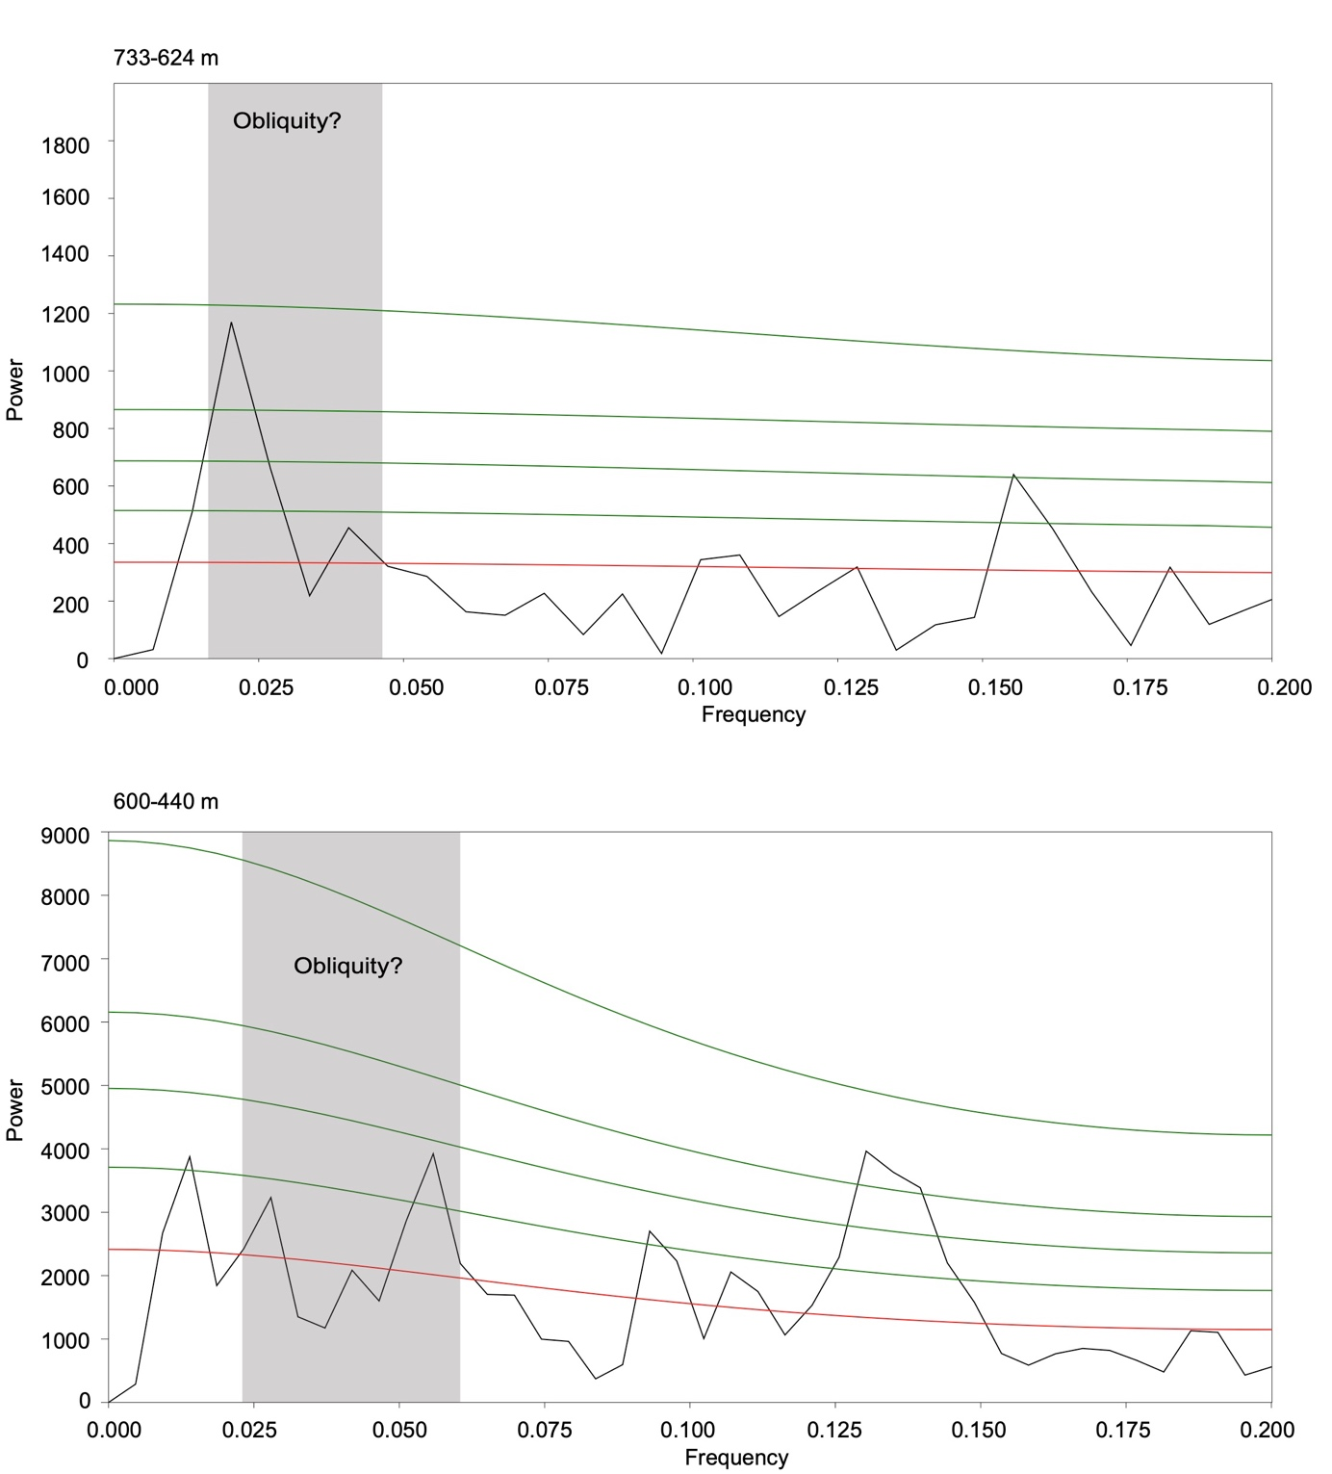 Supplementary Fig. 4 REDFIT spectral analyses of the arboreal pollen record for the intervals from 733 m to 624 m and from 600 m to 440 m in the MHAFB11 core. Red line shows the AR1 (red-noise level), and green lines represent the 80 %, 90 %, 95 %, and 99 % significance levels, respectively. Grey bars indicate the frequency bandwidths that could be attributed to the orbital obliquity period

Supplementary Fig. 5 Multitaper spectral analyses of the arboreal pollen record for the intervals from 733 m to 624 m and from 600 m to 440 m in the MHAFB11 core. Blue lines show the Multitaper spectrum, green lines show the simple periodogram

References

Torsvik, T. H., Van der Voo, R., Preeden, U., Mac Niocaill, C., Steinberger, B., Doubrovine, P. V., et al. (2012). Phanerozoic polar wander, palaeogeography and dynamics. Earth-Science Reviews, 114, 325–368.
Ogg, J. G. (2012). Geomagnetic polarity time scale. In F. M. Gradstein (Ed.), The geologic time scale (pp. 85–113). Amsterdam, Boston: Elsevier.

