Supplementary Information (SI):
SI Figure S1. Azmaka environment. Picture of the distribution of mammals in different habitats after their ecological requirements which demonstrates a varied landscape in Azmaka (ca. 7.2 Ma), represented by mosaic of semi-open and open biotopes and more swampy or forested areas near the river. Type of habitat (landscape physiognomy) (after the classification of White, 1983) (see also Table 1)
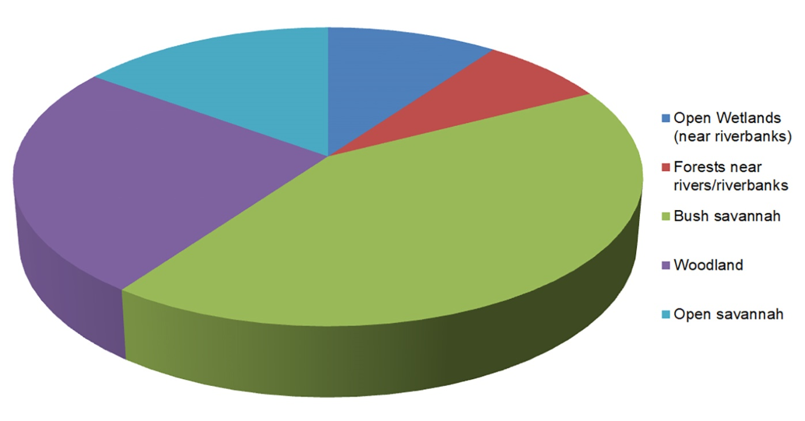

SI Figure S2. CT scan sagittal section of FM3549AZM6, demonstrating the asymmetric femoral neck cortical bone distribution, approximately in the middle part of the neck (see Methods and nomenclature)
.
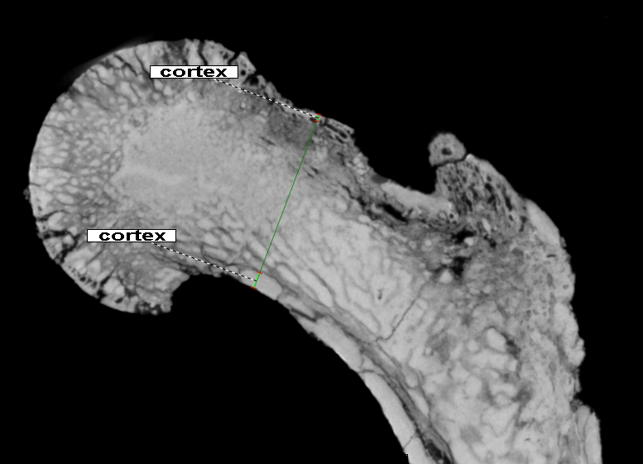

SI Figure S3. Box and whiskers plot of individual geometric means based on the 12 variables used in the PCA (see Table SI3), which serve as a general proxy for overall size in each species sample. The Azmaka femur (AZM) is marked in red. Fossil specimens are AFAR = Australopithecus afarensis AL 288-1 (the following specimens are used only in Fig. 2a: Hadar A.L. 827-1; Hadar A.L. 288-1; Hadar A.L. 333-3; Hadar A.L. 152-2); DRYO Dryopithecus; EQUA Equatorius; GORL Gorilla; AZM Azmaka femur; HISP Hispanopithecus laietanus; HOMO Homo sapiens; HYLO Hylobatidae; MESO Mesopithecus; PAID Paidopithex; PAN Pan paniscus; TROGL Pan troglodytes; PARA Paranthropus; PONG Pongo. Azmaka femur is close in overall size to Paidopithex, a pliopithecoid, and Equatorius, a middle Miocene stem hominid. However, the 12 variables comprising the geometric mean are all on the proximal femur (SI Table S3) and do not include length, for example, which is significantly longer in Equatorius (see Fig. SI 4) and Paidopithex. Azmaka femur is significantly larger than Mesopithecus
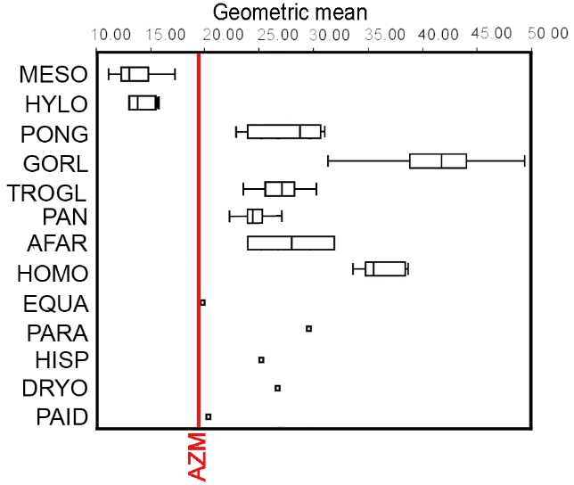

SI Figure S4. Shaft length scaled to the geometric mean. All fossil lengths are estimates based on nearly complete specimens. Azmaka femur is relatively close to Morotopithecus, Rudapithecus and A. afarensis among fossil taxa and Pan and Pongo among extant taxa. The Azmaka femur (AZM) is marked in red. AFAR Australopithecus afarensis AL 288-1; AFRI Australopithecus africanus; AZM Azmaka femur; CERC Cercopithecinae; COLO Colobinae; DANU Danuvius; EQUA Equatorius; GORL Gorilla; HYLO Hylobatidae; MORO Morotopithecus; PAN Pan paniscus; TROGL Pan troglodytes; PONG Pongo; RUDA Rudapithecus.

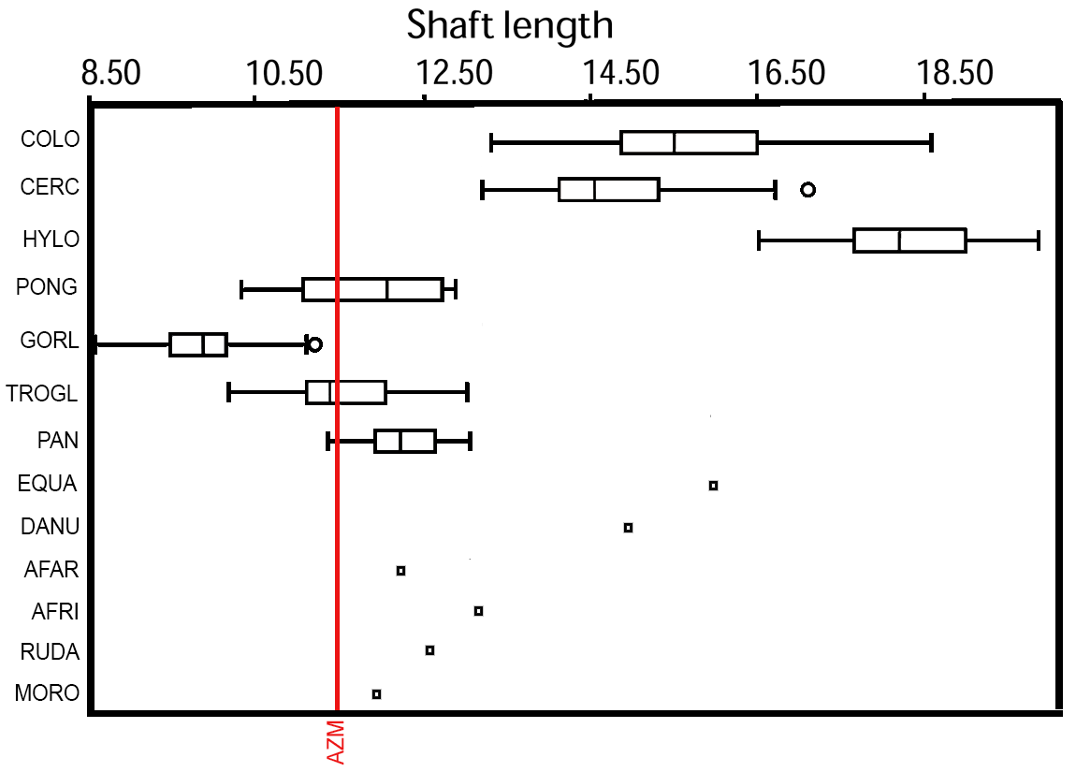
SI Figure S5. Box and whiskers plot of the size-adjusted (this also applies to all comparative figures below) femoral head length of Azmaka femur (AZM) in comparison to extinct and extant hominoids (PAID Paidopithex, PONG Pongo, GORL Gorilla, TROGL Pan troglodytes, PAN Pan paniscus, HYLO Hylobatidae, HOMO Homo sapiens, EQUA Equatorius, PARA Paranthropus, DANU Danuvius, AFAR Australopithecus afarensis, ORR Orrorin, HISP Hispanopithecus, DRYO Dryopithecus)

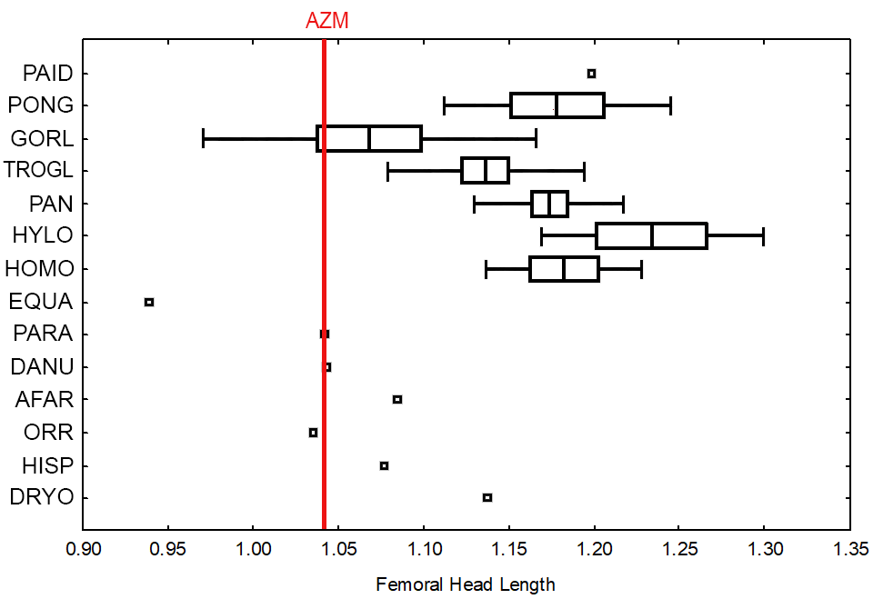

SI Figure S6. Box and whiskers plot of comparative head size. The Azmaka femur (AZM) is marked in red. AFAR Australopithecus afarensis AL 288-1; DRYO Dryopithecus; EQUA Equatorius; GORL Gorilla; AZM Azmaka femur; HISP Hispanopithecus laietanus; HOMO Homo sapiens; MESO Mesopithecus; ORR Orrorin; PAN Pan paniscus; RUDA Rudapithecus; TROGL Pan troglodytes; PARA Paranthropus; PONG Pongo.

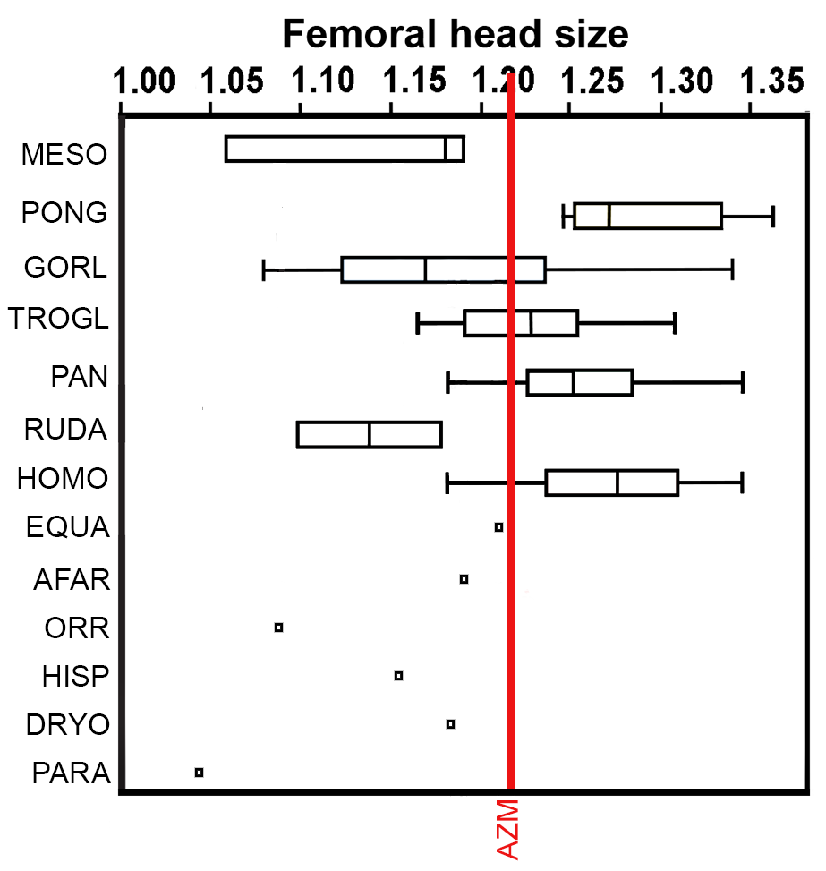
SI Figure S7. Box and whiskers plot of the femoral neck depth (VDN) of Azmaka (AZM) femur in comparison to extinct and extant hominoids. AFAR Australopithecus afarensis AL 288-1; AZM Azmaka femur; DANU Danuvius; DRYO Dryopithecus; EQUA Equatorius; GORL Gorilla; HISP Hispanopithecus laietanus; HOMO Homo sapiens; HYLO Hylobatidae; ORR Orrorin; PAID Paidopithex; PAN Pan paniscus; TROGL Pan troglodytes; PONG Pongo.

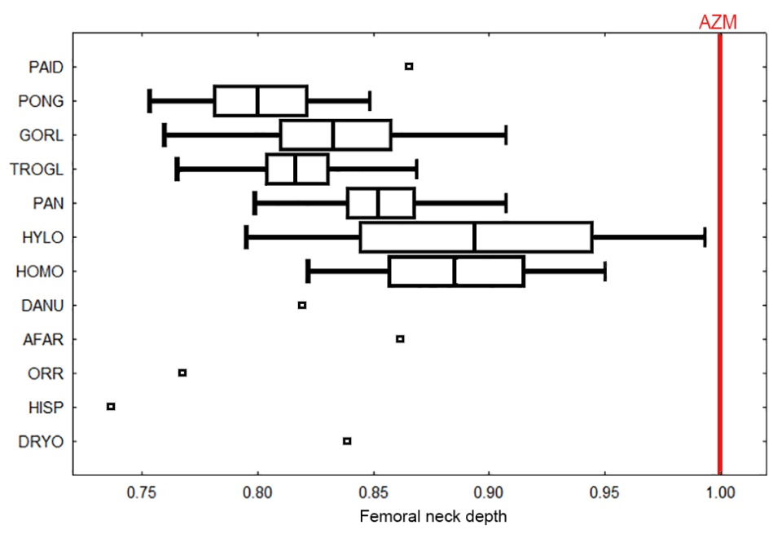

SI Figure S8. Box and whiskers plot of the femoral neck width (APNW) of Azmaka femur (AZM) with extinct and extant hominoids. AFAR Australopithecus afarensis AL 288-1; AZM Azmaka femur; DANU Danuvius; DRYO Dryopithecus; EQUA Equatorius; GORL Gorilla; HISP Hispanopithecus laietanus; HOMO Homo sapiens; HYLO Hylobatidae; ORR Orrorin; PAID Paidopithex; PAN Pan paniscus; TROGL Pan troglodytes; PONG Pongo

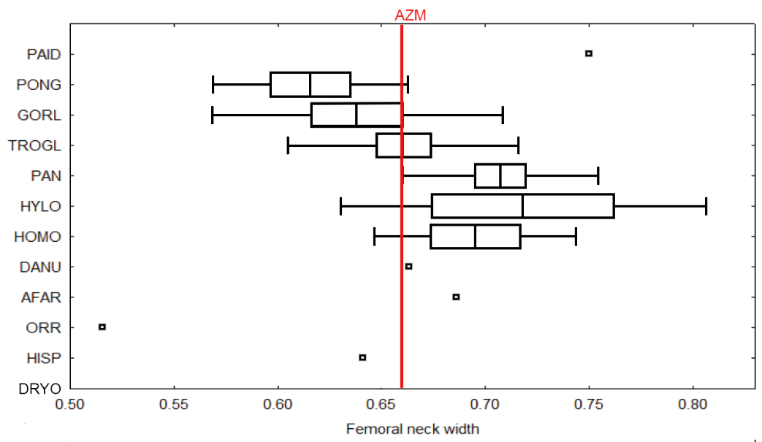

SI Figure S9. Box and whiskers plot of the distal position of the lesser trochanter to the proximal edge of the head (FTMIDSH: see Fig. 2). AFAR Australopithecus afarensis AL 288-1; AZM Azmaka femur; DANU Danuvius; DRYO Dryopithecus; EQUA Equatorius; GORL Gorilla; HISP Hispanopithecus laietanus; HOMO Homo sapiens; HYLO Hylobatidae; ORR Orrorin; PAID Paidopithex; PAN Pan paniscus; PARA Paranthropus; TROGL Pan troglodytes; PONG Pongo

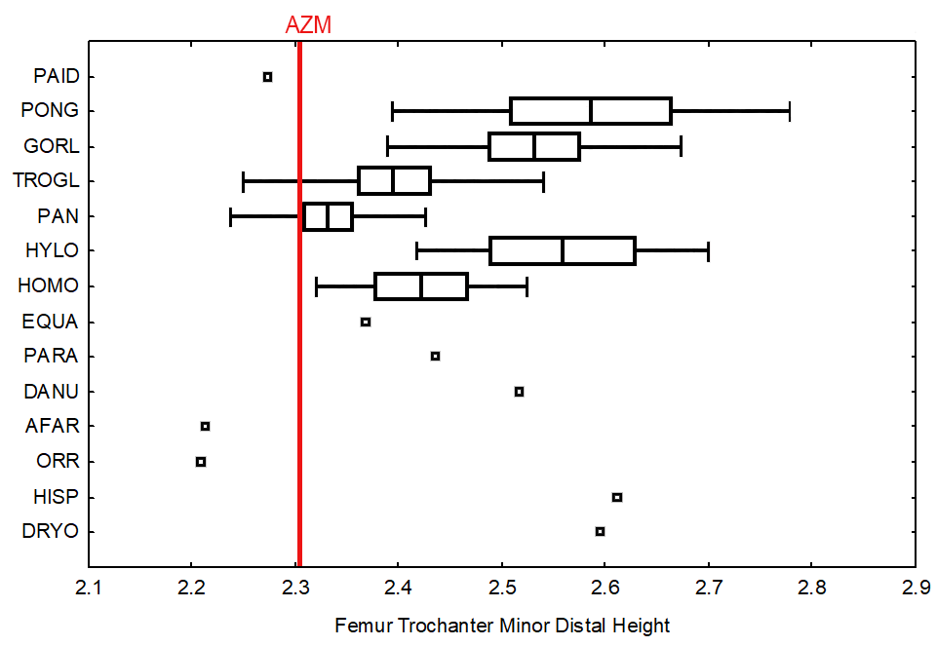

SI Figure S10. Box and whiskers plot of the femoral intertrochanteric distance of Azmaka femur with extinct and extant hominoids (FINTRD: see Fig. 2.1). The Azmaka femur (AZM) is marked in red. AFAR Australopithecus afarensis AL 288-1; Hadar A.L. 827-1; Hadar A.L. 288-1; Hadar A.L. 333-3; Hadar A.L. 152-2); AZM Azmaka femur; DRYO Dryopithecus; EQUA Equatorius; GORL Gorilla; HISP Hispanopithecus laietanus; HOMO Homo sapiens; HYLO Hylobatidae; MESO Mesopithecus; PAN Pan paniscus; TROGL Pan troglodytes; PARA Paranthropus; PONG Pongo.

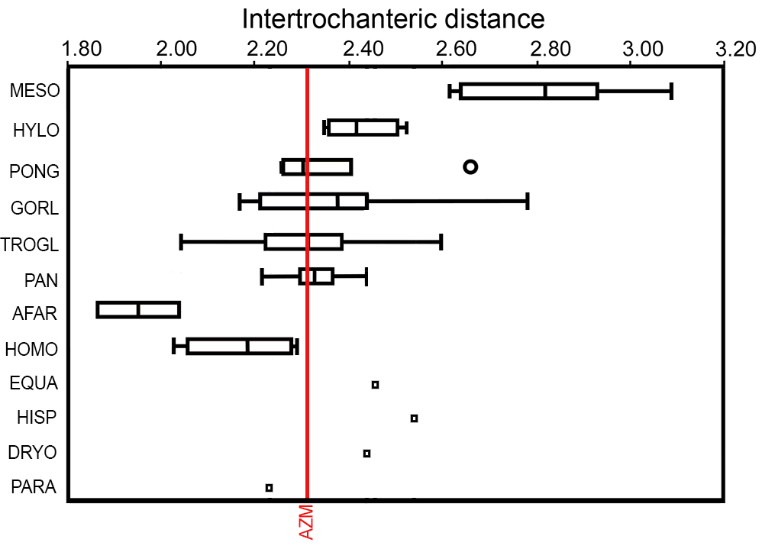
SI Figure S11. Morphological comparison of Azmaka femur (FM3549AZM6) with selected proximal femora of hominids (see table S2), cercopithecids and carnivores. a Canis lupus, (col. NMNHS) in posterior (a1) and lateroposterior (a2) views, (1)- ridge for attachment of m. vastus lateralis, passing distally into the lateral lip of protolinea aspera (2), which is also a site for attachment of the same muscle, (3) – third trochanter (gluteal tuberosity) after (Anderson et al. 1994); b Hispanopithecus laeitanus (IPS18800, cast) in posterior (b1) and lateral (b2) views, (1) - 1 ridge for attachment of m. vastus lateralis (noted in Almécija et al. 2013) as lateraly protrufing gluteal tuberosity) with a probable rudimentary posteriorly positioned and oblique gluteal tuberosity - (3); c Macaca arctoides (NMNHS, RM1071) in posterior view, (1) - ridge for attachment of m. vastus lateralis, passing distally into the lateral lip of linea aspera (2), (3) – gluteal tuberosity-like structure (3), (4) – medial lip of linea aspera; d Dryopithecus fontani (IPS41724, cast) in posterior (d1) and lateral (d2) views, (1) – protrusion (ridge) for attachment of m. vastus lateralis (noted in (Almécija et al. 2013) as a lateraly protruding gluteal tuberosity (it is possible that this protrusion on the lateral surface is for the attachment of both m. vastus lateralis and lateral to it, m. gluteus maximus); e Orrorin tugenensis (BAR1002'00, cast, reversed) in posterior view, (1) – ridge (homolgous to human lateral pilaster, not to be confused with the spiral lateral pilaster of great apes: see the text) for attachment of m. vastus lateralis , (2) - lateral lip of protolinea aspera, (3) – gluteal tuberosity on the posterolateral border; f Australopithecus afarensis (A.L.288-1, cast, reversed), (1) - ridge for attachment of m. vastus lateralis, (3) – gluteal tuberosity on the lateral edge of the posterior surface, (4) – medial lip of linea aspera; g Azmaka femur (FM3549AZM6) in posterior (g1) and lateroposterior (g2) views, (2) – nodules of the lateral lip of protolinea aspera, (3) – a vertical and posteriorly positioned gluteal tuberosity; h Homo sapiens from Salona, Dalmatia, Roman Empire (coll. NMNHS, reversed), lateral view, (1) – lateral pilaster (a site for the attachment of m. vastus lateralis: see Suwa et al.2012), (3) - gluteal tuberosity. Specimens not to scale
SI Figure S12. Pilasteric index (anteroposterior depth/mediolateral breadth) in fossil and extant catarrhines. The Azmaka femur has one of the highest values, matched only by the highest values in Australopithecus (Au. afarensis and Au. africanus), Pan, and cercopithecids among non-Homo taxa. The Azmaka femur (AZM) is marked in red. AFAR Australopithecus afarensis AL 288-1; Hadar A.L. 827-1; Hadar A.L. 288-1; Hadar A.L. 333-3; Hadar A.L. 152-2); AZM Azmaka femur; CERC Cercopithecinae; COLO Colobinae; EQUA Equatorius; GORL Gorilla; HISP Hispanopithecus laietanus; HOMO Homo sapiens; HYLO Hylobatidae; MORO Morotopithecus; ORR Orrorin; PAN Pan paniscus; TROGL Pan troglodytes; PONG Pongo

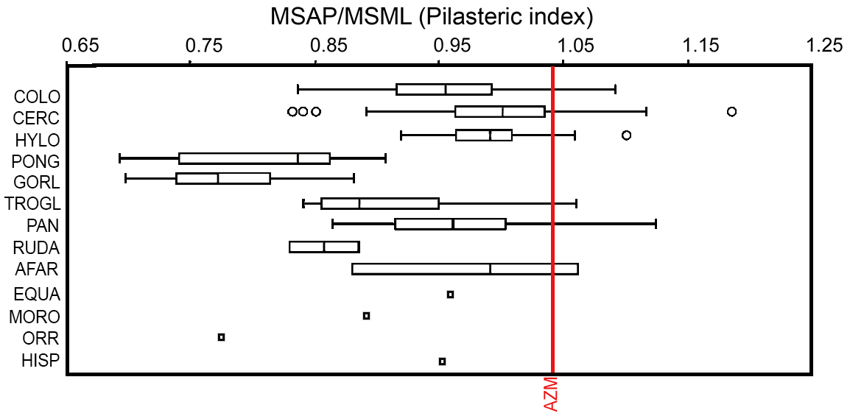

SI Fig. S13. We employed Rein’s (2020) regression using the natural log (ln)-transformed of the Biomechanical neck length (BNL), as introduced by Lovejoy et al.’s (1973, 2002), plotted against the natural log (ln)-transformed estimated body mass. Our results indicate that the Azmaka femur (red asterisk) falls within the cluster of semi-terrestrial quadrupeds, basically composed of cercopithecoids (STQ), and far from bipeds (Homo - OTB). This placement is mainly influenced by body mass, as the estimated mass for the Azmaka femur (24 Kg) is well below the values of great apes (KW and OC) and humans. This placement is further substantiated when the y-axis residuals are calculated. In terms of locomotor groups, the Azmaka femur falls within the range of semi-terrestrial quadrupeds and arboreal quadrupedal leapers and in terms of taxonomic groups falls within the upper range of the cercopithecoids (see the discussion in the main text)

SI Figure S14. Additional Principal Component Analysis (PCA) which include the neck measurements that are supposedly critical for assessing bipedal tendencies of the proximal femur. We included neck width (anteroposterior dimension APNW), neck length (mediolateral dimension PNL) and neck height (proximodistal dimension VDN see the text to the caption of Fig. 2.1. The first three PCs accounted for a total of 73.19 % of explained variance with PC 1 explaining 31.36% and PC 2 26.31%. Two analyses were conducted, one on taxa and one of locomotor groups. The top plot shows the first PCA. The Azmaka femur (AZM) is placed close to humans (HOMO), a group set apart from the rest of the specimens. Paranthropus (PARA) is set within the human cluster and Au. afarensis (AUSA) is isolated away from humans but within the hominin quadrat. The bottom plot depicts the second PCA with locomotor groups. Once more, the Azmaka femur (AZM) is placed close to the bipedal group (BIP), composed of modern and extinct bipedal hominids. There appears to be a relatively clear distinction between bipeds (BIP) and knuckle walker (KNL), the latter occupying the major part of the morphospace. In both plots, Orrorin (ORR), generally classified as bipedal, is within the hominin quadrant, but relatively distant from humans (top). It is placed also close to chimpanzees (TRGL top) and knuckle walkers (KNL bottom).

SI Figure S15. Hominid fossil localities of the Balkan-Iranian paleozoographic province. Azmaka is about 770 km south-southeast of the closest late Miocene ape site outside of the Balkan-Iranian paleozoographic province, Rudabánya, in north central Hungary.

