Annex II: Estimated mycotoxin contamination of feed ingredients
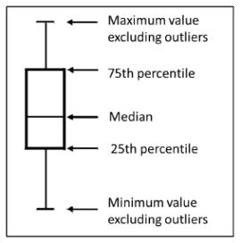
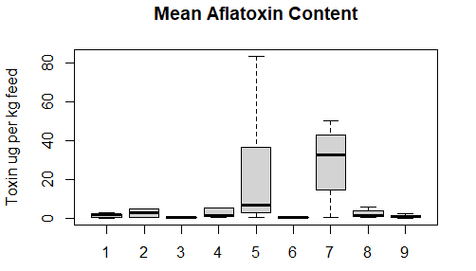
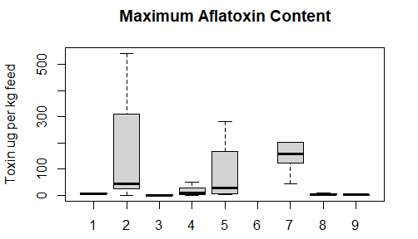
Figure S1. Mean (upper graph) and maximum (lower graph) content of aflatoxin B₁ in feed ingredients (excluding outliers) according to the literature (listed in Annex III). 1 = wheat. 2 = corn, 3 = barley, 4 = soya, 5 = sunflower, 6 = canola, 7 = beans, 8 = DDGS, 9 = meat.

Table S2 Literature data for aflatoxin B₁ (AFB₁) in feed ingredients (μg/kg), average values for all reported studies and the percentage of positive tested samples are shaded in light blue.
AFB₁ in wheat
1.34 |  | 9.48 |  |  | 34.1 %
mean |  | max |  | min | N (pos/all) |  |  | References
 |  | 10 |  | 1 | 9/80 |  |  | Martins et al. 2008
3 |  | 6 |  | 2 | 3/3 |  |  | Griessler et al. 2010
2  0 |  | 6  20 |  |  | 7/15  6/122 |  |  | Rodrigues and Naehrer 2012
0.4 |  |  |  |  | 6/? |  |  | EFSA CONTAM Panel 2014
1.7 |  | 5.4 |  |  | 15/201 |  |  | Pleadin et al. 2015
AFB₁ in corn
7.42 | 717 |  |  |  |  | 28.8 %
mean | max |  | min |  |  | N (pos/all) | References
4.4 |  |  |  |  |  | 83/110 | Piva et al. 2006
 | 45 |  | 1 |  |  | 30/248 | Martins et al 2008
 | 311 |  |  |  |  | 3/? | Binder et al. 2007
0.42 |  |  |  |  |  | 1/? | Mage et al. 2007
3.4 | 4.5 |  | 2.7 |  |  | 4/12 | Segvić Klarić et al. 2009
 | 0.5 |  | 0.1 |  |  | 8/95 | Soares and Venancio 2011
5 | 6 |  | 1 |  |  | 3/15 | Griessler et al. 2010ª
3 | 39 |  | 1 |  |  | 6/16
3.2 | 42.6 |  |  |  |  | 8/21 | Tabuc et al. 2011
 | 45 |  | 1 |  |  | 30/248 | Martins et al. 2008
0.28 |  |  |  |  |  | 1/28 | Grajewski et al. 2012
0.61 |  |  |  |  |  | 1/14
1 | 26 |  |  |  |  | 4/50 | Rodrigues and Naehrer 2012
38 | 6105 |  |  |  |  | 409/1077
37 | 542 |  |  |  |  | 15/30
0.6 |  |  |  |  |  | 62/127 | EFSA CONTAM Panel 2014
1.6 |  |  |  |  |  | 16/?
38.46 | 2072 |  |  |  |  | 305/972 | Pleadin et al. 2015
0.18 |  |  |  |  |  | 1/8 | Kosicki et al. 2016
 | 88.8 |  | 1.3 |  |  | 103/180 | Hajnal et al. 2017
a = reported only means of all samples

AFB₁ in barley
0.51 | 2.33 |  | 43.4 %
mean | max | min | N (pos/all) | References
0.11 | 0.24 |  | 21/21 | Ibáñez-Vea et al. 2012 a
0.13 | 0.22 |  | 40/40
0.14 | 0.28 |  | 30/30
0.13 | 0.34 |  | 14/14
 | 10 | 1 | 5/74 | Martins et al. 2008
 | 2 |  | 1/24 | Rodrigues and Naehrer 2012
1.54 | 3.22 |  | 9/147 | Pleadin et al. 2015

AFB₁ in beans
21.45 | 146 |  | 63.0 %
mean | max | min | N (pos/all) | References
35.73 | 158.6 | 0.3 | 17/27 | Beuchat-Leuchowich 1970
29.18 | 203.3 | 0.1 | 17/27
50.42 | 202.4 | 0.1 | 17/27
 | 122 | 5.3 | 9/? | Bankole et al. 1996
 | 42.3 | 7.7 | 7/?
0.38 |  |  | 2/? | EFSA CONTAM Panel 2014

AFB₁ in sunflower products
35.53 | 123 |  | 70.3 %
mean | max | min | N (pos/all) | References
0.4 |  |  | 2 | EFSA CONTAM Panel 2014
1.7 | 8.8 | 0.1 | 40/125 | Mortensen and Granby 2014
5.14 | 13.8 | 1.5 | 5/7 | Mmongoyo et al. 2017^{b}
19.7 | 52.8 | 3.2 | 4/7
209.43 | 598.4 | 7.1 | 4/7
148.97 | 536 | 2.7 | 6/6
5.13 | 12 | 1.5 | 3/7
7.1 | 20.3 | 1.4 | 9/9
6.45 | 11.2 | 1.7 | 2/5
1.75 | 2.3 | 1.4 | 4/7
39.43 | 217.6 | 1.6 | 6/7
1.8 | 2 | 1.6 | 2/7
244.17 | 662.7 | 2.8 | 3/6
6.7 | 28.6 | 1.5 | 6/7
23.69 | 174.2 | 1.4 | 8/9
2.63 | 3.7 | 1.9 | 3/5
56.24 | 162 | 1.8 | 5/6
54.96 | 261.8 | 1.4 | 5/6
83.5 | 280.6 | 1.7 | 5/7
2.7 | 1.9 | 1.6 | 2/5
 |  | 1.4 | 1/7
2.4 | 2.7 | 2.1 | 3/4
6 | 17.8 | 1.7 | 7/7
13.2 | 34.3 | 2 | 6/6
33.53 | 88.2 | 1.9 | 7/7
13.45 | 31.9 | 2.2 | 4/5
2.9 | 5.3 | 1.7 | 7/7
33.62 | 97.7 | 3 | 6/6
1.9 | 2.2 | 1.5 | 4/5
^{b} = these data have been obtained from outside of Europe.

AFB₁ in soybean products
3.48 | 17.7 |  | 26.7 %
mean | max | min | N (pos/all) | References
 | 14 | 7 | 2/1046 | Nesheim and Wood 1995
 | 0.41 |  | 32/55 | Valenta et al. 2002
5.37 |  |  | 2/7 | Kokic et al. 2009
 | 10 | 1 | 2/66 | Martins et al. 2008
13.3 |  |  |  | Deng et al. 2010
 | 51.7 |  | ?/12 | Tabuc et al. 2011
1 | 2 |  | 4/7 | Rodrigues and Naehrer 2012
1 | 42 |  | 28/159
0.32 |  |  | 30/? | EFSA CONTAM Panel 2014
1.88 | 4.02 | 0.5 | 5/23 | Fapohunda et al. 2018

AFB₁ in DDGS
4.19 | 15.5 |  | 13.5 %
mean | max | min | N (pos/all) | References
1.18 | 1.21 | 1.15 | 2/16 | Zhang et al. 2009 ^{b}
1.83 | 2.56 | 1.04 | 3/69
2.2 | 3.7 | 1.1 | 6/20
1 | 89 |  | 18/393 | Rodrigues-Chin 2011
1.29 | 2 | 1 | 13/59 | Zhang and Caupert 2012 ^{b}
20 |  |  | 62/1238 | Schatzmayr and Streit 2013
0.2 | 0.3 | 0.1 | 2/13 | Mortensen and Granby 2014
5.8 | 9.9 | 1 | 21/150 | Abudabos et al. 2017
^{b} = these data have been obtained from outside of Europe.

AFB₁ in rapeseed products
0.39 | ? |  | 100
mean | max | min | N (pos/all) | References
0.39 |  |  | 6/? | EFSA CONTAM Panel 2014

AFB₁ in chicken meat
0.91 | 1.76 |  | 43.9 %
mean | max | min | N (pos/all) | References
0.11 |  |  |  | Richard et al. 1986
0.14
0.37 | 0.49 | 0.23 | 3/8 | Hussain et al. 2010
0.67 | 0.77 | 0.48 | 3/8
1.63 | 2.18 | 0.65 | 3/8
0.33 | 0.41 | 0.25 | 2/6
0.41 | 0.49 | 0.32 | 3/6
1.35 | 1.9 | 0.95 | 5/6
0.86 | 1.63 | 0.22 | 3/8
1.02 | 1.9 | 0.24 | 3/8
2.4 | 3.27 | 0.95 | 4/8
0.63 |  |  |  | Herzallah 2013
1.19 | 4.41 |  | 15/39 | Iqbal et al. 2014
0.89 | 1.89 |  | 18/45
^{b} = these data have been obtained from outside of Europe.

AFB₁ in fishmeal
1.6 | ? |  | 100
mean | max | min | N (pos/all) | References
1.6 |  |  | ? | Deng et al. 2010

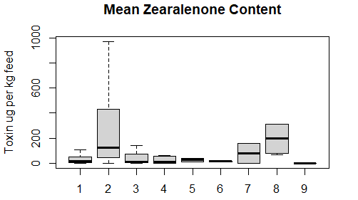
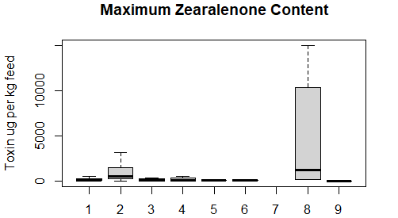
Figure S2. Mean (upper graph) and maximum (lower graph) content of zearalenone in feed ingredients (excluding outliers) according to the literature (listed in Annex III). 1 = wheat. 2 = corn, 3 = barley, 4 = soya, 5 = sunflower, 6 = canola, 7 = beans, 8 = DDGS, 9 = meat.

Table S3 Literature data for zearalenone (ZEN) in feed ingredients (μg/kg), average values for all reported studies and the percentage of positive tested samples are shaded in light blue.
ZEN in wheat
33.87 | 492 |  | 46.8 %
mean | max | min | N (pos/all) | References
 | 182 | 61 | 7/? | Bartos and Matyas 1981
80 | 1560 |  | 61/? | Gleissenthal et al. 1989
 | 1560 |  | 58% | Lepschy-von Gleissenthal et al. 1989
27 | 64 | 4 | 7/? | Ranfft et al. 1990
45 | 174 | 2 | 7/? | Tanaka et al. 1990
22 | 32 | 12 | 2/? | Hietaniemi and Kumpulainen 1991
178 | 8036 |  | 80% | Müller and Schwadorf 1993b
17 | 120 |  | ?/97 | Vrabcheva et al. 1996
178 | 8036 | 1 | 67/? | Müller et al. 1997ª
3 | 6 | 3 | 11/?
5 | 15 | 1 | 9/?
20 | 109 | 1 | 10/?
4 | 20 | 1 | 15/?
11 | 52 | 2 | 28/?
5 |  |  | 7/? | Eriksen and Alexander 1998
 | 170 |  | 25/25 | Curtui et al. 1998
210.3 | 890 | 50 | 215/367 | Rafai et al. 2000
 | 860 | 11 | 22/24 | Schneweis et al. 2002
 | 2 | 1 | 3/28 | Schollenberger et al. 2002
 | 8 | 1 | 4/13 | Schollenberger et al. 2002
 | 24 | 2 | 15/19 | Schollenberger et al. 2002
 | 2 |  | 10/30 | Rasmussen et al. 2003
19000 |  |  | ? | Pussemier et al. 2006
187 | 921 |  | 44/48 | Binder et al 2007
 | 184 | 2.5 | 8/? | Mage et al. 2007
 | 95.6 |  | 16/51 | Mankevičienė et al. 2007
 | 33.4 |  | 16/49
 | 28.1 |  | 33/48
 | 45.8 |  | 33/34
 | 1292 |  | 309/1624 | Edwards 2009
35.7 |  |  | 1/1 | Kokic et al. 2009
 |  | 10 | 1/54 | Manova and Mladenova 2009
 |  | 27 | 1/7 | Cunha and Fernandes 2010
156.5 | 200 | 113 | 2/33 | Giraud et al. 2010
57 |  |  | 1/25 | Griessler et al. 2010 ª
 | 50 | 13 | 4/6 | Klarić et al. 2009
108 | 155 |  | 2/? | Monbaliu et al. 2010
 | 67.3 | 36.7 | 6/12 | Stroia et al. 2010
 | 5.52 |  | 4/40 | Banu et al. 2011
2.225 | 3.57  41.8 | 0.88  0.41  0.42 | 2/2  5/16  1/1 | Galbenu et al. 2011a
 | 6 | 3 | 4/40 | Banu et al. 2011
110 | 490 | 4 | 35/35 | Chelkowski et al. 2012
53 | 145 |  | 14/208 | Rodrigues and Nährer 2012
43 | 513 |  | 62/184
 | 21.1 | 1.9 | 5/15 | Škrbić et al. 2012
 | 143 | 10 | 22/28 | Stankovic et al. 2012
 | 201 | 16 | 71/75
 | 310 |  | 27/312 | Van Der Fels-Klerx et al. 2012
 | 1000 | 37.6 | 18/26 | Alexa et al. 2013
 | 105.6 | 28 | 20/26
 | 27.15 | 2.35 | 5/57 | Juan et al. 2013
 | 86 |  | 31/31 | Lindblad et al. 2013
 | 25 |  | 2/33
 | 32 |  | 10/28
 | 678 |  | 13/33
 | 507 |  | 432/3088 | Marin et al. 2013
 | 107 |  | 35/51 | Pleadin et al. 2013
13.05 | 13.7 | 12.4 | 2/2 | Aldana et al. 2014
 | 15.3 | 7.4 | 4/17
18 | 19 | 17 | 2/5 | Alkadri et al. 2014
88 | 231 | 8 | 5/12
15 | 26 | 7 | 4/7
46 |  |  | 1/3
7 |  |  | 1/4
38 | 62 | 11 | 3/12
2.7 |  |  | 5/165 | EFSA CONTAM Panel 2014
3 |  |  | 2/45
10 |  |  | 1/41
2.6 |  |  | 11/38
1.3 |  |  | 5/59
5.4 |  |  | 27/27
3 |  |  | 44/137
3.6 |  |  | 50/113
3 |  |  | 37/120
64 |  |  | 1/2 | Mortensen and Granby 2014
 | 80 |  | 17/336 | Misca et al. 2014
 | 116 |  | 10/29 | Nordkvist and Häggblom 2014
39 | 113 |  | 17/? | Kirinčič et al. 2015
7 | 7 |  | 2/?
 | 113 |  | 19/80 | Kirinčič et al. 2015
15.5 | 17 | 14 | 2/4 | Nacher-Mestre et al. 2015
9 | 15 | 2 | 9/9 | Bryła et al. 2016
43  16  3.5 | 100  45  4 | 7  1  3 | 18/18 | Bryła et al. 2016
43  16  3.5 | 100  45  4 | 7  1  3 | 18/18  2/36 | Bryła et al. 2016
45 | 3070 |  | 179/527 | Vogelsang et al. 2017
18 | 1000 |  | 35/159
ª = reported only means of all samples

ZEN in corn
459 | 3345 |  | 71.1 %
mean | max | min | N (pos/all) | References
2350 |  |  | 1/? | Jemmali 1973
5100 | 10000 | 43 | 3/? | Balzer et al. 1977
105 |  |  | 1/? | Bartos and Matyas 1981
12 | 35 | 5 | 6/? | Ranfft et al. 1990
677 |  |  | 1/? | Tanaka et al. 1990
30 | 79 | 6 | 17/? | Fazekas et al. 1996
 | 41 | 6.5 | 4/? | Patel et al. 1996
1080 | 1500 | 640 | 3/? | Scudamore et al. 1998
46 | 150 | 4 | 14/? | Visconti and Pascale 1998
228.9 | 1350 | 60 | 140/760 | Rafai et al., 2000
1.14 | 2.24 | 0.47 | 4/27 | Jaimez et al. 2004
 | 3100 |  |  | Zinedine et al. 2007
279 | 921 |  | 4/484 | Binder et al. 2007
 | 1403 | 218 | 3/? | Mage et al 2007
112.0 | 1182 | 27.7 | 21/24 | Segvić Klarić et al. 2009
27  22 | 178  258 | 20  48 | 4/12  10/66 | Griessler et al. 2010 ª  ª
70  480 | 860  14580 |  | 12/44  37/40 | Goertze et al. 2010
387  147  166.7  127.2 | 356  281 |  | 1/?  1/?  3/?  5/? | Monbaliu et al. 2010
 | 1260 | 16 | 15/19 | Dorn et al. 2011
122.0  47.2  43.0  34.3 | 603  447  292  422 |  | 26/37  24/25  49/49  66/68 | Grajewski et al. 2012
41  121  1848 | 1014  7422  16712 |  | 126/394  380/979  28/30 | Rodrigues and Nährer 2012
246 |  |  | 16/? | EFSA CONTAM Panel 2014
1225  18 | 4578  31 |  | 8/17.6  4/? | Kirincic et al. 2015
 | 13 | 8 | 3/3 | Nacher-Mestre et al. 2015
970  2540 | 16200  30130 |  | ?/78  ?/90 | Gromadzka et al. 2016 ª
58.2  31.3  48.5  161.0 | 312  430  405  521 |  | 42/43  78/88  80/91  73/73 | Kosicki et al. 2016
 |  | 2  2 | 1/1  1/1 | Dzuman et al. 2017 Supplementary Data
ª = reported only means of all samples

ZEN in barley
55.8 | 624 |  | 32.1 %
mean | max | min | N (pos/all) | References
 | 261 | 61 | ? | Bartos and Matyas 1981
24 | 320 |  | 24/? | Gleissenthal et al. 1989
7 | 9 | 4 | 6/? | Tanaka et al. 1990
26 | 30 | 21 | 2/? | Hietaniemi and Kumpulainen 1991
3  36 | 311 |  | 68/?  68/? | Müller et al. 1997b
18 |  |  | 23/? | Eriksen and Alexander 1998
139.8 | 840 | 50 | 108/222 | Rafai et al. 2000
221 | 970 |  | 9/81 | Binder et al 2007
1.89 | 18.53 |  | 48/123 | Ibáñez-Vea et al. 2012 a
323 |  |  | 18/47 | Rodrigues and Nährer 2012
11.15 | 15 | 7.3 | 2/9 | Juan et al. 2013
0.9  3.9  1  3.7 | 21.5  59.4  21.1  47.9 |  | 7/85  18/75  5/85  27/80 | Beláková et al. 2014
7.2 | 8952 |  | 34/62 | EFSA CONTAM Panel 2014
75  192  95  2  3 | 214  1558  1116  4  50 |  | ?/12  ?/30  ?/21  ?/35  ?/45 | Nielsen et al 2014
192.8 | 204.4 | 181.2 | 2/22 | Bolechova et al. 2015
79 | 203 |  | 5/11 | Kirincic et al. 2015
7  13 | 19  31 | 2  2 | 10/16  6/8 | Bryła et al. 2016
3.7  10.2 | 84  240 |  | 59/280  22/160 | Schönenberger et al. 2016

ZEN in soybean products
51.6 | 245 |  | 41.7 %
mean | max | min | N (pos/all) | References
181.1 | 520 | 50 | 38/119 | Rafai et al 2000
 | 18 |  | 23/51 | Valenta et al. 2002
50 | 50 |  | 1/18 | Binder et al. 2007
62.16 | 74.3 |  | 7/7 | Kokic et al. 2009
13 | 807 |  | 22/156 | Rodrigues and Nährer 2012
2.7 |  |  | 17/? | EFSA CONTAM Panel 2014
0.73 | 1.4 | 0.3 | 3/23 | Fapohunda et al. 2018 ^{b}
^{b} = these data have been obtained from outside of Europe.

ZEN in sunflower products
 |  |  | 100 %
mean | max | min | N (pos/all) | References
 | 83 | 2.5 | ? | Mage et al. 2007
39.9 | 48.4 |  | 7/7 | Kokic et al. 2009
13 |  |  | 7/? | EFSA CONTAM Panel 2014

ZEN in beans
80.5 | ? |  | 100
mean | max | min | N (pos/all) | References
160 |  |  | 1/? | Pepeljnjak 1984
1 |  |  | 2/? | EFSA CONTAM Panel 2014

ZEN in DDGS
262 | 4653 |  | 59.2 %
mean | max | min | N (pos/all) | References
227 | 10374 |  | 85/405 | Rodrigues Chin 2011 ª
910 | 14990 | 100 | 48/59 | Tansakul et al. 2013 ª
65.63 | 2120 | <250 | 27/81 | Khatibi et al. 2014
78 | 160 | 12 | 4/4 | Mortensen and Granby 2014
167.6 | 501 | 33 | 52/150 | Abudabos et al. 2017
ª = reported only means of all samples

ZEN in rapeseed products
13.4 | 27.0 |  | 95.6 %
mean | max | min | N (pos/all) | References
12.3  14.3  14.3  19.6  18.6 | 25.1  32.3  25.1  25.6 | 10.6 | 6/7  11/11  25/25  12/13  12/12 | Mankeveciene et al. 2012
1.3 |  |  | 6/? | EFSA CONTAM Panel 2014

ZEN in yeast
31.8 | ? |  | 100 %
mean | max | min | N (pos/all) | References
31.8 |  |  | 1/1 | Kokic et al. 2009
ZEN in sugarbeetle molasses
6.0 | 391 |  | 100 %
mean | max | min | N (pos/all) | References
 | 391 | 12  0 | 6/?  10/? | Bosch and Mirocha 1992
ZEN in chicken meat
30.2 | 36.4 |  | 58.2 %
mean | max | min | N (pos/all) | References
 | 103 | 59 | ? | Mirocha et al. 1982 ^{b}
1.45  1.37 | 3.2  2.89 |  | 22/39  27/45 | Iqbal et al. 2014
^{b} = these data have been obtained from outside of Europe.

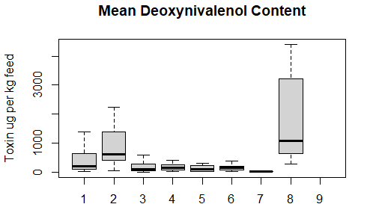
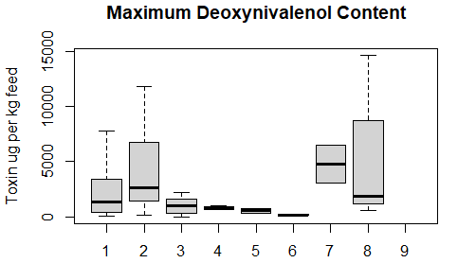
Figure S3. Mean (upper graph) and maximum (lower graph) content of DON in feed ingredients (excluding outliers) according to the literature (listed in Annex III). 1 = wheat. 2 = corn, 3 = barley, 4 = soya, 5 = sunflower, 6 = canola, 7 = beans, 8 = DDGS, 9 = meat.

Table S4 Literature data for deoxynivalenol (DON) in feed ingredients (μg/kg), average values for all reported studies and the percentage of positive tested samples are shaded in light blue.
DON in wheat
894 | 4701 |  | 76.4 %
mean | max | min | N (pos/all) | References
3960 | 43800 |  | 87% | Lepschy-von Gleissenthal et al. 1989
1632 | 20538 |  | 96% | Müller and Schwadorf 1993b
 | 8200 |  | ? | Adler et al. 1995
 | 5600 |  | 25/25 | Curtui et al. 1998
 | 77 | 20 | 8/10 | Moura et al. 1998
 |  |  | 24/169 | Langseth and Rundberget 1999
298.9 | 1560 | 70 | 287/367 | Rafai et al. 2000
3385  1371  146  70  202 | 6465  3010  330  105  1000 | 1610  380  55  50  60 | 2/2  2/2  5/36  18/35  24/26 | Pascale et al. 2000/2001
 | 1379  965  756 | 15  15  38 | 19/19  28/28  12/13 | Schollenberger et al. 2002
 | 2591 | 10 | 108/120 | Rasmussen et al. 2003
 | 1821 | 333 | 4/10 | Peito and Venâncio 2004
 | 2270 | 20 | 51/103 | Biselli and Hummert 2005
705 | 5510 |  | 157/254 | Binder et al. 2007
 | 2265.2  804.9  721.9  702 | 17  22.8  18.6  6.8 | 48/48  43/47  44/45  40/41 | Hajšlova et al. 2007
 | 618 | 22 | 13/? | Mage et al. 2007
 | 642  1121  223  445 |  | 61/62  83/88  48/48  32/34 | Mankevičienė et al. 2007
 | 997 |  | 19/32 | Perkowski et al. 2012
 | 455  341 |  | 17/19  12/15 | Perkowski et al. 2007
1235  182  223  177 | 1840  423  410  208 | 630  57  90  142 | 2/4  4/12  12/34  3/9 | Jajic et al. 2008
 | 200 | 100 | 8/50 | Martins et al. 2008
 | 4130 | 203 | 23/23 | Berthiller et al. 2009
 | 20333 |  | 1396/1624 | Edwards 2009
600 |  |  | 1/1 | Kokic et al. 2009
 | 3395 | 21 | 38/42 | Macri et al. 2009
 | 434 | 205 | 3/7 | Cunha and Fernandes 2010
838.29  1163.73 | 4506  8111 | 70  70 | 14/17  12/16 | Giraud et al. 2010
275 | 2232 | 338 | 8/29 | Griessler et al. 2010 ª
4642  1970  750 | 8841  2113 | 443  1799 | 2/?  3/?  1/? | Monbaliu et al. 2010
 | 154.3 | 6.1 | 10/12 | Stroia et al. 2010
 | 95.7 | 19 | 17/40 | Banu et al. 2011
 | 177 |  | 2/18 | Reinhold and Reinhardt 2011
 | 309 | 41 | 15/54 | Škrbić et al. 2011
23090  30800 | 69150  52700 | 4010  13400 | 35/35  10/10 | Chelkowski et al. 2012
 | 150 |  | 4/6 | De Boevre et al. 2012
494.5  1400 | 4557  49000 |  | 188/325  101/191 | Rodrigues and Nährer 2012
 | 976 | 17.5 | 13/15 | Škrbić et al. 2012
 | 3306  1090 | 52  50 | 24/28  70/75 | Stankovic et al. 2012
 | 5865  10000  890  890 |  | 101/338  671/940  245/832  114/554 | Van Der Fels-Klerx et al. 2012
 | 3390  1440 | 294  254 | 19/26  5/26 | Alexa et al. 2013
 | 99.6 | 9.6 | 16/57 | Juan et al. 2013
 | 77 | 20 | 8/10 | Abrunhosa et al. 2016
68.1  82.2  103.3  41  31  818 | 180  120  551  93  37  1230 | 19  53  62  14  24  13 | 6/12  5/5  5/12  5/7  ¾  3/3 | Alkadri et al. 2014
104  84  218  161  50  71  118  108  39  16  109  155  62  83  256  209  153  130  405  94  213  161  152  224 |  |  | 136/165  100/107  110/128  83/131  55/142  19/39  7/42  16/38  29/59  83/83  59/59  18/18  74/74  88/88  60/60  93/93  22/22  6/6  30/30  28/31  132/137  106/113  119/120  89/90 | EFSA CONTAM Panel 2014
 | 303  1394  1189  6460 |  | 25/31  21/33  26/28  30/33 | Lindblad et al., 2013
 | 278 |  | 33/51 | Pleadin et al. 2013
 | 83.2 |  | 55/119 | Rodríguez-Carrasco et al. 2013
 | 3230 |  | 26/29 | Nordkvist and Häggblom 2014
 | 7780 |  | 229/290 | Šliková et al. 2014
 | 2940 | 200 | 145/186 | Šliková et al. 2014
 | 7780 | 220 | 20/20 | Šliková et al. 2014
315 | 330 | 300 | 2/2 | Mortensen and Granby 2014
473  513 | 3070  2142  3070 |  | 49/?  6/?  55/80 | Kirincic et al. 2015
 | 371  504 | 53  17 | 3/3  4/4 | Nacher-Mestre et al. 2015
25  590  960  762 | 1616  2975  1721 | 25  82  209  277 | 1/36  18/18  18/18  9/9 | Bryła et al. 2016
108.2  262.67 | 3602.6  5027.7 | <18.5  <18.5 | ?/816  ?/740 | Gagiu and Smeu 2017
647  473 | 10600  9880 |  | 442/527  105/159 | Vogelsang et al. 2017
1063.3 | 1400 | 790 | 3/3 | Yli-Mattila et al. 2017
ª = reported only means of all samples

DON in corn
3068 | 45380 |  | 73.3 %
mean | max | min | N (pos/all) | References
191 | 870 | 50 | 84/780 | Rafai et al. 2000
1073 | 3970 |  | 197/244 | Binder et al. 2007
401 | 617 |  | 2/? | Mage et al. 2007
536  327  426  58 | 2460  2210  1340  172 | 42  40  140  27 | 5/10  32/76  8/21  30/119 | Jajic et al. 2008
 | 500 | 100 | 15/74 | Martins et al. 2008
460 |  |  | 1/4 | Kokic et al. 2009
1780  2240 | 19570  16250 |  | 33/44  36/40 | Goertze et al. 2010
233  547 | 1687  3025 | 68  253 | 7/14  60/71 | Griessler et al. 2010^{c}
2067  268  824  696 | 9528  899  1920  3039 |  | 6/?  7/?  11/?  10/? | Monbaliu et al. 2010
 | 8580 | 210 | 19/19 | Dorn et al. 2011
 | 2248.2 |  | ?/21 | Tabuc et al. 2011
 | 1900 | 300 | 13/? | Cortinovis et al. 2012
1130  613  653  432 | 6817  3090  4503  4405 |  | 65/66  41/41  53/53  65/68 | Grajewski et al. 2012
240  634  1705 | 546  26121  11836 |  | 358/459  465/878  26/30 | Rodrigues and Nährer 2012
2200  1300 | 2900  1900 | 1700  900 | 14/14  14/14 | Zhang and Caupert 2012
72 |  |  | 16/? | EFSA CONTAM Panel 2014
 | 1523 | 624 | 8/? | Zachariasova et al. 2014
473  1872 | 3070  11800 |  | 8/?  4/? | Kirincic et al. 2015
 | 814 | 139 | 3/3 | Nacher-Mestre et al. 2015
6150  90690 | 134360  1505000 |  | ?/78  ?/90 | Gromadzka et al. 2016 ª
624  391  494  1486 | 2027  3075  2473  6688 |  | 42/43  67/88  79/91  73/73 | Kosicki et al. 2016
548  599.5 | 686  787 | 410  412 | 2/2  2/2 | Dzuman et al. 2017 Supplementary Data
ª = reported only means of all samples
^{c} = DON and ADON levels have been summarized

DON in barley
270 | 2376 |  | 63.2 %
mean | max | min | N (pos/all) | References
400 | 4760 |  | 89% | Müller and Schwadorf 1993a
268 | 1200 | 50 | 174/222 | Rafai et al 2000
805 | 1540 | 70 | 2/2 | Pascale et al. 2000/2001
394 |  |  | 95/191 | Binder et al. 2007
 | 304 | 40 | 1/? | Jajic et al. 2008
 | 300 | 100 | 3/29 | Martins et al. 2008
 | 997 |  | 1/19 | Griessler et al. 2010
 | 900 | 200 | ? | Cortinovis et al. 2012
59.6 | 1111 |  | 117/123 | Ibáñez-Vea et al. 2012 b
1677 | 29300 |  | 19/45 | Rodrigues and Nährer 2012
 |  | 35.5 | 1/9 | Juan et al. 2013
31.1  256  13.5  48.4 | 407.5  2213.5  106.1  985.9 |  | 47/85  73/75  31/85  62/80 | Beláková et al. 2014
37 |  |  | 805/805 | EFSA CONTAM Panel 2014
283  211  134  14  56 | 974  3599  707  66  255 |  | ?/12  ?/30  ?/21  ?/35  ?/45 | Nielsen et al. 2014
284.14 | 602.3 | 69.9 | 19/22 | Bolechova et al. 2015
289 | 640 |  | 8/11 | Kirincic et al. 2015
3.4 | 15.1 | 0.2 | 9/50 | Piacentini et al. 2015
138  602 | 222  1602 | 76  54 | 4/8  16/16 | Bryła et al. 2016
239.8  46.7 | 4860  1725 |  | 257/280  50/160 | Schönenberger et al. 2016

DON in beans
10 | 4800 |  | 100 %
mean | max | min | N (pos/all) | References
 | 3100  6500 |  |  | Tseng et al. 1995
10 |  |  | 2/? | EFSA CONTAM Panel 2014

DON in soybean products
173 | 703 |  | 32.4 %
mean | max | min | N (pos/all) | References
252.7 | 720 | 60 | 78/119 | Rafai et al. 2000
108 |  |  | 1/51 | Valenta et al. 2002
397 | 840 |  | 13/32 | Binder et al. 2007
100 |  |  | 2/? | Jajic et al. 2008
250 |  |  | 1/7 | Kokic et al. 2009
202  62 | 908  1019 |  | 10/24  48/159 | Rodrigues and Nährer 2012
 | 30 |  |  | Souza et al. 2013 ^{b}
10 |  |  | 17/? | EFSA CONTAM Panel 2014
^{b} = these data have been obtained from outside of Europe.

DON in sunflower products
106 | 559 |  | 30.8
mean | max | min | N (pos/all) | References
150 |  |  | 1/22 | Rafai et al. 2000
25 |  |  | 1/? | Mage et al. 2007
 | 788 | 40 | 9/? | Jajic et al. 2008
302.5 | 330 |  | 4/7 | Kokic et al. 2009
12 |  |  | 7/? | EFSA CONTAM Panel 2014

DON in rapeseed products
165 | 188 |  | 72.9 %
mean | max | min | N (pos/all) | References
387  209.7  133  165 | 226  278.3  181  176.5 | 153.5 | 7/7  2/11  21/25  6/8  8/8 | Mankeveciene et al. 2012
19 |  |  | 6/? | EFSA CONTAM Panel 2014
79 | 79 | 68 | 3/5 | Mortensen and Granby 2014

DON in DDGS
1919 | 6017 |  | 79.9 %
mean | max | min | N (pos/all) | References
461.04  1018.13  684.24  767 | 1900  1680  1420  1200 | 200  130  120  100 | 77/77  16/16  66/69  9/20 | Zhang et al. 2009 ^{b}  ^{b}
1755 | 24269 |  | 77/409 | Rodrigues-Chin 2011 ª
7900  4400  3408.47 | 9300  5600  12300 | 6200  3200  300 | 14/14  14/14  59/59 | Zhang and Caupert 2012 ^{b}
1160 | 6750 | 260 | 29/59 | Tansakul et al. 2013 ª
1915.29 | 14620 | <500 | 87/141 | Khatibi et al. 2014
580  290 | 1100  570 | 140  90 | 4/4  7/7 | Mortensen and Granby 2014
3000 | 8100 | 800 | 43/150 | Abudabos et al. 2017
579.5 | 724 | 435 | 2/2 | Dzuman et al. Supplementary Data
869 | 724 | 435 | 2/2 | Duzman et al. 2017
ª = reported only means of all samples
^{b} = these data have been obtained from outside of Europe.

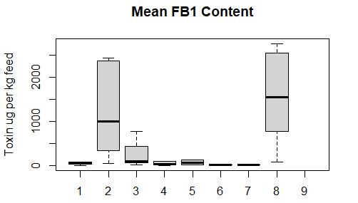
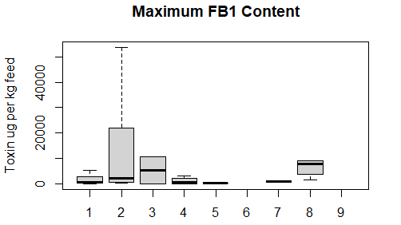
Figure S4. Mean (upper graph) and maximum (lower graph) content of fumonisin B₁ in feed ingredients (excluding outliers) according to the literature (listed in Annex III). 1 = wheat. 2 = corn, 3 = barley, 4 = soya, 5 = sunflower, 6 = canola, 7 = beans, 8 = DDGS, 9 = meat.

Table S5 Literature data for fumonisin B₁ (FB₁) in feed ingredients (μg/kg), average values for all reported studies and the percentage of positive tested samples are shaded in light blue.
FB₁ in wheat
202 | 1565 |  | 42.7 %
mean | max | min | N (pos/all) | References
 | 736  4343 |  | 87/110  42/256 | SCOOP 2003
580 | 580 |  | 1/1 | Binder et al. 2007
 | 40 | 10 | 4/50 | Martins et al. 2008
78 |  |  | 1/? | Monbaliu-et-al-2010
 |  |  | 12/21 | Tabuc et al. 2011
 | 5400  4900 | 750  750 | 23/28  69/75 | Stankovic et al. 2012
28 | 874 |  | 16/175 | Rodrigues and Nährer 2012
 | 59.8  125.8 | 20.2  75.7 | 6/44  9/63 | Rubert et al. 2013
15 |  |  | 6/? | EFSA CONTAM Panel 2014
1159.7 | 2319 | 0.4 | 3/3 | Nacher-Mestre et al. 2015
50  68 | 150 | 50  40 | 1/9  4/18 | Bryła et al. 2016

FB₁ in corn
3221 | 28816 |  | 62.6 %
mean | max | min | N (pos/all) | References
100 | 800 |  | 44/120 | Shephard et al 1996
11900 | 32200 | 25 | 8/12 | Peito and Venancio 2004
460 | 1162 | 113 | 8/11 | Lino et al. 2006b
836 |  |  | 9/16 | Binder et al. 2007
 | 300 | 10 | 12/58 | Martins et al. 2008
443.7 | 543 |  | 3/4 | Kokic et al. 2009
7630 | 20700 |  | 3/12 | Klarić et al. 2009 ^{d}
1910 | 20690 |  | 15/44 | Goertze et al. 2010
2195  6306 | 7714  36390 | 92  584 | 20/21  18/29 | Griessler et al. 2010 ª
370.6  200.8  1425.6  1121.4 | 853  511  5114  3761 |  | 5/?  6/?  12/?  11/? | Monbaliu et al. 2010
 | 2110 | 1180 | 2/19 | Dorn et al. 2011
 | 100 | 0.1 | 61/95 | Soares and Venancio 2011
 |  |  | 10/21 | Tabuc et al. 2011
11300.0  959.0  78.8  51.0 | 9409  6163  701  435 |  | 41/45  10/10  15/18  22/42 | Grajewski et al. 2012 ^{d}
813  2431  5871 | 22900  53700  32510 |  | 70/157  921/1110  29/29 | Rodrigues and Nährer 2012
992  1662 |  |  | 49/55  13/? | EFSA CONTAM Panel 2014
 | 189 |  | 8/? | Zachariasova et al. 2014
6404  238 | 27483  304 |  | 5/?  3/? | Kirincic et al. 2015 e
1159.7 | 2319 | 0.4 | 3/3 | Nacher-Mestre et al. 2015
44460  2310 | 525920  103210 |  | ?/78  ?/90 | Gromadzka et al. 2016 ª
550.0  67.1  83.3  307.0 | 1885  219  264  1559 |  | 10/17  6/25  16/24  16/17 | Kosicki et al. 2016
 |  | 43  45 | 1/1  1/1 | Dzuman et al. 2017 Supplementary Data
ª = reported only means of all samples
^{d} = summarized values for FB1, FB2 and FB3
^{e} = summarized values for FB1, FB2 and FB3

FB₁ in barley
222 | 5243 |  | 13.8 %
mean | max | min | N (pos/all) | References
10 |  |  | 2/29 | Martins et al. 2008
777 | 10485 |  | 6/23 | Rodrigues and Nährer 2012
 | 0.013 | 0.001 | 5/50 | Piacentini et al. 2015
101 |  |  | 1/8 | Bryła et al. 2016

FB₁ in beans
5 | 800 |  | 100%
mean | max | min | N (pos/all) | References
 | 500  1100 |  |  | Tseng et al. 1995
5 |  |  | 2/? | EFSA CONTAM Panel 2014
FB₁ in rapeseed products
6.7 | ? |  | 100 %
mean | max | min | N (pos/all) | References
6.7 |  |  | 6/? | EFSA CONTAM Panel 2014
FB₁ in sunflower products
63.9 | 168 |  | 28.6 %
mean | max | min | N (pos/all) | References
117.8 | 168 |  | 2/7 | Kokic et al. 2009
10 |  |  | 2/? | EFSA CONTAM Panel 2014

FB₁ in soybean products
546 | 1060 |  | 25.8 %
mean | max | min | N (pos/all) | References
3120 | 3120 |  | 1/2 | Binder et al. 2007
97.4 | 97.4 |  | 1/7 | Kokic et al. 2009
 | 1008.1 |  | ? | Tabuc et al. 2011
27 |  |  | 9/157 | Rodrigues and Nährer 2012
22 |  |  | 30/? | EFSA CONTAM Panel 2014
0.4 |  |  | 2/4 | Nacher-Mestre et al. 2015
97.4 | 97.4 |  | 1/7 | Fapohunda et al. 2018 ^{b}
^{b} = these data have been obtained from outside of Europe.

FB₁ in DDGS
2401 | 22949 |  | 80.4 %
mean | max | min | N (pos/all) | References
2758.67  1471.25  2327.24  85.22 | 7200  2770  5880  8600 | 800  280  120  100 | 75/77  69/69  69/69  13/20 | Zhang et al. 2009 ^{b,e}
892 | 9042 |  | 91/390 | Rodrigues-Chin-2011 ª
2162.36 | 8900 | 100 | 44/59 | Zhang and Caupert 2012 ^{b,d}
7590  9080 | 38860  143000 | 840  320 | ?/30  58/59 | Tansakul et al. 2013 ª
650 | 1600 | 33 | 19/19 | Mortensen and Granby 2014
1640 | 3640 | 430 | 38/150 | Abudabos et al. 2017
80 |  |  | 1/1 | Dzuman et al. 2017 Supplementary Data
 |  | 80 | 1/1 | Duzman et al. 2017
ª = reported only means of all samples
^{b} = these data have been obtained from outside of Europe.
^{d} = summarized values for FB₁, FB₂ and FB₃
^{e} = summarized values for FB₁ and FB₂

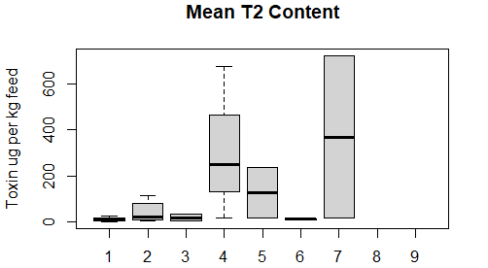
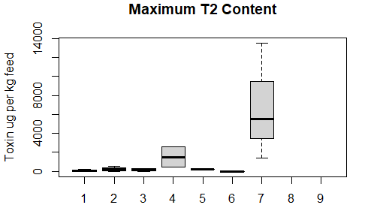
Figure S5. Mean (upper graph) and maximum (lower graph) content of T-2 toxin in feed ingredients (excluding outliers) according to the literature (listed in Annex III). 1 = wheat. 2 = corn, 3 = barley, 4 = soya, 5 = sunflower, 6 = canola, 7 = beans, 8 = DDGS, 9 = meat.

Table S6 Literature data for T-2 toxin in feed ingredients (μg/kg), average values for all reported studies and the percentage of positive tested samples are shaded in light blue.
T-2 in wheat
22.9 | 124 |  | 41.2 %
mean | max | min | N (pos/all) | References
 | 600 | 5 | 38.0% | Lepschy-von Gleissenthal et al. 1989
82 | 249 |  | 26.0 % | Müller and Schwadorf 1993b
55 |  |  | 1/140 | Vrabcheva et al. 1996
 | 63 |  | 6/25 | Curtui et al. 1998
 |  | 20 | 1/169 | Langseth and Rundberget 1999
193.8 | 370 | 80 | 25/367 | Rafai et al. 2000
 |  | 4 | 1/19 | Schollenberger et al. 2002
 | 153 |  | 11/38 | Rasmussen et al. 2003
187 | 829 |  | 18/18 | Binder et al. 2007
 | 8.2 | 5.7 | 16/41 | Hajšlova et al. 2007
 | 1.9 |  | 110/130 | Gottschalk et al. 2009
26 |  |  | 1/? | Monbaliu et al. 2010
0.9 | 1 | 0.8 | 2/2 | Galbenu-Morvay et al. 2011
 | 18.8  23 |  | 33/48  34/34 | Mankevičienė et al. 2011
 | 4 |  | 3/19 | Perkowski et al. 2012
 | 26.9 | 9.8 | 4/15 | Škrbić et al. 2012
12.5 | 17.8 | 7.17 | 2/57 | Juan et al. 2013
 | 18 |  | 13/51 | Pleadin et al. 2013
9  12  11  2 | 51 | 2 | 1/12  7/12  1/7  1/4 | Alkadri et al. 2014
15  19  15  14  13  5.3  15  15  15  15  14  13  15  15  3.1  8.5  15  19 |  |  | 1/42  3/38  1/59  83/83  59/59  18/18  74/74  1/88  1/60  1/93  22/22  6/6  1/30  27/27  1/137  12/113  14/120  1/90 | EFSA CONTAM Panel 2014
4  4 |  |  | 1/3  2/4 | Nacher-Mestre et al. 2015
4  2  3 | 5  6  22 | 3  1  1 | 7/9  18/18  16/18 | Bryła et al. 2016

T-2 in corn
28 | 265 |  | 52.3 %
mean | max | min | N (pos/all) | References
225.2 | 980 | 50 | 220/780 | Rafai et al. 2000
188 | 188 |  | 1/18 | Binder et al. 2007
4  10 | 30  340 |  | 6/44  4/49 | Goertze et al. 2010
13.5  112  10 | 18 |  | 4/?  1/?  1/? | Monbaliu et al. 2010
45.7  36.5  191 | 289  174  11 |  | 10/10  22/25  44/68 | Grajewski et al. 2012
15 |  |  | 16/? | EFSA CONTAM Panel 2014
2.8 |  |  | 1/3 | Nacher-Mestre et al. 2015
45  7.81  10.3  29.3 | 434  63.7  100  550 |  | 34/43  30/88  67/91  71/73 | Kosicki et al. 2016

T-2 in barley
91.8 | 178 |  | 36.6 %
mean | max | min | N (pos/all) | References
220 | 310 | 50 | 16/222 | Rafai et al. 2000
921 | 921 |  | 1/5 | Binder et al. 2007
34.9 | 332 |  | 12/123 | Ibáñez-Vea et al. 2012 b
15 |  |  | 785/785 | EFSA CONTAM Panel 2014
5  6  12  9  5 | 5  24  130  52  22 |  | ?/12  ?/30  ?/21  ?/35  ?/45 | Nielsen et al. 2014
24 | 30.5 | 14.85 | 8/22 | Bolechova et al. 2015
5  3 | 11  5 | 2  1 | 8/8  7/16 | Bryła et al. 2016
15.4  9.7 | 319  155 |  | 11/180  10/160 | Schönenberger et al. 2016

T-2 in soybean products
93.0 | 450 |  | 100 %
mean | max | min | N (pos/all) | References
249.1 | 450 | 50 | 22/119 | Rafai et al. 2000
15 |  |  | 7/? | EFSA CONTAM Panel 2014
T-2 in beans
15 | 9500 |  | 100 %
mean | max | min | N (pos/all) | References
 | 13500  5500 |  | ?  ? | Tseng et al. 1995
15 |  |  | 2/? | EFSA CONTAM Panel 2014
T-2 in rapeseed products
11.4 | 11.5 |  | 93.3 %
mean | max | min | N (pos/all) | References
11.8  9.7  9.2 | 10.1  11.6  10.1  10.2 | 8.5 | 2/3  9/9  19/19  8/8  8/8 | Mankeveciene et al. 2012
15 |  |  | 6/? | EFSA CONTAM Panel 2014
T-2 in sunflower products
126 | 250 |  | 13.6 %
mean | max | min | N (pos/all) | References
236.7 | 250 | 230 | 3/22 | Rafai et al. 2000
15 |  |  | 7/? | EFSA CONTAM Panel 2014
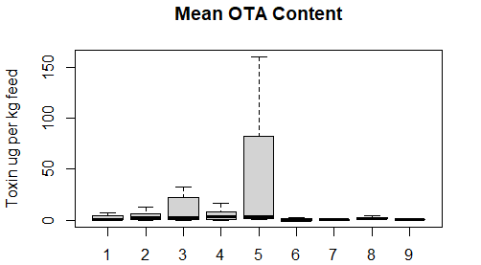
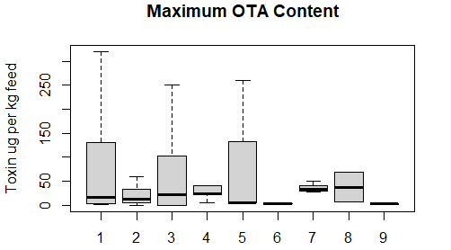
Figure S6. Mean (upper graph) and maximum (lower graph) content of ochratoxin (OTA) in feed ingredients (excluding outliers) according to the literature (listed in Annex III). 1 = wheat. 2 = corn, 3 = barley, 4 = soya, 5 = sunflower, 6 = canola, 7 = beans, 8 = DDGS, 9 = meat.

Table S7 Literature data for ochratoxin A (OTA) in feed ingredients (μg/kg), average values for all reported studies and the percentage of positive tested samples are shaded in light blue.
OTA in wheat
18.8 | 125 |  | 30.8 %
mean | max | min | n | References
 | 17 |  | 10/50 | Scudamore et al. 1997
 | 231 | 0.3 | 32/201 | Prickett et al. 2000
207.8  120 | 320  320 | 90 | 9/367  1/32 | Rafai et al. 2000
0.83 | 1.2 | 0.48 | 3/31 | Czerwiecki et al. 2002a
267  1.17 | 1024  1.6 | 0.6  0.8 | 18/37  8/34 | Czerwiecki et al. 2002b
0.3  0.5  0.3  0.3 | 16  19  32  1.6 |  | 108/156  101/120  217/405  6/14 | Jørgensen and Jacobsen 2002
0.19  0.25 |  |  | 2/34  2/8 | Miraglia and Brera 2002
1.4 | 1.47 |  | 6/70 | Palermo et al. 2002
4.6 | 12.1 |  | 10/14 | Beg et al. 2006
4 | 7 |  | 5/12 | Binder et al. 2007
 | 3 | 2.3 | ? | Mage et al. 2007
12.7 | 31.7 |  | 3/12 | Klaric´ et al. 2009
4.79 |  |  | 1/1 | Kokic et al. 2009
0.3 |  | 3 | 1/4 | Griessler et al. 2010
1  5.7 | 331 |  | 26/124  4/20 | Rodrigues and Nährer 2012
0.2  0.7  0.4  0.3  0.4  0.2  0.5  0.3 |  |  | 5/165  8/18  5/33  6/45  2/42  16/38  3/59  28/? | EFSA CONTAM Panel 2014
2.1 |  |  | 1/2 | Mortensen and Granby 2014
3.9 | 5.8 |  | 2/80 | Kirincic et al. 2015
0.4 | 5.2 | 2 | 1/3  4/4 | Nacher-Mestre et al. 2015
7  4 |  | 7  4 | 1/9  1/18 | Bryła et al. 2016

OTA in corn
19.6 | 122 |  | 35.0 %
mean | max | min | n | References
 | 35  25 | 25  10 | ?  ? | Petkova-Bocharova and Castegnaro 1985
320 | 1850 | 60 | 70/760 | Rafai et al 2000
1.7 | 5.2 |  | 19/70 | Palermo et al. 2002
1.95  3.95 | 3.2  12.2 |  | 2/13  9/27 | Jaimez et al. 2004
1.47 | 2.54 |  | 19/49 | Domijan et al. 2005
6.38 | 14.5 |  | 31/32 | Beg et al. 2006
0 |  |  | 0/11 | Binder et al. 2007
 | 6 | 5.8 | 3/? | Mage et al. 2007
12.7 | 31.7 | 2.5 | 3/12 | Klarić et al. 2009
1 |  |  | 2/7 | Griessler et al. 2010
22 |  |  | 1/? | Monbaliu et al. 2010
0.25  0.21  0.51  4.33 | 0.78  0.23  1.15  13.6 |  | 28/37  7/19  5/30  5/39 | Grajewski et al. 2012
1  3  6 | 11  355  59.7 |  | 1/12  61/557  20/30 | Rodrigues and Nährer 2012
1.3 |  |  | 16/? | EFSA CONTAM Panel 2014
0.4 |  |  | 3/3 | Nacher-Mestre et al. 2015
20.1  32.2  2.39  5.78 | 32.5  86  5.09  11.9 |  | 2/30  3/19  3/32  4/32 | Kosicki et al. 2016

OTA in barley
13.7 | 58.1 |  | 16.9 %
mean | max | min | n | References
 | 102 |  | 12/45 | Scudamore et al. 1997
 | 117 | 0.3 | 20/106 | Prickett et al. 2000
76.7 | 250 | 50 | 6/222 | Rafai et al. 2000
25.73 | 57 | 0.3  6.7 | 1/26  3/40 | Czerwiecki et al. 2002a
5.45  18.4 | 9.7  35.3 | 1.2  1.43 | 2/36  2/17 | Czerwiecki et al. 2002b
33 |  |  | 1/31 | Binder et al. 2007
2.6 |  |  | 1/6 | Klarić et al. 2009
0.1 | 3.53 |  | 71/123 | Ibáñez-Vea et al. 2012 a
1 | 9.6 |  | 1/15 | Rodrigues and Nährer 2012
1.01 |  |  | 27/82 | EFSA CONTAM Panel 2014

OTA in soybean products
42.9 | 77.1 |  | 35.3 %
mean | max | min | n | References
350 | 350 | 50 | 2/119 | Rafai et al. 2000
1 |  |  | 5/51 | Valenta et al. 2002
7.9 | 40 |  | 18/21 | Beg et al. 2006
0.02 |  |  | 2/? | Mage et al. 2007
3.97 | 5.12 |  | 6/7 | Kokic et al. 2009
5  1 | 21.4  23 |  | 1/4  24/122 | Rodrigues and Nährer 2012
0.06 |  |  | 21/? | EFSA CONTAM Panel 2014
16.8 | 23.1 | 10.5 | 2/23 | Fapohunda et al. 2018 ^{b}
^{b} = these data have been obtained from outside of Europe.

OTA in fishmeal
2.31 | 3.48 |  | 20.0 %
mean | max | min | n | References
 | 0.13 | 0.06 | 4/? | Mage et al. 2007
6.83 | 6.83 |  | 1/5 | Kokic et al. 2009
0.05 |  |  | 49/? | EFSA CONTAM Panel 2014
OTA in beans
20.3 | 36.7 |  | 36.7 %
mean | max | min | n | References
 | 27  50 | 25  25 | 16.7%  7.1% | Petkova-Bocharova and Castegnaro 1985
 | 33 |  | 1/15 | Scudamore et al. 1997
0.41 |  |  | 17/45 | Domijan et al. 2005
0.03 |  |  | 2/? | EFSA CONTAM Panel 2014
1.8 |  |  | 1/3 | Nacher-Mestre et al. 2015
OTA in rapeseed products
0.77 | 2.6 |  | 100 %
mean | max | min | n | References
0.02 |  |  | 1/? | Mage et al. 2007
0.04 |  |  | 6/? | EFSA CONTAM Panel 2014
2.6 | 2.6 |  | 1/1 | Mortensen and Granby 2014
0.4 |  |  | 1/1 | Nacher-Mestre et al. 2015
OTA in sunflower products
33.9 | 89.9 |  | 63.2 %
mean | max | min | N | References
160 | 260 | 100 | 4/22 | Rafai et al 2000
 | 5.8 | 2.4 | 5/? | Mage et al. 2007
2.73 | 3.82 |  | 5/7 | Kokic et al. 2009
3.9 |  |  | 7/? | EFSA CONTAM Panel 2014
0.4 |  |  | 1/1 | Nacher-Mestre et al. 2015
OTA in yeast
2.26 | 2.26 |  | 100 %
mean | Max | min | n | References
2.26 | 2.26 |  | 1/1 | Kokic et al. 2009
OTA in DDGS
2.57 | 37.7 |  | 45.0 %
mean | max | min | n | References
2 | 68 |  | 25/173 | Rodrigues-Chin 2011
4 |  |  | 433/1238 | Schatzmayr and Streit 2013
1.7 | 7.3 | 0.5 | 6/7 | Mortensen and Granby 2014
OTA in chicken meat
0.81 | 2.49 |  | 45.0 %
mean | max | min | n | References
0.28 | 3.67 |  | 16/39 | Rodrigues-Chin 2011
0.81 | 1.3 |  | 22/45 | Mortensen and Granby 2014

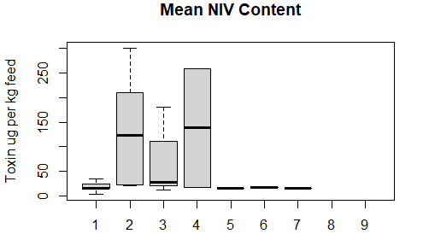
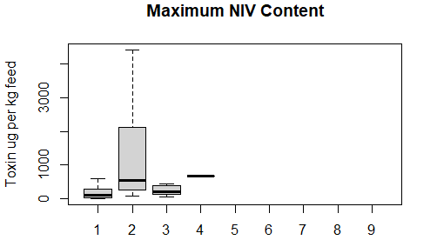
Figure S7. Mean (upper graph) and maximum (lower graph) content of nivalenol (NIV) in feed ingredients (excluding outliers) according to the literature (listed in Annex III). 1 = wheat. 2 = corn, 3 = barley, 4 = soya, 5 = sunflower, 6 = canola, 7 = beans, 8 = DDGS, 9 = meat.

Table S8 Literature data for nivalenol (NIV) in feed ingredients (μg/kg), average values for all reported studies and the percentage of positive tested samples are shaded in light blue.
NIV in wheat
28.9 | 177 |  | 33.1 %
mean | max | min | n | References
 |  |  | 30% | Lepschy-von Gleissenthal et al. 1989
 | 32 | 9 | 26% | Müller and Schwadorf 1993b
177.3 | 590 | 50 | 33/367 | Rafai et al. 2000
 | 25 | 25  25 | 1/28  1/13  5/19 | Schollenberger et al. 2002
 | 234 | 10 | 57/120 | Rasmussen et al. 2003
 | 440 |  | ? | SCOOP 2003
 | 25.9 | 15.4 | 32/41 | Hajšlova et al. 2007
 | 80 |  | 14/32 | Perkowski et al. 2007
 | 430 |  | 1088/1624 | Edwards 2009
 |  | 7 | 1/42 | Macri et al. 2009
 | 13 |  | 3/57 | Scudamore et al. 2009
256.7 | 293 | 236 | 3/? | Giraud et al. 2010
86 |  |  | 1/? | Monbaliu et al. 2010
 | 23  18 |  | 8/15  16/19 | Perkowski et al. 2012
 | 26.9 | 9.8 | 5/14 | Škrbić et al. 2012
 | 495  200 | 60  86 | 21/28  45/75 | Stankovic et al. 2012
 | 106  106 | 12  12 | 16/57  11/57 | Juan et al. 2013
 | 111  39  39  50 |  | 29/31  11/33  14/28  9/33 | Lindblad et al. 2013
 | 53.6 |  | 16/119 | Rodríguez-Carrasco et al. 2013
183 | 290 | 67 | 3/12 | Alkadri et al. 2014
27  35  25  25  26  25  10  21  11  12  11  5.3  15  15  15  15  15  13  15  16  3.9  15  16  19 | 290 | 40 | 1/165  27/107  1/128  1/131  4/142  1/39  1/42  7/38  8/59  83/83  59/59  18/18  74/74  1/88  1/60  1/93  22/22  6/6  1/30  28/28  11/137  2/113  10/111  1/72 | EFSA CONTAM Panel 2014
 | 12 |  | 2/29 | Nordkvist and Häggblom 2014
15  16 | 470  290 |  | 100/527  40/159 | Vogelsang et al. 2017

NIV in corn
1551 | 29540 |  | 53.2 %
mean | max | min | n | References
186.7 | 260 | 130 | 3/780 | Rafai et al. 2000
 | 340 |  | ? | SCOOP 2003
2547  94 |  |  | 1/?  1/? | Monbaliu et al. 2010
 | 1300 | 80 | 7/19 | Dorn et al. 2011
160  210 | 4410  2120 |  | 10/44  19/40 | Goertze et al. 2010
37.3 | 76.8 | < 15 | 2/2  30/68 | Grajewski et al. 2012
21 |  |  | 16/? | EFSA CONTAM Panel 2014
153 | 580 |  | 8/? | Zachariasova et al. 2014
300  17970 | 5720  368200 |  | 78  90 | Gromadzka et al. 2016 ª
20.7  22.1  23.2  39 | 89.2  251  122  550 |  | 34/43  45/88  80/91  73/73 | Kosicki et al. 2016
ª = reported only means of all samples

NIV in barley
57.5 | 296 |  | 34.8 %
mean | max | min | n | References
130 |  |  | 1/2 | Hysek et al. 1999
136.4 | 340 | 60 | 14/222 | Rafai et al 2000
20.8 | 142.5 |  | 25/123 | Ibáñez-Vea et al. 2012 b
 | 106 | 21.7 | 3/9 | Juan et al. 2013
16 |  |  | 805/805 | EFSA CONTAM Panel 2014
24  22  34  26  180 | 47  206  122  209  1089 |  | ?/12  ?/30  ?/21  ?/35  ?/45 | Nielsen et al. 2014
93.4 | 123.3 | 52 | 8/22 | Bolechova et al. 2015
12.5  31 | 435  431 |  | 73/280  10/160 | Schönenberger et al. 2016

NIV in soybean products
138 | 680 |  | 100 %
mean | max | min | n | References
258.7 | 680 | 50 | 22/119 | Rafai et al. 2000
18 |  |  | 7/? | EFSA CONTAM Panel 2014
NIV in beans
15 | ? |  | 100 %
mean | max | min | N | Reference
15 |  |  | 2/? | EFSA CONTAM Panel 2014
NIV in rapeseed prducts
18 | ? |  | 100 %
mean | max | min | N | Reference
18 |  |  | 6/? | EFSA CONTAM Panel 2014
NIV in sunflower products
15 | ? |  | 100 %
mean | max | min | n | Reference
15 |  |  | 7/? | EFSA CONTAM Panel 2014

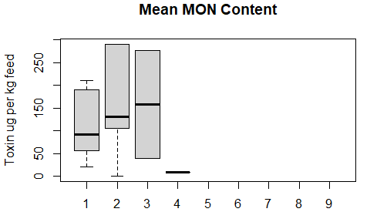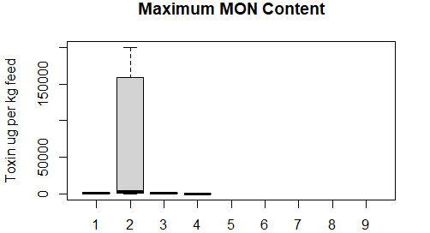
Figure S8. Mean (upper graph) and maximum (lower graph) content of moniliformin (MON) in feed ingredients (excluding outliers) according to the literature (listed in Annex III). 1 = wheat. 2 = corn, 3 = barley, 4 = soya, 5 = sunflower, 6 = canola, 7 = beans, 8 = DDGS, 9 = meat.

Table S9 Literature data for moniliformin (MON) in feed ingredients (μg/kg), average values for all reported studies and the percentage of positive tested samples are shaded in light blue.
MON in wheat
657 | 2985 |  | 86.4 %
mean | max | min | n | References
8670 | 17100 | 500 | 6/6 | Sharman et al. 1991
 | 880 |  | ? | Adler et al. 1995
 | 200 |  | 10/? | Krysinska-Traczyk et al. 2001
171.9 | 810 | 30 | 10/14 | Jestoi et al. 2004a
 | 950 | 130 | 83/? | Uhlig et al. 2004
 | 950 |  | ? | Sørensen et al. 2007
98  71  52  211  59  47 |  |  | 25/?  30/?  27/?  25/?  30/?  27/? | Bernhoft et al. 2008
 | 6.5 | 7  3.1 | 1/3  2/2 | vanBargen et al. 2012
20  92  210 |  |  | 13/13  35/35  35/35 | EFSA CONTAM Panel 2014

MON in corn
9318 | 111412 |  | 65.7 %
mean | max | min | n | References
 |  |  | 23/58 | Thalmann et al. 1985
130 | 200 | 60 | 2/12 | Scott and Lawrence 1987
0.73  97715 | 399300 | 4200 | 1/10  20/20 | Sharman et al.1991
 | 425000 | 17000 | ? | Logrieco et al 1993
 | 8530 | 450 | 6/12 | Kostecki et al. 1995
 | 200000 |  | 8/14 | Logrieco et al 1995
 | 2000 | 50 | ? | Filek and Lindner, 1996
 | 530000  20000 | 4200 | 87/87  21/25 | Lew et al. 1991,1996
 | 530000  530000 | 66000  30000 | ?  ? | Chelkowski et al. 1998
 | 1340 |  | ? | Noser et al. 2001
 | 4600 |  | 60% | Scudamore et al. 1998
280  110 | 3330  1850 |  | 19/44  18/40 | Goertze et al. 2010
 | 1030 | 160 | ? | Parich et al. 2003
1127  106  262  89 | 2606  527  920  409 |  | 16/16  13/16  39/40  33/36 | Scarpinio et al. 2012
126 | 126 | 18  31.1 | 1/3  1/2  1/1 | vanBargen et al. 2012
290  5290 | 3100  118500 |  | 78/?  90/? | Gromadzka et al. 2016 ª
ª = reported only means of all samples

MON in barley
149 | 350 |  | 88.6 %
mean | max | min | n | References
276.8 | 290 | 25 | 17/22 | Jestoi et al. 2004
 | 380 | 130 | ?/83 | Uhlig et al. 2004
 | 380 |  | ? | Sørensen et al. 2007
40 |  |  | 75/75 | EFSA CONTAM Panel 2014

MON in soybean products
9 | 33 |  | 30.4 %
mean | max | min | n | References
9.4 | 33.34 | 0.12 | 7/23 | Fapohunda et al. 2018 ^{b}
^{b} = these data have been obtained from outside of Europe.

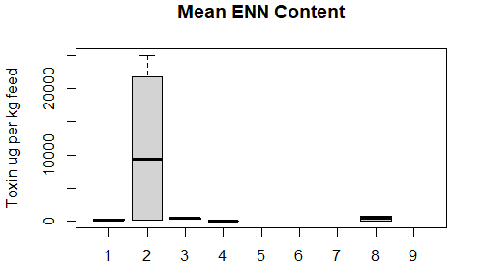
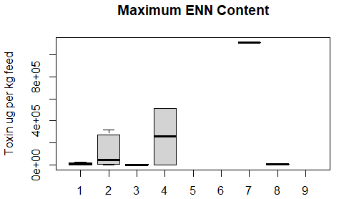
Figure S9. Mean (upper graph) and maximum (lower graph) content of enniatins (ENN) in feed ingredients (excluding outliers) according to the literature (listed in Annex III). 1 = wheat. 2 = corn, 3 = barley, 4 = soya, 5 = sunflower, 6 = canola, 7 = beans, 8 = DDGS, 9 = meat.

Table S10 Literature data for enniatins (ENN) in feed ingredients (μg/kg), average values for all reported studies and the percentage of positive tested samples are shaded in light blue.
ENN in wheat
174 | 67514 |  | 85.2
mean | max | min | n | References
 | 136000 | 6 | 12/14 | Logrieco et al. 2002
 | 24830 | 5.4 | 14/19 | Jestoi et al. 2004
 | 7620 | 12 | 80/80 | Uhlig et al. 2006
 | 2397 | 16.18 | 9/9 | Jestoi et al. 2008
 | 634850 | 140 | 13/21 | Meca et al. 2010
 | 325.1 | 30.37 | 18/57 | Juan et al. 2013
79.4 | 215.5 | 12.2 | 18/43 | Alkadri et al. 2014
126  730  297 |  |  | 12/12  34/34  34/34 | EFSA CONTAM Panel 2014
4  27  133  284  727 | 10  184  241  2400  1097 | 2  5  57  30  179 | 18/18  30/36  18/18  18/18  9/9 | Bryła et al. 2016

ENN in corn
4033 | 202571 |  | 81.2
mean | max | min | n | References
 | 46000 |  | 15/27 | Chelkowski et al. 2007
 | 3307 | 44 | 70/73 | Sørensen et al. 2008
70  160 | 1210  2960 |  | 18/44  12/40 | Goertze et al. 2010
 | 823651 | 450 | 25/28 | Meca et al. 2010
25040  18580 | 225170  315700 |  | ?/78  ?/90 | Gromadzka et al. 2016 ª
 |  | 2  4  4  3  1 | 2/2  1/1  1/1  1/1  3/3 | Dzuman et al. 2017 Supplementary Data
ª = reported only means of all samples

ENN in barley
233 | 40496 |  | 93.9 %
Mean | max | min | n | References
 | 18430 | 5.4 | 22/22 | Jestoi et al. 2004
 | 5800 | 12 | 80/80 | Uhlig et al. 2006
 | 735.8 | 16.18 | 29/29 | Jestoi et al. 2008
 | 335850 | 450 | 2/4 | Meca et al. 2010
 | 67.3 | 12.1 | 8/9 | Juan et al. 2013
363 |  |  | 75/75 | EFSA CONTAM Panel 2014
696.7  231.42 | 2078.86  601.42 | 33.26  31.32 | 22/22  6/6 | Bolechova et al. 2015
202  339 | 350  549 | 58  191 | 16/16  8/8 | Bryła et al. 2016

ENN in soybean products
0.01 | 257000 |  | 54.3 %
Mean | max | min | n | References
 | 514000 |  | 1/1 | Wang et al. 2013
0.00525 | 0.0055 | 0.005 | 2/23 | Fapohunda et al. 2018 ^{b}
^{b} = these data have been obtained from outside of Europe.

ENN in beans
? | 1113000 |  | 100 %
Mean | max | min | n | References
 | 1113000 |  | 1/1 | Wang et al. 2013
^{b} = these data have been obtained from outside of Europe.

ENN in DDGS
366 | 1830 |  | 92.9 %
mean | max | min | n | References
730 | 1830 | <10 | 6/7 | Mortensen and Granby 2014
2 |  |  | 1/1 | Dzuman et al. 2017 Supplementary Data

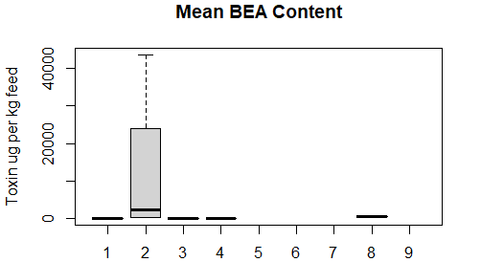
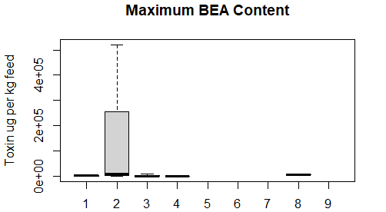
Figure S10. Mean (upper graph) and maximum (lower graph) content of beauvericin (BEA) in feed ingredients (excluding outliers) according to the literature (listed in Annex III). 1 = wheat. 2 = corn, 3 = barley, 4 = soya, 5 = sunflower, 6 = canola, 7 = beans, 8 = DDGS, 9 = meat.

Table S10 Literature data for beauvericin (BEA) in feed ingredients (μg/kg), average values for all reported studies and the percentage of positive tested samples are shaded in light blue.
BEA in wheat
22.7 | 1791 |  | 68.6 %
mean | max | min | n | References
 | 3500 |  | ? | Kostecki et al. 1997
 | 3703  3500 | 20 | ?  14/14 | Logrieco et al. 2002
10 |  |  | 13/14 | Jestoi et al. 2004
 | 0.8 | 0.3 | 10/80 | Uhlig et al. 2006
 |  | 10 | 8/9 | Jestoi et al. 2008
 | 3500 | 170 | 9/21 | Meca et al. 2010
 | 35 | 9.6 | 5/57 | Juan et al. 2013
2.7 | 5.1 | 1.8 | 6/43 | Alkadri et al 2014
1.5  1.5  1.5 |  |  | 12/12  34/34  34/34 | EFSA CONTAM Panel 2014

BEA in corn
3611 | 2299903 |  | 52.3 %
mean | max | min | n | References
 | 60000 | <1000 | 13/14 | Logrieco et al. 1993
 | 10000 | <3000 | 4/6 | Bottalico et al. 1995
 | 36890 | 1800 | 12/12 | Kostecki 1995
 | 520000 | 100 | 6/22 | Ritieni et al. 1997
 | 450 | 50 | 3/99 | Noser et al. 2001
 | 1864000 | 10 | 19/209 | Jurjevic et al. 2002
 | 3000 |  | 1/22 | Srobarova et al. 2002
 | 988  496 | 7  7 | 45/73  5/7 | Sørensen et al. 2008
390  240 | 6402  5100 |  | 23/44  9/40 | Goertze et al. 2010
 | 9310 | 172 | 6/28 | Meca et al. 2010
4330  43670 | 256500  445500 |  | ?/78  ?/90 | Gromadzka et al. 2016
 |  | 1  1 | 2/2  2/2 | Dzuman et al. 2017 Supplementary Data

BEA in barley
31.4 | 1747 |  | 67.6 %
mean | max | min | n | References
 | 19 | 10 | 22/22 | Jestoi et al. 2004
 | 21 | 3 | 14/75 | Uhlig et al. 2006
 |  | 10 | 27/29 | Jestoi et al. 2008
 | 6940 | 170 | 2/4 | Meca et al. 2010
 |  | 7.3 | 1/9 | Juan et al. 2013
1.5 |  |  | 75/75 | EFSA CONTAM Panel 2014
18.2 | 47.91 | 5.13 | 22/22 | Bolechova et al. 2015

BEA in soybean products
3.69 | 23.04 |  | 56.5 %
mean | max | min | n | References
3.69 | 23.04 | 0.018 | 13/23 | Fapohunda et al. 2018 ^{b}
^{b} = these data have been obtained from outside of Europe.

BEA in DDGS
176 | 4220 |  | 99.2 %
mean | max | min | n | References
350 | 4220 | 40 | 58/59 | Tansakul et al. 2013
 |  | 2 | 1/1 | Dzuman et al. 2017 Supplementary Data

