Supplementary Materials
Combining community wastewater genomic surveillance with state clinical surveillance: a framework for SARS-CoV-2 public health practice
Ted Smithª, Rochelle H. Holm^{a*}, Ray Yeager ^{a,b}, Joseph B. Moore IV ^{a,c}, Eric C. Rouchka^{d}, Kevin J. Sokoloski^{e,f}, Erin M. Elliott^{a,c}, Daymond Talley^{g}, Vaneet Arora^{h,i}, Sarah Moyer^{j,k}, Aruni Bhatnagarª

ªChristina Lee Brown Envirome Institute, School of Medicine, University of Louisville, 302 E. Muhammad Ali Blvd., Louisville, KY 40202, United States
^{b}Department of Environmental and Occupational Health Sciences, School of Public Health and Information Sciences, University of Louisville, 485 E. Gray St., Louisville, KY 40202, United States
^{c}Diabetes and Obesity Center, School of Medicine, University of Louisville, 580 S. Preston St., Louisville, KY 40202, United States
^{d}Department of Biochemistry and Molecular Genetics, School of Medicine, University of Louisville, 319 Abraham Flexner Way, Louisville, KY 40202, United States
^{e}Department of Microbiology and Immunology, School of Medicine, University of Louisville, 505 S. Hancock St., Louisville, KY 40202, United States
^{f}Center for Predictive Medicine for Biodefense and Emerging Infectious Diseases, University of Louisville, 505 S. Hancock St., Louisville, KY 40202, United States
^{g}Louisville/Jefferson County Metropolitan Sewer District, Morris Forman Water Quality Treatment Center, 4522 Algonquin Parkway, Louisville, KY 40211, United States
^{h}Kentucky Department for Public Health, Division of Laboratory Services, 100 Sower Blvd., Suite 204, Frankfort, KY 40601, United States
^{i}Department of Pathology and Laboratory Medicine, University of Kentucky, 800 Rose St., Lexington, KY 40536, United States
^{j}Department of Health Management and System Sciences, School of Public Health and Information Sciences, University of Louisville, 485 E. Gray St., Louisville, KY 40202, United States
^{k}Department of Public Health and Wellness, Louisville-Jefferson County Metro Government, 400 E. Gray St., Louisville, KY 40202, United States

*Corresponding author: Rochelle H. Holm (rochelle.holm@louisville.edu)

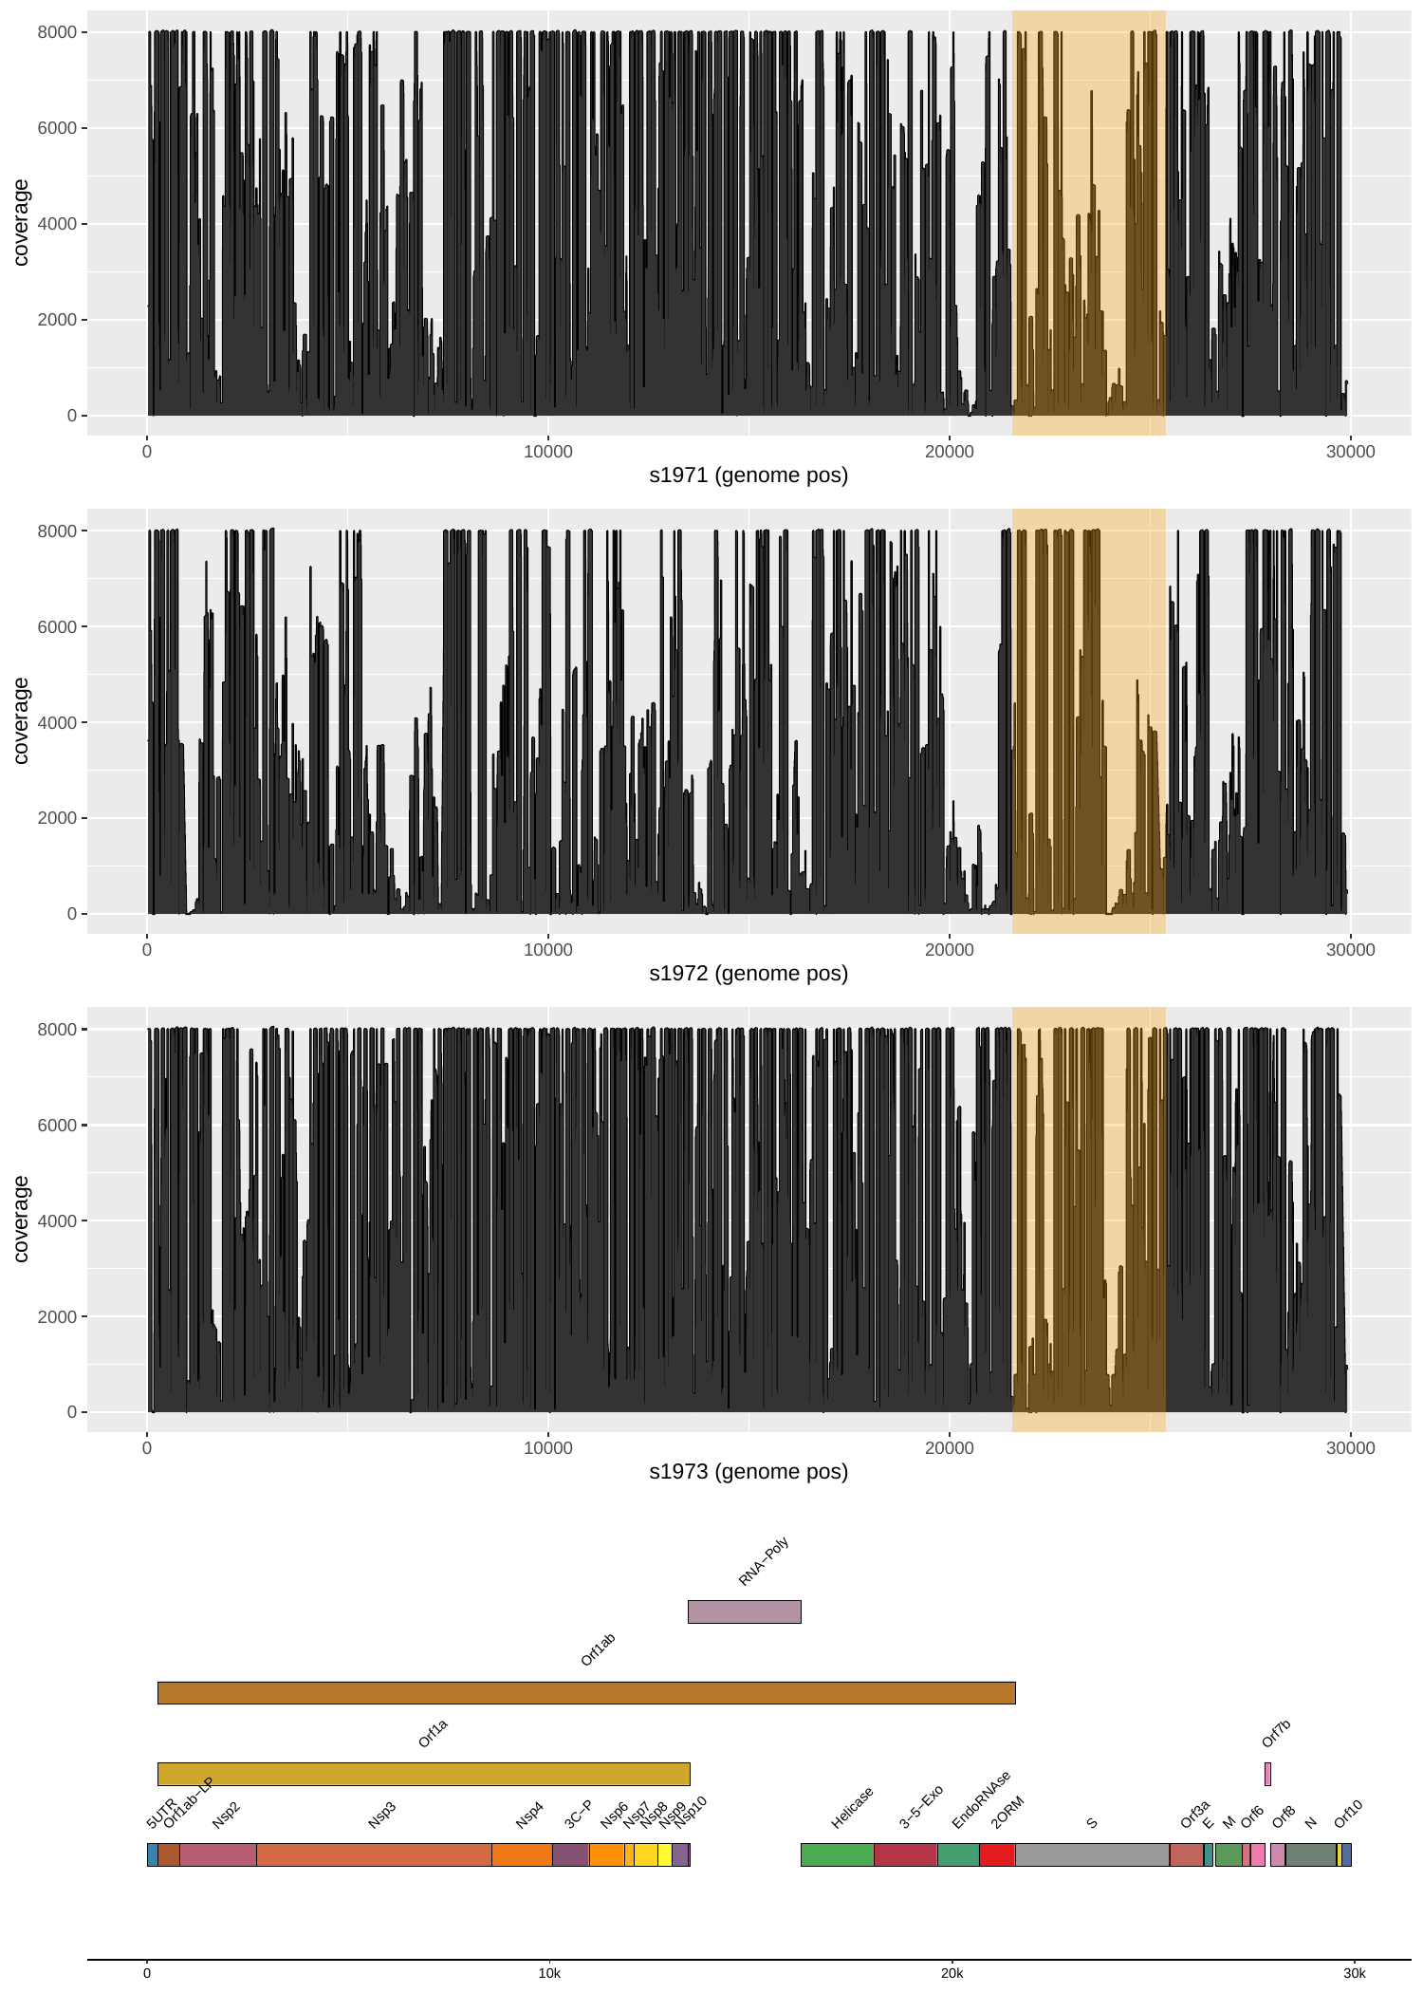
Fig S1 Typical depth coverage (y-axis) across the complete genome (x-axis) at various sampling locations
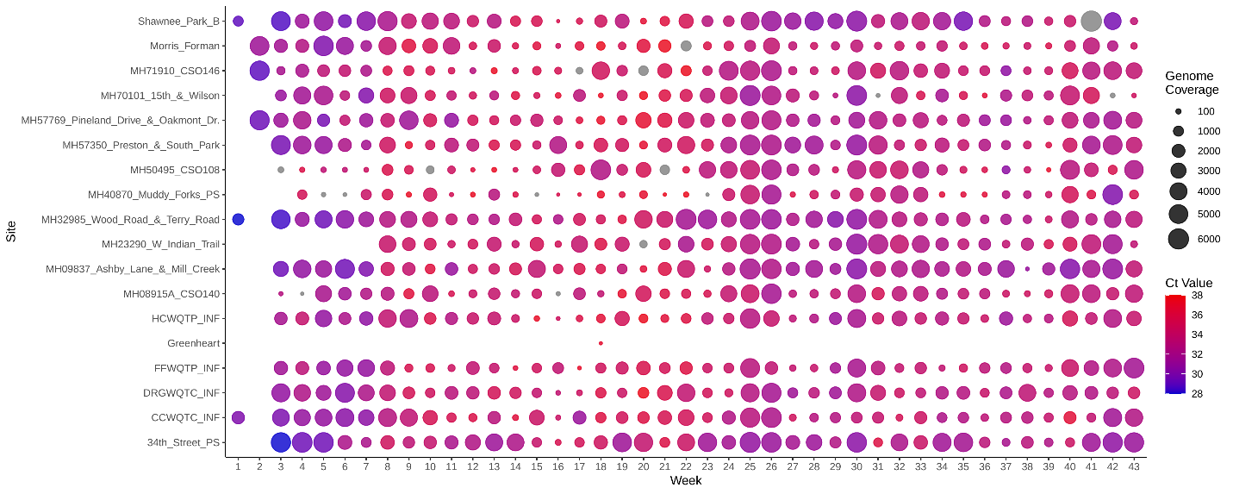
Fig S2 Relationship between genome coverage (area) vs. Ct value (color) for sampled sites

Fig S3 Clinical sequencing yielded a B.1.526 sample from an individual in the area within 40219 zip code (left) from a sample analyzed on September 7, 2021, in Louisville/Jefferson County, Kentucky (USA). Results indicated the presence of B.1.526 in a nearby wastewater collection site two weeks prior, on August 16, 2021 (right).

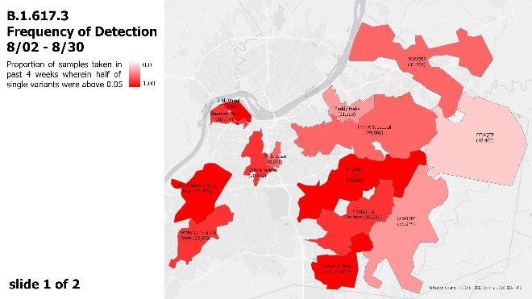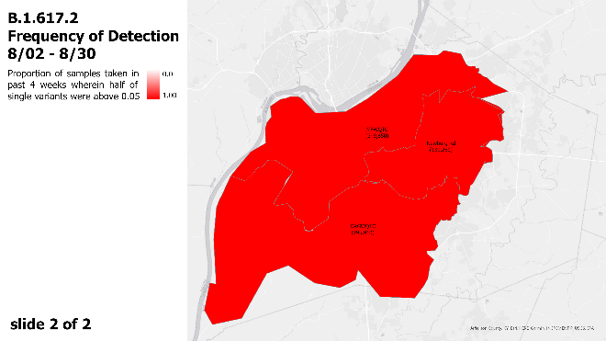
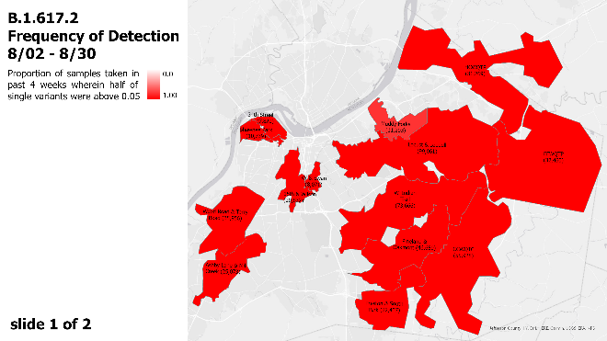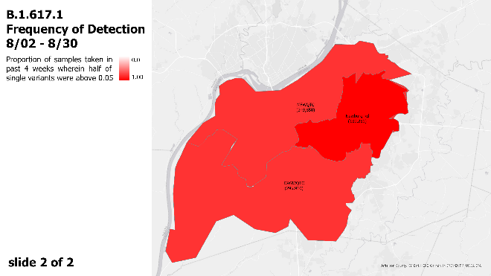
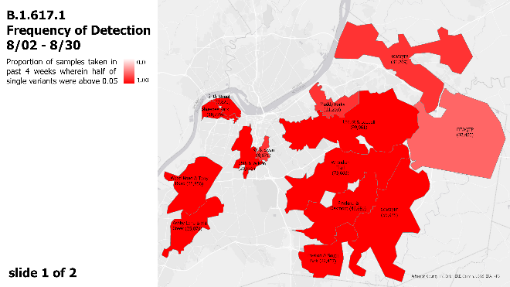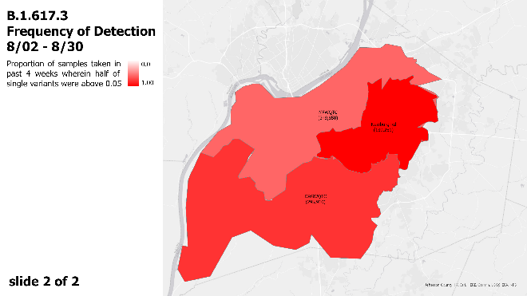
Fig S4 Example report from August 2021 of genomic surveillance of SARS-CoV-2 in wastewater data in Louisville/Jefferson County, Kentucky (USA), as presented weekly by academic partners to Louisville Metro Public Health and Wellness.

