Unveiling novel lytic bacteriophages as natural biocontrol agents against multidrug-resistant Escherichia coli: Isolation, characterization, and in vitro application

Semra Tasdurmazli¹, Berna Erdogdu^{1,2}, Hamza Saghrouchni³, Isil Var⁴, Luís D. R. Melo^{5,6,7}, Tulin Ozbek¹*

¹Yıldız Technical University, Faculty of Science and Arts, Department of Molecular Biology and Genetics, Istanbul, Turkey

²Department of Molecular Biology and Genetics, Faculty of Arts and Science, Istanbul Aydin University

³Cukurova University, Institute of Natural and Applied Sciences, Department of Biotechnology, Adana, Turkey

⁴Cukurova University, Engineering Faculty, Department of Food Engineering, Adana, Turkey

⁵Center of Biological Engineering, University of Minho, 4710-057 Braga, Portugal

⁶LABBELS –Associate Laboratory, Braga, Guimarães, Portugal

⁷Faculty of Pharmacy, University of Coimbra, 3000-548 Coimbra, Portugal

*Corresponding author
E-mail: tulin.ozbek@yildiz.edu.tr/ ozbektulin@gmail.com
ORCID ID: 0000-0001-6858-7045

ABBREVIATIONS:
MRD-Ec, Multidrug-resistant Escherichia coli; Sem1, E. coli phage Sem1; Sem2, E. coli phage Sem2; Sem3, E. coli phage Sem3; Sem4, E. coli phage Sem4; MOI, multiplicity of infection; OSGC, one-step growth curve; MIC, minimum inhibitory concentration

Table S1 Antimicrobial resistance profile of MDR-Ec
Class of Antibiotic | Antibiotics | MIC | Interpretation[1]
Penicillin | Ampicillin
Penicillin | oral | ≥32 | R
Penicillin | other | ≥32 | R
Penicillin | Amoxicillin/ Clavulanate
Penicillin | urine | [32] | R
Penicillin | other | 32 | R
Penicillin | Piperacillin/ Tazobactam | [8] | R
2nd generation Cephalosporin | Cefuroxime | ≥64 | R
2nd generation Cephalosporin | Cefoxitin | ≥64 | R
3rd generation Cephalosporin | Ceftazidime | ≥32 | R
3rd generation Cephalosporin | Ceftriaxone
3rd generation Cephalosporin | meningitis | ≥64 | R
3rd generation Cephalosporin | other | ≥64 | R
4th generation Cephalosporin | Cefepime | 8 | R
Carbapenem | Ertapenem | ≥8 | R
Carbapenem | Imipenem | ≤0.25 | S
Carbapenem | Meropenem
Carbapenem | meningitis | 1 | S
Carbapenem | other | 1 | S
Aminoglycoside | Amikacin | ≤1 | S
Fluoroquinolone | Ciprofloxacin
Fluoroquinolone | meningitis | 0.5 | R
Fluoroquinolone | other | 0.5 | I
Glycylcycline | Tigecycline | ≤0.5 | S
Sulphonamide | Trimethoprim/ Sulfamethoxazole | ≤20 | S

Table S2 Mean values and standard deviations of test water's physical-chemical properties (n = 3)

Parameter | Tested tap water
pH | 7.2 ± 0.3
Conductivity (μS/cm) | 453 ± 8.18
Chloride (mg/mL) | 55.0 ± 4.18
Calcium (mg/mL) | 48.9 ± 5.09
Magnesium (mg/mL) | 6.8 ± 1.4
Sodium (mg/mL) | 25.7 ± 6.5
Total organic carbon (%) | 2.24 ± 0.53
Total pesticides (µg/mL) | <0.5
Total hardness (mg/L CaCO₃) | 150 ± 17.7

Table S3 Mean OD₆₀₀ values (n = 3) of MDR-Ec growth at different MOIs (10, 1, 0.1, 0.01) and uninfected control, measured every 30 minutes at 37 °C

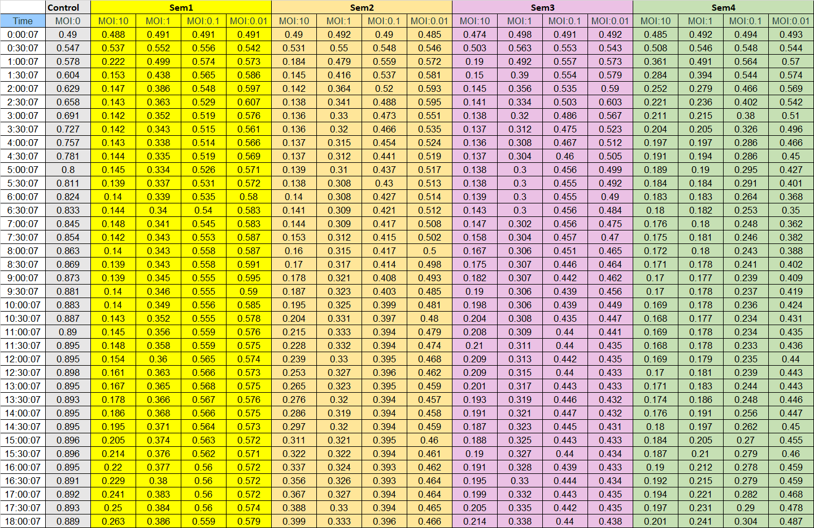
Table S4 Comparison of different annotation programs
 | PHANOTATE |  | PHAROKKA |  | manually curated CDS
Phage ID | Hypothetical | CDSs | Hypothetical | CDSs | Hypothetical | CDSs
Sem1 | 38 | 72 | 46 | 72 | 42 | 66
Sem2 | 43 | 78 | 49 | 78 | 45 | 74
Sem3 | 39 | 71 | 48 | 71 | 45 | 68
Sem4 | 44 | 79 | 49 | 79 | 43 | 73

REFERENCES
[1] European Committee on Antimicrobial Susceptibility Testing (EUCAST). Breakpoint tables for interpretation of MICs and zone diameters, version 15.0. 2025.

