[Fisheries Science]
Dispersion and degradation of environmental DNA from caged fish in a marine environment

Hiroaki Murakami^{1*}, Seokjin Yoon², Akihide Kasai², Toshifumi Minamoto³, Satoshi Yamamoto⁴, Masayuki K. Sakata³, Tomoya Horiuchi¹, Hideki Sawada¹, Michio Kondoh⁵, Yoh Yamashita⁶, Reiji Masuda¹

*Corresponding author: Tel: 81-773-62-9063. Fax: 81-773-62-5513.
E-mail (Hiroaki Murakami): murakami.hiroaki.77m@st.kyoto-u.ac.jp
E-mail (Reiji Masuda): reiji@kais.kyoto-u.ac.jp

¹ Maizuru Fisheries Research Station, Kyoto University, Maizuru, Kyoto 625-0086, Japan
² Faculty of Fisheries Sciences, Hokkaido University, Hakodate, Hokkaido 041-8611, Japan
³ Graduate School of Human Development and Environment, Kobe University, Kobe, Hyogo 657-8501, Japan
⁴ Department of Zoology, Graduate School of Science, Kyoto University, Kyoto, Kyoto 606-8502, Japan
⁵ Graduate School of Life Sciences, Tohoku University, Sendai 980-8578, Japan
⁶ Field Science Education and Research Center, Kyoto University, Kyoto, Kyoto 606-8502, Japan

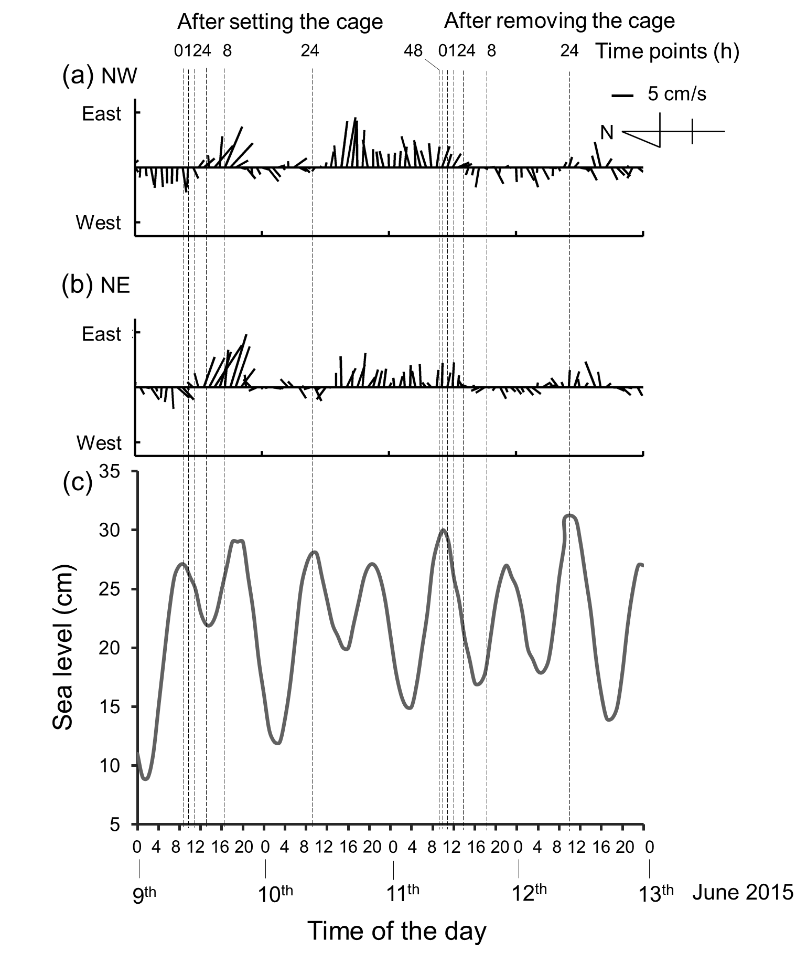

Fig. S1 Observed flow velocities (a and b) and sea level (c) during the experiment. The length and angle of stick represent flow velocity and direction, respectively, recorded at NW (a) and NE (b) in Fig. 1. The eDNA sampling time points are represented by dotted lines.

