Fisheries Science
Online Resource of FISC-D-23-00048

Evolutionary genomics of white spot syndrome virus
ªSatoshi Kawato, ^{b}Risako Omine, ^{c}Shinnosuke Teruya, ^{c}Hirofumi Kubo, ^{d}Shinya Yasumoto, ^{d}Masakazu Kondo, ^{d}Yukinori Takahashi, ªReiko Nozaki, ªHidehiro Kondo, ªIkuo Hirono
ªLaboratory of Genome Science, Tokyo University of Marine Science and Technology, Tokyo, Japan.
^{b}Okinawa Prefectural Fisheries Research and Extension Center, Okinawa, Japan.
^{c}Deep Sea Water Research Center, Okinawa Prefectural Government, Okinawa, Japan.
^{d}Department of Applied Aquabiology, National Fisheries University, Japan Fisheries Research and Education Agency, Yamaguchi, Japan.

Corresponce to:
Ikuo Hirono
hirono@kaiyodai.ac.jp
Tel & Fax: +81-3-5463-0689

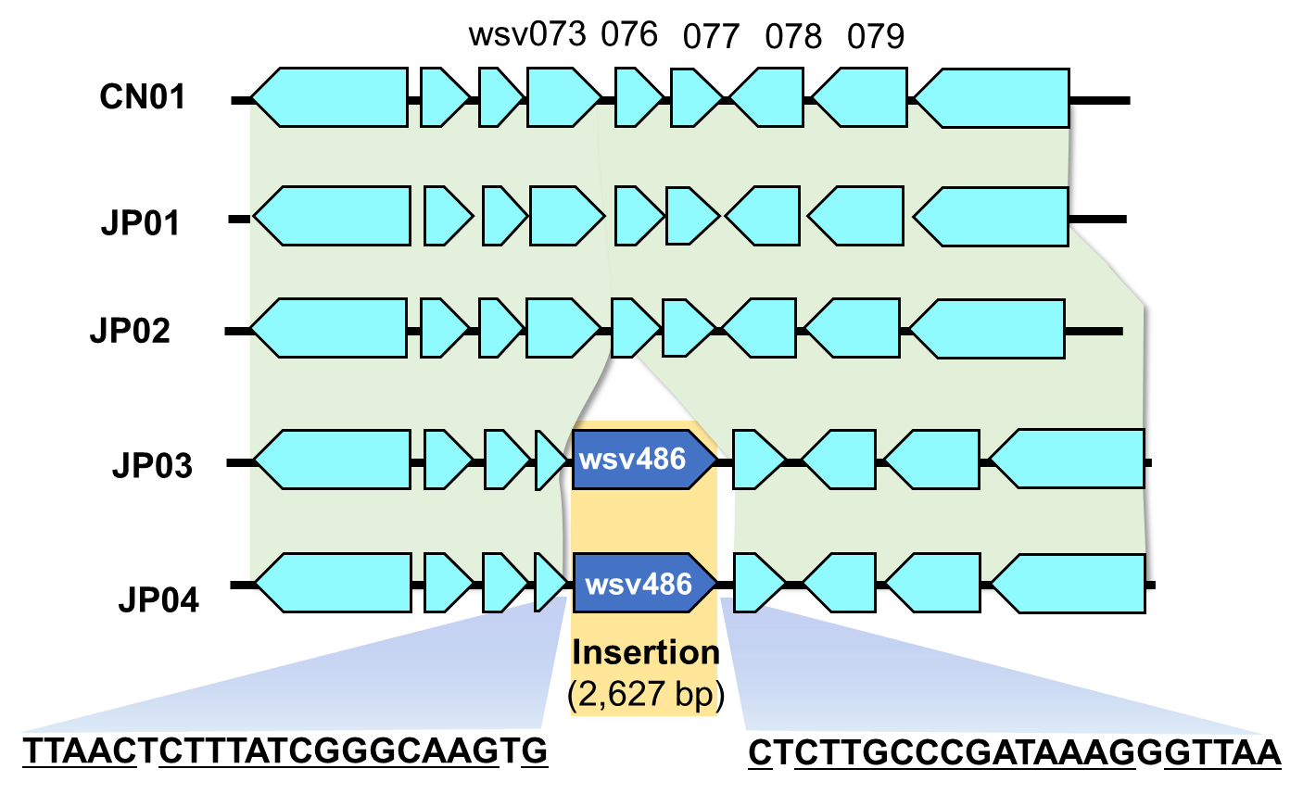

Fig. S1. Translocation of wsv486 in JP03 and JP04.
Colored arrows indicate protein-coding genes and their transcriptional orientations.
JP03 and JP04 share a 2,627-base translocation of wsv486 gene, flanked by an incomplete 22-mer inverted repeat.

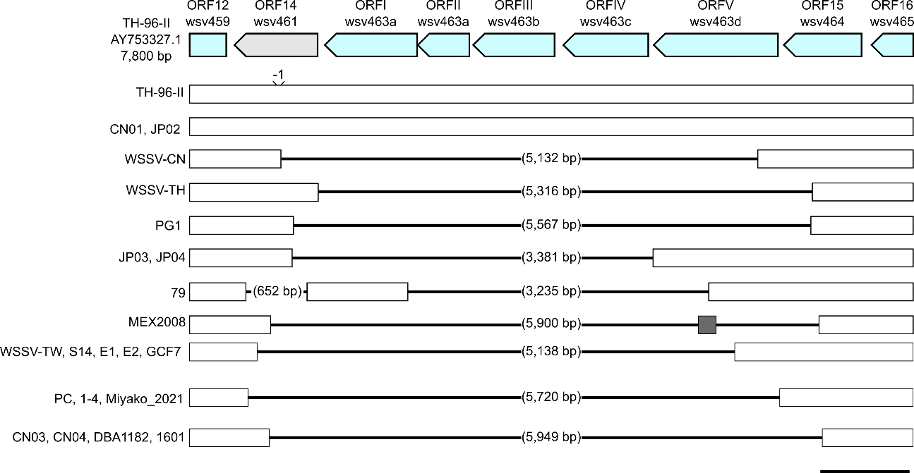

Fig. S2. Genome deletions around ORF14/15 region.
Arrows on the top line indicate protein-coding genes and their transcriptional orientations. ORF14 (wsv461) is shaded by gray because this gene is nonfunctional due to a nonsense deletion in TH-96-II, as indicated by a “-1” sign. White bars on the subsequent lines indicate the presence of sequences in the corresponding regions, and black lines indicate gaps. Gray bar in MEX2008 indicate the unique insertion sequence of unknown origins. The black bar on the bottom line indicates 500 bases.

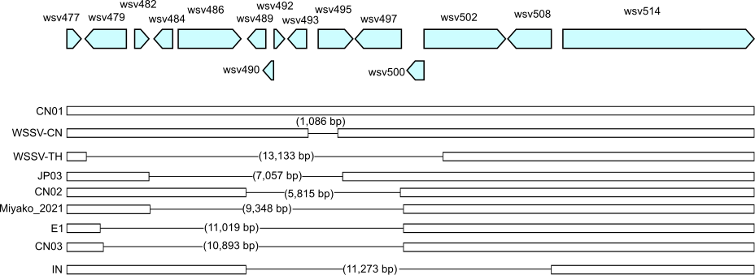

Fig. S3. Genome deletions around ORF23/24 region.
Arrows on the top line indicate protein-coding genes and their transcriptional orientations. White bars on the subsequent lines indicate the presence of sequences in the corresponding regions, and black lines indicate gaps.

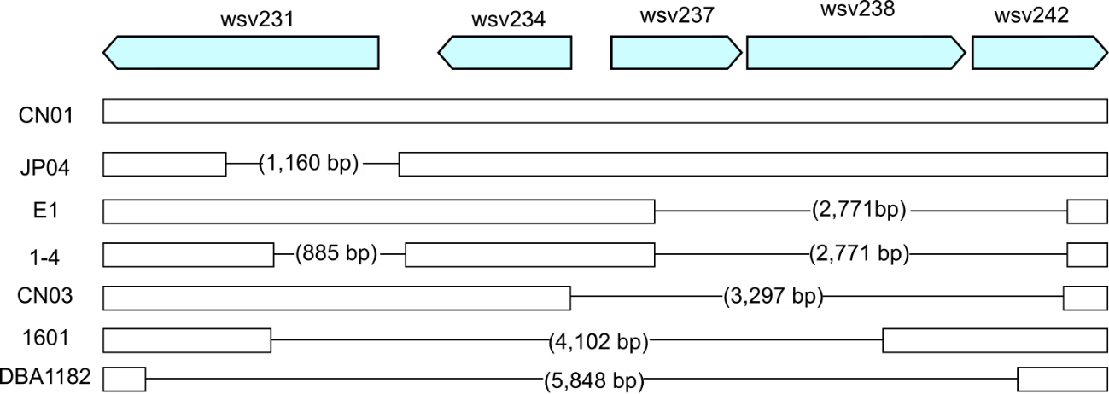

Fig. S4. 2771-bp deletion incurring wsv237-wsv242 in WSSV genomes from Okinawa Prefecture.
Arrows on the top line indicate protein-coding genes and their transcriptional orientations. White bars on the subsequent lines indicate the presence of sequences in the corresponding regions, and black lines indicate gaps.

