Fisheries Science, Online Resource of FISC-D-25-00160
Antioxidant production by the katsuobushi mold Aspergillus chevalieri revealed using fermentation-mimicking solid cultures

Soshi Ogawa,¹ Shigeru Okada,¹ Akihiro Ninomiya^{1＊}

Graduate School of Agricultural and Life Sciences, the University of Tokyo, 1-1-1 Yayoi, Bunkyo-ku, Tokyo 113-8657, Japan

*Corresponding author
E-mail: ninomiya-akihiro@g.ecc.u-tokyo.ac.jp
Phone: +81-3-5841-5301

Soshi Ogawa
ogawa-soshi17@g.ecc.u-tokyo.ac.jp

Shigeru Okada
aokada@mail.ecc.u-tokyo.ac.jp

Table S1. List of katsuobushi molds used in this study.
Table S2. Results of screening.
Table S3. ¹H and ¹³C NMR data for neoechinulin (1) in CDCl₃.
Table S4. ¹H and ¹³C NMR data for isodihydroauroglaucin (2) in CDCl₃.
Table S5. List of biosynthetic genes detected in the genome of Aspergillus chevalieri M1.
Table S6. List of genes encoded by ACHE_61021A gene cluster of Aspergillus chevalieri M1.
Table S7. Primers used in this study.

Figure S1. ¹H NMR spectrum of neoechinulin C (1) in CDCl₃.
Figure S2. ¹³C NMR spectrum of neoechinulin C (1) in CDCl₃.
Figure S3. COSY spectrum of neoechinulin C (1) in CDCl₃.
Figure S4. HSQC spectrum of neoechinulin C (1) in CDCl₃.
Figure S5. HMBC spectrum of neoechinulin C (1) in CDCl₃.
Figure S6. NOESY spectrum of neoechinulin C (1) in CDCl₃.
Figure S7. Key correlations observed in NMR data of neoechinulin C (1).
Figure S8. ¹H NMR spectrum of isodihydroauroglaucin (2) in CDCl₃.
Figure S9. ¹³C NMR spectrum of isodihydroauroglaucin (2) in CDCl₃.
Figure S10. COSY spectrum of isodihydroauroglaucin (2) in CDCl₃.
Figure S11. HSQC spectrum of isodihydroauroglaucin (2) in CDCl₃.
Figure S12. HMBC spectrum of isodihydroauroglaucin (2) in CDCl₃.
Figure S13. NOESY spectrum of isodihydroauroglaucin (2) in CDCl₃.
Figure S14. Key NOESY correlations observed in NMR data of isodihydroauroglaucin (2).
Figure S15. Detection of compound 1 in Aspergillus chevalieri JCM23047 arabushi culture by LC–MS.
Figure S16. Pictures of Aspergillus chevalieri JCM23047 grown on arabushi medium.
Figure S17. Comparison of Aspergillus chevalieri JCM23047 ACHE_61021A gene cluster and Aspergillus ruber CBS135680 echinulin biosynthetic gene cluster.
Figure S18. Pictures of five strains of Aspergillus chevalieri grown on arabushi medium.
Figure S19. Amplified sequence from Aspergillus chevalieri JCM23063.
Figure S20. Detection of neoechinulin C from commercially available karebushi.

Table S1. List of katsuobushi molds used in this study.

Species | Strain
Aspergillus chevalieri | NBRC4090
A. chevalieri | JCM23047
A. chevalieri | JCM23061
A. chevalieri | JCM23062
A. chevalieri | JCM23063
Aspergillus conicus | NBRC4046
Aspergillus sulphureus | NBRC4095
Aspergillus sydowii | NBRC4097
Aspergillus wentii | NBRC4107

Table S2. Results of screening. Regarding antioxidant activity, samples that showed a radical scavenging rate of 50% or higher are indicated by “+”. Regarding antibacterial and antifungal activity, samples that gave an inhibition circle in a disk diffusion assay are indicated by “+”.

Species | Strain | Fraction | Antioxidant | Antibacterial | Antifungal
Aspergillus chevalieri | NBRC4090 | H₂O | - | - | -
Aspergillus chevalieri | NBRC4090 | BuOH | - | - | -
Aspergillus chevalieri | NBRC4090 | 90% MeOH | + | - | -
Aspergillus chevalieri | NBRC4090 | Hexane | - | - | -
Aspergillus chevalieri | JCM23047 | H₂O | - | - | -
Aspergillus chevalieri | JCM23047 | BuOH | - | + | -
Aspergillus chevalieri | JCM23047 | 90% MeOH | + | + | -
Aspergillus chevalieri | JCM23047 | Hexane | + | ⁻ | -
Aspergillus chevalieri | JCM23061 | H₂O | - | - | -
Aspergillus chevalieri | JCM23061 | BuOH | - | - | -
Aspergillus chevalieri | JCM23061 | 90% MeOH | + | - | -
Aspergillus chevalieri | JCM23061 | Hexane | - | - | -
Aspergillus chevalieri | JCM23062 | H₂O | - | - | -
Aspergillus chevalieri | JCM23062 | BuOH | - | - | -
Aspergillus chevalieri | JCM23062 | 90% MeOH | + | + | -
Aspergillus chevalieri | JCM23062 | Hexane | + | - | -
Aspergillus chevalieri | JCM23063 | H₂O | - | - | -
Aspergillus chevalieri | JCM23063 | BuOH | - | - | -
Aspergillus chevalieri | JCM23063 | 90% MeOH | - | - | -
Aspergillus chevalieri | JCM23063 | Hexane | - | - | -
Aspergillus conicus | NBRC4046 | H₂O | - | - | -
Aspergillus conicus | NBRC4046 | BuOH | - | - | -
Aspergillus conicus | NBRC4046 | 90% MeOH | - | - | -
Aspergillus conicus | NBRC4046 | Hexane | - | - | -
Aspergillus sulphureus | NBRC4095 | H₂O | - | - | -
Aspergillus sulphureus | NBRC4095 | BuOH | - | - | -
Aspergillus sulphureus | NBRC4095 | 90% MeOH | - | - | -
Aspergillus sulphureus | NBRC4095 | Hexane | - | - | -
Aspergillus sydowii | NBRC4097 | H₂O | - | - | -
Aspergillus sydowii | NBRC4097 | BuOH | - | - | -
Aspergillus sydowii | NBRC4097 | 90% MeOH | - | - | -
Aspergillus sydowii | NBRC4097 | Hexane | - | - | -
Aspergillus wentii | NBRC4107 | H₂O | - | - | -
Aspergillus wentii | NBRC4107 | BuOH | - | - | -
Aspergillus wentii | NBRC4107 | 90% MeOH | - | - | -
Aspergillus wentii | NBRC4107 | Hexane | - | - | -

Table S3. ¹H and ¹³C NMR data for neoechinulin C (1) in CDCl₃.

No. | δ_{C} | Type | δ_{H}, mult (J in Hz)
1 |  |  | 8.52, s
2 | 143.8 | C
3 | 102.7 | C
3a | 123.8 | C
4 | 118.7 | CH | 7.18, d (8.2)
5 | 122.2 | CH | 6.99, d (8.1）
6 | 136.3 | C
7 | 110.4 | CH | 7.12, s
7a | 134.7 | C
8 | 113.2 | CH | 7.26, s
9 | 123.9 | C
10 | 157.2 | C
11 |  |  | 8.69, s
12 | 133.6 | C
13 | 155.7 | C
14 |  |  | 7.70, s
15 | 39.1 | C
16 | 144.1 | CH | 6.02, dd (10.5, 17.4)
17 | 113.2 | CH₂ | 5.13, d (17.4)
 |  |  | 5.19, d (10.5)
18 | 27.3 | CH₃ | 1.48, s
19 | 27.3 | CH₃ | 1.48, s
20 | 101.4 | CH₂ | 4.89, s
 |  |  | 5.55, s
21 | 34.2 | CH₂ | 3.39, d (7.2)
22 | 123.5 | CH | 5.32, m
23 | 132.2 | C
24 | 25.6 | CH₃ | 1.72, s
25 | 17.7 | CH₃ | 1.70, s

Table S4. ¹H and ¹³C NMR data for isodihydroauroglaucin (2) in CDCl₃.

No. | δ_{C} | Type | δ_{H}, mult (J in Hz)
1 | 117.5 | C
1-CHO | 195.8 |  | 10.21, s
2 | 155.1 | C
2-OH |  |  | 11.86, s
3 | 128.4 | C
4 | 126.0 | CH | 6.94, s
5 | 146.5 | C
6 | 128.4 | C
1' | 24.2 | CH₂ | 3.00, t (7.6)
2' | 34.4 | CH₂ | 2.33, m (7.6)
3' | 130.0 | CH | 5.58, m
4' | 131.6 | CH | 6.00, m
5' | 131.4 | CH | 6.00, m
6' | 127.9 | CH | 5.57, m
7' | 18.1 | CH₃ | 1.70, d (6.9)
1" | 27.0 | CH₂ | 3.24, d (7.6)
2" | 121.5 | CH | 5.22, m
3" | 133.7 | C
4" | 25.8 | CH₃ | 1.67, s
5" | 17.8 | CH₃ | 1.61, s

Table S5. List of biosynthetic genes detected in the genome of Aspergillus chevalieri M1.

Region | Type | Gene | Length (bp) | Domain structure
1.1 | PKS | ACHE_11097A | 3,481 | KS-AT
1.2 | PKS | ACHE_11445S | 8,966 | KS-AT-DH-cMT-ER-KR-PKS_PP-TD
2.1 | PKS | ACHE_20017S | 7,950 | KS-AT-DH-cMT-ER-KR-PKS_PP
2.2 | PKS | ACHE_20978A | 5,486 | SAT-KS-AT-PT-ACP
3.1 | NRPS | ACHE_30035A | 9,273 | PPb-C-A-PPb-C-PPb-C-PPb-C
3.2 | PKS | ACHE_30166S | 8,138 | KS-AT-DH-cMT-ER-KR-PKS_PP
3.5 | PKS | ACHE_30894S | 5,386 | KS-AT-DH-KR-ACP
3.5 | NRPS | ACHE_30895S | 3,318 | A-ACP-TD
4.3 | PKS | ACHE_40803A | 5,570 | KS-AT-PT-ACP-PPb-TE
4.4 | PKS | ACHE_41117A | 7,189 | KS-AT-DD-PPb-PPb-cMT
5.1 | PKS | ACHE_50023A | 3,369 | KS-AT-PT
5.2 | PKS | ACHE_50466A | 9,056 | KS-AT-DH-cMT-ER-KR-PKS_PP-TD
5.3 | PKS | ACHE_50703S | 6,681 | SAT-KS-AT-PT-ACP-PPb-TE
6.1 | NRPS | ACHE_60351A | 3,789 | A-PCP-C
6.3 | PKS | ACHE_60930S | 8,306 | A-PCP-C-A-PCP-E-C
6.4 | NRPS | ACHE_61021A | 6,635 | A-C-A-PPb-C
7.1 | PKS | ACHE_70048S | 7,872 | KS-AT-DH-cMT-ER-KR-PKS_PP
7.2 | PKS | ACHE_70151S | 7,988 | SAT-KS-AT-PPb-ACP-cMT-TD
8.1 | PKS | ACHE_80124A | 6,711 | KS-AT-PPb-NAD
8.2 | PKS-NRPS | ACHE_80169S | 12,399 | KS-AT-DH-cMT-KR-PKS_PP-C-A-PCP-TD

Table S6. List of genes encoded by ACHE_61021A gene cluster of Aspergillus chevalieri M1.

Gene | Length (bp) | Proposed function
ACHE_61018A | 1,122 | hypothetical protein
ACHE_61019A | 1,340 | prenyltransferase
ACHE_61020A | 918 | transporter
ACHE_61021A | 6,635 | NRPS
ACHE_61022S | 1,569 | cytochrome P450
ACHE_61023A | 1,282 | prenyltransferase
ACHE_61024A | 2,572 | hypothetical protein
ACHE_61025S | 1,321 | NADH oxidase
ACHE_61026A | 1,169 | reductase
ACHE_61027S | 1,308 | hypothetical protein
ACHE_61028A | 2,252 | acyl-CoA dehydrogenase
ACHE_61029A | 1,567 | transporter

Table S7. Primers used in this study.

Name | Sequence (5’-3’) | Note
Ache_act_Q_F | ACGGAACCACCTTCAATTCC | Quantification of ACHE_50215A gene expression by qPCR
Ache_act_Q_R | GGGTACATAGTAGTACCACC | Quantification of ACHE_50215A gene expression by qPCR
61021_Q_F | GGTCGGAAGCTGTACAATGC | Quantification of ACHE_61021A gene expression by qPCR
61021_Q_R | AGTGTGTTTGGCGGCTGAAG | Quantification of ACHE_61021A gene expression by qPCR

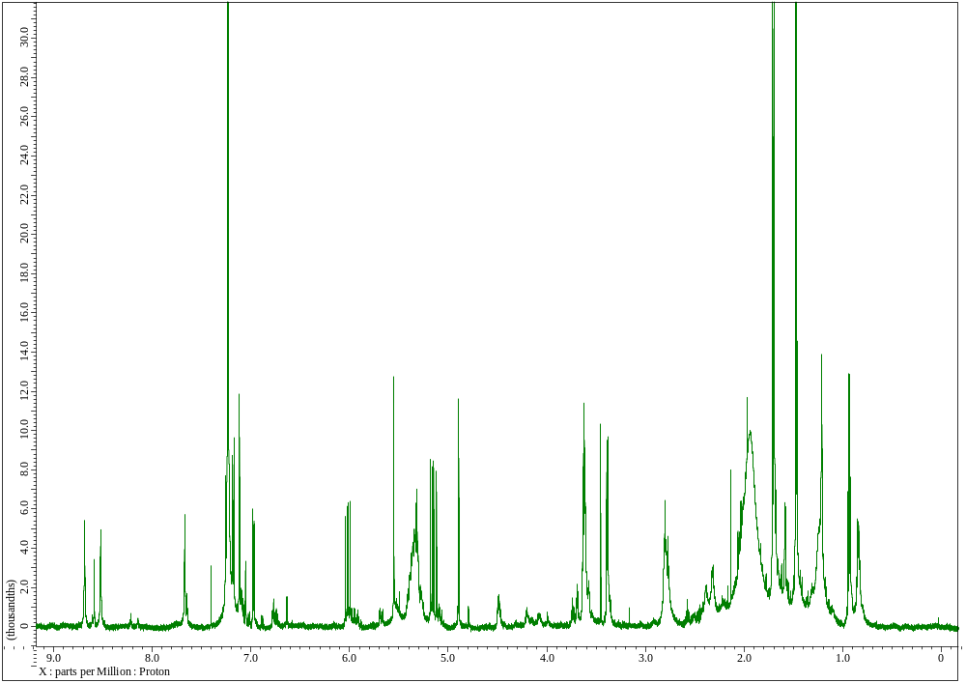
Figure S1. ¹H NMR spectrum of neoechinulin C (1) in CDCl₃.
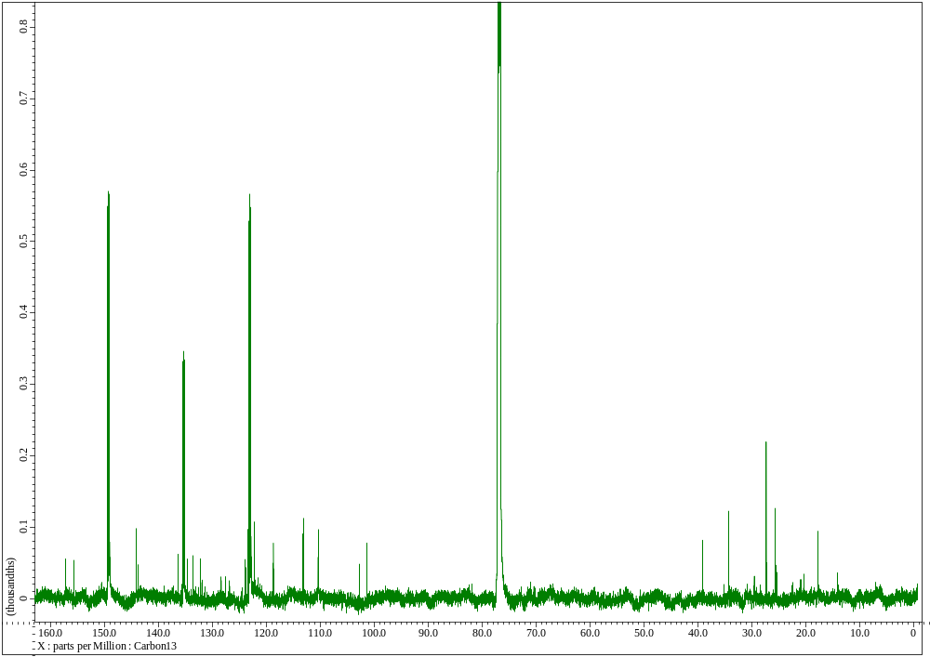
Figure S2. ¹³C NMR spectrum of neoechinulin C (1) in CDCl₃.

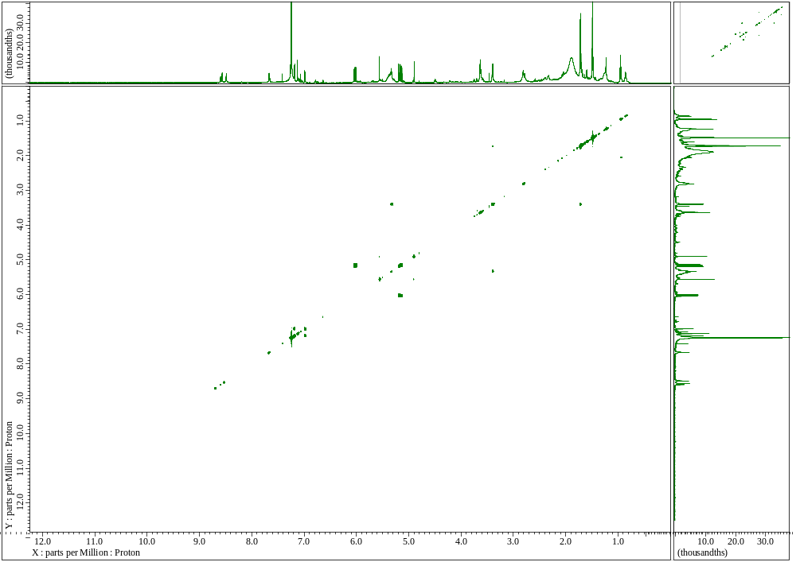
Figure S3. COSY spectrum of neoechinulin C (1) in CDCl₃.

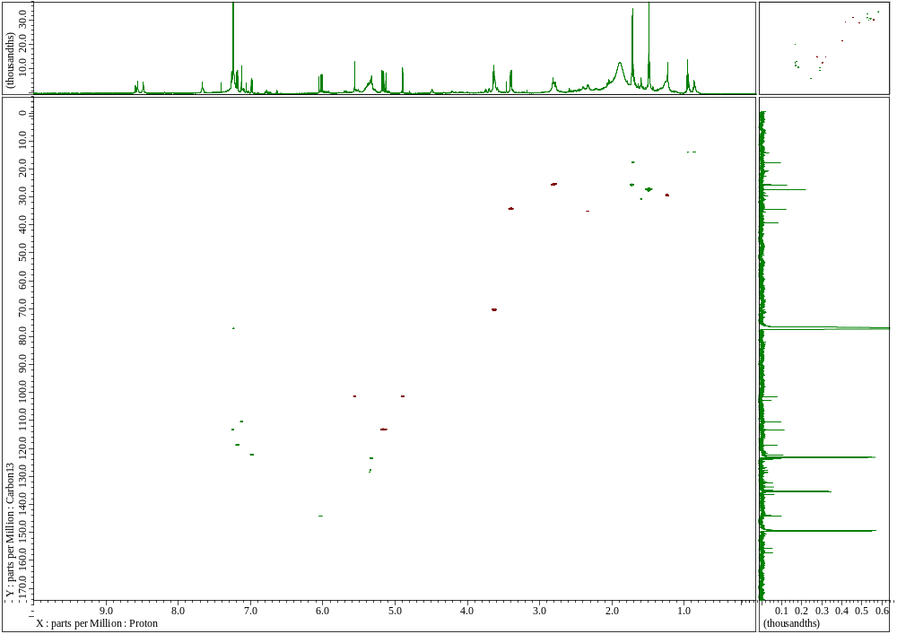
Figure S4. HSQC spectrum of neoechinulin C (1) in CDCl₃.

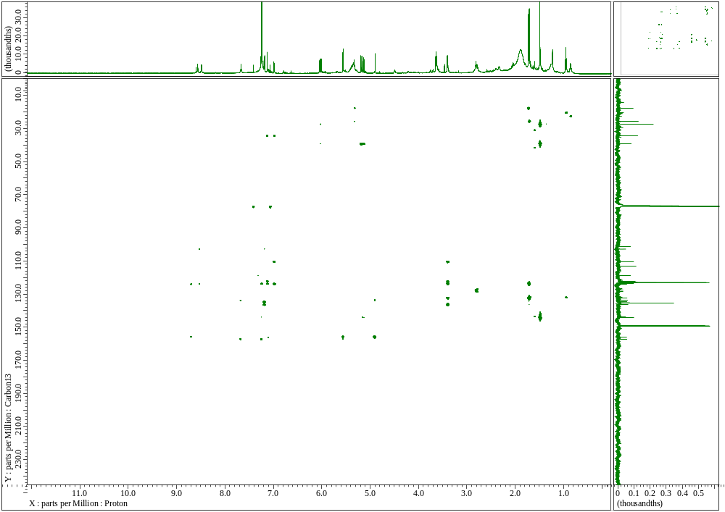
Figure S5. HMBC spectrum of neoechinulin C (1) in CDCl₃.
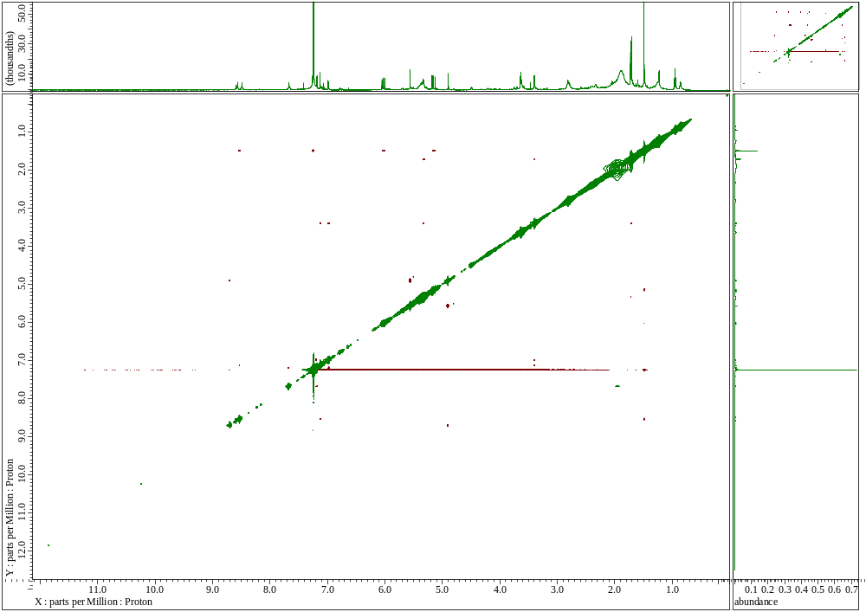
Figure S6. NOESY spectrum of neoechinulin C (1) in CDCl₃.

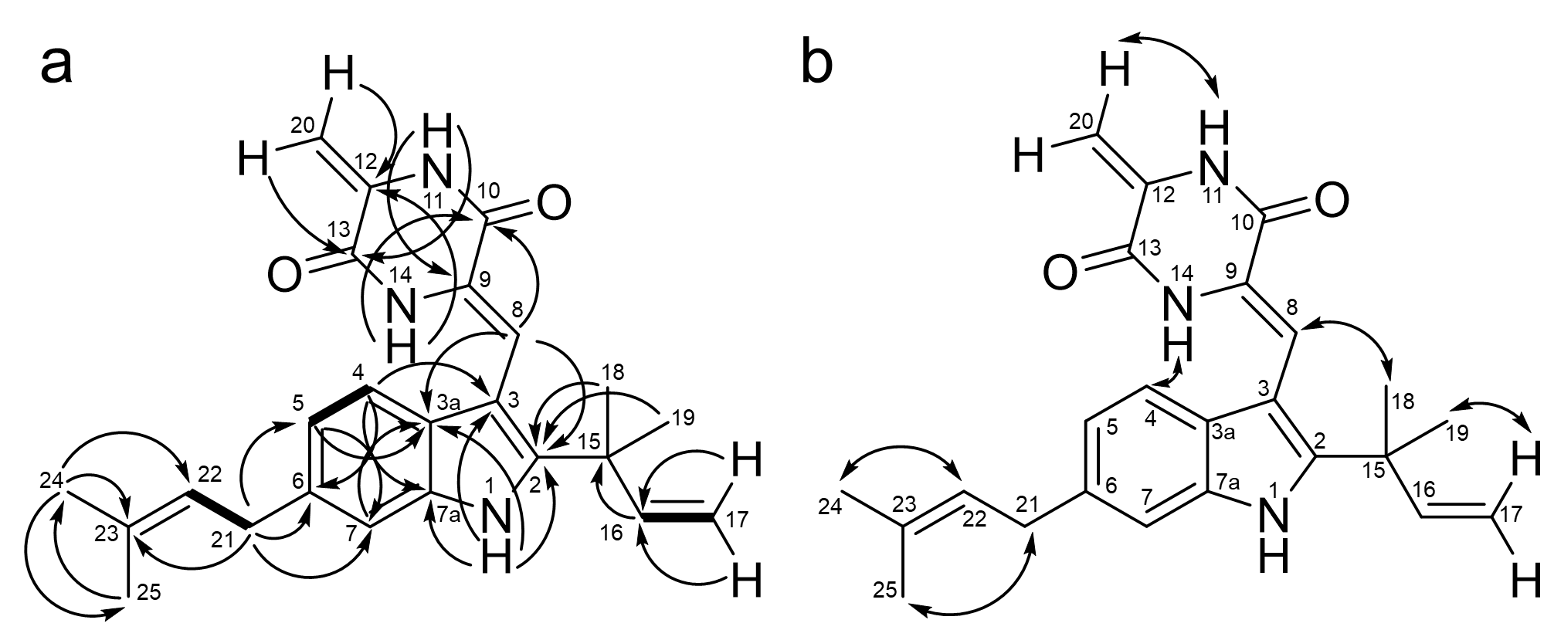
Figure S7. Key correlations observed in NMR data of neoechinulin C (1). (a) Key COSY and HMBC correlations are shown by bold lines and arrows, respectively. (b) Key NOESY correlations are indicated by arrows.
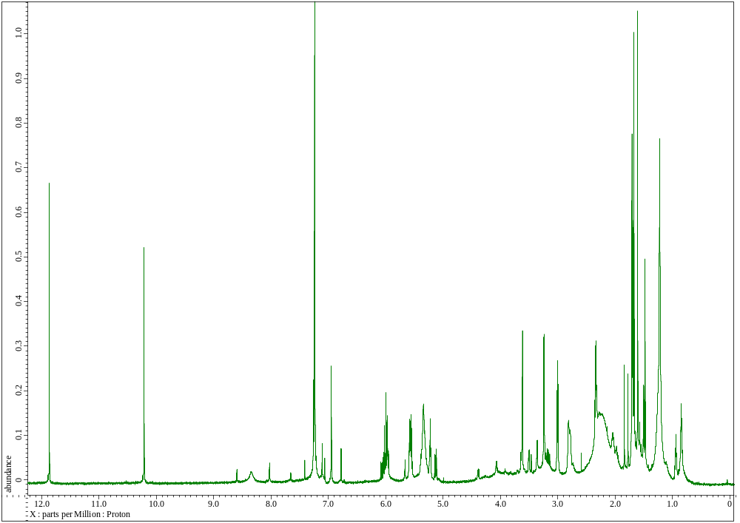
Figure S8. ¹H NMR spectrum of isodihydroauroglaucin (2) in CDCl₃.
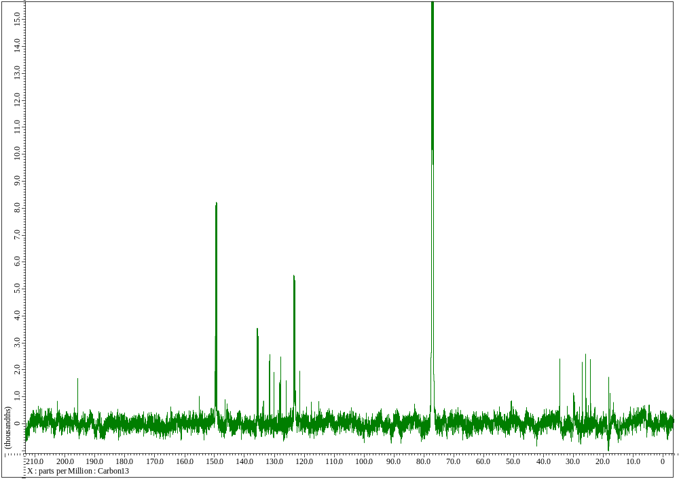
Figure S9. ¹³C NMR spectrum of isodihydroauroglaucin (2) in CDCl₃.
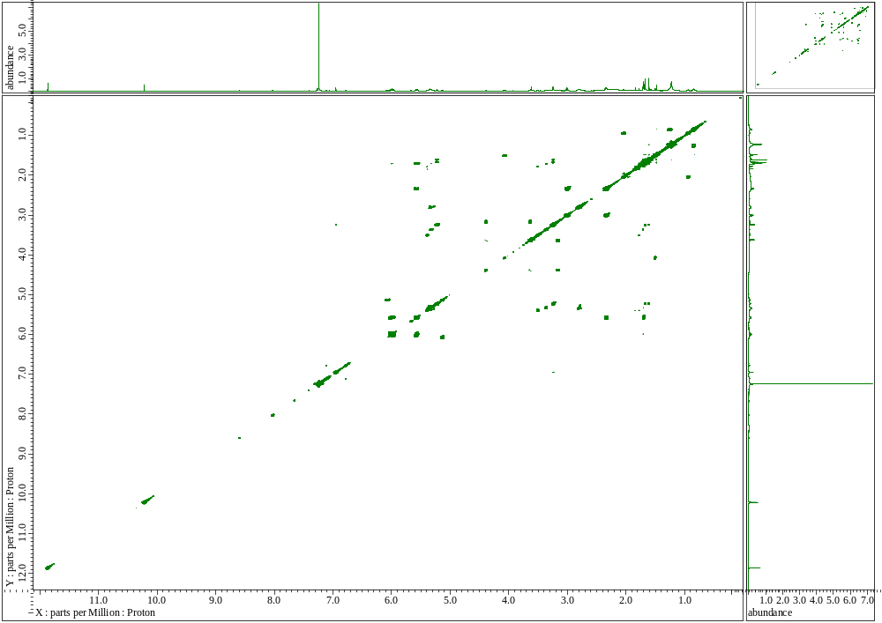
Figure S10. COSY spectrum of isodihydroauroglaucin (2) in CDCl₃.
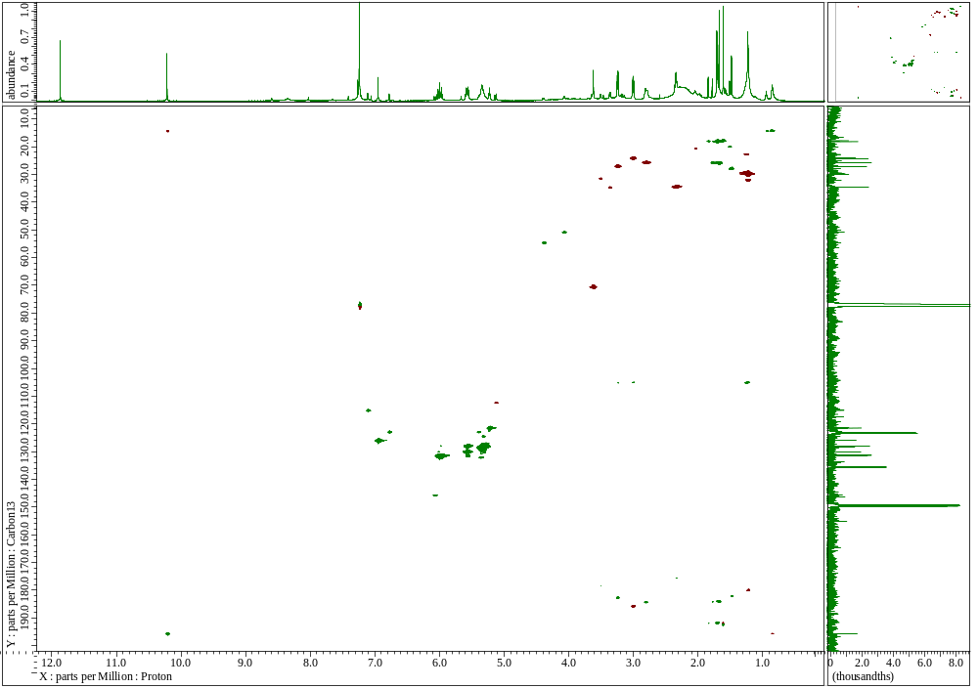
Figure S11. HSQC spectra of isodihydroauroglaucin (2) in CDCl₃. Signals in the black rectangle are noise.
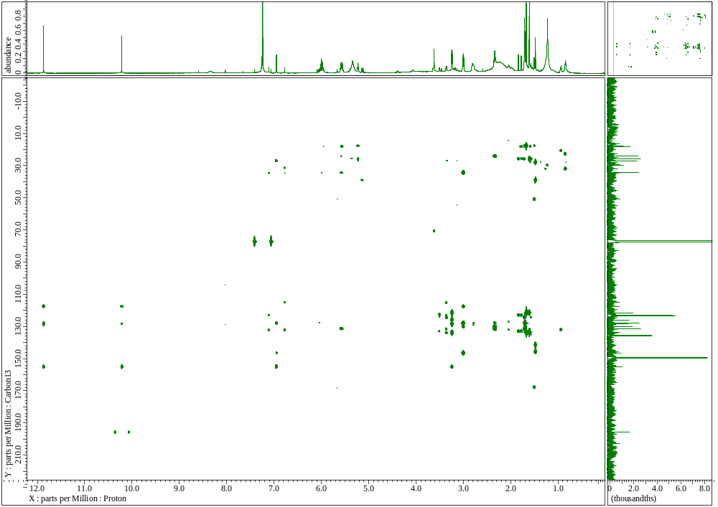
Figure S12. HMBC spectra of isodihydroauroglaucin (2) in CDCl₃.

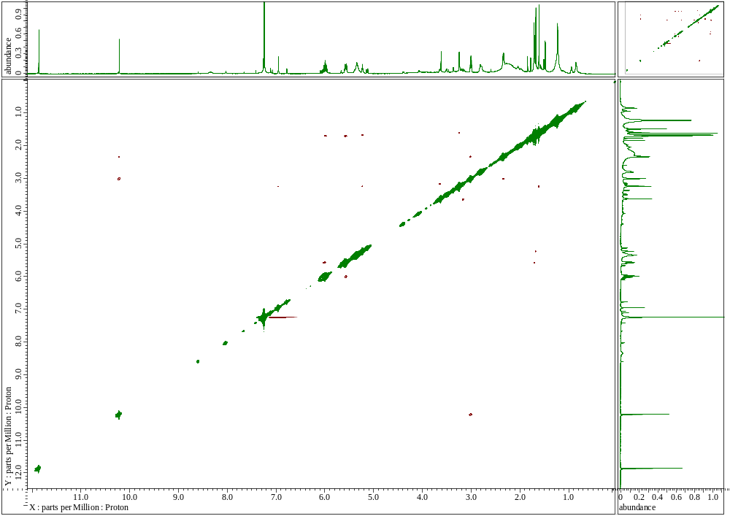
Figure S13. NOESY spectra of isodihydroauroglaucin (2) in CDCl₃.

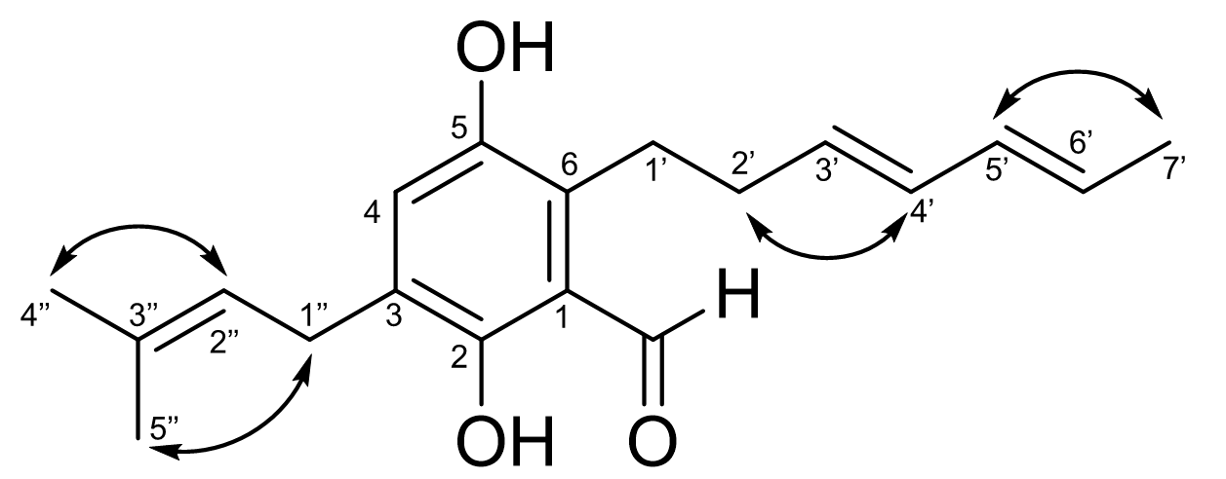
Figure S14. Key NOESY correlations observed in NMR data of isodihydroauroglaucin (2).

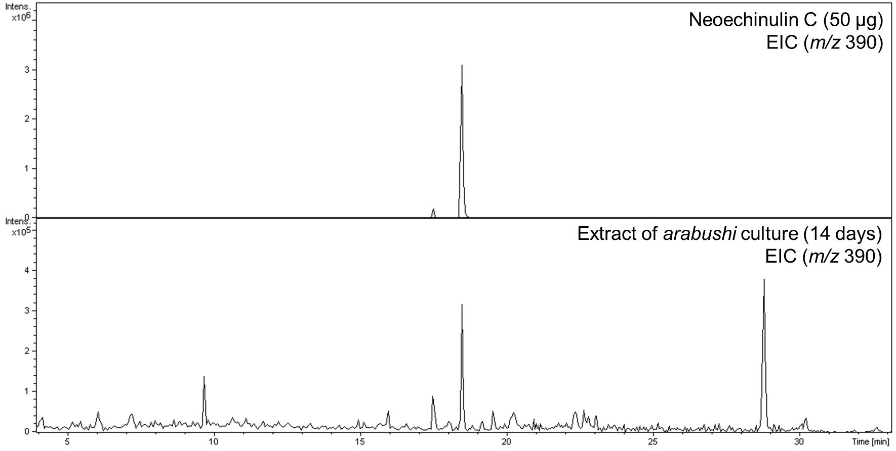
Figure S15. Detection of compound 1 in Aspergillus chevalieri JCM23047 arabushi culture by LC–MS.

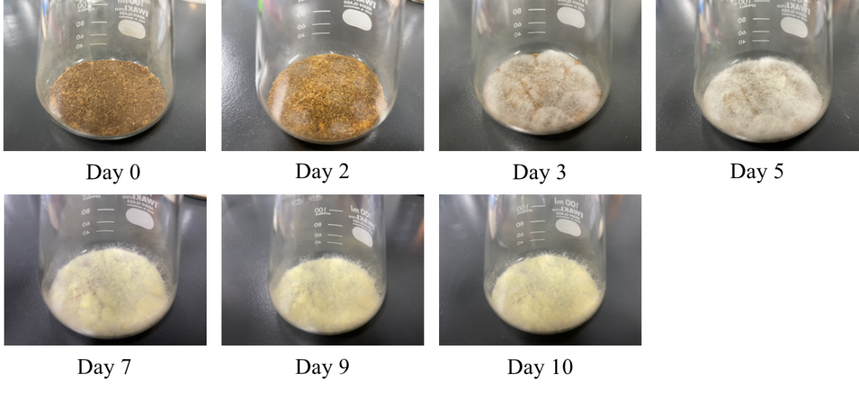
Figure S16. Pictures of Aspergillus chevalieri JCM23047 grown on arabushi medium.

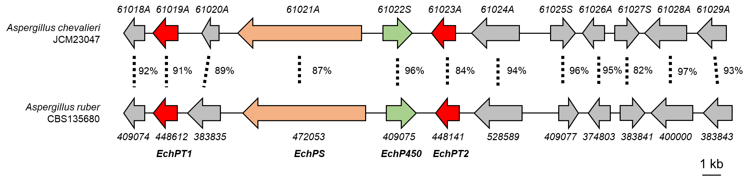
Figure S17. Comparison of Aspergillus chevalieri JCM23047 ACHE_61021A gene cluster and Aspergillus ruber CBS135680 echinulin biosynthetic gene cluster. The numbers next to the dotted lines show percentage identity of the corresponding proteins.

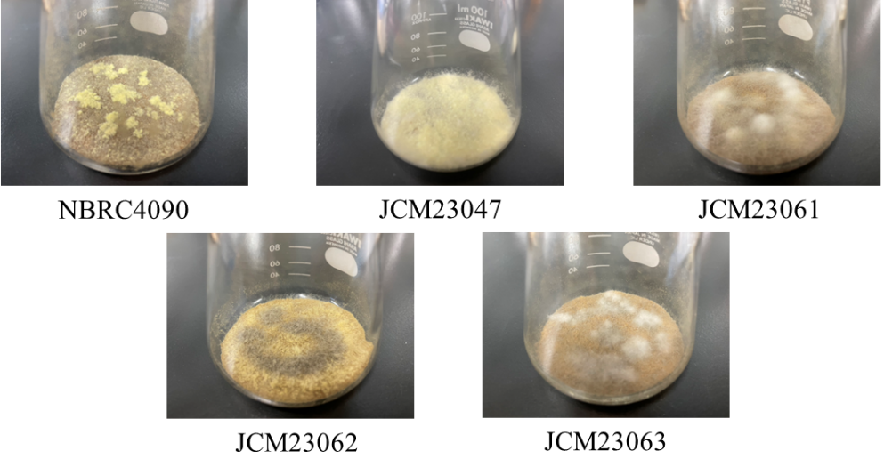
Figure S18. Pictures of five strains of Aspergillus chevalieri grown on arabushi medium. The fungi were cultured for 10 days.
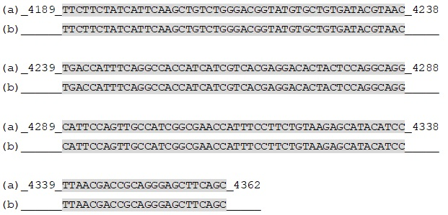
Fugure S19. Amplified sequence from Aspergillus chevalieri JCM23063. (a) The partial sequence of the ACHE_61021A gene of A. chevalieri JCM23047. (b) The amplified sequence from A. chevalieri JCM23063.

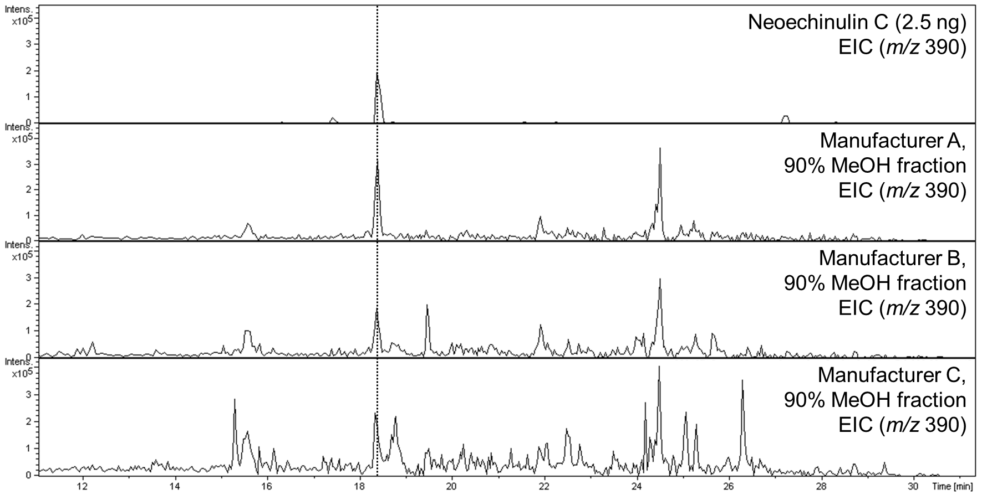
Figure S20. Detection of neoechinulin C from commercially available karebushi.

