Fisheries Science, Online Resource of FISC-D-26-00043

Toward CPUE standardization of commercial passenger fishing vessel fisheries for largehead hairtail Trichiurus japonicus in Tokyo Bay

Author names
Hiroaki Kurihara^{1*}, Toyomitsu Horii¹

¹Fisheries Stock Assessment Center, Fisheries Resources Institute, Japan Fisheries Research and Education Agency, 2-12-4 Fukuura, Kanazawa-ku, Yokohama, Kanagawa 236-8648, Japan

*Corresponding author: Hiroaki Kurihara
TEL: 045-788-7912; E-mail address: kurihara_hiroaki58@fra.go.jp

Toyomitsu Horii
E-mail address: horii_toyomitsu26@fra.go.jp

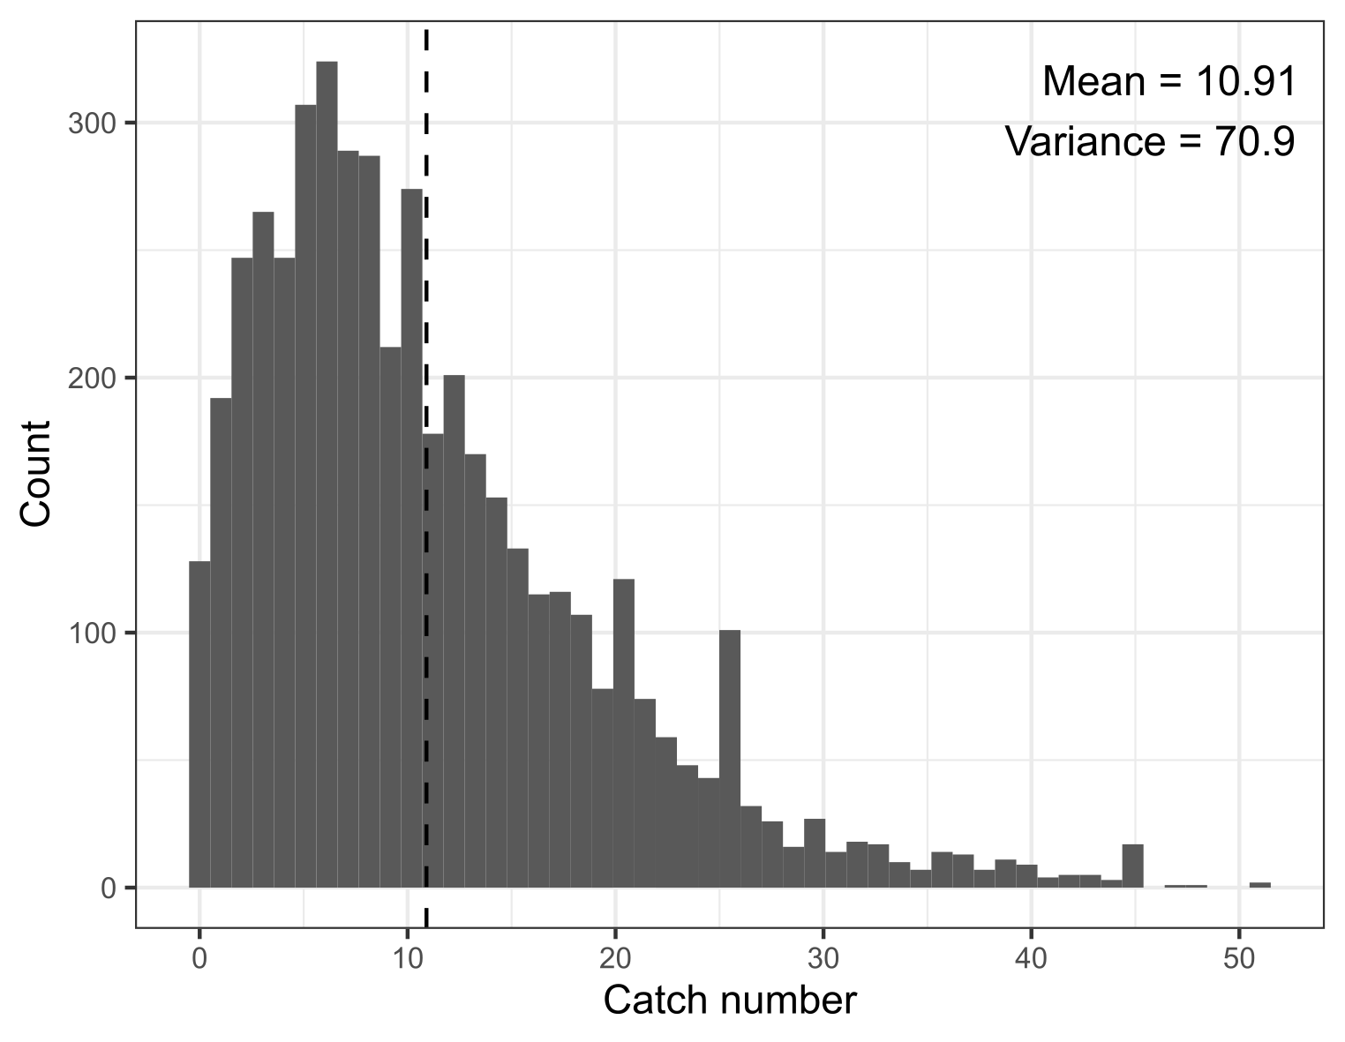
Fig. S1. Distribution of the number of Trichiurus japonicus caught by 4,728 cumulative anglers aboard two CPFVs in Tokyo Bay during the period from 1 April 2024 to 31 March 2025. The dashed line indicate mean catch number per angler of this species in the data.

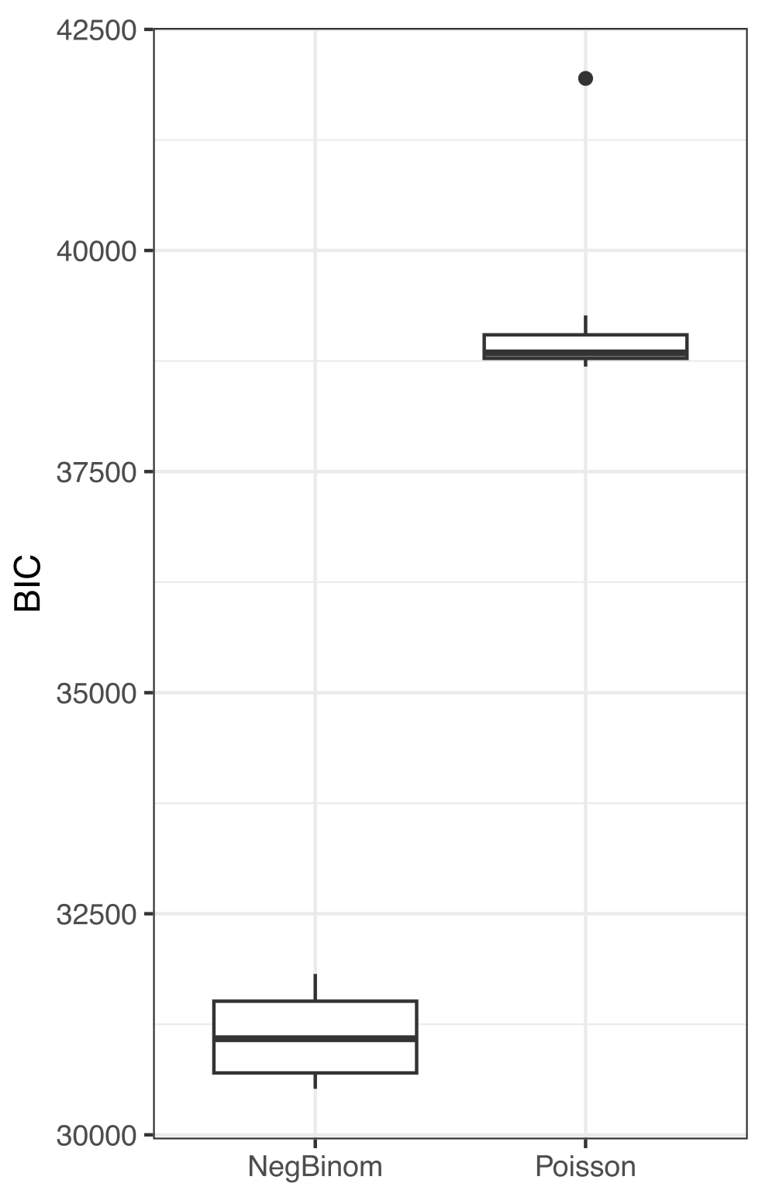
Fig. S2 Comparison of BIC distributions between Poisson and Negative Binomial (NegBinom) models

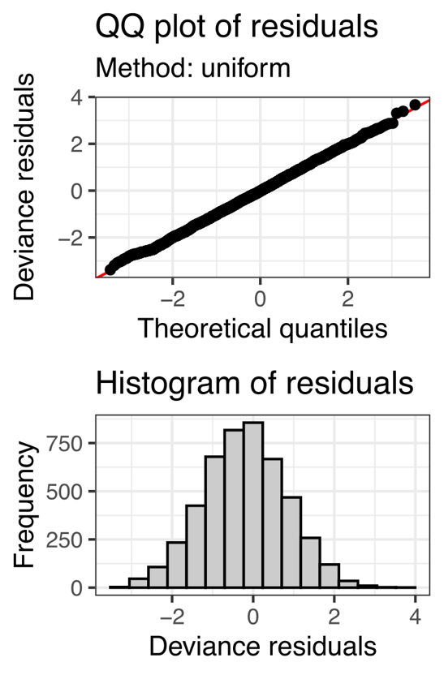
Fig. S3. Upper panel: Quantile-Quantile plot of the best generalized additive model (red line indicates ideal position of data). Lower panel: Deviance residuals histogram of the generalized additive model.

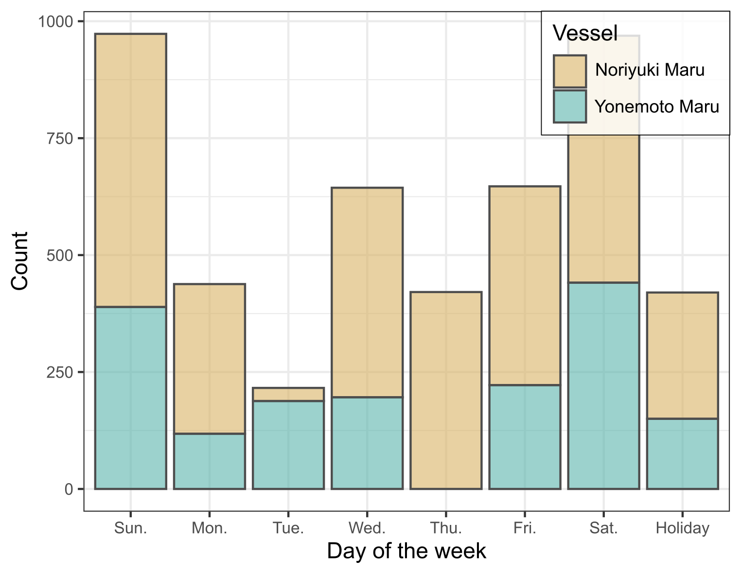
Fig. S4 Number of anglers by day of the week for each of the two CPFV.s.

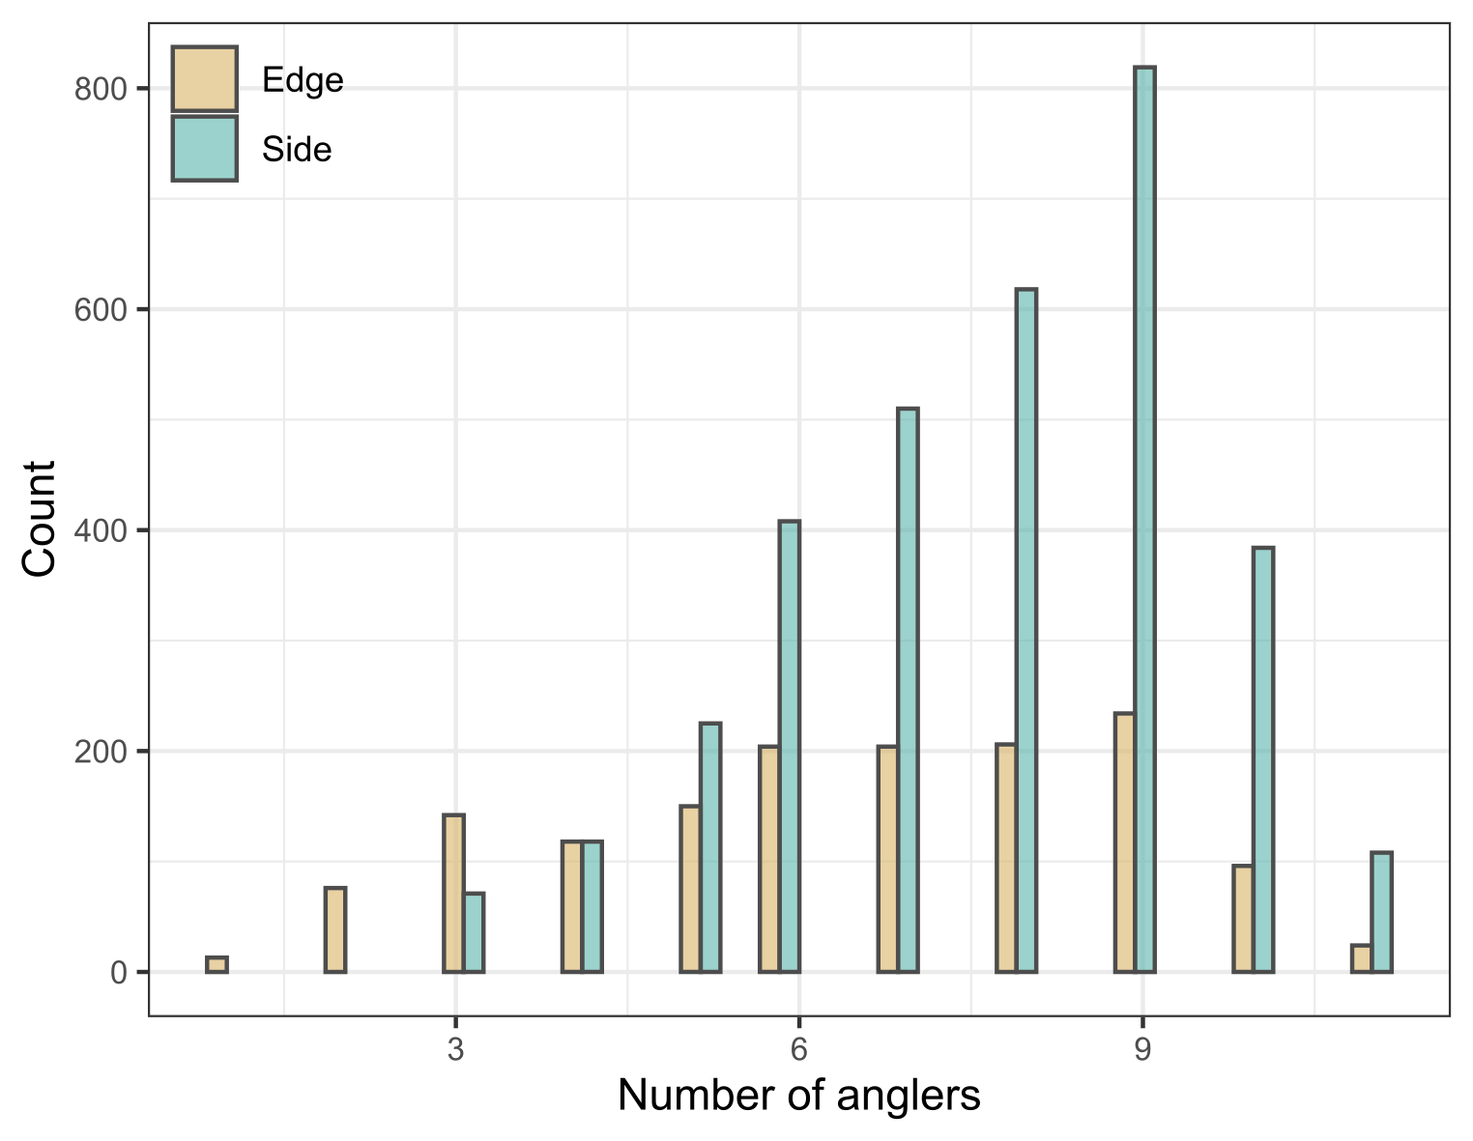
Fig. S5 Relationship between number of fish caught (count), seat position (end or side) and passenger density (number of recreational anglers).

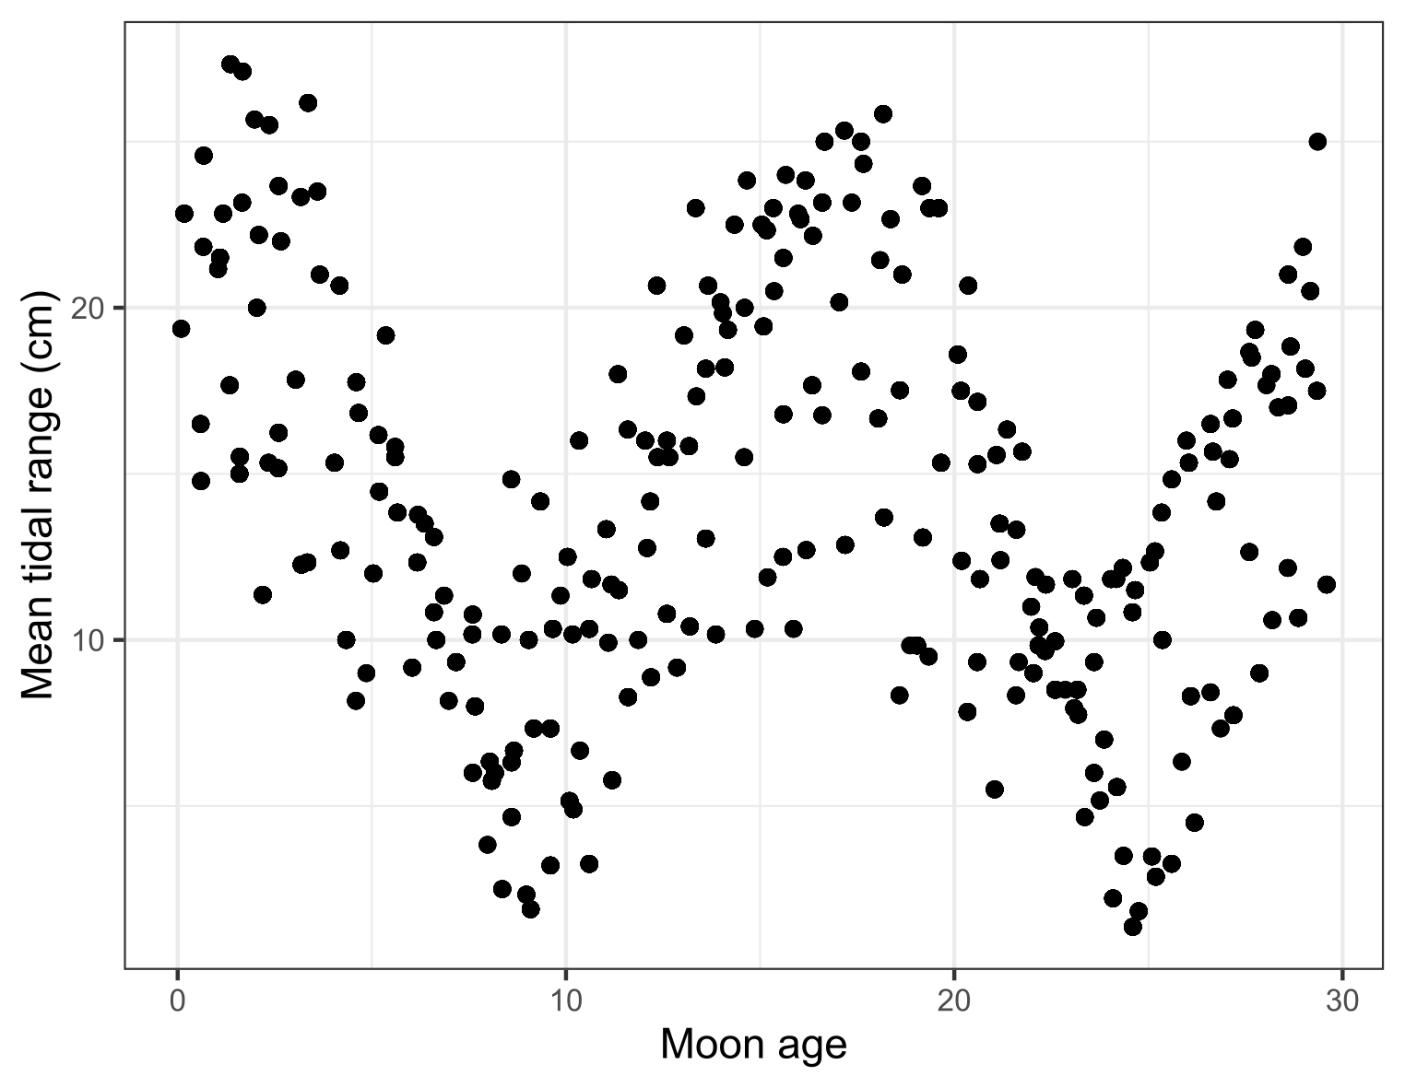
Fig. S6 Relationship between moon age and the mean tidal range during CPFV operations.

Table S1. Summary and definition of the continuous variables used in this study.
Variables | Definition | N | Mean | SD | Median | Min | Max | Data source
Number of catches* | Number of T. japonicus caught per angler per trip | 4728 | 10.9 | 8.72 | 9 | 0 | 51 | SNS; vessel website
Number of anglers† | Number of anglers per side of the vessel per trip | 740 | 7.3 (6.4, 7.7) | 2.11 (2.4, 1.8) | 8 (7, 8) | 1 (1, 3) | 11 (11, 11) | SNS; vessel website
Temperature (°C) ‡ | Daily water temperature at 50 m depth in the main fishing area | 261 | 18.3 | 3.62 | 18.2 | 13.4 | 25.7 | FRAROMS-II
Salinity‡ | Daily salinity at 50 m depth in the main fishing area | 261 | 34.4 | 0.29 | 34.5 | 33.6 | 34.7 | FRAROMS-II
Mean tidal range (cm) ‡ | Mean tidal range during fishing hours (07:00–13:00) | 261 | 13.9 | 6.06 | 13.3 | 1.36 | 27.3 | Regional Delayed Mode Database
Mean wind direction (°) ‡ | Mean wind direction during fishing hours (07:00–13:00) | 261 | 95.12 | 75.1 | 93.21 |  |  | Japan Meteorological Agency database
Precipitation (mm) ‡ | Daily precipitation in Yokohama on the fishing day | 261 | 13.9 | 6.76 | 0 | 0 | 58.5 | Japan Meteorological Agency database
Moon phase age‡ | Moon phase age on the fishing day | 261 | 15.0 | 8.38 | 14.6 | 0.09 | 29.6 | Calendar
Note: Values in parentheses indicate seat-position-specific summaries, shown as side seats followed by end seats. For the variable “Mean wind direction,” the reported values are the circular mean, circular standard deviation (SD), and circular median. *, Angler-level variable; †, Trip-side-level variable (defined for each vessel × date × side combination); ‡, Day-level variable (one value per fishing day, shared across vessels).

Table S2. Summary and definition of the categorical variables used in this study.
Variables | Definition | Level | N | % | Source
Vessel | Identity of the commercial passenger fishing vessel | Yonemoto Maru | 3024 | 64.0 | SNS; vessel website
 |  | Noriyuki Maru | 1704 | 36.0
Seat position | Seating position of each angler on the vessel | End | 1467 | 31.0 | SNS; vessel website
 |  | Side | 3261 | 69.0
Day of the week | Calendar day category of the fishing trip | Sunday | 973 | 20.6 | Calendar
 |  | Monday | 438 | 9.3
 |  | Tuesday | 216 | 4.6
 |  | Wednesday | 644 | 13.6
 |  | Thursday | 421 | 8.9
 |  | Friday | 647 | 13.7
 |  | Saturday | 969 | 20.5
 |  | Holiday | 420 | 8.9
Fishing gear | Type of fishing gear used by each angler | Tenya | 3334 | 70.5 | SNS; vessel website
 |  | Balance | 1317 | 27.9
 |  | Lure | 77 | 1.6
Month | Calendar month of the fishing trip | January | 606 | 12.8 | Calendar
 |  | February | 463 | 9.8
 |  | March | 402 | 8.5
 |  | April | 318 | 6.7
 |  | May | 112 | 2.4
 |  | June | 369 | 7.8
 |  | July | 605 | 12.8
 |  | August | 547 | 11.6
 |  | September | 549 | 11.6
 |  | October | 399 | 8.4
 |  | November | 170 | 3.6
 |  | December | 188 | 4.0
Vessel side | Side of the vessel from which the angler fished | Port | 2349 | 49.7 | SNS; vessel website
 |  | Starboard | 2379 | 50.3
Note: n and % indicate, respectively, the number and proportion of observations at the corresponding level of variation.

