Supplementary Material

Population genetic structure and spring–summer spatial distribution of common minke whales (Balaenoptera acutorostrata) in feeding grounds and migratory corridors of the western North Pacific

Mutsuo Goto¹, Mioko Taguchi¹, Taro Sugimoto², Satoko Inoue² and Luis A. Pastene¹

^{１}Institute of Cetacean Research, 4-5 Toyomi-cho, Chuo-ku, Tokyo 104-0055, Japan
²Institute of Cetacean Research, 1770-1 Taiji-cho, Taiji, Higashimuro-gun, Wakayama 649-5171, Japan

Corresponding author: Mutsuo Goto, Tel: +81-3-3536 6521; Fax: +81-3-3536-6522; e-mail: goto@cetacean.jp

Table S1. Locus-specific microsatellite summary statistics for each sub-area within each stock based on individual assignments using an 80% threshold
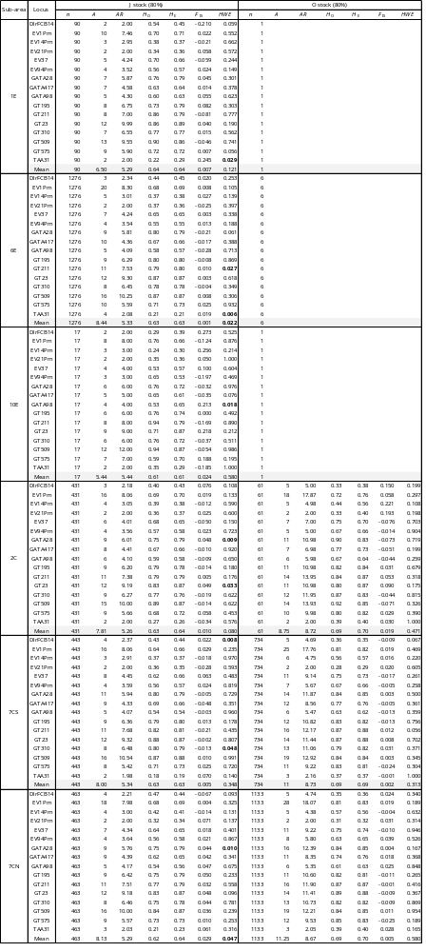
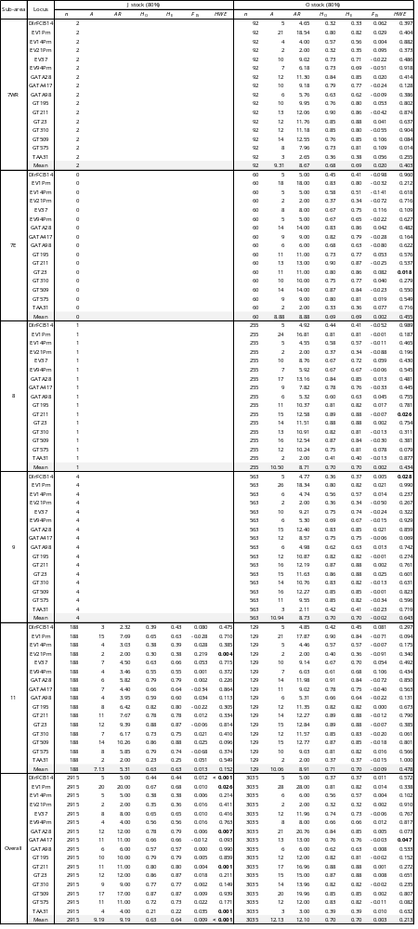
n = sample size; H = number of haplotypes; h = haplotype diversity; s.d. = sample standard deviation; π = nucleotide diversity; A = number of alleles; AR = allelic richness; H_{O} = observed heterozygosity; H_{E} = expected heterozygosity; F_{IS} = inbreeding coefficient; HWE = p-value of the Hardy−Weinberg equilibrium test. Bold values indicate significant departure from Hardy−Weinberg equilibrium at α = 0.05.

Table S2. Summary statistics by stock and sub-area using assignment thresholds of 50% and 90%

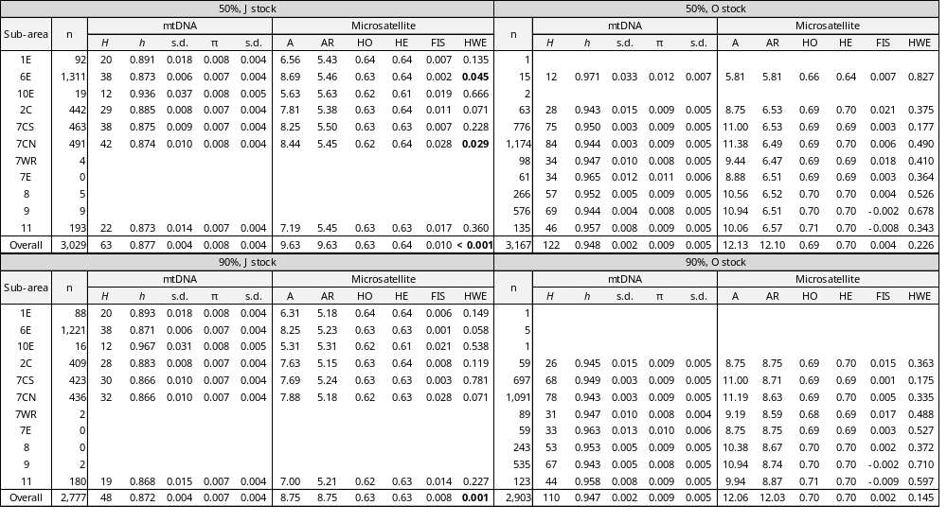
n = sample size; H = number of haplotypes; h = haplotype diversity; s.d. = sample standard deviation; π = nucleotide diversity; A = number of alleles; AR = allelic richness; H_{O} = observed heterozygosity; H_{E} = expected heterozygosity; F_{IS} = inbreeding coefficient; HWE = p-value of the Hardy−Weinberg equilibrium test. Bold values indicate significant departure from Hardy−Weinberg equilibrium at α = 0.05.

Table S3. Pairwise genetic differentiation among sub-areas within the J and O stocks using assignment thresholds of 50% and 90%

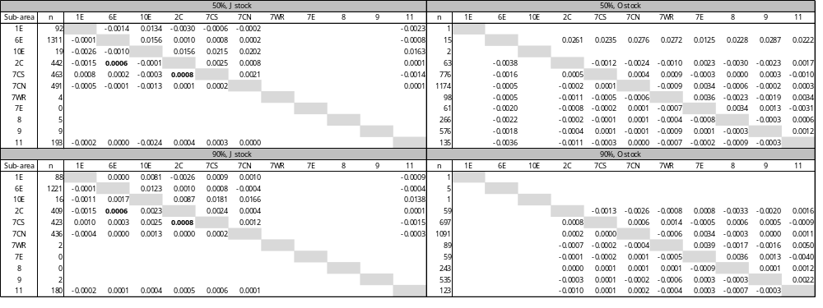
Upper and lower triangular matrices show pairwise F_{ST} estimates for mtDNA and microsatellite markers, respectively. Bold values indicate statistically significant heterogeneity test results based on adjusted p-values (α = 0.05).

Table S4. Pairwise genetic differentiation among sampling years within the J and O stocks
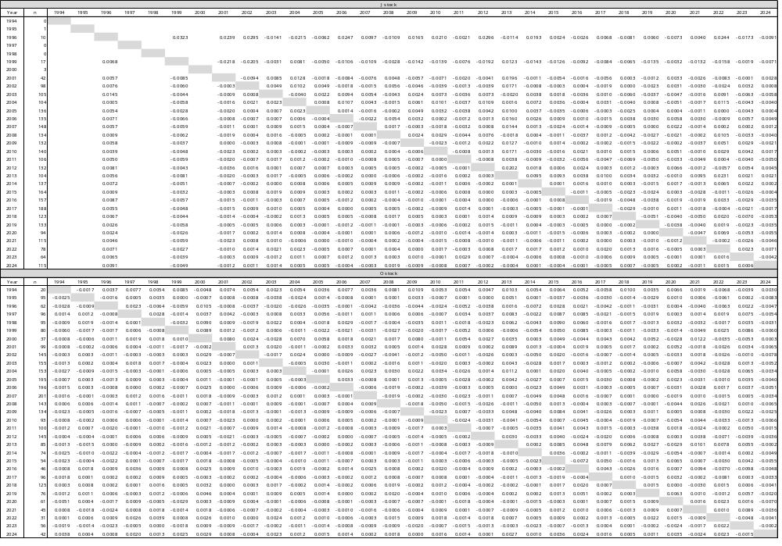
Upper and lower triangular matrices show pairwise F_{ST} estimates for mtDNA and microsatellite markers, respectively. No pairwise heterogeneity tests were statistically significant after adjustment for multiple testing (α = 0.05).

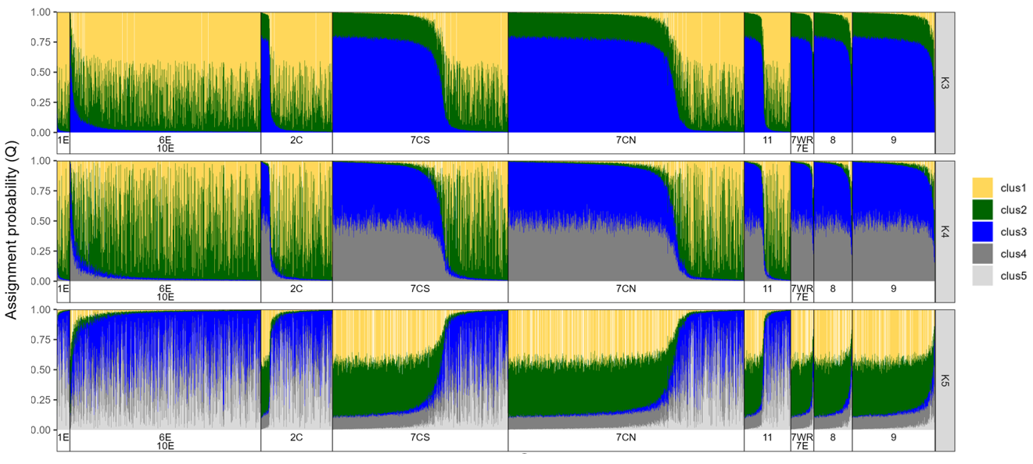

Fig. S1. STRUCTURE membership probabilities inferred at K = 3, 4 and 5 for each individual western North Pacific common minke whale, plotted across sub-areas. Each individual is represented by a vertical bar, which is colored according to cluster membership.

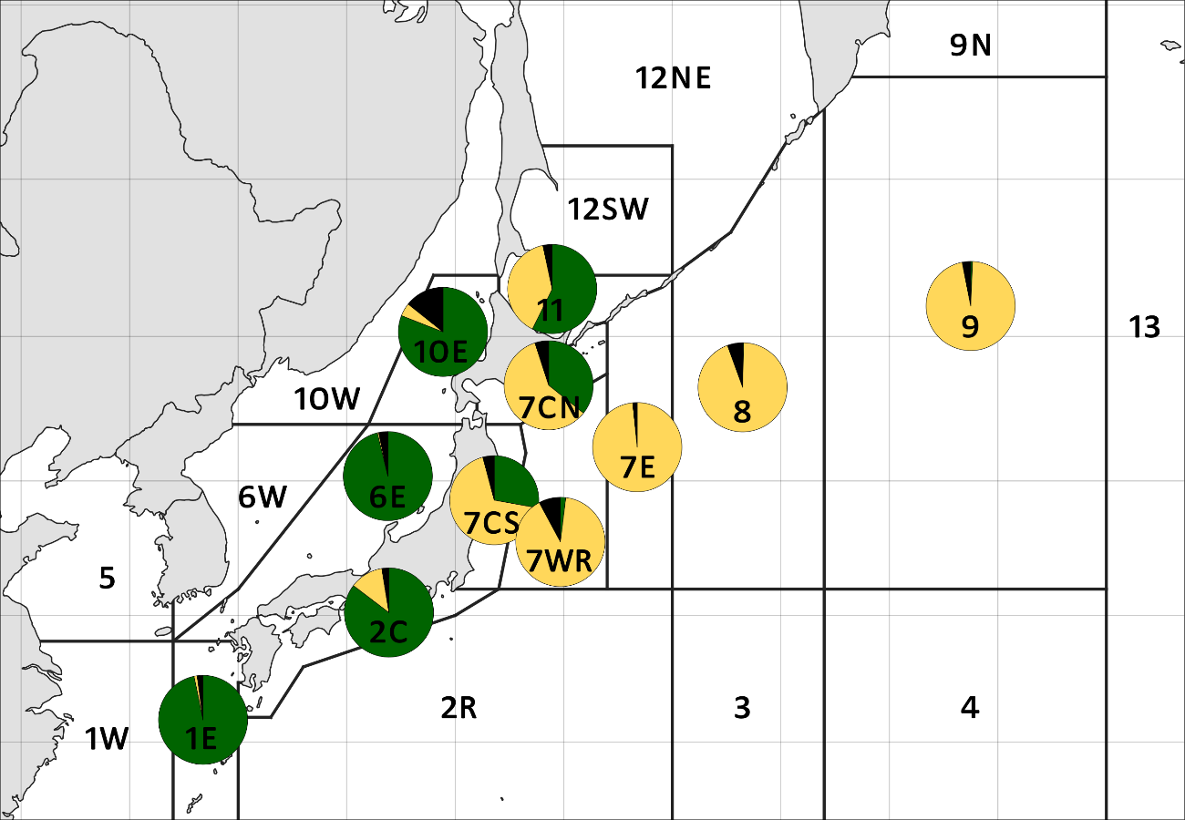

Fig. S2. Proportions of individuals assigned to the J (green) and O (orange) stocks by STRUCTURE at an 80% assignment threshold in each sub-area. Individuals with membership probabilities below 80% are shown in black.

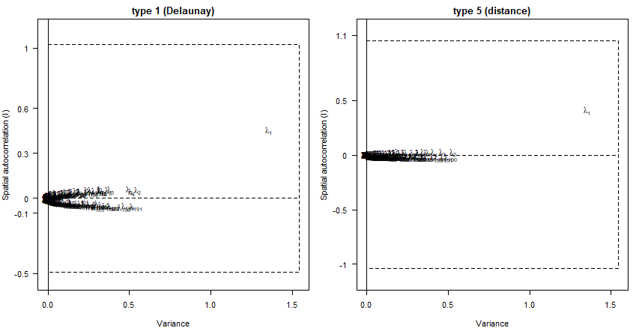

Fig. S3. sPCA screeplots showing eigenvalues in terms of genetic variance and spatial autocorrelation, based on two alternative connection networks: Delaunay triangulation (type 1; left) and distance-based neighborhoods (type 5; right).

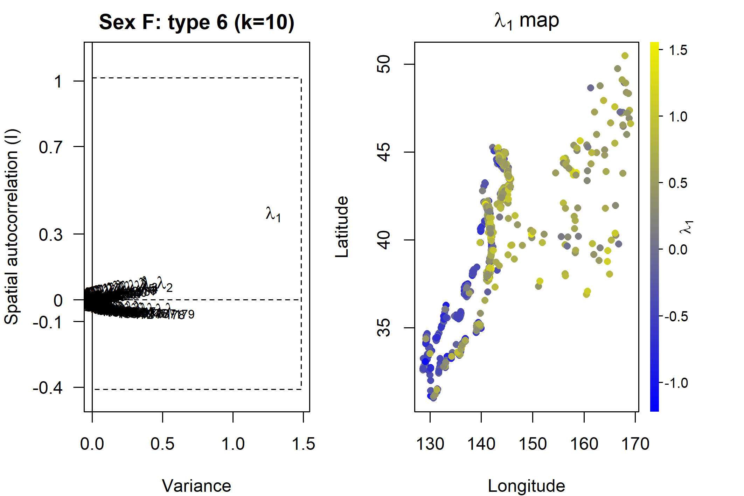
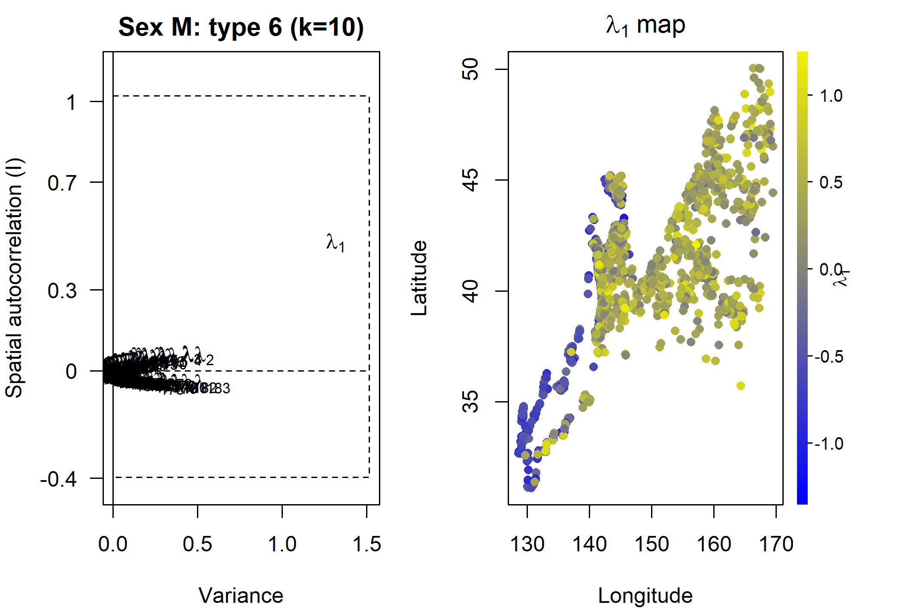
Fig. S4. sPCA results for females (top) and males (bottom) using a k-nearest neighbor connection network: screeplots (left) of eigenvalues maximizing genetic variance and spatial autocorrelation, and geographic distribution (right) of the first global score (λ1). The color scale for the geographic maps represents the first global score.

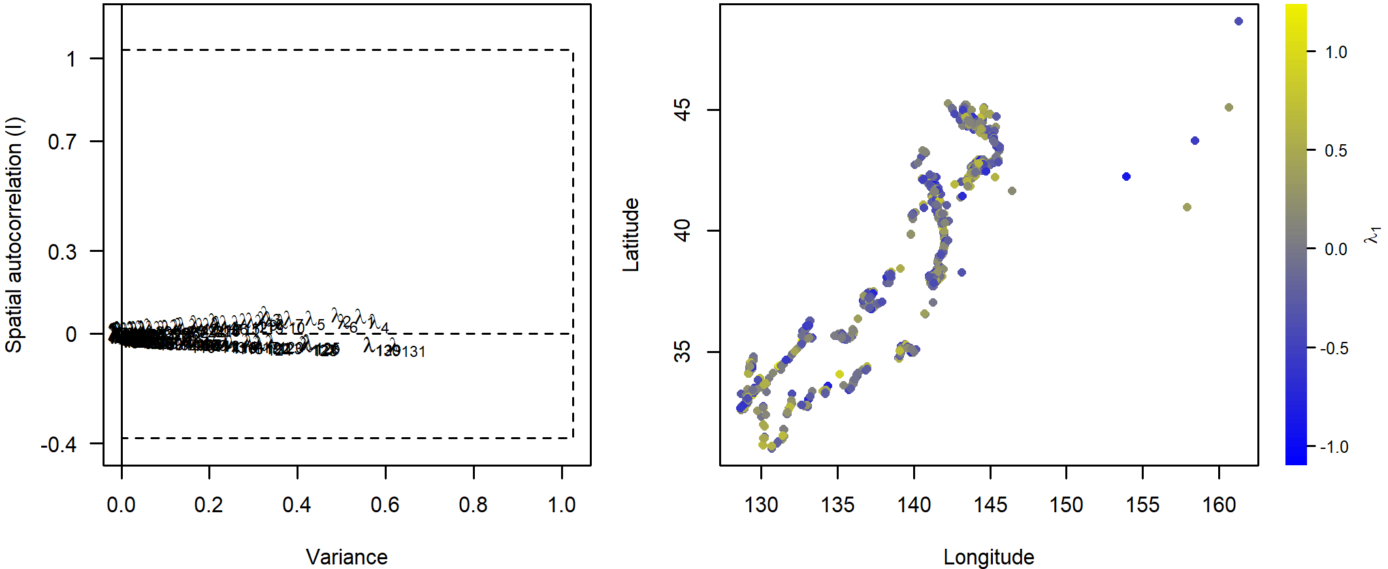

Fig. S5. Result of sPCA for the J stock using a k-nearest neighbor connection network. The scree plot is shown on the left, and the geographic distribution of individual scores on the first global axis (λ1) is shown on the right.

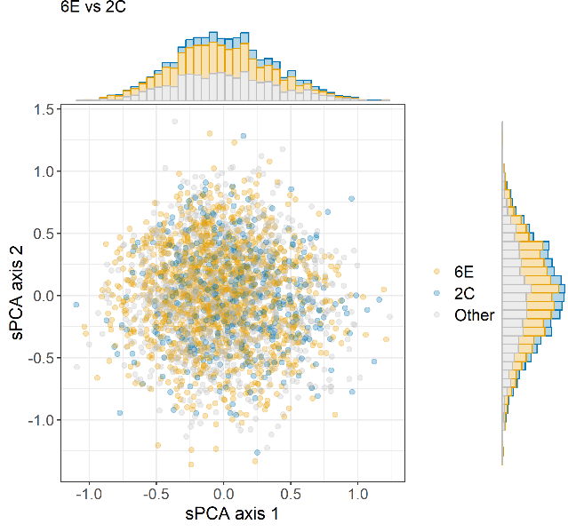
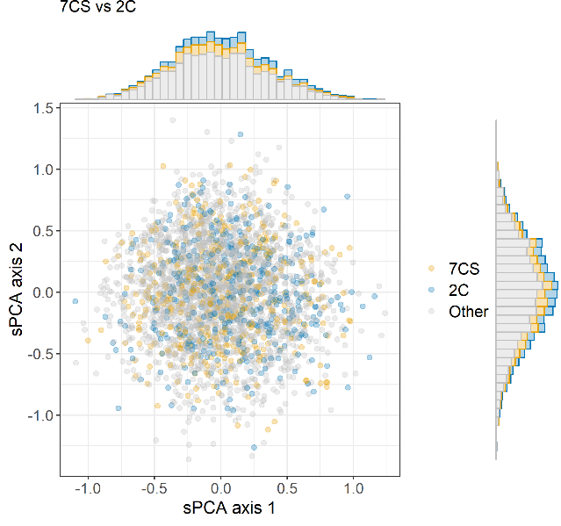

Fig. S6. Scatter plots of the first two global scores from the sPCA of all individuals assigned to the J stock using a k-nearest neighbor connection network, highlighting individuals from the two pairs of sub-areas showing significant heterogeneity in microsatellite allele frequencies: 6E and 2C (left) and 7CS and 2C (right). Marginal histograms show the distributions of individual scores along each sPCA axis.

