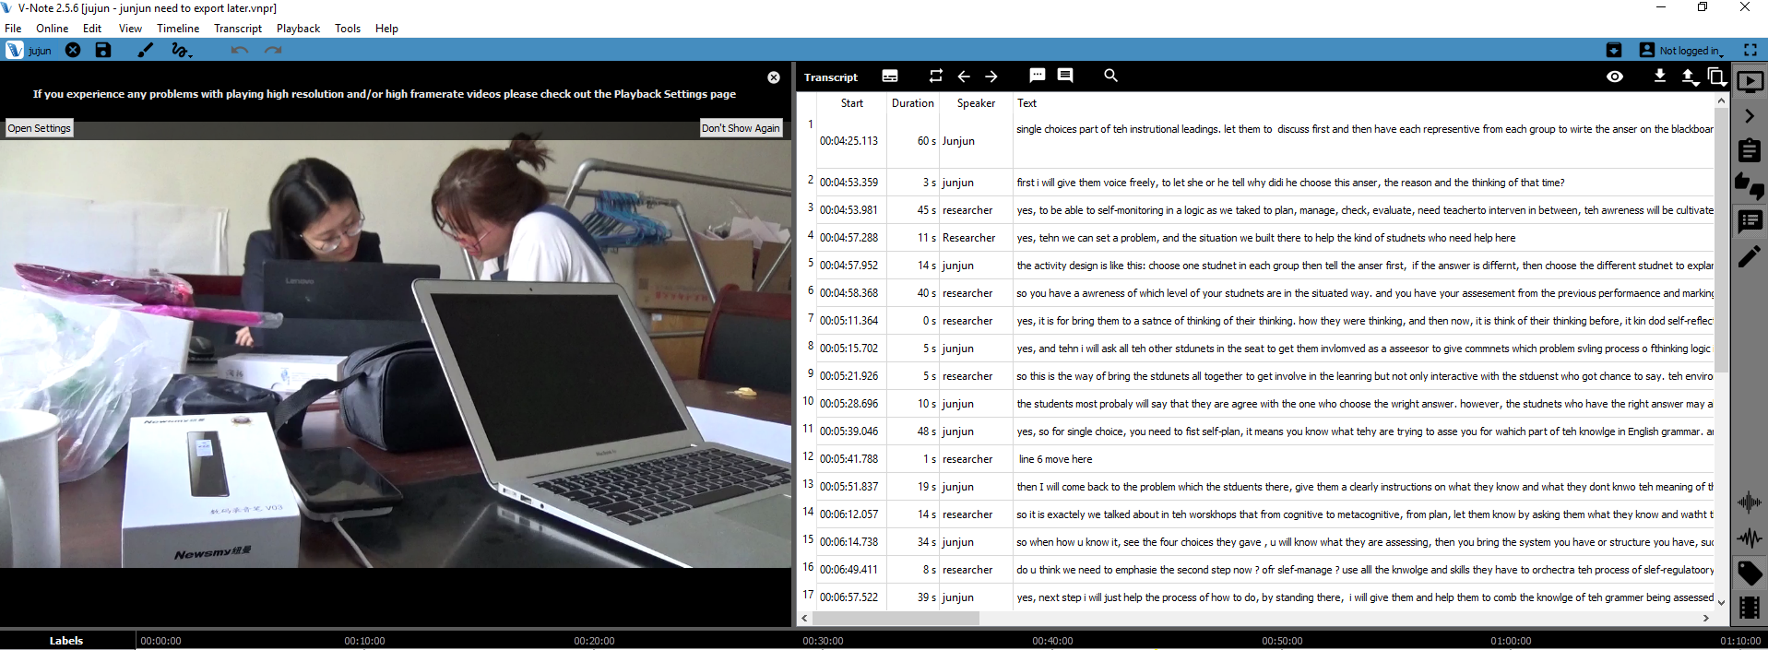
Appendix 1 one example of an instructional co-designing scene with one of the teachers

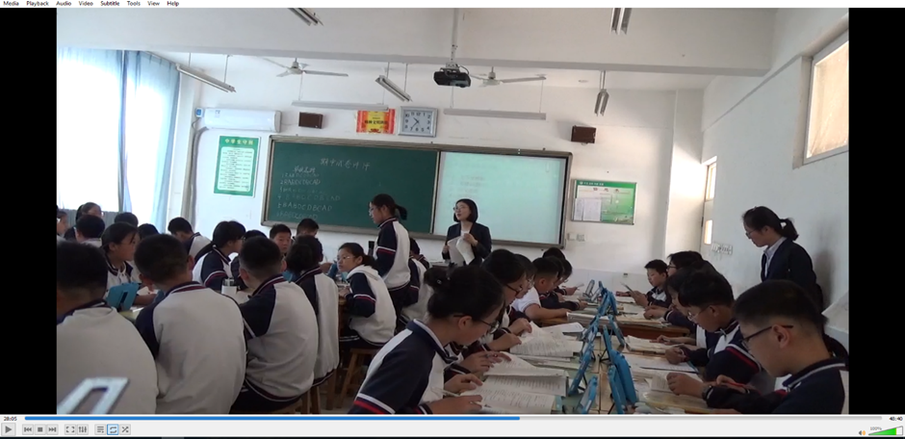
Appendix 2: an example picture was taken from one of the classroom observation

