Supplementary Material

Search strategy development and execution
Electronic search strategies were designed to identify studies reporting the prevalence of high jugular bulb (HJB) and jugular bulb dehiscence (JBD). An experienced information specialist developed the initial strategies, which were peer-reviewed by a second reviewer using the PRESS 2015 Evidence-Based Checklist. Revisions included the addition of variant terminology, the correction of truncation syntax, the refinement of subject headings, and the optimization of Boolean operators.
Searches were conducted across six bibliographic databases: MEDLINE via PubMed, EMBASE via Ovid, Web of Science Core Collection, Scopus, Cochrane CENTRAL, and Google Scholar. All databases were searched from inception through 9 September 2025, with no restrictions on language, publication status, or study design.
Strategies combined controlled vocabulary (MeSH, EMTREE) and free-text terms across three concept groups: (1) anatomical structure (jugular bulb, jugular fossa, bulbus jugularis); (2) anatomical variants (high-riding, high-lying, dehiscence, dehiscent, diverticulum/diverticula); and (3) epidemiological parameters (prevalence, frequency, incidence, proportion, rate, epidemiology). Additional terms considered at extraction included landmarks (round window, internal auditory canal, basal cochlear turn) and imaging modalities (CT, CBCT, MRI, HRCT, temporal bone imaging).
Grey literature sources included ProQuest Dissertations & Theses Global, ClinicalTrials.gov, the WHO International Clinical Trials Registry Platform, and conference proceedings from major otolaryngology and neuroradiology societies. Citation chasing used the reference lists of included studies and the “cited by” function in Web of Science and Scopus.
Search strategies were validated against a sentinel set of nine key studies (Friedmann, 2011; Sayit, 2016; Wang, 2020; Prasad, 2018; Woo, 2012; Atmaca, 2014; Irabien, 2022; Atilla, 1995; Manzoor, 2013), all of which were retrieved in the final iterations.
Human limits were applied where available (PubMed/EMBASE) and verified against the sentinel set to ensure no loss of recall.

Expanded eligibility criteria and operational coding rules
Operational definitions were taken verbatim from the study authors to support harmonization across definition families. For HJB, eligible definitions included landmark-referenced criteria (e.g., jugular bulb dome at/above the round window [RW], internal acoustic meatus [IAM] floor, basal cochlear turn, or inferior tympanic annulus) and/or explicit quantitative thresholds when stated. For JBD, eligibility required radiologic or anatomic evidence of absence of the bony plate over the jugular bulb; when specified, JBD subtypes (e.g., middle-ear wall dehiscence, jugular bulb–vestibular aqueduct/endolymphatic sac [VA/ES] region involvement, or other inner-ear–adjacent defects) were extracted. Studies describing only jugular bulb diverticulum or cortical thinning without an explicit bony plate defect were not classified as JBD unless dehiscence was clearly stated. Laterality (right/left) and bilaterality were extracted when reported. For potentially overlapping cohorts, the most comprehensive and/or most recent report that contributed the most significant non-overlapping sample was retained; additional reports were excluded or used only for clearly non-overlapping strata (e.g., distinct age groups or distinct operational definitions), as appropriate.

Data collection, coding, and data integrity procedures
Two reviewers independently extracted study-level data with arbitration by consensus. Core fields included study citation, sample size, imaging or ascertainment method, and unit of analysis (persons vs ears/temporal bones). Group characteristics were extracted when reported, including enrichment for temporal bone or middle-ear pathology and clinical indications (e.g., chronic otitis media, cholesteatoma, otosclerosis, cochlear implant work-up, trauma, vascular variants, tumors, congenital anomalies, prior surgery). Non-English reports were screened and translated.
Outcomes comprised the prevalence numerator and denominator for HJB and JBD, along with the verbatim operational definitions provided by each study. HJB definitions were mapped to prespecified harmonized categories: at/near the internal auditory meatus (IAM) floor; at/above the basal cochlear turn; above the round window; above the inferior tympanic annulus; quantitative threshold-based definitions; and other/unspecified. JBD was coded only when the report explicitly described radiologic or anatomic absence of the bony plate over the jugular bulb; when available, JBD subtypes were extracted (e.g., middle-ear wall dehiscence, jugular bulb–vestibular aqueduct dehiscence, and other inner-ear–adjacent defects). Studies describing jugular bulb diverticulum or cortical thinning without an explicit plate defect were not classified as JBD. Definition coding was cross-validated by two reviewers, who mapped verbatim criteria to harmonized families; disagreements were resolved by consensus.
Numerators were not imputed. Denominators were not imputed unless directly reconstructable from the text or tables. Per-ear and per-person datasets were curated and analyzed separately to prevent cross-mixing of denominators; conversion between units was not performed unless bilateral data permitted exact reconstruction. When a study reported multiple non-independent estimates (e.g., alternative definitions or multiple subgroups), one prespecified primary estimate was selected for the main meta-analysis; remaining estimates were retained for multilevel or robust-variance sensitivity analyses.
Data quality checks assessed range and internal consistency, units, duplication, and coding completeness. Numerator values were verified to be ≤ denominator values; prevalences were expressed as percentages (0–100%), and reported percentages were reconciled with extracted counts within ±0.5 percentage points where comparable. Denominator units were audited to prevent inadvertent mixing of per-patient and per-temporal-bone datasets in primary analyses. Potential duplicate/overlapping cohorts were evaluated based on author/year/institution, recruitment window, setting, and identical or highly similar sample sizes; overlapping datasets were handled in accordance with the prespecified protocol.
A sensitivity analysis excluded cohorts enriched for temporal bone or middle-ear pathology to approximate background prevalence. A secondary analysis grouped studies by definition category to evaluate operational-definition–driven variability in prevalence estimates.

Risk-of-bias tool and scoring rules (NOS adaptation)
Methodological quality was assessed using an a priori adaptation of the Newcastle–Ottawa Scale (NOS) for case–control studies, tailored to prevalence evidence on HJB and JBD. Selection Item 3 (selection of controls) and Exposure Item 3 (non-response rate) were removed as not applicable, yielding a 7-point instrument: Selection (3 points), Comparability (2 points), and Exposure/Outcome (2 points). Two reviewers independently rated each study after a calibration exercise on a pilot set; disagreements were resolved by consensus. Inter-rater agreement was summarized using Cohen’s κ with 95% confidence intervals.

Selection domain (maximum three stars).
One star was awarded for a clear, reproducible case definition anchored to recognized criteria: for HJB, definitions tied to established landmarks (e.g., RW- or IAM-related, at/above the basal cochlear turn, above the round window, or a quantitative threshold); for JBD, explicit radiologic or anatomic absence of the bony plate over the jugular bulb. A second star reflects representativeness of the sampling frame (e.g., consecutive or population-based cohorts versus narrowly referred surgical series without justification). A third star required a transparent and symmetrical definition of non-cases (non-HJB or non-JBD), applying the same acquisition planes, thresholds, and reading rules as for cases. Reports describing only cortical thinning or diverticulum without an explicit plate defect were not classified as JBD and were scored accordingly.

Comparability domain (maximum two stars).
One star was awarded for design or analysis addressing age and/or sex (e.g., restriction, matching, stratification, or stratum-specific prevalence reporting). A second star was awarded if at least one prespecified technical or context factor was addressed, such as imaging modality/parameters (e.g., CT vs CBCT; slice thickness thresholds), scanner era, clinical setting/indication (general imaging vs ENT/otology referral), or geography. Acceptable control methods included matching, stratified reporting, or prespecified subgroup analyses; covariate listing without control did not qualify.

Exposure/Outcome domain (maximum two stars).
One star required an appropriate reference method with sufficient detail to reproduce the measurement and ascertainment, including (as applicable) high-resolution CT/CBCT with reported slice thickness and reconstruction approach, MRI with reported field strength, anatomical dissection, or histology, alongside qualified readers and preferably consensus or blinded assessment. A second star required uniform acquisition and reading procedures across all participants/ears. Inter-reader agreement reporting was extracted when available; when absent, it did not preclude this star if procedures were otherwise uniform. For anatomical studies, specimen selection procedures and inspection method (macroscopy vs histology) informed these judgments.

Overall scoring, eligibility for pooling, and handling of missing reporting. Each study received a total score from 0 to 7. Studies scoring ≥4 points were eligible for quantitative synthesis; those scoring <4 were excluded from pooling but described qualitatively. Unclear or unreported items were scored as not meeting the criterion (no star) rather than assumed adequate.

Use of risk-of-bias assessments in analyses.
The impact of methodological quality was examined using prespecified approaches: (i) leave-one-out influence analyses, (ii) meta-regression and sensitivity pooling, and (iii) definition-specific analyses to probe measurement-domain effects.

Statistical analysis
Study-level 95% CIs were computed using Wilson or Jeffreys methods (preferred over Wald intervals for small samples and for proportions near 0% or 100%). Zero-event strata were retained without ad hoc continuity corrections using the Jeffreys approach. For each extracted row (study/stratum), we recorded the event count and denominator, and audited counts/percentages for internal consistency.

Primary pooling model and dependence handling
Pooled prevalences were obtained using a GLMM on the logit scale with REML estimation of τ² under a binomial likelihood. Back-transformed pooled estimates were reported as percentages with 95% CIs and 95% PIs. When studies contributed multiple non-independent strata within the same denominator stream (e.g., numerous operational definitions or prespecified subgroups), all eligible strata were retained, and within-study dependence was addressed using CRVE with a CR2 small-sample correction and Satterthwaite degrees of freedom, clustering by study.

Definition-family mapping and pooling rules
Verbatim HJB definitions were harmonized into mutually exclusive definition families (Table 1). Mapping rules were applied to the author-stated definition; if multiple criteria were presented and were analytically separable, the study contributed multiple definition-specific strata (handled via CRVE as above). Definition-family pooling followed prespecified minimum-information rules: for k≥3 within a family, random-effects GLMM pooling was performed; for k=2, pooling was reported but interpreted descriptively due to imprecision; for k=1, no pooling was performed, and the single-study estimate with Jeffreys/Wilson CI was reported.

Subgroup analyses and meta-regression
Definitional heterogeneity was evaluated using prespecified subgroup analyses across definition families and, where data permitted, random-effects meta-regression on logit-transformed prevalence with definition family as a categorical moderator (reference: IAM floor), fitted separately for per-ear and per-person streams with REML τ². Back-transformed predicted prevalences with 95% CIs were obtained for each family; omnibus and family-specific contrasts were reported. When only a single study defined a family, its observed Jeffreys CI was presented descriptively and excluded from inferential contrasts. The proportion of between-study variance explained was quantified as the reduction in τ² relative to the unmoderated model.

Sensitivity analyses and alternative estimators
Robustness was examined a priori using an alternative random-effects approach based on the Freeman–Tukey double-arcsine transformation, with REML for τ² and Hartung–Knapp adjustment where appropriate. If alternative models failed to converge or yielded boundary estimates of τ², the Paule–Mandel or DerSimonian–Laird estimators were used in sensitivity analyses and compared with the GLMM results. Additional sensitivity analyses excluded pathology-enriched cohorts (e.g., chronic otitis media, Menière’s/endolymphatic hydrops, symptomatic ENT referrals).

Influence diagnostics
Influence was examined using studentized residuals, Cook’s distance, and leave-one-out re-pooling, with prespecified thresholds (e.g., |studentized residual| > 2 or Cook’s distance > 4/n). Pooled results were compared with and without the influential strata.

JBD context analyses
JBD prevalence was additionally evaluated by anatomical context using three families: (i) middle ear/tympanic cavity exposure, (ii) inner-ear structure involvement (e.g., vestibular/cochlear aqueduct, posterior semicircular canal), and (iii) site not specified. Primary models employed the same GLMM (logit-REML) framework in separate per-ear and per-person panels. As a sensitivity analysis, an inverse-variance random-effects model on logit-transformed proportions was fitted using a 0.5 continuity correction for zero cells. For subgroup differences, Wald-type tests from meta-regression (small-sample corrected where applicable) were used, with Cochran’s Q as a fixed-effects check.

Study selection process
Records were exported to EndNote 20 and deduplicated using the Bramer method (automated field-based matching plus manual verification).
Two reviewers independently screened all titles and abstracts against predefined eligibility criteria. Studies were included if they: (1) reported original prevalence data for HJB or JBD; (2) used radiologic imaging (CT, CBCT, MRI) or cadaveric dissection; (3) provided explicit diagnostic criteria or anatomical landmarks; and (4) included quantitative prevalence estimates or raw data enabling calculation. We excluded case reports, case series with <10 participants, narrative reviews without original data, and studies lacking extractable prevalence.
Inter-rater agreement for title/abstract screening was Cohen’s κ = 0.78 (95% CI 0.72–0.84). Discrepancies were resolved through discussion and consensus, with adjudication as needed.
Full texts of potentially eligible reports were retrieved and independently assessed by two reviewers. Reasons for exclusion at the full-text level were recorded. Agreement at full text was Cohen’s κ = 0.89 (95% CI 0.84–0.93).
Data were extracted independently by two reviewers using a standardized form, which was pilot-tested on five studies, to capture study characteristics, demographics, imaging parameters, diagnostic criteria for HJB/JBD, and prevalence (with 95% CIs when available).
Numerators were not imputed, and denominators were only reconstructed when explicitly derivable from text or tables. Per-ear and per-person datasets were curated separately; conversion between units was performed only when bilateral data permitted exact reconstruction.

Search results
Records identified from databases (n = 3,014) and registers (n = 64) totaled 3,078. After removal of duplicates before screening (n = 718), 2,360 records were screened at the title/abstract. 1,904 records were excluded. 456 reports were sought for retrieval; 13 full texts could not be obtained. 443 reports were assessed for eligibility. 394 were excluded at full text for the following reasons: wrong outcome (no prevalence/definition) n = 217; wrong design (case report/series <10, review/editorial) n = 138; duplicated data or cohort overlap n = 4; insufficient imaging/anatomical detail to classify n = 35. 49 studies were included in the quantitative synthesis (meta-analysis).
The PRISMA 2020 flow diagram is presented in Figure 1. Reporting follows PRISMA-S guidance.

Database-specific search strategies
PubMed (MEDLINE) — searched 7 Sep 2025
("jugular bulb"[MeSH Terms] OR "jugular bulb"[tiab] OR "jugular fossa"[tiab] OR "bulbus jugularis"[tiab])
AND
("high-riding"[tiab] OR "high riding"[tiab] OR "high-lying"[tiab] OR "high lying"[tiab] OR "dehiscence"[tiab] OR "dehiscent"[tiab] OR "diverticulum"[tiab] OR "diverticula"[tiab])
AND
(prevalence[tiab] OR frequency[tiab] OR incidence[tiab] OR proportion[tiab] OR rate[tiab] OR epidemiolog*[tiab] OR "cross sectional"[tiab] OR "observational study"[tiab])
NOT (animals[MeSH Terms] NOT humans[MeSH Terms])
EMBASE via Ovid — searched 7 Sep 2025
1. 'jugular bulb'/exp OR 'jugular bulb':ti,ab OR 'jugular fossa':ti,ab OR 'bulbus jugularis':ti,ab
2. 'high-riding':ti,ab OR 'high riding':ti,ab OR 'high-lying':ti,ab OR 'high lying':ti,ab
3. dehiscence:ti,ab OR dehiscent:ti,ab OR diverticulum:ti,ab OR diverticula:ti,ab
4. prevalence:ti,ab OR frequency:ti,ab OR incidence:ti,ab OR proportion:ti,ab OR rate:ti,ab OR epidemiolog*:ti,ab OR 'cross sectional':ti,ab
5. 1 AND (2 OR 3) AND 4
6. limit 5 to human
7. limit 6 to (Embase NOT Medline)
Web of Science Core Collection — searched 8 Sep 2025
TS=("jugular bulb" OR "jugular fossa" OR "bulbus jugularis")
AND
TS=("high-riding" OR "high riding" OR "high-lying" OR "high lying" OR "dehiscence" OR "dehiscent" OR "diverticulum" OR "diverticula")
AND
TS=(prevalence OR frequency OR incidence OR proportion OR rate OR epidemiolog*)
Scopus — searched 8 Sep 2025
TITLE-ABS-KEY("jugular bulb" OR "jugular fossa" OR "bulbus jugularis")
AND
TITLE-ABS-KEY("high-riding" OR "high riding" OR "high-lying" OR "high lying" OR "dehiscence" OR "dehiscent" OR "diverticulum" OR "diverticula")
AND
TITLE-ABS-KEY(prevalence OR frequency OR incidence OR proportion OR rate OR epidemiolog*)
Cochrane CENTRAL — searched 9 Sep 2025
("jugular bulb" OR "jugular fossa" OR "bulbus jugularis")
AND
("high-riding" OR "high riding" OR "high-lying" OR "high lying" OR "dehiscence" OR "dehiscent" OR "diverticulum" OR "diverticula")
AND
(prevalence OR frequency OR incidence OR proportion OR rate OR epidemiolog*)
Google Scholar — searched 9 Sep 2025
("jugular bulb" OR "jugular fossa" OR "bulbus jugularis")
("high-riding" OR "high riding" OR "high-lying" OR "high lying" OR dehiscence OR dehiscent OR diverticulum OR diverticula)
(prevalence OR frequency OR incidence OR proportion OR epidemiology)
The first 200 results sorted by relevance were screened.

Small-study effects
Small-study effects were assessed a priori using Doi plots (Figure S1) and Peters’ regression, implemented as a weighted linear regression of logit-transformed prevalence on the inverse of total sample size (1/N) with inverse-variance weights (w = 1/SE² of the logit). Standard errors of the logit were computed from continuity-corrected counts (x+0.5, n−x+0.5):
Var[logit(p)] = 1/(x+0.5) + 1/(n−x+0.5).
Doi plots are provided for four analysis streams (HJB/JBD × per-patient/per-ear). We report two-sided p-values for the Peters slope (using a normal approximation); these are descriptive indicators of small-study effects in prevalence syntheses and should not be interpreted as evidence of publication bias.
Peters’ test: HJB per patient p = 0.054 (k = 19); HJB per ear/temporal bone p = 0.0089 (k = 31); JBD per patient p = 0.198 (k = 14); JBD per ear/temporal bone p = 1.37×10⁻⁶ (k = 14).
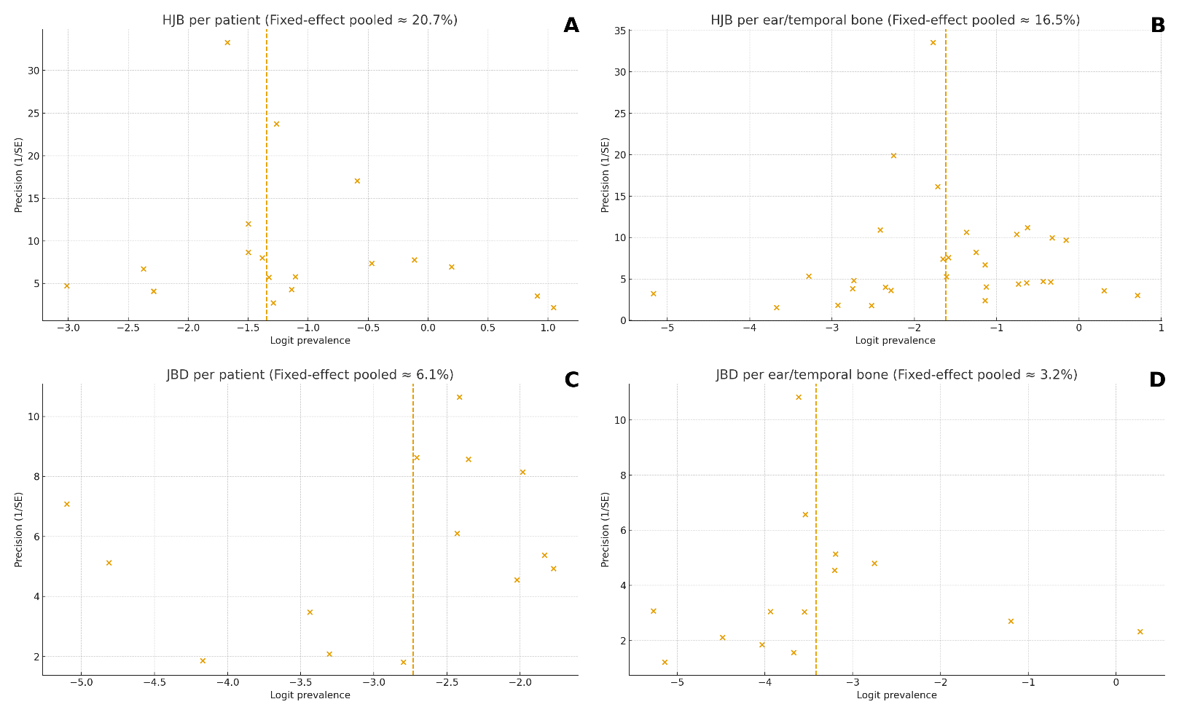
Figure S1. Doi plots for high jugular bulb (HJB) and jugular bulb dehiscence (JBD) (A–D). A: HJB, per patient. B: HJB, per ear/temporal bone. C: JBD, per patient. D: JBD, per ear/temporal bone. Each panel displays study logit-transformed prevalence (x-axis) versus precision (1/SE) (y-axis). The dashed vertical line indicates the fixed-effect center (as indicated in each title) and serves only as a visual reference; the primary pooling in the manuscript uses a random-effects GLMM with cluster-robust SEs. A Haldane–Anscombe ±0.5 continuity correction was applied before transformation to handle 0% or 100% cells. Apparent asymmetry may reflect small-study effects and/or definitional/contextual heterogeneity; interpret alongside prediction intervals and prespecified sensitivity analyses.
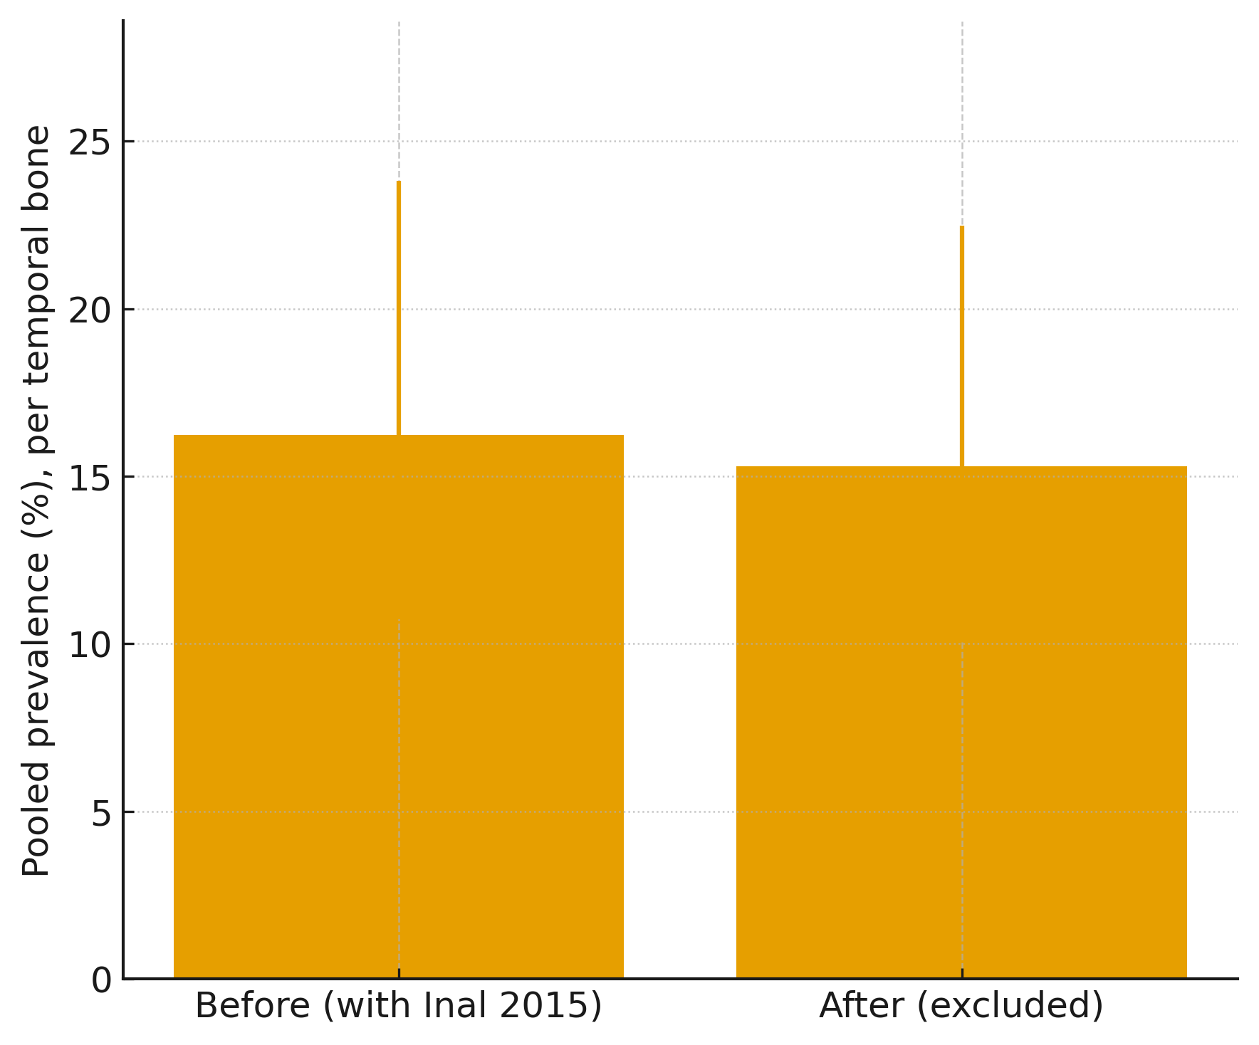
Figure S2. Comparison of pooled prevalence estimates (per temporal bone) of high jugular bulb before and after exclusion of Inal et al. (2015). Bars represent pooled prevalence with 95% confidence intervals.

