A model-based exploration of farm-household livelihood and nutrition indicators to guide nutrition-sensitive agriculture interventions
Natalia Estrada Carmona^{1,2*}, Jessica E. Raneri^{2,4}, Stephanie Alvarez¹, Carl Timler¹, Shantonu Abe Chatterjee¹, Lenora Ditzler¹, Gina Kennedy², Roseline Remans², Inge Brouwer³, Karin Borgonjen-van den Berg ³, Elise F. Talsma³, Jeroen C.J. Groot ^{1,5,6}

Affiliations:
¹ Farming Systems Ecology Group, Wageningen University and Research, 6700AK Wageningen, The Netherlands.
² Bioversity International, Parc Scientifique Agropolis II, 1990 Boulevard de la Lironde, 34397 Montpellier, France.
³ Division of Human Nutrition and Health, Wageningen University and Research, 67000AA Wageningen, The Netherlands.
⁴ Department of Food Safety and Food Quality, Faculty of Bioscience Engineering, Ghent University, 9000 Ghent, Belgium.
⁵ Bioversity International, Viale dei Tre Denari, 472/a, 00054 Maccarese (Fiumicino), Italy
⁶ International Maize and Wheat Improvement Center (CIMMYT), Carretera México-Veracruz, Km. 45, El Batán, 56237 Texcoco, México

* Corresponding author email: n.e.carmona@cgiar.org; phone: +33(0)4 27 04 04 49; ORCID ID 0000-0003-4329-5470

_____________________________________________________________________________________________

Appendix 2. Visual representation of the farm-household
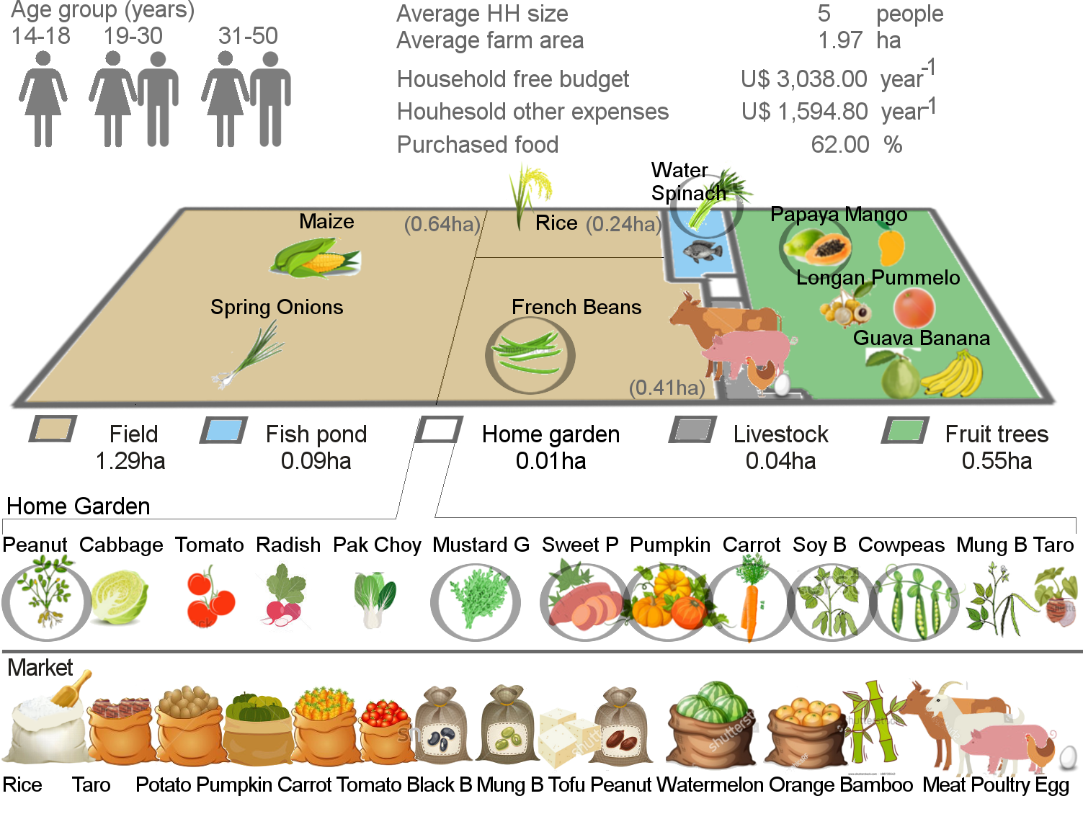
Fig. A2 Visual representation of the Baseline farm-household. The figure represents the household demographics and economic aspects as well as the cultivated crops in the farm, the different components of the farm and its areas. Finally, the icons at the bottom depict the food consumed from off-farm sources (i.e. market). The Selected Crops for the nutrition sensitive intervention are indicated by the grey circle. All the vector illustrations were sourced and adapted from Shutterstock (E).

