A model-based exploration of farm-household livelihood and nutrition indicators to guide nutrition-sensitive agriculture interventions
Natalia Estrada Carmona^{1,2*}, Jessica E. Raneri^{2,4}, Stephanie Alvarez¹, Carl Timler¹, Shantonu Abe Chatterjee¹, Lenora Ditzler¹, Gina Kennedy², Roseline Remans², Inge Brouwer³, Karin Borgonjen-van den Berg ³, Elise F. Talsma³, Jeroen C.J. Groot ^{1,5,6}

Affiliations:
¹ Farming Systems Ecology Group, Wageningen University and Research, 6700AK Wageningen, The Netherlands.
² Bioversity International, Parc Scientifique Agropolis II, 1990 Boulevard de la Lironde, 34397 Montpellier, France.
³ Division of Human Nutrition and Health, Wageningen University and Research, 67000AA Wageningen, The Netherlands.
⁴ Department of Food Safety and Food Quality, Faculty of Bioscience Engineering, Ghent University, 9000 Ghent, Belgium.
⁵ Bioversity International, Viale dei Tre Denari, 472/a, 00054 Maccarese (Fiumicino), Italy
⁶ International Maize and Wheat Improvement Center (CIMMYT), Carretera México-Veracruz, Km. 45, El Batán, 56237 Texcoco, México

* Corresponding author email: n.e.carmona@cgiar.org; phone: +33(0)4 27 04 04 49; ORCID ID 0000-0003-4329-5470

_____________________________________________________________________________________________

Appendix 3. Modelled diet in Doan Ket Baseline farm
The modelled diet in the Baseline farm from the 7-day dietary recall and extrapolated to a yearly consumption follows a similar pattern in the region from the general nutrition survey 2009-2010 (NIN 2012; Fig. A3). The modelled diet potentially underestimated the consumption of dark green leafy vegetables, eggs and nuts, and seeds whereas potentially overestimated the consumption of the other food groups.
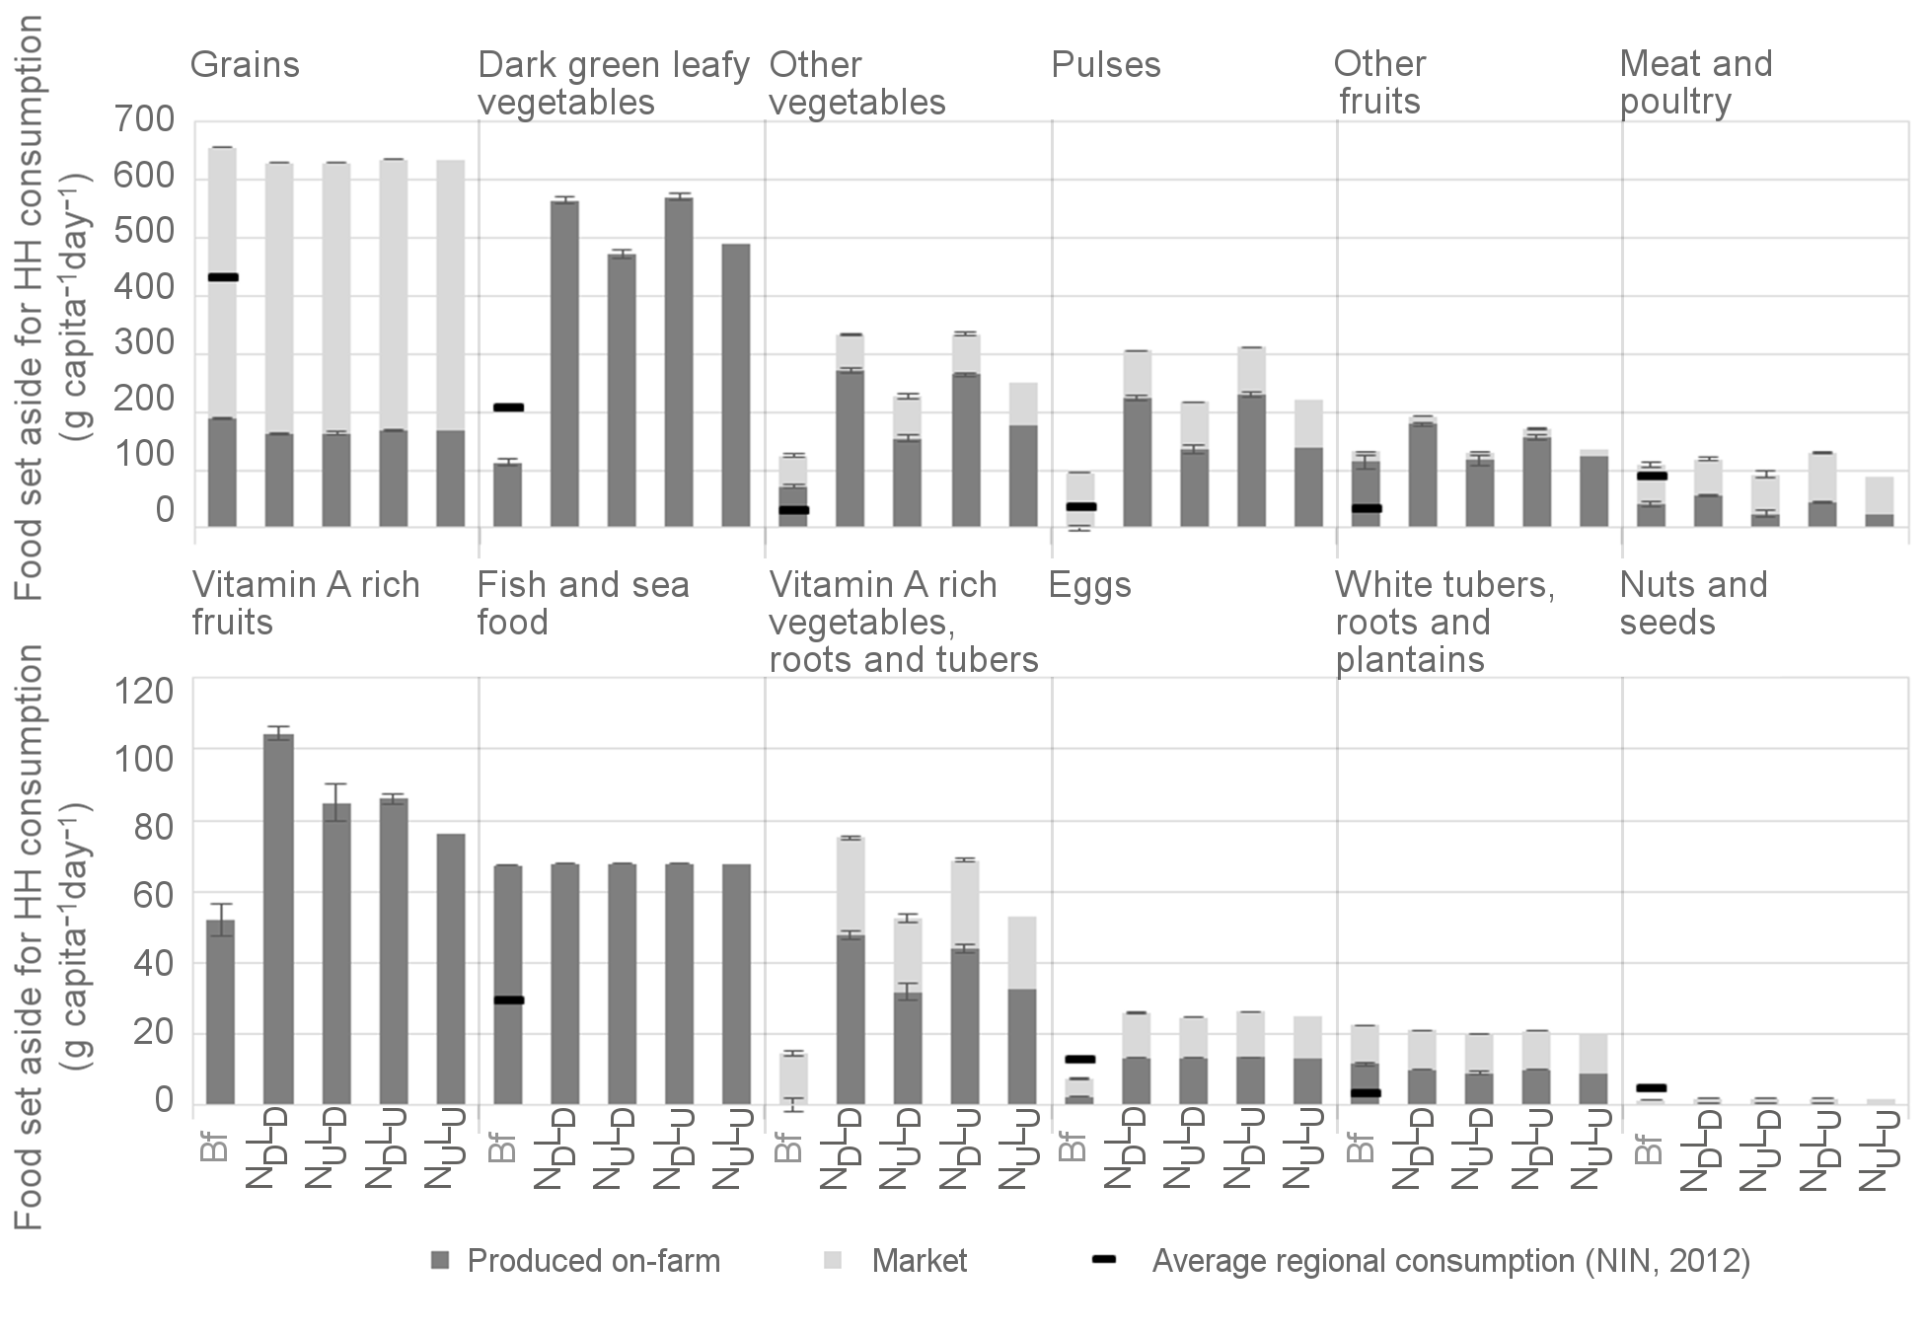
Fig. A3 Quantity of food set aside for household (HH) consumption per food group from both on- and off-farm sources. Error bars indicate standard error for each group of alternative farm configurations given desirable (+) or undesirable (–) Nutrition (N) or Livelihoods (L) outcomes. Black lines indicate the average (maximum and minimum) values consumed in the North Central area and the central coastal region of Vietnam in 2009-2010 (NIN 2012). Bf: Baseline farm.

References Appendix 3
NIN (2012). Vietnam General Nutrition Survey 2009-2010. General Statistics Office (Viet Nam), Ministry of Health (Vietnam), National Institute of Nutrition (Vietnam), United Nations Children's Fund (UNICEF). https://www.unicef.org/vietnam/resources_21138.html. Accessed 10 January 2018

