Supplementary online materials for the article
Integrating the soybean-maize-chicken value chains to attain nutritious diets in Tanzania
Journal of Food Security (FOSE)
Wilson Charles Wilson, Maja Slingerland, Frederick P. Baijukya, Hannah van Zanten, Simon Oosting and Ken E. Giller.

Results
Table S1. Crop production and utilization in the Southern Highlands of Tanzania
- Legume production and utilization in the interviewed households during the N2Africa survey¹
 | Bush bean | Soybean | Groundnut | Climbing bean | Cowpea
Number of farmers interviewed (n=448) | 199 | 72 | 111 | 7 | 1
Farm area (ha/household) | 0.7 | 0.9 | 0.9 | 0.5 | 0.4
Legume production; sole crop (kg/household/year) | 493.4 | 525.4 | 376.3 | 317.5 | -
Std. Deviation | 693.2 | 547.3 | 263.6 | 306.5 | -
Legume production in the intercrop (kg/household/year) | 157.6 | 251.7 | 176.3 | 154.0 | 50.0
Std. Deviation | 155.1 | 190.4 | 16.3 | - | -
% consumed | 30.2 | 1.0 | - | - | -
% sold | 50.5 | 99.0 | - | - | -
% other use (seed, stored) | 19.3 | 99.0 | - | - | -
Crop processing and value addition (% farmers) | 1.4 | 0.3 | 1.3 | 0.1 | 0.2
(b) Maize production in the SH regions of Tanzania based on the annual agricultural sampling 2016/17²
Region | Ruvuma | Iringa | Mbeya | Rukwa | Njombe | Katavi | Total (Southern Highlands) | Country’s Total
Planted area (1000 ha/year) | 169 | 113 | 376 | 186 | 135 | 72 | 1,050 | 6,068
Harvested area (1000 ha/year) | 157 | 101 | 335 | 181 | 128 | 70 | 973 | 4,901
Quantity harvested (1000 t/year) | 314 | 163 | 578 | 338 | 223 | 83 | 1,699 | 5,767
Average yield (t/ha/year) | 1.9 | 1.6 | 1.9 | 1.7 | 1.8 | 1.2 | 1.7 | 1.2
Quantity sold (1000 t/year) | 78 | 28 | 133 | 113 | 35 | 11 | 398 | 1,269
Data sources:
¹N2Africa – Tanzania Annual Report (Baijukya et al., 2019)
²The United Republic of Tanzania. Annual agriculture sample survey. Crop and Livestock report (NBS, 2017)
Table S2. Characterization of chicken production systems in urban and rural areas, the case of Iringa region
 |  | Farm location
 |  | Urban (n=48) | Rural (n=73)
Chicken breeds | Traditional (n=94) | 0.34 | 0.66
Chicken breeds | Exotic (n=18) | 0.72 | 0.28
Chicken breeds | Cross-bred (n=33) | 0.58 | 0.42
Chicken breeds | Multiple breeds (n=22) | 0.59 | 0.41
Rearing system | Free range (n=40) | 0.25 | 0.75
Rearing system | Intensive (n=57) | 0.54 | 0.46
Rearing system | Semi-intensive (n=30) | 0.17 | 0.83
Number of chicken per household (mean and range) | Layers¹ (n=21) | 482.80 (9-5700) | 278.00 (30-600)
Number of chicken per household (mean and range) | Broilers¹ (n=14) | 378.00 (15-994) | 220.83 (47-400)
Number of chicken per household (mean and range) | Dual purpose¹ (n=11) | 106.27 (7-500) | 51.10 (2-300)
Products for sale and household consumption | Egg production/week^{1*} | 550.45 (4-11970)ª | 74.91 (0-950)^{b}
Products for sale and household consumption | Eggs sold per week^{1*} | 496.11 (0-11940) ª | 58.29 (0-900) ^{b}
Products for sale and household consumption | Eggs retained for home consumption/week¹ | 11.89 (0-30) ª | 6.76 (0-30) ^{b}
Products for sale and household consumption | Chicken sold/month¹ | 17.97 (0-167) ª | 8.29 (0-61) ^{b}
Products for sale and household consumption | Chicken retained for home consumption/month¹ | 1.80 (0-18) | 1.22 (0-5)
Main sources of feed | Commercial feed (n=35) | 0.54 | 0.46
Main sources of feed | Locally-made feed (n=68) | 0.49 | 0.51
Main sources of feed | Scavenge (n=36) | 0.28 | 0.72
¹mean and minimum and maximum number
Different superscripts (a,b) indicates a significant difference between urban and rural at p-value ≤ 0.05 level
Data source: Survey conducted in Iringa region (Wilson et al, 2021) – Unpublished

Table S3. Categorization of the value chain components categorised into different types based on indegree, outdegree and centrality of the components (summation of the indegree and out-degree) in the integrated soybean-maize-chicken value chain using FCM
Value chain component | Indegree | Outdegree | Centrality | Type
Research and development organisations (local and international) | 0 | 9.5 | 9.5 | driver
Large scale & local hatcheries | 0 | 1.75 | 1.75 | driver
Government policy, regulation | 0 | 13 | 13 | driver
Agricultural Development Bank | 1 | 1.25 | 2.25 | ordinary
Declining soil fertility | 2.3 | 2.2 | 4.5 | ordinary
Effects of climate change | 0.75 | 1 | 1.75 | ordinary
Export burn | 1 | 4.5 | 5.5 | ordinary
AMCOS, VICOBA, SACCOS | 0.75 | 1.5 | 2.25 | ordinary
Inadequate farm machinery | 2 | 1.25 | 3.25 | ordinary
Lack of quality inputs i.e. inoculants, seeds | 1.5 | 0.5 | 2 | ordinary
Farmer group & emerging platform | 2.25 | 3.55 | 5.8 | ordinary
Market uncertainties | 1.8 | 2.25 | 4.05 | ordinary
Limited access to finance | 0.5 | 1.75 | 2.25 | ordinary
High input costs | 0.75 | 2.3 | 3.05 | ordinary
Inadequate knowledge | 2 | 2.35 | 4.35 | ordinary
Lack of market information | 1 | 2 | 3 | ordinary
Soybean production | 10.85 | 2.2 | 13.05 | ordinary
Local consumers | 2 | 1 | 3 | ordinary
Disorganised farmers | 1.75 | 2.25 | 4 | ordinary
Local feed stores/home-made | 1.75 | 1.75 | 3.5 | ordinary
Maize production | 9.75 | 6.75 | 16.5 | ordinary
Imports (soybean meal) | 0.5 | 3.75 | 4.25 | ordinary
Chicken feed processors | 2.35 | 2.35 | 4.7 | ordinary
Inadequate supply of day-old chicks | 2.25 | 0.5 | 2.75 | ordinary
Disorganised market | 4.25 | 1.25 | 5.5 | ordinary
Cash | 8.5 | 1 | 9.5 | ordinary
Existence of diseases and pests | 3 | 3.25 | 6.25 | ordinary
Grain millers | 1.75 | 4 | 5.75 | ordinary
Lack of market infrastructures | 1 | 1.75 | 2.75 | ordinary
Extension & Veterinary services | 1 | 6 | 7 | ordinary
limited access to quality feed | 3.35 | 1 | 4.35 | ordinary
Chicken production (meat and eggs) | 11.85 | 2 | 13.85 | ordinary
Household food | 7.95 | 0 | 7.95 | Receiver

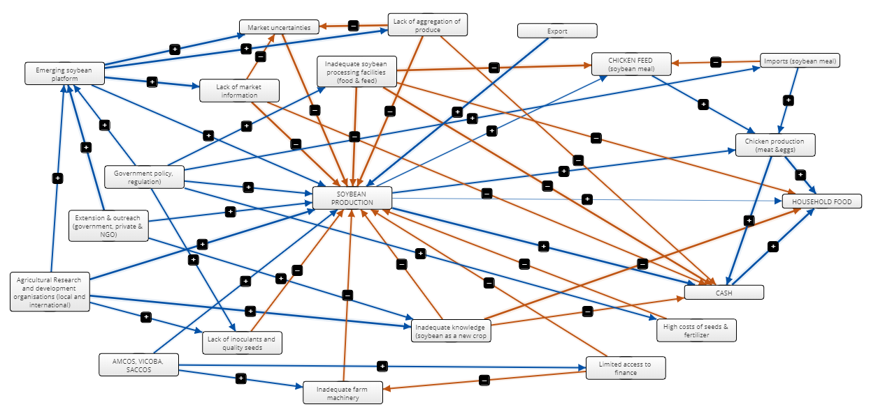

Figure S1. Stakeholders network and relation in the soybean value chain based on the FCM. The colour of the lines indicates whether the relationship is positive (blue) or negative (orange) whereas arrow thickness indicates the strength of the connection between the stakeholders i.e. the thicker the arrow the stronger the relationship. AMCOS stands for Agricultural and Marketing Cooperative Societies while VICOBA and SACCOS sands for Village Community Banks and Savings and Credit Cooperative Societies, respectively.
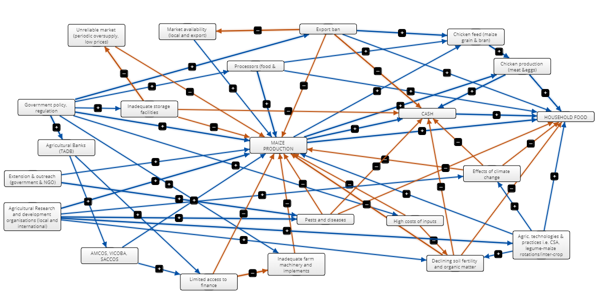
Figure S2. Stakeholders network and relation in the maize value chain based on the FCM. The colour of the lines indicates whether the relationship is positive (blue) or negative (orange) whereas arrow thickness indicates the strength of the relationship between the stakeholders i.e. the thicker the arrow the stronger the relationship. AMCOS stands for Agricultural and Marketing Cooperative Societies while VICOBA and SACCOS sands for Village Community Banks and Savings and Credit Cooperative Societies, respectively.
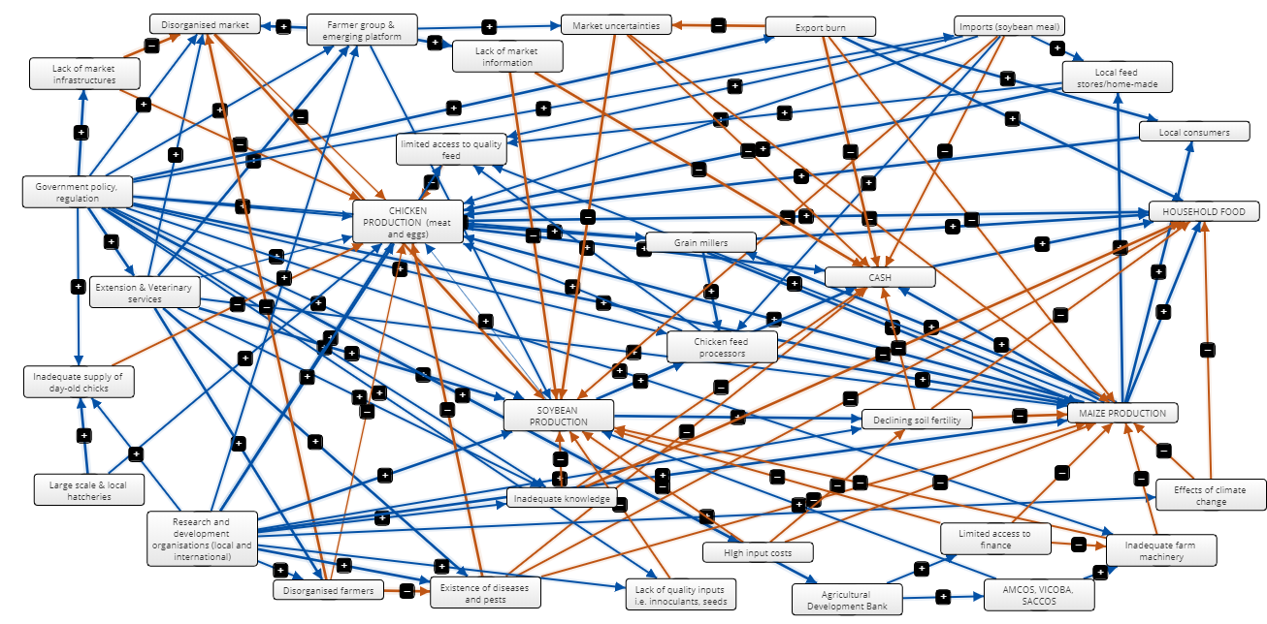 Figure S3. Stakeholders network and relationship in the integrated chicken-maize-soybean value chains using FCM. The colour of the lines indicates whether the relationship is positive (blue) or negative (orange) whereas arrow thickness indicates the strength of the relationship between the stakeholders i.e. the thicker the arrow the stronger the relationship. AMCOS stands for Agricultural and Marketing Cooperative Societies while VICOBA and SACCOS sands for Village Community Banks and Savings and Credit Cooperative Societies, respectively. AMCOS stands for Agricultural and Marketing Cooperative Societies while VICOBA and SACCOS sands for Village Community Banks and Savings and Credit Cooperative Societies, respectively.

