Online Resource 1

Maize-grain zinc and iron concentrations as influenced by agronomic management and biophysical factors: a meta-analysis

Food Security

Job Kihara¹*, Gudeta W Sileshi², Peter Bolo¹, Dominic Mutambu¹, Kalimuthu Senthilkumar³, Andrew Sila¹, Mina Devkota⁴, Kazuki Saito⁵
¹International Center for Tropical Agriculture (CIAT), c/o ICIPE Duduville Complex, Nairobi, Kenya
²Department of Plant Biology and Biodiversity Management, Addis Ababa University, Ethiopia
³Africa Rice Center (AfricaRice), P.O. Box 1690 Ampandrianomby, Antananarivo, Madagascar
⁴International Center for Agricultural Research in the Dry Areas (ICARDA), Rabat, Morocco
⁵Africa Rice Center (AfricaRice), 01 B.P. 2551, Bouaké 01, Cote d’Ivoire
*Corresponding author:
Job Kihara, International Center for Tropical Agriculture (CIAT), c/o ICIPE Duduville Complex, Nairobi, Kenya; e-mail: j.kihara@cgiar.org

Supplementary Figure 1. Empirical distributions of protein, nitrogen and phosphorus concentrations in maize grain
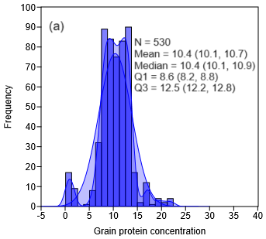 | 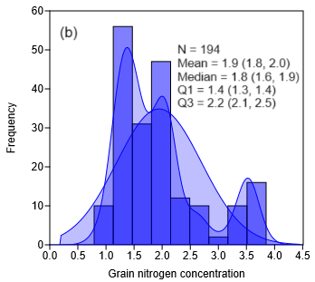
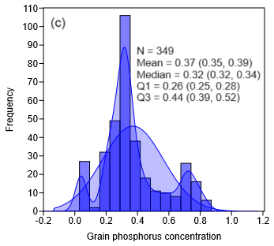
Fig. S1. Empirical distributions of protein, nitrogen, and phosphorus concentrations in maize grain. The jagged and smooth lines represent the kernel density and normal probability distributions of the observed values, respectively. Grain Zn and Fe were expressed in mg kg⁻¹, while protein, nitrogen and P were expressed in %. The lower quartile (Q1) represents the midpoint of values that fall between the smallest and the median of the distribution of the analyzed variable. The median (Q2) represents the midpoint of the entire frequency distribution, while the upper quartile (Q3) represents the midpoint of values that fall between the median and the highest value. N represents the total sample size used for the distribution.

Supplementary Figure 2. Inter-study variation in response ratios of grain yield
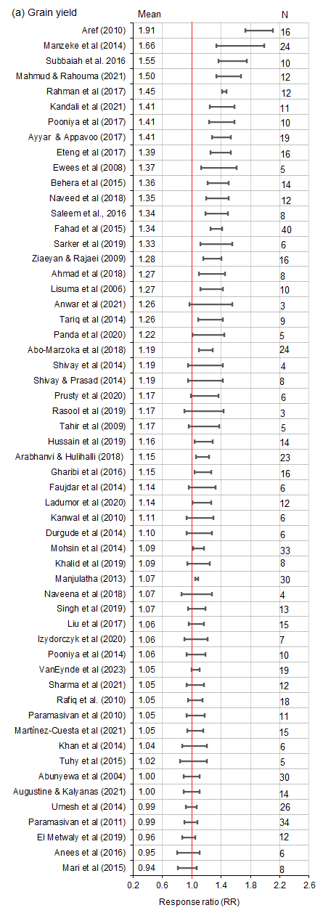
Fig. S2. Variation in the response ratios of grain yield among studies. Horizontal bars represent 95% confidence limits estimated using linear mixed effects models. The red vertical lines represent RR = 1. When the 95% CL encompasses the redline, the treatment is not significantly different from the control. Figures on the left and right sides of the horizontal bars represent the marginal means and the number of studies, respectively. Studies with <3 observations were excluded

Supplementary Figure 3. Inter-study variation in response ratios of grain Zn and Fe

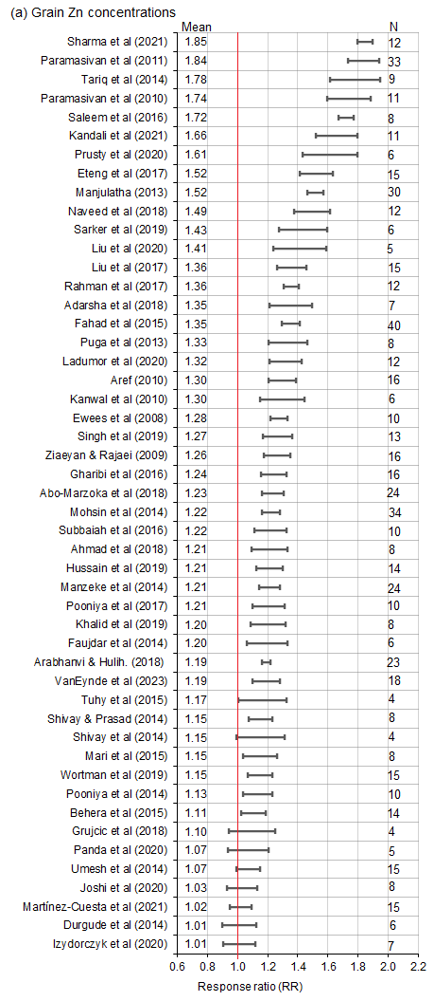 | 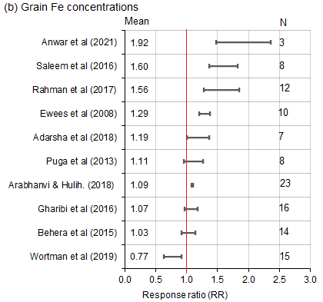
Fig. S3. Variation in the response ratios of grain zinc (Zn) concentrations (a) and grain iron (Fe) concentrations among studies. Horizontal bars represent 95% confidence limits estimated using linear mixed effects models. The red vertical lines represent RR = 1. When the 95% CL encompasses the redline, the treatment is not significantly different from the control. Figures on the left and right sides of the horizontal bars represent the marginal means and the number of studies, respectively

Supplementary Figure 4. Inter-country variation in response ratios of grain yield, Zn and Fe

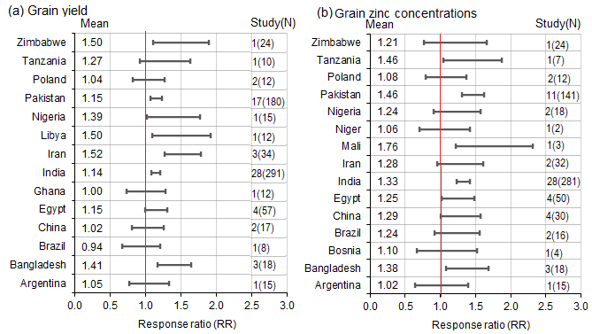
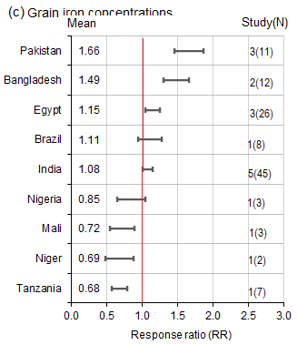
Fig. S4. Variation in response ratios of grain yield, grain zinc and iron concentration among countries in studies where Zn and Fe were applied. Horizontal bars represent 95% confidence limits of means estimated using linear mixed effects models. The red vertical lines represent RR = 1. When the 95% CL encompasses the redline the response in the treatment is not significantly different from the response in the control. Figures on the left and right sides of the horizontal bars represent the marginal means and the number of studies (total sample sizes in parentheses), respectively. Treatments with fewer than 3 observations were excluded

Supplementary Figure 5. Trends in grain Zn and Fe
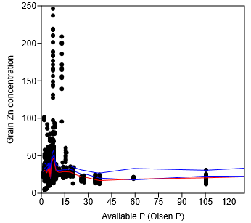 | 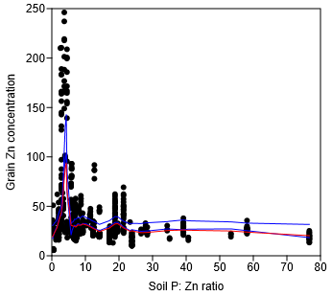
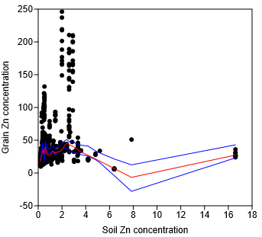 | 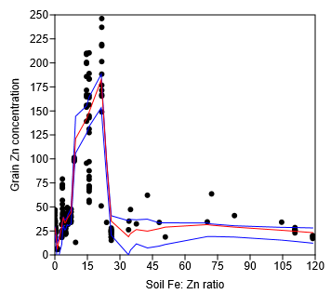
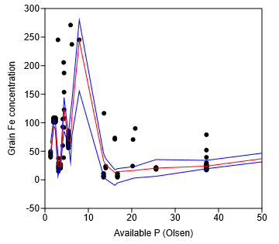 | 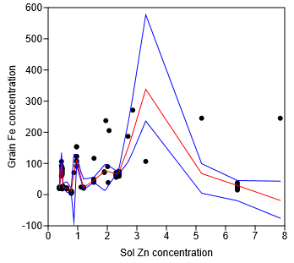
Fig. S5. Trends in grain Zn concentrations with soil available P (Olsen P), the ratio of available Zn to P ratios (P:Zn), soil Zn concentrations and the soil Fe to Zn ratio. The red and blue lines represent the trend lines and their 95% CLs.

