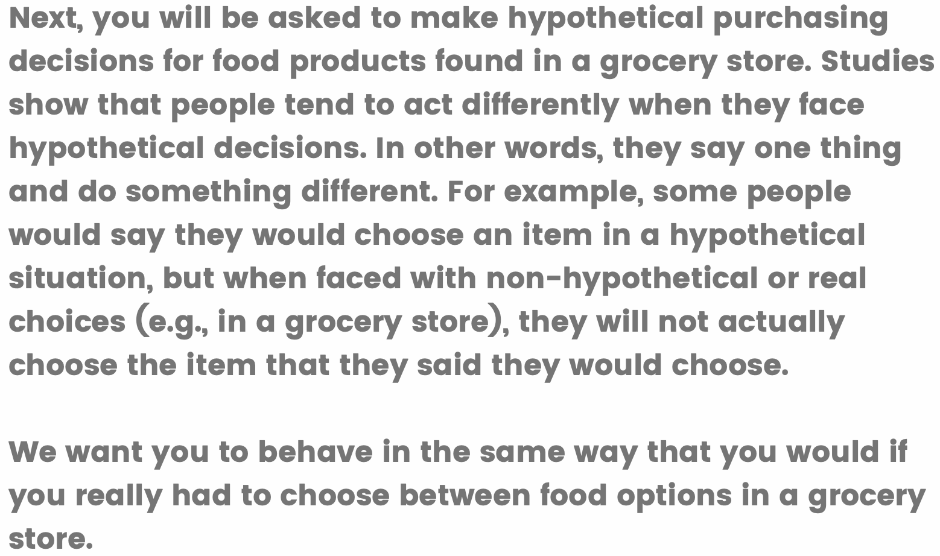
Appendix Figure 1. The cheap talk script shown to respondents before the dichotomous choice contingent valuation (DCCV) questions

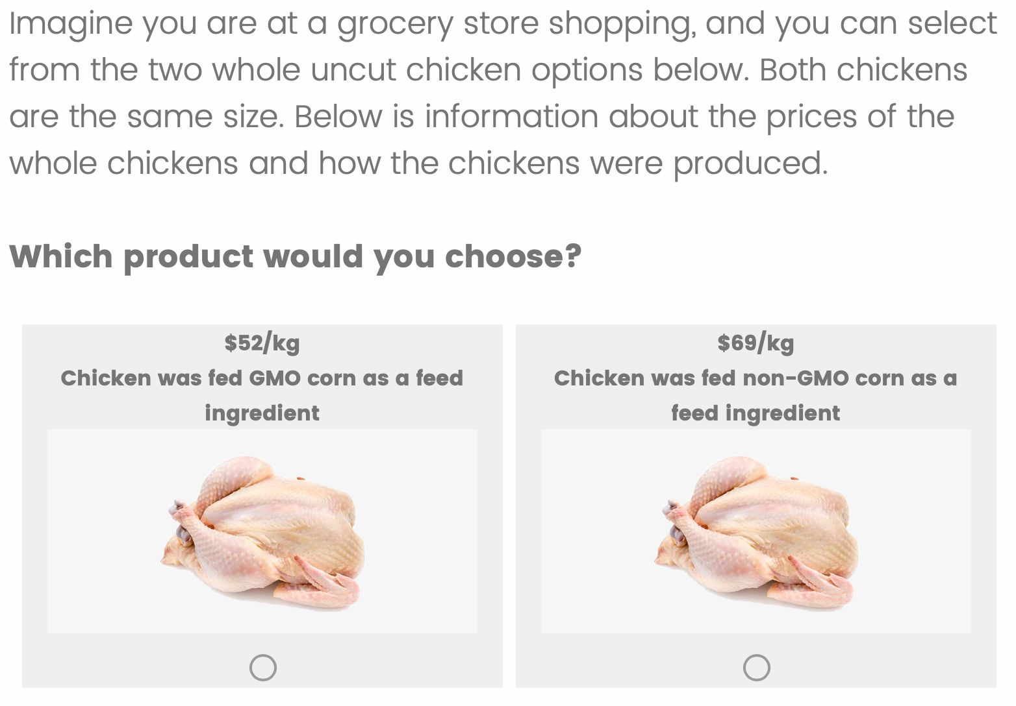
Appendix Figure 2. The first dichotomous choice contingent valuation (DCCV) question for chicken shown to respondents

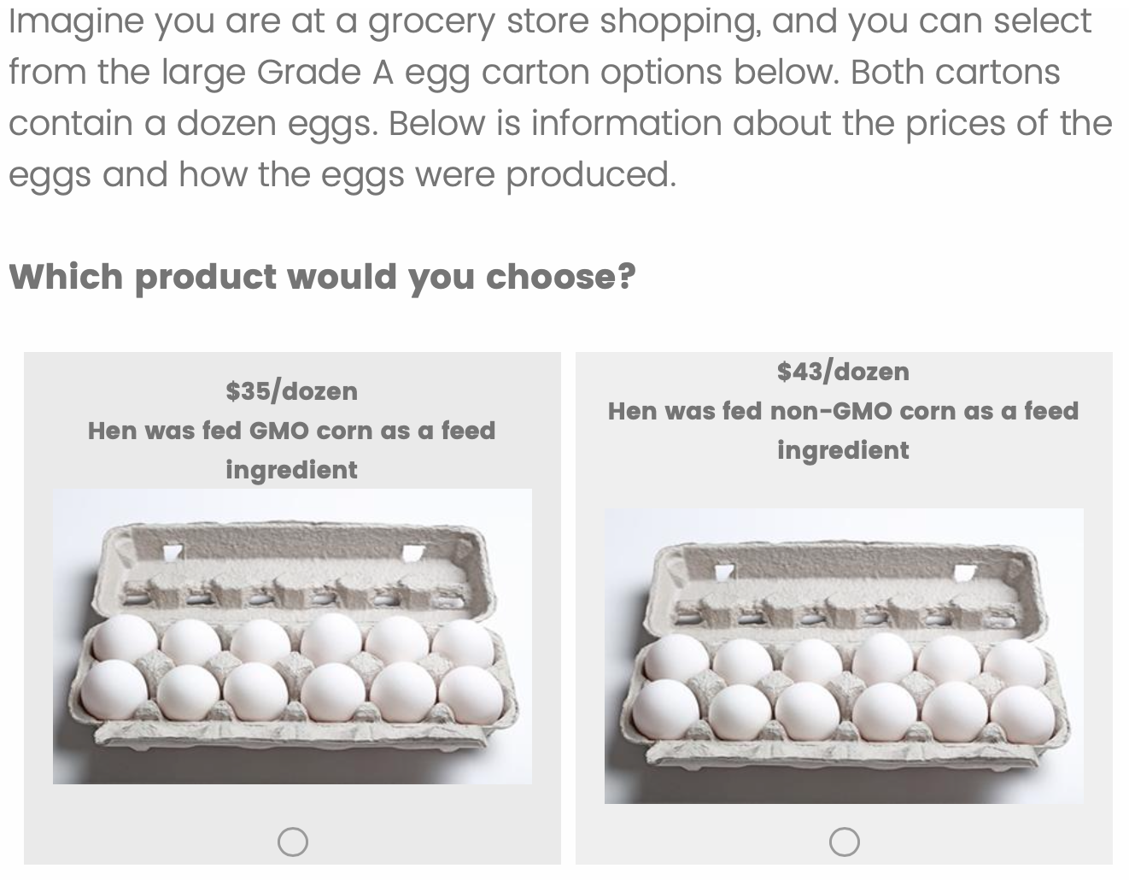
Appendix Figure 3. The first dichotomous choice contingent valuation (DCCV) question for eggs shown to respondents

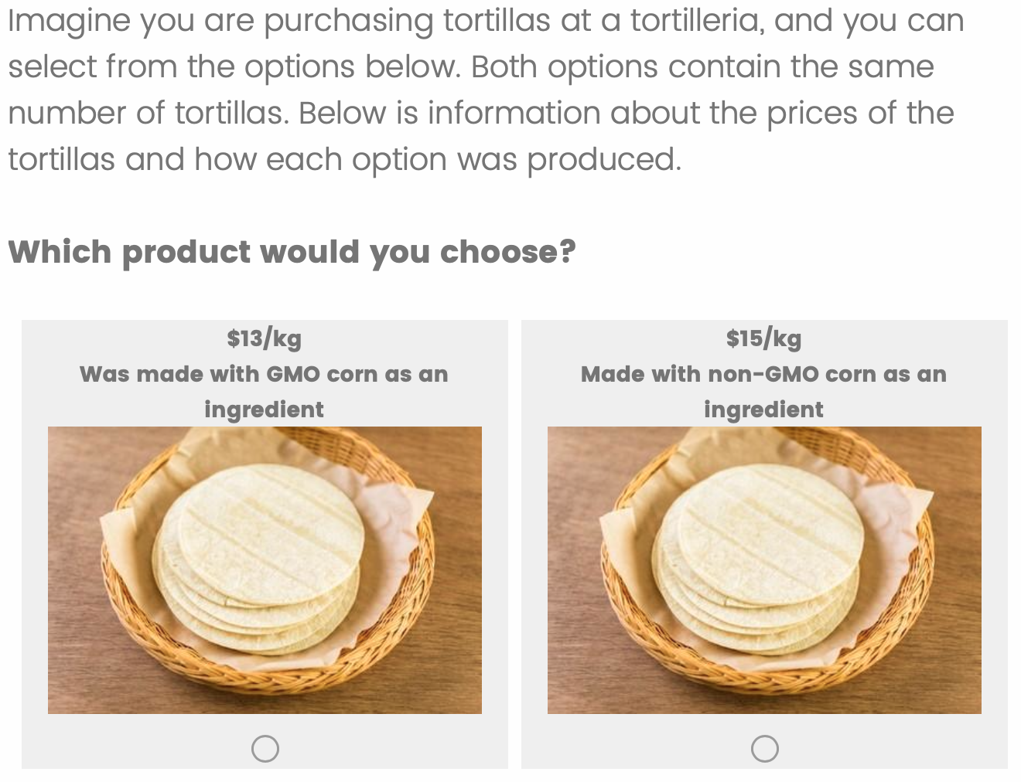
Appendix Figure 4. The first dichotomous choice contingent valuation (DCCV) question for tortillas shown to respondents

Appendix Table 1. Summary statistics for the sample's demographic characteristics
Region of Mexico | Frequency (%)
Central | 32.71
Eastern | 14.94
Northern | 22.78
Southern | 13.65
Western | 15.91
Education
High school or less | 48.79
Bachelor’s degree | 43.21
Graduate degree | 8.00
Gender
Female | 61.23
Male | 37.64
Non-binary / Prefer not to say | 1.13
Shopping Responsibilities
I buy almost all the groceries for my household | 54.28
I buy most of the groceries for my household | 21.08
I buy about half of the groceries for my household | 11.95
I buy less than half of the groceries for my household | 5.82
I rarely buy the groceries for my household | 6.87
Income
Less than $7,000 | 22.05
$7,000 to $20,000 | 23.18
$20,000 to $60,000 | 17.29
$60,000 to $120,000 | 18.42
More than $120,000 | 19.06
Race
Hispanic | 66.85
White | 25.08
Indigenous | 7.05
Black | 1.02
Neighborhood Density
Rural | 14.94
Suburban | 20.19
Urban | 64.86
Age* | 30.03
 | (9.90)
*The mean is reported for age, instead of frequency, and the standard deviation is reported in parentheses.

